Signature _______________________________________________

Name (print, please) ______________________________________

Lab section No. __________________________________________

Lab partner's name _______________________________________

Date(s) and time(s) lab was performed_____________________________________________

ECE 2100 Experiment VI

Frequency Response

# Introduction

## Purpose

In this experiment we will explore the frequency response of RC and RLC circuits.

## Background

Remember that Fourier’s Theorem allows us to find the response of a linear circuit to an arbitrary periodic signal if we know the response to a sinusoid of arbitrary frequency. In other words, if we know how the circuit behaves when a sinusoid is applied at any frequency, we can add the sum of the responses produced by sinusoids at several frequencies to find the response to any periodic signal. Mathematically, we need an infinite number of frequencies, but in practice only a few are needed.

We will be looking at the frequency response of the voltage gain, *Av*, of the circuits in this lab. The voltage gain will be defined as Av = , where  is the output voltage phasor, and  is the input voltage phasor.

**Bode Plots** are commonly used to characterize the frequency response of circuits. We use two kinds: magnitude Bode plots, and phase Bode plots.

A **Magnitude Bode plot** is a plot of in dB (deciBels) as a function of log().

A **Phase Bode plot** is a plot of the phase  in (deg) vs. log().

The deciBel is a measure of a ratio, for example the ratio in the exercises below. For voltage ratios, it is calculated as follow: Av [dB] = 20log().

## Components Required

Your lab kit does not include the 12[] resistor or the inductor. You will need to get those from the parts bins behind the TA desk.

1/4 watt Resistors:

12[] 2.2[k]

Capacitors:

0.047[F] 47[F]

# Pre-Lab

1. Using phasor analysis, find the ratio of the output to the input of Figure 1 as a function of frequency. That is, find as a function of . Make a magnitude and phase Bode plot, that is, plot 20log() vs. log () and in [deg] vs. log(). Use enough values of  to get a reasonable plot. You will be provided with log graph paper for this purpose.
2. Make the same plots for the circuit of Figure 2.

# Results and Discussion

***RC Circuit: Output across the capacitor***

1. Consider the circuit in Figure 1. Here, *vi* is a sinusoid: . Construct the circuit, and apply a sinusoidal signal. Note that the amplitude we use here is arbitrary because our measurements will involve the ration *vo*/*vi*.

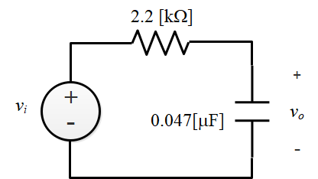

**Figure 1.** RC circuit, output across the capacitor.

1. Examine the output and input on the oscilloscope. Vary the frequency to note the behavior of the output frequency sweeps from low values to high values. The meaning of “low” and “high” should be clear from the behavior observed on the scope. We can use the value  as a reference, and vary the frequency around that point. Remember that the function generator produces frequencies f, not angular frequencies .
2. Measure the magnitude in dB and phase shift of the output relative to the input at several frequencies. Note that the multimeter will do the dB calculation 20log() for you; instructions for that are in the presentation “Bode Plots for 2100H”.
3. Plot your measured values on the graphs you made in the Prelab. Comment on the comparison between the calculation of the Prelab and the measurement made here.

***RC Circuit: Output across the resistor***

1. Consider the circuit in Figure 2, and make the same measurements as for Figure 1. Again comment on the comparison between calculation and measurement.

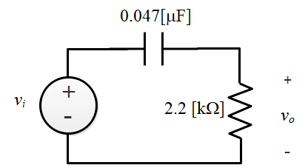

**Figure 2.** RC circuit, output across the resistor.

***RLC Resonant Circuit***

1. Consider the circuit in Figure 3. This is a series RLC circuit. Using phasor analysis, find the ratio as you did for the previous circuits.

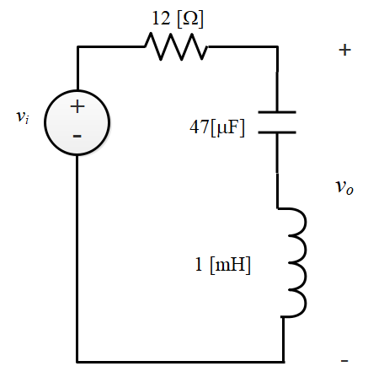

**Figure 3.** RLC circuit.

1. Find the value of the output for a frequency . This is called the resonant frequency; at this frequency the impedance of the capacitor and inductor are equal and opposite, and therefore cancel, so the output voltage is 0. Measure the amplitude of and construct a magnitude Bode plot of this circuit (we’ll skip the phase for this one). For , consider a range of angular frequencies from about 0.1 o to about 10 o.

Although the output voltage is predicted to be 0 at the resonant frequency, you will probably not be able to find the precise frequency at which this happens. You will see that there is a minimum in the output voltage, but it will not be 0. Do the best you can to adjust the frequency to get the minimum output.

**Conclusions**

1. Let’s think about the behavior of the circuits we have looked at. Specifically, let’s think in terms of the frequencies that “pass” through the circuit from input to output. One of these circuits is called a “high pass” filter; another is called a “low pass” filter; one is a “notch” filter. Which is which?

2. How does all of this relate to Fourier’s Theorem? In particular, if the input were a complex signal comprising frequencies in a wide range from low to high, how would the signal be modified in passing through to the output of each of the circuits?