Circuits and Electronics, by Dave Shattuck
Chapter 1
Section 1

Introduction to Electrical and Computer Engineering

This textbook is intended, in large part, to help prepare student in the fields of Electrical Engineering and Computer Engineering to be ready to be productive and successful engineers. Specifically, it attempts to do that by teaching the concepts of the fields of circuit analysis and electronics, which are fundamental to both areas. Another way of preparing students is by giving them an opportunity to develop, use and refine skills in problem solving. The reason this is important is because of the very nature of the field of engineering, broadly defined. To make sure that this is clear, we will begin by attempting to define engineering itself.
There are a number of definitions of engineering that are published in various places. Many of these are excellent definitions, but some of them use terms such as “applied science” which may not convey the key goal of engineering, which is problem solving. Therefore, we propose here a definition of engineering as follows.
Engineering is technical problem solving, particularly those problems that have not been solved before.
We can begin by contrasting engineering with science. Science is a field where the goal is the acquisition, preservation, and dissemination of knowledge. As a knowledge-gaining field, science is in some ways similar to engineering, and in some ways different. It is important to note that there is significant overlap in the actual things that they do, and this overlap is completely appropriate.
The field of science, or knowledge gaining, is based on the scientific method, where experiments are performed to get clear information about the subject being studied. Generally, designed an experiment to give clear information is not easy, as many variables can change, and the relationship between these variables and the results can be elusive. Therefore, coming up with a good experiment requires that problems be solved. Thus, scientists need to do problem solving. The field of engineering, or problem solving, requires that we know something about the problem we are solving. In general, to do a good job, the engineer will need to gain some knowledge about the problem first. Thus, the engineer will do some knowledge gaining.
So, we have scientists who are knowledge gainers who solve problems, and engineers who are problem solvers who gain knowledge. The key difference between them is the goal towards which they are aiming. For the engineer, the goal is the solution to the problem, and the gaining of knowledge is a means to that end. For the scientist, the goal is the gaining of the knowledge, and the solving of problems is a means to that end. They do the same things, but their goals are different.
Some examples may be useful here. We would argue that Galileo was a scientist, since his goal was understanding of the movement of the planets and the stars. While he and others solved some problems, such as the use of telescopes, as a means to gain that understanding, the knowledge gaining was the goal. See Figure 1.1.1. We would argue that Leonardo da Vinci was an engineer, since his goal was to be able to do things like fly. He studied birds, and gained knowledge of the structure of their wings, but that was a means of getting to where he could design a flying machine. See Figure 1.1.2. We would choose to categorize Albert Einstein as a scientist, since his goal was understanding of the fields and interactions of matter and energy. See Figure 1.1.3. In contrast, we would categorize Robert Oppenheimer, the director of the Manhattan Project that developed the first atomic bomb, as an engineer, since his goal was the solution of the problem of how to build that bomb. Of course, these categorizations are generalizations, and the actual individuals involved are much more complex that we have made them here, but the examples illustrate the general concept.
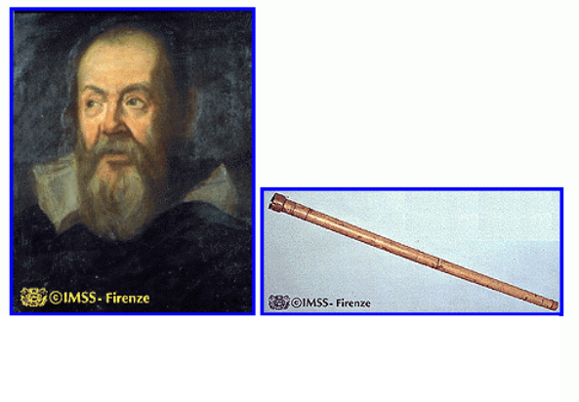
Figure 1.1.1 Galileo Galilei and His Telescope. Galileo used a telescope, and improved it, to try to better understand the motion of the planets and stars. (###Note: I need to get permissions to be able to use these images.) (I got it at http://atropos.as.arizona.edu/aiz/teaching/nats102/lecture4.html)

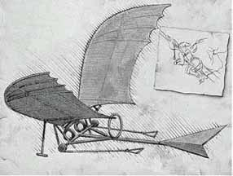
Figure 1.1.2. Leonardo da Vinci’s Flying Machine. This sketch of a flying machine by Leonardo da Vinci shows that his designs were influenced by his study of birds. (###Note: I need to get permissions to be able to use these images.) (I got it at http://www.jwdc.com/stj/renweb99/imagine1.html)

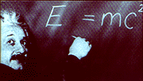
Figure 1.1.3. Albert Einstein and His Famous Equation. While his work led to the solution of many problems, Einstein’s goal was to understand the nature of mass and energy, and their relationship, among many other areas of physics. (###Note: I need to get permissions to be able to use these images.) (I got it at
http://archives.arte-tv.com/hebdo/archimed/19990525/ftext/sujet6.html)

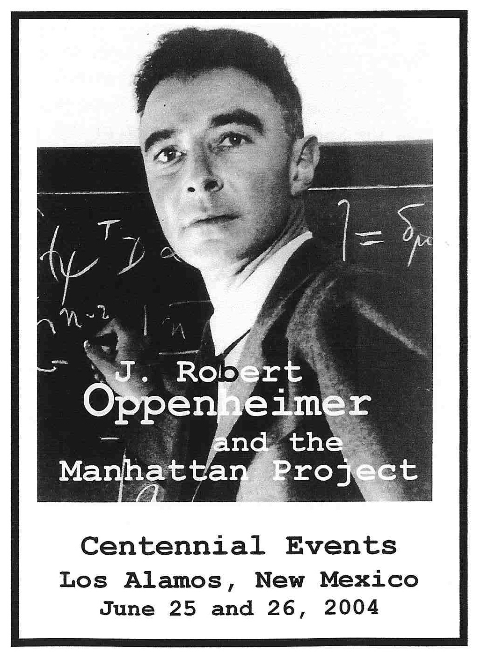
Figure 1.1.4. Robert Oppenheimer of the Manhattan Project. Robert Oppenheimer led the group that developed the first atomic bomb. Although he was trained as a physicist, and referred to in this way, his work on the atomic bomb had as a goal the solution to a technical problem, and one that had not been solved before. By our definition, on this project he was an engineer. (###Note: I need to get permissions to be able to use these images.) (I got it at
http://www.atomicheritage.org/oppenheimer_centennial.htm)
Next, we should point out that there are many fields that involve problem solving. Nursing, for example, is a largely a problem solving field, where the problem is how to care for the patient’s medical needs and other needs while the patient is healing, and how to assist that healing process. Thus, we make the distinction that engineering is a technical problem solving field. While this is still quite general, it separates engineering from other fields that have the goal of solving problems.
Finally, it should be noted that the field of technology also meets the definition of a technical problem solving field. While the distinction is not always a firm one, generally an engineer is called upon to solve problems that have not been specifically solved before. As an example, the repair of television sets is a technical problem solving task, but the repair of standard television sets is largely a task which has been mapped out. To be a technician requires training and understanding, but a technician is usually called on to perform tasks which have been performed before.
Engineering, on the other hand, is typically the solution of problems that have not been solved before. For example, the design of a new kind of television display would likely be implemented by a team of engineers. Design, by its nature, is a task which implies solving a problem that has not been solved before. Not all engineering tasks are design tasks. However, the field of designing technical solutions to new problems is thought of as an engineering field.
The solving of problems that have not been solved before leads to a key aspect of engineering field; one needs to understand the fundamental concepts very thoroughly to be able to use them to solve a new problem. It is relatively easy to learn how to perform a particular task that solves a problem. It is more difficult to learn how the solution of one problem relates to the solution of a new and different problem, which is governed by the same concepts and parameters. This, then, will be our goal in this textbook. We wish to help you learn fundamental concepts that apply broadly to the fields of circuit analysis and electronics. Then, we want to help you practice taking these concepts and using them in new and different ways. In addition, as we move to the field of electronics, we want you to be able to experiment with the approach to design problems. These problems are usually iterative in nature, and may not have a single closed-form solution. This problem solving approach requires understanding and practice. We hope to provide the framework to help you both gain understanding and facilitate the practice required to become adept at solving new problems.
There are three aspects of the engineering approach to problem solving that bear some comment at the outset. First, the engineering aesthetic is that the best solution method for solving a problem is the fastest method that gives the right answer, in a legal and ethical way. Second, the solution that is obtained only needs to be accurate enough for the application, and that therefore approximation may be a very good thing, if it can speed up the solution. Third, design is inherently an iterative process, which requires trial and error. One should expect to fail on some attempts, but one should learn from those failures and make a better attempt on the next try.
Generally, an aesthetic is something that considered beautiful and important. The engineering aesthetic then is intended to convey what is beautiful and important in engineering. In mathematics, a particular proof may be said to be an elegant proof, because it conveys the solution very well. Since in engineering we are interested in practical problem solving, speed is important. If you can get the same solution, and everything else is the same, quicker is better. Note that a quick solution approach that does not always give the correct answer is not of much use, unless you know in advance when it will work and when it will not work. It is also useful to note that in engineering, having an ethical approach is traditionally valued very highly. One approach to getting quick and correct answers to an exam question would be to copy them from a good student; this is not ethical, probably not legal, and not appropriate for engineering. The key point in the engineering aesthetic, though, is that degree of difficulty in the solution technique is not an issue. This is a contrast with fields like diving. In Olympic diving competitions, you get more points for doing a dive in a more difficult way. There is no advantage in taking a more difficult approach in engineering problem solving; if you find an easier way to get the same answer, you should use it.
The issue of approximating quantities on the way to a solution can be very upsetting for someone who is new to engineering. However, it is an important skill. For example, if you only need to know the distance to another city to within a mile or two, spending time getting the most accurate possible answer is not a good use of time. It is better to approximate, and get the answer quickly. The key in approximating is that you need to know that application area before deciding how to approximate. As another example, if you are going to paint the floor of a room with conventional paint, you might be interested in its area to within a few square meters. If you are going to cover it with expensive rose petals to impress someone you like, you may want to know its area more accurately, perhaps to within a few square centimeters, so that you can minimize your cost. The accuracy needed for any quantity depends on the application. This is one of the things in engineering that takes some practice.
The subject of design begins to become important in circuit analysis, but its application is even more obvious in electronics. We will practice doing some design problems in the electronics part of this textbook, which simulate real world design. Design is usually used when the solution is not obvious, and often cannot be easily obtained through a linear process. As a result, we need to iterate in a design problem. We have an idea for a solution, and we build it, in whatever way might be appropriate. We might actually build a physical circuit, or we might simulate the solution on a computer, or write a program to perform the solution. In some way, we build the solution we have thought of. Then, we test it. Typically, our first attempt does not succeed in meeting whatever conditions we have, which are called design constraints. Using what we learned in our previous attempt, we modify our idea, and try again. This iterative approach is presented in Figure 1.1.5. In some designs we need to go around the loop shown many times. This is the nature of design.
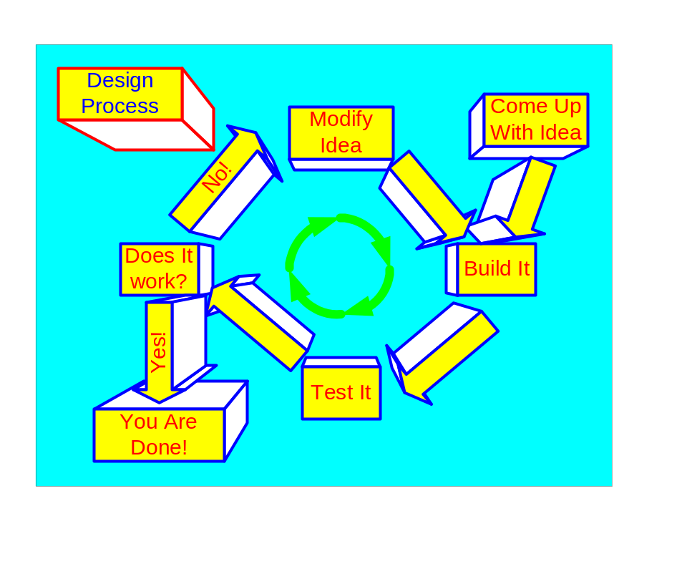
Figure 1.1.5. The Design Process. When we are designing something, we start with an idea for a solution. In this diagram, it says that we build that solution, but this should be taken in a very general way. Building it may mean coming up with an accurate model, running a computer simulation, or other implementations. The key here is that we should be able to test that implementation of the solution. If it doesn’t meet the criteria, you change the solution, and repeat the process until solution does meet the criteria, that is, it works.

As we begin our study of engineering, we often do not do many design problems. There is a good reason for this. A key part of the design process is the analysis of a proposed solution. If you cannot do this, you cannot go through the iterative process effectively. Since this is relatively easy, in that analysis is easier than figuring out how to come up with new solutions, we generally learn to do analysis first. The part of the design process that is called analysis is indicated in Figure 1.1.6.
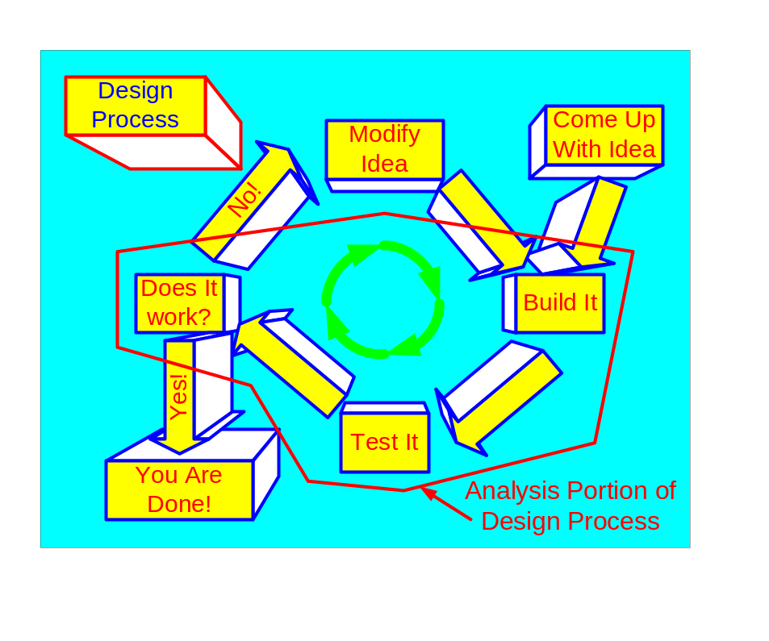
Figure 1.1.6. Analysis Portion of the Design Process. One part of the design process is the analysis of the solution that you are testing. This analysis part is in some ways the easiest part of the design process, so we generally teach that part first.

A nice set of web pages on the building of the early airplanes by the Wright brothers is available at http://www.first-to-fly.com/. In these web pages around this site, maintained by the Wright Brothers Aeroplane Company, the process of iteration, including several airplane designs that did not fly, is described. Many interesting pictures and descriptions of the iterations attempted are available. They use the word invention where we are using the word design, but the meaning is the same. They describe an iterative process that involved gaining knowledge, and quantifying key parameters such as lift from a wing shape. They have a wonderful paragraph that begins one section; that paragraph is repeated here.
Invention is where poetry and engineering come together. It is a creative endeavor where the heart beats faster with each intuitive leap, yet success is measured by the stern, unforgiving ruler of the Scientific Method. It’s not a predictable process; you never march a straight path to your goal. Instead, you crisscross the same ground over and over again as you search for the answer that you’re sure is there somewhere. Every successful invention is the result of false starts, dead ends, disappointments, self-doubt, perseverance, and the elation that comes when your faith in yourself is at last rewarded.
This paragraph describes in a very powerful way how the entire field of engineering can feel, once we get the skills we need to do it well. Our goal in this textbook is to help you get to that stage.

