Circuits and Electronics, by Dave Shattuck
Chapter 1
Section 3

Current and Voltage

The two fundamental quantities of interest to us in circuit analysis are current and voltage. We need to understand these quantities to be able to understand the field of circuit analysis. Although you may have seen these quantities before, and have heard their definitions in other courses, we will start with them again, as if you had never seen them before. It is very important that we get them clearly defined from the beginning.
We will begin with current. Current is defined as the net flow of positive charges, through some plane in an electrical device, per time. First, let’s discuss the charges. Electrical charges can be positive or negative. While we know that in most cases the charges that move are electrons, which have a negative charge, we will generally not be concerned about whether negative or positive charges are moving. While the charges that move may be important in some special applications, very often the nature of the charges, positive or negative, does not matter. We will think in terms of the movement of positive charges. Thus, when we say the net flow of positive charges, we mean that positive charges flowing from left to right have the same net result as negative charges flowing from right to left. There are other fields where current is defined in a different way, often referred to as electron flow. In Electrical Engineering, the definition is in terms of the flow of positive charges.
Second, let’s talk about flow through a plane in an electrical device. We use the term device to refer to almost anything that could have charges moving through it. Thus, although we have not formally defined them yet, we could be talking about things such as resistors or sources. However, it is important to note that we could talk about the flow through almost anything. We could be interested the current through the filament of a light bulb, through a pen or a pencil, or even through your own body. The concept that is important here is that in anything; when we talk about current through that thing, there must be a plane that could be imagined as cutting across that object. We then imagine that we could count the charges going past that plane, per time. That net number of positive charges, going through that plane, is current.
Definition: Current is the net flow of positive charges through some plane in an electrical device, per time.
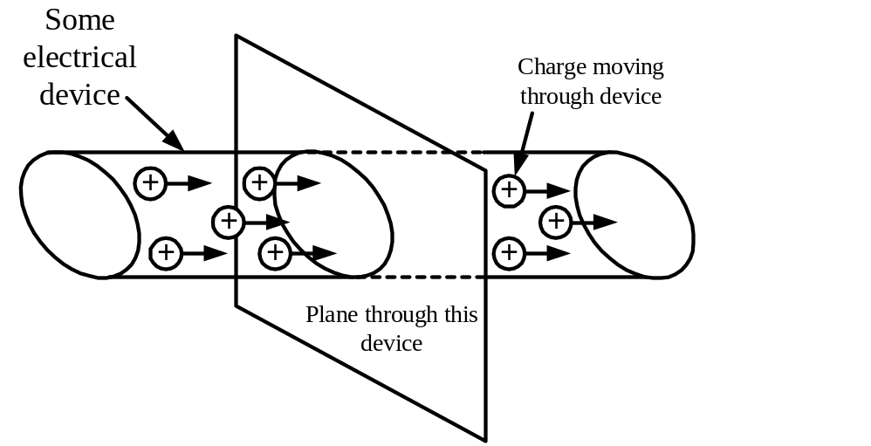
Figure 1.3.1. Current Flowing Through a Device. This is a conceptual picture of current flow through a device. The device could be anything that has charges moving through it. If we were to count the net number of charges to flow through a plane that cuts through the device, as shown here, as a function of time, that would be current. Note that if we had negative charges moving to the left, this would be the same net result as positive charges moving to the right.
We will use the letter i for the current variable. Historically, this is due the term intensity that had been used for this quantity, but we should not use this term any more, since it could be confused with other quantities with that name. We can now show the formal mathematical definition of current, which is
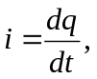 (Eq. 1.1)
where q is the charge, and t is time. Here, defining current as a differential equation brings out the part of the definition where we recognize current as the number of charges per time. This mathematical definition, while also useful, does not make clear that we are talking about the charges moving through a plane in some object, nor that we are talking about the net flow of positive charges. We should think of the definition in words, and the definition in mathematical terms, as being complementary views of the same thing.
Now, we immediately need to talk about a key issue in all of our discussions of these two fundamental quantities of current and voltage. This key issue is that of polarity. By this, we mean, which way does it go? For current the specific question is, which way are the positive charges flowing? The answer to this question may be extremely important. Indeed, in some cases the polarity of the quantity may be more important than the magnitude or size of the quantity. We will keep track of polarity by using what we call reference polarities and actual polarities. After we have defined voltage, we will describe what reference polarities and actual polarities are for both quantities, and explain how they are defined and used.
The next issue is that of units. While Eq. 1.1 does not have units shown in it, in accordance with our plan as laid out in Section 1.2, it is reasonable to introduce the units for current here. We use the unit [Amperes] for current, where an [Ampere] is defined as a [Coulomb] per [second]. We abbreviate Amperes as [A], Coulombs as [C], and seconds as [s]. So, we have
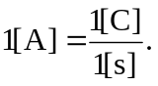 (Eq. 1.2)
Note that the case (uppercase or lowercase) is important in these units. For example, the uppercase version of the letter s, [S], is used for the units of conductance, which will be introduced later. A [Coulomb], or [C], is a defined number of electron charges, approximately 6.24 x 10¹⁸ electron charges.
Hydraulic Analogy for Current
It is often useful to look at analogies in our attempts to understand certain concepts. The concept of current is a very important one, so we will introduce a hydraulic analogy to current. Before we do so, however, it is important to note that these analogies are always limited; not everything in the analogy is completely the same for both of the analogous parts. Still, many people find these analogies useful.
In this case, in a water system, or hydraulic system, the volume flow rate would be analogous to current. Think of water flow in a pipe. If you were to imagine having a plane that cuts across this pipe in some location, you can measure the volume of water that flowed through that plane per time. For example, in a water pipe you might have 3 cubic meters of water flow past that plane per second. This volume flow rate, in some ways, would be analogous to current. It is a rate, in that a given amount moves in a given time. In addition, it is about the amount that flows past a specific plane in some object.
However, this analogy breaks down when we consider that we have positive and negative charges, but we really do not have positive and negative water. Someone might suggest that we have air in a water pipe, which might be thought of as negative water, but that air does not have negative mass, it has zero mass. The point here is that in all analogies, we should use them to help us understand, but we should not expect the analogy to be perfect in all respects.
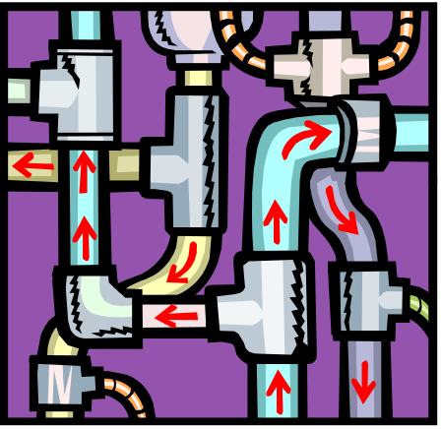
Figure 1.3.2. Water Flow Analogy to Current. The volume flow rate of water through a pipe can be thought of as being analogous to current. If you were to have a plane cut across a pipe, then the volume flow rate past that point could be measured. That is analogous to the number of charges going past a plane in an electrical device.
Next, we will discuss voltage. Voltage is defined as the change in potential energy between two points, caused by electromagnetic fields, per charge. First, it is extremely important to note that voltage is always about two points. It is meaningless to speak of the voltage at a point, unless a second point is understood. You may hear someone speak about the voltage at a point, but if that is meaningful, it is only because the second point is assumed to be known, and to be clear to everyone who is listening. Much later in this book, we will introduce situations where this second point is assumed to be known, in an agreed upon way. Until then, we will be very careful to always specifically indicate the two points in question.
Second, let us consider what we mean by potential energy. Potential energy is a concept that we have seen in other fields. This can be a difficult concept, and one that may take some time to get comfortable with. The idea is that an object has the opportunity, or potential, to do work in the future. We may think of the opportunity for charges to do work, by considering the diagrams in Figures 1.3.3 and 1.3.4. In these diagrams, we illustrate the idea that charges in an electric field have the ability to do work in the future, and therefore have potential energy. This potential energy changes with the size of the charge. The change in this potential energy between two points, per charge, is called voltage.
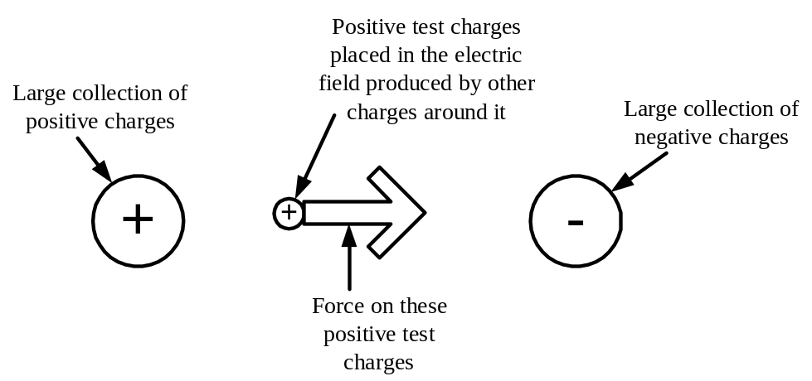
Figure 1.3.3. Forces on Test Charges in Electric Field. In this diagram, we have a large collection of positive charges in one place, and a large collection of negative charges somewhere else nearby. Some positive test charges that might be placed between these two collections would have a force on them due to the electric fields from these two collections. Thus, these test charges have the potential to do work, and have potential energy. The amount of potential energy is proportional to the size of the test charge.

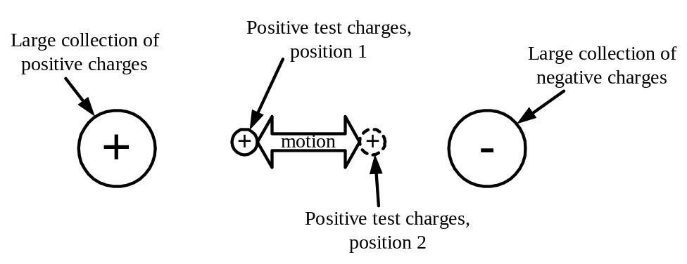
Figure 1.3.4. Change in Potential Energy Between Two Points. In this diagram, we look at the movement of some positive test charges between two points, called position 1 and position 2. Between these two points, we have a change in potential energy. We call this change in potential energy voltage. We say that if we look at position 1, with respect to position 2, position 1 had more potential energy. We call this a positive voltage at position 1 with respect to position 2. In this case, we could also say that we have a negative voltage at position 2 with respect to position 1.

Definition: Voltage is the change in potential energy between two points, per charge.
We will use the letter v for the voltage variable. We can now show the formal mathematical definition of voltage, which is
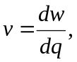 (Eq. 1.3)
where q is the charge, and w is energy. Here, defining voltage as a differential equation brings out the part of the definition where we recognize voltage as the change in energy with respect to charge. This mathematical definition, while useful, does not make clear that we are talking about the two points, nor that we are talking about positive charges. As before, these two definitions are complementary views of the same thing.
The polarity of the voltage is just as important as it was with current. Again, we will discuss polarities in detail, in terms of reference polarities and actual polarities, later in this section.
The next issue is that of units. We use the unit [Volts] for voltage, where a [Volt] is defined as a [Joule] per [Coulomb]. We abbreviated Volts as [V], Coulombs as [C], and Joules as [J]. So, we have
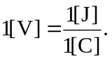 (Eq. 1.4)
As before, the case (uppercase or lowercase) is important in these units.
One way we can make the definition clearer is to state it in another way. So, we could say the following:
One [Joule] of energy is lost from an electric system when one [Coulomb] of positive charges moves from one potential to another potential that is one [Volt] lower.
This statement indicates that when we are talking about voltage, we are typically talking about energy changes for a positive charge. It is important to note that if we were talking about negative charges, the energy changes would be opposite. This should make sense. If we were moving a positive charge in a direction where it is opposed by the electromagnetic field, a negative charge moving in the same direction would be assisted in its motion by that same field.

Hydraulic Analogy for Voltage
There is a similar analogy for voltage in a hydraulic system. In this case, in a water system, the change in height would be analogous to voltage. Water has mass, and there is an assumption here, that we operating in the presence of a gravitational field. Of course, this is generally true when we are not in space. Therefore, when you take water and move it from one place to higher place, the water will have gained potential energy. Thus, there was a change in potential energy between those two places. This change in potential energy between two places is analogous to voltage.
Again, this analogy breaks down when we consider that we have positive and negative charges, but we really do not have positive and negative water. We don’t have anything that has negative mass. The point here is that in all analogies, we should use them to help us understand, but we should not expect the analogy to be perfect in all respects.

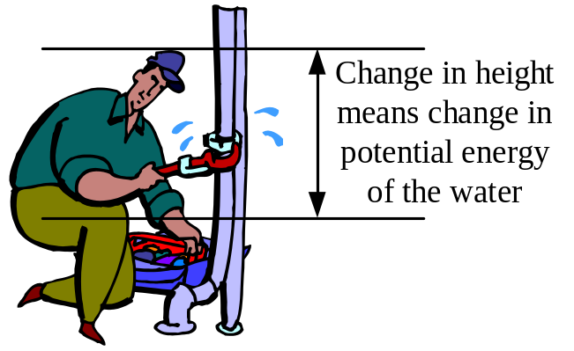
Figure 1.3.5. Analogy of Voltage to Change in Height. The change in potential energy between water at one height and another height in a hydraulic system is a result of the gravitational field, and is a function of how much water you have. This change in potential energy between two points is analogous to voltage.

Reference Polarities and Actual Polarities
We wish to be able to talk about, solve for, and indicate clearly the directions for both current and voltage. For current, we wish to be clear about which direction positive charges are moving. For voltage, we wish to be clear about which direction would result in a positive charge losing energy. These directions we have just described are what we will call actual polarities. The actual polarity is the direction which things are. This is relatively straightforward. However, to get to the actual polarity, we use an approach involving something called reference polarities. A reference polarity is a direction chosen for the purposes of keeping track. A reference polarity is an arbitrary choice. One can pick a reference polarity in any way one wishes. Then, with any quantity with a reference polarity, the sign of the value of that quantity tells you the actual polarity.
This concept of reference polarities can be difficult at the beginning, until you become comfortable with this approach. Again, to illustrate this idea we will turn again to an analogy to this approach. The analogy we choose here is to the directions on a compass. More or less arbitrarily, in aircraft navigation, north has been chosen as a reference direction. Having made this choice, one can then say to a pilot of an airplane to go in the direction of 135°. This is now unambiguous, and will be interpreted as indicating that the pilot should fly southeast. This is clear because southeast is 135°, clockwise, from north. The point to be made here is that this direction is only clear because a reference direction, north, has been chosen.
The actual polarity is the direction something is actually going. The reference polarity is a direction chosen for the purposes of keeping track. We have only two possible directions for current and voltage. This is in contrast to our example with the compass, where there are essentially an infinite number of possible directions to go. Since there are only two possible directions for each quantity, this means that we can indicate the polarity using positive and negative signs. Thus, if we have a reference polarity defined, and we know the sign of the value of that quantity, we can get the actual polarity. As another more direct example, suppose we pick our reference direction for motion as ‘up’. Then, let us imagine that we say that the distance we go ‘up’ is –5[feet]. We know then, that we have moved an actual distance of +5[feet] down.
We will do a similar thing for voltage and current. We have an advantage in these cases, in that voltage, being the change in potential energy between two points, has only two possible polarities. Similarly, for current, charge can move through a plane in only two different directions. Thus, the approach we use is as follows.
We pick a reference polarity for a quantity, which is a voltage or a current. Then, the sign of the number that goes with that quantity indicates whether the actual polarity is in that same direction as that reference polarity, or the opposite direction from that reference polarity. If the sign of the quantity is positive, the actual polarity is the same as the reference polarity. If the sign of the quantity is negative, the actual polarity is in the opposite direction from the reference polarity.
The key to this process is that the reference polarity must be chosen, and the choice must be clear to all. We say that the choice of a reference polarity, along with the choice of a name, defines a voltage or a current. As with all variables, these variables must be defined, or else they are of very limited use. If the defining has not yet been done when we encounter a variable, we must define it before we use it. Generally, we can define such variables in any polarity we wish. It is not possible to make a mistake picking a reference polarity. The only mistake we can make in defining reference polarities is to fail to do it. We show how we will define voltages and currents in the figures that follow.
To define a current, and to indicate the reference polarity for this current, we place an arrow next to the device or object that has the current going through it. Next to that arrow, we place a current variable, which should be the letter i, typically with a subscript. Alternatively, the arrow can have a number with units next to it. It is also acceptable to have both the current variable and the number with units as the label for the arrow. See Figure 1.3.6 for examples for these options.
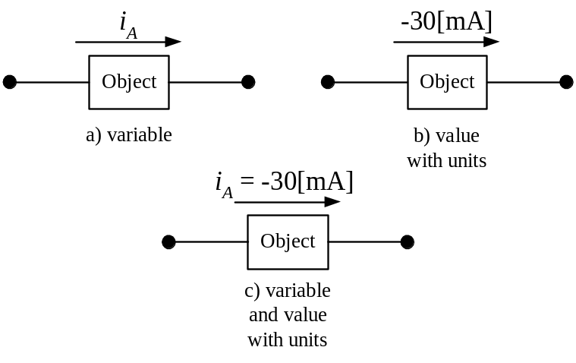
Figure 1.3.6. Options for Defining Currents. In each of these options, we are given the reference polarity from the arrow. The sign of the number associated with that polarity, tells us what the actual polarity is. In cases b) and c), since we know the sign of the value, we know that the actual polarity of the current is from right to left. In other words, positive charges are flowing from right to left.
To define a voltage, and to indicate the reference polarity for this voltage, we place a + sign and a - sign at the two points across which the voltage is defined. On an imaginary line between these two signs, we place a voltage variable, which should be the letter v, typically with a subscript. Alternatively, we can place a number with units next to it, in this location. It is also acceptable to have both the current variable and the number with units. These should be along a line between the signs, but the line itself should not be drawn. See Figure 1.3.7 for examples for these options.
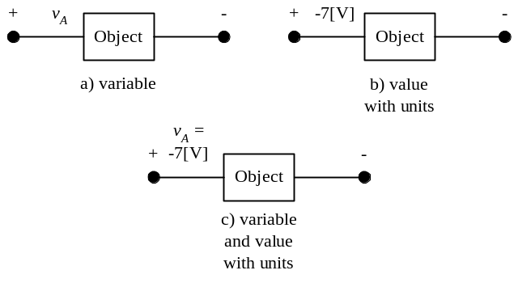
Figure 1.3.7. Options for Defining Voltages. In each of these options, we are given the reference polarity from the + sign and the - sign that are shown. The sign of the number associated with that polarity, tells us what the actual polarity is. In cases b) and c), since we know the sign of the value, we know that the actual polarity of the voltage is at the right with respect to the left. In other words, the right hand side has a higher potential energy.
We should note that the variables shown are given as lowercase variables, with uppercase subscripts. This is appropriate, and you should get into the habit of doing this. The reason for this is difficult to explain at this point, but we will lay out the reasons in a later chapter.
Before leaving the subject of current and voltage, it is good to note the issues of path dependence for these two variables. Current is a path dependent variable. The value of the current for any object depends on the path being one that goes through that object. This is why we use the preposition “through” when we talk about currents, as in “this is the value of the current through the wire”. In contrast, voltage is a path independent variable. The value of the voltage between at any two points does not depend on the path that one has taken to get between those two points. This is why we use the preposition “across” when we talk about voltages, as in “this is the value of the voltage across the gap”. See Figure 1.3.8 for an example, in terms of our hydraulic analogies.
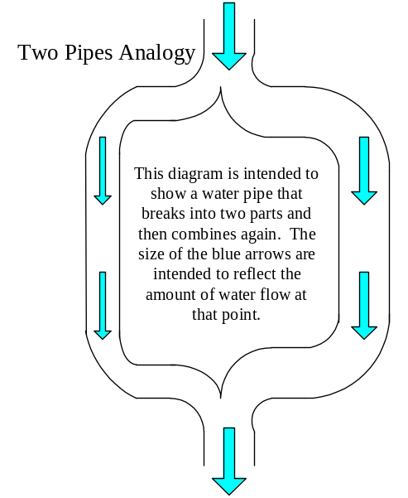
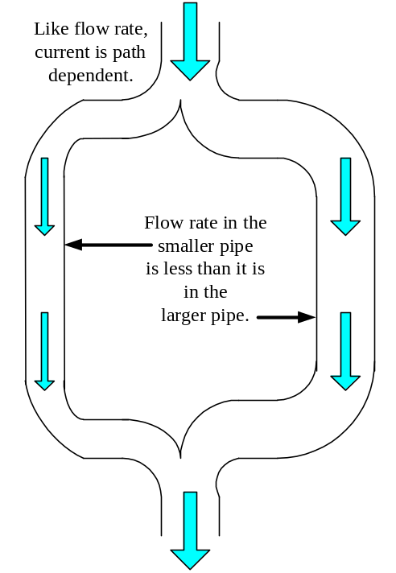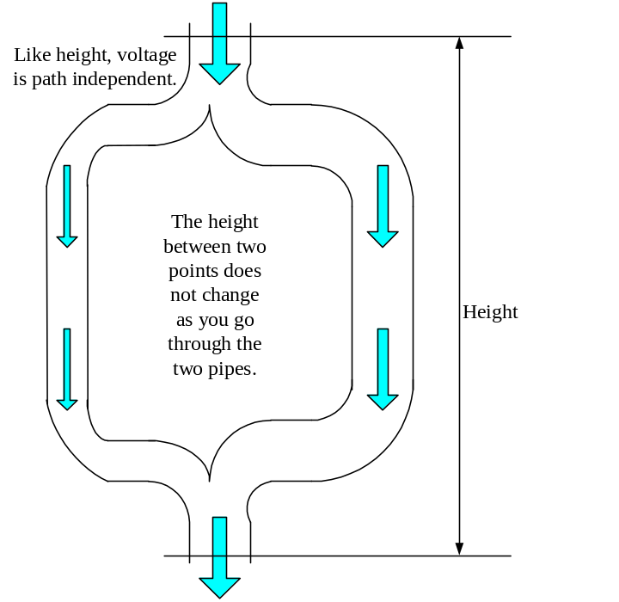
Figure 1.3.8. Hydraulic Analogies to Illustrate Path Dependence. If we look at the flow rate through two pipes, we note that the flow rate is different for the two pipes. This is because flow rate, as with current, is a path dependent variable. If we look at the change in height across the two pipes, which are connected together at each end, we note that the change in height is the same for each pipe. This is because the change in height between two points is path independent, in the same way as voltage is path independent.
It will be very important that we understand voltage and current, and the appropriate way to define them and to talk about them. It will be crucial for the remainder of the text, and indeed for your future with the field itself.

