Name: _____________________________ (please print)
Signature: __________________________
Circle your class time: 5:30-7PM, TuTh 1-2:30PM, MW 2:30-4PM, MW

DO NOT OPEN THIS BOOKLET UNTIL INSTRUCTED TO DO SO

ECE 2300 – FINAL EXAM
December 10, 2002

1. This exam is closed book, closed notes. You may use up to three 8.5” x 11” crib sheets, or their equivalent. You may use any calculator. Turn all cell phones or other communications devices off.
2. Show all work on these pages. Show all work necessary to complete the problem. If you go on to another page, indicate clearly where your work can be found. A solution without the appropriate work shown will receive no credit. Clearly indicate your answer (for example, by enclosing it in a box).
3. Show all units in solutions, intermediate results, and figures. Units in the exam will be included between square brackets.
4. Use appropriate notation for all quantities.
5. Do not use red ink. Do not use red pencil.
6. You will have 180 minutes to work on this exam.

1. ________________/1
2. ________________/22
3. ________________/15
4. ________________/14
5. ________________/15
6. ________________/8
7. ________________/11
8. ________________/15
- {1 Point} On the front page, circle your class time.

Room for extra work
2) {22 Points} a) For the circuit shown, use the node-voltage method to write a complete set of independent equations that could be used to solve this circuit. Do not attempt to solve the equations. Do not attempt to simplify the circuit.
b) Write expressions for the power delivered by each of the current sources, in terms of the defined voltages and currents in part a), and the component values.
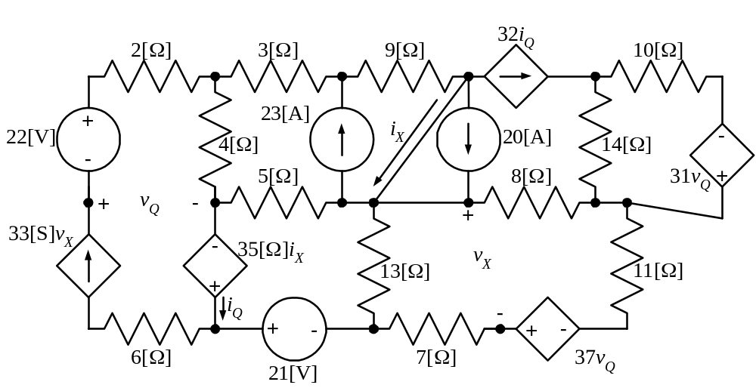

3) {15 Points} a) For the circuit shown, find the Norton equivalent circuit as seen by the light-emitting diode (LED) in this diagram.
b) It is given that v_{D} = 0.7[V] in this circuit. Find the power delivered by the LED.
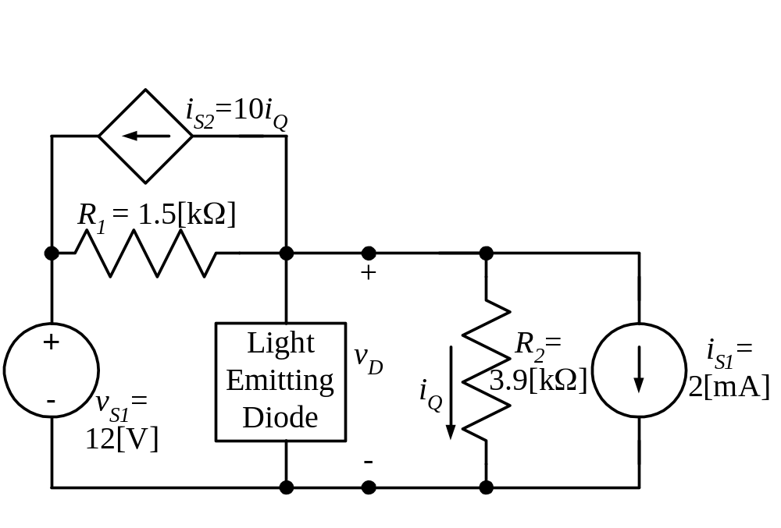
4) {14 Points} In the circuit shown, switches SW1 and SW2 have been in position a for a long time before t = 0.
At t = 0, both switches move simultaneously to position b. Then at t = 0.1[s] both switches move simultaneously to position c, and stay there.
Find the total energy trapped in the capacitors.
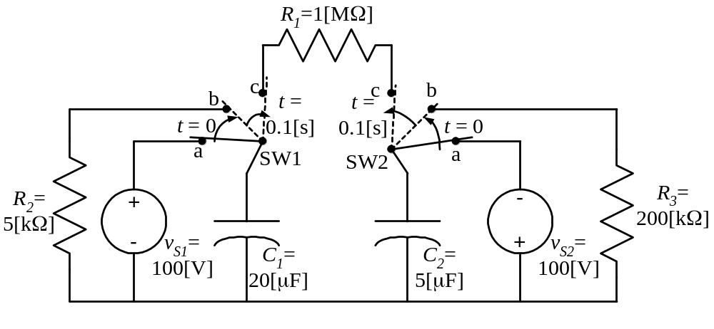
5) {15 Points} For the circuit shown, both switches SW1 and SW2 have been in position a for a long time before t = 0.
Then, at t = 0, the switch SW1 moves to position b, and remains there.
At t = 0.2[s], the switch SW2 moves to position b, and remains there.
For the time intervals 0 < t < 0.2[s] and t > 0.2[s], define the numerical expressions for the current i_{X}(t) flowing in the wire from d to e. The reference polarity for the current i_{X}(t) is given in the figure.
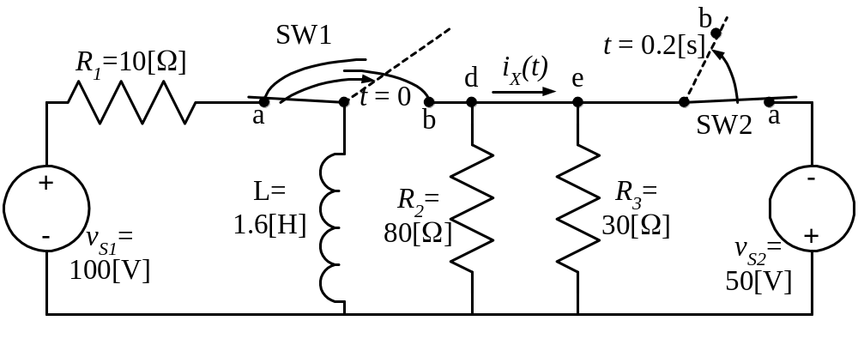

6) {8 Points} For the circuit shown, write a numerical expression for i(t), the current through the inductance in the steady state. The reference polarity of i(t) is given in the figure. The voltage v_{S}(t) is
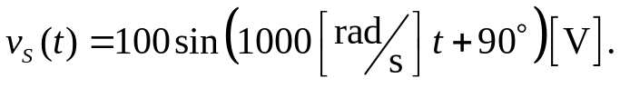

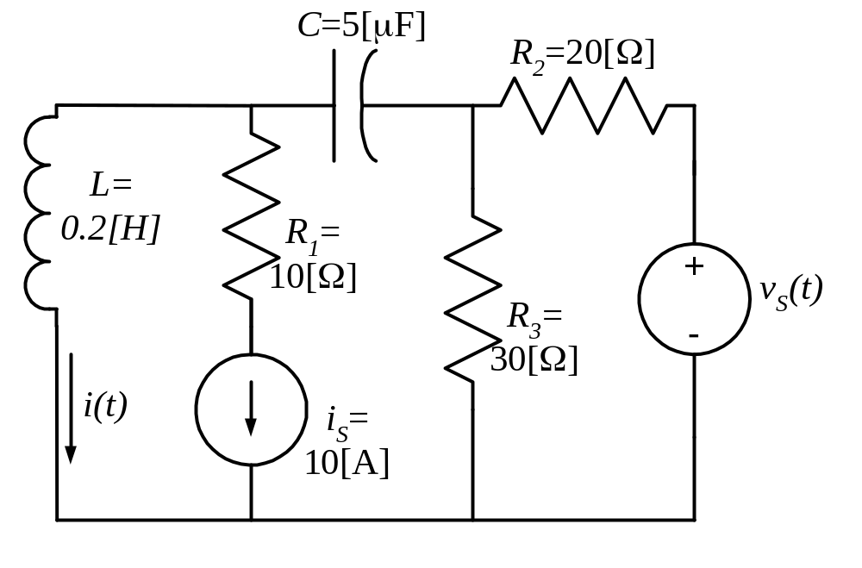
7) {11 Points} For the circuit shown, calculate the value for I_{x}.
Note that in this machine-produced circuit diagram, phasors are represented with bold variables. For your handwritten work, you should use the notation for phasors discussed in class.
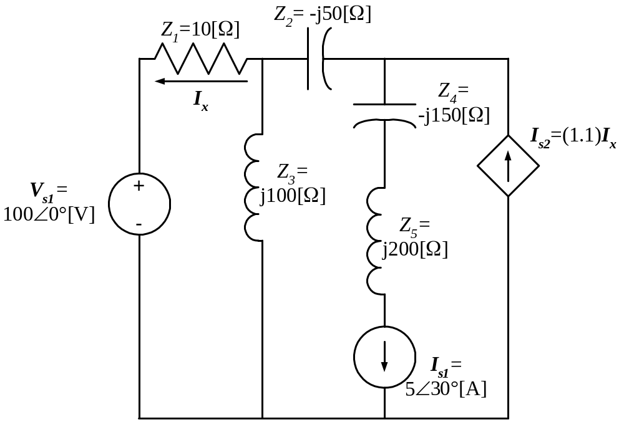
8) {15 Points} For the circuit shown, calculate the complex, apparent, average, and reactive powers absorbed by the load, and the corresponding power factor. It is given that
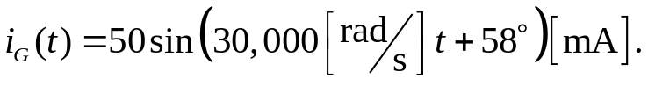
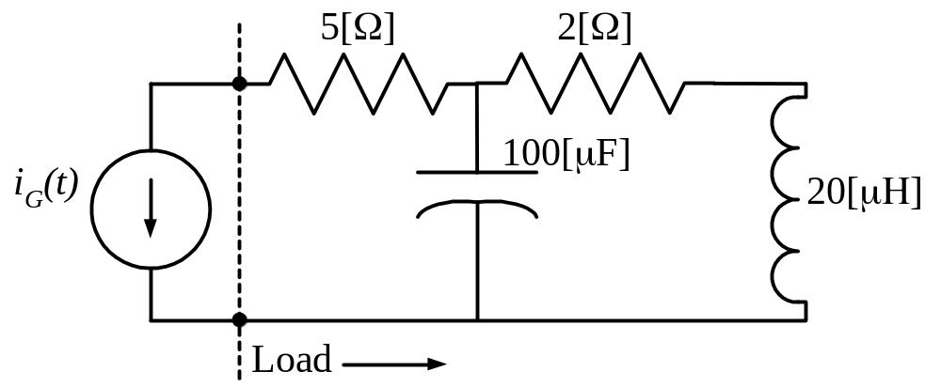
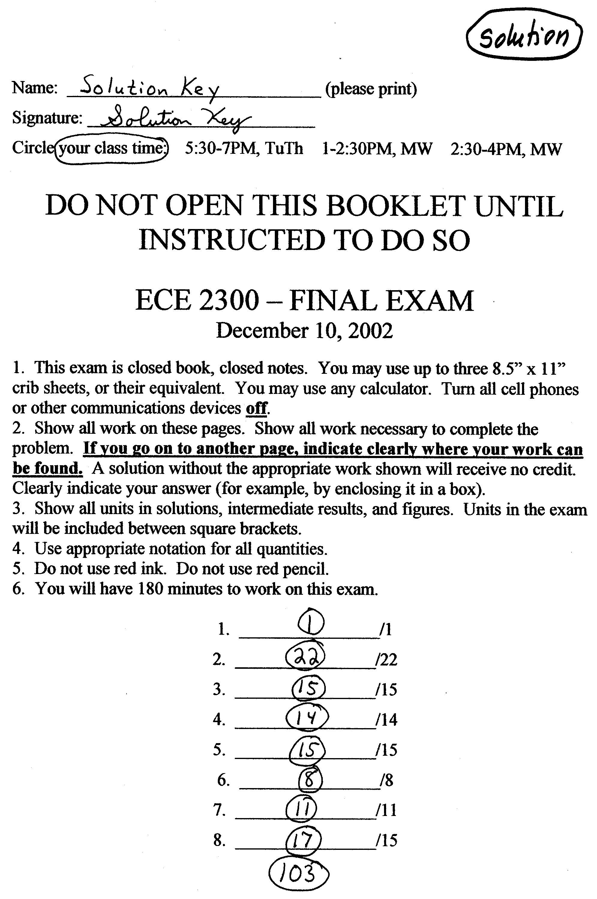
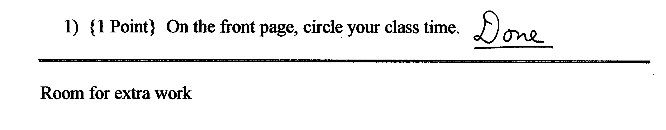
2) {22 Points} a) For the circuit shown, use the node-voltage method to write a complete set of independent equations that could be used to solve this circuit. Do not attempt to solve the equations. Do not attempt to simplify the circuit.
b) Write expressions for the power delivered by each of the current sources, in terms of the defined voltages and currents in part a), and the component values.
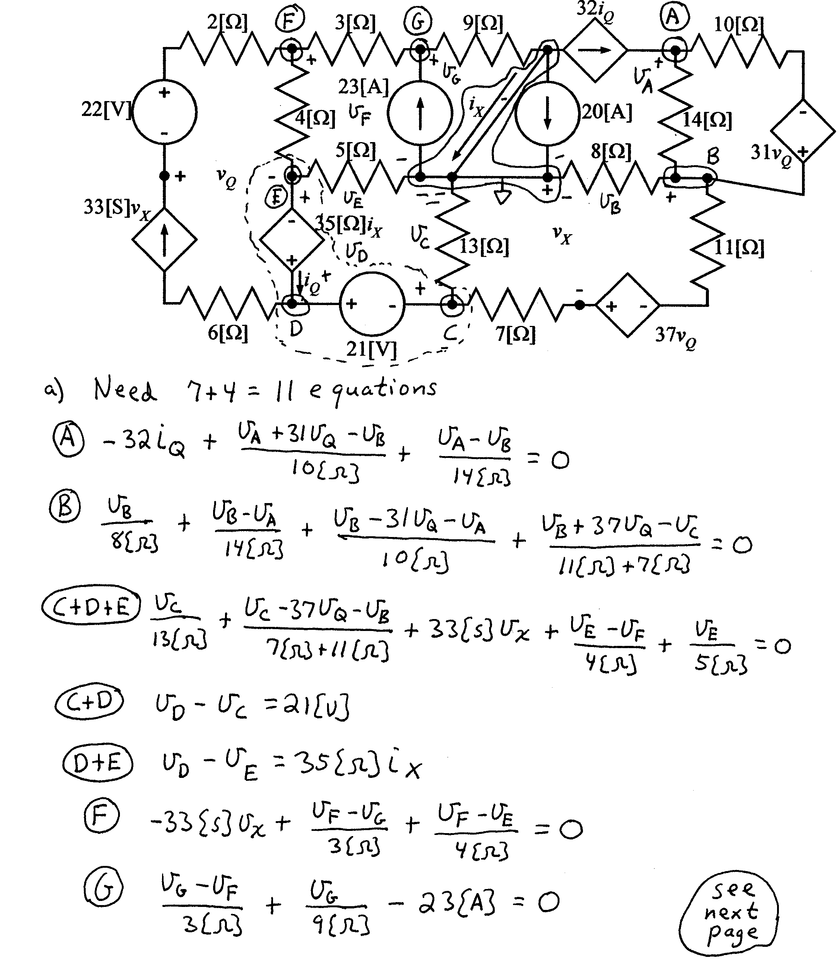
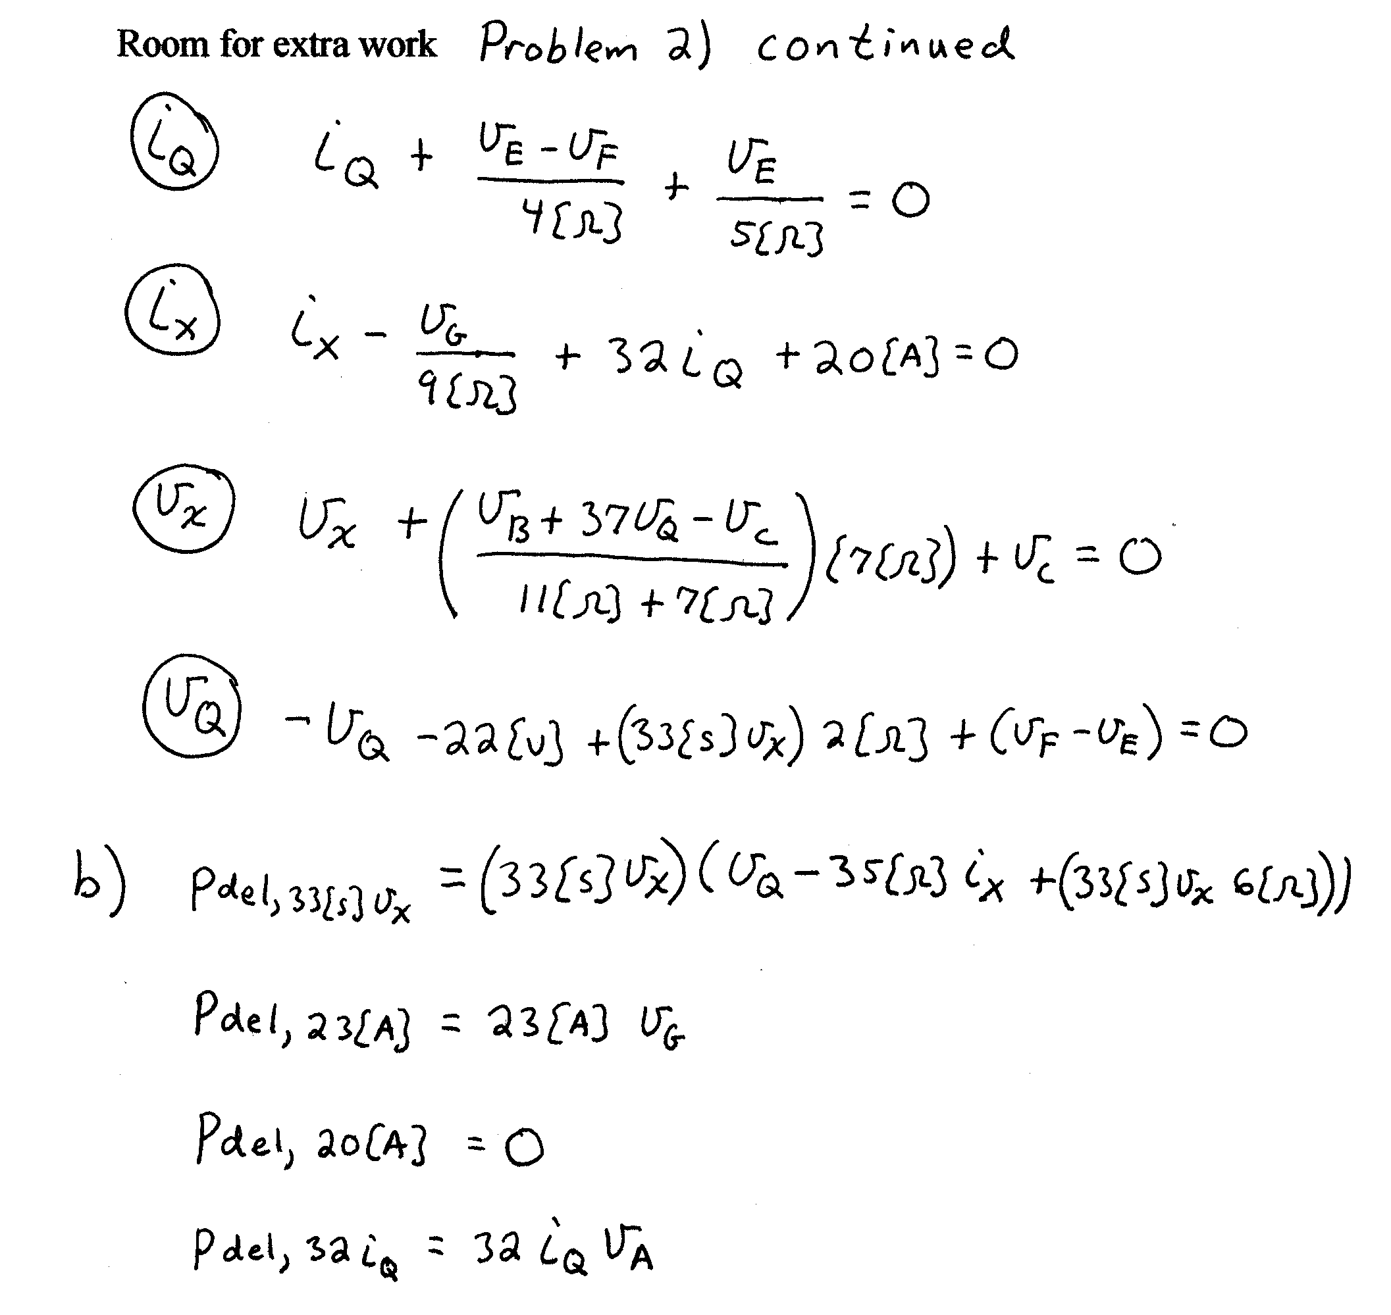
3) {15 Points} a) For the circuit shown, find the Norton equivalent circuit as seen by the light-emitting diode (LED) in this diagram.
b) It is given that v_{D} = 0.7[V] in this circuit. Find the power delivered by the LED.
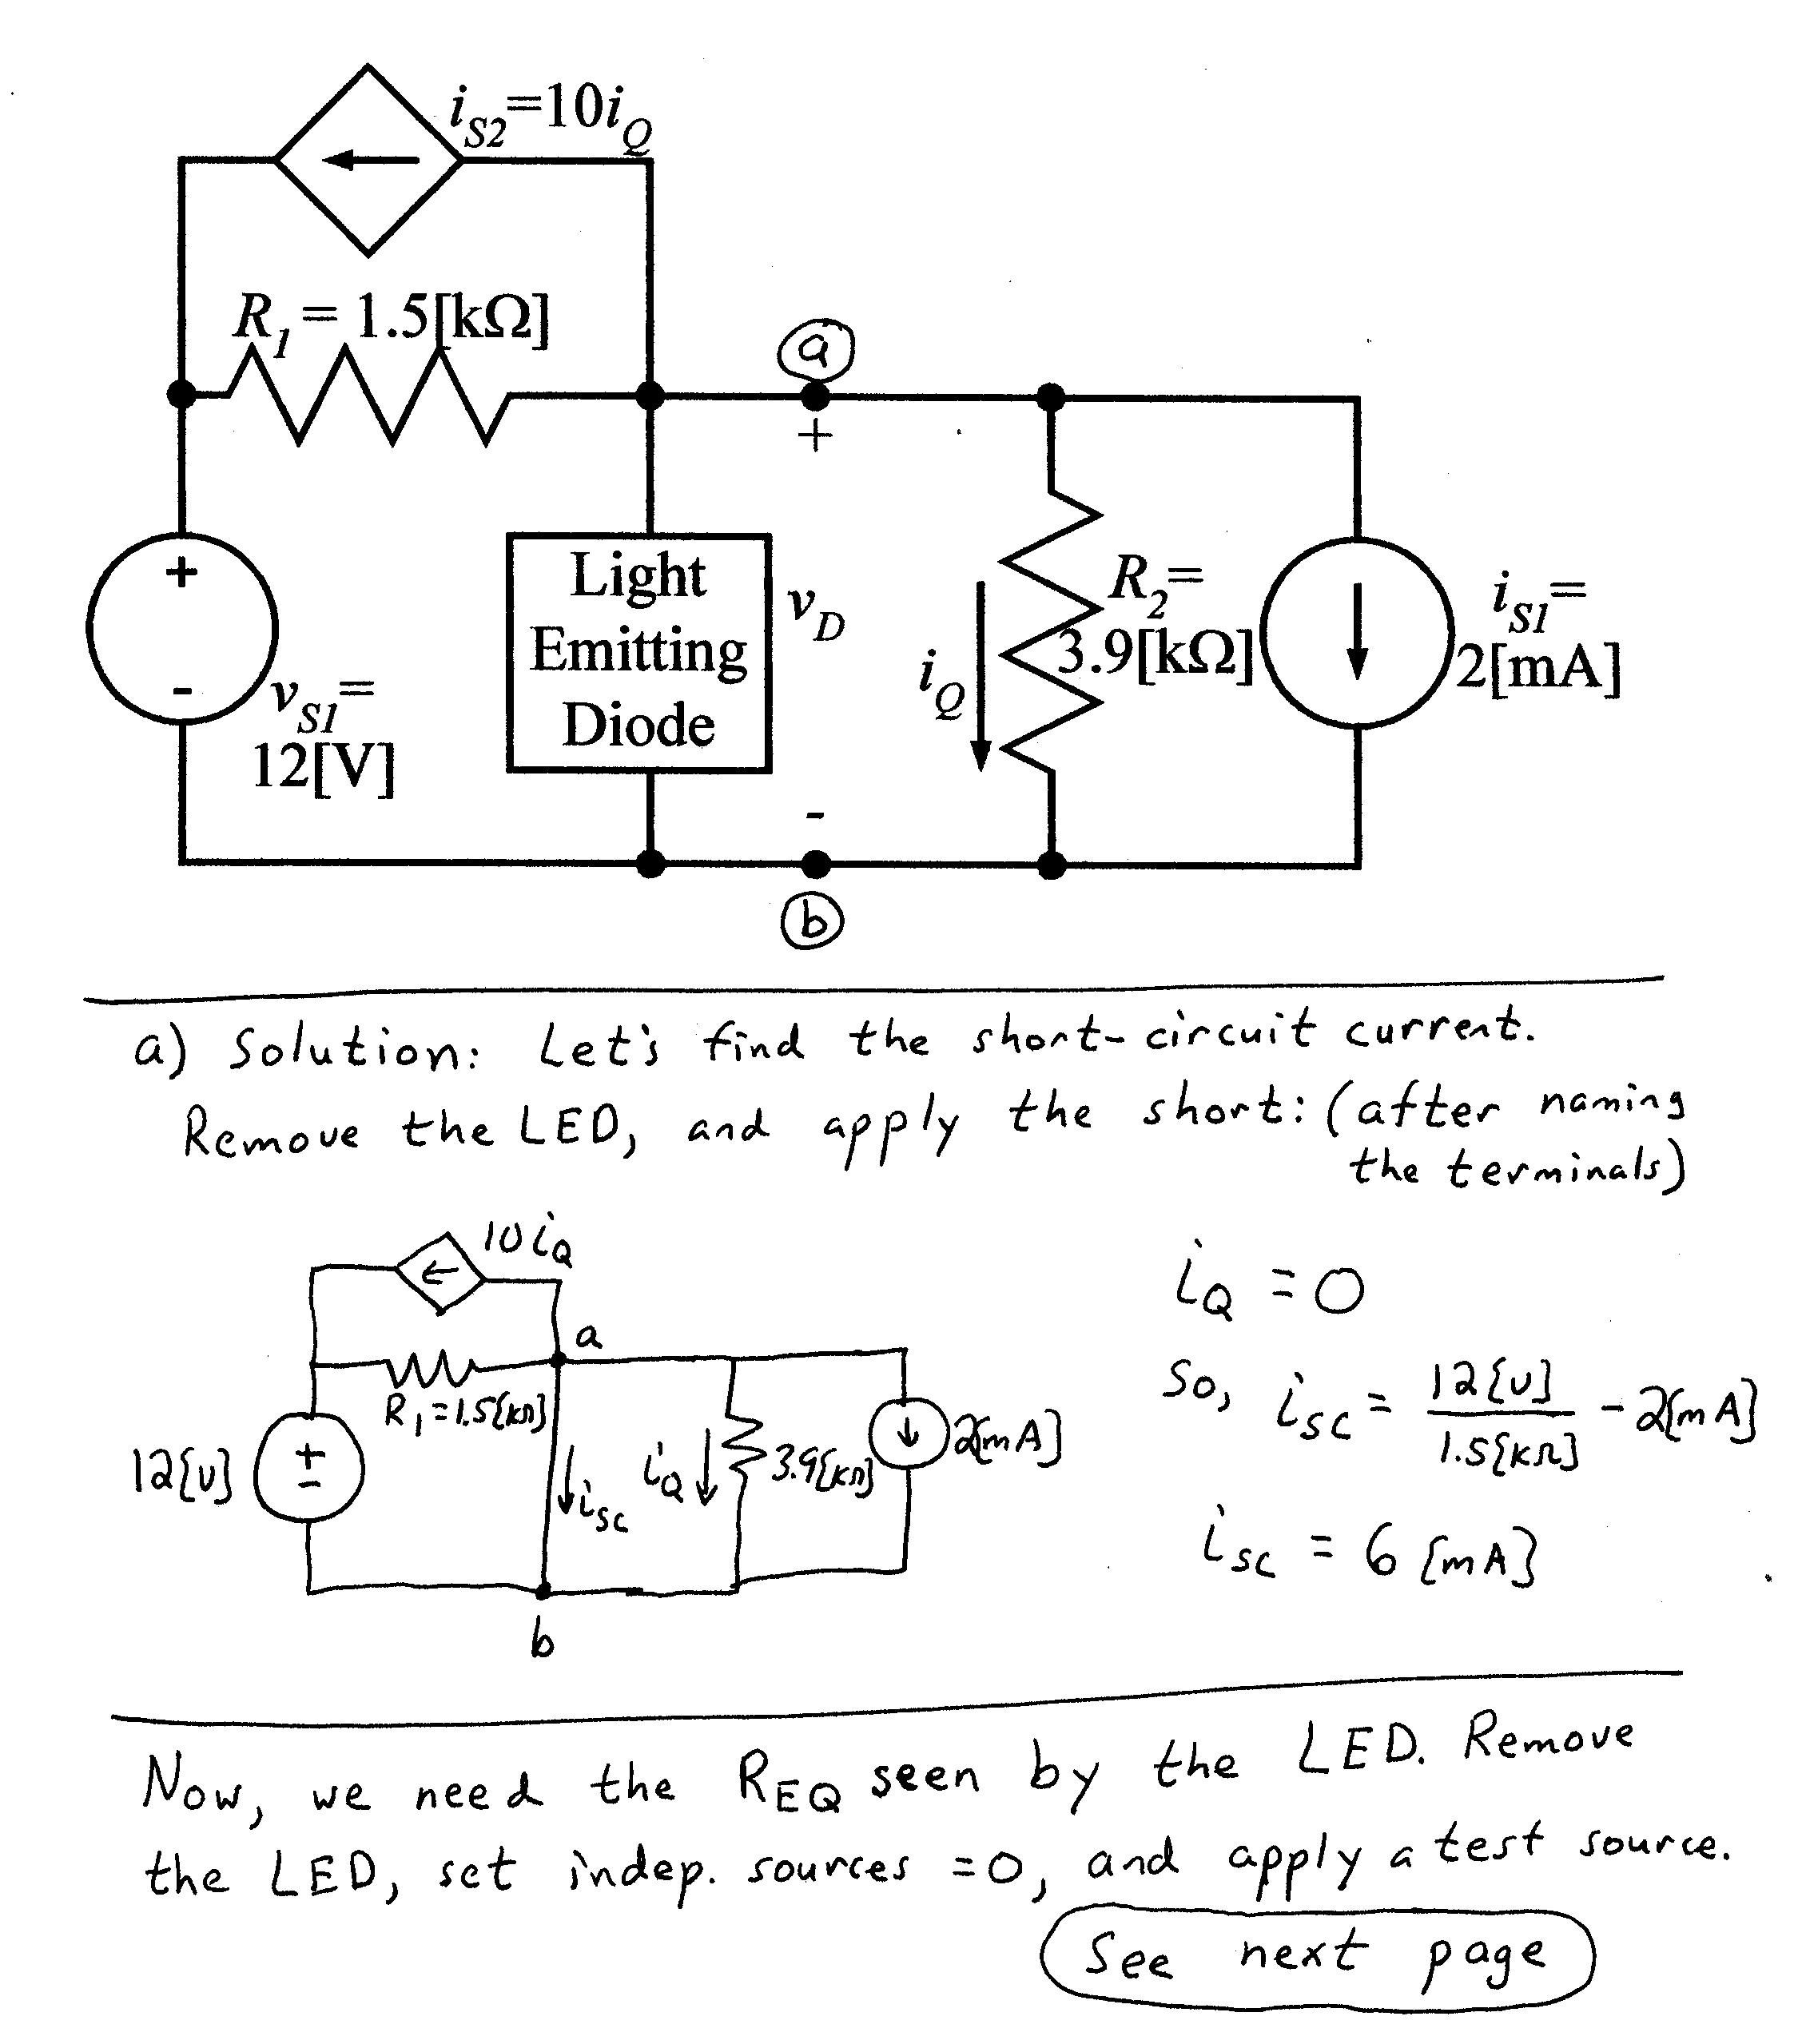
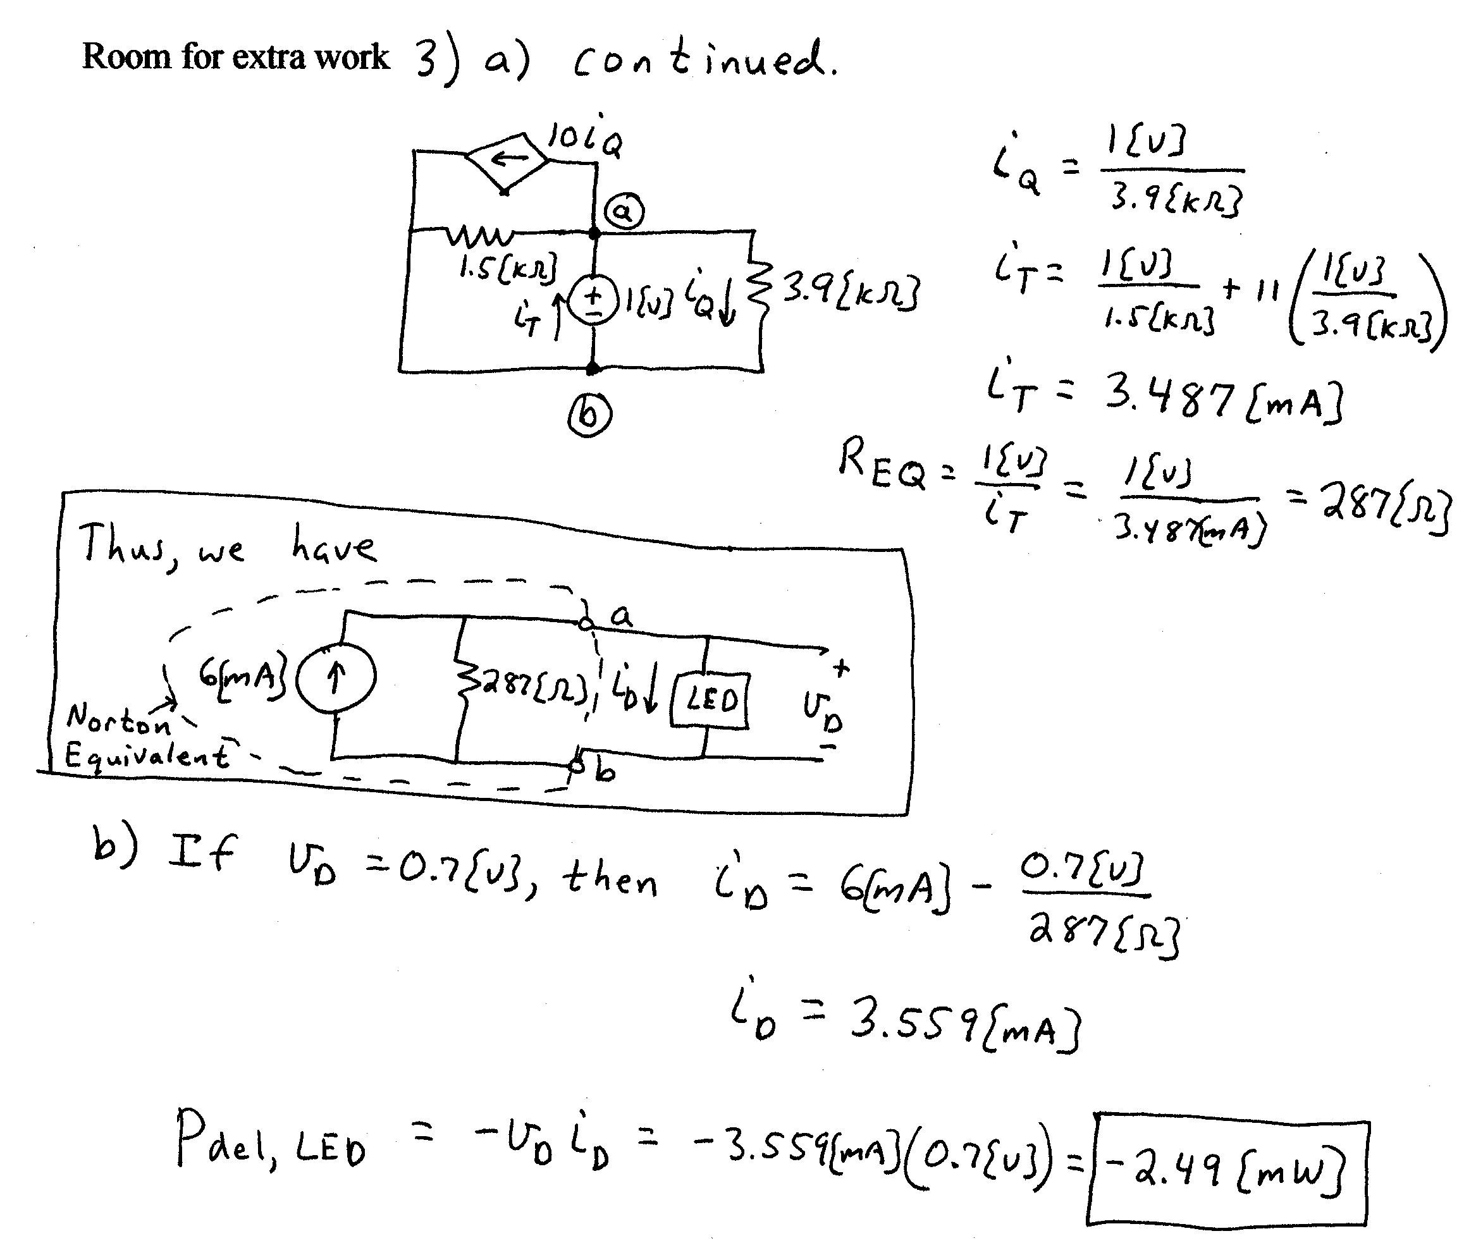
4) {14 Points} In the circuit shown, switches SW1 and SW2 have been in position a for a long time before t = 0.
At t = 0, both switches move simultaneously to position b. Then at t = 0.1[s] both switches move simultaneously to position c, and stay there.
Find the total energy trapped in the capacitors.
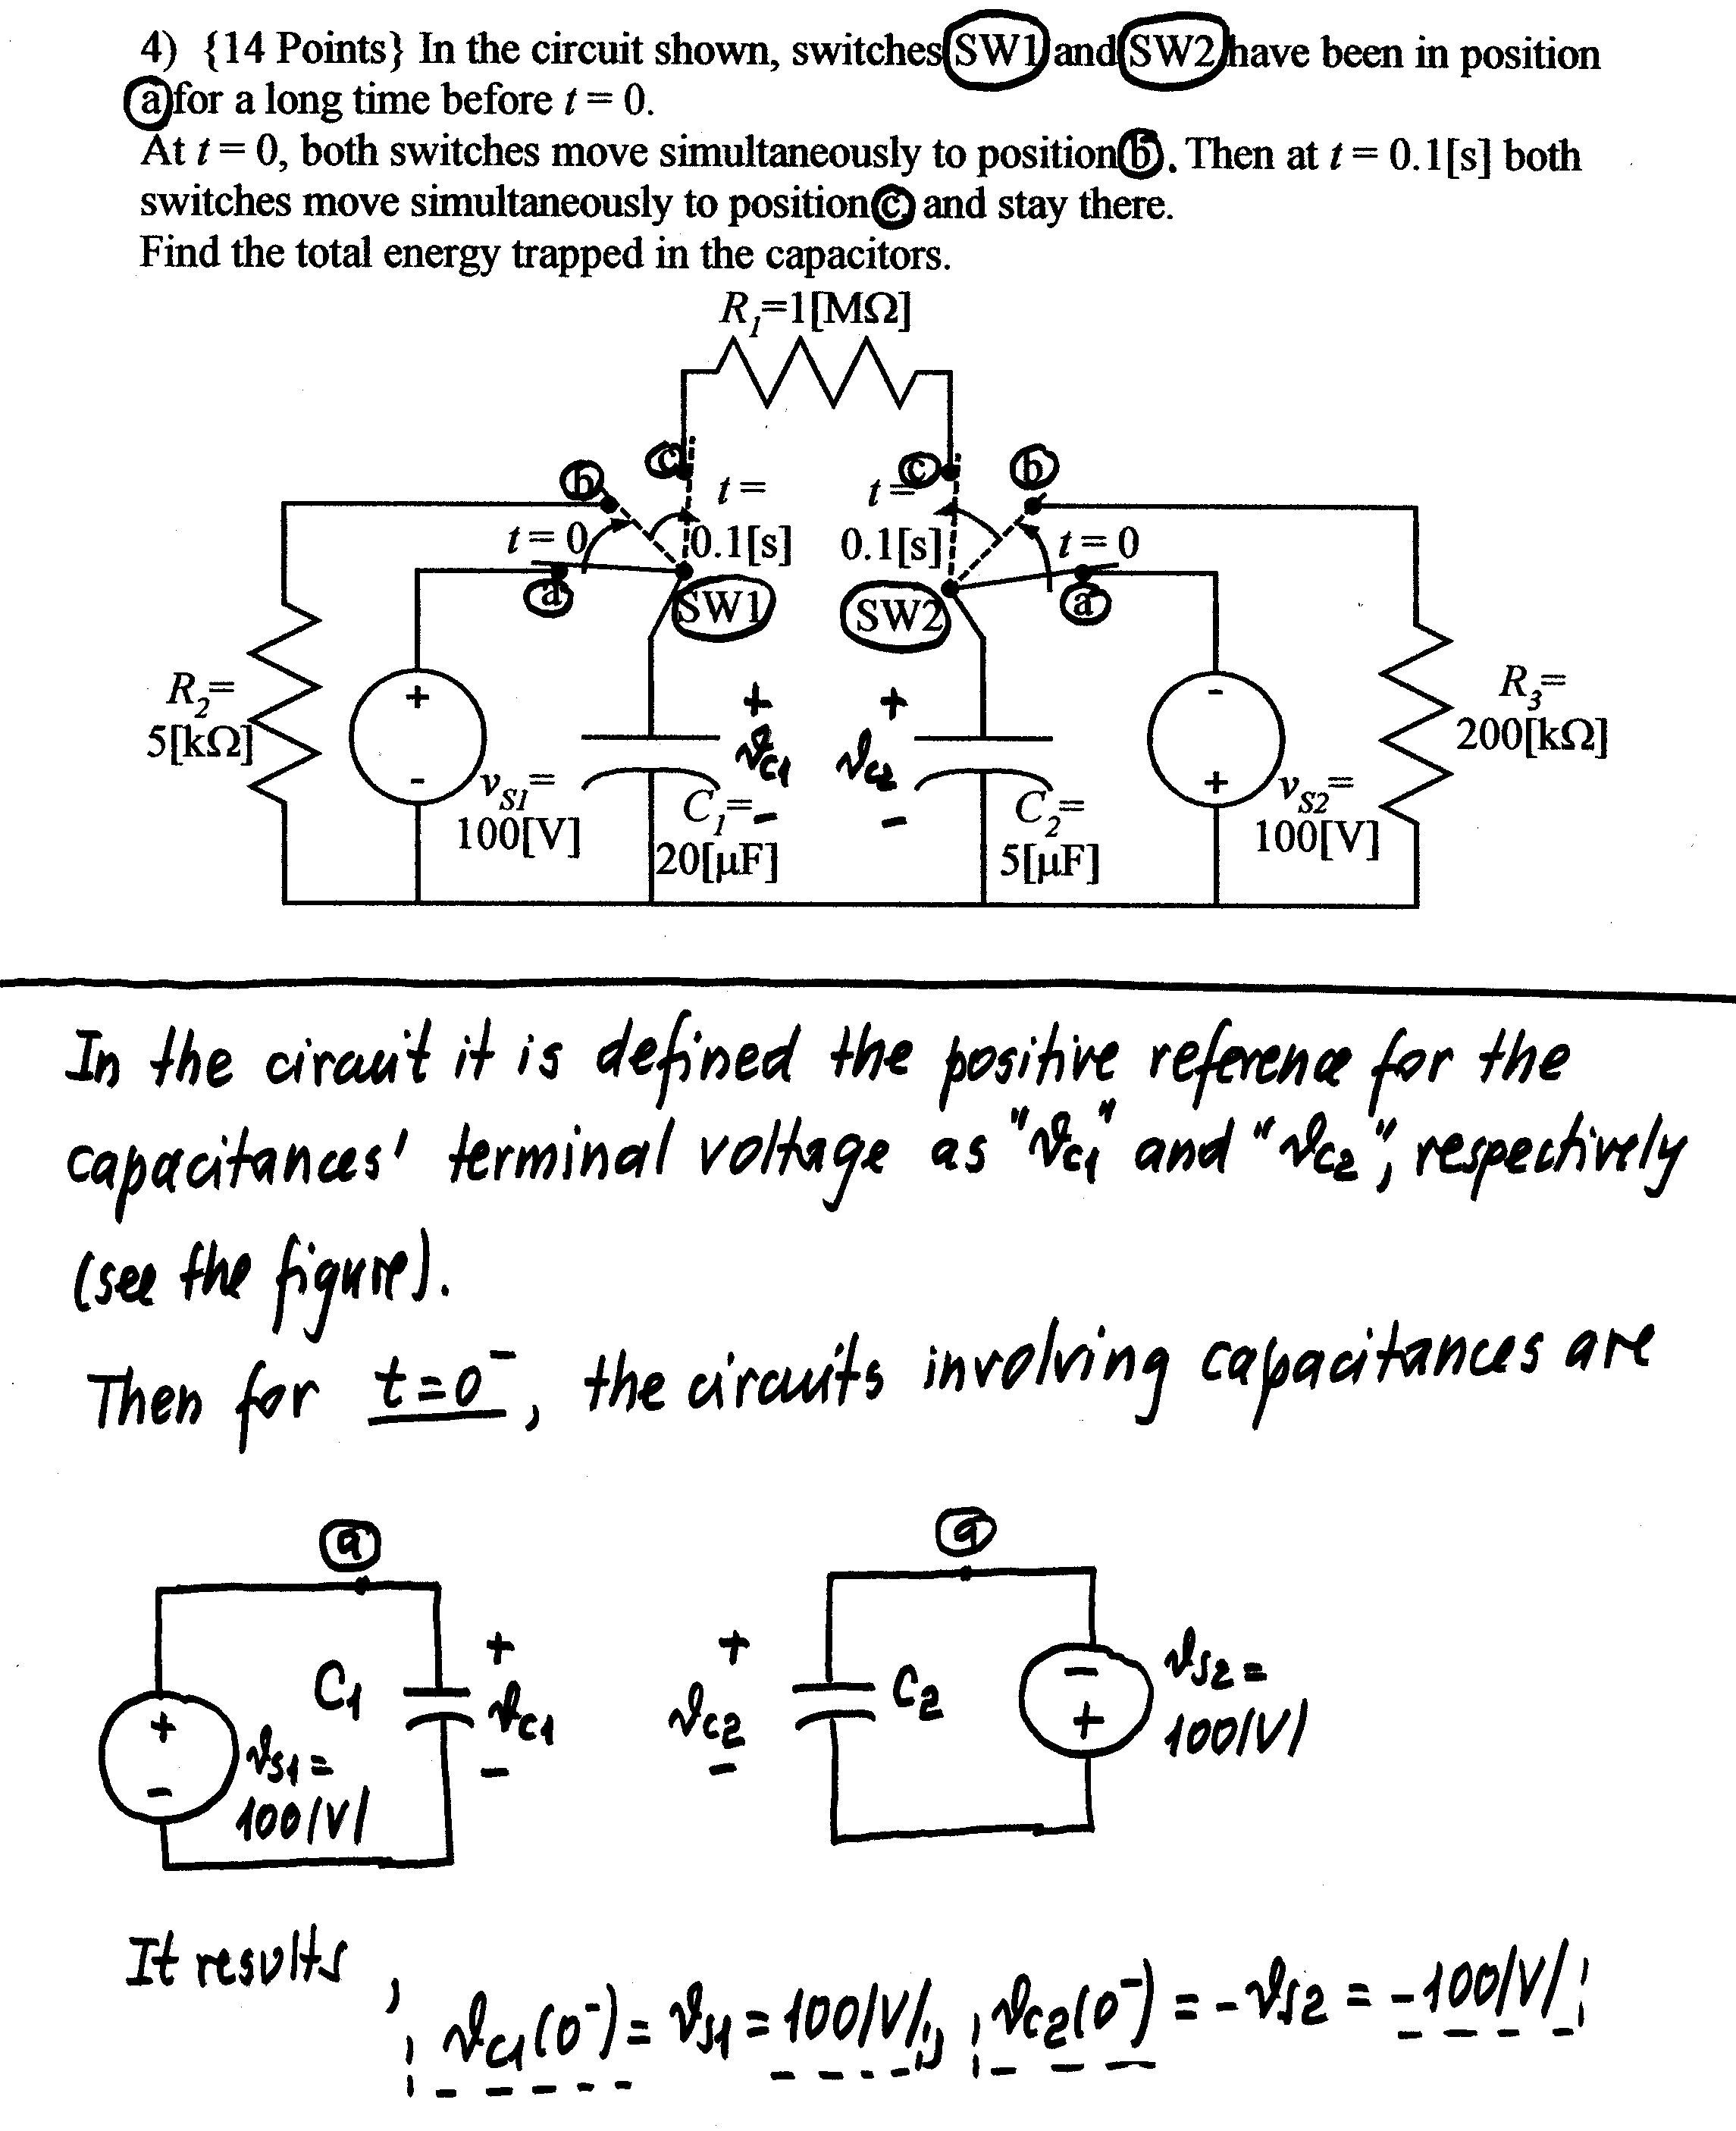
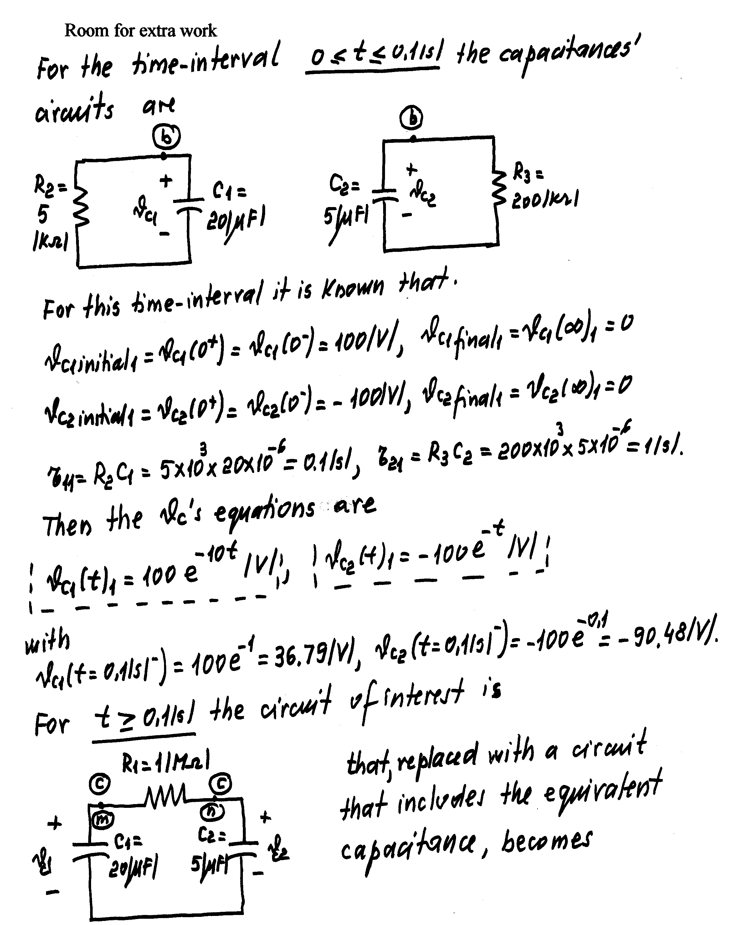
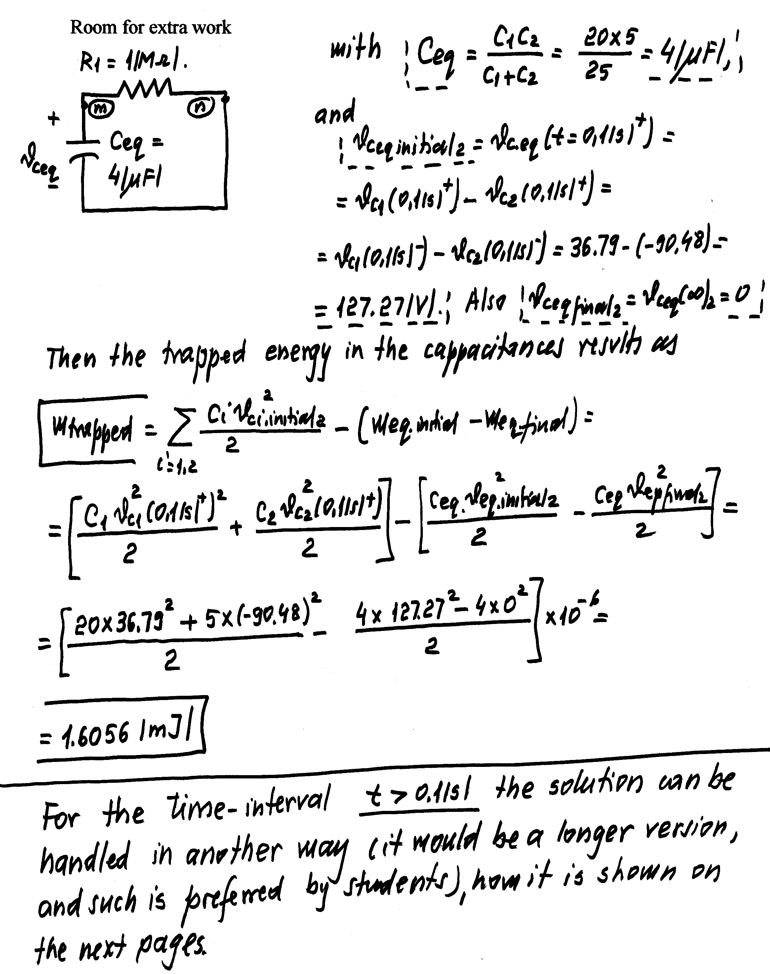
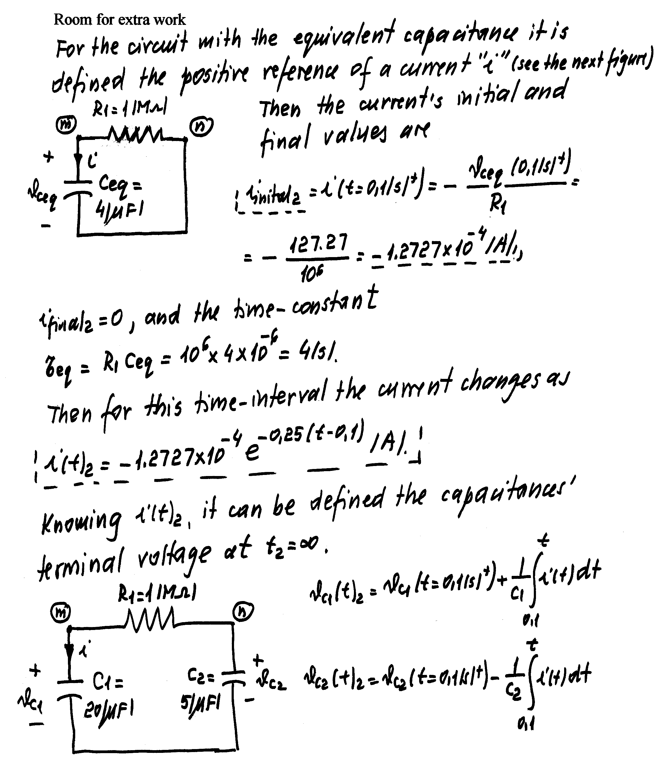
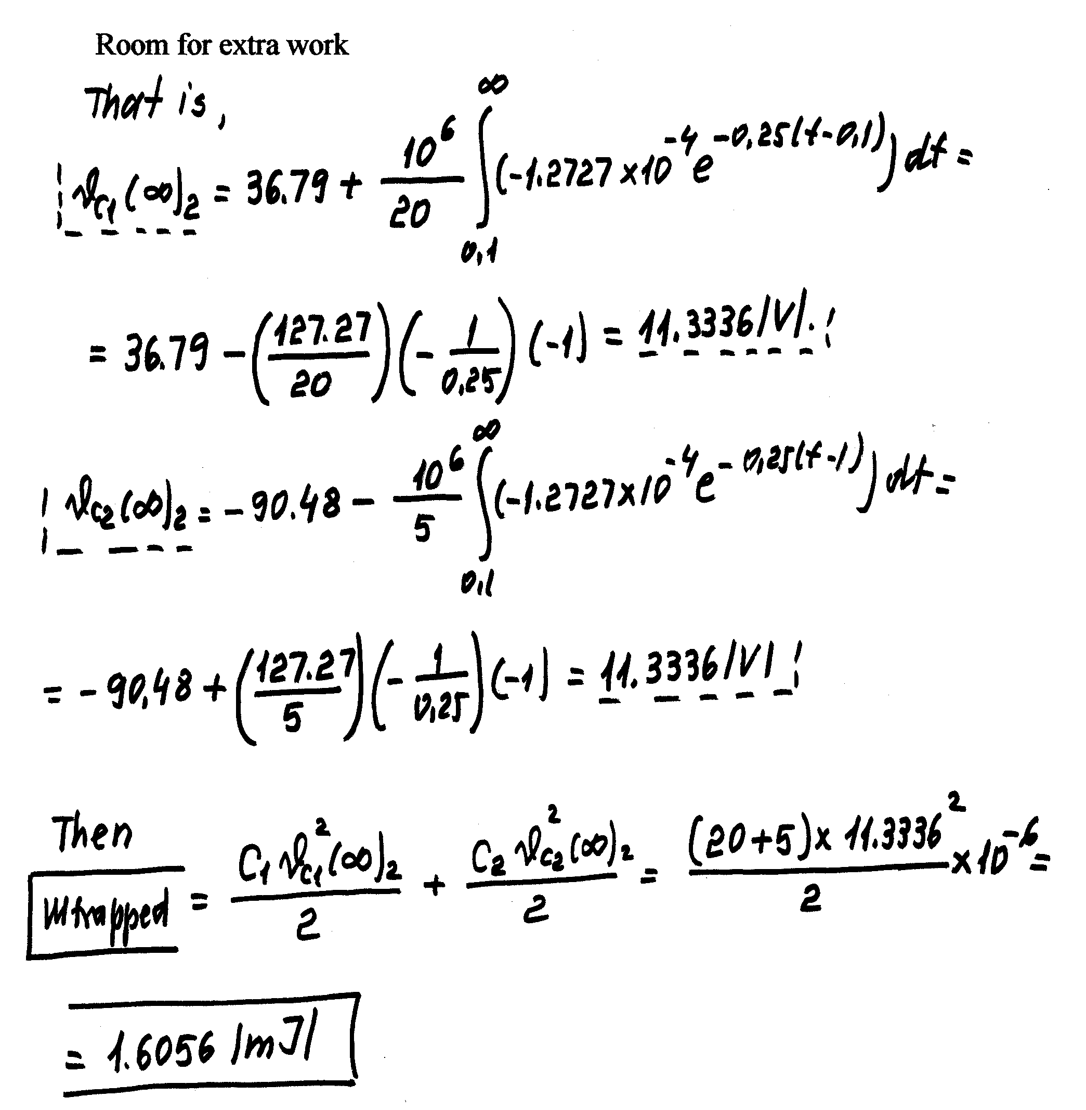
5) {15 Points} For the circuit shown, both switches SW1 and SW2 have been in position a for a long time before t = 0.
Then, at t = 0, the switch SW1 moves to position b, and remains there.
At t = 0.2[s], the switch SW2 moves to position b, and remains there.
For the time intervals 0 < t < 0.2[s] and t > 0.2[s], define the numerical expressions for the current i_{X}(t) flowing in the wire from d to e. The reference polarity for the current i_{X}(t) is given in the figure.
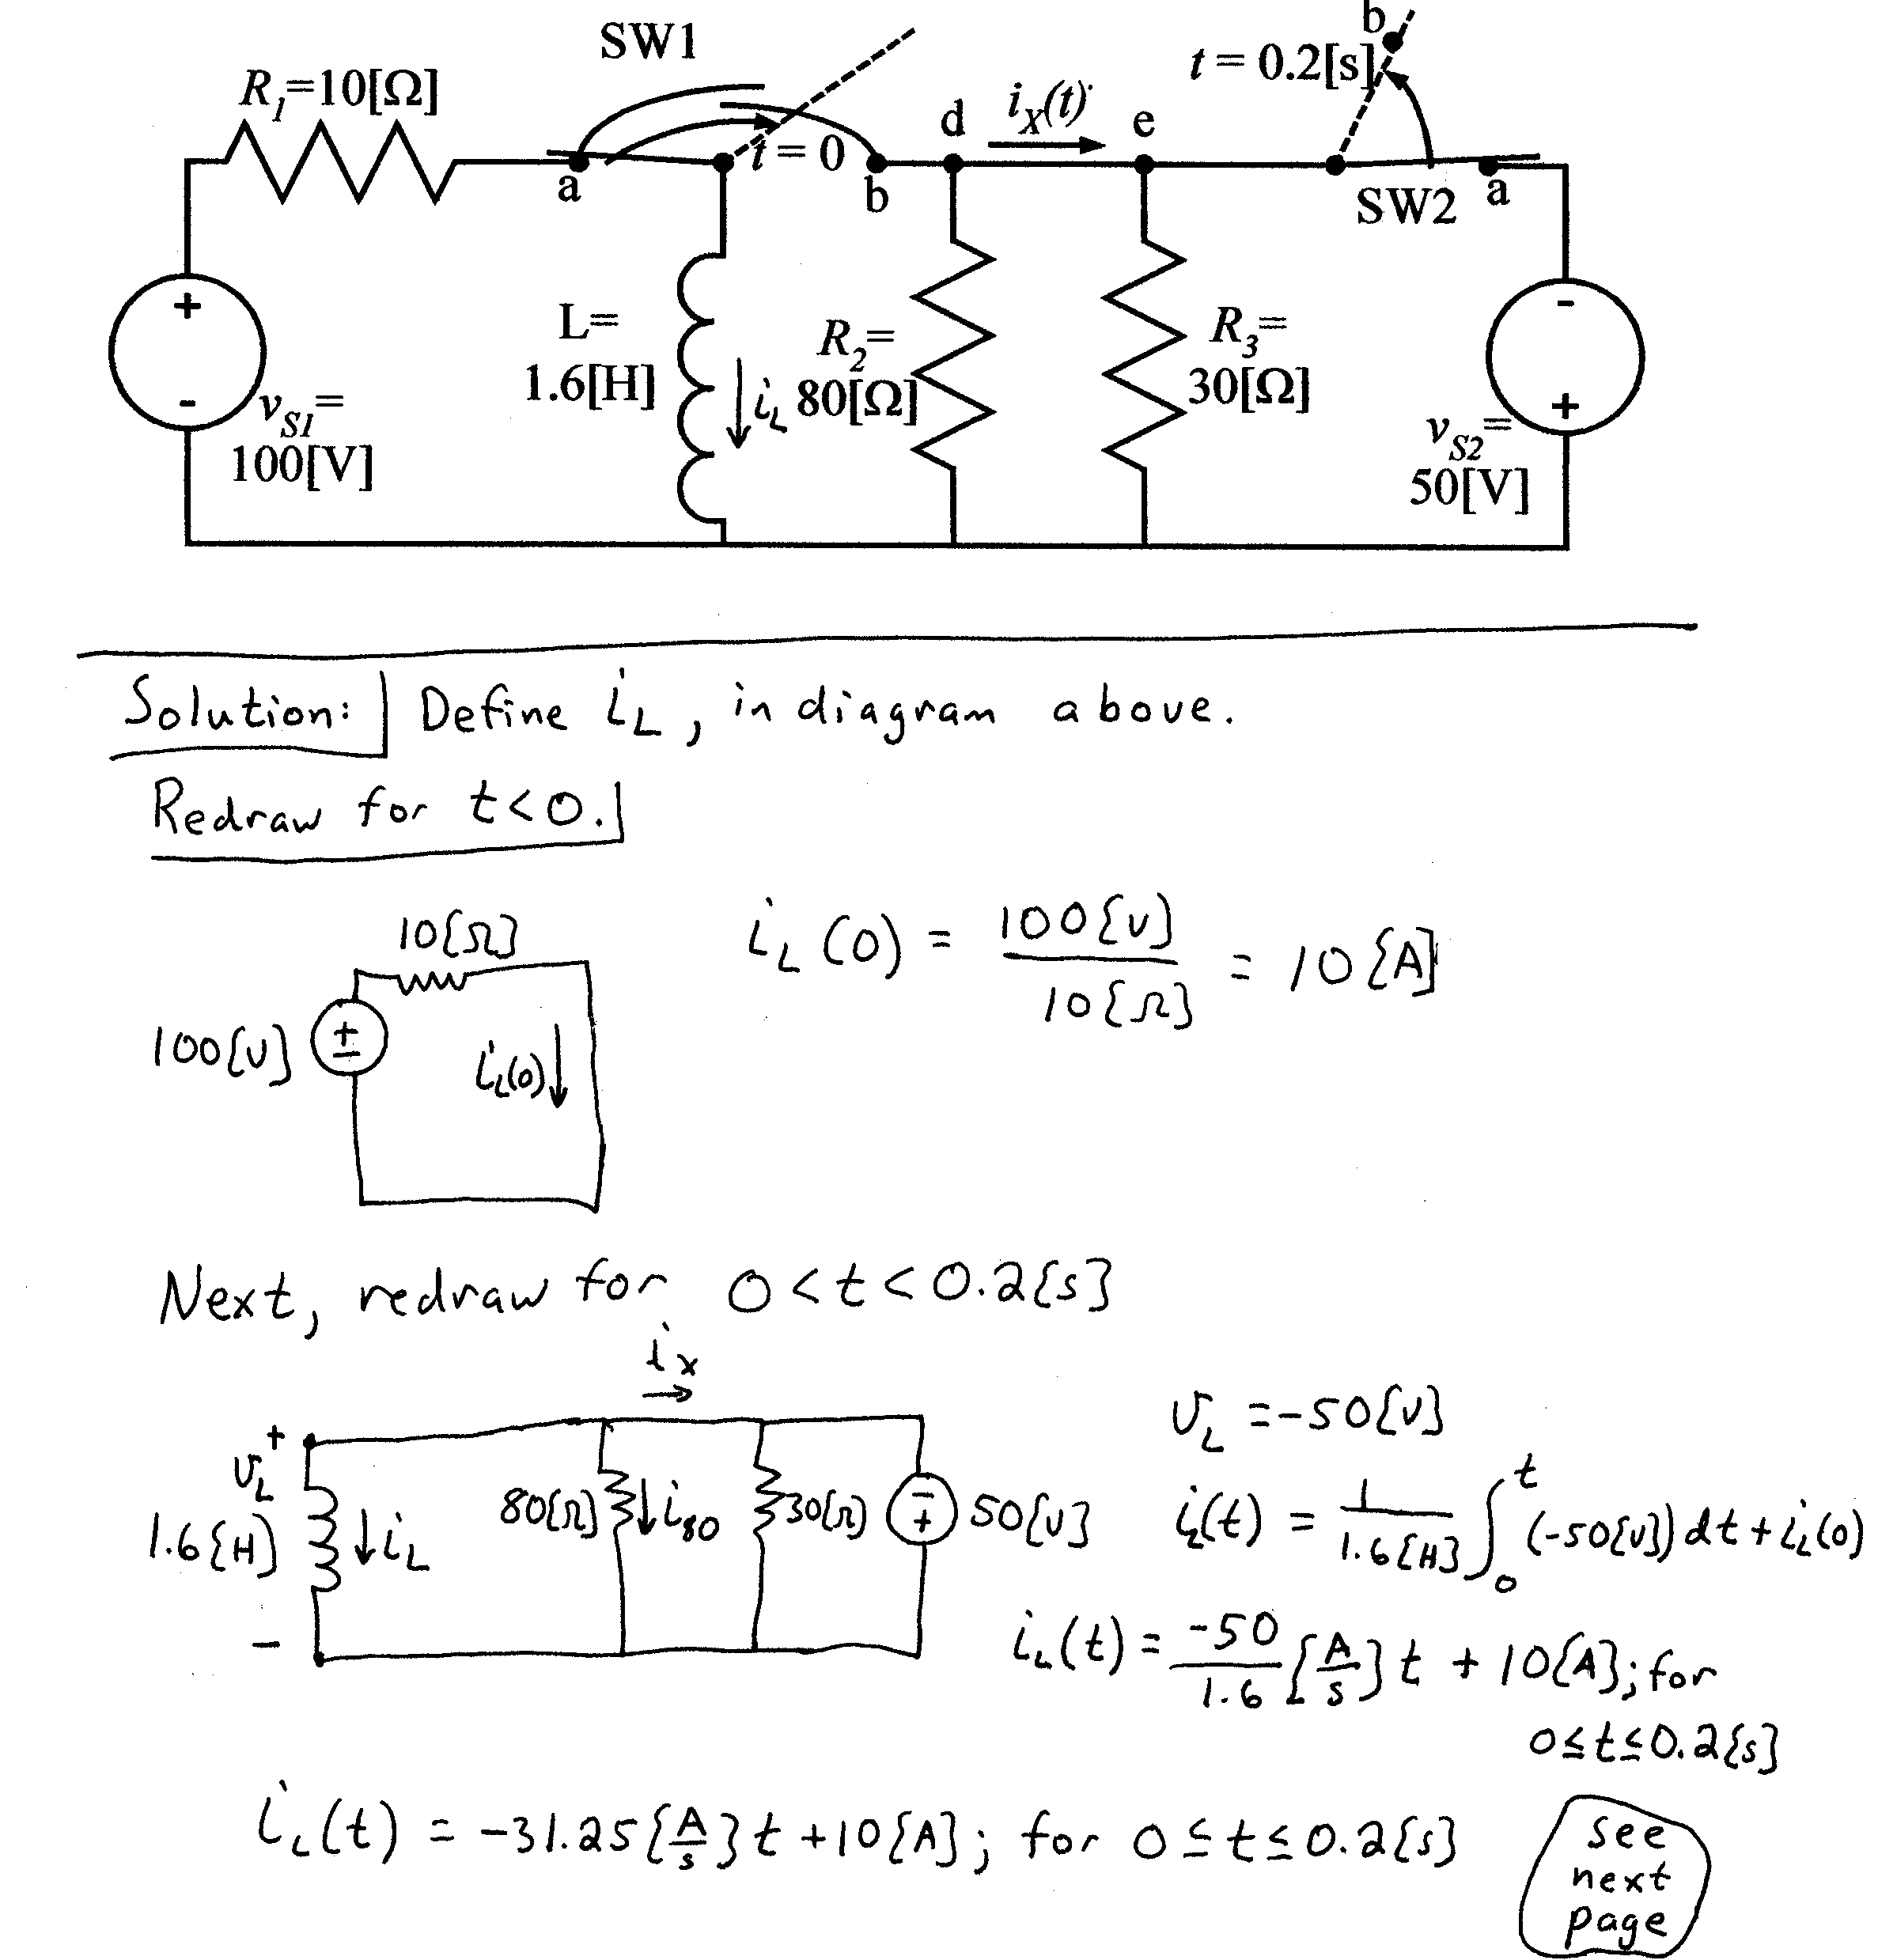
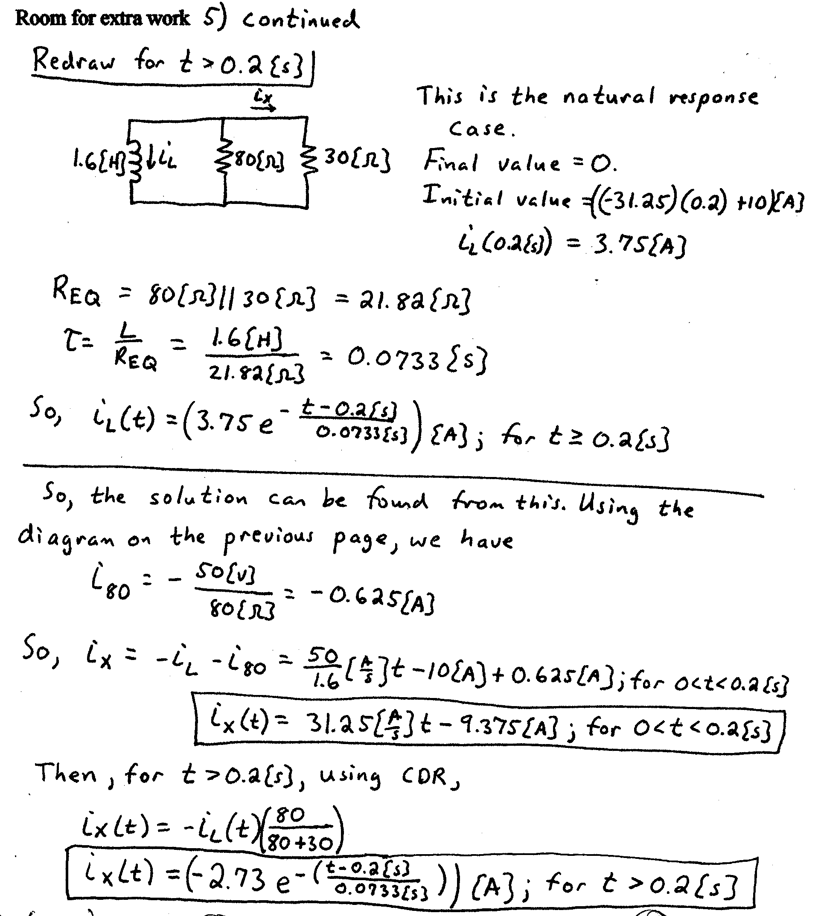
6) {8 Points} For the circuit shown, write a numerical expression for i(t), the current through the inductance in the steady state. The reference polarity of i(t) is given in the figure. The voltage v_{S}(t) is

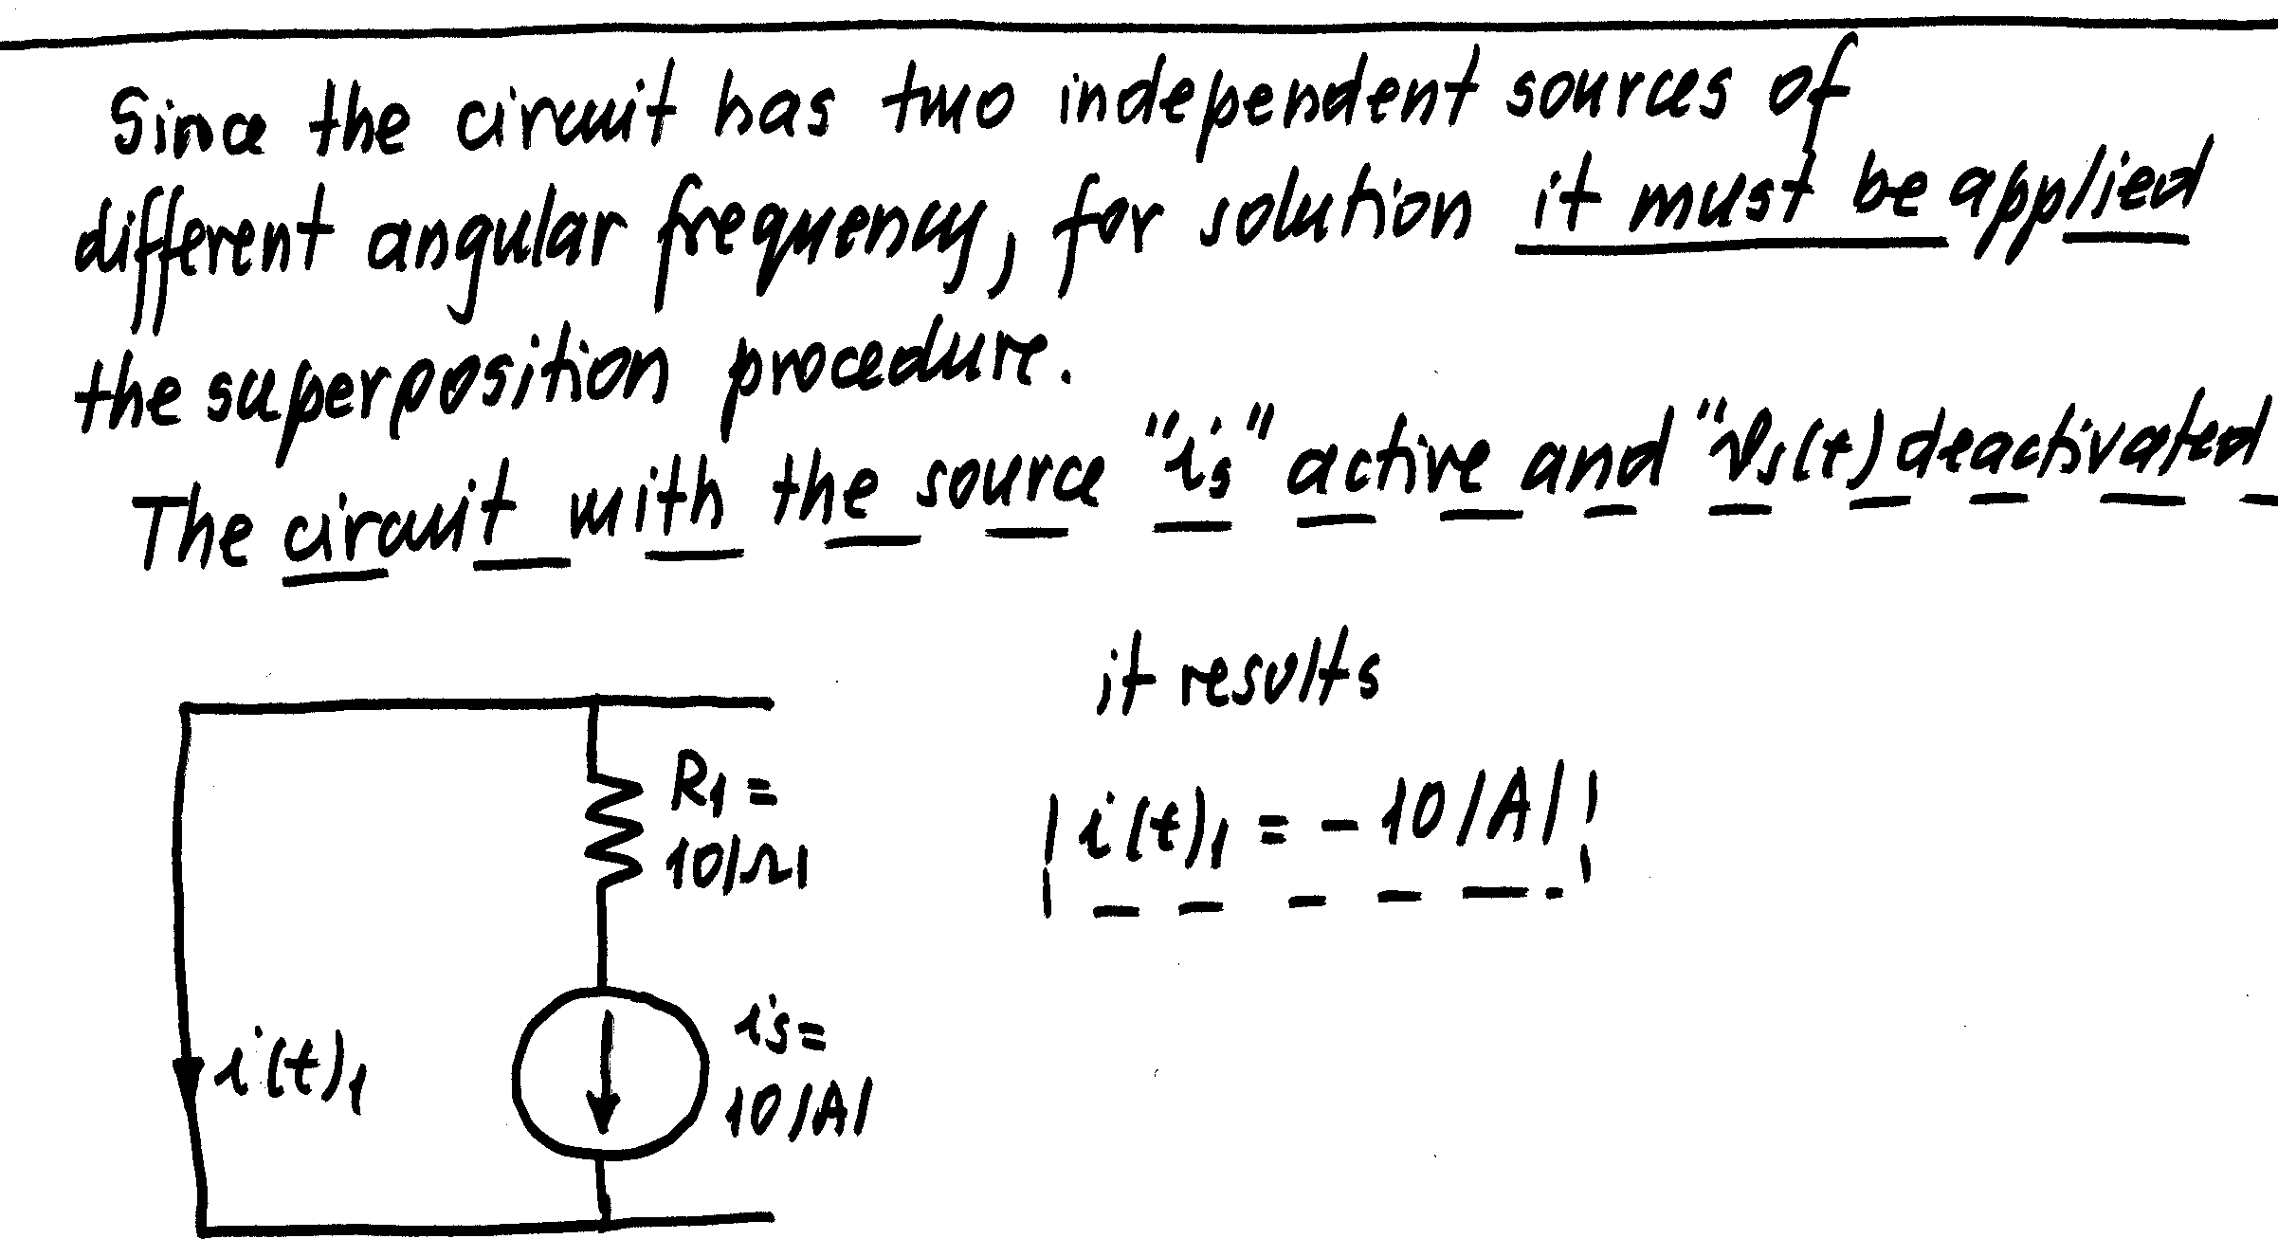
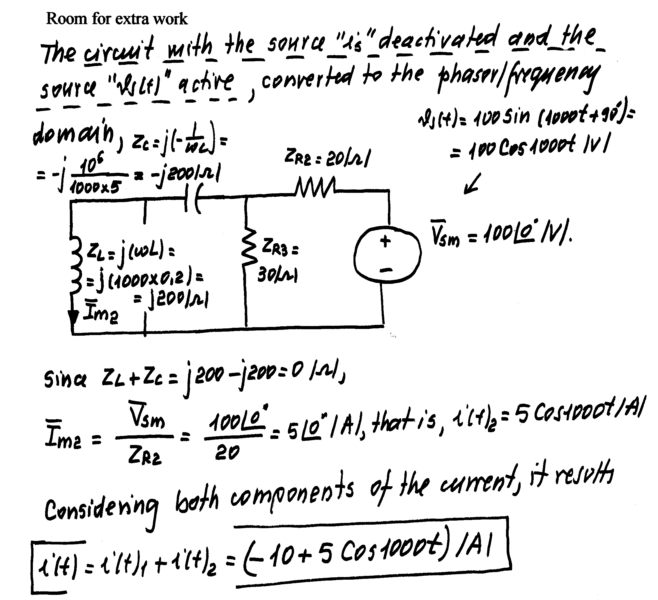

7) {11 Points} For the circuit shown, calculate the value for I_{x}.
Note that in this machine-produced circuit diagram, phasors are represented with bold variables. For your handwritten work, you should use the notation for phasors discussed in class.
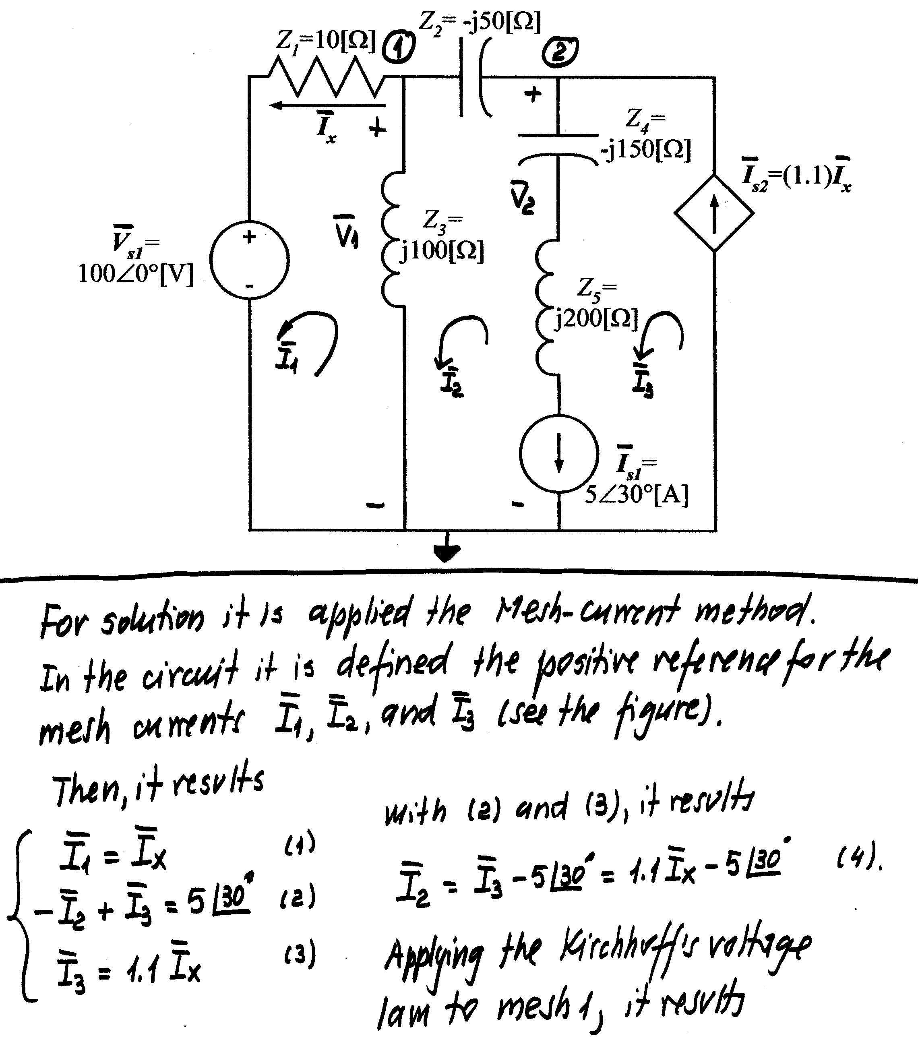

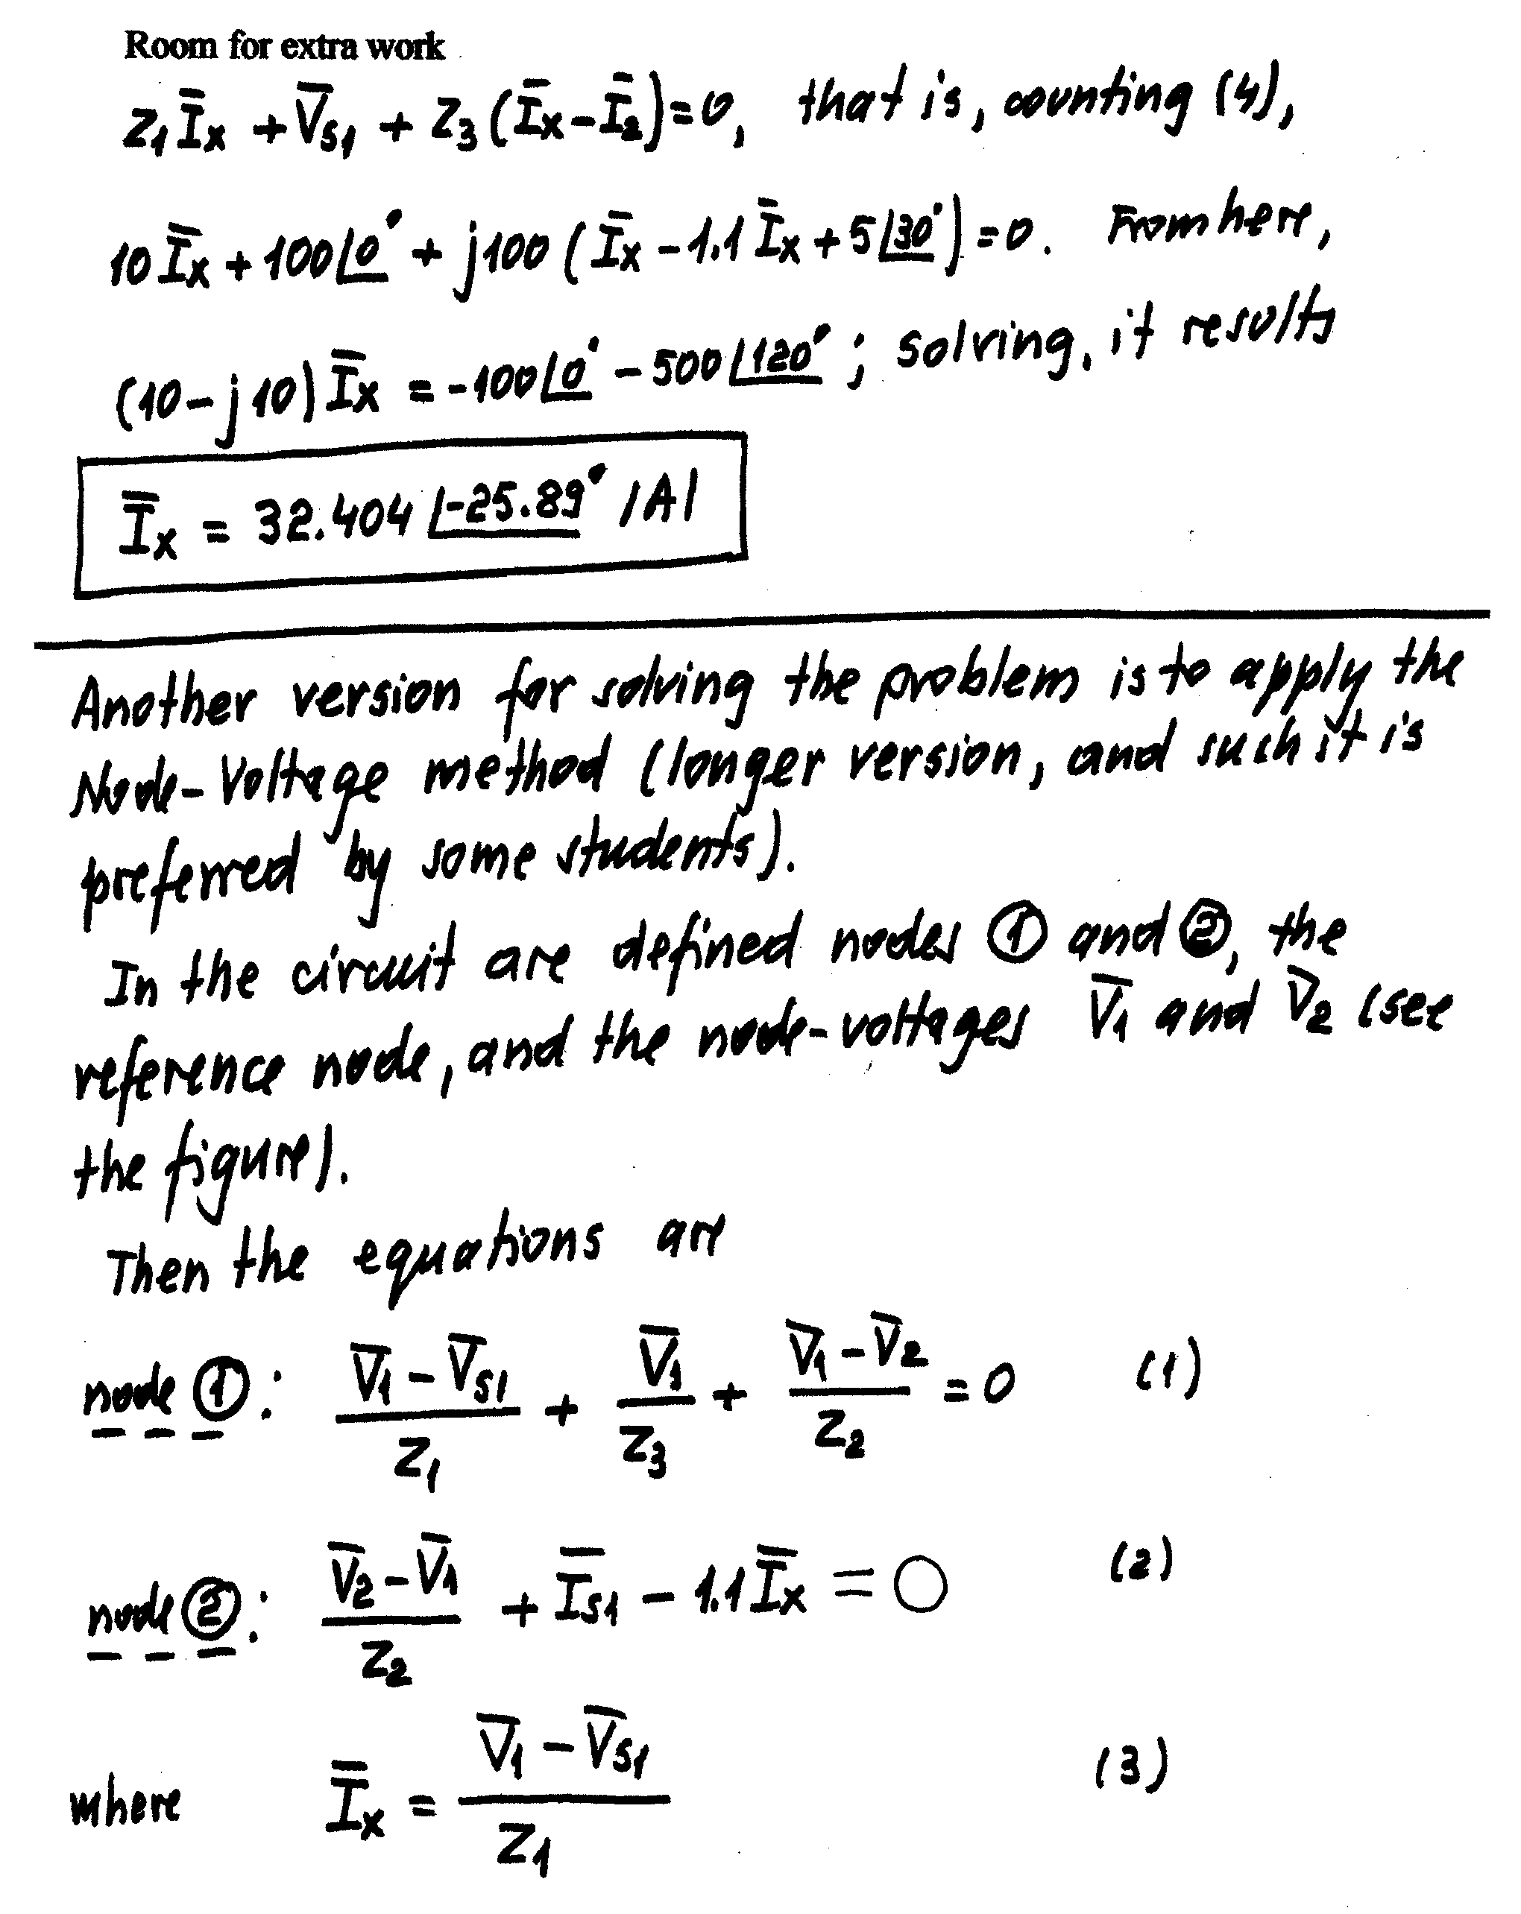
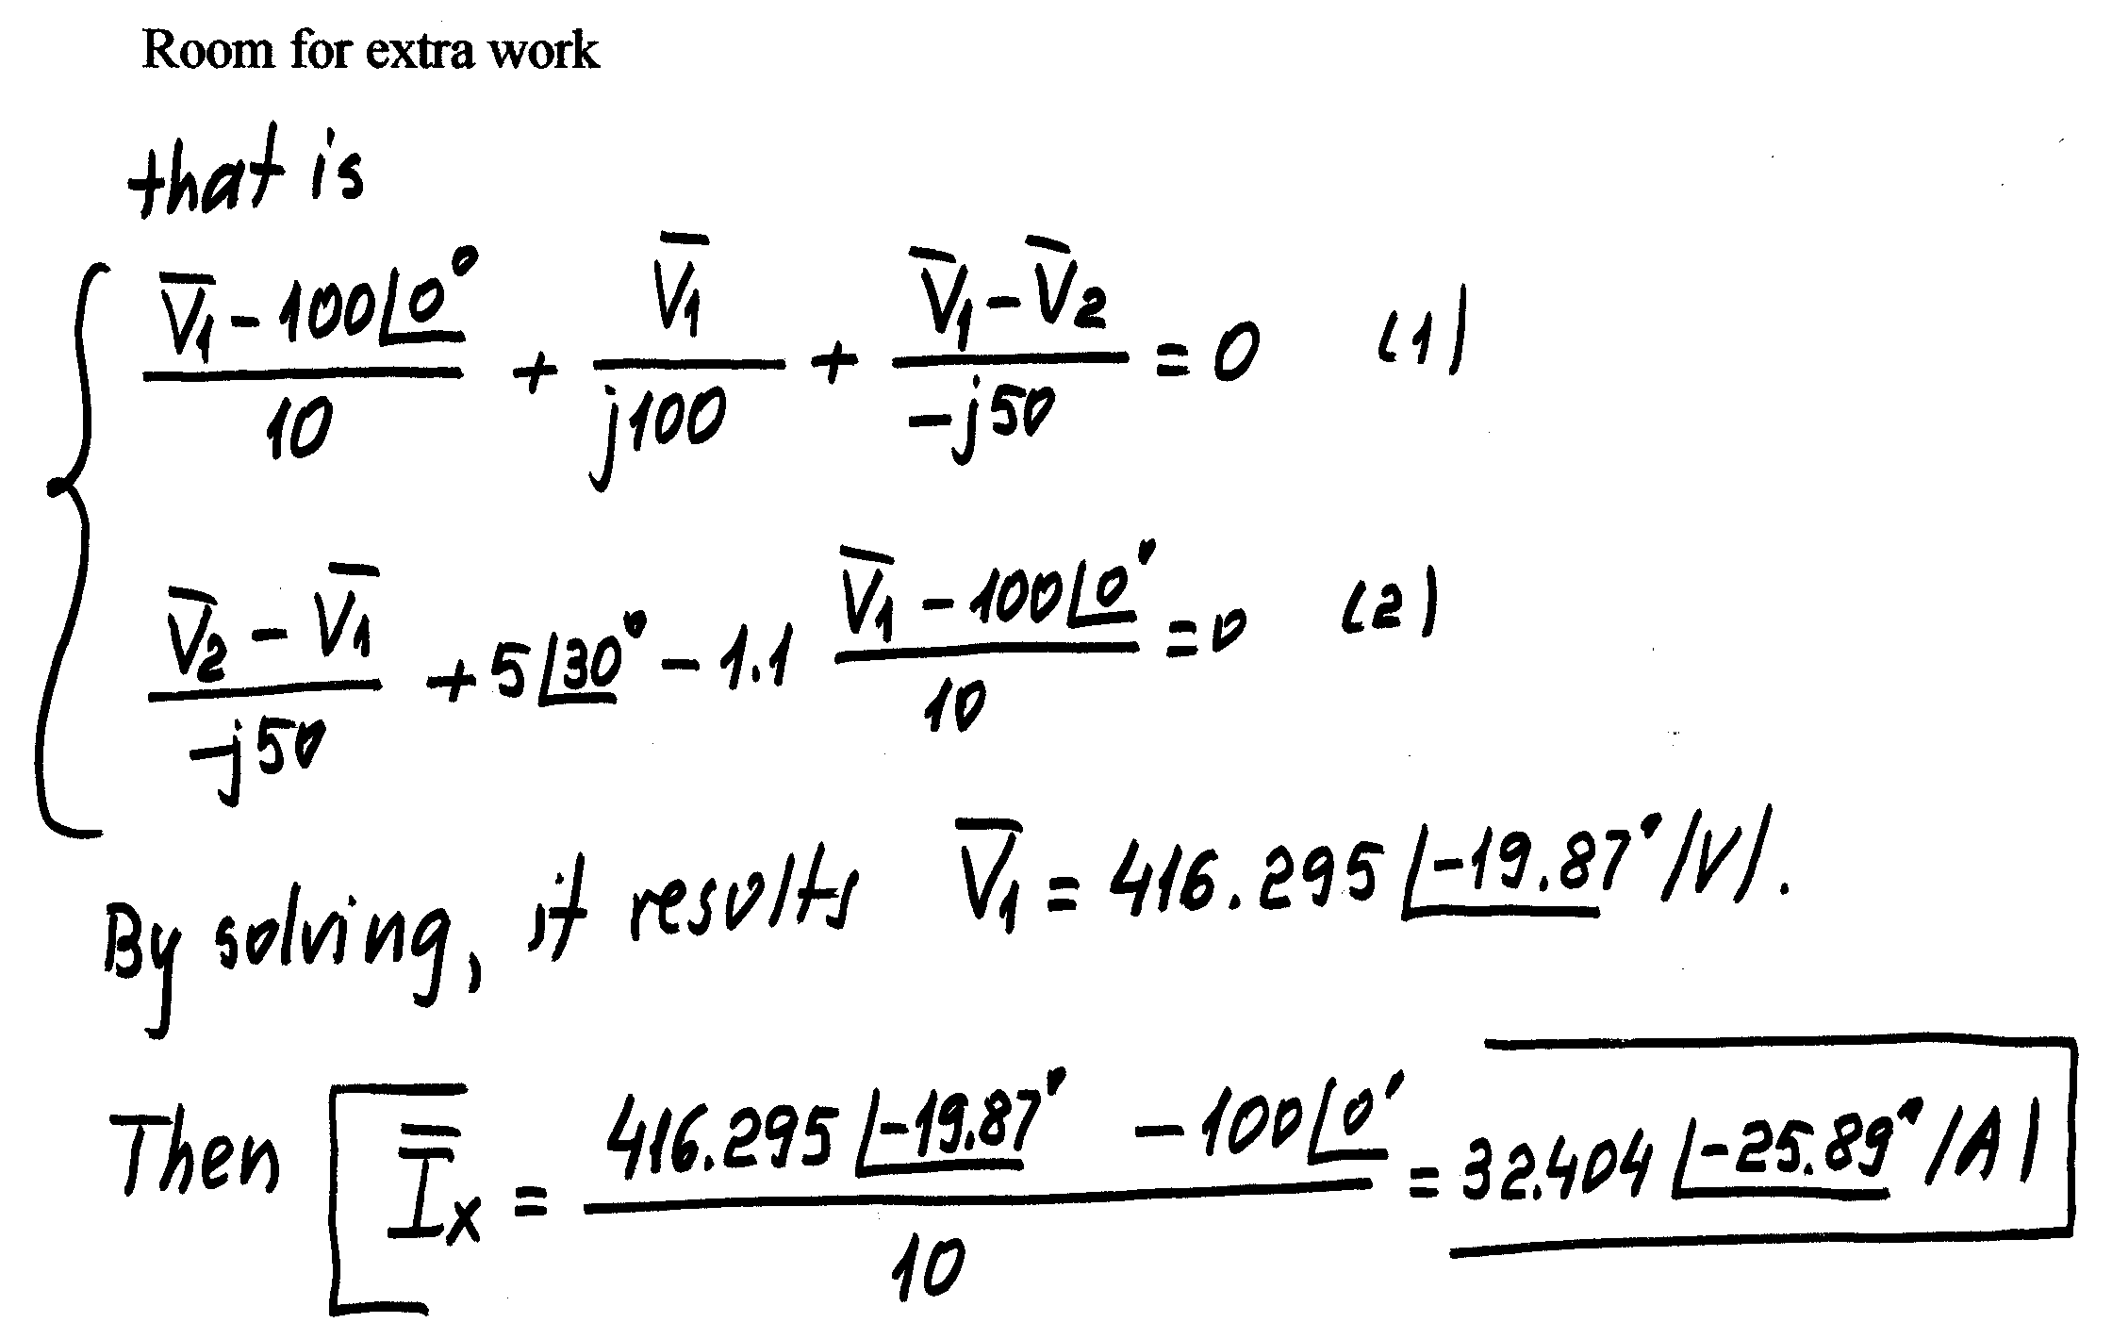
8) {15 Points} For the circuit shown, calculate the complex, apparent, average, and reactive powers absorbed by the load, and the corresponding power factor. It is given that


