Name: _____________________________ (please print)
Signature: __________________________

ECE 2300 -- Quiz #1
Shattuck Section – TuTh 5:30-7PM
September 18, 2003

Keep this quiz closed and face up until you are told to begin.

1. This quiz is closed book, closed notes. You may use one 8.5” x 11” crib sheet, or its equivalent.
2. Show all work on these pages. Show all work necessary to complete the problem. If you go on to another page, indicate clearly where your work can be found. A solution without the appropriate work shown will receive no credit.
3. Show all units in solutions, intermediate results, and figures. Units in the quiz will be included between square brackets.
4. Do not use red ink. Do not use red pencil.
5. You will have 30 minutes to work on this quiz.

________________/20
Room for extra work
A device, shown in Figure 1, can be modeled by a voltage source in series with a resistance. When a resistor with a resistance of 120[Ω] is connected between terminals a and b of the device, the current i_{T} is equal to 230[mA].
Then, when the 120[Ω] resistor is removed, and a resistance of 160[Ω] is connected between terminals a and b of the device, the current i_{T} is equal to 570[mA].
Find i_{T} when the 120[Ω] resistor and the 160[Ω] resistor are removed, and a 200[Ω] resistor is connected between terminals a and b of the device.
Remember to use lower-case variables for voltage and current.

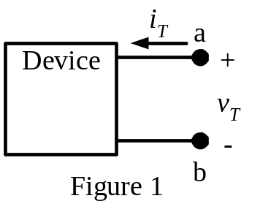
ECE 2300 -- Quiz #1 – September 18, 2003 –5:30-7PM TuTh Shattuck Section Solution
A device, shown in Figure 1, can be modeled by a voltage source in series with a resistance. When a resistor with a resistance of 120[Ω] is connected between terminals a and b of the device, the current i_{T} is equal to 230[mA].
Then, when the 120[Ω] resistor is removed, and a resistance of 160[Ω] is connected between terminals a and b of the device, the current i_{T} is equal to 570[mA].
Find i_{T} when the 120[Ω] resistor and the 160[Ω] resistor are removed, and a 200[Ω] resistor is connected between terminals a and b of the device.
Remember to use lower-case variables for voltage and current.



