Name: _____________________________ (please print)
Signature: __________________________

ECE 2300 -- Quiz #6
Shattuck Section – Fall 2003
December 4, 2003

Keep this quiz closed and face up until you are told to begin.

1. This quiz is closed book, closed notes. You may use one 8.5” x 11” crib sheet, or its equivalent.
2. Show all work on these pages. Show all work necessary to complete the problem. If you go on to another page, indicate clearly where your work can be found. A solution without the appropriate work shown will receive no credit.
3. Show all units in solutions, intermediate results, and figures. Units in the quiz will be included between square brackets.
4. Do not use red ink. Do not use red pencil.
5. You will have 40 minutes to work on this quiz.

________________/20
Room for extra work
In the circuit shown, the device can be modeled as a voltage source, v_{S}(t), in series with a resistor, R_{S}. The voltage source v_{S}(t) is sinusoidal, with a
zero-to-peak amplitude of 12[V], a frequency of 200[Hz], and an arbitrary phase. The resistance of the resistor R_{S} is 4[Ω]. The circuit is operating in steady-state.
- Find the apparent power delivered by the device.
- Find the complex power delivered by the device.
- Find the average power delivered by the device.
- Find the reactive power delivered by the device.
- Find the power factor for the circuit that is connected to the device.
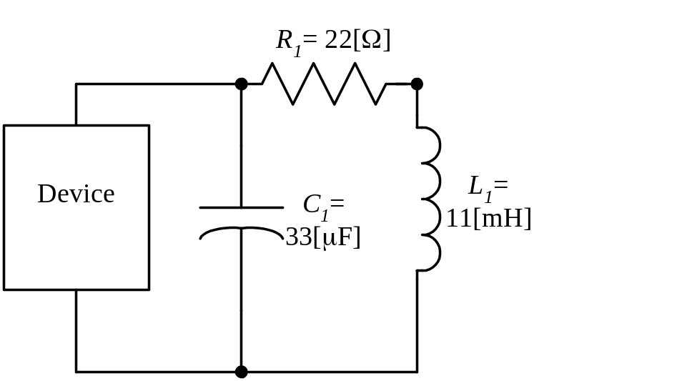

ECE 2300 -- Quiz #6 – December 4, 2003 – Shattuck Section Solution

In the circuit shown, the device can be modeled as a voltage source, v_{S}(t), in series with a resistor, R_{S}. The voltage source v_{S}(t) is sinusoidal, with a zero-to-peak amplitude of 12[V], a frequency of 200[Hz], and an arbitrary phase. The resistance of the resistor R_{S} is 4[Ω]. The circuit is operating in steady-state.
- Find the apparent power delivered by the device.
- Find the complex power delivered by the device.
- Find the average power delivered by the device.
- Find the reactive power delivered by the device.
- Find the power factor for the circuit that is connected to the device.


