Name: _____________________________ (please print)

Signature: __________________________

TuTh 1PM ------------- TuTh 4PM

ECE 2300 -- Exam #1

October 6, 2007

Keep this exam closed until you are told to begin.

1. This exam is closed book, closed notes. You may use one 8.5” x 11” crib sheet, or its equivalent.

2. Show all work on these pages. Show all work necessary to complete the problem. A solution without the appropriate work shown will receive no credit. A solution that is not given in a reasonable order will lose credit. Clearly indicate your answer (for example by enclosing it in a box).

3. It is assumed that your work will begin on the same page as the problem statement. If you choose to begin your work on another page, you must indicate this on the page with the problem statement, with a clear indication of where the work can be found. **If your work continues on to another page, indicate clearly where your work can be found. Failure to indicate this clearly will result in a loss of credit.**

4. Show all units in solutions, intermediate results, and figures. Units in the exam will be included between square brackets.

5. Do not use red ink. Do not use red pencil.

6. You will have 90 minutes to work on this exam.

1. ________________/1

2. ________________/25

3. ________________/25

4. ________________/25

5. ________________/25

Total = 101

1. {1 Point} Circle the time that your section meets, below your name on page 1.

Room for extra work

2. {25 Points} A device, shown in Figure 1, can be modeled by a voltage source in series with a resistance. The device has been connected to the circuit in Figure 2, connecting terminals A to A, and B to B. The current source in this case absorbs 6.42[mW]. Find the power absorbed by the device for this situation.

 

# Room for extra work

3. {25 Points} The multi-range voltmeter in Figure 1 has been modified by placing a 1[k] resistor between the 25[V] and Common terminals.

a) Find the largest voltage that can be measured by this modified meter, connecting the voltage to be measured between the 200[V] terminal and the Common terminal.

b) Assume the circuit in Figure 2 is connected to the modified multi-range voltmeter. Terminal A is connected to the 85[V] terminal, and Terminal B is connected to the Common terminal. Find the reading on the 200[V] scale for this condition.

 

Room for extra work

4. {25 Points} The meter in this circuit reads zero, until a wire is connected between terminals B and F. Find the power delivered by the voltage source with this wire in place.

*R1* = 10[k],   
*R2* = 4.7[k],   
*R3* = 6.8[k],   
*RA* = 330[], and  
*RB* = 560[].



Room for extra work

5. {25 Points} For the given circuit, use the Node-Voltage method to write a complete set of independent equations that could be used to solve this circuit. You only need to write one set of equations. Do not simplify the circuit. Do not attempt to solve or simplify your equations. Define all variables.



Room for extra work

Solutions:

2. {25 Points} A device, shown in Figure 1, can be modeled by a voltage source in series with a resistance. The device has been connected to the circuit in Figure 2, connecting terminals A to A, and B to B. The current source in this case absorbs 6.42[mW]. Find the power absorbed by the device for this situation.

 

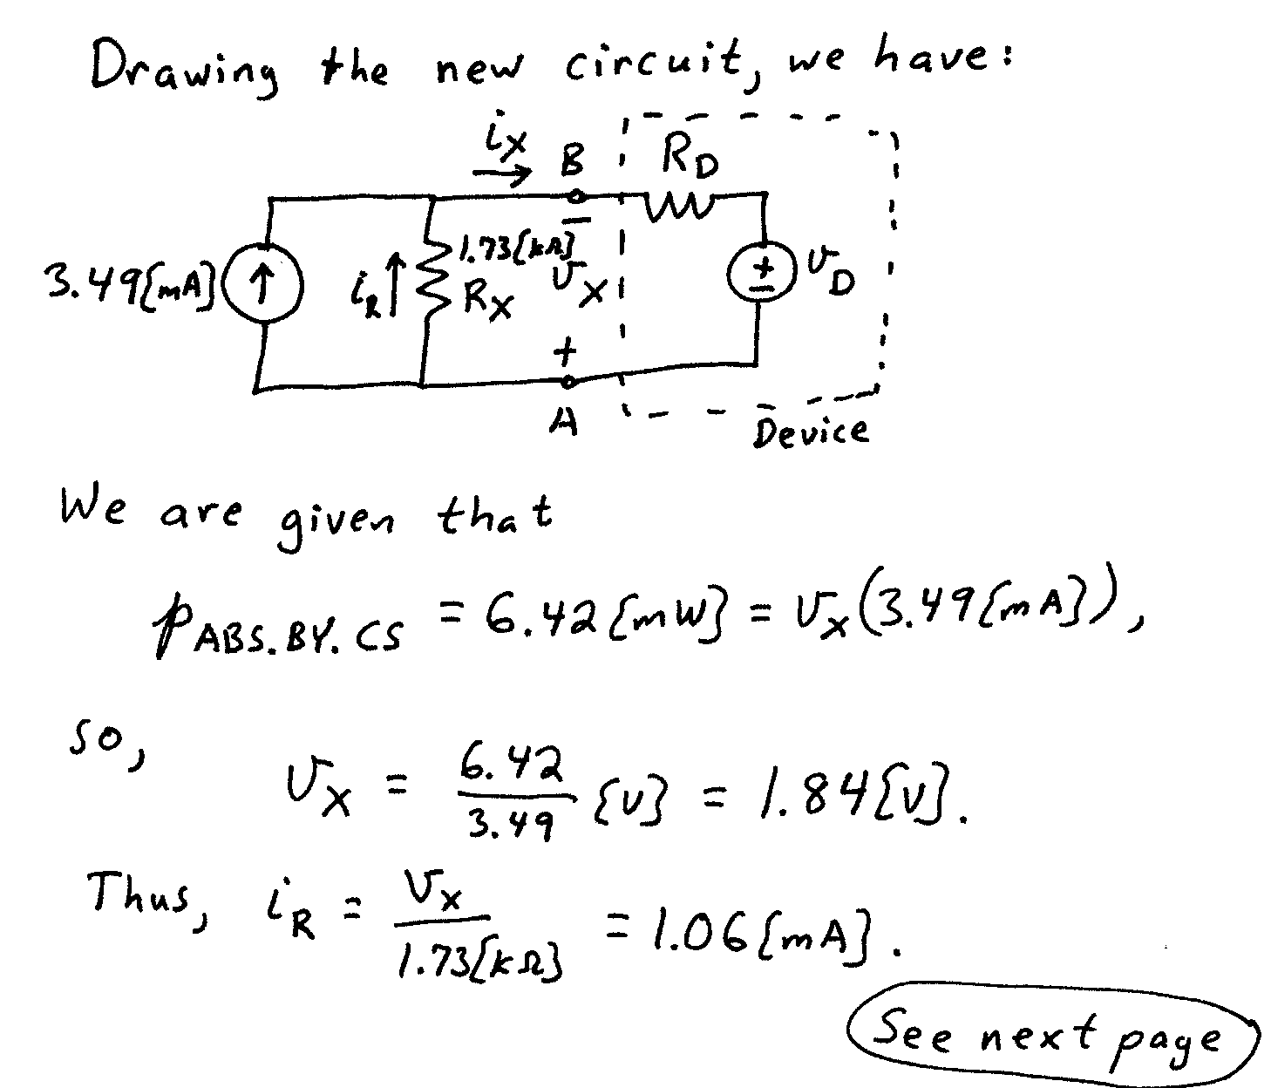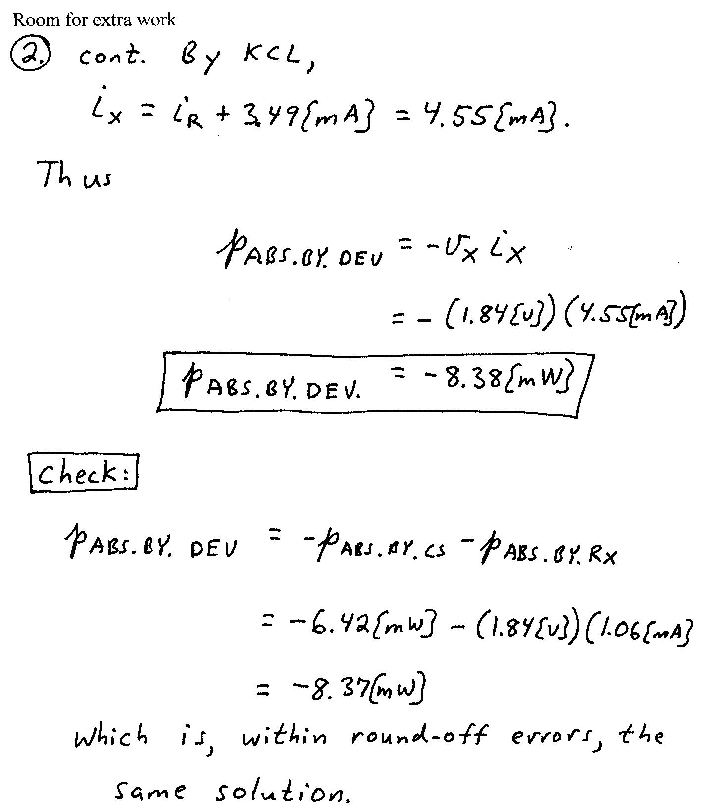

3. {25 Points} The multi-range voltmeter in Figure 1 has been modified by placing a 1[k] resistor between the 25[V] and Common terminals.

a) Find the largest voltage that can be measured by this modified meter, connecting the voltage to be measured between the 200[V] terminal and the Common terminal.

b) Assume the circuit in Figure 2 is connected to the modified multi-range voltmeter. Terminal A is connected to the 85[V] terminal, and Terminal B is connected to the Common terminal. Find the reading on the 200[V] scale for this condition.

 

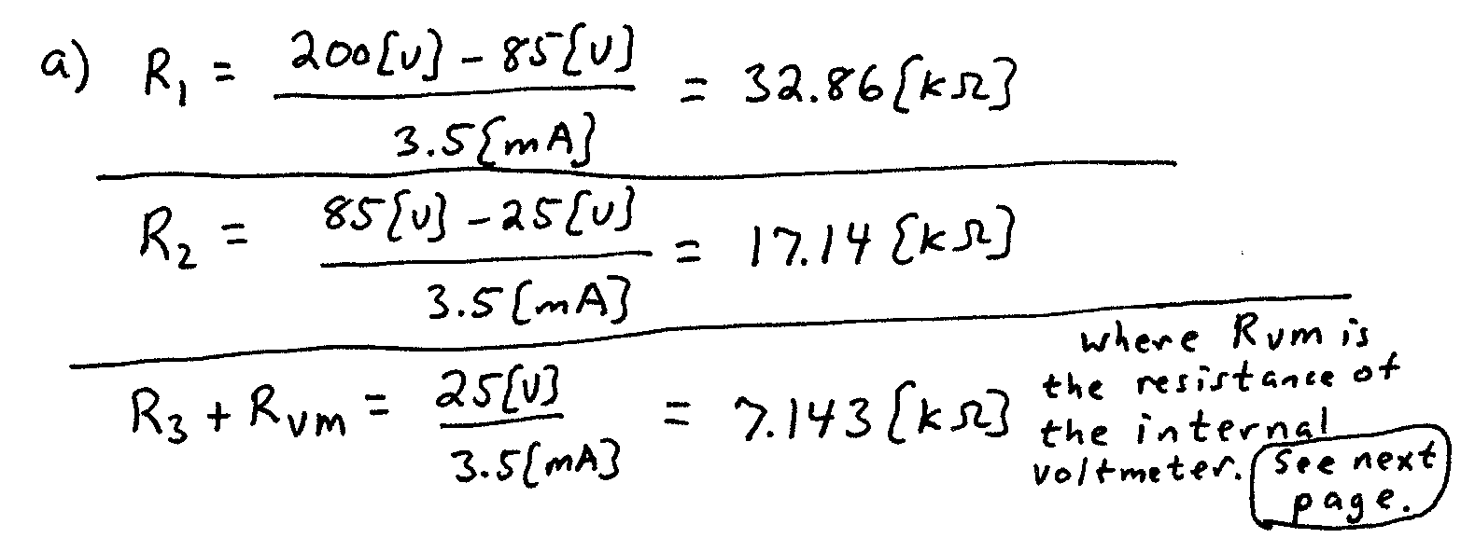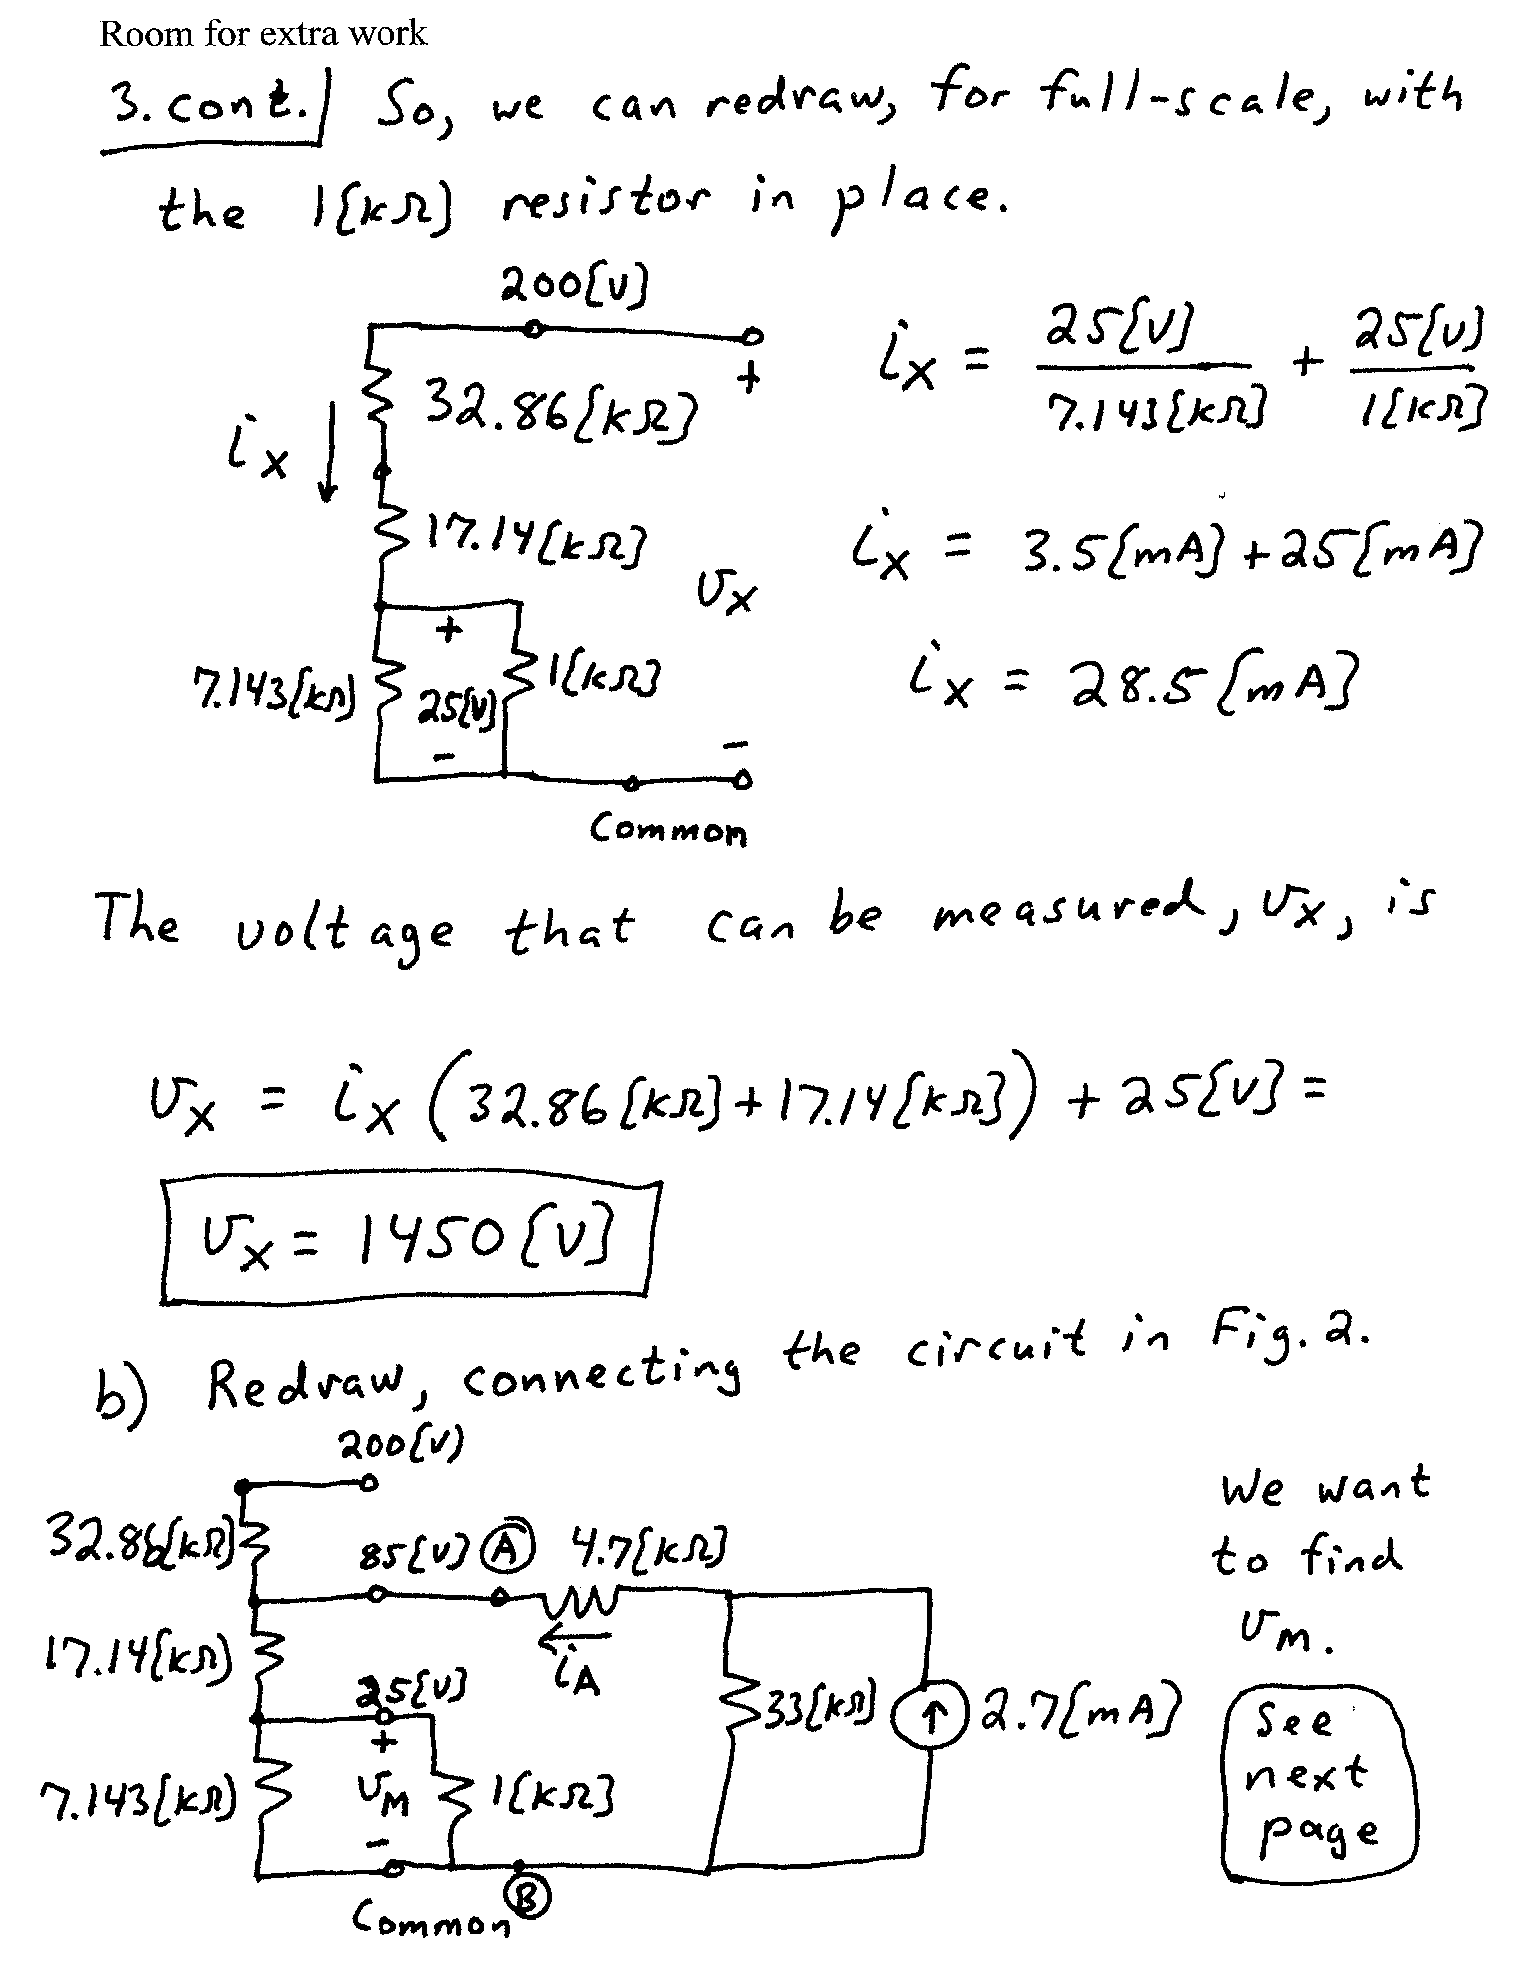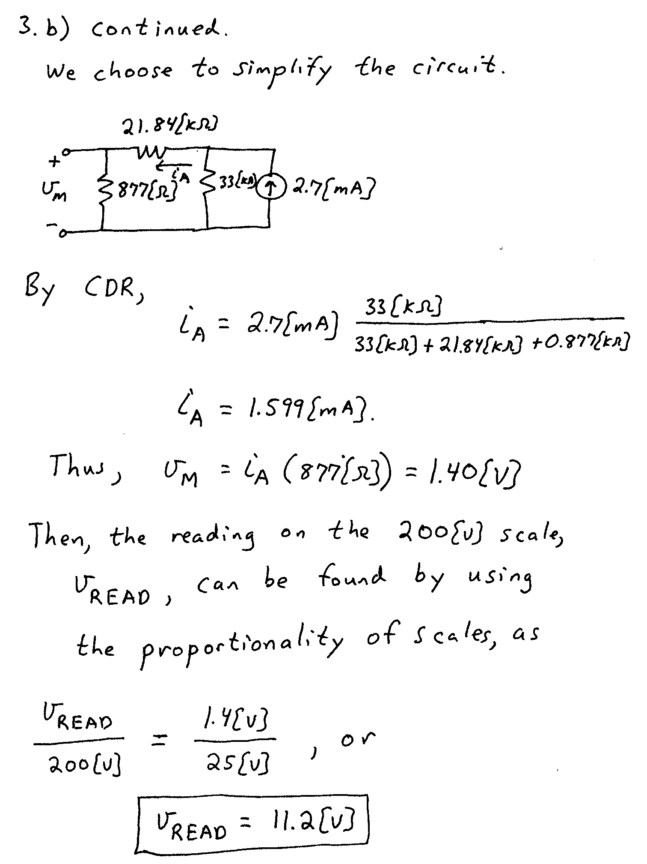

4. {25 Points} The meter in this circuit reads zero, until a wire is connected between terminals B and F. Find the power delivered by the voltage source with this wire in place.

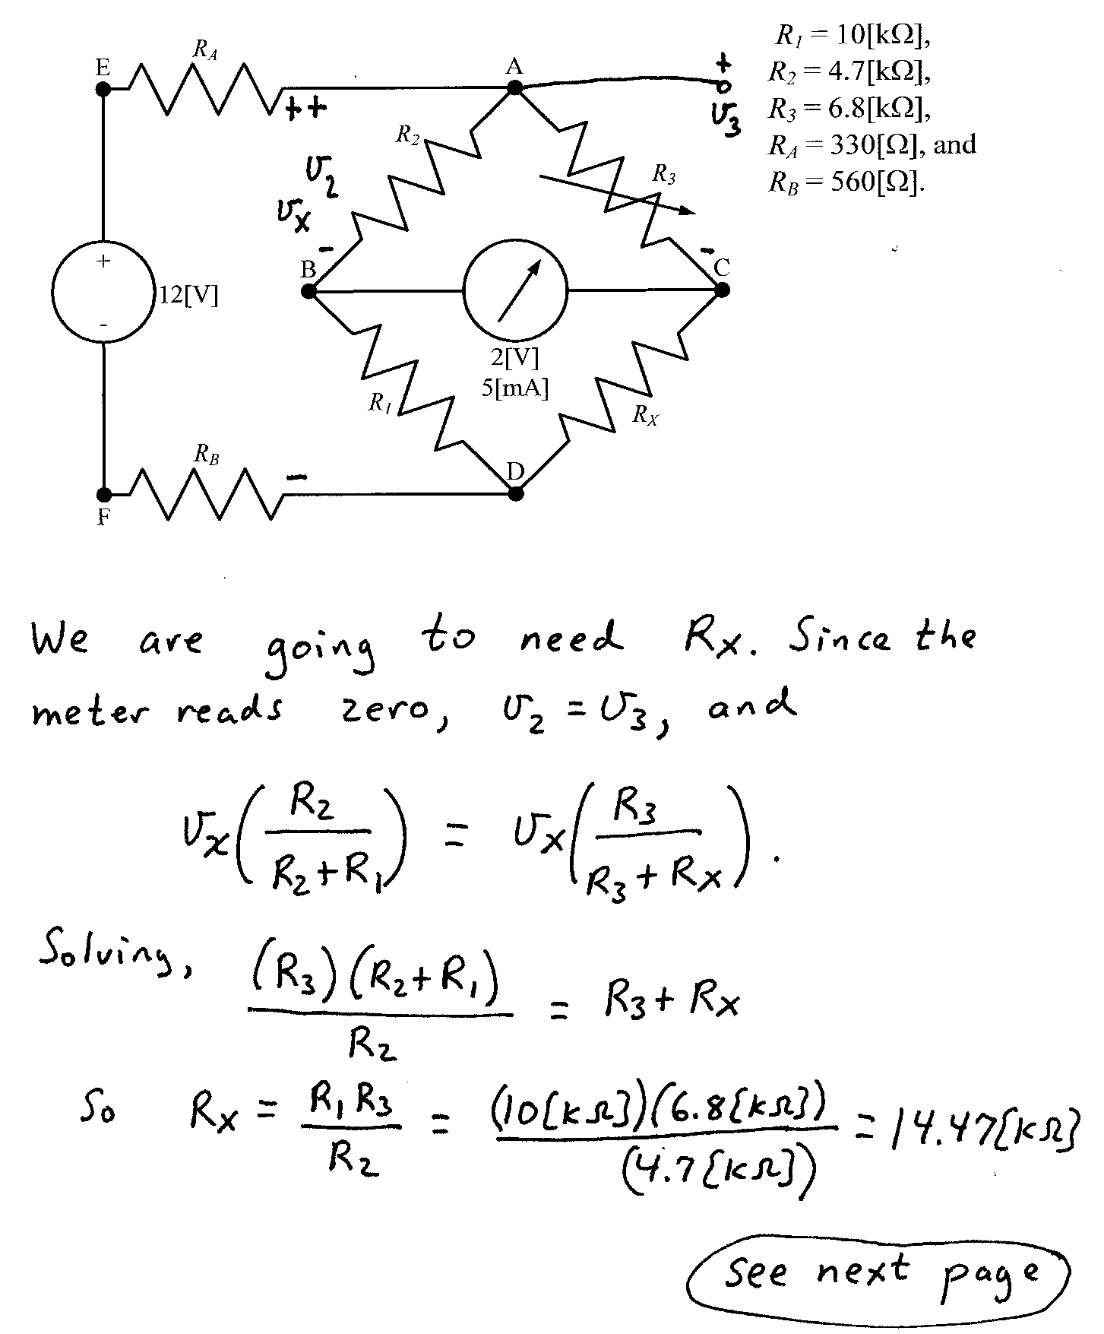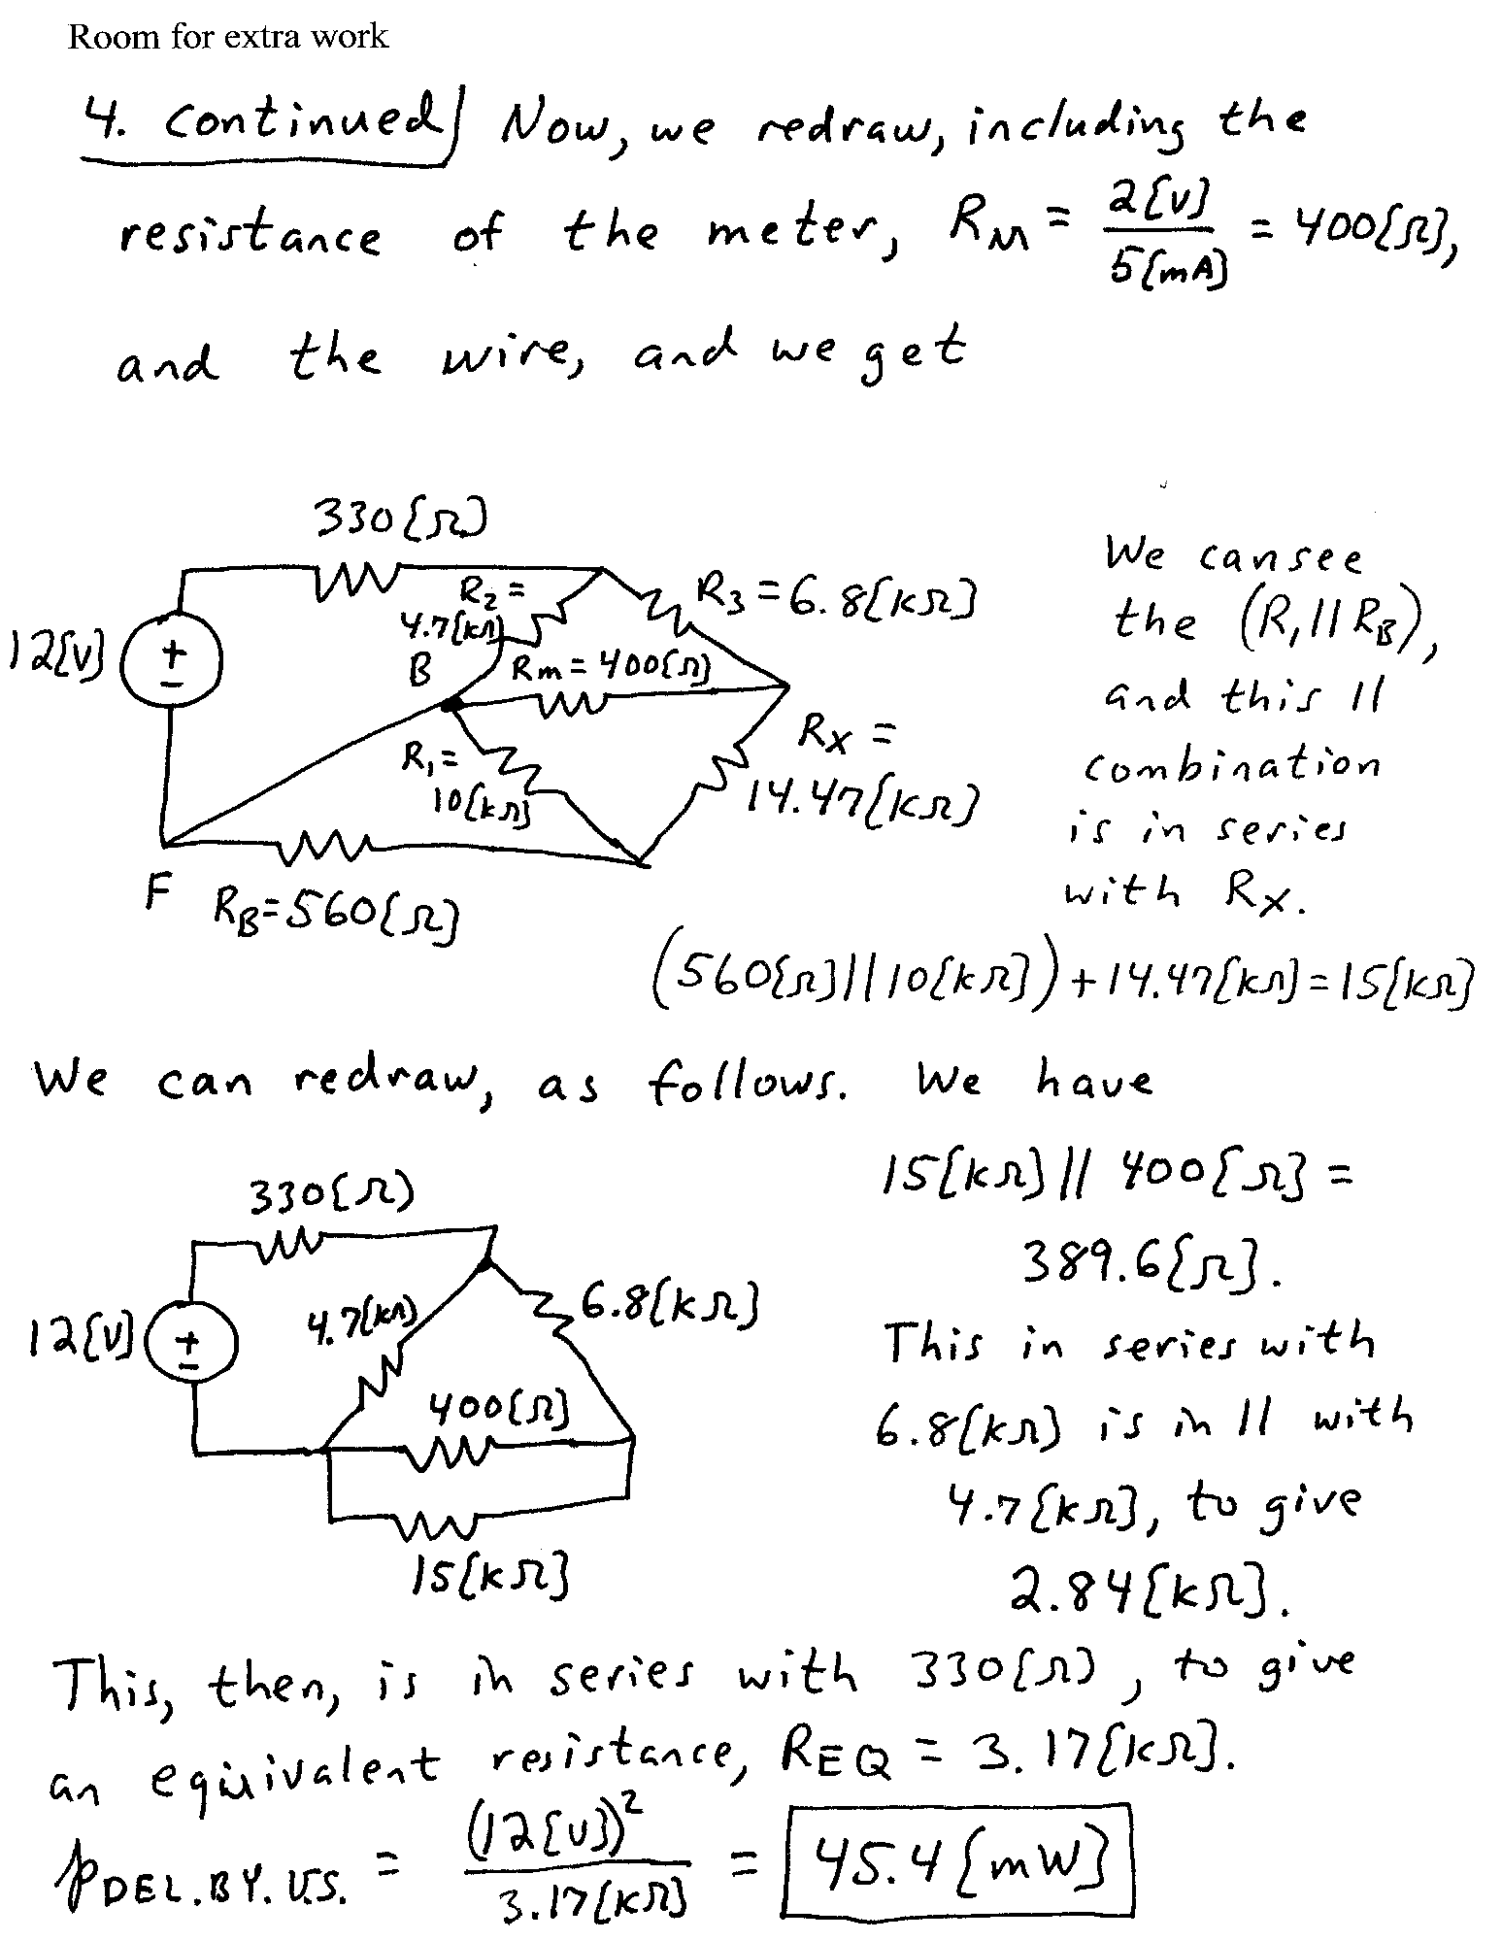

5. {25 Points} For the given circuit, use the Node-Voltage method to write a complete set of independent equations that could be used to solve this circuit. You only need to write one set of equations. Do not simplify the circuit. Do not attempt to solve or simplify your equations. Define all variables.

