Name: _____________________________ (please print)
Signature: __________________________

ECE 2300 – Quiz #2 – 1PM Section
September 25, 2007

Keep this quiz closed and face up until you are told to begin.

1. This quiz is closed book, closed notes. You may use one 8.5” x 11” crib sheet, or its equivalent.
2. Show all work on these pages. Show all work necessary to complete the problem. A solution without the appropriate work shown will receive no credit. A solution which is not given in a reasonable order will lose credit.
3. It is assumed that your work will begin on the same page as the problem statement. If you choose to begin your work on another page, you must indicate this on the page with the problem statement, with a clear indication of where the work can be found. If your work continues on to another page, indicate clearly where your work can be found. Failure to indicate this clearly will result in a loss of credit.
4. Show all units in solutions, intermediate results, and figures. Units in the quiz will be included between square brackets.
5. Do not use red ink. Do not use red pencil.
6. You will have 40 minutes to work on this quiz.

________________/20
Room for extra work
- Use the circuit given below to solve for the numerical value of the equivalent resistance as seen from terminals A and B.
- For 5 points of extra credit, use the circuit given below to solve for the numerical value of the equivalent resistance as seen from terminals A and C.

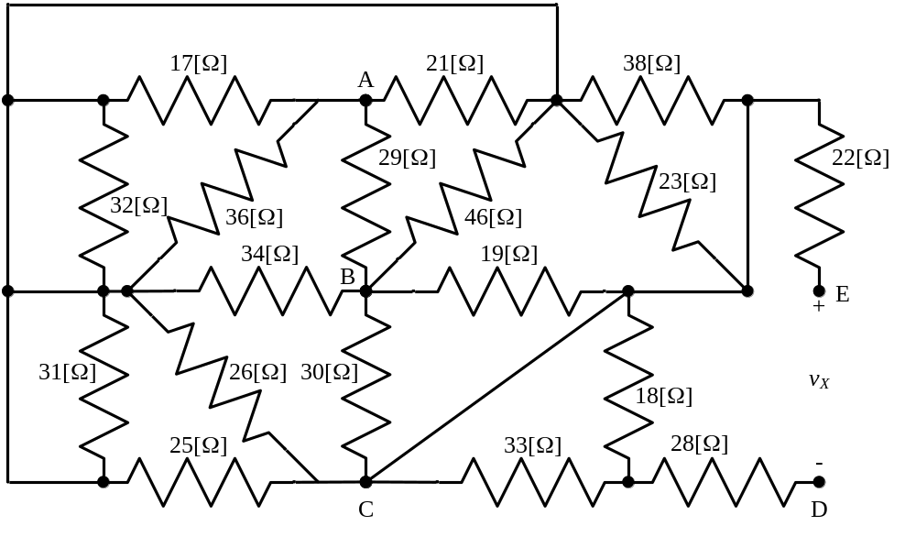

Room for extra work
Solution: Quiz 3, Fall 2007, ECE 2300, 1PM Section
- Use the circuit given below to solve for the numerical value of the equivalent resistance as seen from terminals A and B.
- For 5 points of extra credit, use the circuit given below to solve for the numerical value of the equivalent resistance as seen from terminals A and C.

We start by simplifying the circuit. We will make some simplifications, and then redraw. We don’t need to get everything at once; it is usually easiest to make a few simplifications, and then when we redraw that simplified circuit, we will see other things we can do. Note that the 28[Ω] and 22[Ω] resistors are in series with an open circuit, that is, they are connected at one end only. Thus, they will have no effect, and can be removed. Also, we see that the 33[Ω] and 18[Ω] resistors will now be in series, and then the series equivalent will be in parallel with a wire. Thus, they will have no effect.
Next, we note that the 32[Ω] and 31[Ω] resistors are in parallel with a wire, and can be removed. With these simplifications, we are ready to redraw the circuit. We will mark each of the nodes with a name and a closed surface. This helps us to see what to do in the next step. The simplified circuit follows.
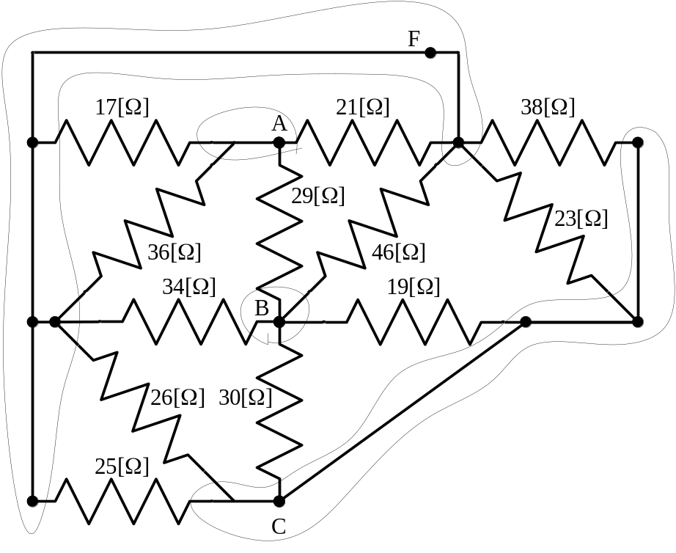
Note that we are left with only four nodes. We have named the remaining unnamed node, as F. We can see that the 17[Ω] and 36[Ω] resistors are in parallel, and can be combined. Similarly, the 26[Ω] and 25[Ω] resistors are in parallel, the 38[Ω] and 23[Ω] resistors are in parallel, the 19[Ω] and 30[Ω] resistors are in parallel, and can be combined. We have
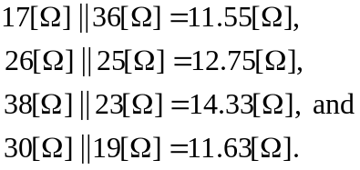
With these changes, we have a much simpler circuit, which follows.
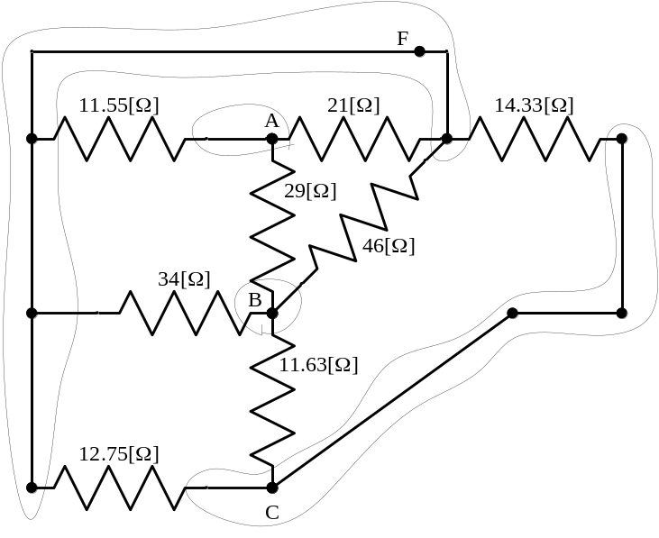
We can see from this diagram that the 12.75[Ω] and 14.33[Ω] resistors are connected between the same two nodes, and are in parallel. Similarly, the 21[Ω] and 11.55[Ω] resistors are in parallel, the 34[Ω] and 46[Ω] resistors are in parallel, and can be combined. We have
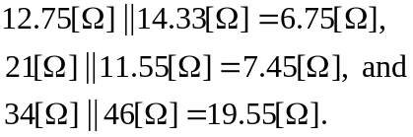
With these changes, we have an even simpler circuit, which follows.
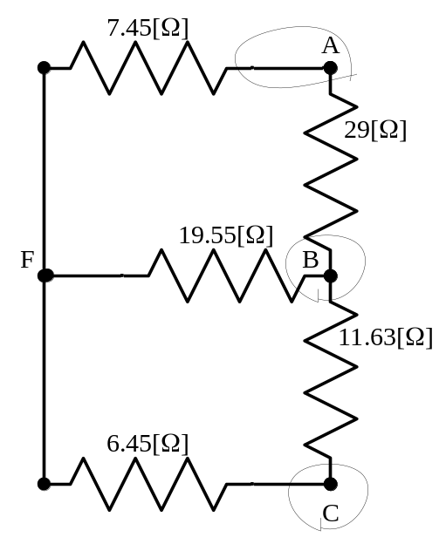
Now we have a circuit we can use to find the quantities requested. For part a), we need the resistance seen at terminals A and B. This means that nothing will be connected to terminal C, and the 11.63[Ω] and 6.45[Ω] resistors will be in series, and then combine that in parallel with the 19.55[Ω] resistor. We now have
the circuit that follows.
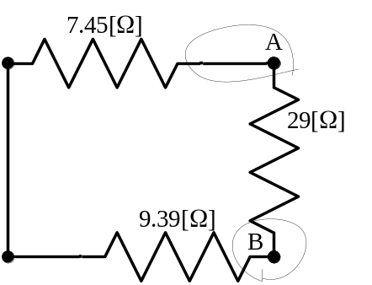
At this point it should be clear that the 9.39[Ω] resistor is in series with the 7.45[Ω] resistor, and that this series combination is in parallel with the 29[Ω] resistor. We have
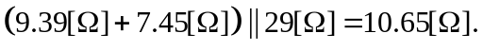
The resistance between terminals A and B, which we will call R_{AB}, is
R_{AB} = 10.65[Ω].

To get the extra credit for part b), we look at the earlier circuit before we removed terminal C. This circuit is reproduced here for convenience.
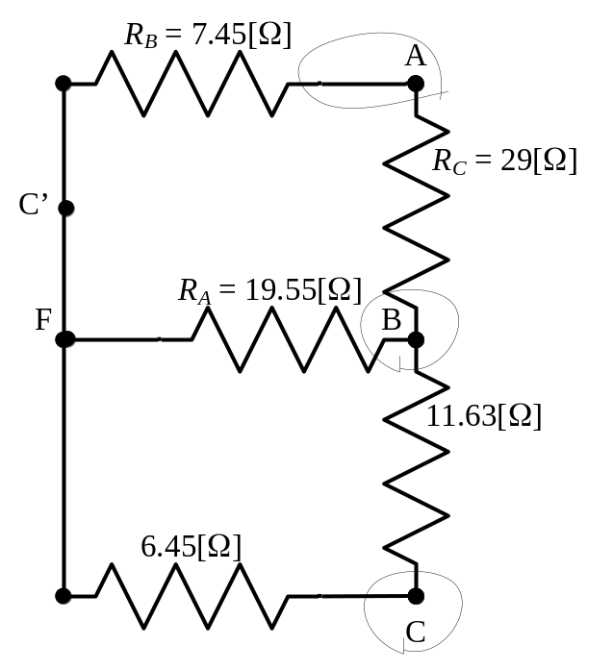
We may notice that this is a circuit which we have solved before. It is the circuit for a Wheatstone Bridge, and we can use our delta-to-wye transformations to solve it. Indeed, this is a case where this approach is particularly useful, since no resistors are in series or in parallel, as seen from terminals A and C. We have added a name for terminal F, as C’, to avoid confusion with the existing terminal C. Also, we have added the appropriate names for the resistors in the delta equivalent, to facilitate the use of the equations for this transformation.
The new version of this circuit follows. In this version, we have replaced the delta with its wye equivalent. To get to this, we have used the following equations:
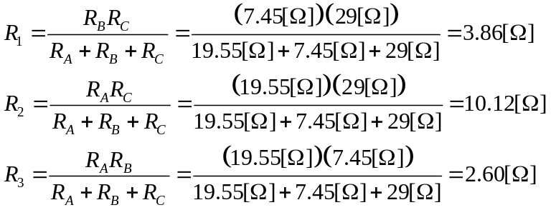
This allows us to redraw the circuit as follows.
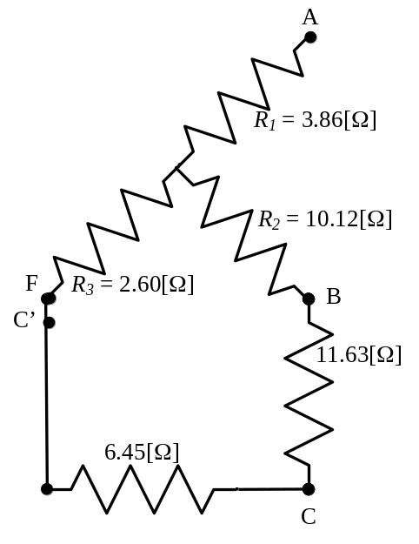
We can see that we have series and parallel combinations, which leads to the resistance between A and C, R_{AC}, as
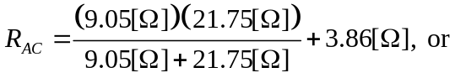
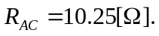
Note that we can use this equivalent, given above, to confirm our answer for part a). If you look at this equivalent, the resistance between terminals A and B is
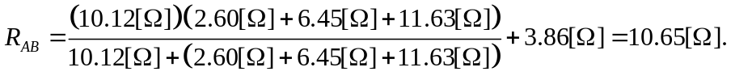
This is the same result that we obtained earlier.
Name: _____________________________ (please print)
Signature: __________________________

ECE 2300 – Quiz #2 – 4PM Section
September 25, 2007

Keep this quiz closed and face up until you are told to begin.

1. This quiz is closed book, closed notes. You may use one 8.5” x 11” crib sheet, or its equivalent.
2. Show all work on these pages. Show all work necessary to complete the problem. A solution without the appropriate work shown will receive no credit. A solution which is not given in a reasonable order will lose credit.
3. It is assumed that your work will begin on the same page as the problem statement. If you choose to begin your work on another page, you must indicate this on the page with the problem statement, with a clear indication of where the work can be found. If your work continues on to another page, indicate clearly where your work can be found. Failure to indicate this clearly will result in a loss of credit.
4. Show all units in solutions, intermediate results, and figures. Units in the quiz will be included between square brackets.
5. Do not use red ink. Do not use red pencil.
6. You will have 30 minutes to work on this quiz.

________________/20
Room for extra work

The internal voltmeter shown has a full-scale current of 7[mA]. The internal voltmeter is incorporated into a multi-range voltmeter, with full scale ranges of 50[V], 85[V], and 225[V].
Assume that a user wishes to add a resistor, R_{X}, between the 50[V] terminal and the Common terminal, so that voltages up to 500[V] can be measured using the 225[V] terminal and the Common terminal. Find the numerical value of the resistor R_{X}, which is being added.
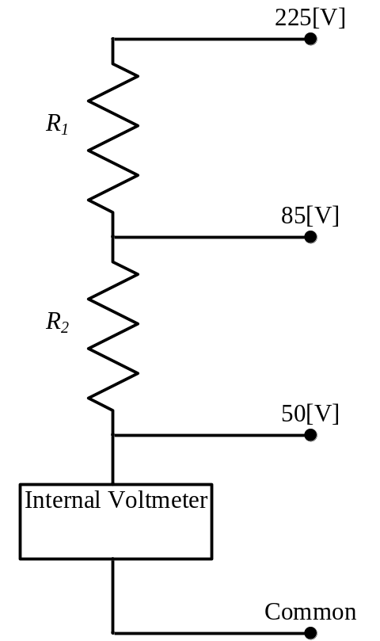

Room for extra work
Solution: Quiz 3, Fall 2007, ECE 2300, 4PM Section
The internal voltmeter shown has a full-scale current of 7[mA]. The internal voltmeter is incorporated into a multi-range voltmeter, with full scale ranges of 50[V], 85[V], and 225[V].
Assume that a user wishes to add a resistor, R_{X}, between the 50[V] terminal and the Common terminal, so that voltages up to 500[V] can be measured using the 225[V] terminal and the Common terminal. Find the numerical value of the resistor R_{X}, which is being added.

We start by solving for the resistances that we need here. Since we will not be connecting anything to the 85[V] terminal, we can begin by ignoring that terminal, and combining R₁ and R₂ in series. That resistor, which we will call R₁₂, has the value
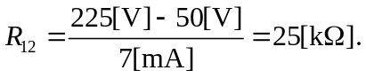
Thus, we can redraw the circuit, inserting this resistor, and also adding the resistor R_{X} that is added between the 50[V] terminal and the Common terminal. This circuit follows.
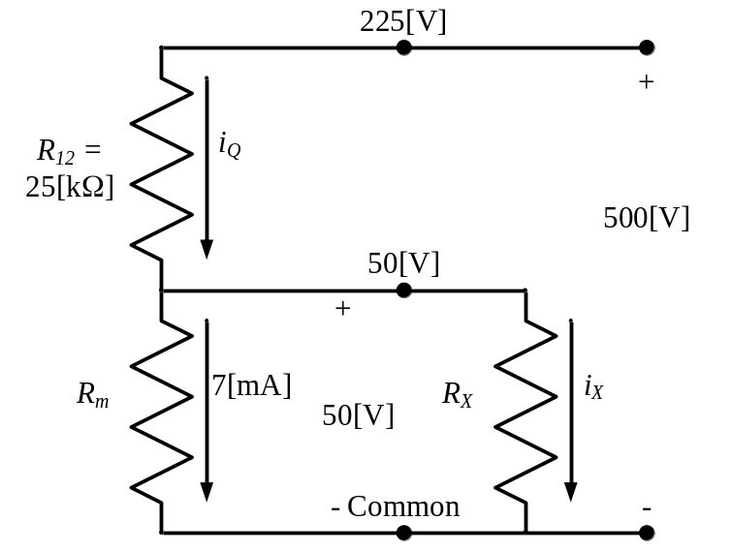
We have also added some other information that will be useful to us. This diagram is given when the meter is reading full-scale. Thus, the current through the internal voltmeter must be the full-scale value, which is 7[mA]. Since this is the full-scale current, the full-scale voltage across that internal voltmeter must be its full-scale value, or 50[V]. Finally, the voltage we wish to measure, at full scale, across the 225[V] terminal and the Common terminal, is also shown.
From this information, we can find the current i_{Q} from
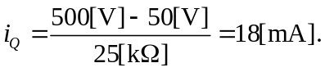
Using this, and KCL at the 50[V] terminal we can see that
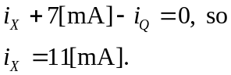
Then, from Ohm’s Law, we can write that


