Name: _____________________________ (please print)
Signature: __________________________

ECE 2300 -- Exam #1
October 10, 2009

Keep this exam closed until you are told to begin.

1. This exam is closed book, closed notes. You may use one 8.5” x 11” crib sheet, or its equivalent.
2. Show all work on these pages. Show all work necessary to complete the problem. A solution without the appropriate work shown will receive no credit. A solution that is not given in a reasonable order will lose credit. Clearly indicate your answer (for example by enclosing it in a box).
3. It is assumed that your work will begin on the same page as the problem statement. If you choose to begin your work on another page, you must indicate this on the page with the problem statement, with a clear indication of where the work can be found. If your work continues on to another page, indicate clearly where your work can be found. Failure to indicate this clearly will result in a loss of credit.
4. Show all units in solutions, intermediate results, and figures. Units in the exam will be included between square brackets.
5. Do not use red ink. Do not use red pencil.
6. You will have 90 minutes to work on this exam.

1. ________________/30
2. ________________/30
3. ________________/20
4. ________________/30
Total = 110
Room for extra work
1. {30 Points} A device can be modeled as a current source in parallel with a resistance. The device is shown in Figure 1. When the device is left by itself, it has a voltage at a with respect to b of 5.310[V].
Three identical versions of this device are connected in parallel, and connected to a voltmeter, as shown in Figure 2.
The voltmeter has a resistance of 20[kΩ], and a full scale reading of ±10[V]. Stated in a different way, the voltmeter can read negative and positive voltages in the range from -10[V] to +10[V]. In the connection shown in Figure 2, the voltage reading is v_{M} = 5.516[V].
Find all the possible readings of the voltmeter when the voltmeter described is connected to just one of these devices. Please give your answer(s) with at least 4 significant figures.

Room for extra work

2. {30 Points} Use the circuit shown below to solve this problem. Find the power delivered by the 10[V] voltage source. Show your steps in some clear fashion. You are strongly encouraged to redraw the diagram as needed to make your work more clear.

Room for extra work

3. {20 Points} It is given that a AA battery can be modeled as a voltage source in series with a resistor.
a) Assume that you have n AA batteries connected in series, where the polarity of each battery is arbitrary. Assume that the series combination of batteries is connected to a 10[kΩ] resistor. Determine the number of possible solutions for the power absorbed by the 10[kΩ] resistor, as a function of the number of batteries, n. (Hint: you may wish to consider the cases of n being odd and even separately.)
b) Assume that you have n AA batteries connected in parallel, where the polarity of each battery is arbitrary. Assume that the parallel combination of batteries is connected to a 10[kΩ] resistor. Determine the number of possible solutions for the power absorbed by the 10[kΩ] resistor, as a function of the number of batteries, n.

Room for extra work

4. {30 Points} For the given circuit, use the Node-Voltage method to write a complete set of independent equations that could be used to solve this circuit. Do not simplify the circuit. Do not attempt to solve or simplify your equations. Define all variables.

Solutions:
1. {30 Points} A device can be modeled as a current source in parallel with a resistance. The device is shown in Figure 1. When the device is left by itself, it has a voltage at a with respect to b of 5.310[V].
Three identical versions of this device are connected in parallel, and connected to a voltmeter, as shown in Figure 2.
The voltmeter has a resistance of 20[kΩ], and a full scale reading of ±10[V]. Stated in a different way, the voltmeter can read negative and positive voltages in the range from -10[V] to +10[V]. In the connection shown in Figure 2, the voltage reading is v_{M} = 5.516[V].
Find all the possible readings of the voltmeter when the voltmeter described is connected to just one of these devices. Please give your answer(s) with at least 4 significant figures.
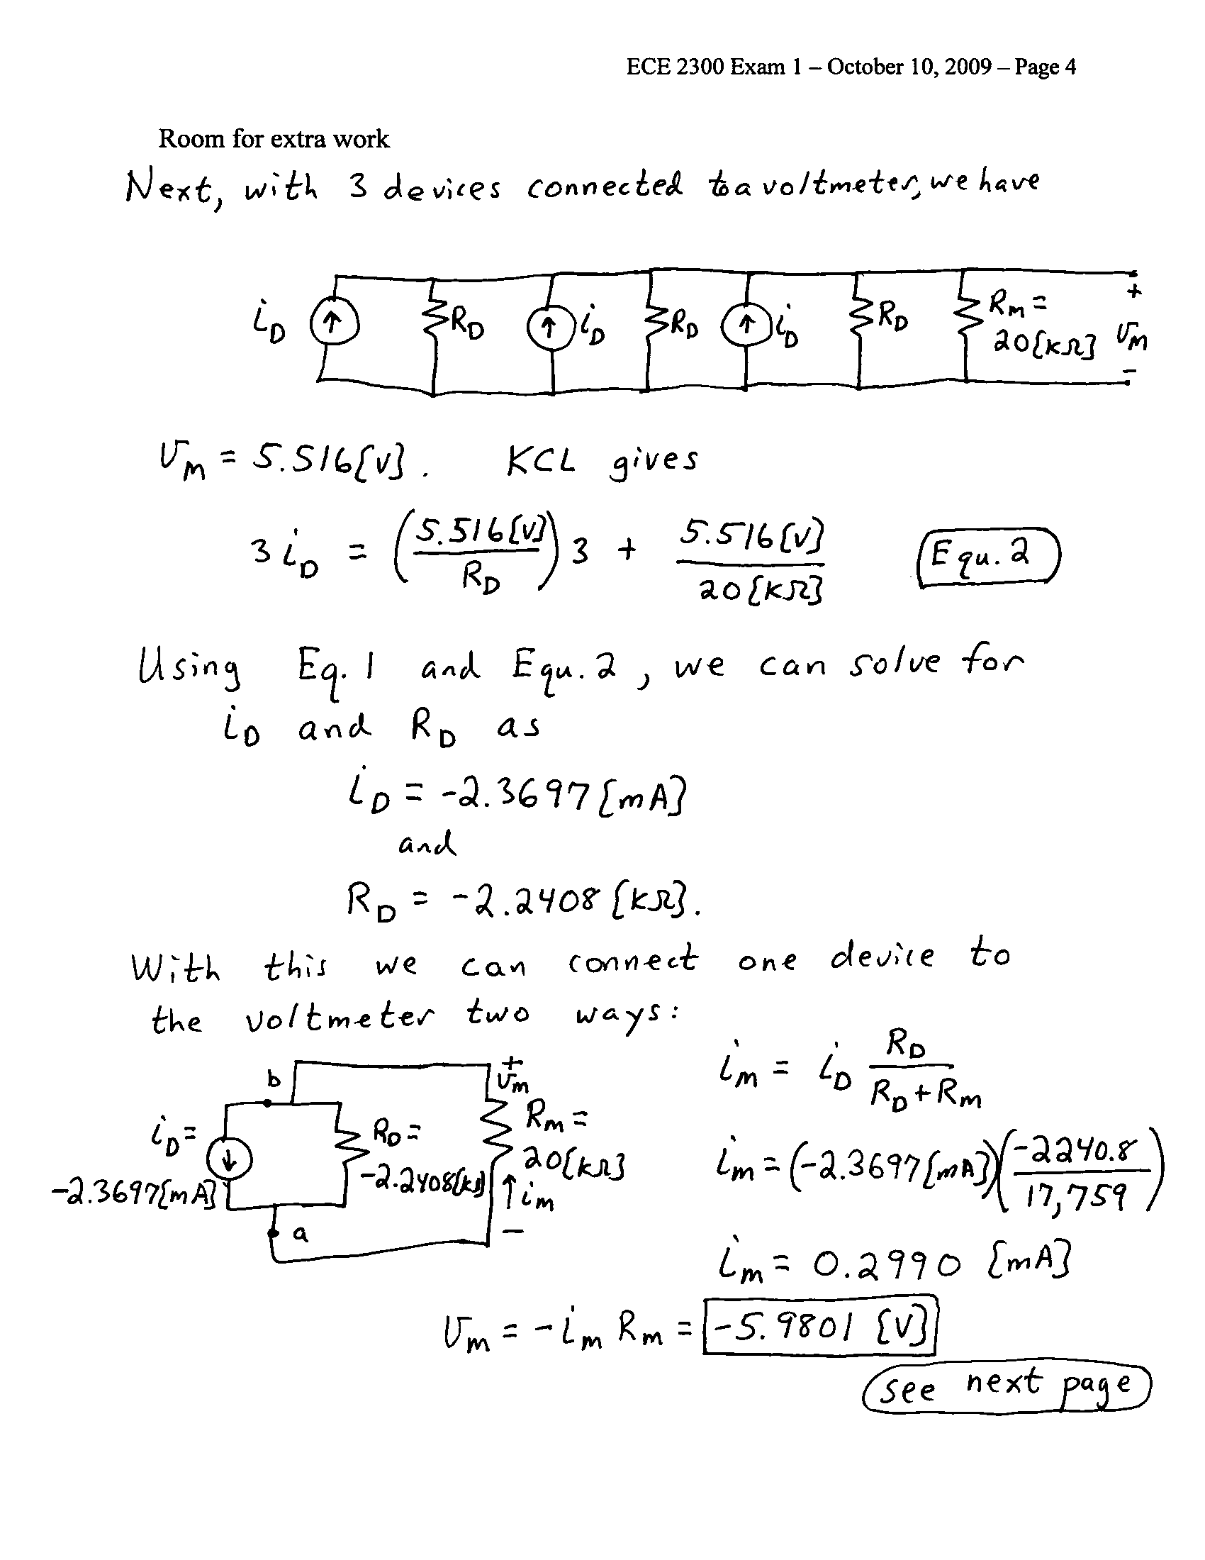

2. {30 Points} Use the circuit shown below to solve this problem. Find the power delivered by the 10[V] voltage source. Show your steps in some clear fashion. You are strongly encouraged to redraw the diagram as needed to make your work more clear.
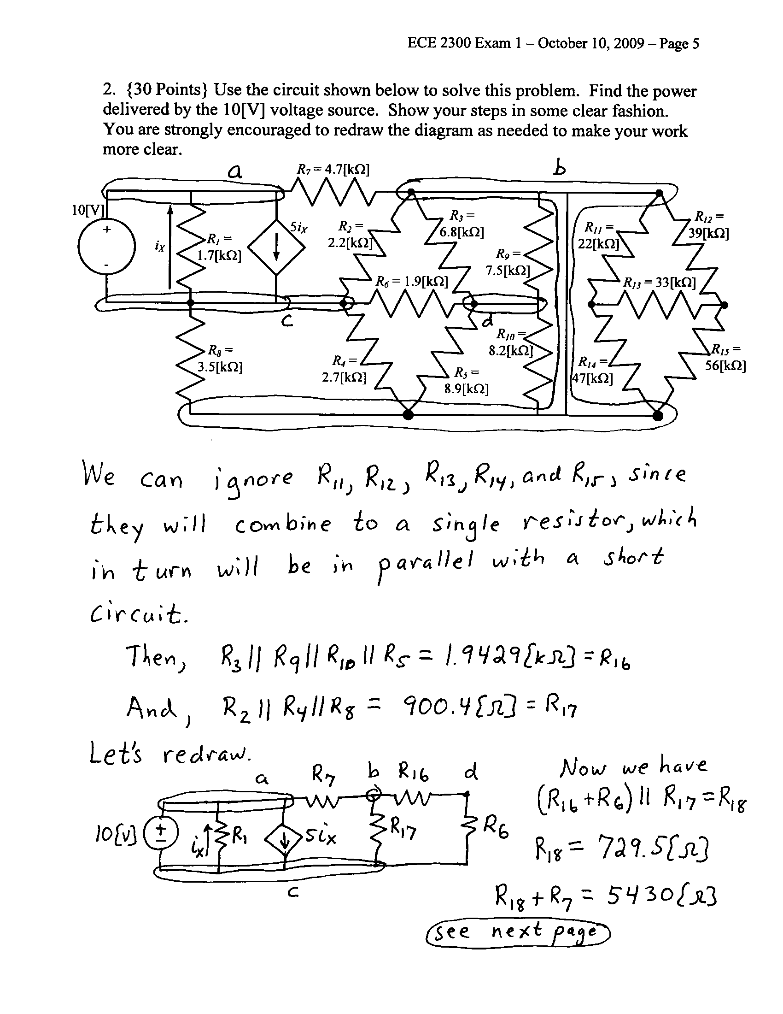

3. {20 Points} It is given that a AA battery can be modeled as a voltage source in series with a resistor.
a) Assume that you have n AA batteries connected in series, where the polarity of each battery is arbitrary. Assume that the series combination of batteries is connected to a 10[kΩ] resistor. Determine the number of possible solutions for the power absorbed by the 10[kΩ] resistor, as a function of the number of batteries, n. (Hint: you may wish to consider the cases of n being odd and even separately.)
b) Assume that you have n AA batteries connected in parallel, where the polarity of each battery is arbitrary. Assume that the parallel combination of batteries is connected to a 10[kΩ] resistor. Determine the number of possible solutions for the power absorbed by the 10[kΩ] resistor, as a function of the number of batteries, n.
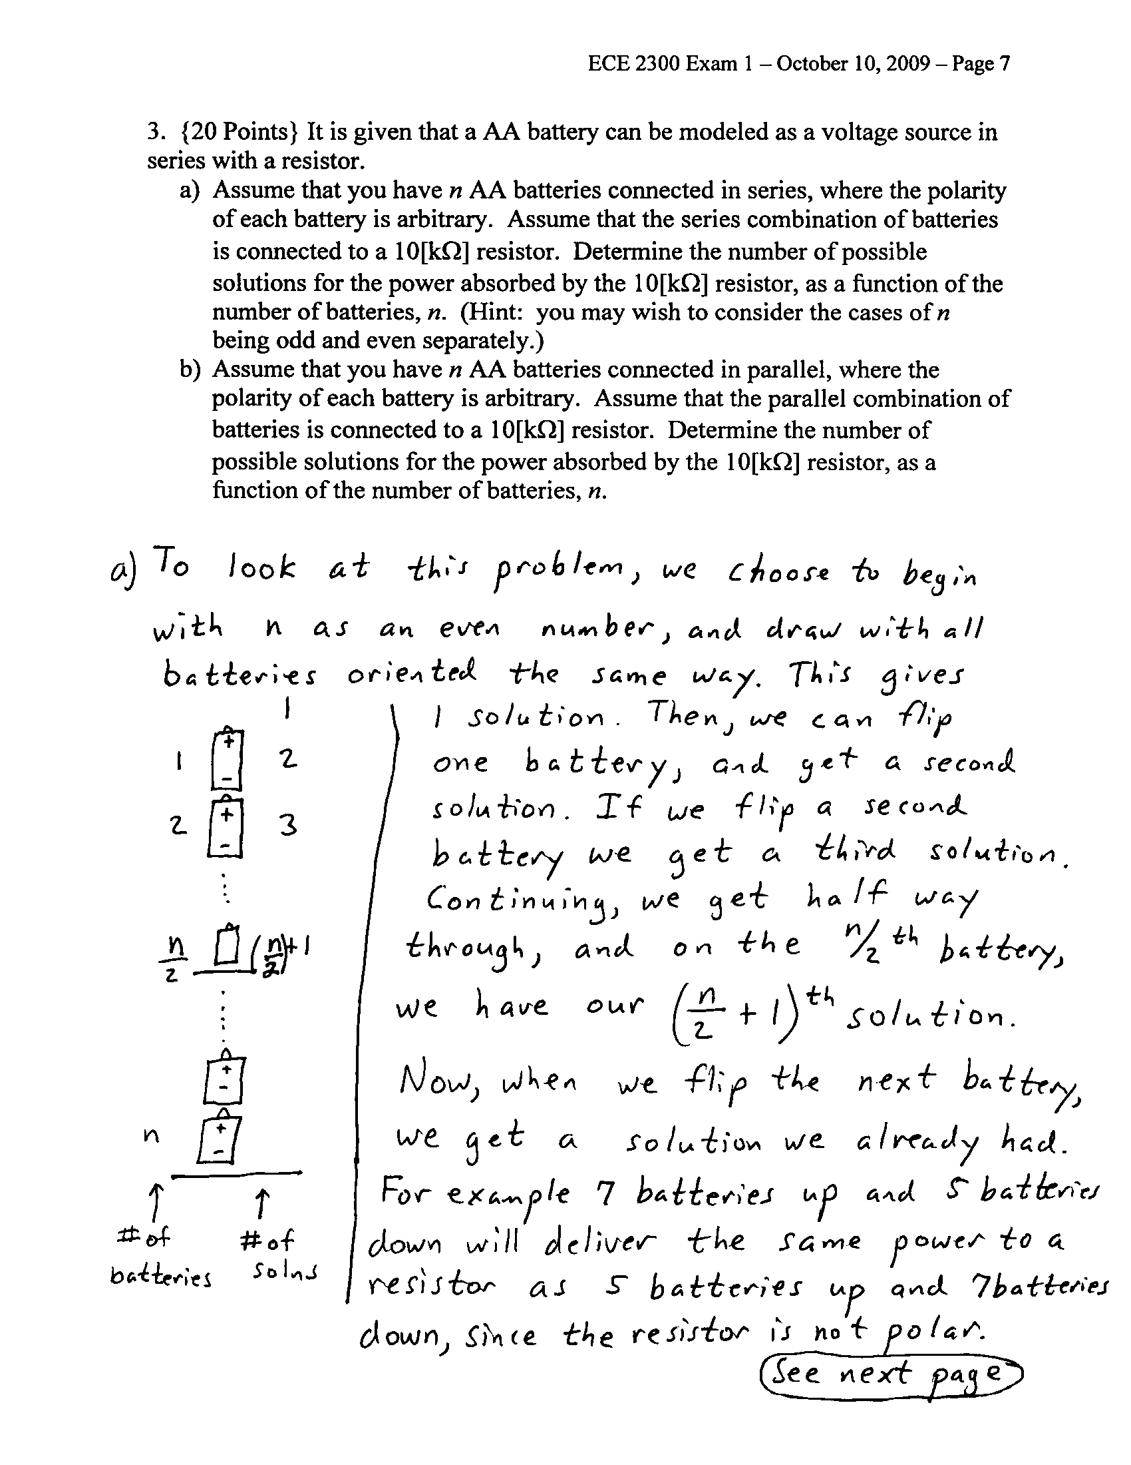
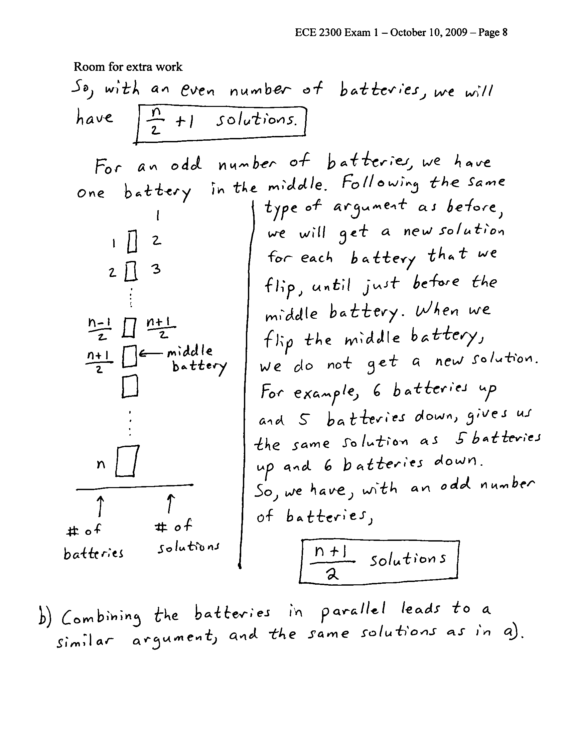
4. {30 Points} For the given circuit, use the Node-Voltage method to write a complete set of independent equations that could be used to solve this circuit. Do not simplify the circuit. Do not attempt to solve or simplify your equations. Define all variables.
