Name: _____________________________ (please print)
Signature: __________________________

ECE 2300 – Final Exam
December 9, 2009

Keep this exam closed until you are told to begin.

1. This exam is closed book, closed notes. You may use one 8.5” x 11” crib sheet, or its equivalent.
2. Show all work on these pages. Show all work necessary to complete the problem. A solution without the appropriate work shown will receive no credit. A solution that is not given in a reasonable order will lose credit. Clearly indicate your answer (for example by enclosing it in a box).
3. It is assumed that your work will begin on the same page as the problem statement. If you choose to begin your work on another page, you must indicate this on the page with the problem statement, with a clear indication of where the work can be found. If your work continues on to another page, indicate clearly where your work can be found. Failure to indicate this clearly will result in a loss of credit.
4. Show all units in solutions, intermediate results, and figures. Units in the exam will be included between square brackets.
5. Do not use red ink. Do not use red pencil.
6. You will have 170 minutes to work on this exam.

1. ________________/15
2. ________________/20
3. ________________/15
4. ________________/20
5. ________________/20
6. ________________/20
Total = 110
Room for extra work
1. {15 Points}
a) Solve the following equation for m and n. You should assume that m and n are real numbers. The variable n is an angle, and you should show your units.

b) Three complex numbers are to be multiplied. Each complex number has a real part which is positive, and an imaginary part which is positive. For each complex number, the imaginary part is larger than the real part. What can you say about the sign of the real part of the product of the three complex numbers?

Room for extra work

2. {20 Points} A car battery is connected to a starter motor. The starter motor can be modeled as a resistor with a resistance in the range from 10[mΩ] to 30[mΩ].
The car battery can be modeled as a voltage source in series with a resistance. When the car battery is connected to nothing, it has a voltage of 14.7[V] across it. When the car battery is connected to a resistance of 100[mΩ], it has a voltage of 9.4[V] across it.
You have two ammeters available to you. One ammeter has a full-scale current of 100[A], and a resistance of 0.05[Ω]. The other ammeter has full-scale current of 50[A], and a resistance of 0.001[Ω]. Neither ammeter will be damaged when a current larger than its full-scale value flows through it.
Describe a way that you could use one or both of these ammeters to monitor the current flow through the starter motor when it is connected to the car battery.

Room for extra work

3. {15 Points} For the given circuit, use the node-voltage method to write a complete set of independent equations that could be used to solve this circuit. Do not simplify the circuit. Do not attempt to solve or simplify your equations. Define all variables.

Room for extra work

4. {20 Points} Use the circuit shown below to solve for the numerical values of the quantities requested.
- Find the Thévenin equivalent as seen by the i_{S1} current source. Draw the equivalent, showing the numerical values of all components, and attach the i_{S1} current source.
- Find the energy delivered by the i_{S1} current source in this circuit during a 3.27[ms] time period.

Room for extra work

5. {20 Points} The circuit shown had been in steady-state until the switch closed at t = 0. Then for a time after that, the circuit was not in steady state.
a) Find the value for the energy stored in the 2[H] inductor a long time after the switch closed.
b) Find an expression for energy stored in the capacitor a long time after the switch closed.

Room for extra work

6. {20 Points} The circuit shown below is operating in steady state. The load absorbs (3950∠34°)[VA]. The voltage source delivers 6400[VAR].
a) Find all the possible values for R_{A}.
b) Find the average power delivered by the source.

Solution:
1. {15 Points}
a) Solve the following equation for m and n. You should assume that m and n are real numbers. The variable n is an angle, and you should show your units.

b) Three complex numbers are to be multiplied. Each complex number has a real part which is positive, and an imaginary part which is positive. For each complex number, the imaginary part is larger than the real part. What can you say about the sign of the real part of the product of the three complex numbers?
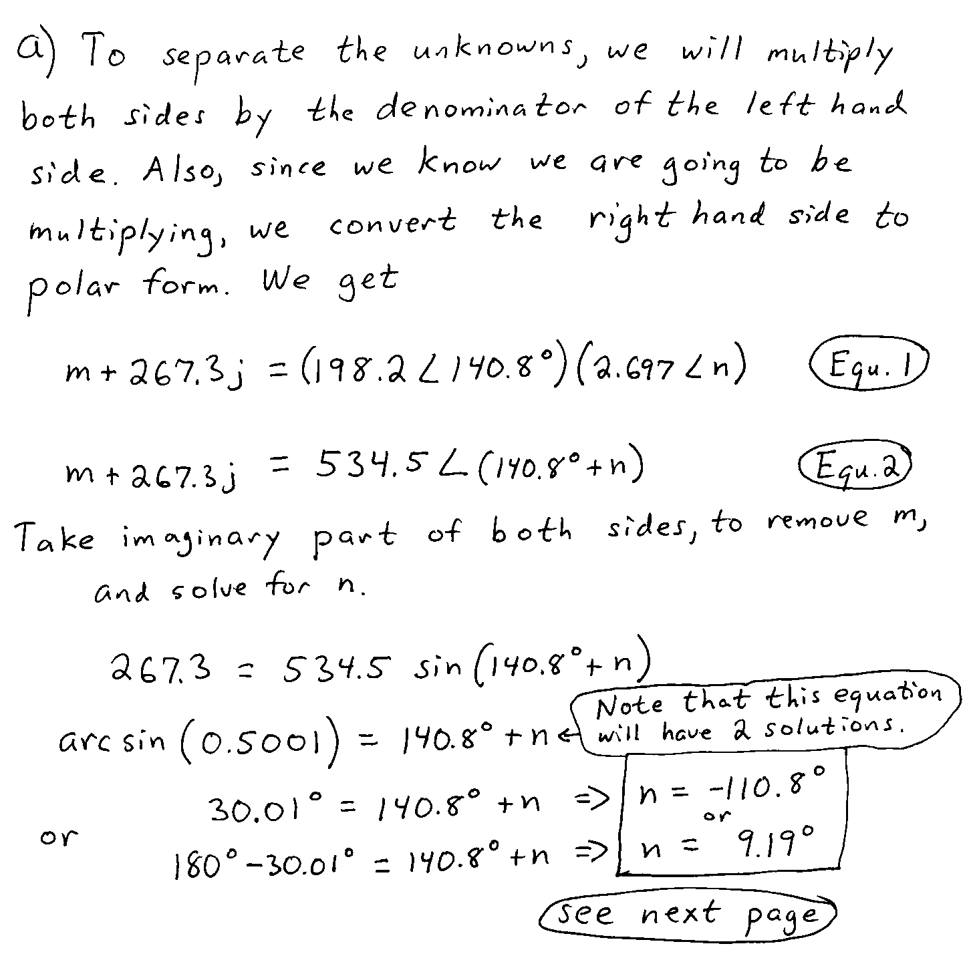
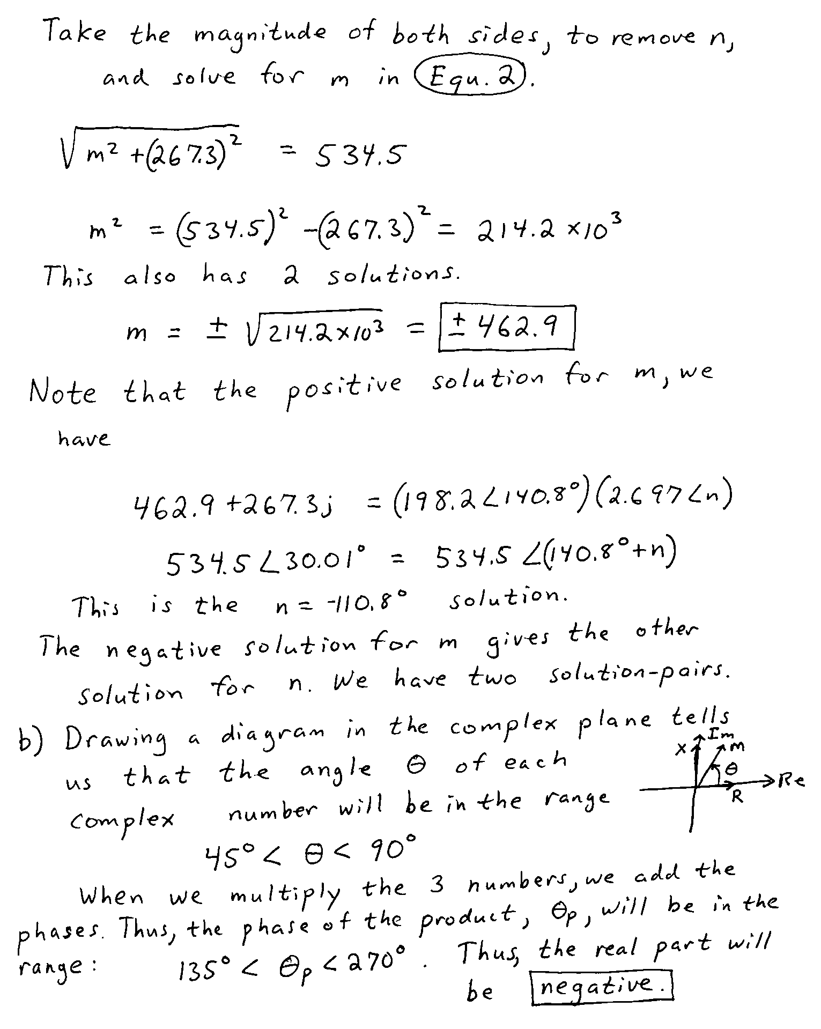

2. {20 Points} A car battery is connected to a starter motor. The starter motor can be modeled as a resistor with a resistance in the range from 10[mΩ] to 30[mΩ].
The car battery can be modeled as a voltage source in series with a resistance. When the car battery is connected to nothing, it has a voltage of 14.7[V] across it. When the car battery is connected to a resistance of 100[mΩ], it has a voltage of 9.4[V] across it.
You have two ammeters available to you. One ammeter has a full-scale current of 100[A], and a resistance of 0.05[Ω]. The other ammeter has full-scale current of 50[A], and a resistance of 0.001[Ω]. Neither ammeter will be damaged when a current larger than its full-scale value flows through it.
Describe a way that you could use one or both of these ammeters to monitor the current flow through the starter motor when it is connected to the car battery.
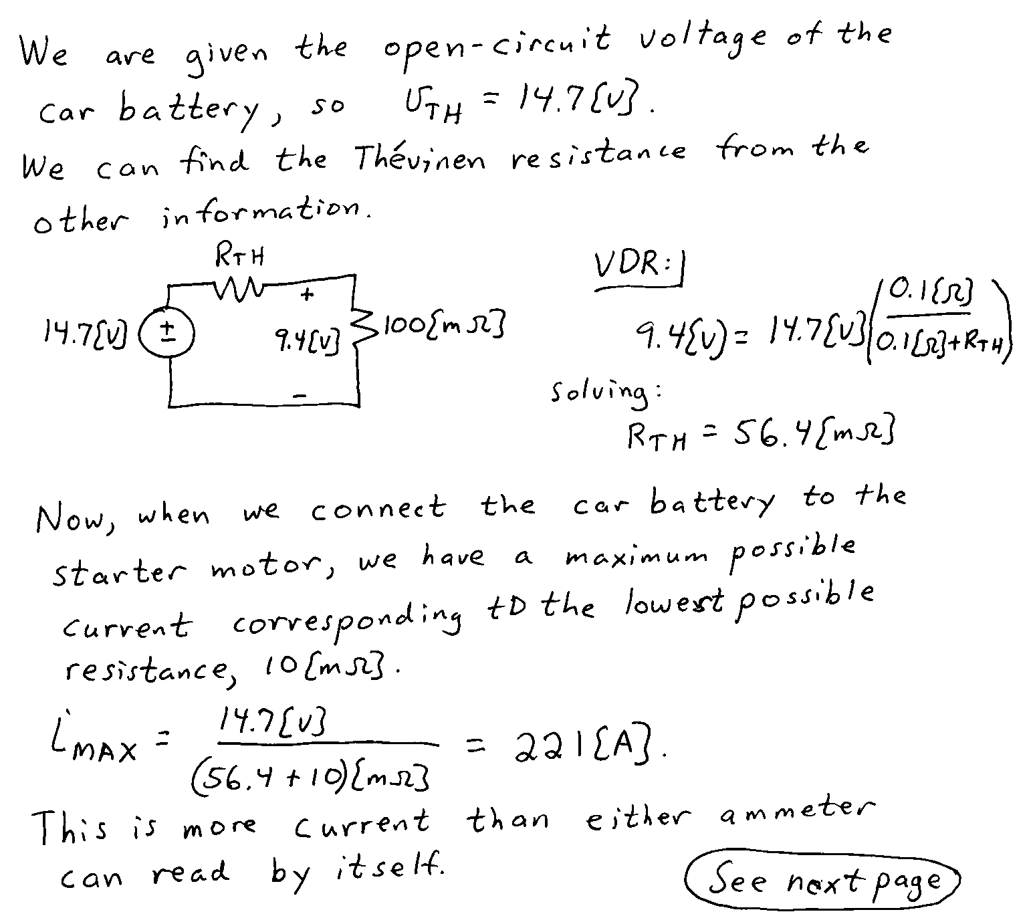
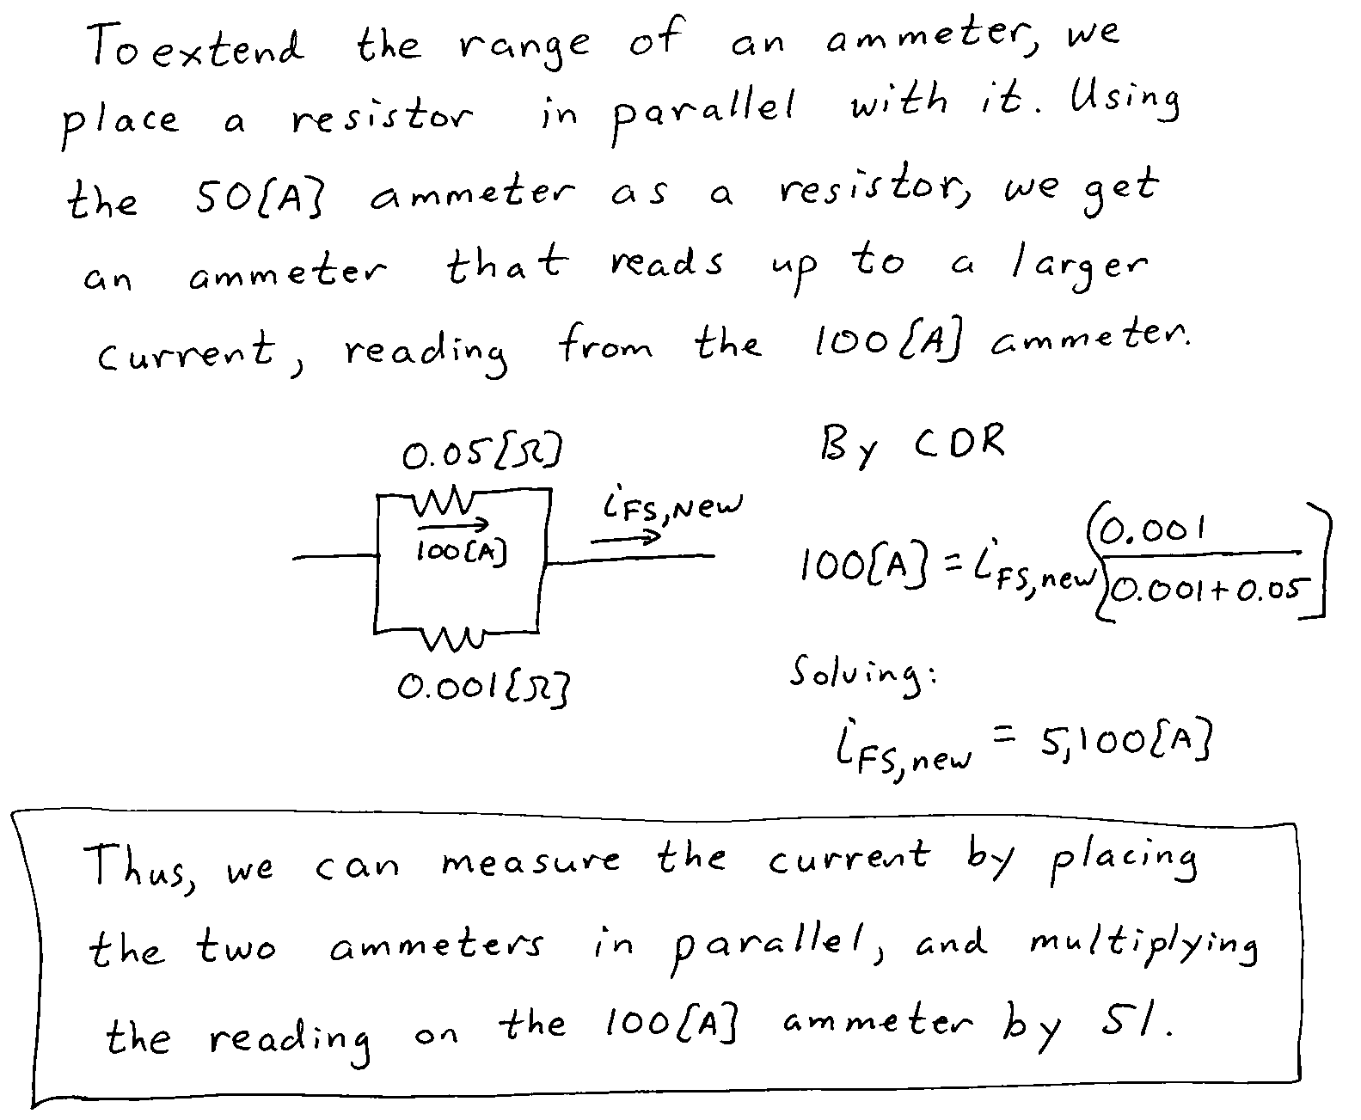

3. {15 Points} For the given circuit, use the node-voltage method to write a complete set of independent equations that could be used to solve this circuit. Do not simplify the circuit. Do not attempt to solve or simplify your equations. Define all variables.
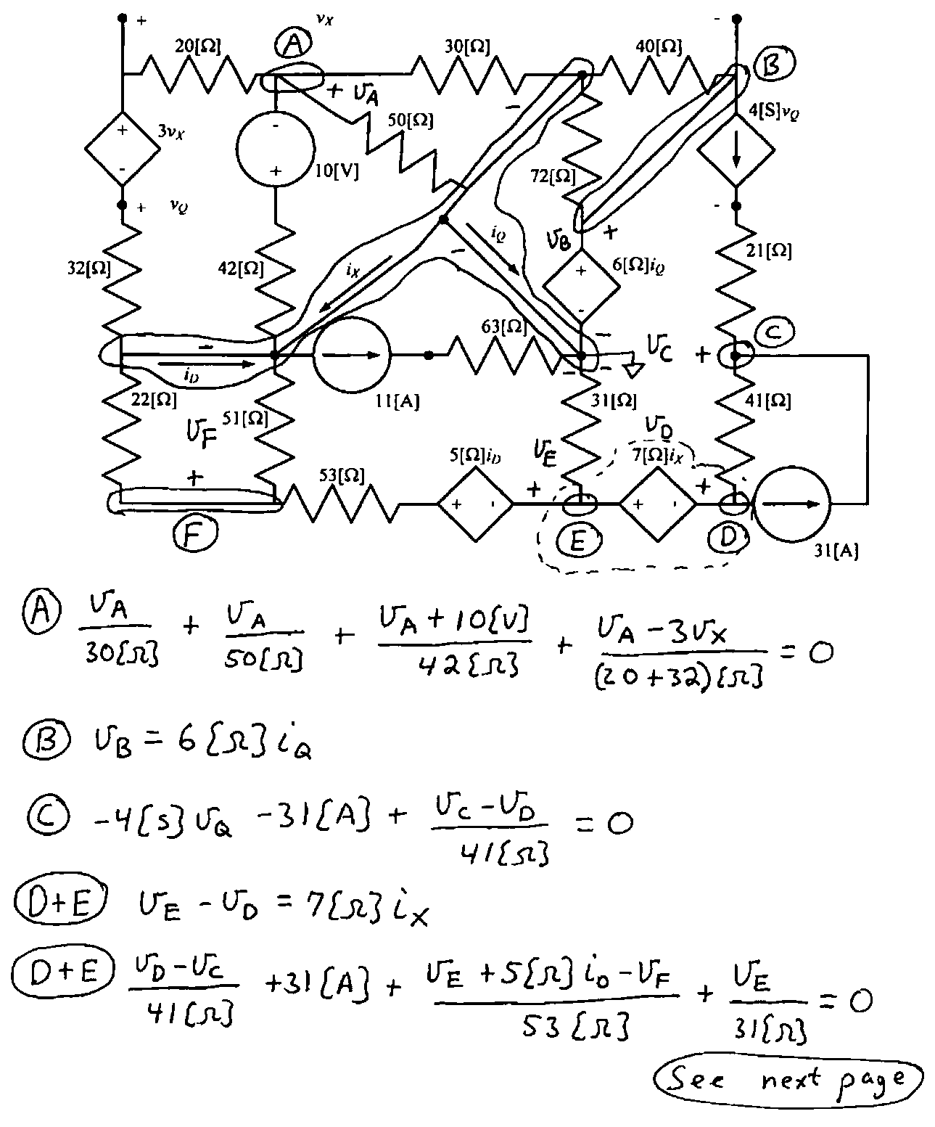
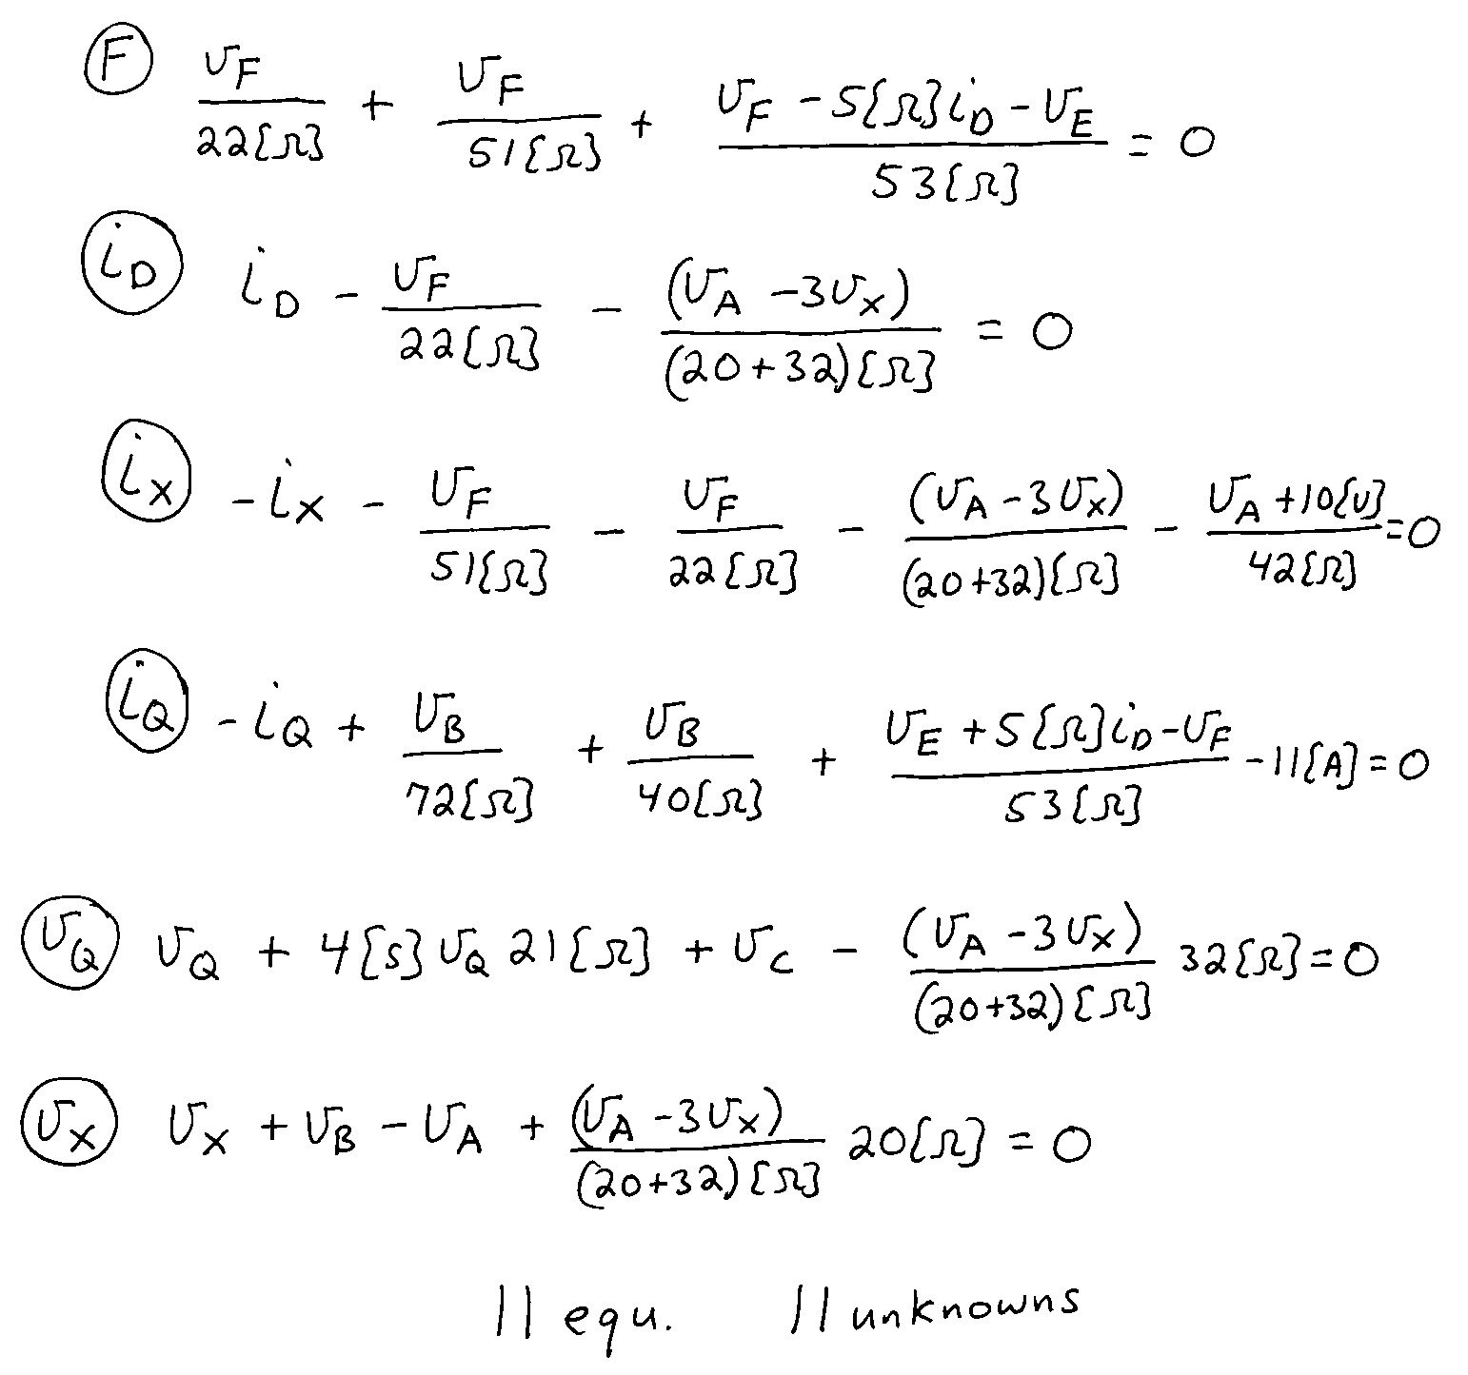

4. {20 Points} Use the circuit shown below to solve for the numerical values of the quantities requested.
- Find the Thévenin equivalent as seen by the i_{S1} current source. Draw the equivalent, showing the numerical values of all components, and attach the i_{S1} current source.
- Find the energy delivered by the i_{S1} current source in this circuit during a 3.27[ms] time period.
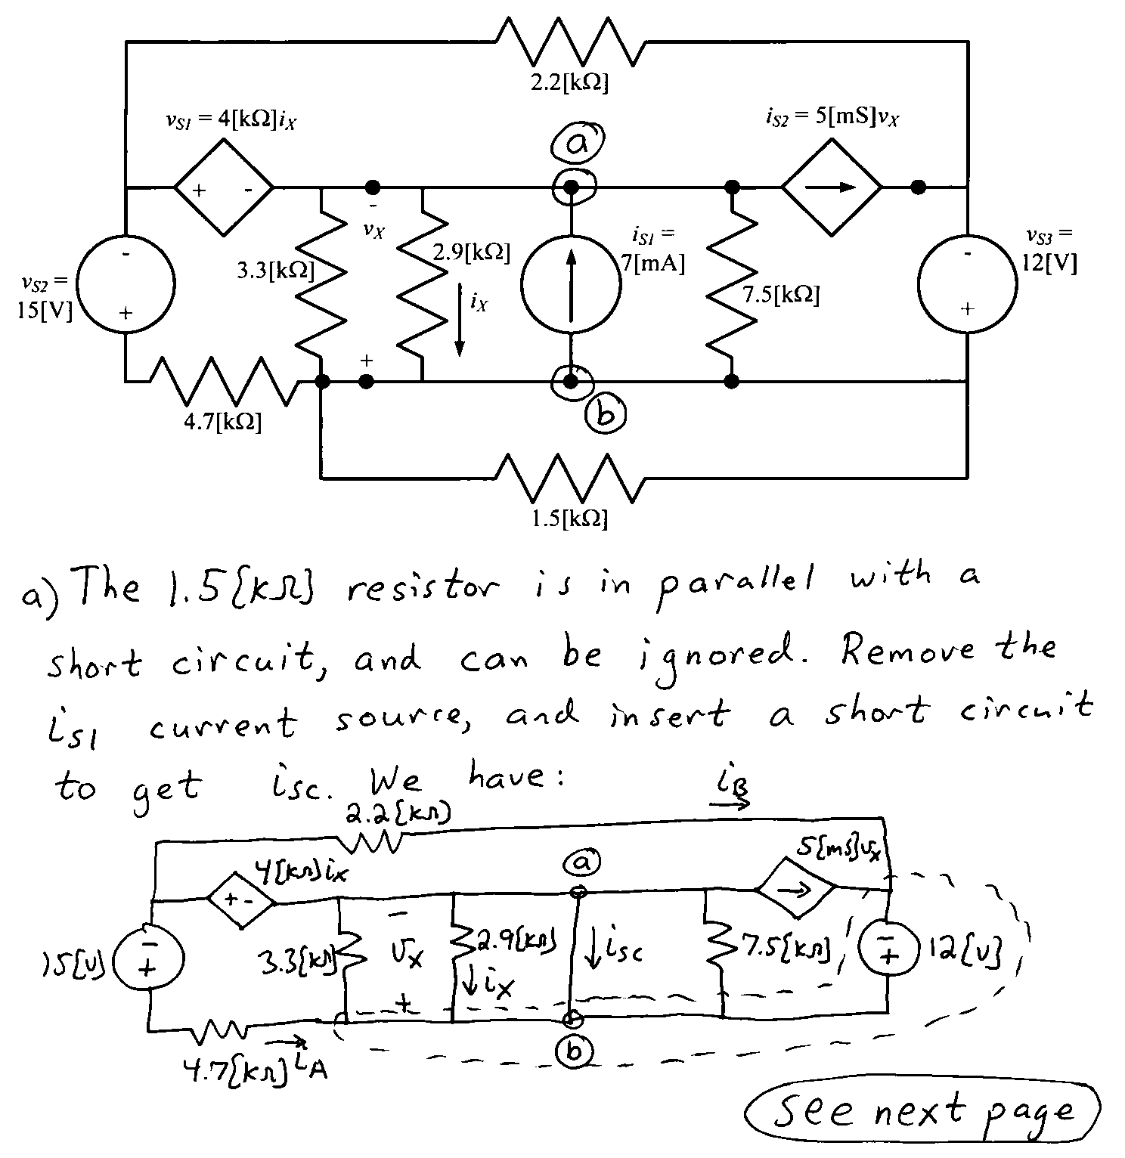

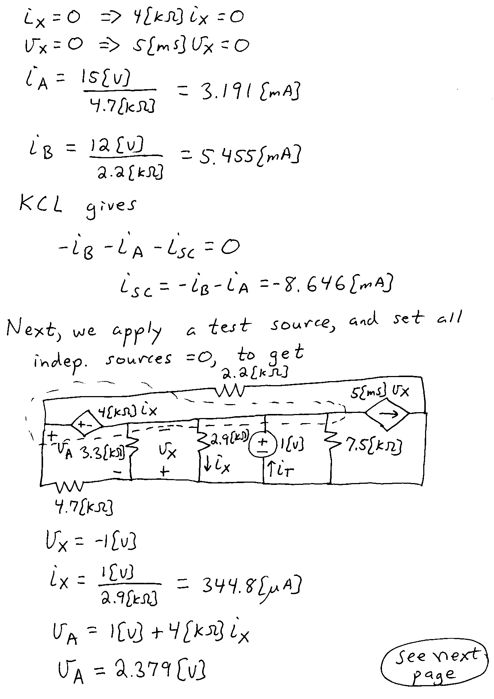
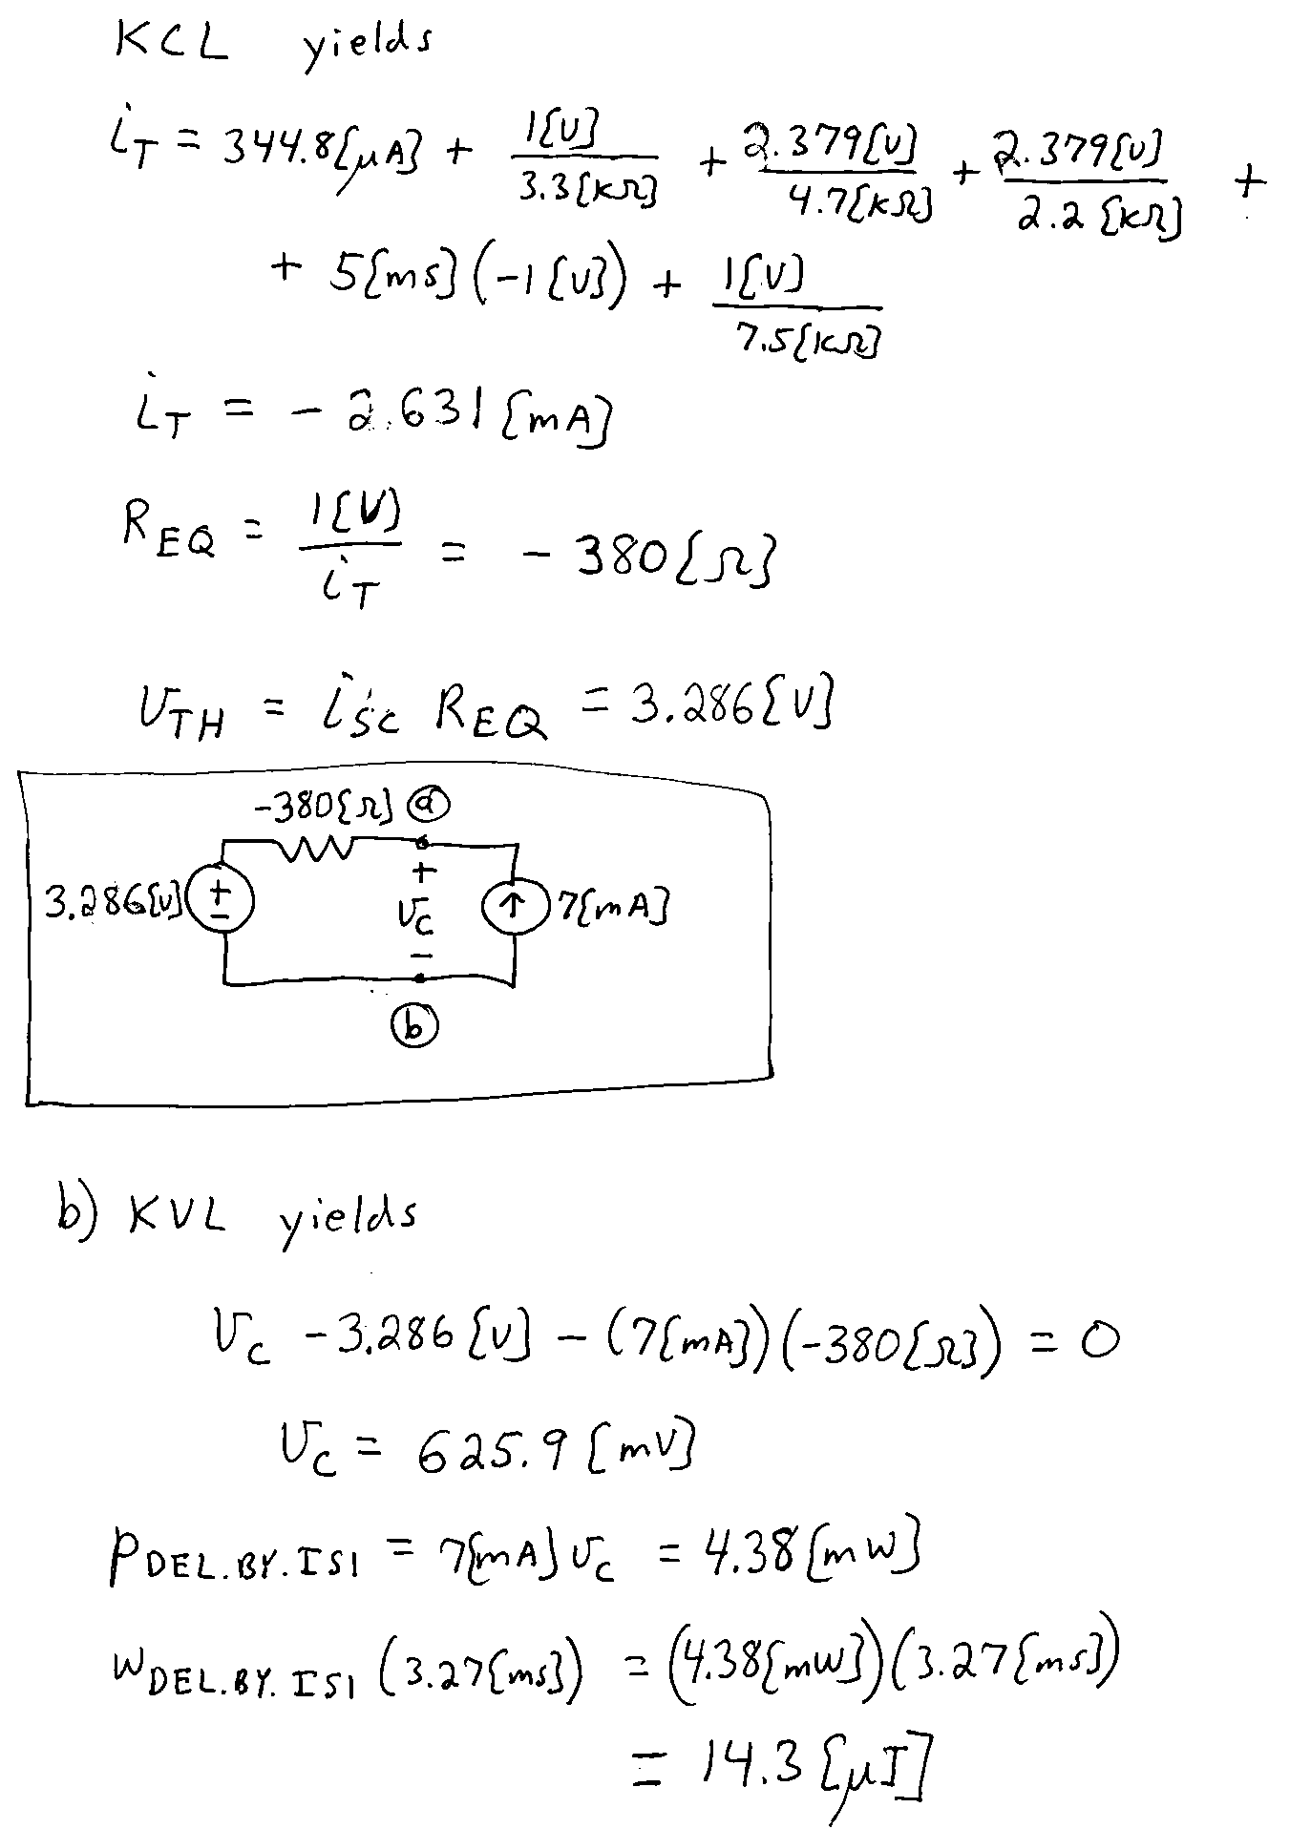

5. {20 Points} The circuit shown had been in steady-state until the switch closed at t = 0. Then for a time after that, the circuit was not in steady state.
a) Find the value for the energy stored in the 2[H] inductor a long time after the switch closed.
b) Find an expression for energy stored in the capacitor a long time after the switch closed.
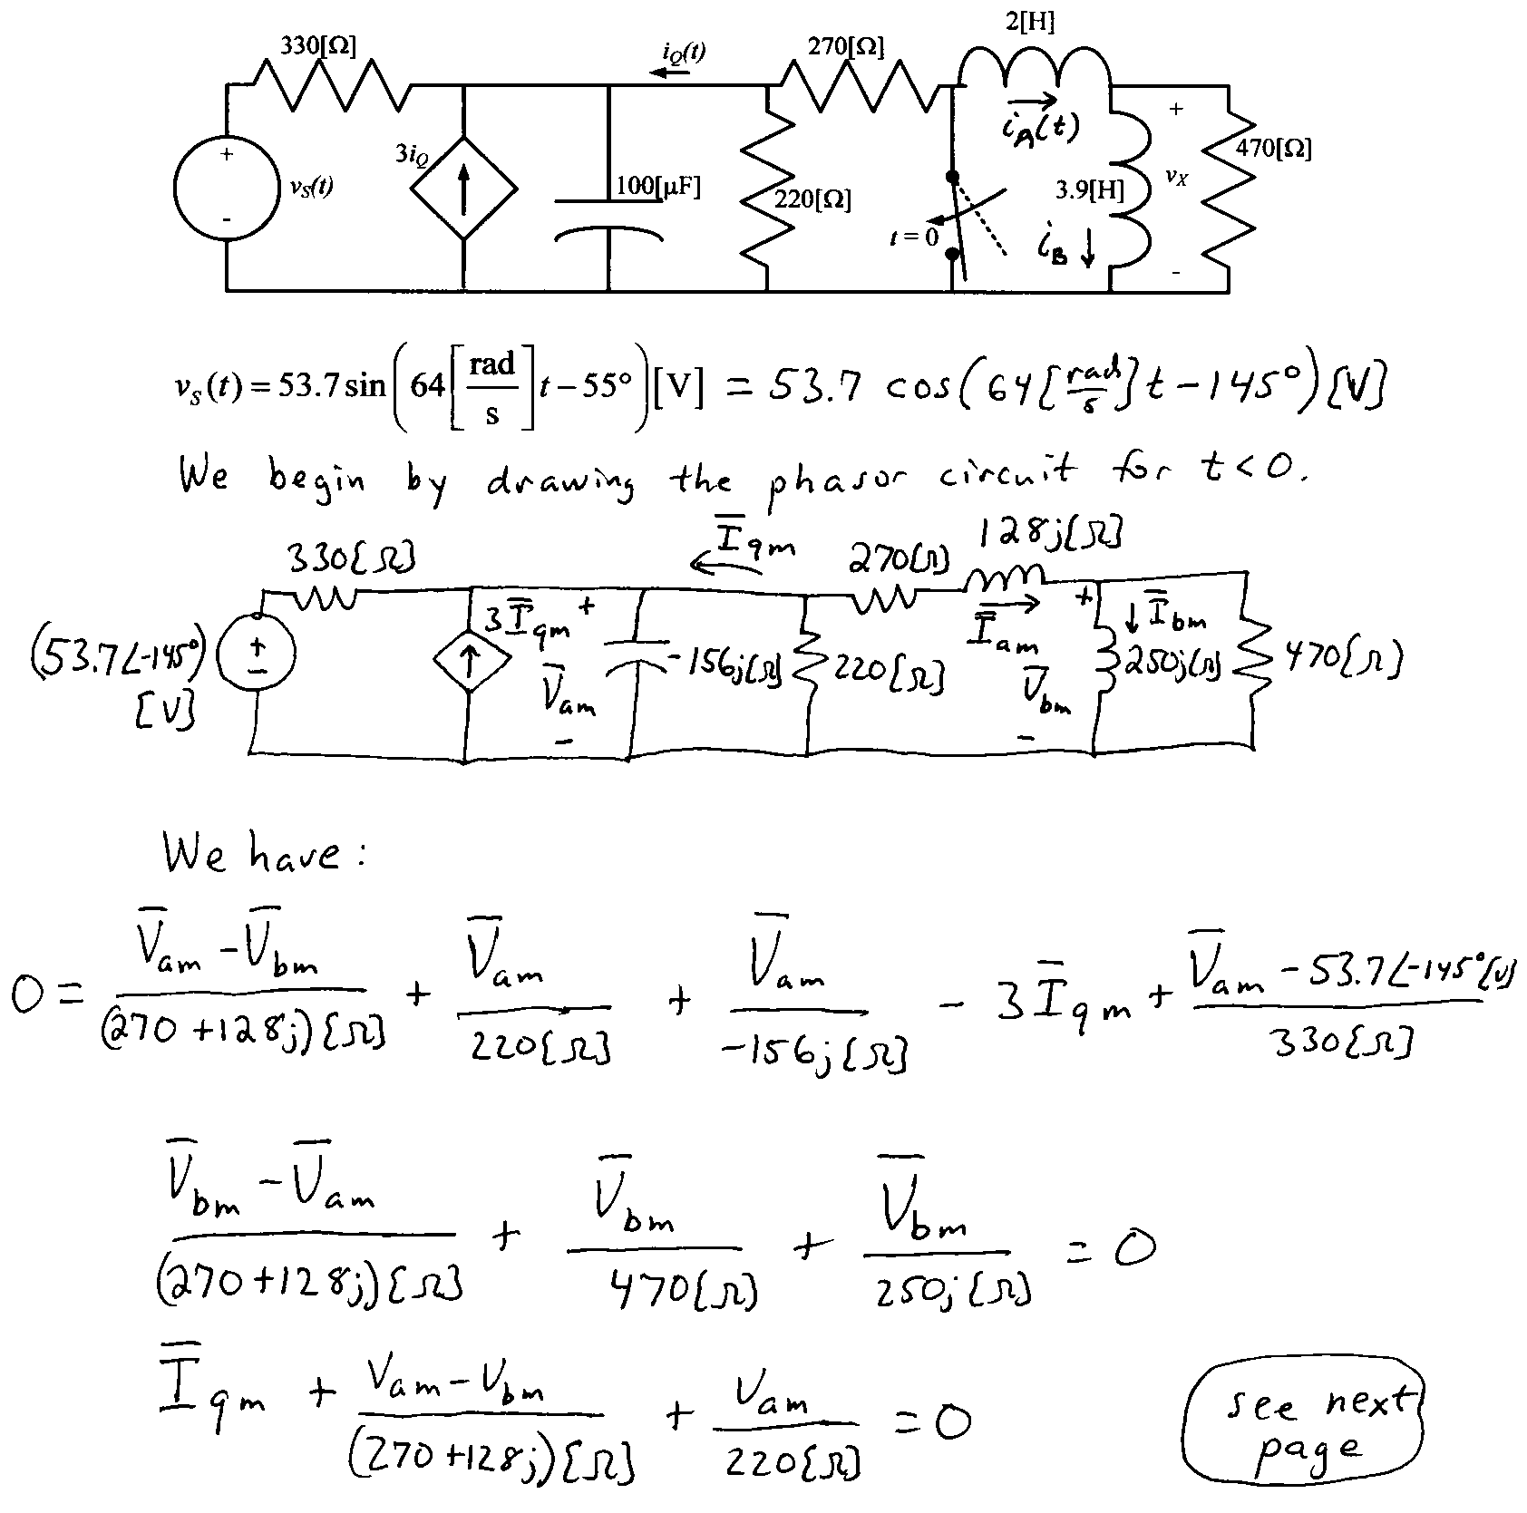
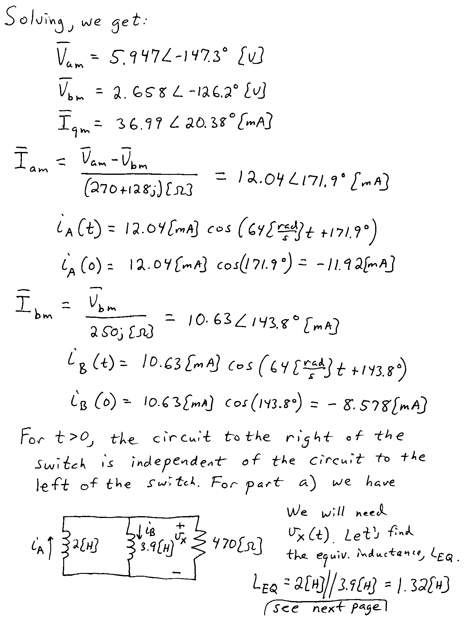
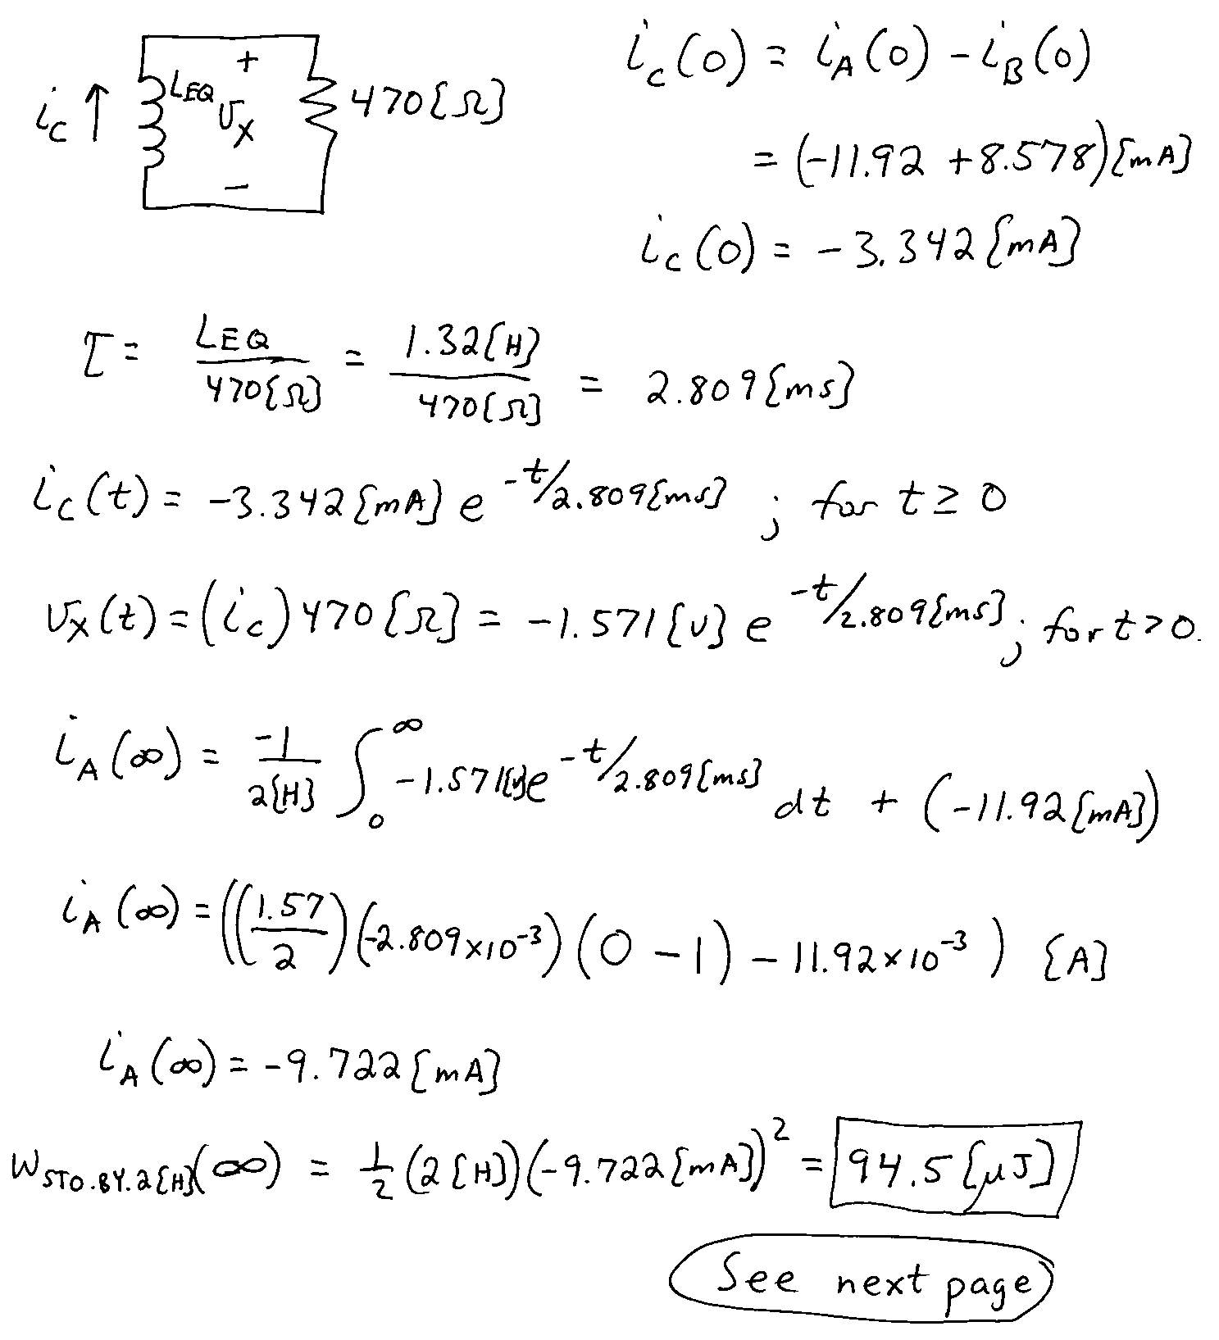
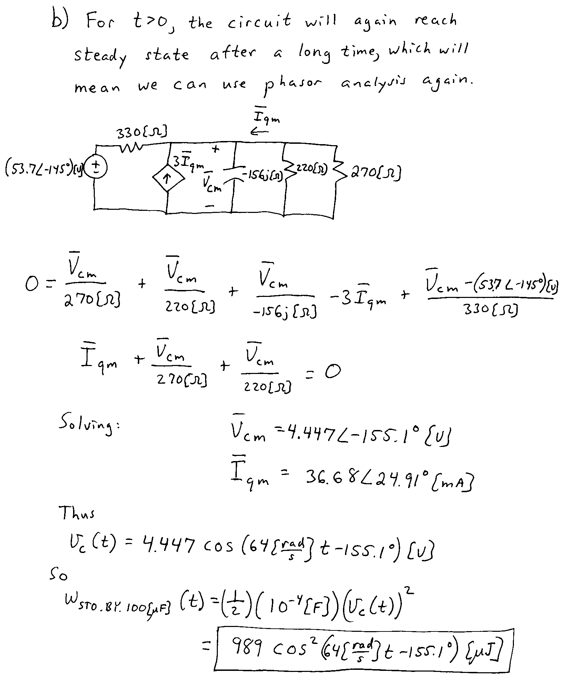
6. {20 Points} The circuit shown below is operating in steady state. The load absorbs (3950∠34°)[VA]. The voltage source delivers 6400[VAR].
a) Find all the possible values for R_{A}.
b) Find the average power delivered by the source.
