Name: _____________________________ (please print)
Signature: __________________________

ECE 2300 – Final Exam
December 11, 2010
Keep this exam closed until you are told to begin.

1. This exam is closed book, closed notes. You may use one 8.5” x 11” crib sheet, or its equivalent.
2. Show all work on these pages. Show all work necessary to complete the problem. A solution without the appropriate work shown will receive no credit. A solution that is not given in a reasonable order will lose credit. Clearly indicate your answer (for example by enclosing it in a box).
3. It is assumed that your work will begin on the same page as the problem statement. If you choose to begin your work on another page, you must indicate this on the page with the problem statement, with a clear indication of where the work can be found. If your work continues on to another page, indicate clearly where your work can be found. Failure to indicate this clearly will result in a loss of credit.
4. Show all units in solutions, intermediate results, and figures. Units in the exam will be included between square brackets.
5. Do not use red ink. Do not use red pencil.
6. You will have 170 minutes to work on this exam.

1. ________________/15
2. ________________/15
3. ________________/15
4. ________________/15
5. ________________/15
6. ________________/20
7. ________________/15
8. ________________/20
Total = 130
Room for extra work
1. {15 Points} For the circuit shown below, v₁ = 10[V], v₂ = 12[V], i_{G} = 6[mA], i_{M} = 24[mA], R₁ = 200[Ω], R₂ = 1[kΩ], and R₃ = 3[kΩ]. Find the value of the voltage at point A with respect to point B, when switch K is
a) open.
b) closed.

Room for extra work

2. {15 Points} For the circuit shown below, R_{B} = 80[Ω] and R_{P} = 5[Ω]. A meter is connected between points A and B to measure current through the wire between A and B, and measures a current i_{M} = 12.5[mA]. The meter resistance is R_{M} = 1[Ω]. Find the following:
a) Current through resistor R_{P} before the meter is connected to the circuit.
b) Relative error of the current measurement.
c) Power delivered by any of the resistors R_{B}, before the meter is connected to the circuit.
d) Power delivered by any of the resistors R_{B}, after the meter is connected to the circuit.

Room for extra work

3. {15 Points} For the given circuit, use the node-voltage method to write a complete set of independent equations that could be used to solve this circuit. Do not simplify the circuit. Do not attempt to solve or simplify your equations. Define all variables.

Room for extra work

4. {15 Points} For the given circuit, use the mesh-current method to write a complete set of independent equations that could be used to solve this circuit. Do not simplify the circuit. Do not attempt to solve or simplify your equations. Define all variables.

Room for extra work

5. {15 Points} A multi-range voltmeter is shown. Design a way to accurately measure voltages up to 550[V] by adding a resistor between the 100[V] terminal and the Common terminal. Give the resistor value and a brief description of how measurements would be made.

Room for extra work

6. {20 Points} In the figure below a circuit with capacitive elements is presented. The current source i_{O} is a constant current source. For the time domain t < 0, the switch B was closed and switches A and C were open, all of them for a long time. At t = 0, the switch B opens and stays open and switch A closes and stays closed. At t = 0.1[s] switch C closes and stays closed. Find the value of the resistance R_{X} for which the current i_{X} at t = 0.2[s] equals 1% of the current i_{O} supplied by the independent current source.

Room for extra work

7. {15 Points} For the circuit shown below the load is represented by a combination of inductors, capacitors, and resistors. If the power factor for this load has a numerical value of 0.5, find:
a) the value of the resistance R_{X}
b) the amplitude of the current i_{O}(t)
c) the average power for the load
d) the complex power for the load
e) the reactive power for the load
f) the real power for the load
g) the apparent power for the load
h) whether the power factor for this load is leading or lagging.

Room for extra work

8. {20 Points} The circuit shown below operates in steady-state. The load absorbs an average power of 1.5[kW]. The line absorbs a real power of 570[W]. The load also absorbs 2.7[kVAR].
a) Find all possible values for C_{X}.
b) Find all possible values for i_{X}(t).

1. {15 Points} For the circuit shown below, v₁ = 10[V], v₂ = 12[V], i_{G} = 6[mA], i_{M} = 24[mA], R₁ = 200[Ω], R₂ = 1[kΩ], and R₃ = 3[kΩ]. Find the value of the voltage at point A with respect to point B, when switch K is
a) open.
b) closed.

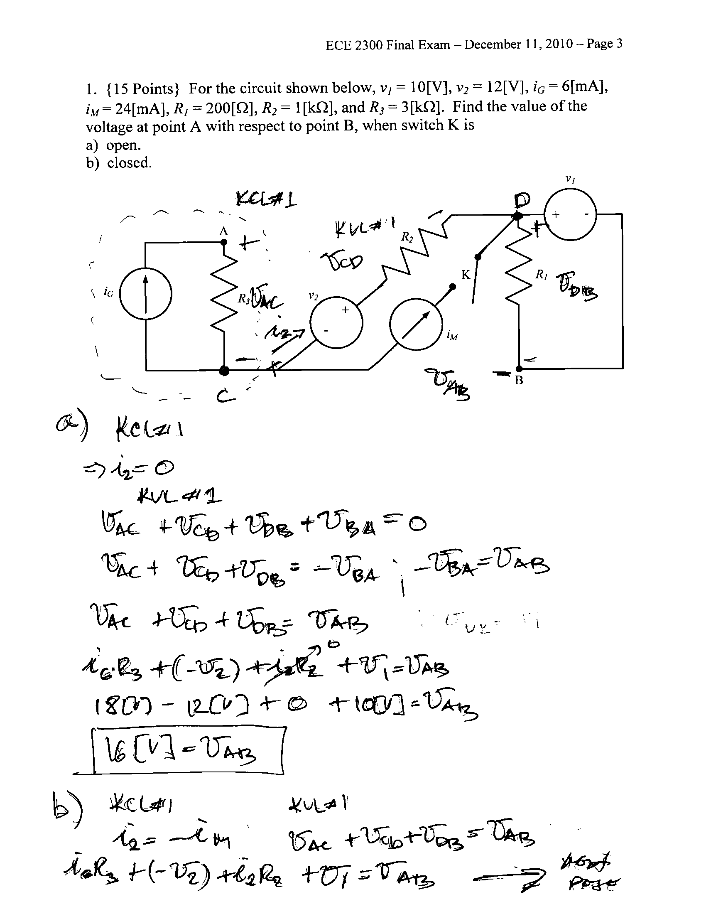

2. {15 Points} For the circuit shown below, R_{B} = 80[Ω] and R_{P} = 5[Ω]. A meter is connected between points A and B to measure current through the wire between A and B, and measures a current i_{M} = 12.5[mA]. The meter resistance is R_{M} = 1[Ω]. Find the following:
a) Current through resistor R_{P} before the meter is connected to the circuit.
b) Relative error of the current measurement.
c) Power delivered by any of the resistors R_{B}, before the meter is connected to the circuit.
d) Power delivered by any of the resistors R_{B}, after the meter is connected to the circuit.
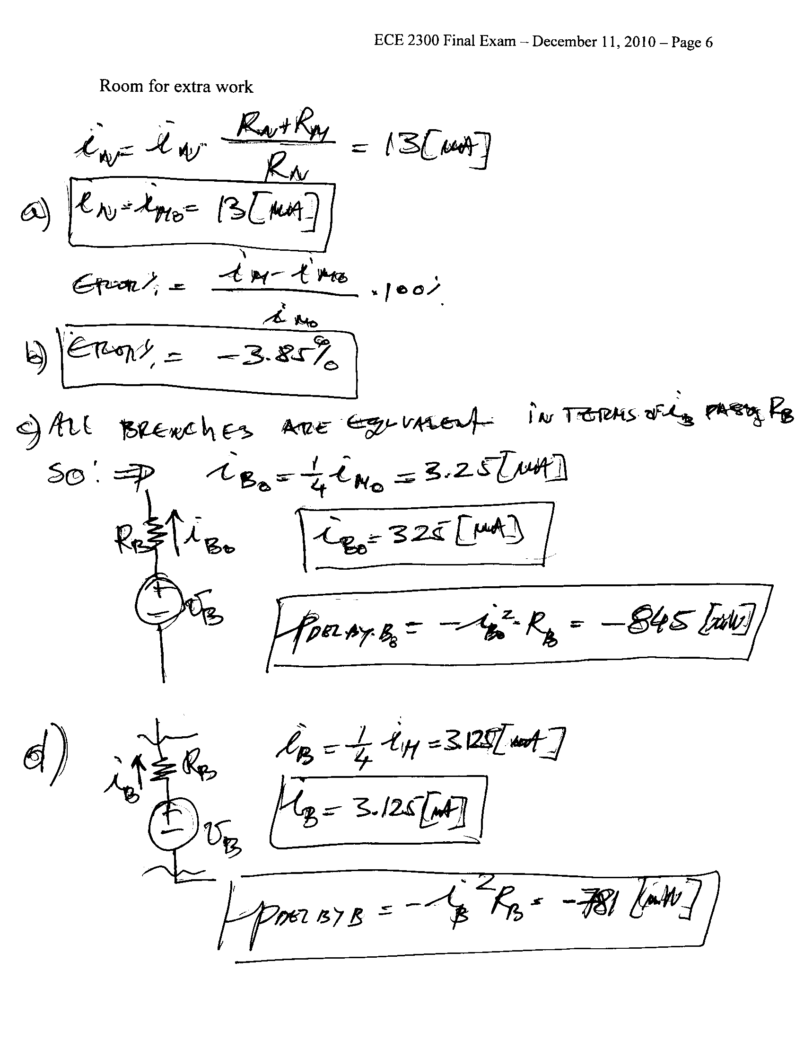
3. {15 Points} For the given circuit, use the node-voltage method to write a complete set of independent equations that could be used to solve this circuit. Do not simplify the circuit. Do not attempt to solve or simplify your equations. Define all variables.
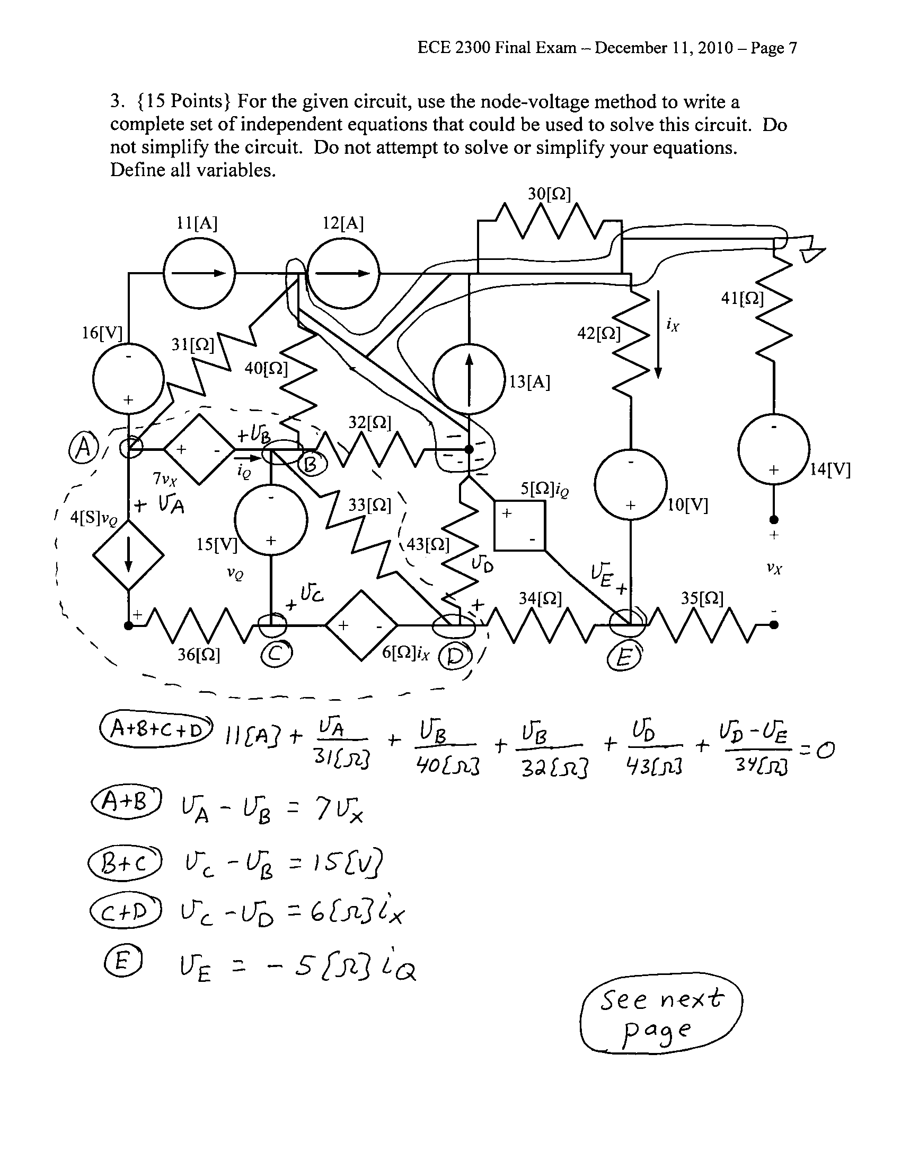
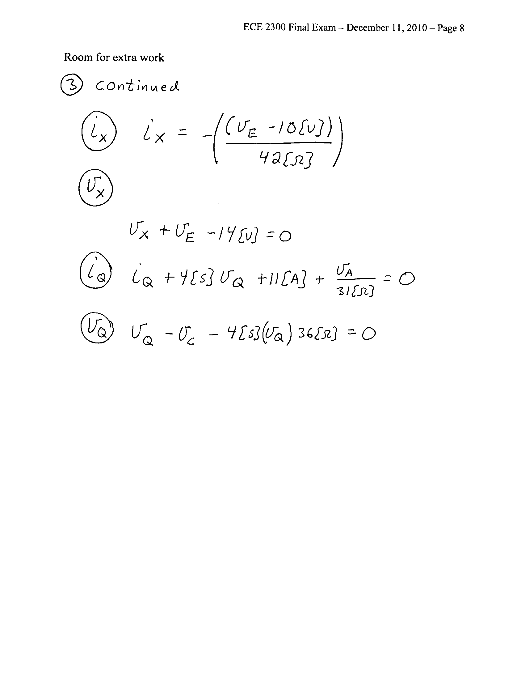

4. {15 Points} For the given circuit, use the mesh-current method to write a complete set of independent equations that could be used to solve this circuit. Do not simplify the circuit. Do not attempt to solve or simplify your equations. Define all variables.
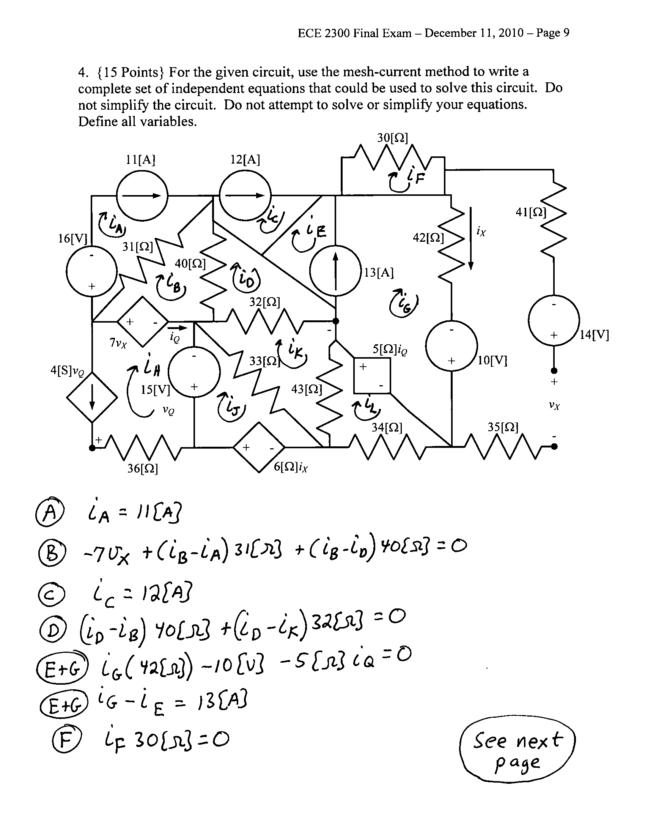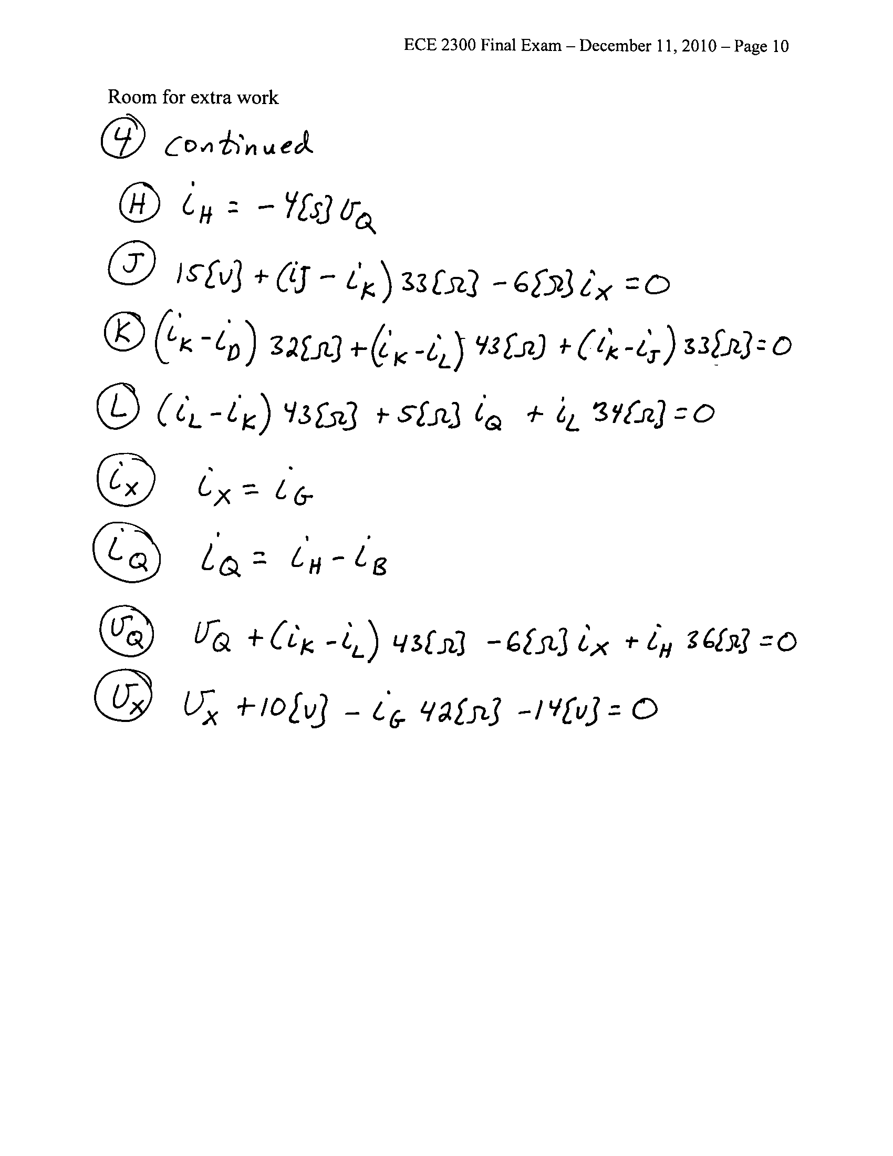
5. {15 Points} A multi-range voltmeter is shown. Design a way to accurately measure voltages up to 550[V] by adding a resistor between the 100[V] terminal and the Common terminal. Give the resistor value and a brief description of how measurements would be made.
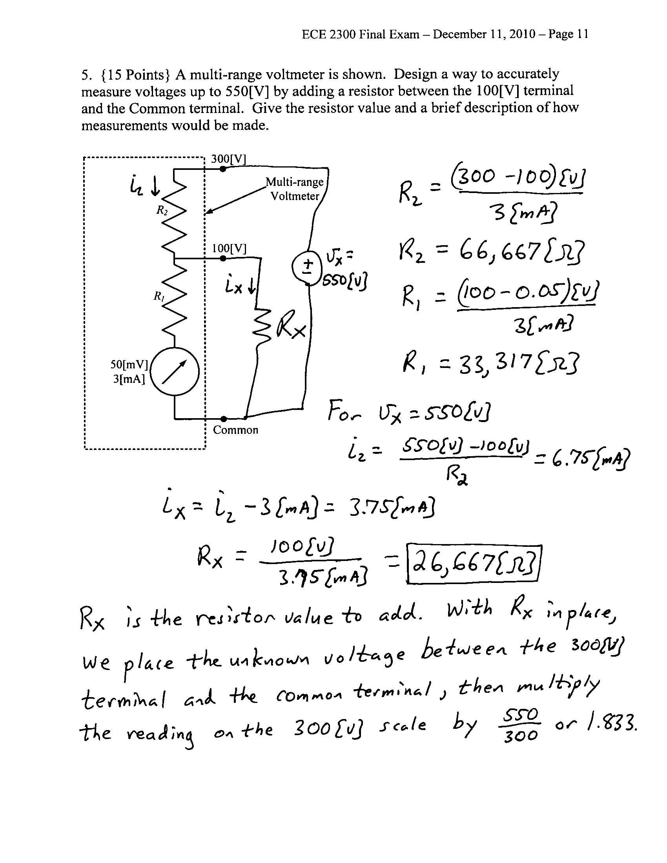

6. {20 Points} In the figure below a circuit with capacitive elements is presented. The current source i_{O} is a constant current source. For the time domain t < 0, the switch B was closed and switches A and C were open, all of them for a long time. At t = 0, the switch B opens and stays open and switch A closes and stays closed. At t = 0.1[s] switch C closes and stays closed. Find the value of the resistance R_{X} for which the current i_{X} at t = 0.2[s] equals 1% of the current i_{O} supplied by the independent current source.

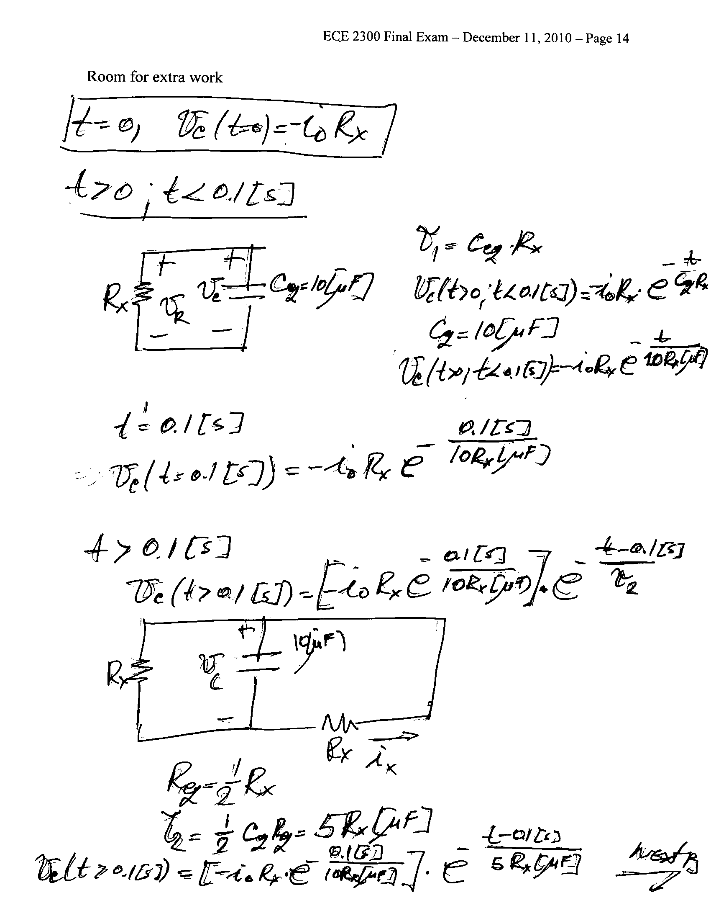
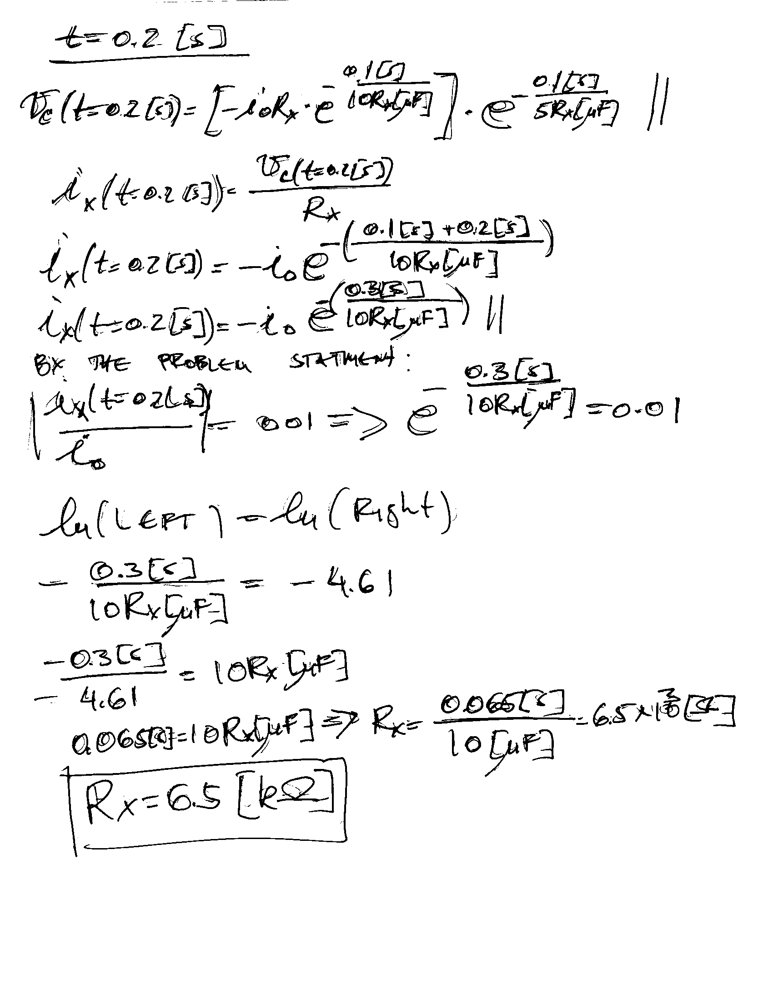
7. {15 Points} For the circuit shown below the load is represented by a combination of inductors, capacitors, and resistors. If the power factor for this load has a numerical value of 0.5, find:
a) the value of the resistance R_{X}
b) the amplitude of the current i_{O}(t)
c) the average power for the load
d) the complex power for the load
e) the reactive power for the load
f) the real power for the load
g) the apparent power for the load
h) whether the power factor for this load is leading or lagging.

See next page for solution
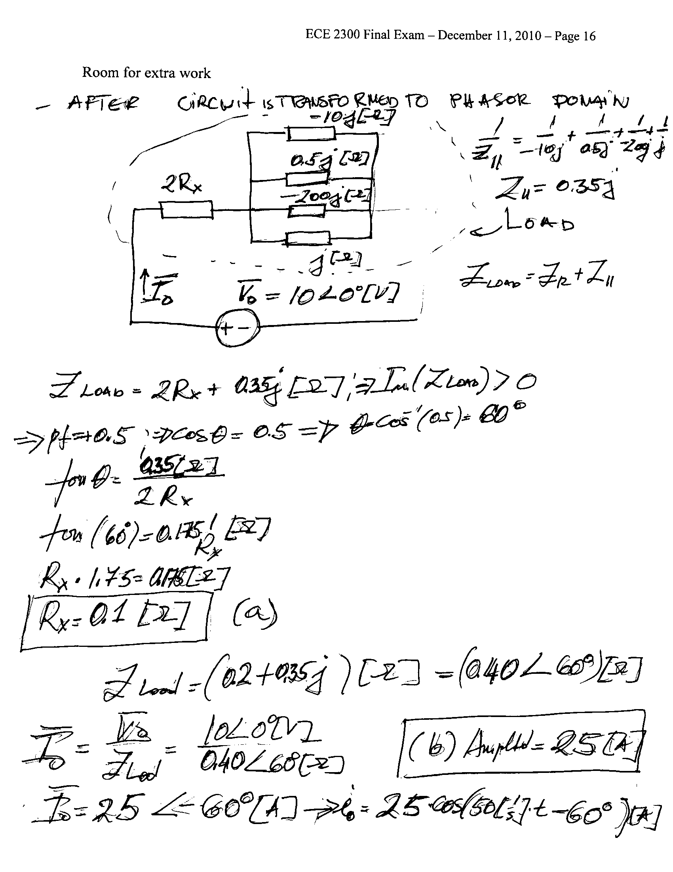
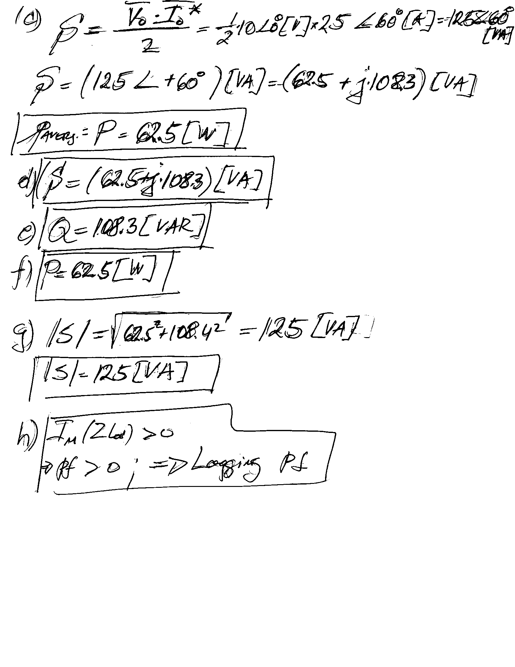
8. {20 Points} The circuit shown below operates in steady-state. The load absorbs an average power of 1.5[kW]. The line absorbs a real power of 570[W]. The load also absorbs 2.7[kVAR].
a) Find all possible values for C_{X}.
b) Find all possible values for i_{X}(t).
