Name: \_\_\_\_\_\_\_\_\_\_\_\_\_\_\_\_\_\_\_\_\_\_\_\_\_\_\_\_\_ (please print)

Signature: \_\_\_\_\_\_\_\_\_\_\_\_\_\_\_\_\_\_\_\_\_\_\_\_\_\_

ECE 2201 -- Exam #1

October 15, 2016

Keep this exam closed until you are told to begin.

1. This exam is closed book, closed notes. You may use one 8.5” x 11” crib sheet, or its equivalent.

2. Show all work on these pages. Show all work necessary to complete the problem. A solution without the appropriate work shown will receive no credit. A solution that is not given in a reasonable order will lose credit. Clearly indicate your answer (for example by enclosing it in a box).

3. It is assumed that your work will begin on the same page as the problem statement. If you choose to begin your work on another page, you must indicate this on the page with the problem statement, with a clear indication of where the work can be found. **If your work continues on to another page, indicate clearly where your work can be found. Failure to indicate this clearly will result in a loss of credit.**

4. Show all units in solutions, intermediate results, and figures. Units in the exam will be included between square brackets.

5. Do not use red ink. Do not use red pencil.

6. You will have 90 minutes to work on this exam.

1. \_\_\_\_\_\_\_\_\_\_\_\_\_\_\_\_/30

2. \_\_\_\_\_\_\_\_\_\_\_\_\_\_\_\_/35

3. \_\_\_\_\_\_\_\_\_\_\_\_\_\_\_\_/35

Total = 100

Room for extra work

1. {30 Points} Use the circuit shown below to solve this problem. Show your steps clearly. You are encouraged to redraw the circuit as needed.

a) Find the equivalent resistance as seen by terminals **B** and **H**.

b) Find the equivalent resistance as seen by terminals **A** and **F**.



# Room for extra work

2. {35 Points} In the circuit shown below, the power delivered by the dependent current source is given as 50[mW].

a) Find the value of **R**.

b) Find the power delivered by the dependent voltage source.

c) Are the electrons moving through the dependent voltage source gaining or losing energy?

C:\Users\gaksu\Desktop\2201 exam\exam1_1_2.emf

Room for extra work

3. {35 Points} A device can be modeled using a current source in parallel with a resistance. The device has two terminals, labeled A and B. This device was connected to a 500[V] voltage source, as shown in Figure 1, and a current of 5.65[mA] resulted. The same device was then connected to a 4[mA] current source as shown in Figure 2, and a voltage of -4087[V] resulted.

a) Find a model for the device, and draw it, labeling terminals A and B. Show on that diagram the numerical values of the components. b) Find the voltage if two identical versions of the device are connected as shown in Figure 3. Note that the terminals of the device, A and B, are connected in a particular way for all three figures.

 



Solutions:

1. {30 Points} Use the circuit shown below to solve this problem. Show your steps clearly. You are encouraged to redraw the circuit as needed.

a) Find the equivalent resistance as seen by terminals **B** and **H**.

b) Find the equivalent resistance as seen by terminals **A** and **F**.

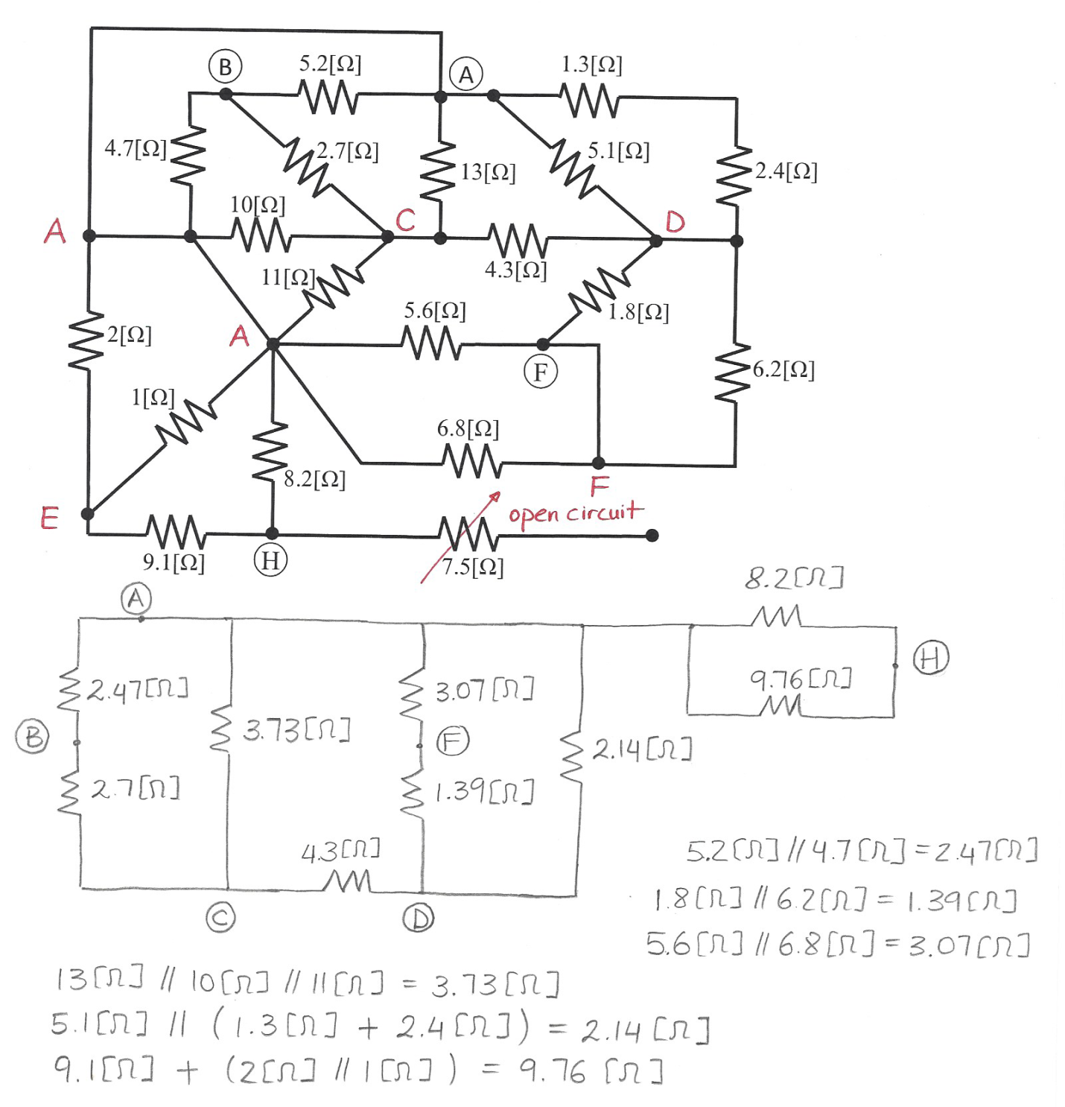

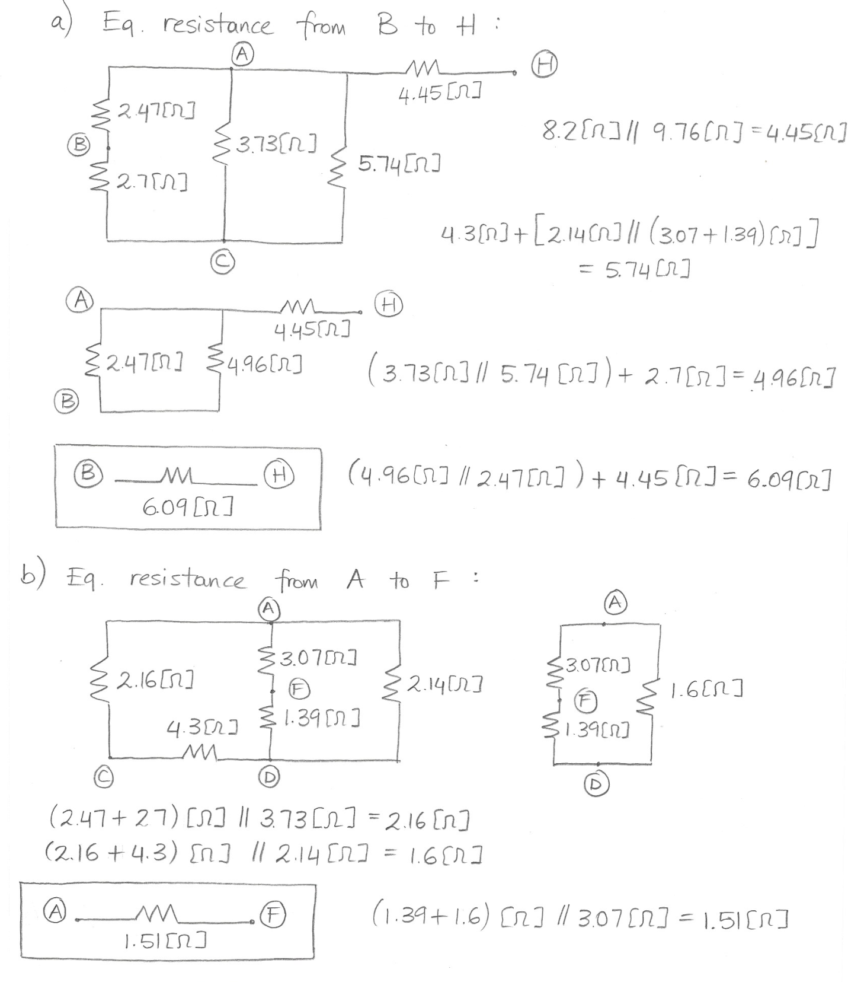

2. {35 Points} In the circuit shown below, the power delivered by the dependent current source is given as 50[mW].

a) Find the value of **R**.

b) Find the power delivered by the dependent voltage source.

c) Are the electrons moving through the dependent voltage source gaining or losing energy?

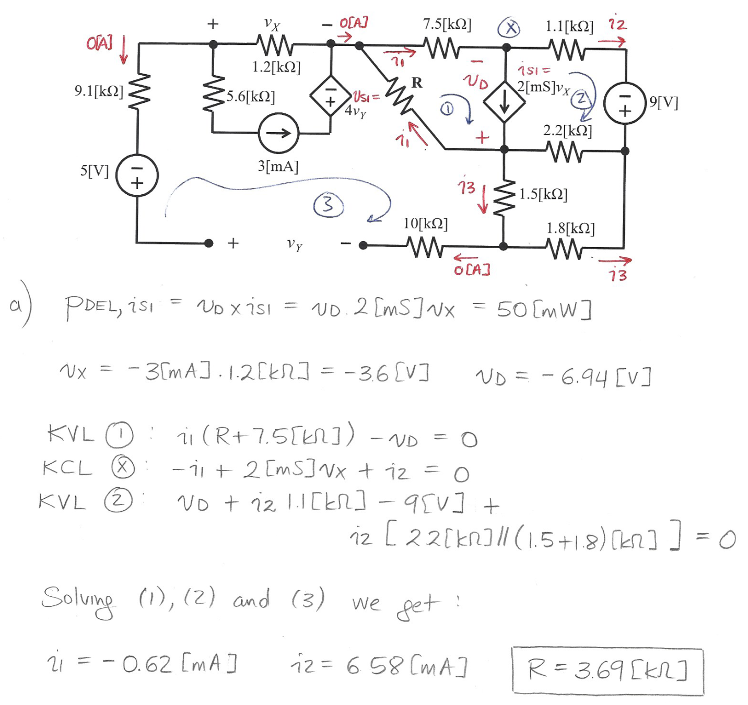

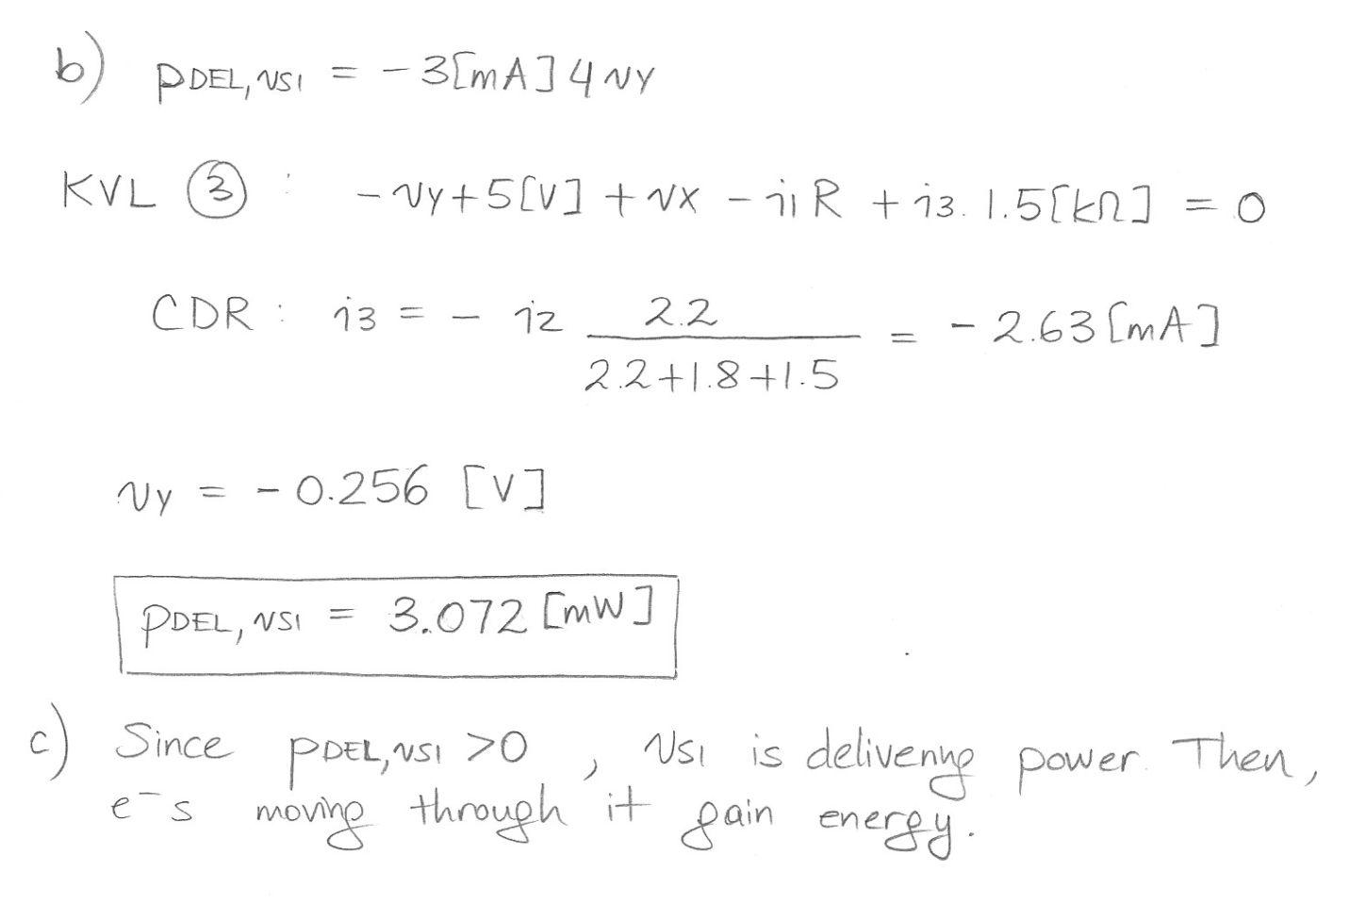

3. {35 Points} A device can be modeled using a current source in parallel with a resistance. The device has two terminals, labeled A and B. This device was connected to a 500[V] voltage source, as shown in Figure 1, and a current of 5.65[mA] resulted. The same device was then connected to a 4[mA] current source as shown in Figure 2, and a voltage of -4087[V] resulted.

a) Find a model for the device, and draw it, labeling terminals A and B. Show on that diagram the numerical values of the components.

b) Find the voltage if two identical versions of the device are connected as shown in Figure 3. Note that the terminals of the device, A and B, are connected in a particular way for all three figures.

 





