Name: _____________________________ (please print)
Signature: __________________________

ECE 2201 -- Exam # 2
November 12, 2016

Keep this exam closed until you are told to begin.

1. This exam is closed book, closed notes. You may use one 8.5” x 11” crib sheet, or its equivalent.
2. Show all work on these pages. Show all work necessary to complete the problem. A solution without the appropriate work shown will receive no credit. A solution that is not given in a reasonable order will lose credit. Clearly indicate your answer (for example by enclosing it in a box).
3. It is assumed that your work will begin on the same page as the problem statement. If you choose to begin your work on another page, you must indicate this on the page with the problem statement, with a clear indication of where the work can be found. If your work continues on to another page, indicate clearly where your work can be found. Failure to indicate this clearly will result in a loss of credit.
4. Show all units in solutions, intermediate results, and figures. Units in the exam will be included between square brackets.
5. Do not use red ink. Do not use red pencil.
6. You will have 90 minutes to work on this exam.

1. ________________/30
2. ________________/30
3. ________________/40
Total = 100
Room for extra work
1. {30 Points} Use the Mesh-current method to write a complete set of equations that could be used to solve the circuit below. Do not attempt to simplify the circuit. Do not attempt to simplify or solve the equations. Define all variables.

Room for extra work

2. {30 Points Use the Node-voltage method to write a complete set of equations that could be used to solve the circuit below. Do not attempt to simplify the circuit. Do not attempt to simplify or solve the equations. Define all variables.

Room for extra work
3. {40 Points} A device can be modeled as a current source in parallel with a resistance with terminals A and B. When that device is connected to the circuit shown in Figure 1, i_{M} is measured to be 4.8[mA]. Then the same device is connected to the circuit shown in Figure 2 and v_{M} is measured to be 12[V].

a) Find a model for this device and draw the model showing terminals A and B.
b) Three identical versions of the device are connected as shown in Figure 3 and a current i_{X} of 12[mA] resulted. Find R_{X}.
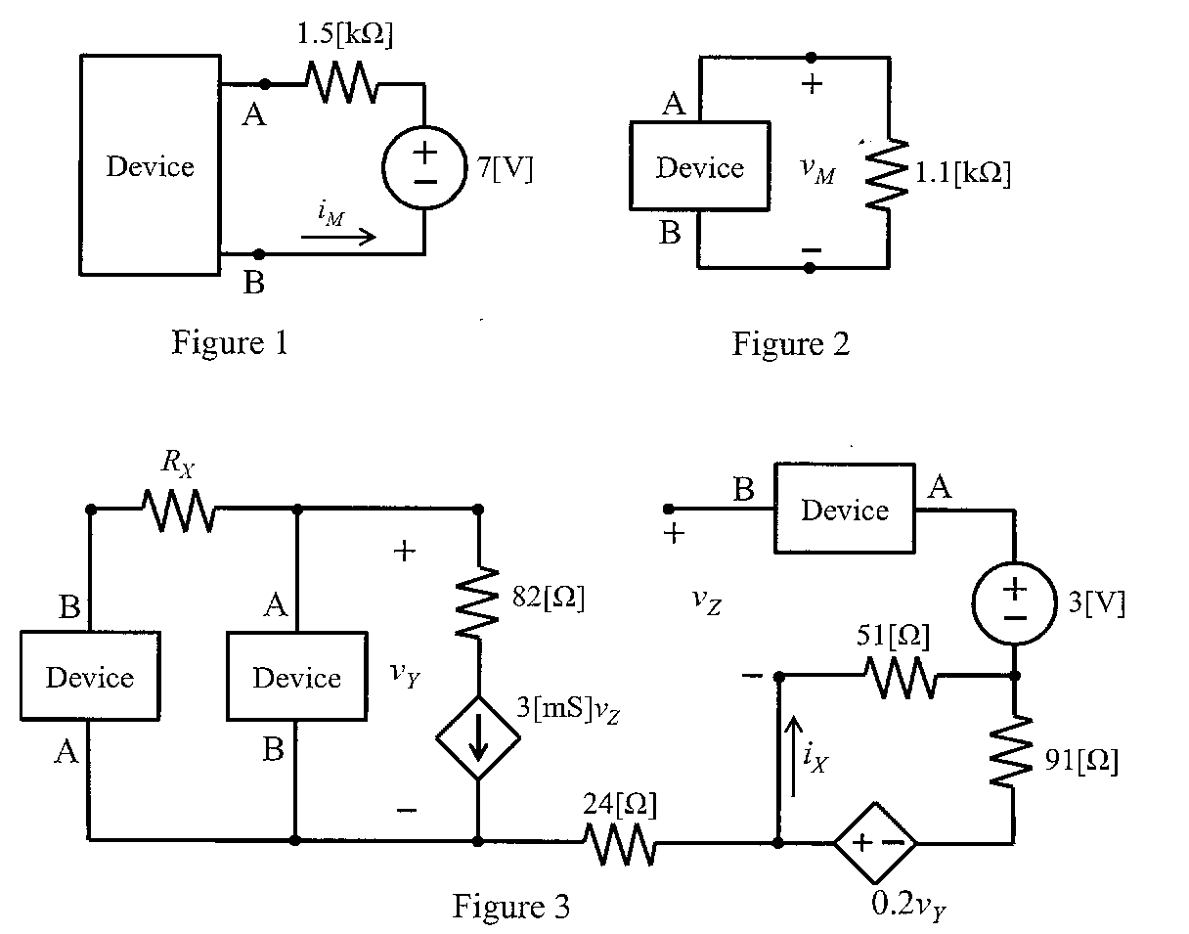

Room for extra work

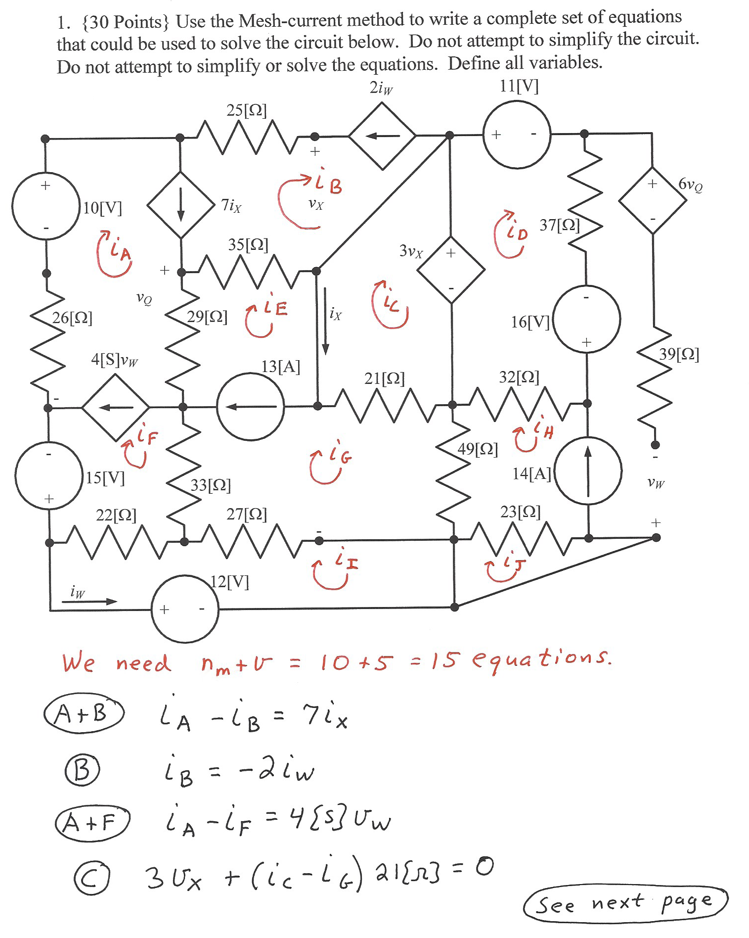
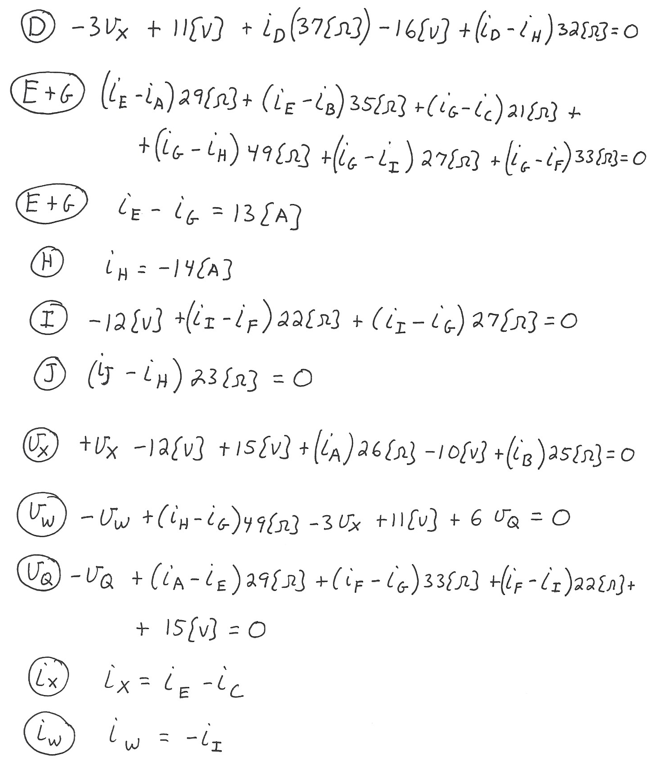

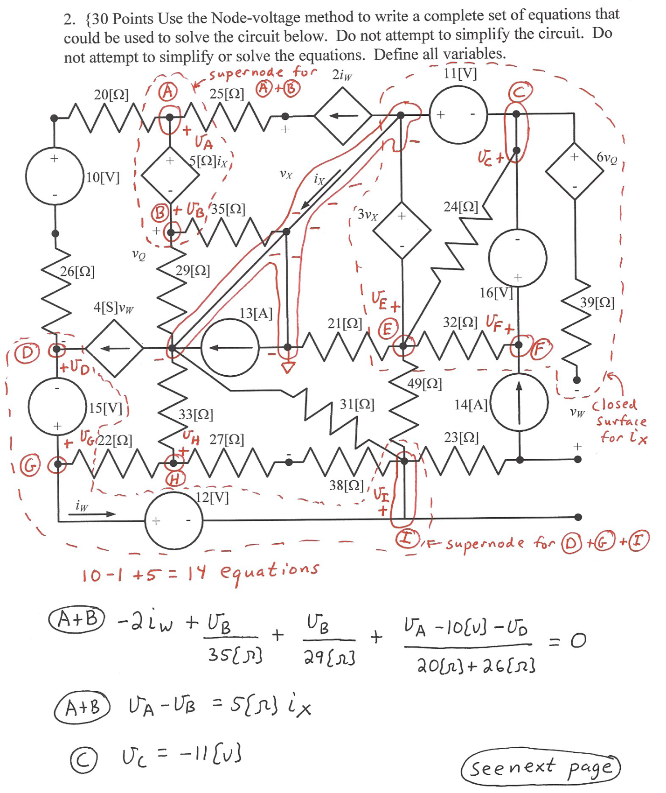
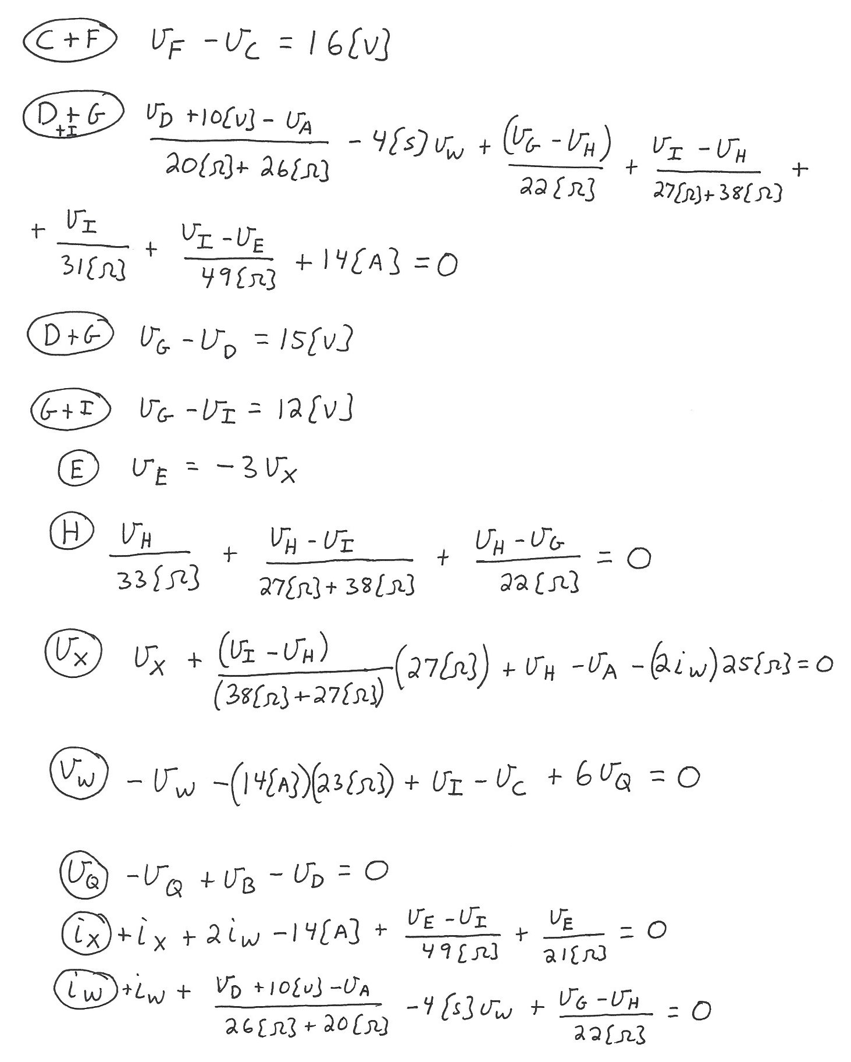

3. {40 Points} A device can be modeled as a current source in parallel with a resistance with terminals A and B. When that device is connected to the circuit shown in Figure 1, i_{M} is measured to be 4.8[mA]. Then the same device is connected to the circuit shown in Figure 2 and v_{M} is measured to be 12[V].
a) Find a model for this device and draw the model showing terminals A and B.
b) Three identical versions of the device are connected as shown in Figure 3 and a current i_{X} of 12[mA] resulted. Find R_{X}.
