Name: ____________________________ (please print)
Signature: __________________________

ECE 2201 – Exam 1
October 7, 2023

Keep this exam closed and face up until you are told to begin.

- This exam is closed book, closed notes. You may use any calculator. You may not use a cell phone, tablet computer, nor laptop computer. You may have a crib sheet in the form of one 8 ½” x 11” piece of paper, with material written on both sides.
- Print your name, and provide your signature above.
- Show all work on these pages. Show all work necessary to complete the problem. A solution without the appropriate work shown will receive no credit. A solution which is not given in a reasonable order will lose credit. You may separate the pages as you work.
- Show all units in solutions, intermediate results, and figures. Units in the exam will be included between square brackets.
- If the grader has difficulty following your work because it is messy or disorganized, you will lose credit.
- Do not use red ink. Do not use red pencil.
- You will have 90 minutes to work on this exam.

1. ________________/30
2. ________________/40
3. ________________/30
Total = 100

Room for extra work

1. (30 points) A device is shown in Figure 1. The charge carriers are electrons. The voltage, v_{X}(t) for 0 ≤ t ≤ 5[s] across the device, and the current i_{X}(t) for
0 ≤ t ≤ 5[s] through the device, are shown in Figures 2 and 3 respectively.
- Plot the power delivered by the device for the time interval 0 ≤ t ≤ 5[s]. Label your axes, showing the scale and units.
- Find the energy delivered by the device in the time interval 0 ≤ t ≤ 5[s].
- Determine the time intervals during which electrons gain energy and those time intervals during which they lose energy as they pass through the device. Consider only the time period 0 ≤ t ≤ 5[s].

Room for extra work

2. (40 points) Use the circuit shown below to solve. The charge carriers are electrons.

- Find v_{B}.
- Find the power delivered by the 7.8[V] voltage source.
- Which way are the electrons moving through the 7.8[V] voltage source? Your answer should be either “from bottom to top”, or “from top to bottom”. Explain your answer briefly, using complete sentences.

Room for extra work

3. (30 points) Two circuits are shown below. In your work, show your steps clearly enough so that a well-prepared ECE 2201 student would be able to follow what you did. Redraw the circuit diagram as needed.
- Find the equivalent resistance as seen from terminals A and B of the circuit in Figure 1.
- Terminal C of Figure 2 is connected to terminal A of Figure 1, and terminal D of Figure 2 is connected to terminal B of Figure 1. Find the current i₁ for this combined circuit.
- What is the power delivered by the circuit in Figure 2 when it is connected to the circuit in Figure 1 as described in part b)?

Solutions:
1. (30 points) A device is shown in Figure 1. The charge carriers are electrons. The voltage, v_{X}(t) for 0 ≤ t ≤ 5[s] across the device, and the current i_{X}(t) for
0 ≤ t ≤ 5[s] through the device, are shown in Figures 2 and 3 respectively.
- Plot the power delivered by the device for the time interval 0 ≤ t ≤ 5[s]. Label your axes, showing the scale and units.
- Find the energy delivered by the device in the time interval 0 ≤ t ≤ 5[s].
- Determine the time intervals during which electrons gain energy and those time intervals during which they lose energy as they pass through the device. Consider only the time period 0 ≤ t ≤ 5[s].

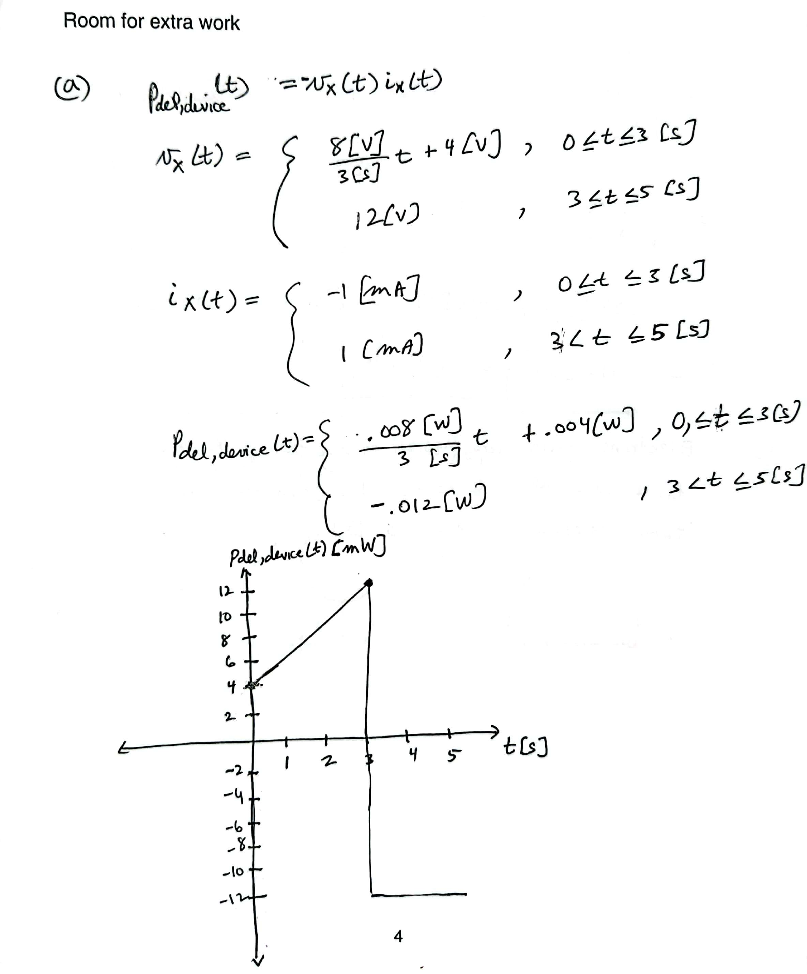
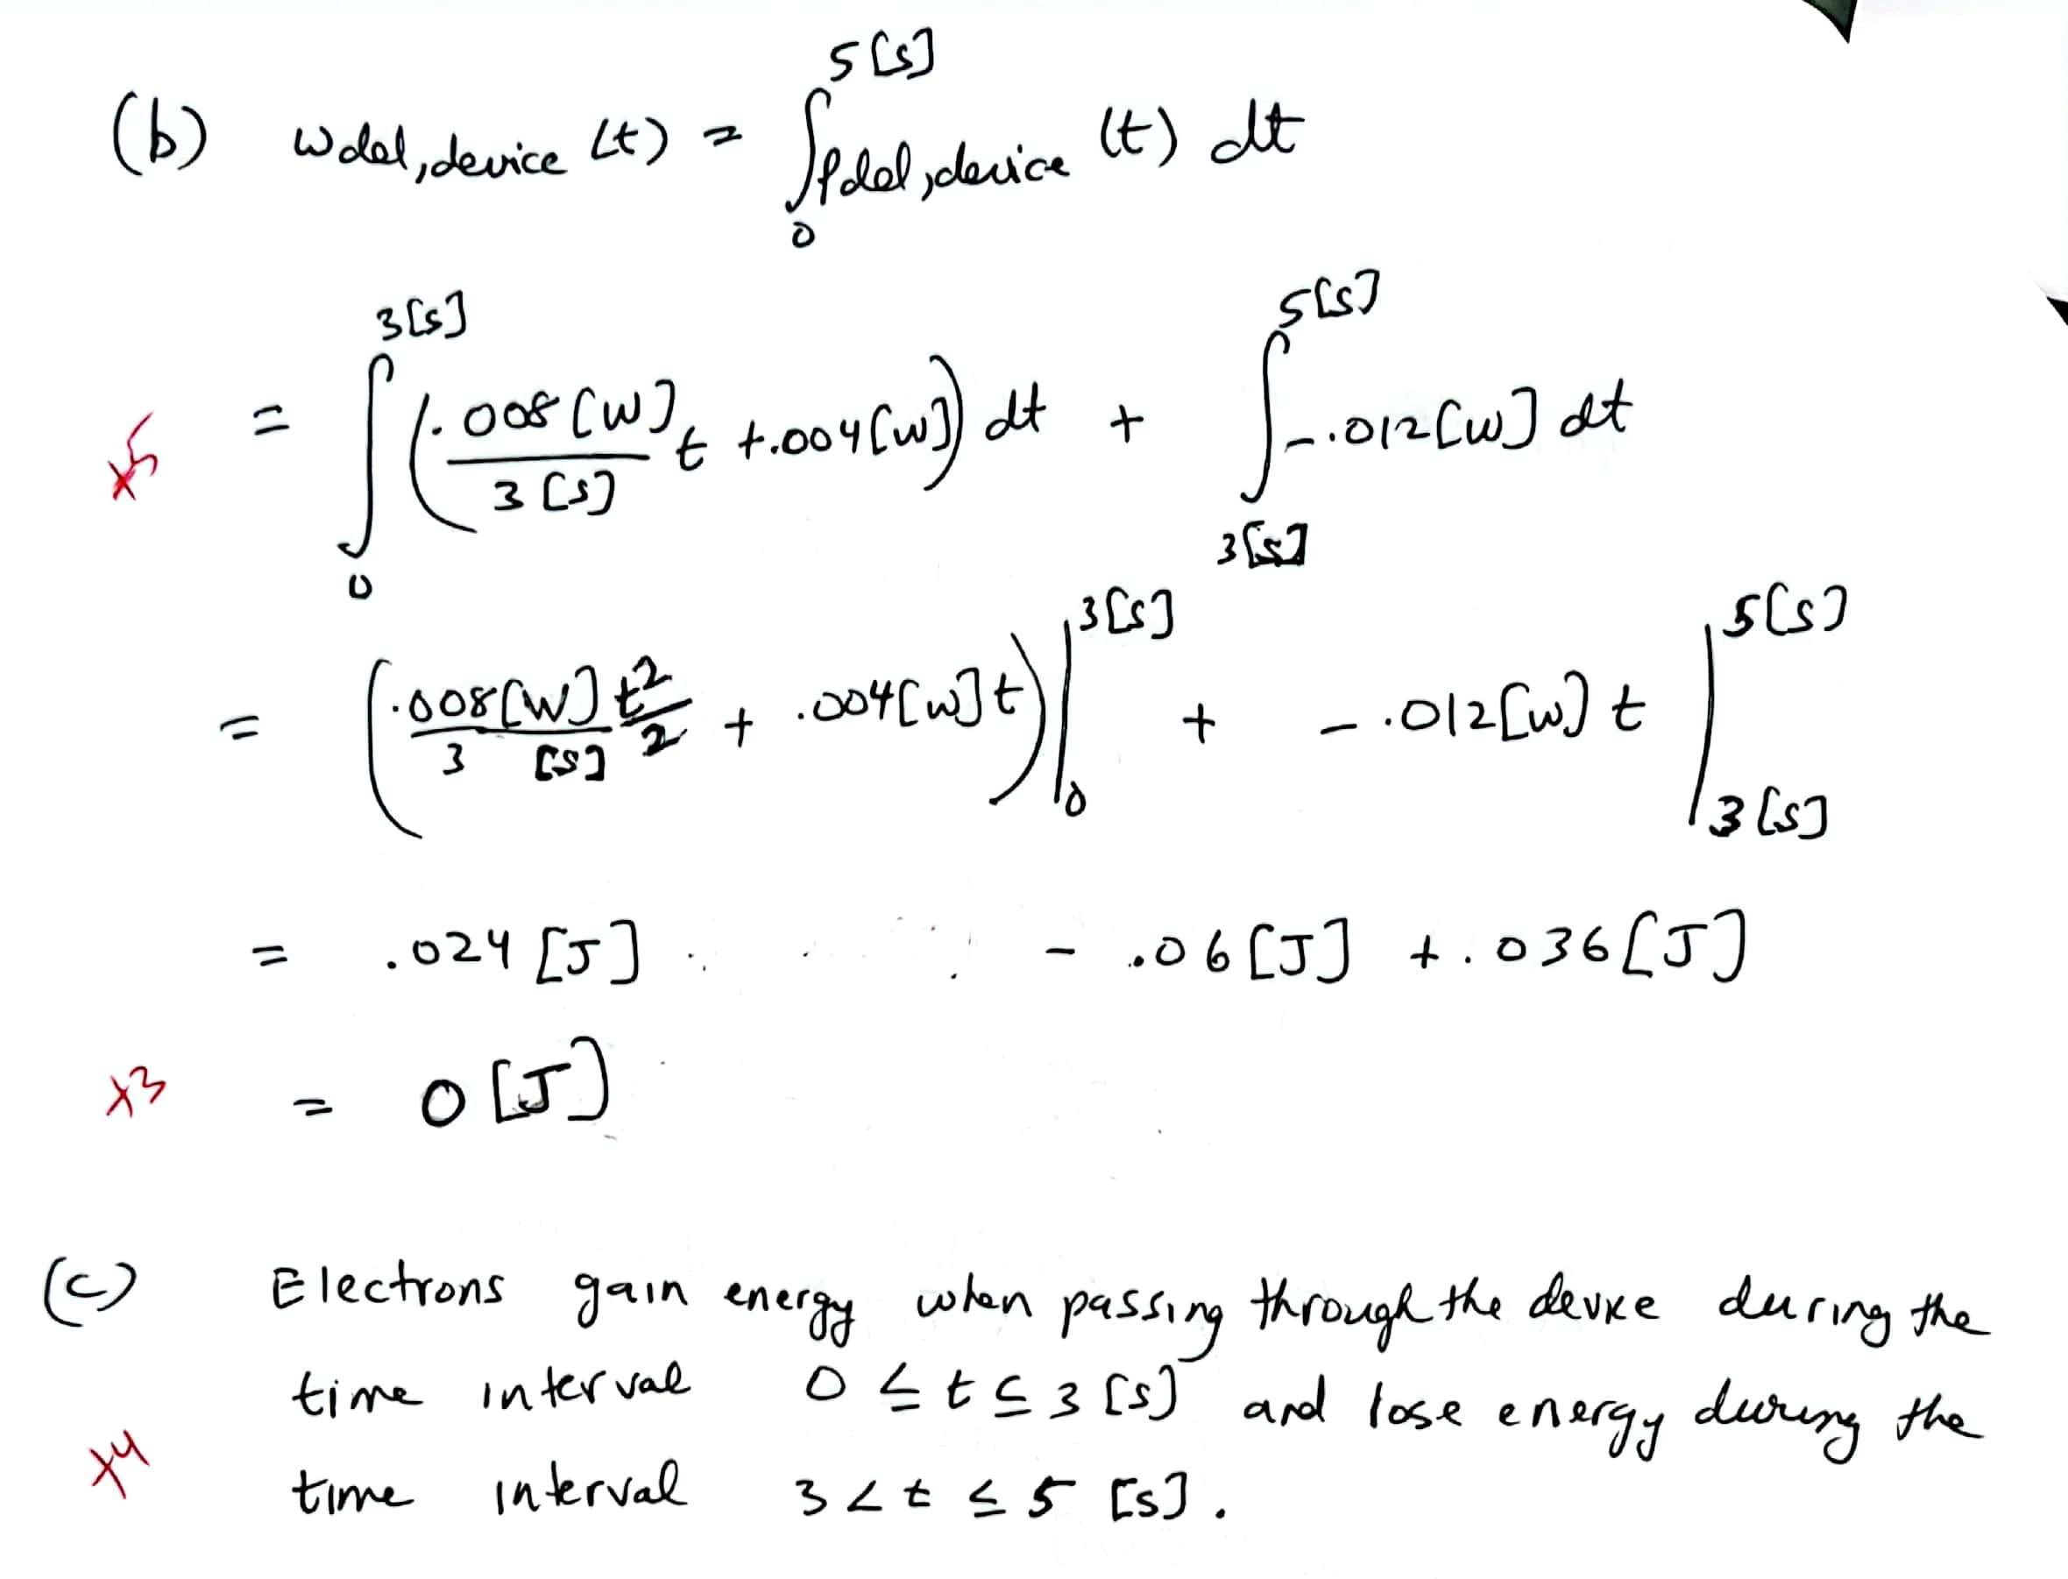

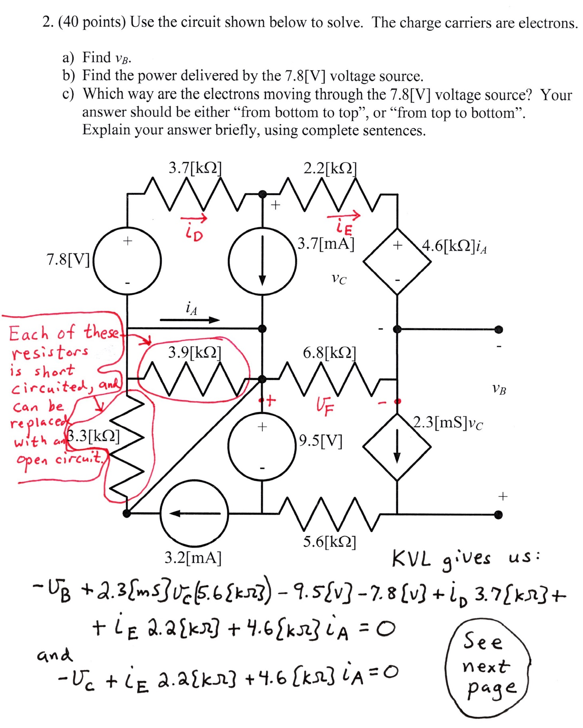
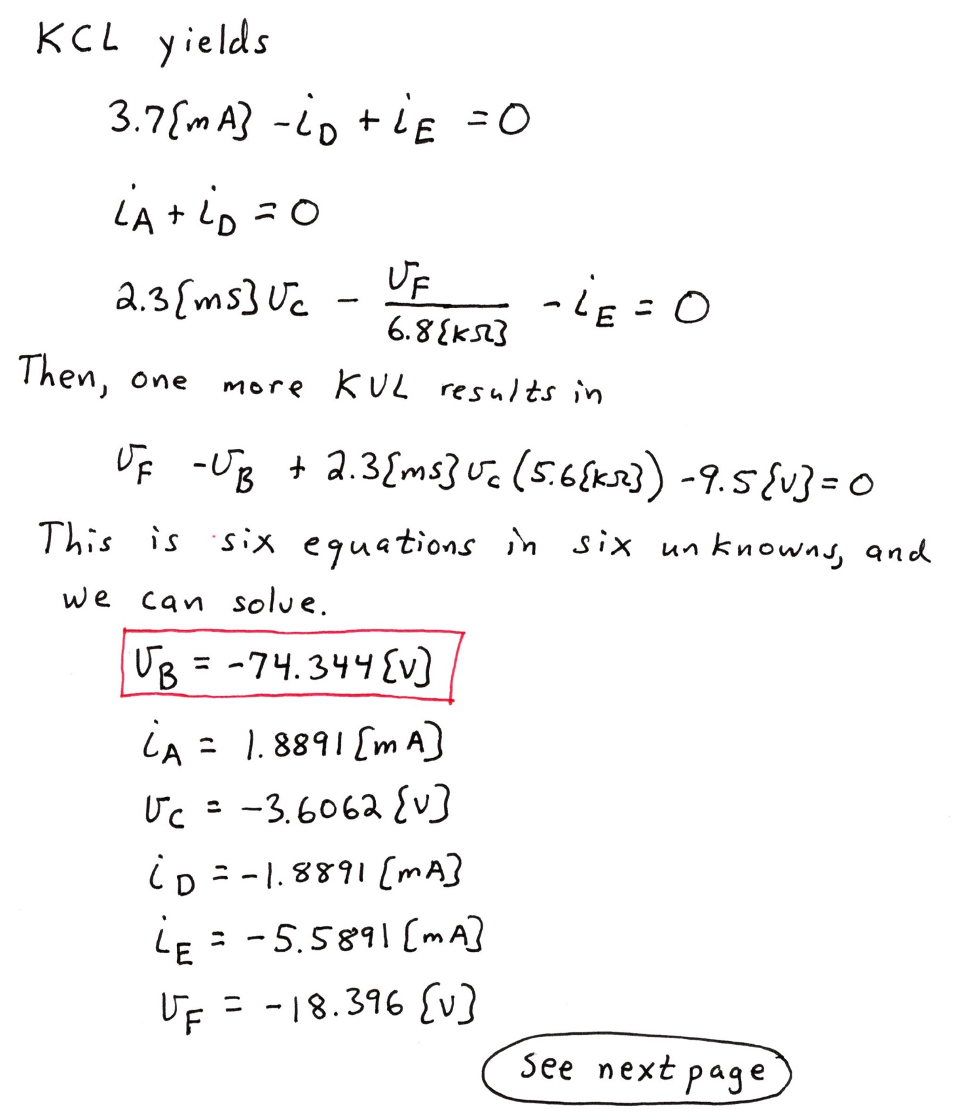

3. (30 points) Two circuits are shown below. In your work, show your steps clearly enough so that a well-prepared ECE 2201 student would be able to follow what you did. Redraw the circuit diagram as needed.
- Find the equivalent resistance as seen from terminals A and B of the circuit in Figure 1.
- Terminal C of Figure 2 is connected to terminal A of Figure 1, and terminal D of Figure 2 is connected to terminal B of Figure 1. Find the current i₁ for this combined circuit.
- What is the power delivered by the circuit in Figure 2 when it is connected to the circuit in Figure 1 as described in part b)?

