Name: ____________________________ (please print)
Signature: __________________________

ECE 2201 – Exam 2
November 4, 2023

Keep this exam closed and face up until you are told to begin.

- This exam is closed book, closed notes. You may use any calculator. You may not use a cell phone, tablet computer, nor laptop computer. You may have a crib sheet in the form of one 8 ½” x 11” piece of paper, with material written on both sides.
- Print your name, and provide your signature above.
- Show all work on these pages. Show all work necessary to complete the problem. A solution without the appropriate work shown will receive no credit. A solution which is not given in a reasonable order will lose credit. You may separate the pages as you work.
- Show all units in solutions, intermediate results, and figures. Units in the exam will be included between square brackets.
- If the grader has difficulty following your work because it is messy or disorganized, you will lose credit.
- Do not use red ink. Do not use red pencil.
- You will have 90 minutes to work on this exam.

1. ________________/40
2. ________________/35
3. ________________/25
Total = 100
Room for extra work
1. (40 points) Device 1, shown in Figure 1, can be modeled as a voltage source in series with a resistance. Device 2, shown in Figure 2, can be modeled as a current source in parallel with a resistance.
- Device 1 is connected to a 120[Ω] resistor (Figure 3A) and current i_{t1} is measured to be 3[A]. Then Device 1 is connected to a 310[V] voltage source (Figure 3B) and the power absorbed by the 310[V] voltage source is measured to be 1240[W]. Find the model for Device 1 and draw a circuit diagram of Device 1 with clear labels.
- The same test is performed on Device 2 to find its model. In other words, Device 2 is connected to a 120[Ω] resistor (Figure 3A) and current i_{t2} is measured to be 1[A]. Then Device 2 is connected to a 310[V] voltage source (Figure 3B) and the power absorbed by the 310[V] voltage source is measured to be -200[W]. Find the model for Device 2 and draw a circuit diagram of Device 2 with clear labels.
- Both devices are used to create the circuit shown in Figure 4. Find the power delivered by the 60[V] voltage source using any circuit analysis method you like.
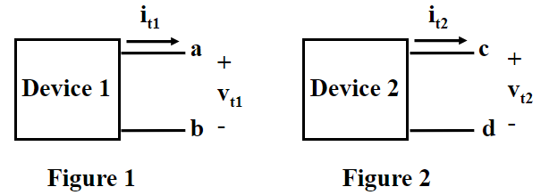
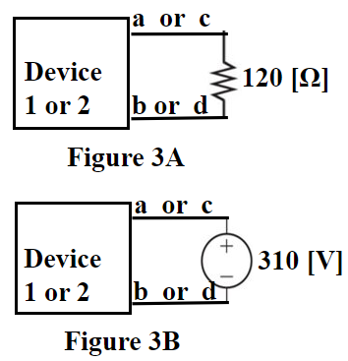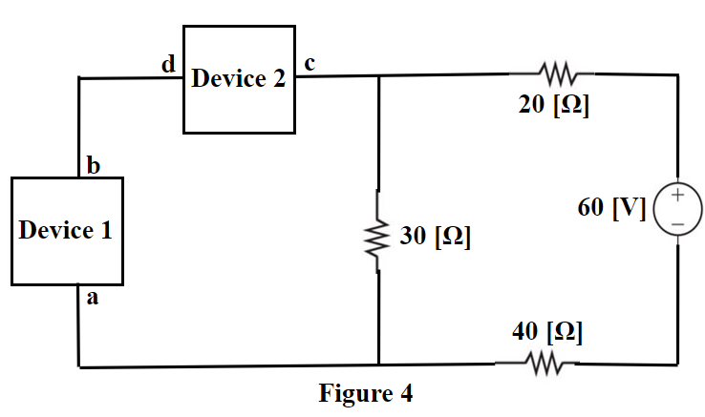

Room for extra work

Room for extra work

2. (35 points) Use the node-voltage method to write a complete set of equations that could be used to solve this circuit. Do not simplify the circuit. Do not attempt to solve or simplify your equations. Define all variables appropriately.

Room for extra work

3. (25 points) Use the mesh-current method to write a complete set of equations that could be used to solve this circuit. Do not simplify the circuit. Do not attempt to solve or simplify your equations. Define all variables appropriately.

1. (40 points) Device 1, shown in Figure 1, can be modeled as a voltage source in series with a resistance. Device 2, shown in Figure 2, can be modeled as a current source in parallel with a resistance.
- Device 1 is connected to a 120[Ω] resistor (Figure 3A) and current i_{t1} is measured to be 3[A]. Then Device 1 is connected to a 310[V] voltage source (Figure 3B) and the power absorbed by the 310[V] voltage source is measured to be 1240[W]. Find the model for Device 1 and draw a circuit diagram of Device 1 with clear labels.
- The same test is performed on Device 2 to find its model. In other words, Device 2 is connected to a 120[Ω] resistor (Figure 3A) and current i_{t2} is measured to be 1[A]. Then Device 2 is connected to a 310[V] voltage source (Figure 3B) and the power absorbed by the 310[V] voltage source is measured to be -200[W]. Find the model for Device 2 and draw a circuit diagram of Device 2 with clear labels.
- Both devices are used to create the circuit shown in Figure 4. Find the power delivered by the 60[V] voltage source using any circuit analysis method you like.

