Name: _____________________________ (please print)
Signature: __________________________
Circle your class time: 10-11AM, MWF 1-2:30PM, MW 4-5:30PM TuTh

DO NOT OPEN THIS BOOKLET UNTIL INSTRUCTED TO DO SO

ECE 2300 – FINAL EXAM
May 2, 2001 5-8PM

1. This exam is open book, open notes. You may use any calculator or computer. Turn all cell phones or other communications devices off.
2. Show all work on these pages. Show all work necessary to complete the problem. If you go on to another page, indicate clearly where your work can be found. A solution without the appropriate work shown will receive no credit. Clearly indicate your answer (for example, by enclosing it in a box).
3. Show all units in solutions, intermediate results, and figures. Units in the exam will be included between square brackets.
4. Use appropriate notations at all times.
5. Do not use red ink. Do not use red pencil.
6. You will have 180 minutes to work on this exam.

- ________________/ 2
- ________________/ 17
- ________________/ 30
- ________________/ 15
- ________________/ 5
- ________________/ 16
- ________________/ 15
1) {2 Points} Circle your class time on the front page of this exam.
2) {17 Points} A circuit is made up of resistors and sources. This same circuit is connected to a series of voltmeters, one at a time.
First, the circuit is connected to Voltmeter #1 with a meter resistance of 10[kΩ], and a full-scale reading of 50[V], as shown in Figure 1. With this voltmeter connected, the voltage v₁ is 22.1[V].
Next, the circuit is connected to Voltmeter #2 with a meter resistance of 20[kΩ], and a full-scale reading of 100[V], as shown in Figure 2. With this voltmeter connected, the voltage v₂ is 15.3[V].
Finally, the circuit is connected to a third voltmeter with a meter resistance of 30[kΩ], and a full-scale reading of 150[V]. Find the voltage read by the third voltmeter.

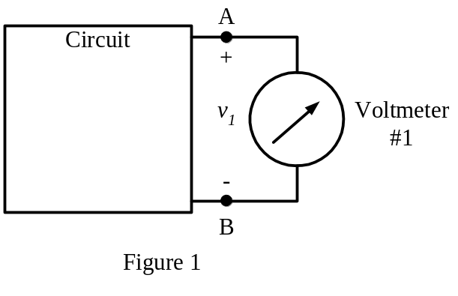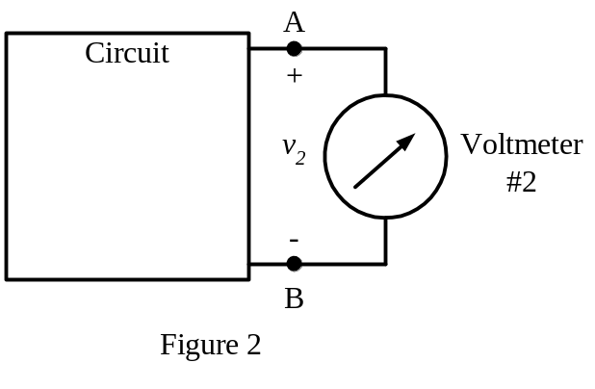

3) {30 Points} In the circuit shown, switch SW1 was closed and switch SW2 was in position 1 for a long time.
Then, switch SW1 was opened at t = 0, and remains open.
Then, switch SW2 was moved to position 2 at t = 1[s], and stays there.
For the time intervals 0 < t < 1[s], and t > 1[s], calculate the numerical expression for the current i_{X}(t) as defined in the circuit shown.
In your expressions, clearly specify the time interval or moment in time for which your expressions apply.
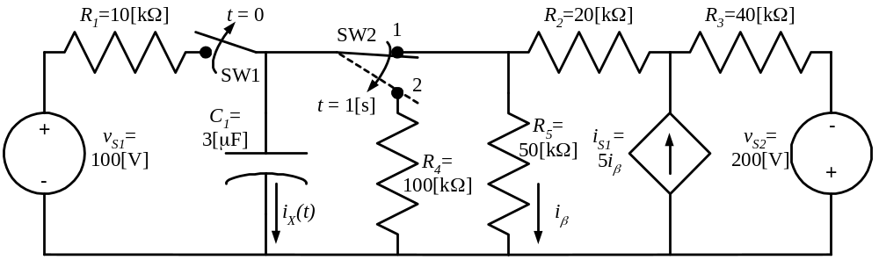
4) {15 Points} For the following circuit, calculate the numerical expression for the current i_{X}(t). This current is defined in the circuit.
Important: For each step in your calculations, show clearly the circuit to which your solution applies.
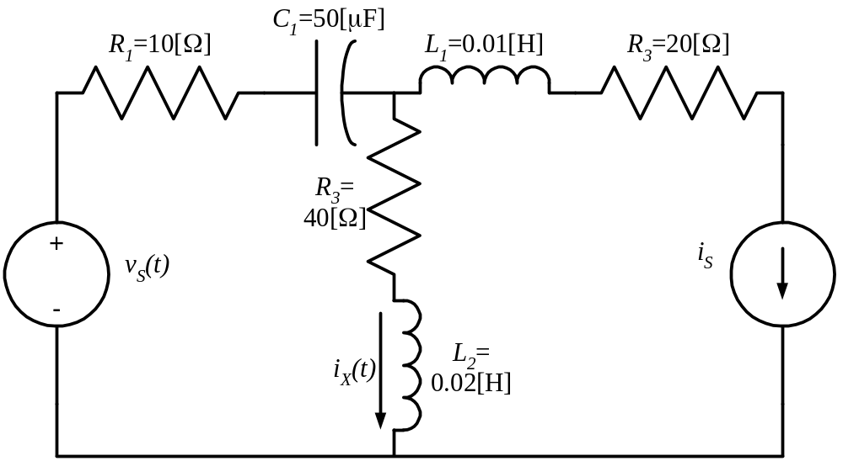
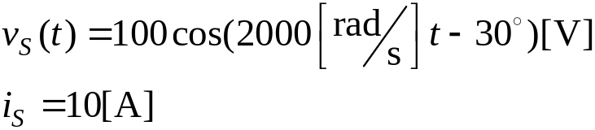

5) {5 Points} Find the rms value of the waveform shown below.
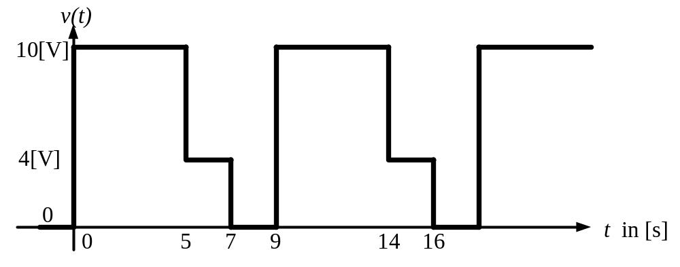

6) {16 Points} For the circuit shown, calculate the complex, apparent, average and reactive power delivered by the ideal voltage source to the circuit, and the corresponding power factor.

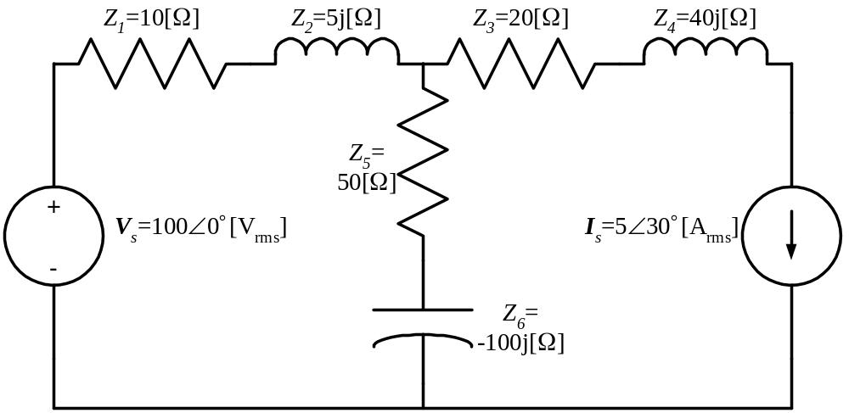
7) {15 Points} The load in the figure below absorbs 5[kW] and absorbs 1[kVAR]. The sinusoidal voltage source has a frequency of 60[Hz], and delivers 7.5[kW], but the reactive power delivered by the source is unknown.
  - Find the inductance of the line, L_{X}.
  - Find the expression for the current i_{X}(t).
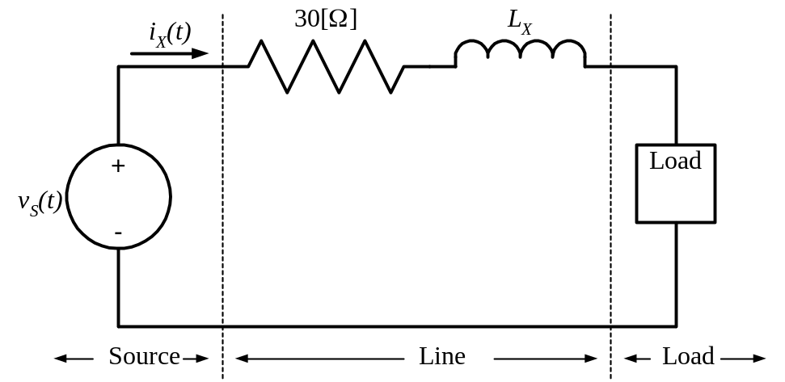
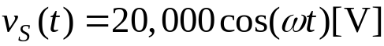

SOLUTION:
2) {17 Points} A circuit is made up of resistors and sources. This same circuit is connected to a series of voltmeters, one at a time.
First, the circuit is connected to Voltmeter #1 with a meter resistance of 10[kΩ], and a full-scale reading of 50[V], as shown in Figure 1. With this voltmeter connected, the voltage v₁ is 22.1[V].
Next, the circuit is connected to Voltmeter #2 with a meter resistance of 20[kΩ], and a full-scale reading of 100[V], as shown in Figure 2. With this voltmeter connected, the voltage v₂ is 15.3[V].
Finally, the circuit is connected to a third voltmeter with a meter resistance of 30[kΩ], and a full-scale reading of 150[V]. Find the voltage read by the third voltmeter.

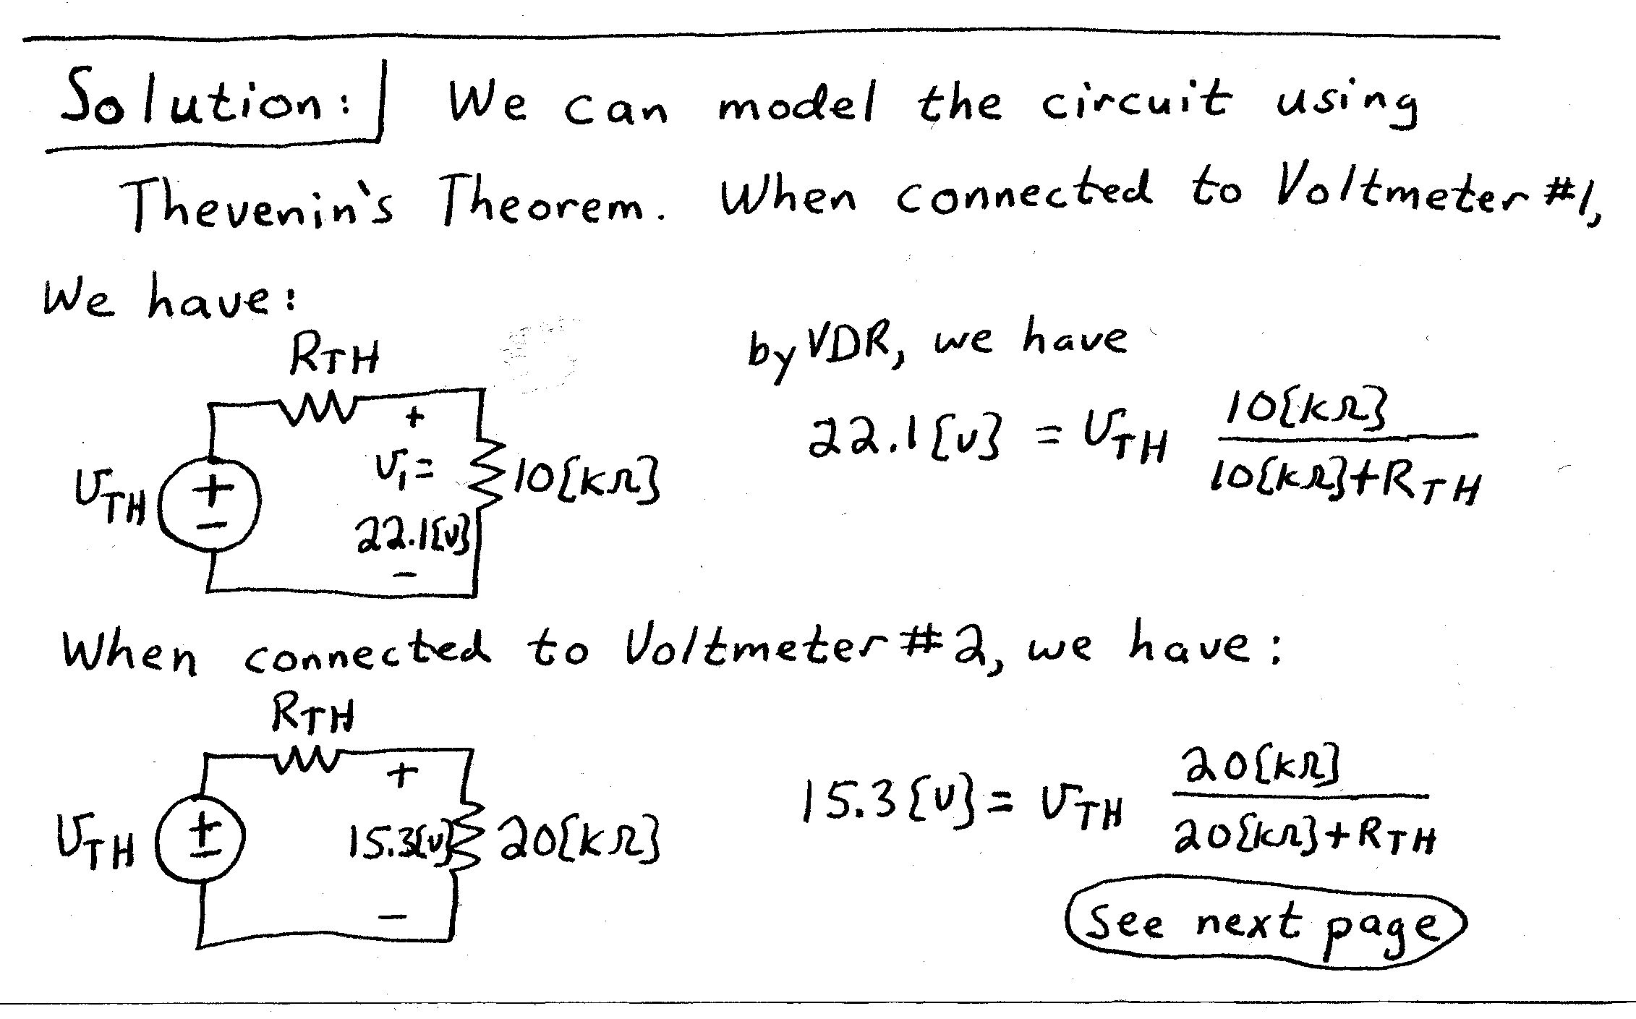
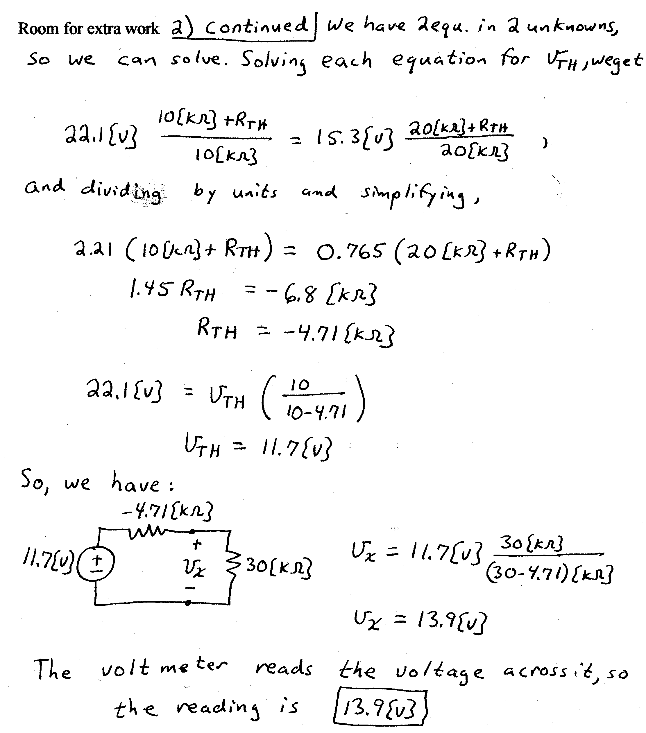

3) {30 Points} In the circuit shown, switch SW1 was closed and switch SW2 was in position 1 for a long time.
Then, switch SW1 was opened at t = 0, and remains open.
Then, switch SW2 was moved to position 2 at t = 1[s], and stays there.
For the time intervals 0 < t < 1[s], and t > 1[s], calculate the numerical expression for the current i_{X}(t) as defined in the circuit shown.
In your expressions, clearly specify the time interval or moment in time for which your expressions apply.
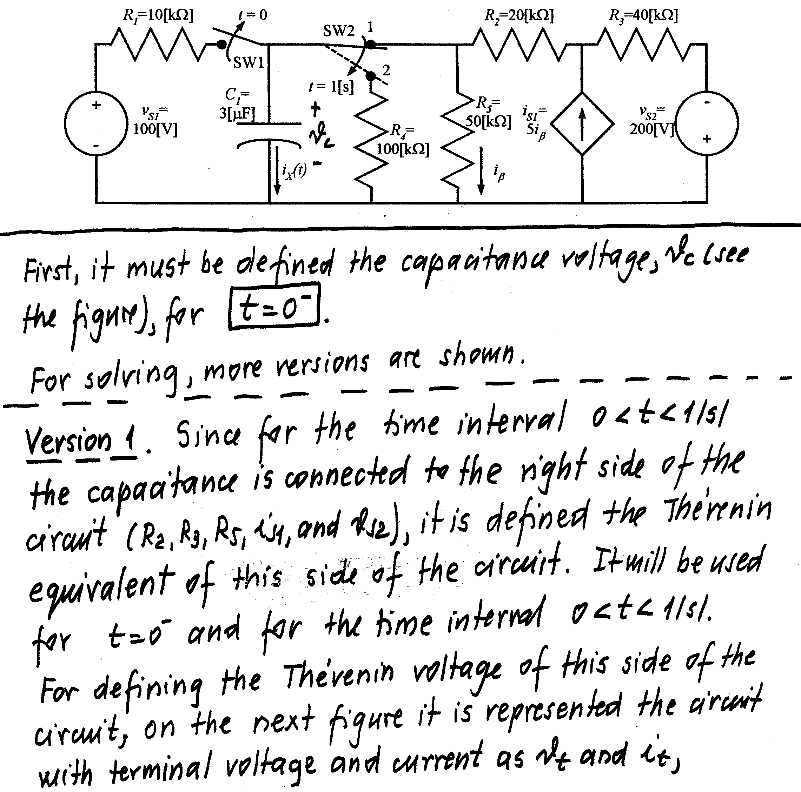
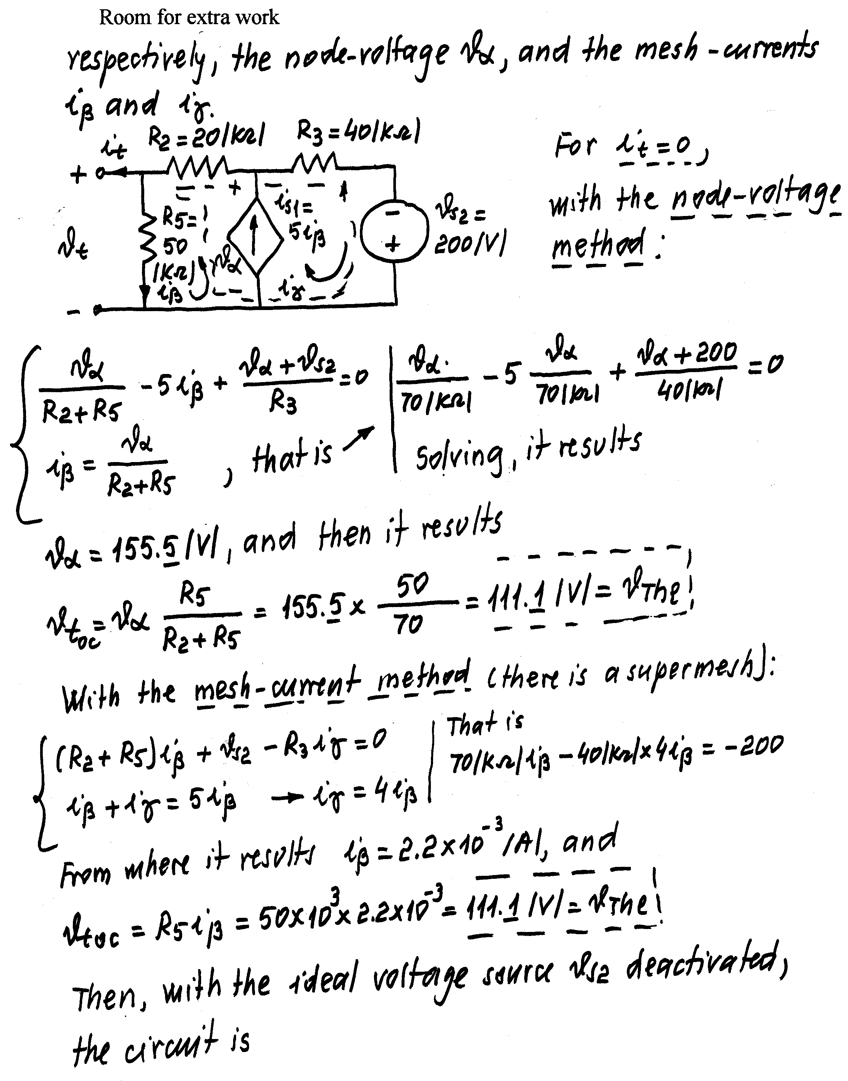
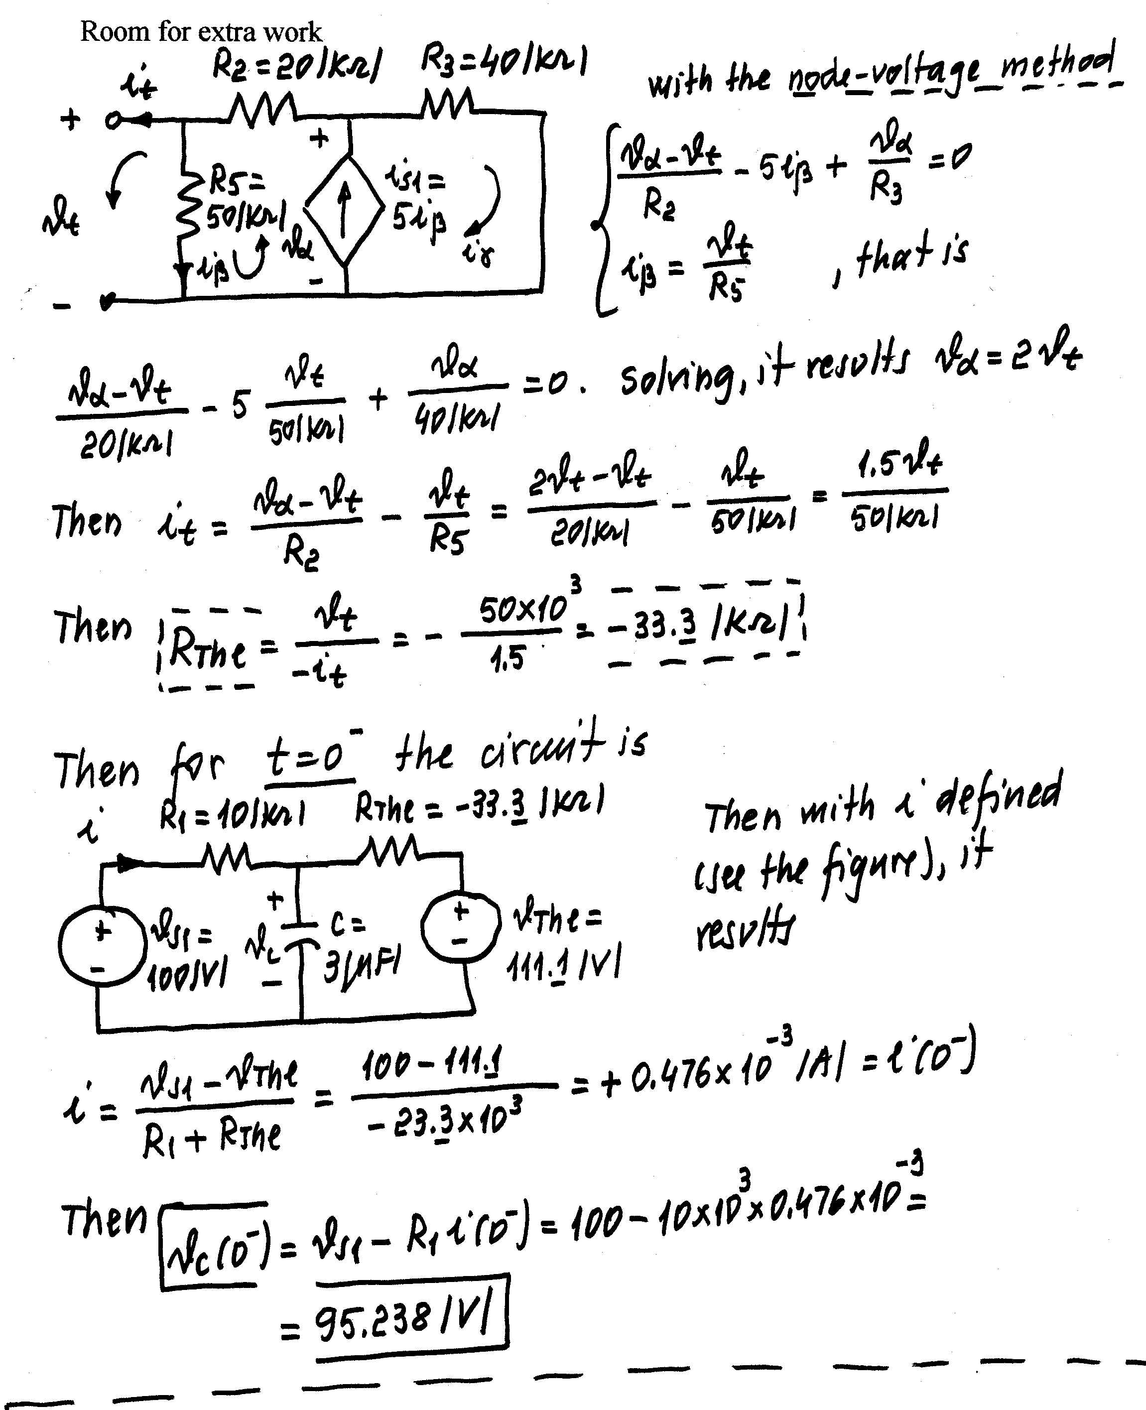
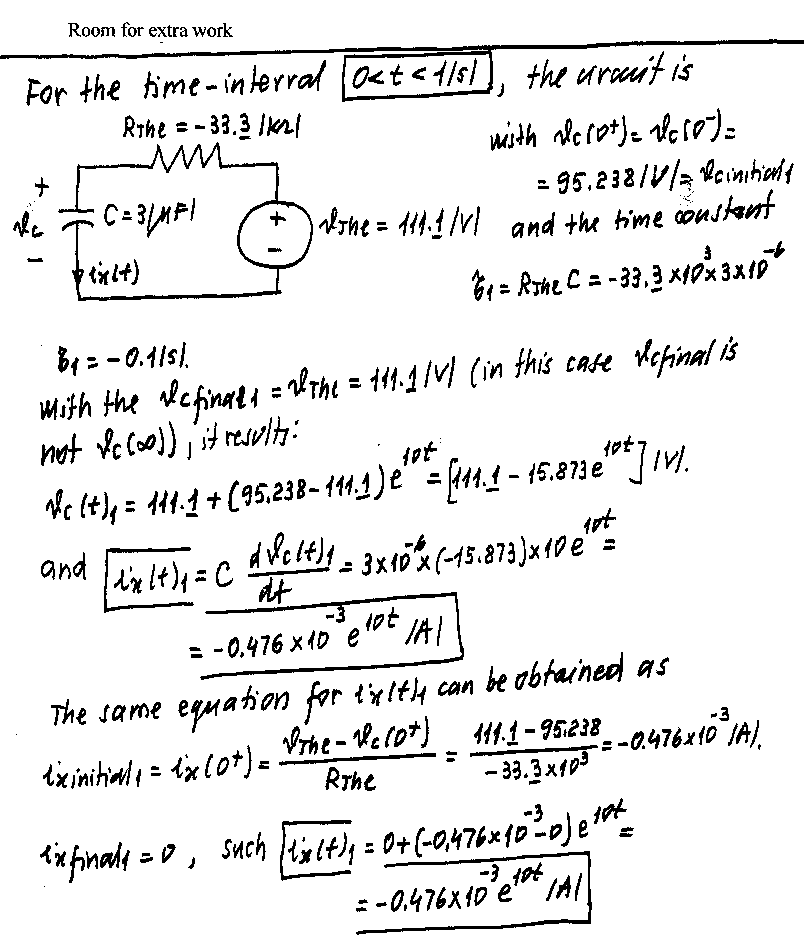
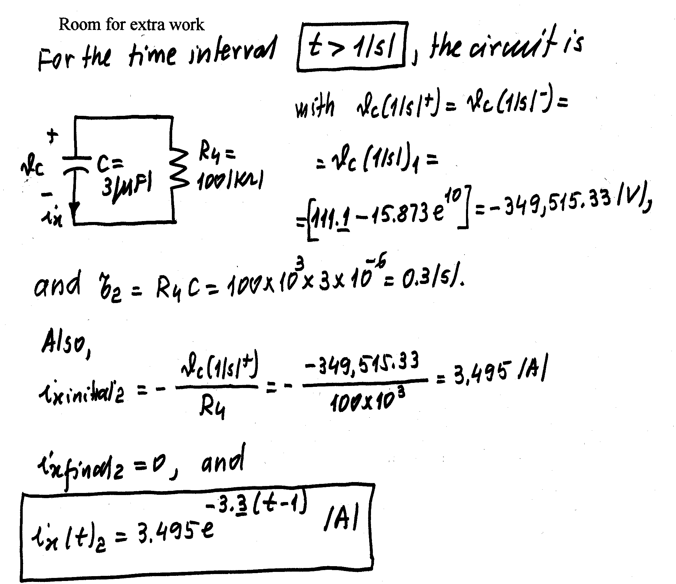

4) {15 Points} For the following circuit, calculate the numerical expression for the current i_{X}(t). This current is defined in the circuit.
Important: For each step in your calculations, show clearly the circuit to which your solution applies.
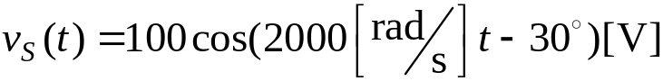
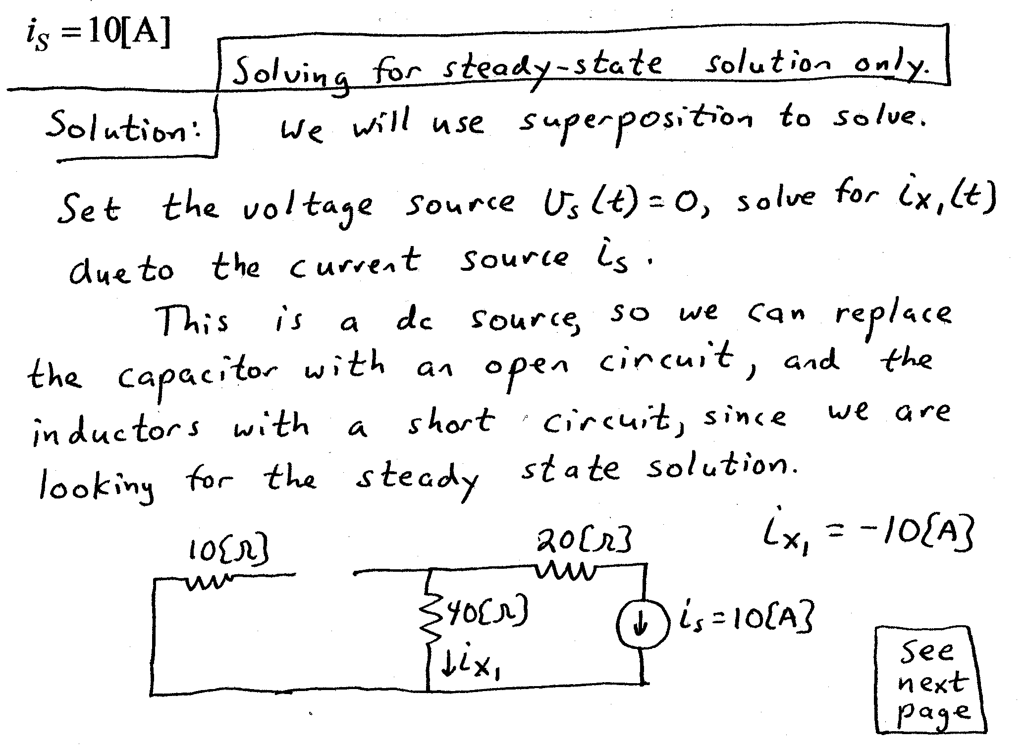
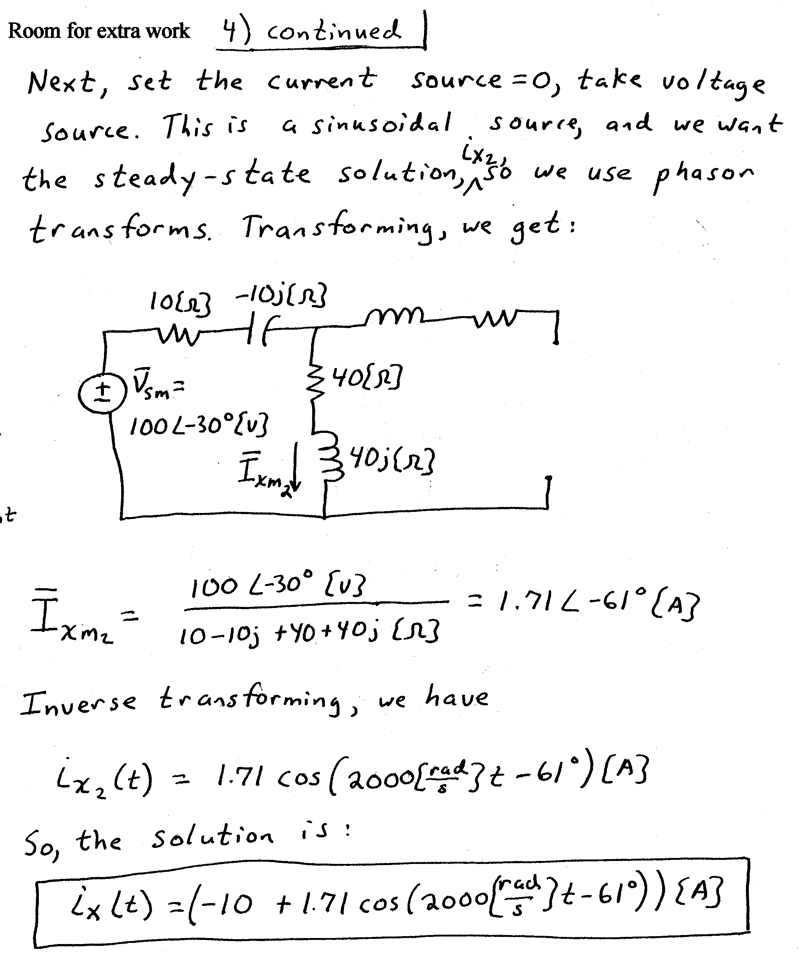
5) {5 Points} Find the rms value of the waveform shown below.
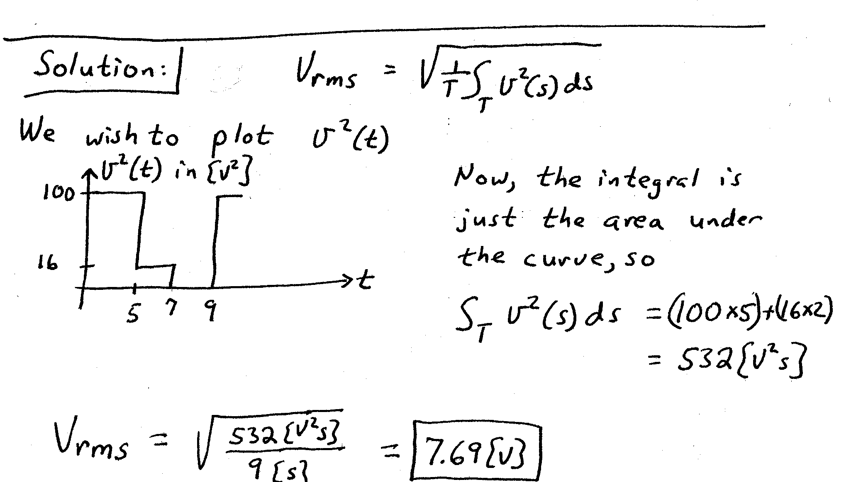
6) {16 Points} For the circuit shown, calculate the complex, apparent, average and reactive power delivered by the ideal voltage source to the circuit, and the corresponding power factor.

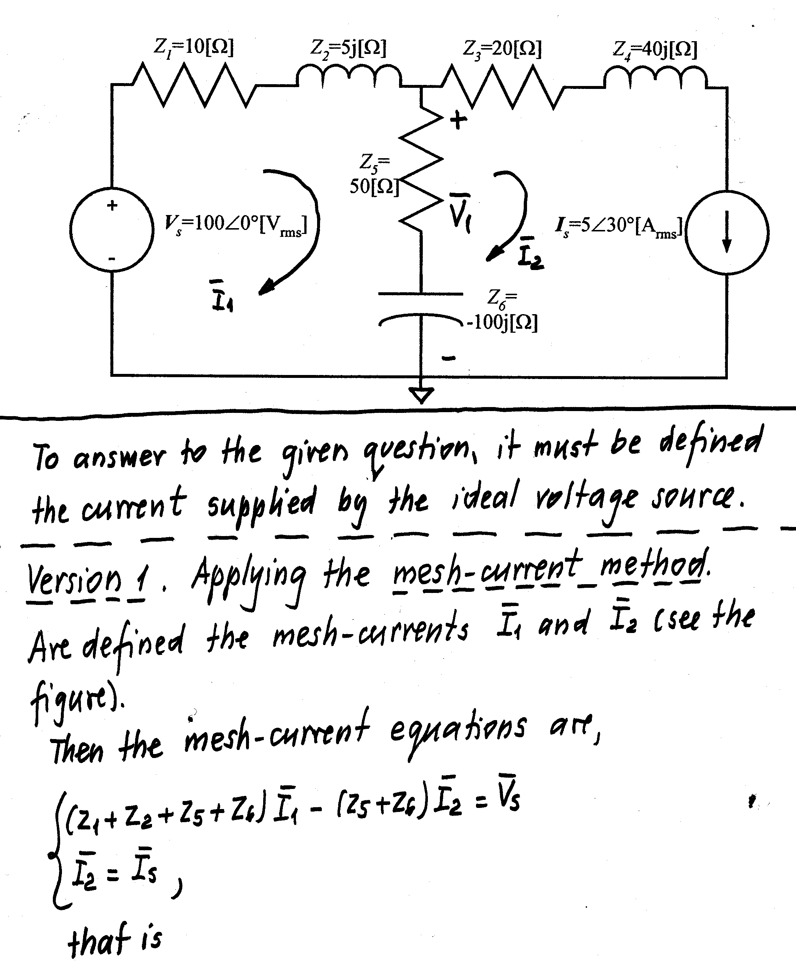
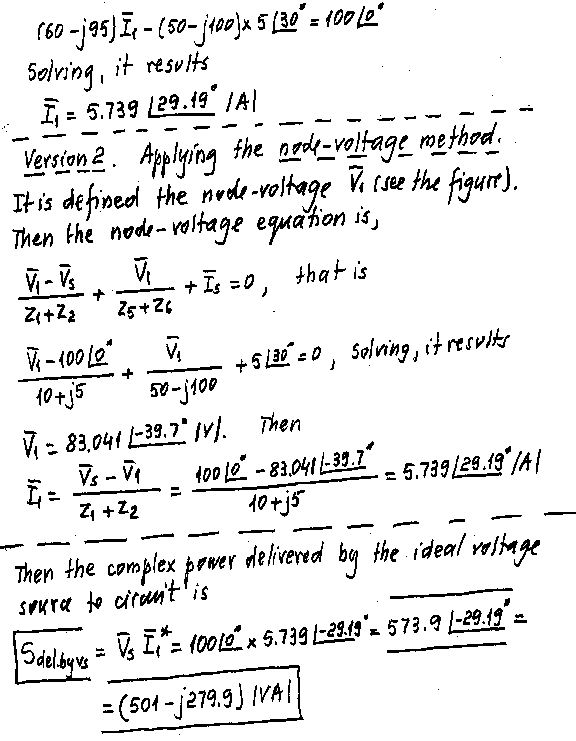
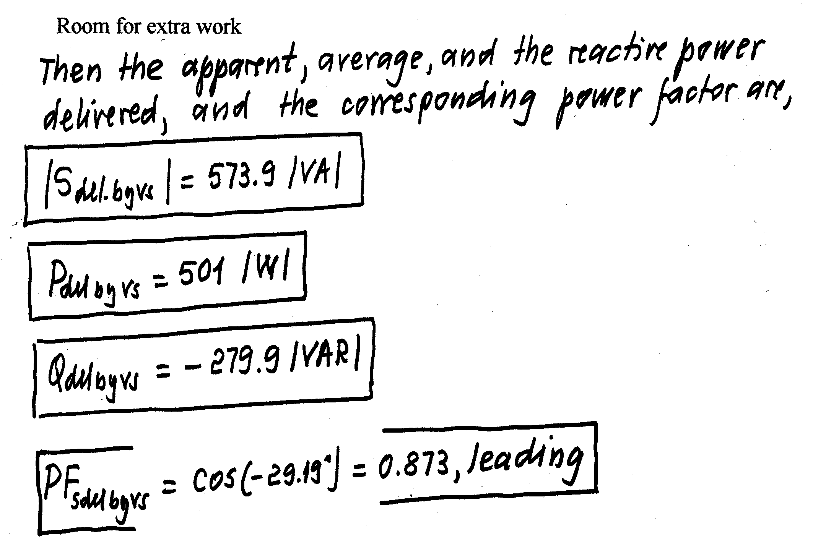
7) {15 Points} The load in the figure below absorbs 5[kW] and absorbs 1[kVAR]. The sinusoidal voltage source has a frequency of 60[Hz], and delivers 7.5[kW], but the reactive power delivered by the source is unknown.
  - Find the inductance of the line, L_{X}.
  - Find the expression for the current i_{X}(t).


