Name: _____________________________ (please print)
Signature: __________________________
Circle your class time: 4-5:30PM, TuTh 1-2:30PM, MW 8:30-10AM, TuTh
DO NOT OPEN THIS BOOKLET UNTIL INSTRUCTED TO DO SO

ECE 2300 -- EXAM #1
February 22, 2003

1. This exam is closed book, closed notes. You may use one 8.5” x 11” crib sheet, or its equivalent. You may use any calculator. Turn all cell phones or other communications devices off.
2. Show all work on these pages. Show all work necessary to complete the problem. If you go on to another page, indicate clearly where your work can be found. A solution without the appropriate work shown will receive no credit. Clearly indicate your answer (for example, by enclosing it in a box).
3. Show all units in solutions, intermediate results, and figures. Units in the exam will be included between square brackets.
4. Do not use red ink. Do not use red pencil.
5. You will have 90 minutes to work on this exam.
6. Be sure to sign the statement below before you turn in your exam. If you fail to sign this statement, your exam will not be graded and you will earn no credit.

1. ________________/1
2. ________________/24
3. ________________/28
4. ________________/24
5. ________________/34
Total = 111

Statement: I understand the Academic Honesty Policy of the University of Houston. I certify that I will not communicate with any other person concerning the material on the exam while I am taking this exam.

Signature: ___________________________________ Date: ________________
1) {1 Point} On the front page, circle your class time.

Room for extra work
2) {24 Points} Show that the total power delivered by the components in the circuit below equals the total power absorbed by the components in this circuit. In other words, find the sum of the powers delivered by each of the elements that deliver positive power, and compare that with the sum of the powers absorbed by the elements that absorb positive power.
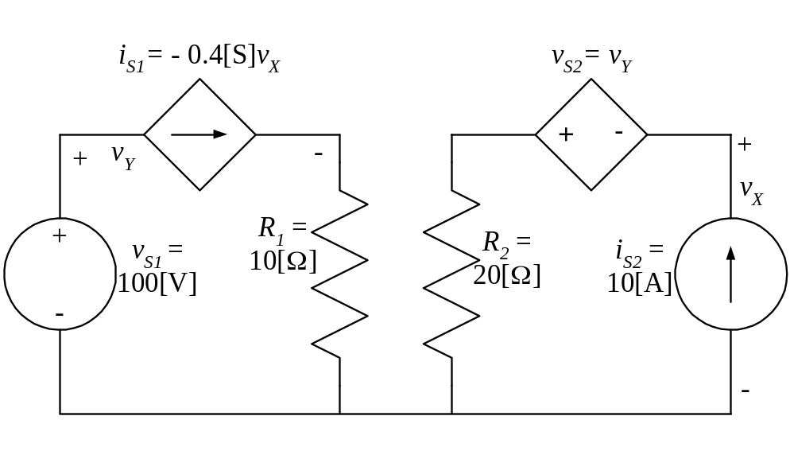

Room for extra work
3) {28 Points} A device can be modeled by an ideal voltage source in series with a resistance. The device was connected to a 7.8[mA] ideal current source, as shown in Figure 1, and a voltage v₁ of – 215.2[V] resulted. The same device was then connected to a 5.6[mA] ideal current source, as shown in Figure 2, and a voltage v₂ of 39.4[V] resulted.
Find the power absorbed by the device if a 50[V] ideal voltage source is connected to the same device, as shown in Figure 3.
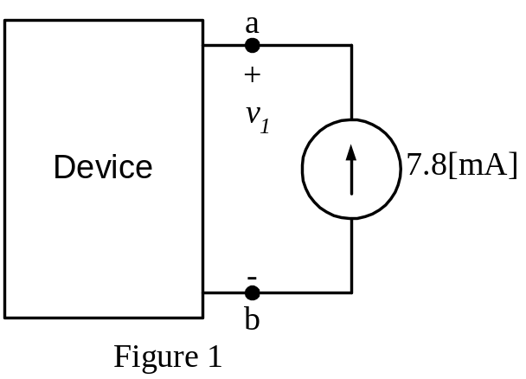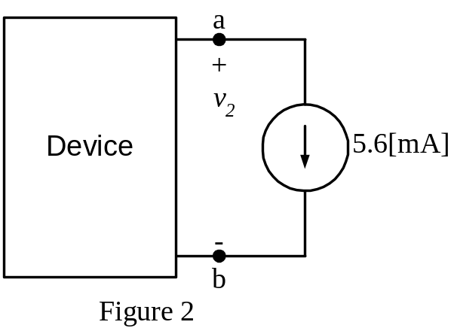
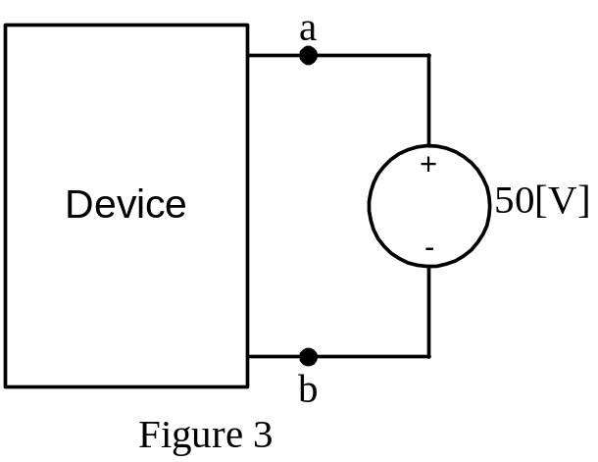
Room for extra work
4) {24 Points} The circuit shown below has two ammeters, two voltmeters, and an unknown resistor R_{X}.
Each ammeter has a full-scale current of 10[mA], and a meter resistance of 7[Ω].
Each voltmeter has a full-scale voltage of 100[V], and a meter resistance of 75[kΩ].
The values of resistors R₂ and R₃ are always in a ratio of 1:10.
Ammeter #2 reads a current, i₂ = 3[mA].
Voltmeter #2 reads a voltage, v₂ = 13.1[V].
Find the numerical value of R_{X}.
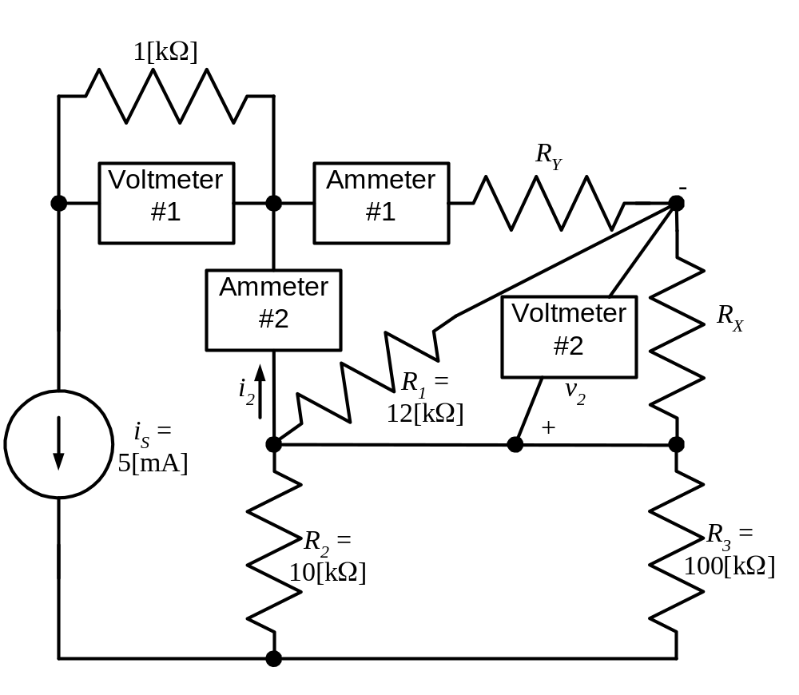

Room for extra work
5) {34 Points} For the circuit shown, use the node-voltage method to write a complete set of independent equations that could be used to solve this circuit. Do not attempt to solve the equations. Do not attempt to simplify the circuit.

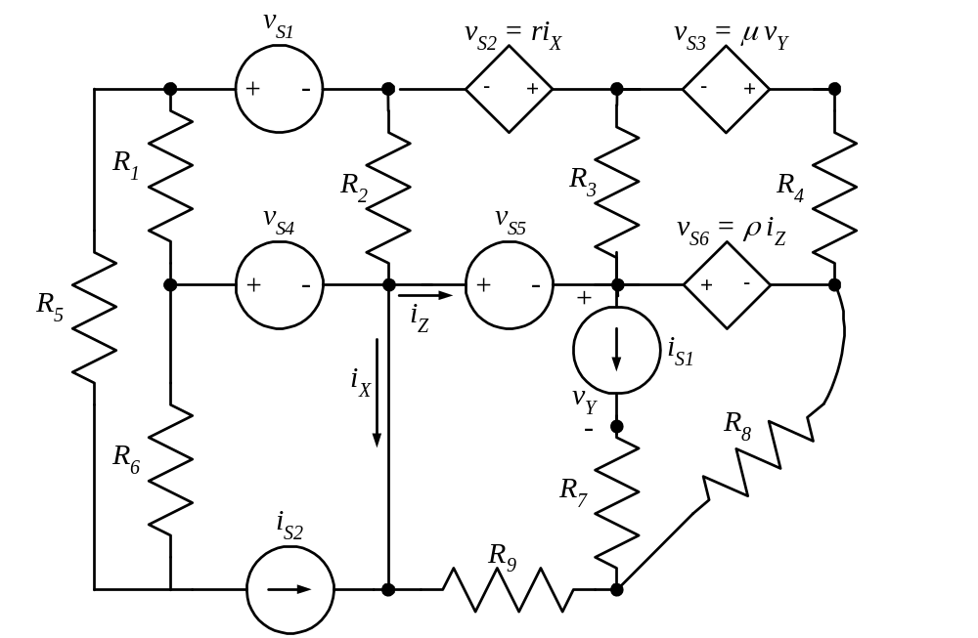

Room for extra work

Solutions:
2) {24 Points} Show that the total power delivered by the components in the circuit below equals the total power absorbed by the components in this circuit. In other words, find the sum of the powers delivered by each of the elements that deliver positive power, and compare that with the sum of the powers absorbed by the elements that absorb positive power.
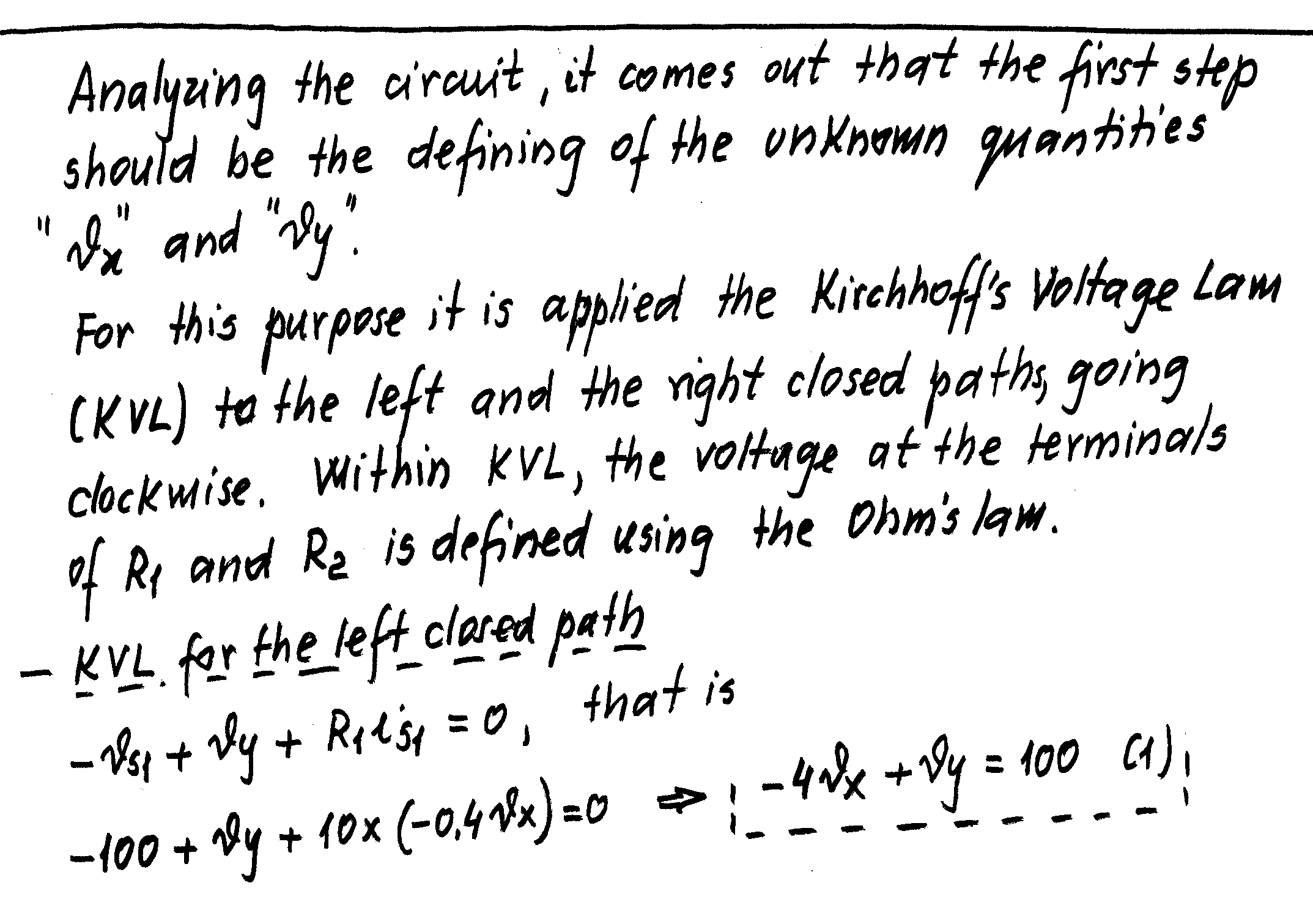
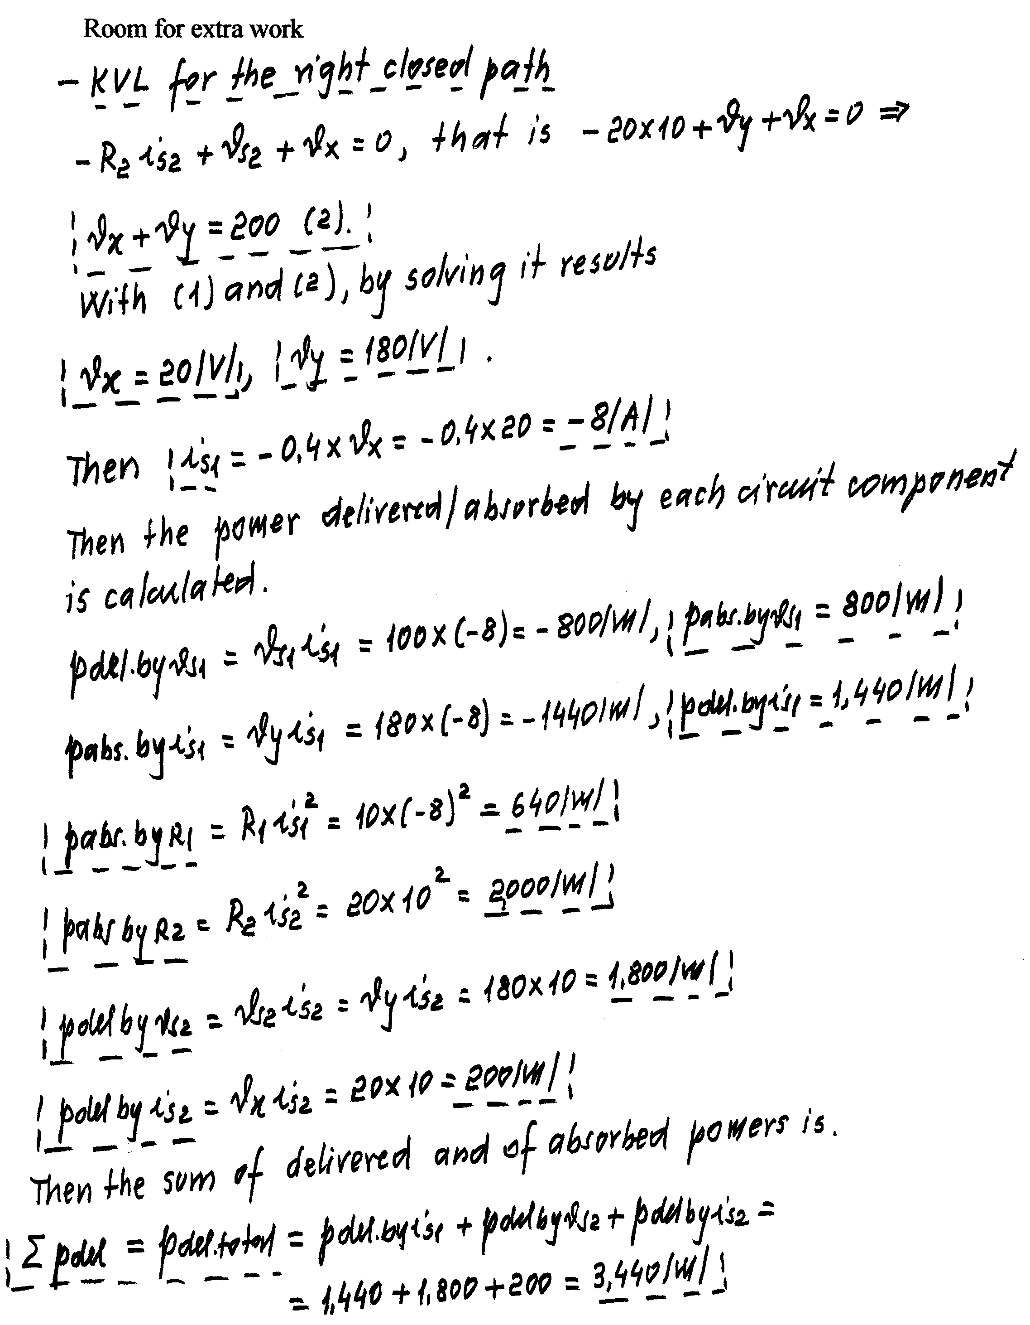
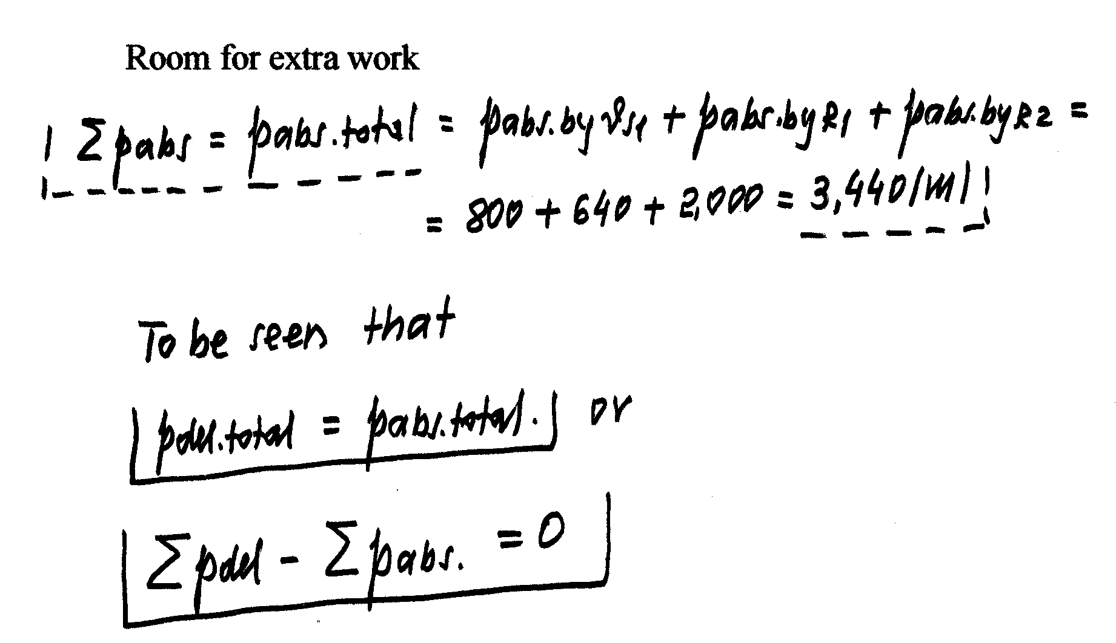
3) {28 Points} A device can be modeled by an ideal voltage source in series with a resistance. The device was connected to a 7.8[mA] ideal current source, as shown in Figure 1, and a voltage v₁ of – 215.2[V] resulted. The same device was then connected to a 5.6[mA] ideal current source, as shown in Figure 2, and a voltage v₂ of 39.4[V] resulted.
Find the power absorbed by the device if a 50[V] ideal voltage source is connected to the same device, as shown in Figure 3.
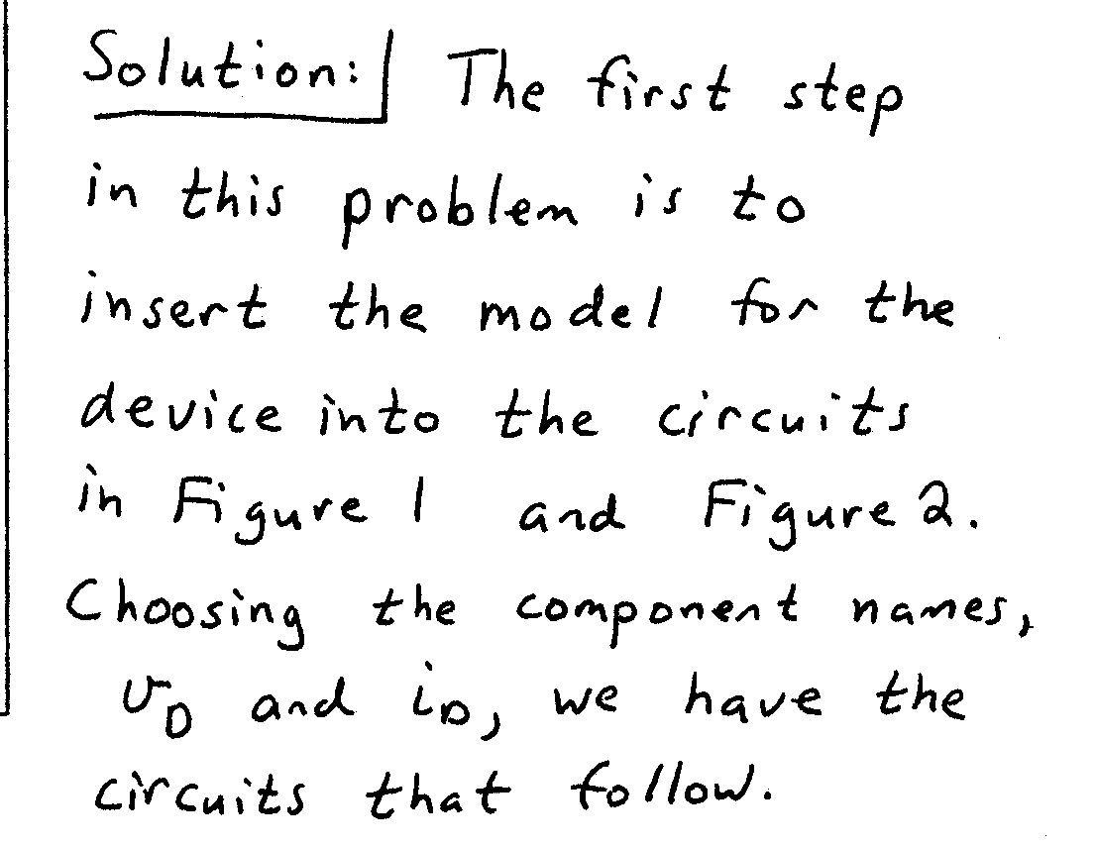
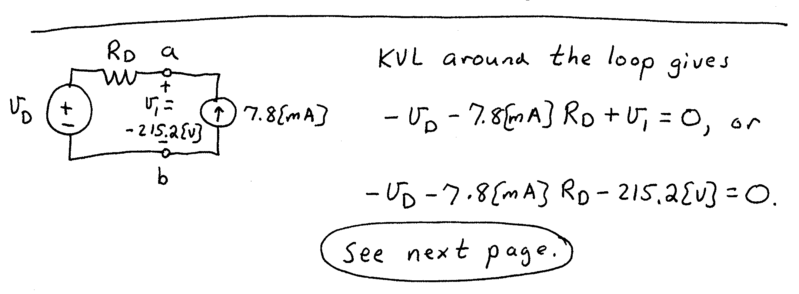

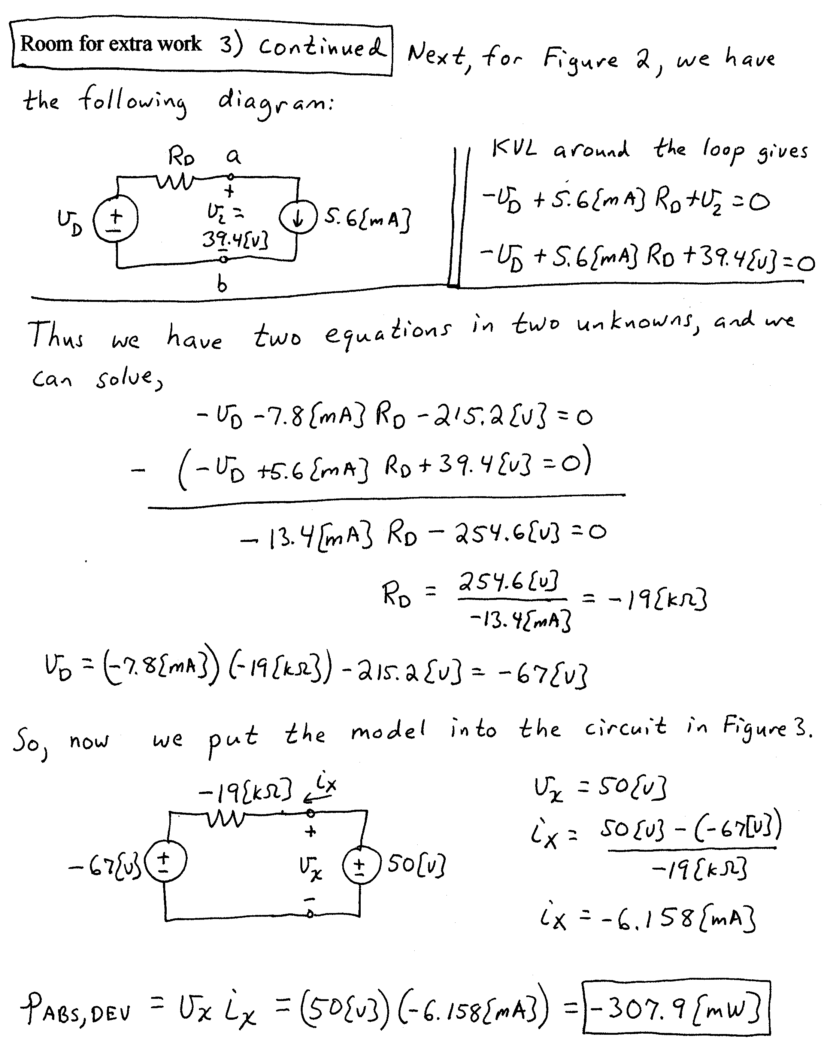
4) {24 Points} The circuit shown below has two ammeters, two voltmeters, and an unknown resistor R_{X}.
Each ammeter has a full-scale current of 10[mA], and a meter resistance of 7[Ω].
Each voltmeter has a full-scale voltage of 100[V], and a meter resistance of 75[kΩ].
The values of resistors R₂ and R₃ are always in a ratio of 1:10.
Ammeter #2 reads a current, i₂ = 3[mA].
Voltmeter #2 reads a voltage, v₂ = 13.1[V].
Find the numerical value of R_{X}.
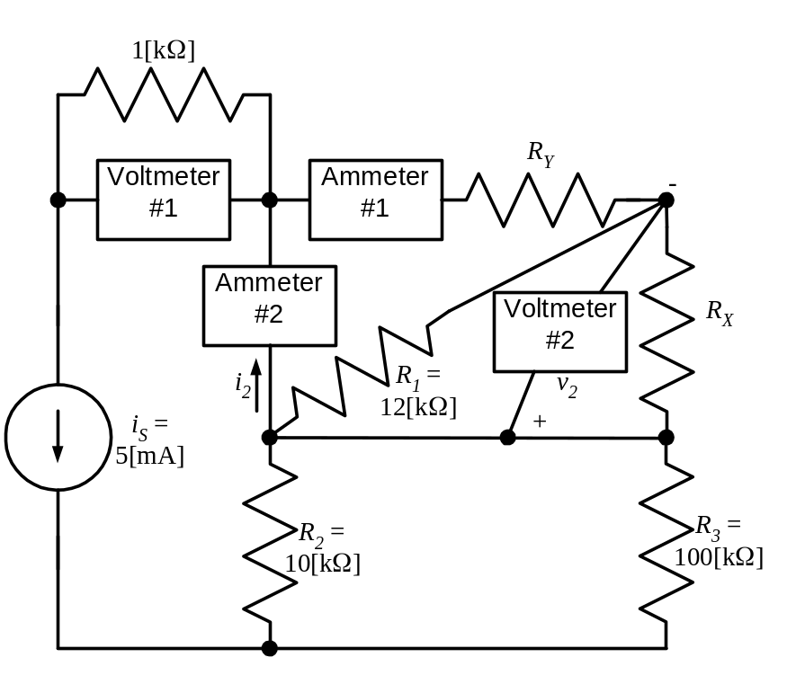
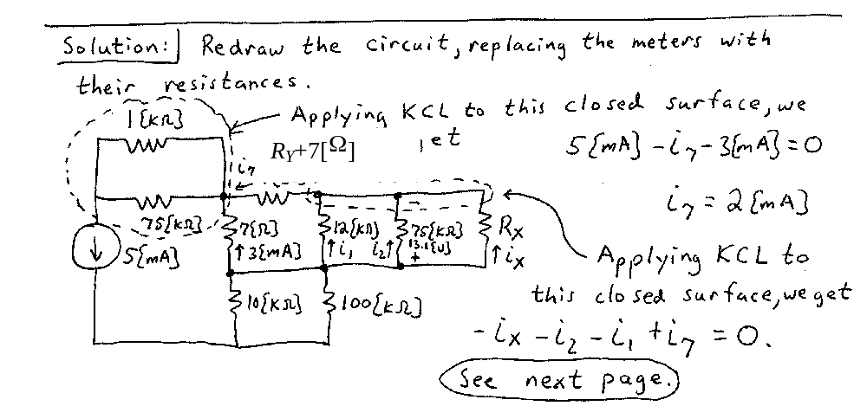
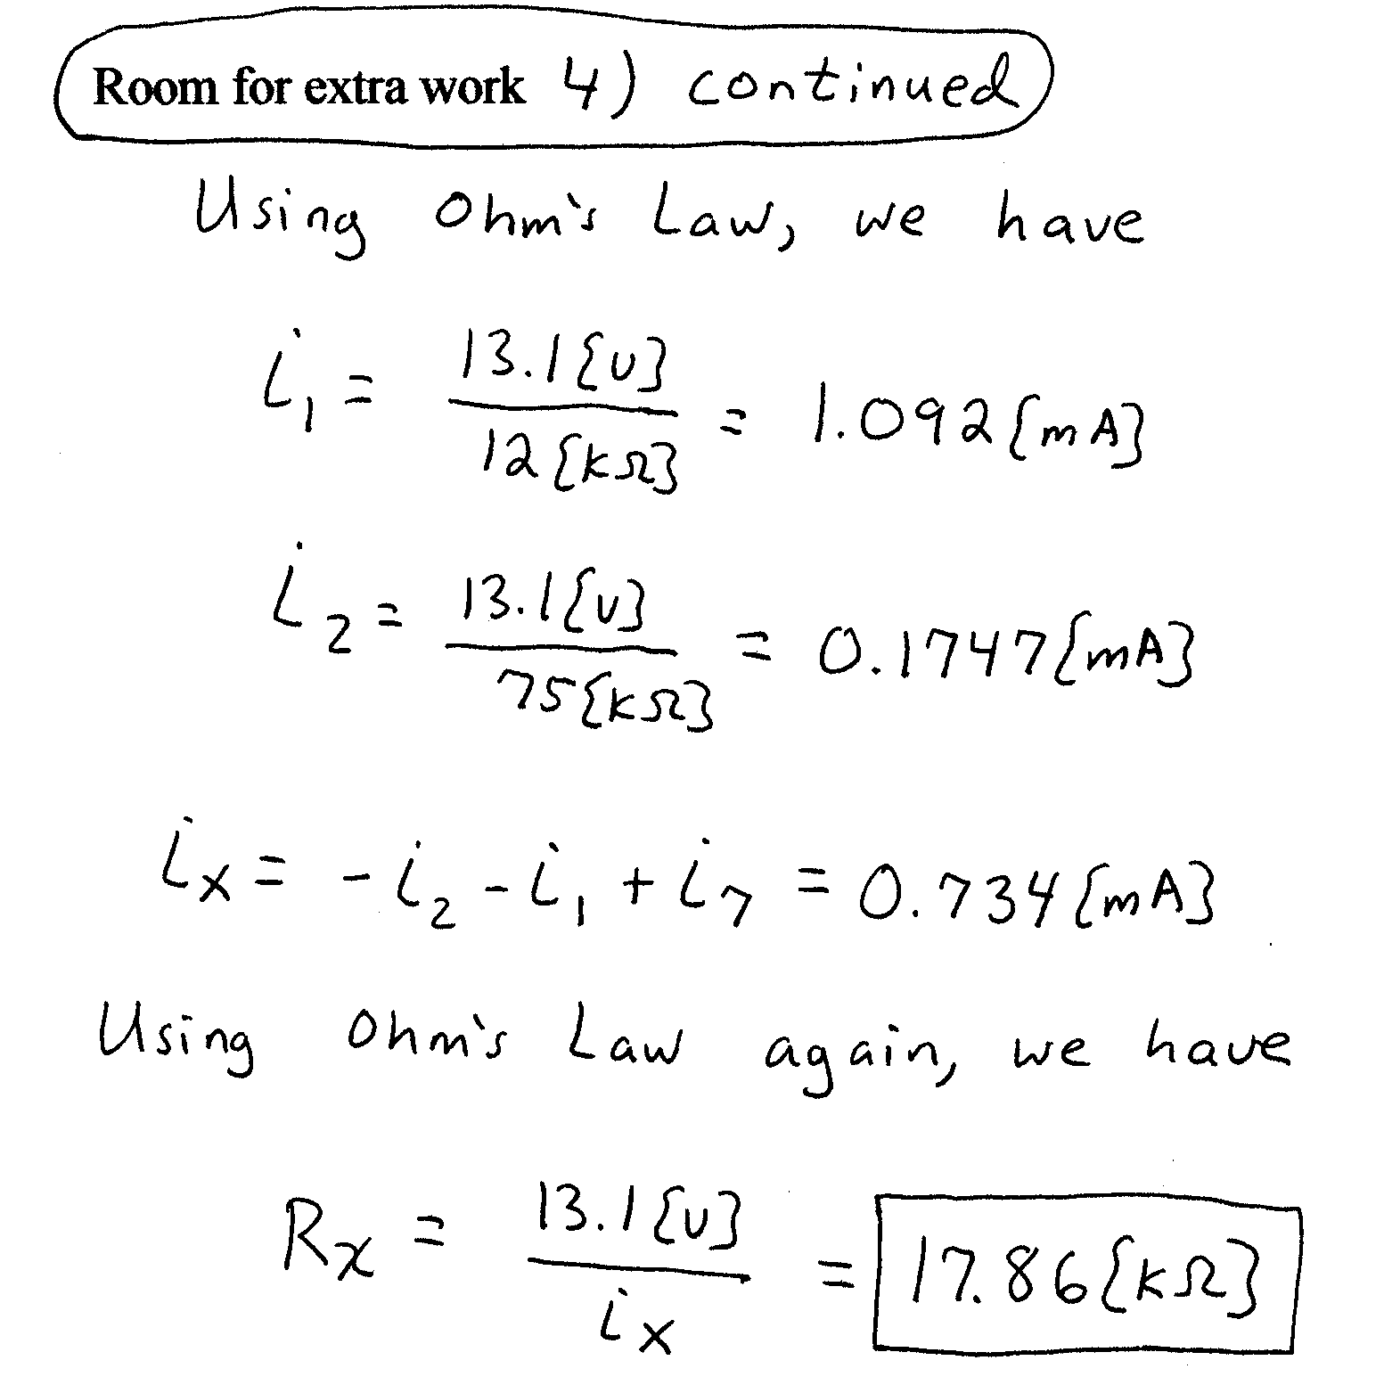
5) {34 Points} For the circuit shown, use the node-voltage method to write a complete set of independent equations that could be used to solve this circuit. Do not attempt to solve the equations. Do not attempt to simplify the circuit.



