Name: _____________________________ (please print)
Signature: __________________________

ECE 2300 -- Quiz #1
Shattuck Section – TuTh 8:30-10AM
February 6, 2003

Keep this quiz closed and face up until you are told to begin.

1. This quiz is closed book, closed notes. You may use one 8.5” x 11” crib sheet, or its equivalent.
2. Show all work on these pages. Show all work necessary to complete the problem. If you go on to another page, indicate clearly where your work can be found. A solution without the appropriate work shown will receive no credit.
3. Show all units in solutions, intermediate results, and figures. Units in the quiz will be included between square brackets.
4. Do not use red ink. Do not use red pencil.
5. You will have 30 minutes to work on this quiz.

________________/20
Room for extra work
For the circuit shown, solve for the numerical values of the quantities requested.
- Find v_{X}.
- Find i_{X}.
- Find i_{Q}.
- Find the power absorbed by the current-dependent voltage source.
Remember to use lower-case variables for voltage, current, and power.
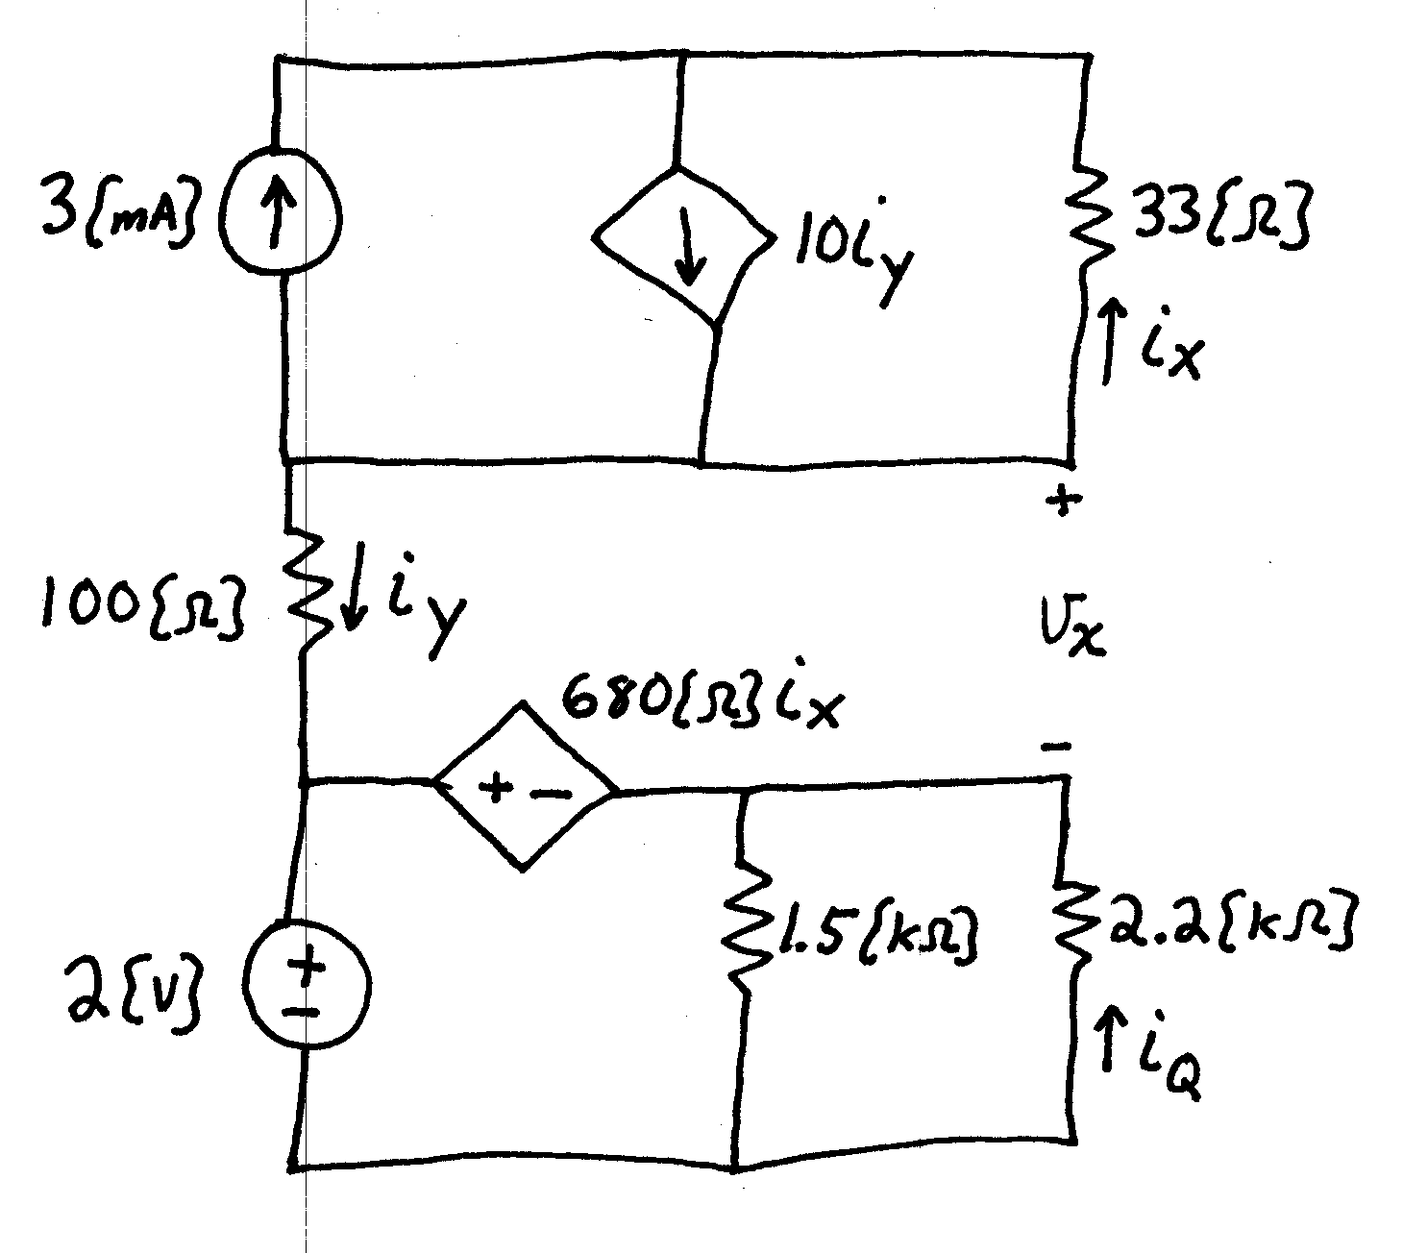
ECE 2300 -- Quiz #1 – February 6, 2003 – 8:30-10AM TuTh Shattuck Section Solution
For the circuit shown, solve for the numerical values of the quantities requested.
- Find v_{X}.
- Find i_{X}.
- Find i_{Q}.
- Find the power absorbed by the current-dependent voltage source.
Remember to use lower-case variables for voltage, current, and power.
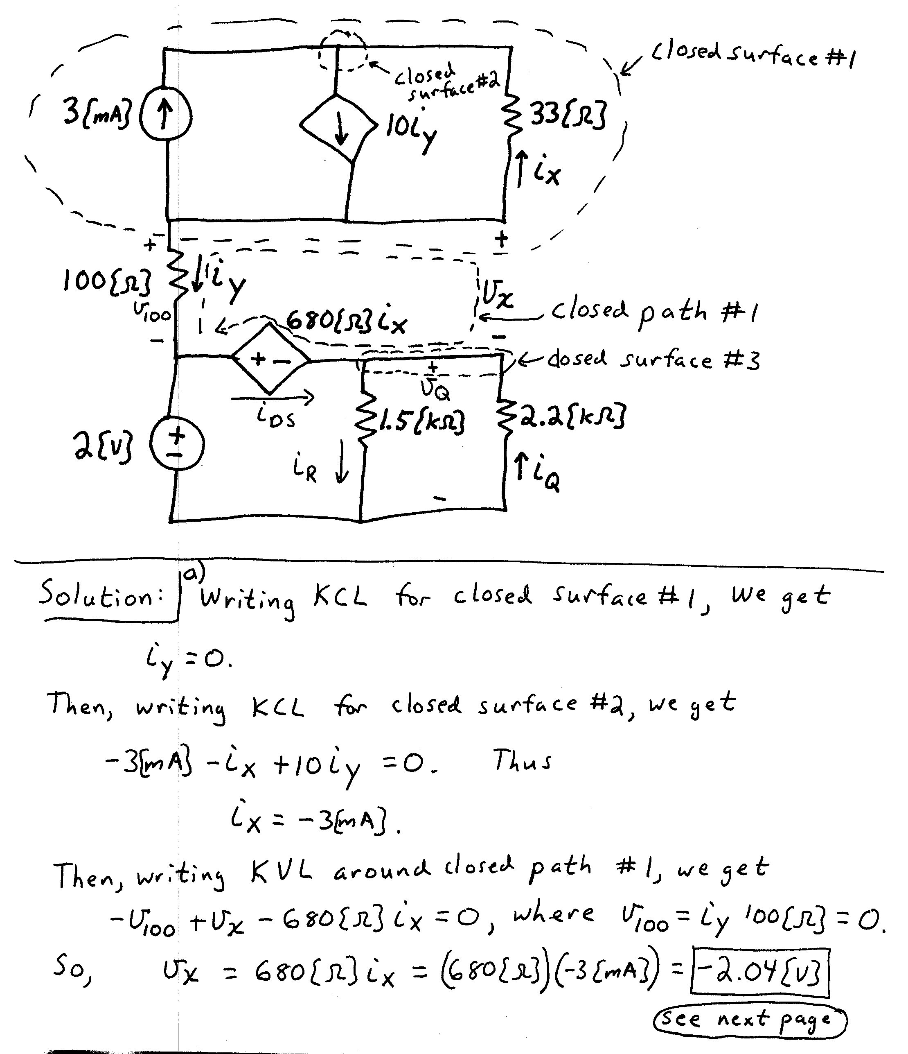
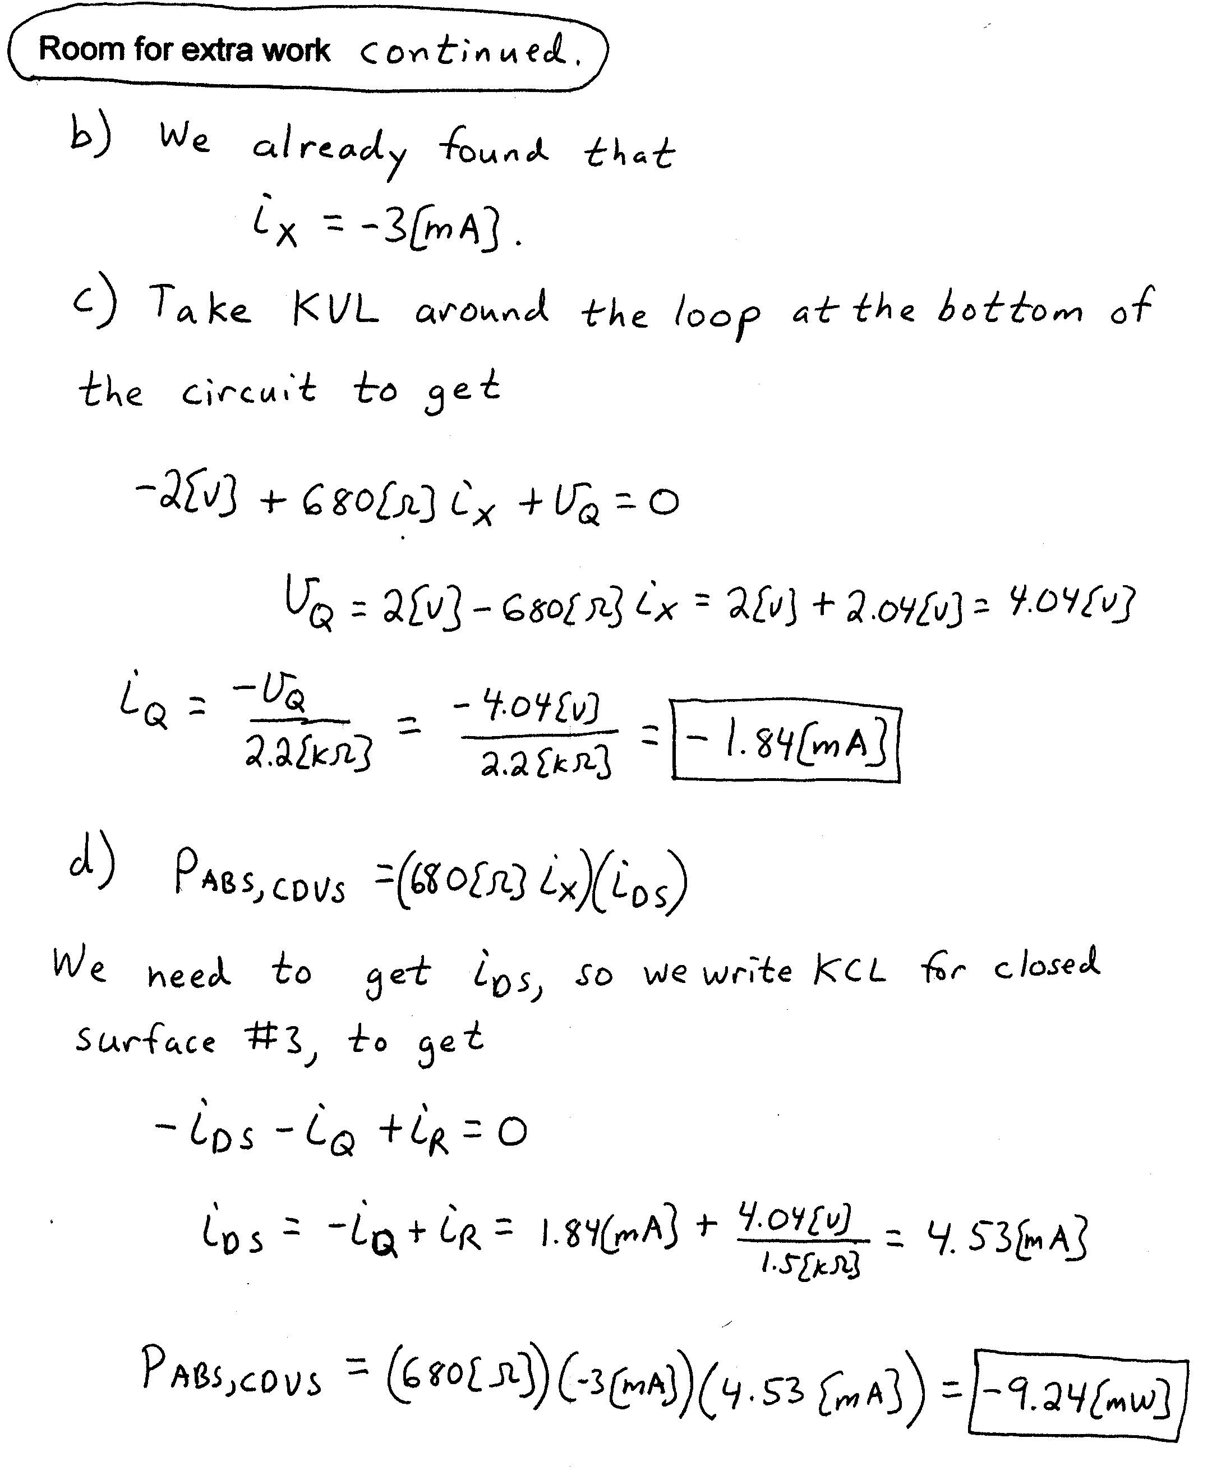

Name: _____________________________ (please print)
Signature: __________________________

ECE 2300 -- Quiz #1
Shattuck Section – TuTh 4-5:30PM
February 6, 2003

Keep this quiz closed and face up until you are told to begin.

1. This quiz is closed book, closed notes. You may use one 8.5” x 11” crib sheet, or its equivalent.
2. Show all work on these pages. Show all work necessary to complete the problem. If you go on to another page, indicate clearly where your work can be found. A solution without the appropriate work shown will receive no credit.
3. Show all units in solutions, intermediate results, and figures. Units in the quiz will be included between square brackets.
4. Do not use red ink. Do not use red pencil.
5. You will have 30 minutes to work on this quiz.

________________/20
Room for extra work
A device, shown in Figure 1, can be modeled by a voltage source in series with a resistance. This device has a relationship between terminal voltage and current shown in Table 1.
Two identical versions of this device are connected in a circuit with a resistor as shown in Figure 2.
- Find i_{X} for this circuit.
- Find the power absorbed by the top device, number 1.
Remember to use lower-case variables for voltage, current, and power.
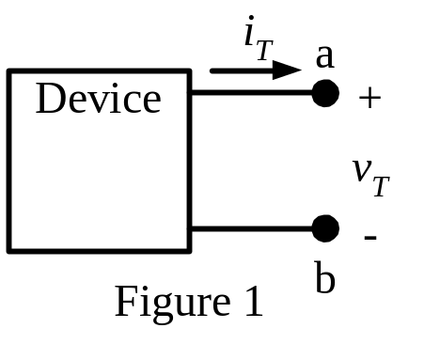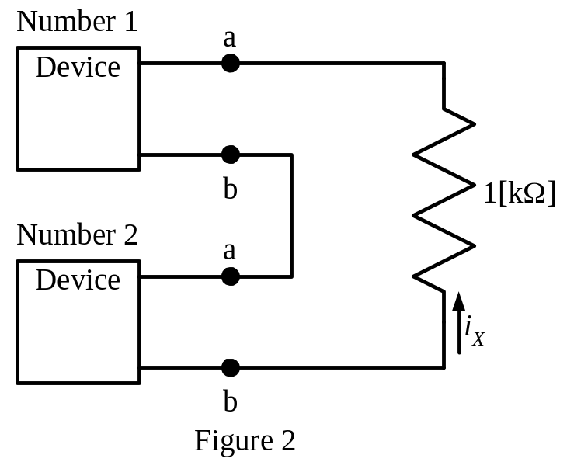

Table 1
v_{T} in [V] | i_{T} in [A]
5.4 | 0
0 | -0.02466
ECE 2300 -- Quiz #1 – February 6, 2003 – 5-5:30PM TuTh Shattuck Section Solution
A device, shown in Figure 1, can be modeled by a voltage source in series with a resistance. This device has a relationship between terminal voltage and current shown in Table 1.
Two identical versions of this device are connected in a circuit with a resistor as shown in Figure 2.
- Find i_{X} for this circuit.
- Find the power absorbed by the top device, number 1.
Remember to use lower-case variables for voltage, current, and power.

Table 1
v_{T} in [V] | i_{T} in [A]
5.4 | 0
0 | -0.02466



