Name: _____________________________ (please print)
Signature: __________________________

ECE 2300 -- Quiz #5
Shattuck Section – TuTh 8:30-10AM
April 8, 2003

Keep this quiz closed and face up until you are told to begin.

1. This quiz is closed book, closed notes. You may use one 8.5” x 11” crib sheet, or its equivalent.
2. Show all work on these pages. Show all work necessary to complete the problem. If you go on to another page, indicate clearly where your work can be found. A solution without the appropriate work shown will receive no credit.
3. Show all units in solutions, intermediate results, and figures. Units in the quiz will be included between square brackets.
4. Do not use red ink. Do not use red pencil.
5. You will have 40 minutes to work on this quiz.

________________/20
Room for extra work
For the circuit shown, the Switch A was open for a long time, and Switch B was closed for a long time, before t = 0. At t = 0, Switch A was closed. Then, 10[μs] later, Switch B was opened. Find v_{R}(11[μs]).

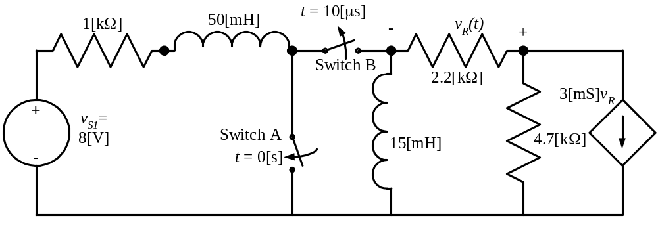

ECE 2300 -- Quiz #5 – April 8, 2003 – 8:30-10AM TuTh Shattuck Section Solution
For the circuit shown, the Switch A was open for a long time, and Switch B was closed for a long time, before t = 0. At t = 0, Switch A was closed. Then, 10[μs] later, Switch B was opened. Find v_{R}(11[μs]).
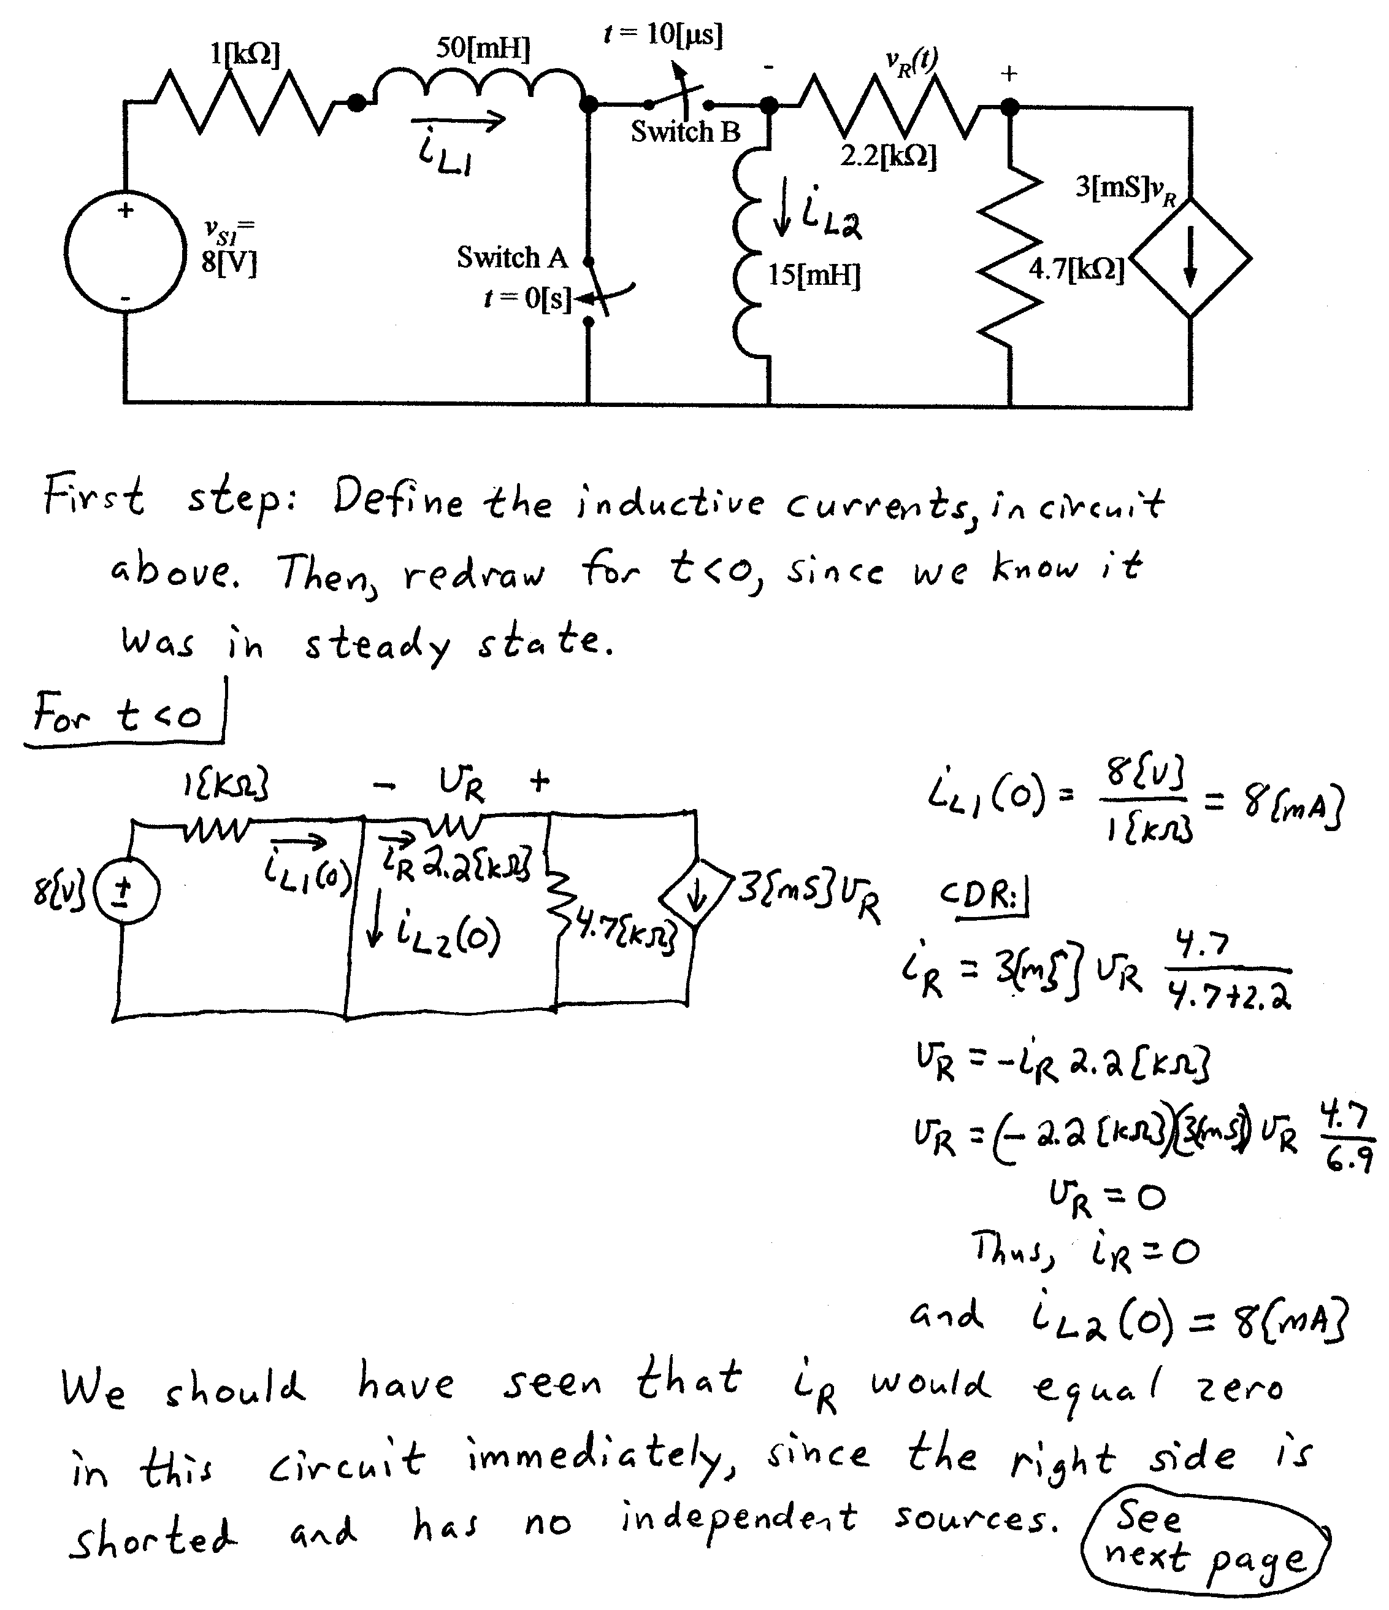
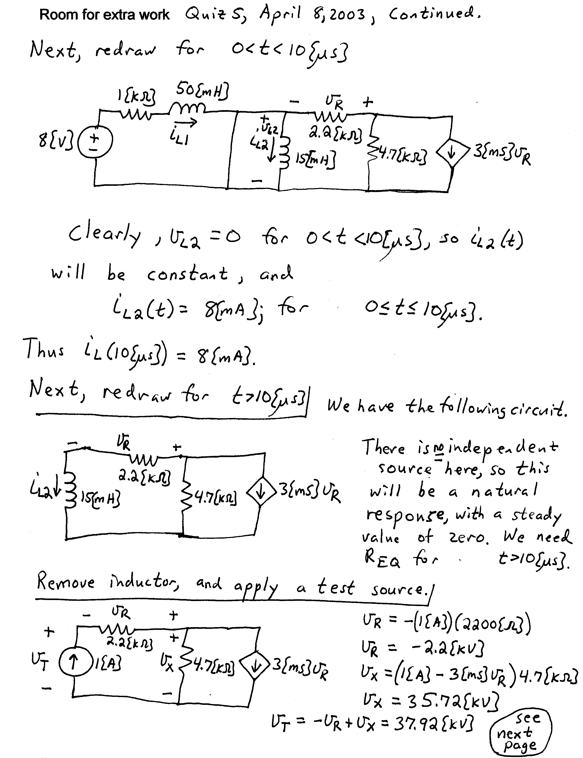
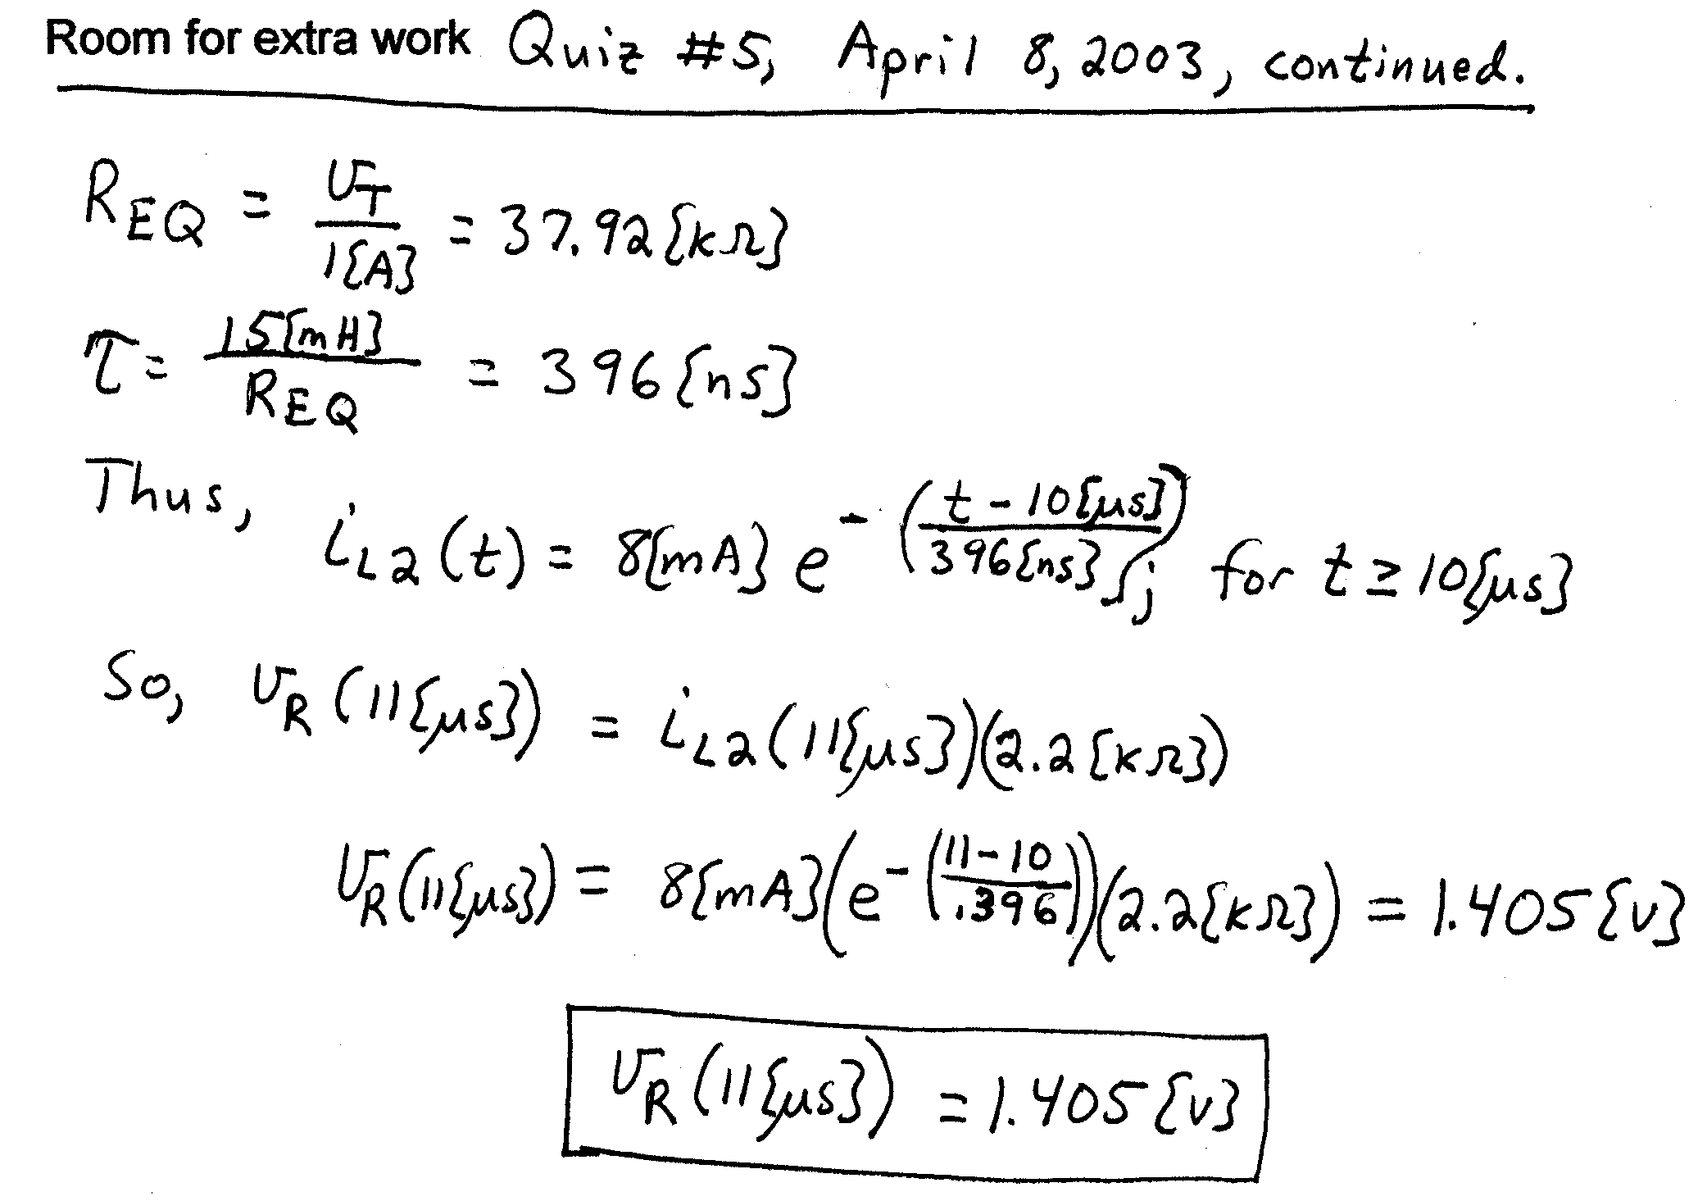

Name: _____________________________ (please print)
Signature: __________________________

ECE 2300 -- Quiz #5
Shattuck Section – TuTh 4-5:30PM
April 10, 2003

Keep this quiz closed and face up until you are told to begin.

1. This quiz is closed book, closed notes. You may use one 8.5” x 11” crib sheet, or its equivalent.
2. Show all work on these pages. Show all work necessary to complete the problem. If you go on to another page, indicate clearly where your work can be found. A solution without the appropriate work shown will receive no credit.
3. Show all units in solutions, intermediate results, and figures. Units in the quiz will be included between square brackets.
4. Do not use red ink. Do not use red pencil.
5. You will have 40 minutes to work on this quiz.

________________/20
Room for extra work
For the circuit shown, Switch A had been closed for a long time, and Switch B had been open for a long time, before t = 0. At t = 0, Switch A opened. Then, 100[ms] later, Switch B closed. Find i_{X}(200[ms]).
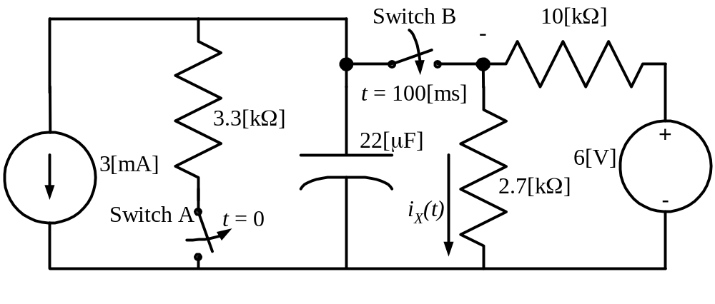

ECE 2300 -- Quiz #5 – April 10, 2003 – 4-5:30PM TuTh Shattuck Section Solution


