Name: _____________________________ (please print)
Signature: __________________________

ECE 2300 -- Quiz #1
Shattuck Section – TuTh 4:00-5:30PM
February 12, 2004

Keep this quiz closed and face up until you are told to begin.

1. This quiz is closed book, closed notes. You may use one 8.5” x 11” crib sheet, or its equivalent.
2. Show all work on these pages. Show all work necessary to complete the problem. If you go on to another page, indicate clearly where your work can be found. A solution without the appropriate work shown will receive no credit.
3. Show all units in solutions, intermediate results, and figures. Units in the quiz will be included between square brackets.
4. Do not use red ink. Do not use red pencil.
5. You will have 25 minutes to work on this quiz.

________________/20
Room for extra work
A device, shown in Figure 1, can be modeled by a current source in parallel with a resistance. The relationship between the current through the device, i_{X}, and the voltage across the device, v_{X}, is given in the plot in Figure 2.
- Find a model for the device that would be valid when current is in the range
1[mA] < i_{X} < 5[mA]. This model must have numerical values for the current and resistance, and the polarities with respect to v_{X} and i_{X} should be shown in a diagram.
- A voltage source is applied across the device so that v_{X} = 10[V]. Find the power delivered by the device in this situation.
Remember to use lower-case variables for voltage and current.

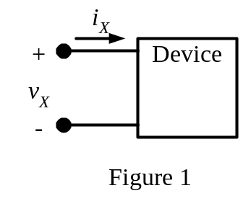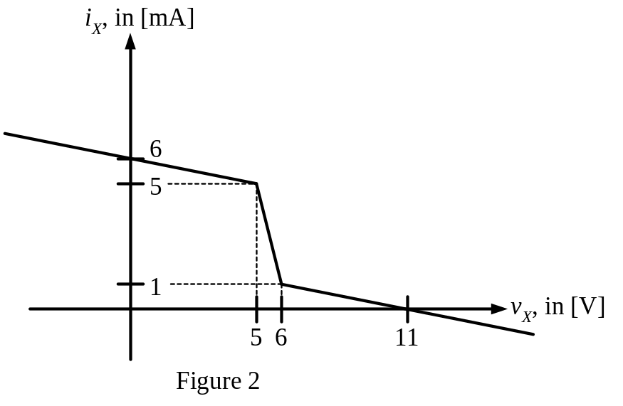
ECE 2300 -- Quiz #1 – February 12, 2004 –4:00 – 5:30PM TuTh Shattuck Section Solution
A device, shown in Figure 1, can be modeled by a current source in parallel with a resistance. The relationship between the current through the device, i_{X}, and the voltage across the device, v_{X}, is given in the plot in Figure 2.
- Find a model for the device that would be valid when current is in the range
1[mA] < i_{X} < 5[mA]. This model must have numerical values for the current and resistance, and the polarities with respect to v_{X} and i_{X} should be shown in a diagram.
- A voltage source is applied across the device so that v_{X} = 10[V]. Find the power delivered by the device in this situation.
Remember to use lower-case variables for voltage and current.

a) The first step in the solution is to draw the model for the device. This is done in the figure that follows.
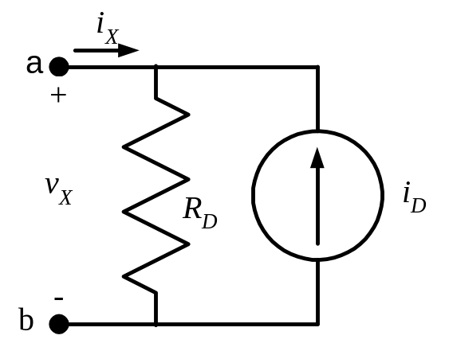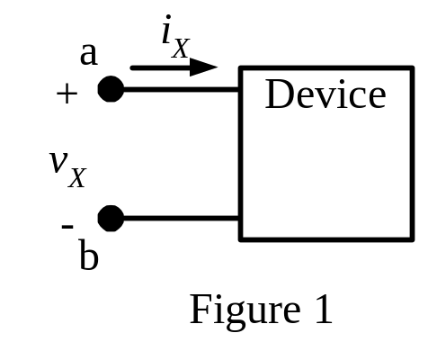
Note that we have named the terminals a and b. It is a good idea to name these terminals in Figure 1 as well, just to be clear.
Now, we can write a KCL for the top node, and we get
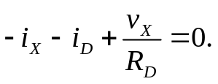
Note that we have really written two equations at once. We wrote an equation for Ohm’s law for the R_{D} resistor, and got an expression for the current going down through that resistor. Then we put that expression in the KCL equation. If you are having difficulty following this, then, please, write two equations, then plug the Ohm’s Law into the KCL. If you do this, then you must define the current through the resistor in the diagram.

Now, for this equation, we can plug in two sets of values that are valid for the region we want the model for, specifically 1[mA] < i_{X} < 5[mA]. The easy values to insert are the end points for this region, 1[mA] and 5[mA]. We do this in the equations
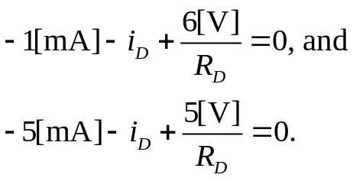
We have two equations in two unknowns, and we can solve to get
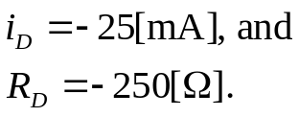
To complete part a), we need to draw the diagram, putting these values in. We get the diagram that follows.
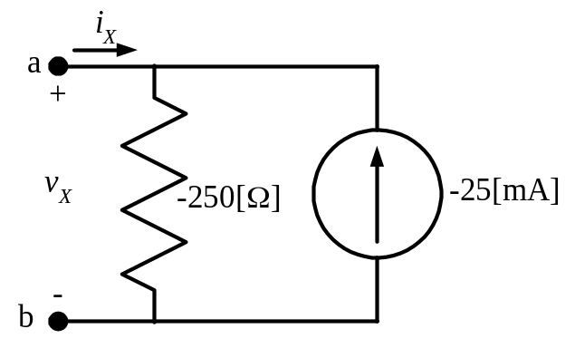

b) First, it is important to recognize that the model we found in part a) is only valid in the range 1[mA] < i_{X} < 5[mA]. Before we use the model we found in part a) by inserting it in part b), we would have to be sure that it is valid at
v_{X} = 10[V]. If you look carefully at the plot in Figure 2, it should be clear that the model is not valid for this value of v_{X}. The straight line for i_{X} as a function of v_{X} is very different where v_{X} = 10[V].

The good news is that we don’t really need to get the model for the device for this value, since we know the value of i_{X} that corresponds to v_{X} = 10[V]. Looking at the plot for Figure 2, which has been duplicated here, it should be clear that when v_{X} = 10[V], i_{X} is equal to +0.2[mA]. (At v_{X} = 10[V], the current has gone down 4/5 of the way from 1 to zero.) Thus, recognizing that i_{X} and v_{X} are defined in the passive sign convention for the device, we can write


