Name: _____________________________ (please print)
Signature: __________________________
Circle your class time: 4:00 – 5:30 PM, TuTh 11:30 AM – 1:00 PM, MW

ECE 2300 -- Exam #1
March 5, 2005

Keep this exam closed until you are told to begin.

1. This exam is closed book, closed notes. You may use one 8.5” x 11” crib sheet, or its equivalent.
2. Show all work on these pages. Show all work necessary to complete the problem. A solution without the appropriate work shown will receive no credit. A solution that is not given in a reasonable order will lose credit. Clearly indicate your answer (for example by enclosing it in a box).
3. It is assumed that your work will begin on the same page as the problem statement. If you choose to begin your work on another page, you must indicate this on the page with the problem statement, with a clear indication of where the work can be found. If your work continues on to another page, indicate clearly where your work can be found. Failure to indicate this clearly will result in a loss of credit.
4. Show all units in solutions, intermediate results, and figures. Units in the exam will be included between square brackets.
5. Do not use red ink. Do not use red pencil.
6. You will have 90 minutes to work on this exam.

1. ________________/1
2. ________________/25
3. ________________/25
4. ________________/25
5. ________________/25
Total = 101
1) {1 Point} On the front page, circle your class time.

Room for extra work
2. {25 Points} The terminal voltage v_{A}(t), and the terminal current i_{A}(t), for the device shown are changing with time. Plots of these two variables are shown in the figures below.
Calculate the energy absorbed by the device during the time interval 0 < t < 3[s].
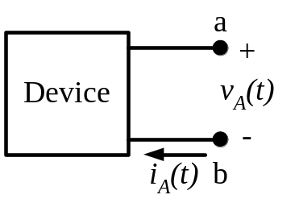
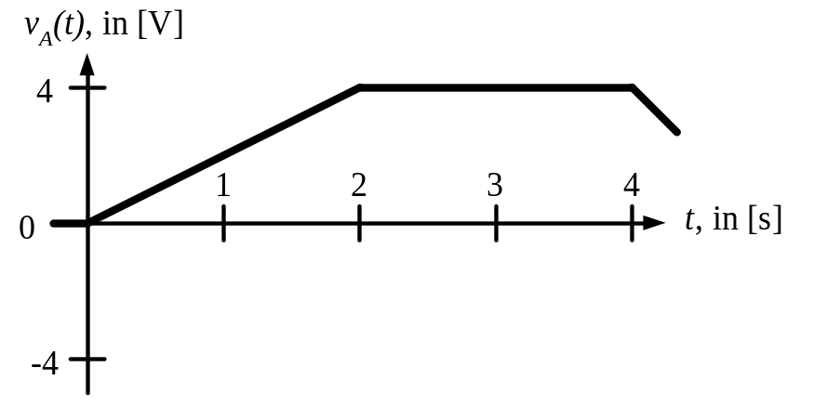
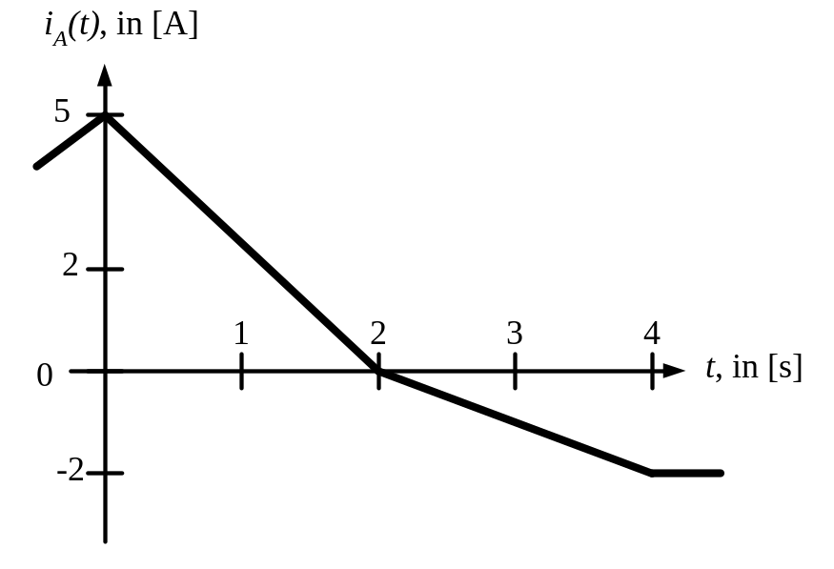

Room for extra work

3. {25 Points} For the circuit shown calculate the numerical value of the power delivered to the circuit by the dependent current source i_{S2}. In your solution technique, use Ohm’s Law and Kirchhoff’s Laws. Do not use other solution methods.
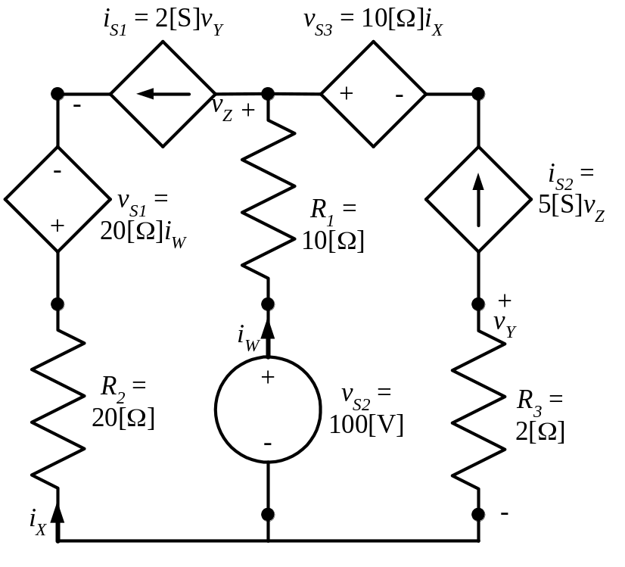

Room for extra work

4. {25 Points} A multi-range voltmeter, shown in Figure 1, is made up of a resistor, R_{V}, and a 10[V] full-scale voltmeter that has a full-scale current of 2[mA]. This multi-range voltmeter is connected in the circuit in Figure 2, where the ammeter has a full scale current of 20[mA], and reads i_{A} = 14.6[mA].
- Find the reading of the multi-range voltmeter on the 80[V] scale.
- Find the power delivered by the ammeter.
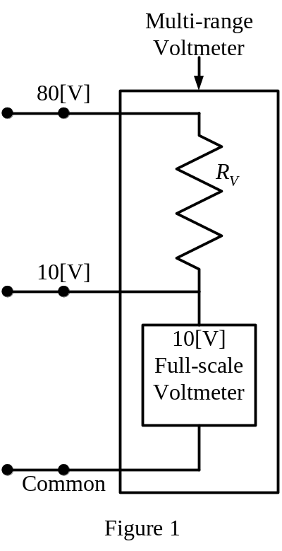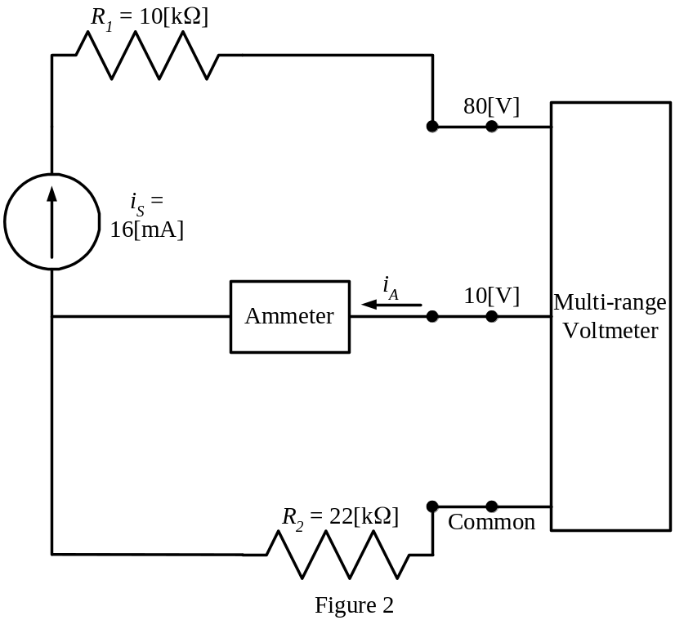

Room for extra work

5. {25 Points} For the given circuit, use the node-voltage method to write a complete set of independent equations that could be used to solve this circuit. Do not simplify the circuit. Do not attempt to solve or simplify your equations. Define all variables. Name all the essential nodes, including your choice of reference node.

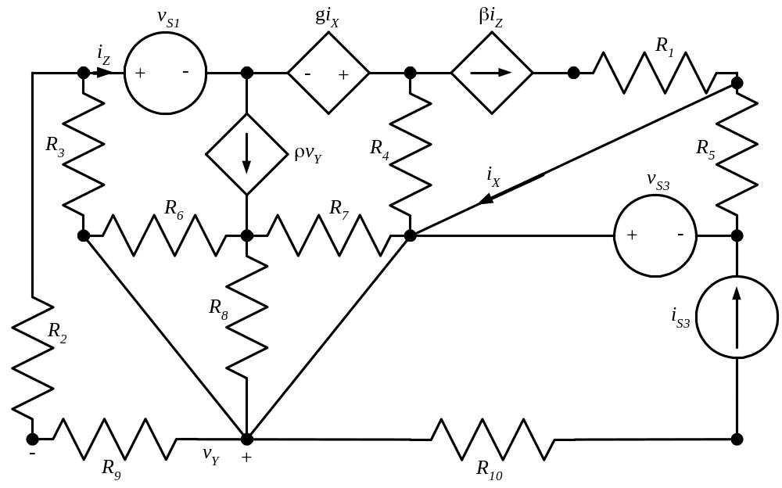

Solution:


