Name: _____________________________ (please print)
Signature: __________________________

ECE 2300 -- Exam #1
March 3, 2007

Keep this exam closed until you are told to begin.

1. This exam is closed book, closed notes. You may use one 8.5” x 11” crib sheet, or its equivalent.
2. Show all work on these pages. Show all work necessary to complete the problem. A solution without the appropriate work shown will receive no credit. A solution that is not given in a reasonable order will lose credit. Clearly indicate your answer (for example by enclosing it in a box).
3. It is assumed that your work will begin on the same page as the problem statement. If you choose to begin your work on another page, you must indicate this on the page with the problem statement, with a clear indication of where the work can be found. If your work continues on to another page, indicate clearly where your work can be found. Failure to indicate this clearly will result in a loss of credit.
4. Show all units in solutions, intermediate results, and figures. Units in the exam will be included between square brackets.
5. Do not use red ink. Do not use red pencil.
6. You will have 90 minutes to work on this exam.

1. ________________/25
2. ________________/35
3. ________________/40
Total = 100
Room for extra work
1. {25 Points} For your solution to this problem, do not use the Node-Voltage Method or the Mesh-Current Method. Use the circuit below to find the numerical value of the following quantities.
a) The power delivered to the circuit by the dependent current source, i_{S1}.
b) The power delivered to the circuit by the independent voltage source v_{S1}.
c) The current i_{W}.

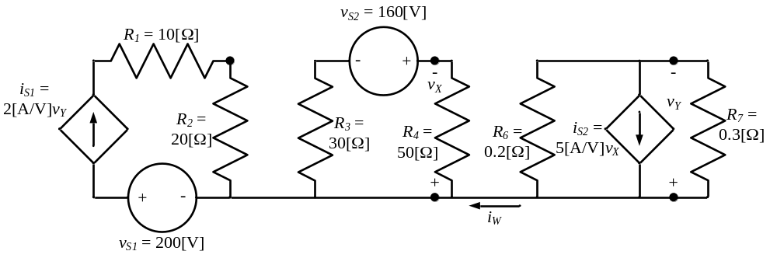

Room for extra work

2. {35 Points} A device can be modeled as a current source in parallel with a resistance.
This device is connected to an ammeter A1 with a full-scale current of 2[A], as shown in Figure 1. The ammeter reads i_{X} = 1.68[A] in this case.
Then, the device is disconnected from this ammeter, and connected to an ammeter A2 with a full-scale current of 5[A], as shown in Figure 2. The ammeter reads i_{Y} = 1.48[A] in this case.
Both ammeters are made with d'Arsonval meter movements with rated values of 2[mA] and 1[V].
Find the power absorbed by the device when it is removed from both ammeters, and connected to a 5[Ω] resistor.
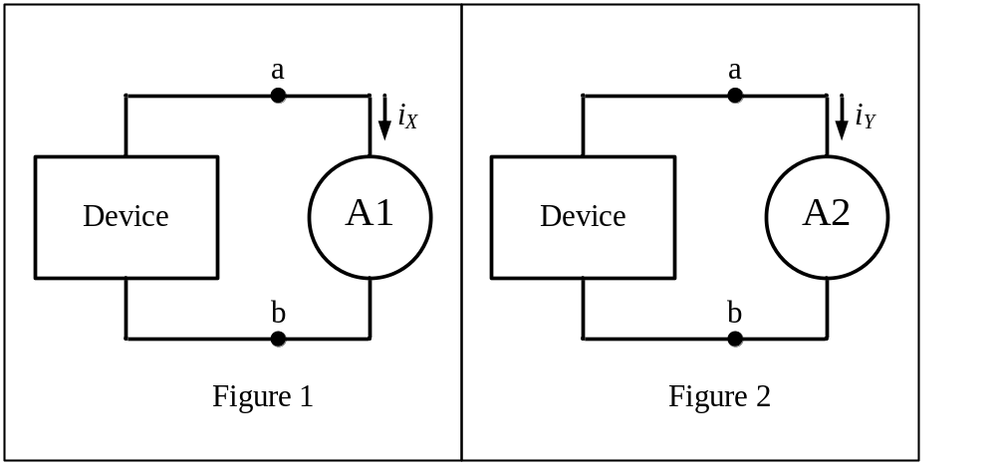

Room for extra work

3. {40 Points} For the given circuit, use the Node-Voltage method to write a complete set of independent equations that could be used to solve this circuit. You only need to write one set of equations. Do not simplify the circuit. Do not attempt to solve or simplify your equations. Define all variables.
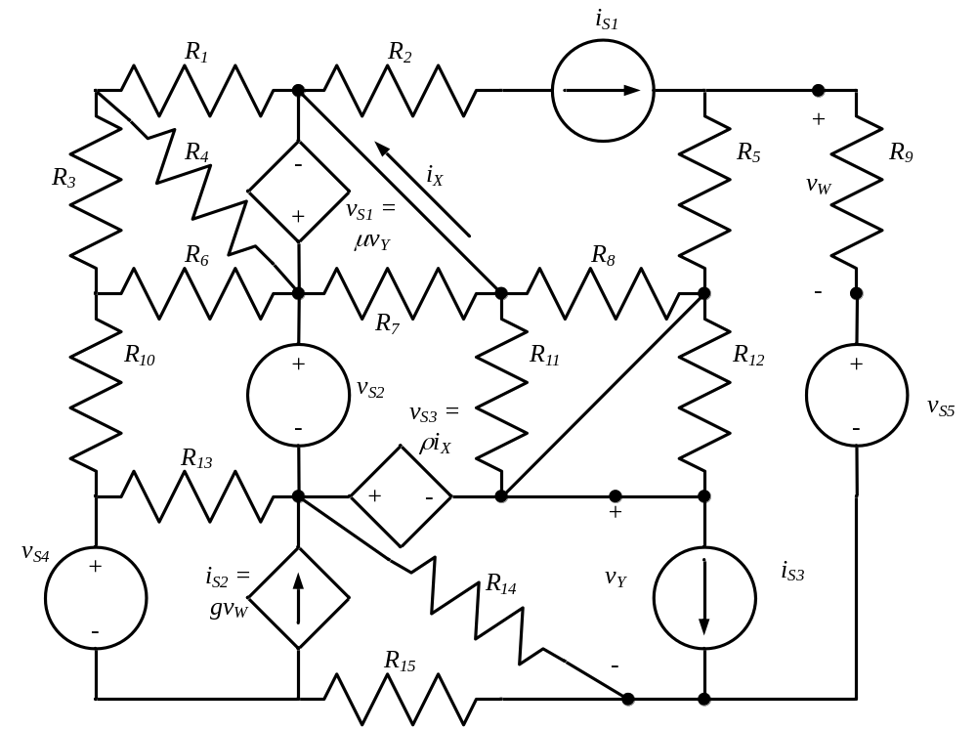

Solution:
1. {25 Points} For your solution to this problem, do not use the Node-Voltage Method or the Mesh-Current Method. Use the circuit below to find the numerical value of the following quantities.
a) The power delivered to the circuit by the dependent current source, i_{S1}.
b) The power delivered to the circuit by the independent voltage source v_{S1}.
c) The current i_{W}.
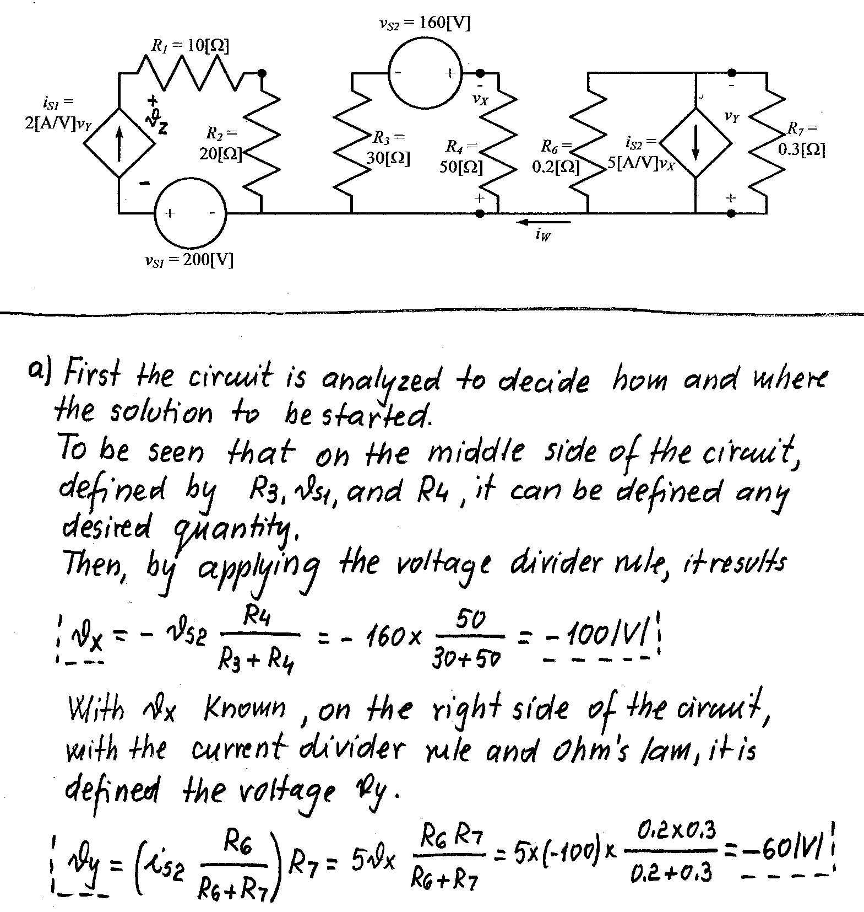
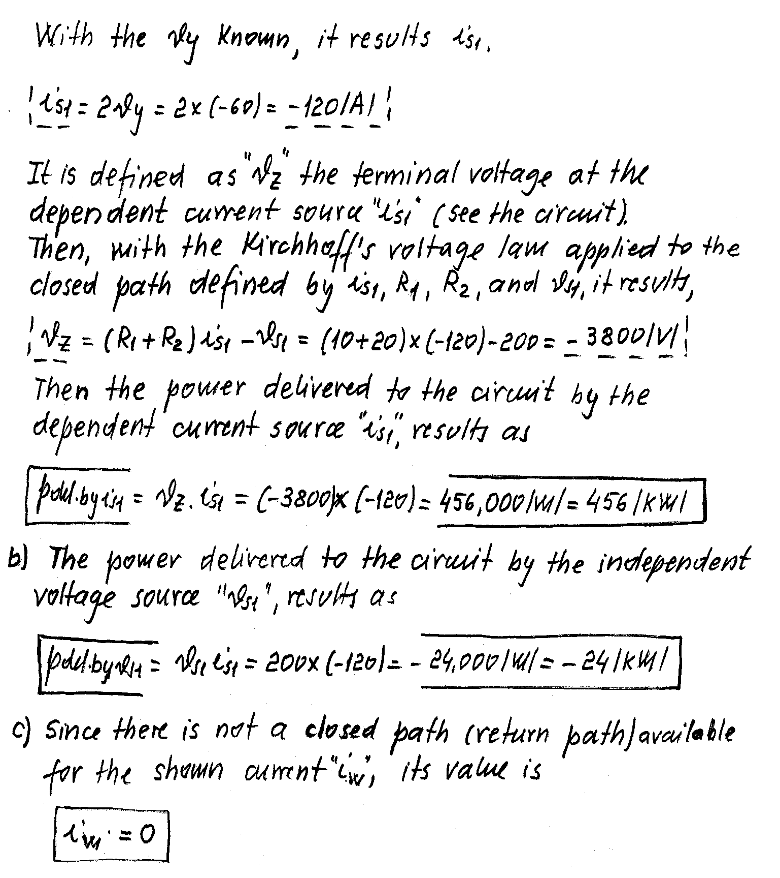

2. {35 Points} A device can be modeled as a current source in parallel with a resistance.
This device is connected to an ammeter A1 with a full-scale current of 2[A], as shown in Figure 1. The ammeter reads i_{X} = 1.68[A] in this case.
Then, the device is disconnected from this ammeter, and connected to an ammeter A2 with a full-scale current of 5[A], as shown in Figure 2. The ammeter reads i_{Y} = 1.48[A] in this case.
Both ammeters are made with d'Arsonval meter movements with rated values of 2[mA] and 1[V].
Find the power absorbed by the device when it is removed from both ammeters, and connected to a 5[Ω] resistor.
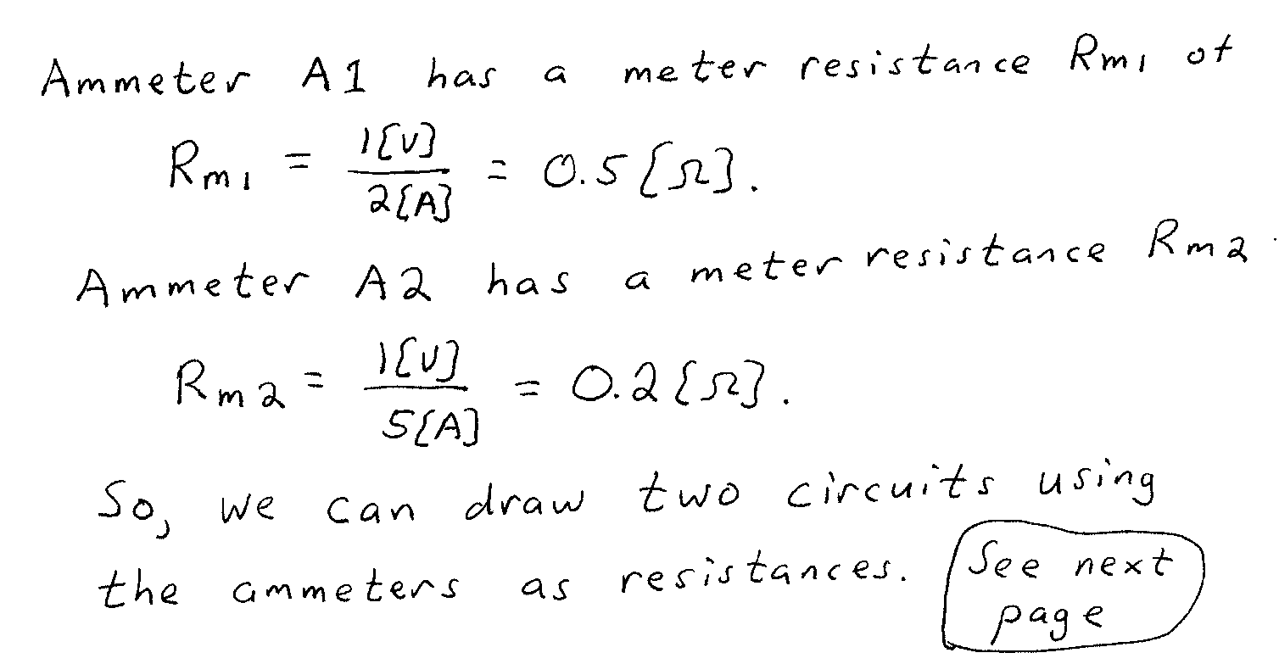
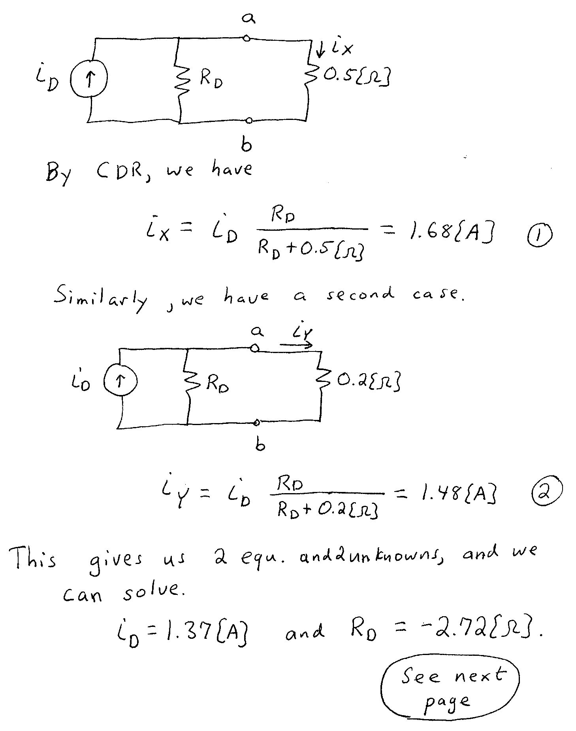
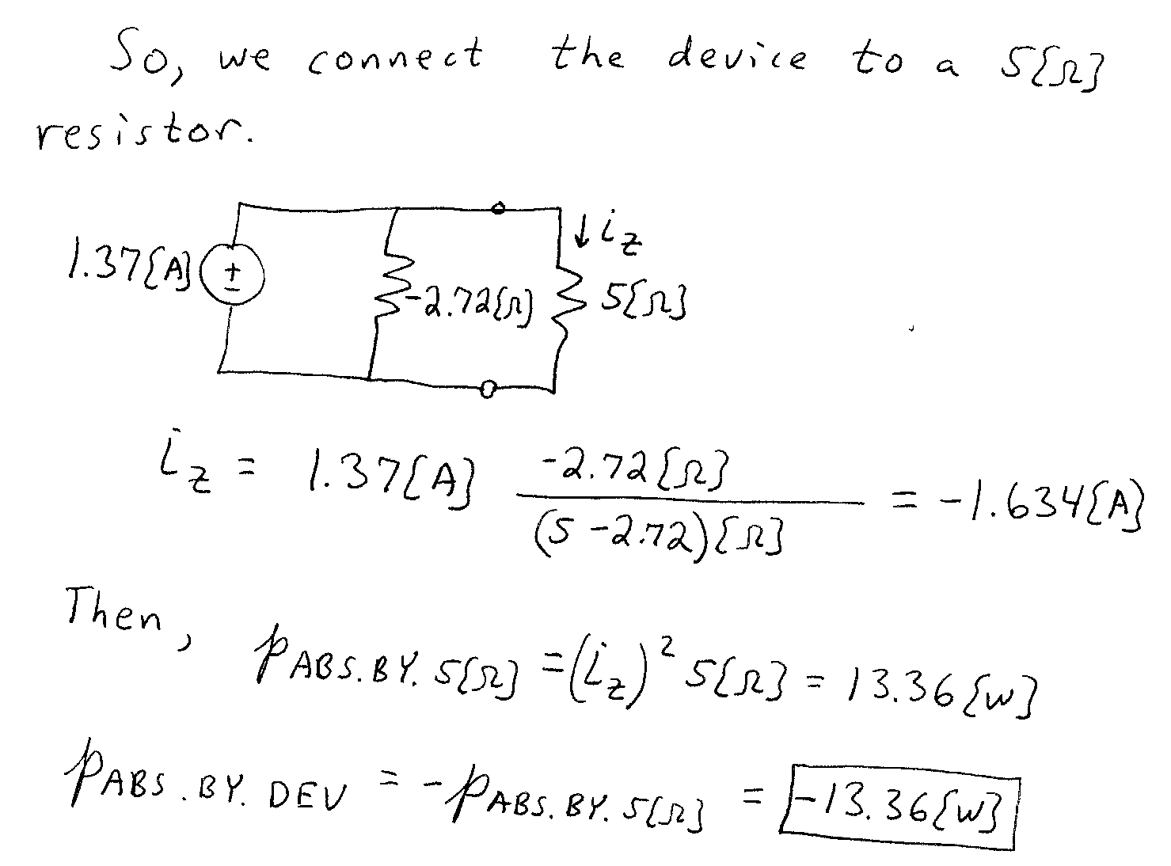

3. {40 Points} For the given circuit, use the Node-Voltage method to write a complete set of independent equations that could be used to solve this circuit. You only need to write one set of equations. Do not simplify the circuit. Do not attempt to solve or simplify your equations. Define all variables.


