Name: _____________________________ (please print)
Signature: __________________________
Section (underline one): Trombetta Shattuck

ECE 2300 – Exam #2
April 14, 2012

Keep this exam closed and face up until you are told to begin.

1. This exam is closed book, closed notes. You may use one 8.5” x 11” crib sheet, or its equivalent.
2. Show all work on these pages. Show all work necessary to complete the problem. A solution without the appropriate work shown will receive no credit. A solution which is not given in a reasonable order will lose credit.
3. It is assumed that your work will begin on the same page as the problem statement. If you choose to begin your work on another page, you must indicate this on the page with the problem statement, with a clear indication of where the work can be found. If your work continues on to another page, indicate clearly where your work can be found. Failure to indicate this clearly will result in a loss of credit.
4. Show all units in solutions, intermediate results, and figures. Units in the exam will be included between square brackets.
5. Do not use red ink. Do not use red pencil.
6. You will have 90 minutes to work on this quiz.

1. ________________/30

2. ________________/35

3. ________________/35

Total________________/100
Room for extra work

1. (30 points) Use either the node voltage method or the mesh current method to write a complete set of equations that could be used to solve the circuit below. Do not simplify the circuit. Do not attempt to solve the equations. You must define all circuit variables.

Room for extra work

2. (35 points) For the circuit shown below, do the following.

a) Find the Thevenin equivalent circuit as seen by the current source i_{S1}. Draw the equivalent circuit. Clearly label the equivalent circuit parameters, and show how it is connected to the current source.
b) Find the power absorbed by the current source i_{S1} in this circuit.

Room for extra work

3. (35 points) In the circuit below, the switch SW1 was in the left-most position for a long time, and switch SW2 was closed for a long time. At t = 0, switch SW1 moved to the right-most position. At t = 300 [μs], switch SW2 opened. Find expressions for v_{C}(t) for t $≥$ 0.

Solution:
1. (30 points) Use either the node voltage method or the mesh current method to write a complete set of equations that could be used to solve the circuit below. Do not simplify the circuit. Do not attempt to solve the equations. You must define all circuit variables.
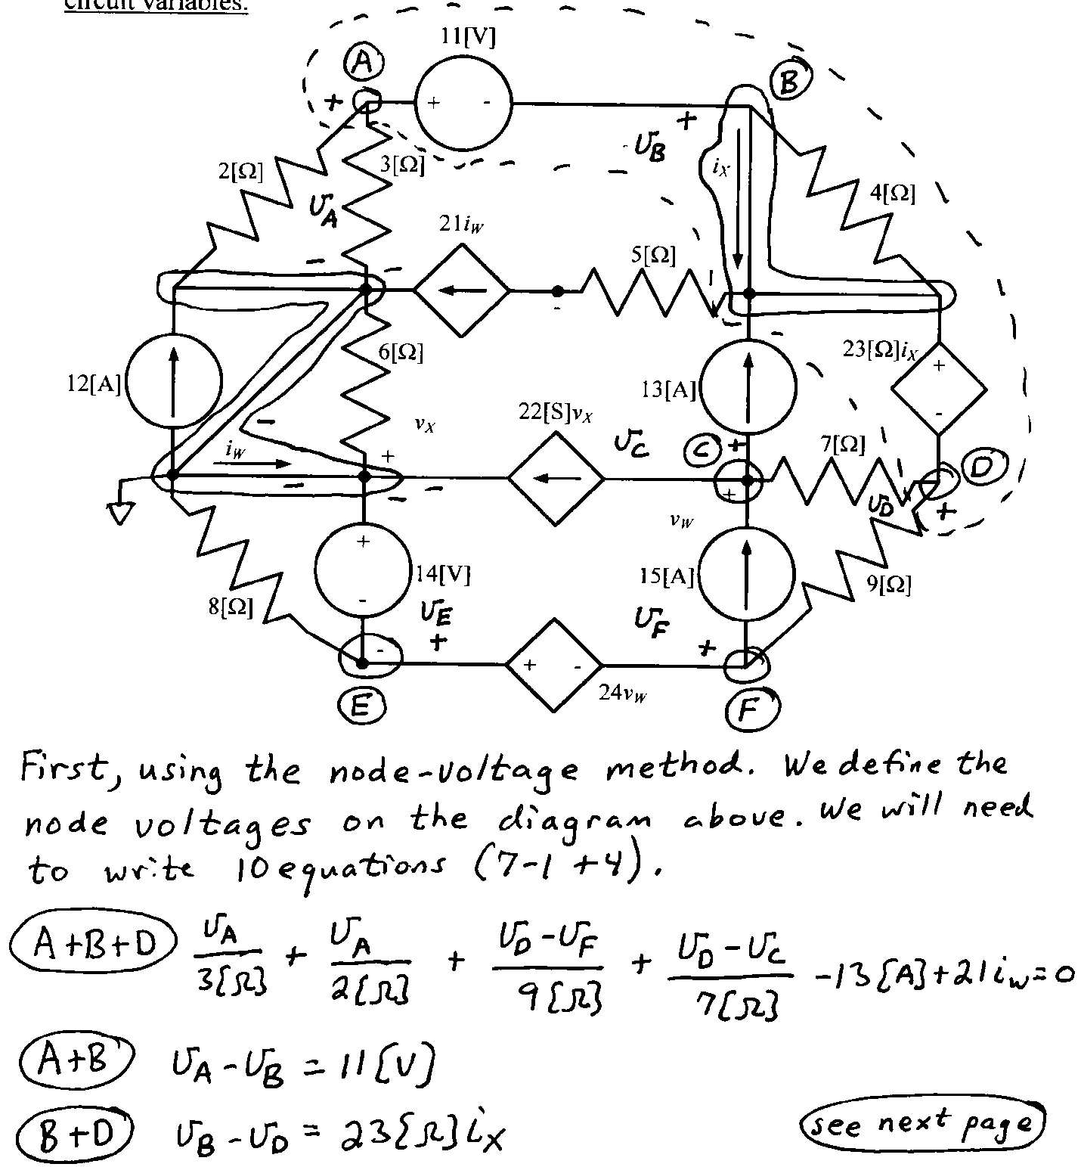
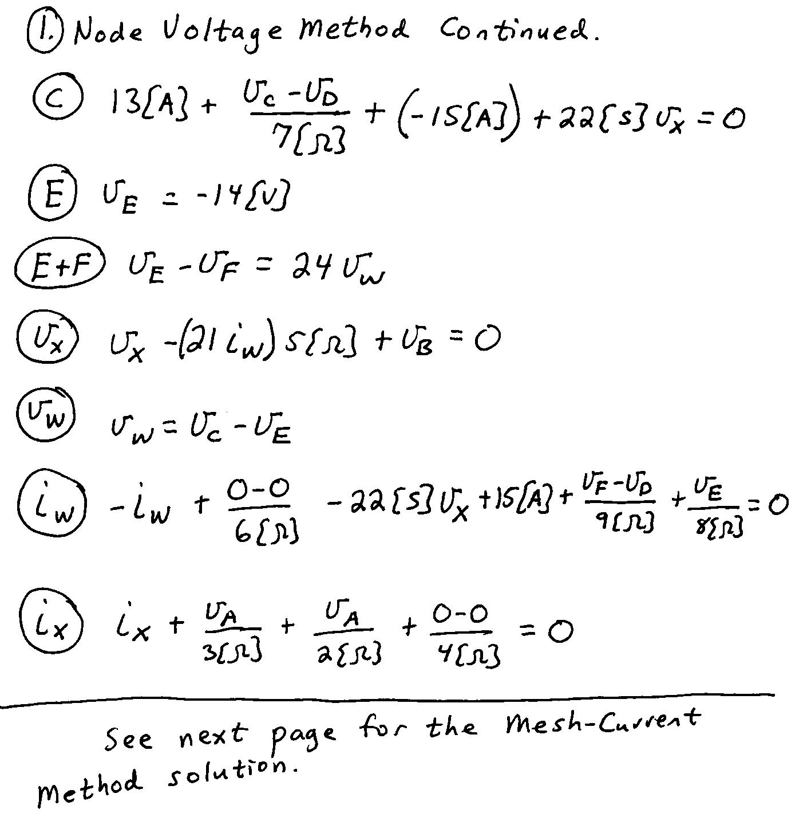
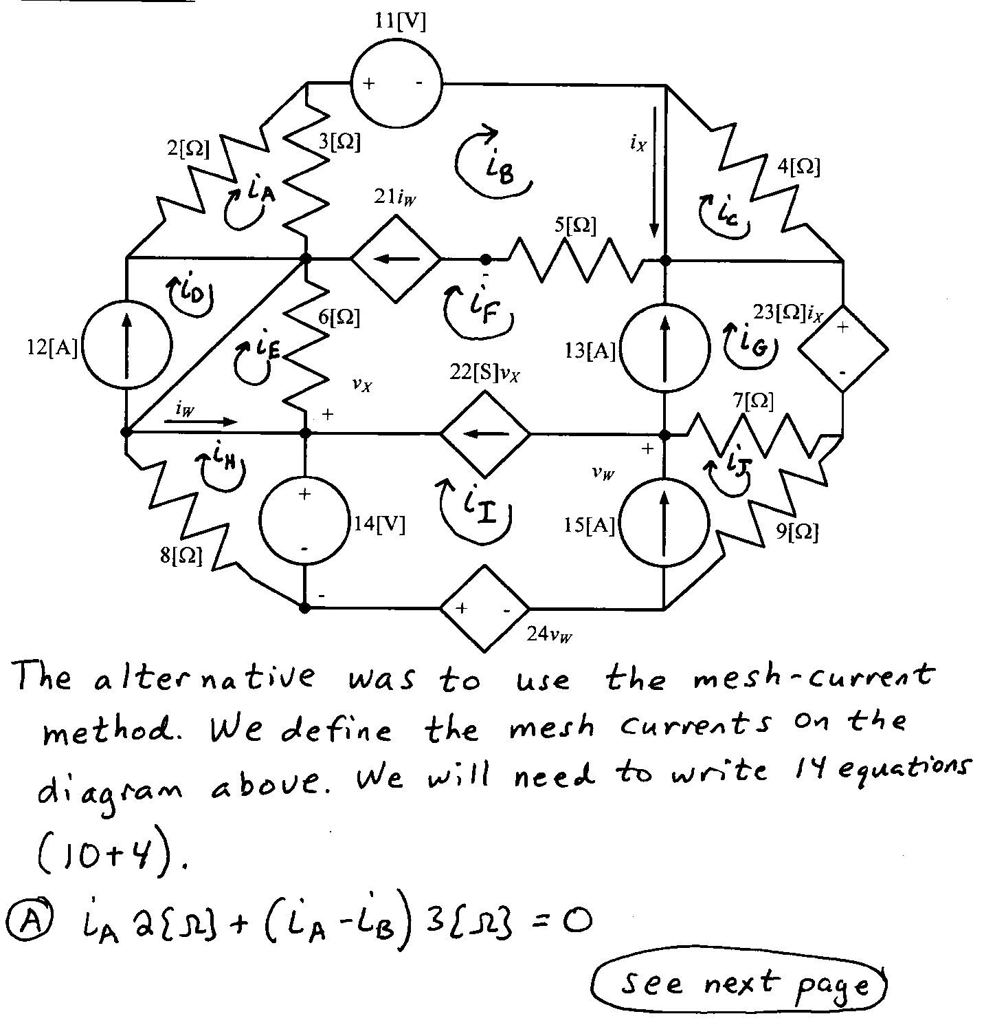
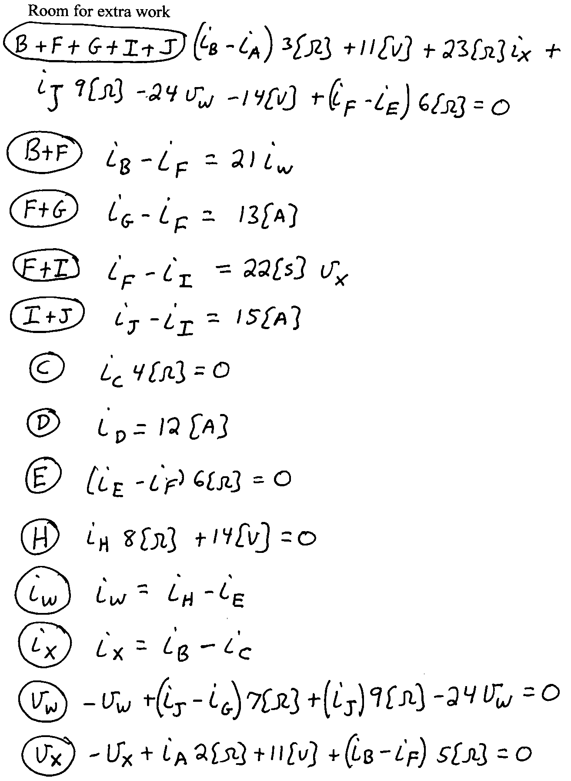

2. (35 points) For the circuit shown below, do the following.

a) Find the Thevenin equivalent circuit as seen by the current source i_{S1}. Draw the equivalent circuit. Clearly label the equivalent circuit parameters, and show how it is connected to the current source.
b) Find the power absorbed by the current source i_{S1} in this circuit.
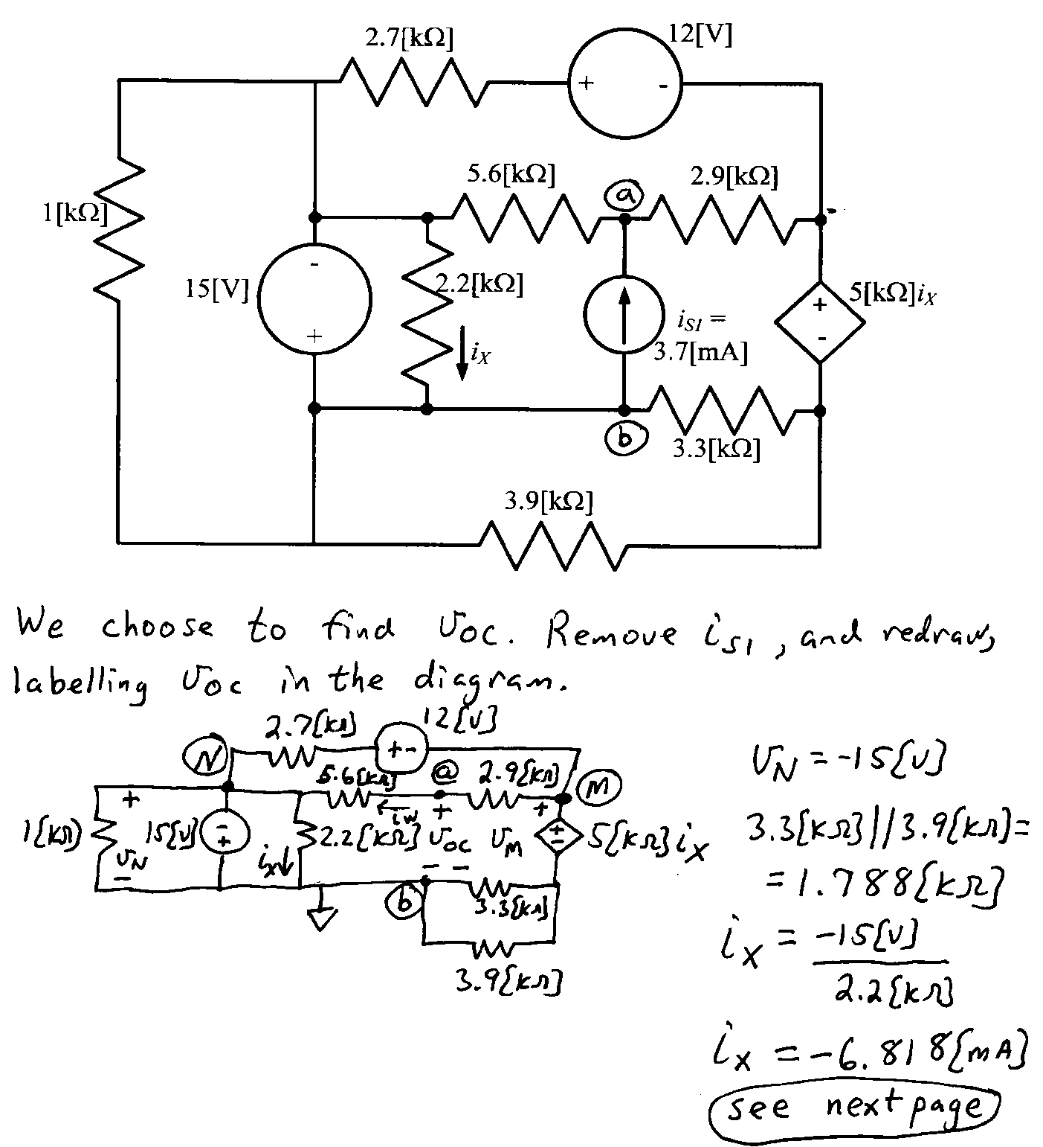
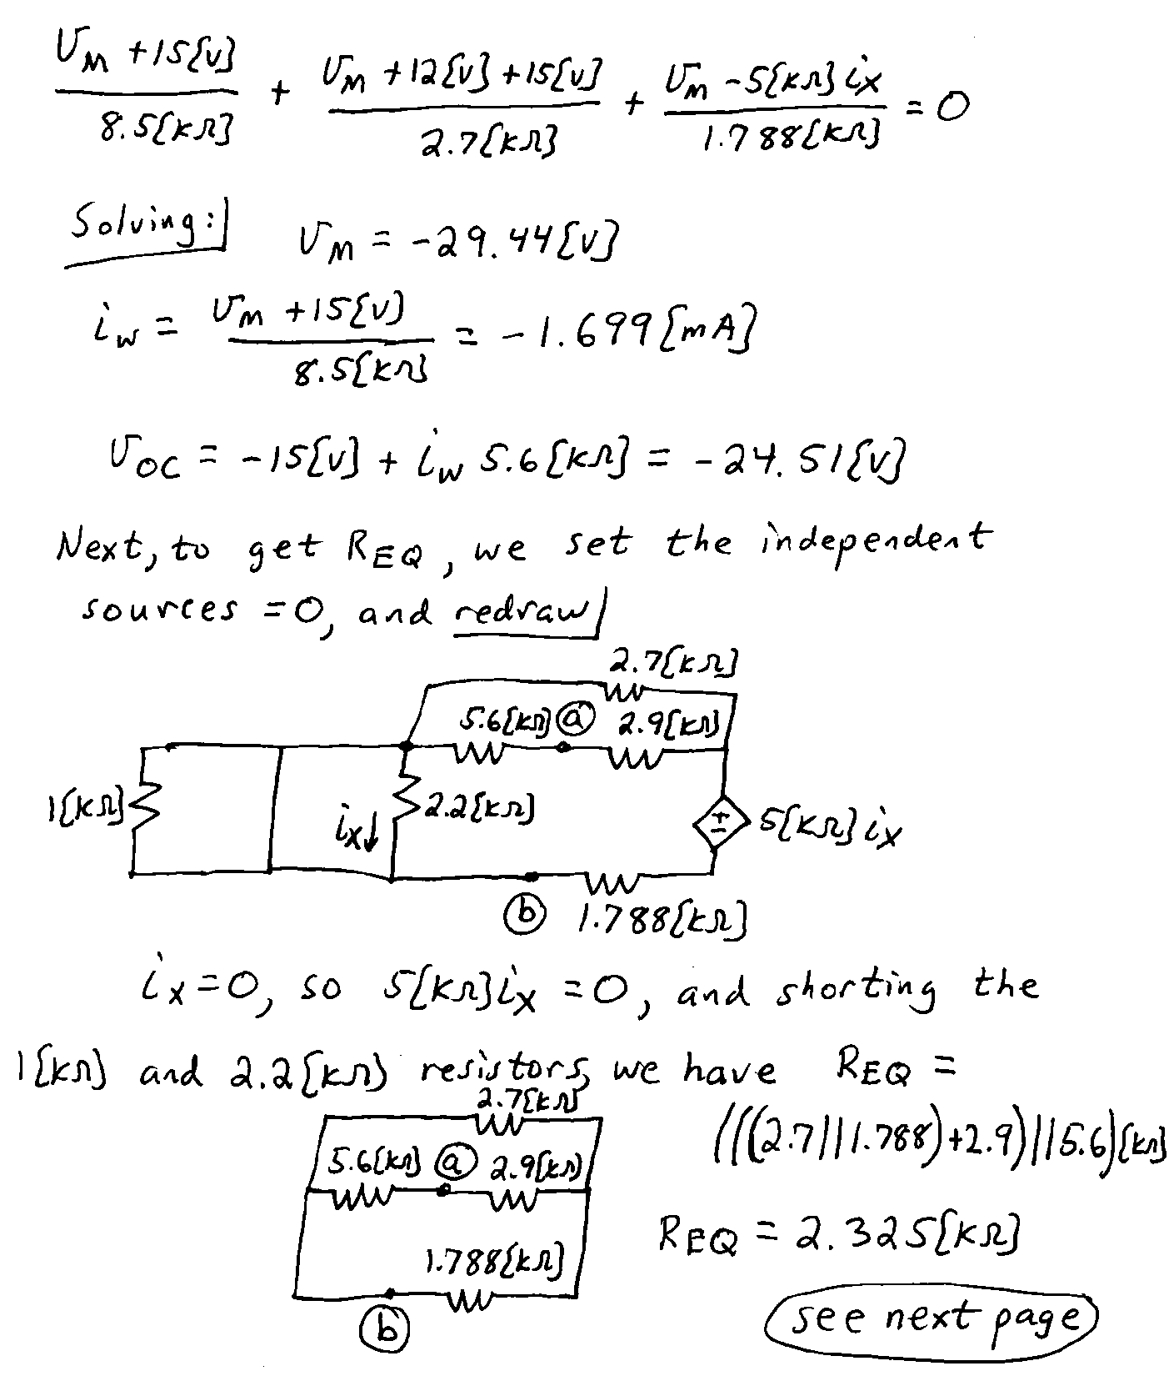

3. (35 points) In the circuit below, the switch SW1 was in the left-most position for a long time, and switch SW2 was closed for a long time. At t = 0, switch SW1 moved to the right-most position. At t = 300 [μs], switch SW2 opened. Find expressions for v_{C}(t) for t $≥$ 0.

