Name: _____________________________ (please print)

Signature: __________________________

ECE 2300 -- Exam #1

March 1, 2014

Keep this exam closed until you are told to begin.

1. This exam is closed book, closed notes. You may use one 8.5” x 11” crib sheet, or its equivalent.

2. Show all work on these pages. Show all work necessary to complete the problem. A solution without the appropriate work shown will receive no credit. A solution that is not given in a reasonable order will lose credit. Clearly indicate your answer (for example by enclosing it in a box).

3. It is assumed that your work will begin on the same page as the problem statement. If you choose to begin your work on another page, you must indicate this on the page with the problem statement, with a clear indication of where the work can be found. **If your work continues on to another page, indicate clearly where your work can be found. Failure to indicate this clearly will result in a loss of credit.**

4. Show all units in solutions, intermediate results, and figures. Units in the exam will be included between square brackets.

5. Do not use red ink. Do not use red pencil.

6. You will have 90 minutes to work on this exam.

1. ________________/30

2. ________________/30

3. ________________/40

Total = 100

Room for extra work

1. {30 Points} Use the circuit shown below to solve this problem. Show your steps in some clear fashion. You are strongly encouraged to redraw the diagram as needed to make your work more clear.

a. Find the equivalent resistance with respect to terminals A and C.

b. Find the equivalent resistance as seen by terminals A and B.



# Room for extra work

2. {30 Points} A d'Arsonval-based multi-range ammeter is shown in Figure 1. The rated values for the d'Arsonval meter movement are given as *vd'A,rated* = 50[mV] and *id'A,rated* = 1[mA]. At any given time, the common terminal and one of the other terminals is used to measure current. For any given measurement, consider that a positive current is entering the terminal named for the full-scale value, and leaving the Common terminal.

Specify the values of *R1*, *R2* and *R3* for the three current ranges shown in Figure 1.



Room for extra work 3. {40 Points} A device can be modeled using a voltage source in series with a resistance. That device is shown in Figure 1. A set of resistors were connected to the terminals of the device, one at a time, and the voltage at the device terminals, *vD*, was measured in each case. The results are shown in Table 1.

a. Find the device model, and redraw it showing terminals a and b.

Two identical versions of this device are connected to a circuit using terminals a and b to show the polarity, as shown in Figure 2.

b. Find the power delivered by *vS3*.



Room for extra work

Solutions:

1. {30 Points} Use the circuit shown below to solve this problem. Show your steps in some clear fashion. You are strongly encouraged to redraw the diagram as needed to make your work more clear.

a. Find the equivalent resistance with respect to terminals A and C.

b. Find the equivalent resistance as seen by terminals A and B.

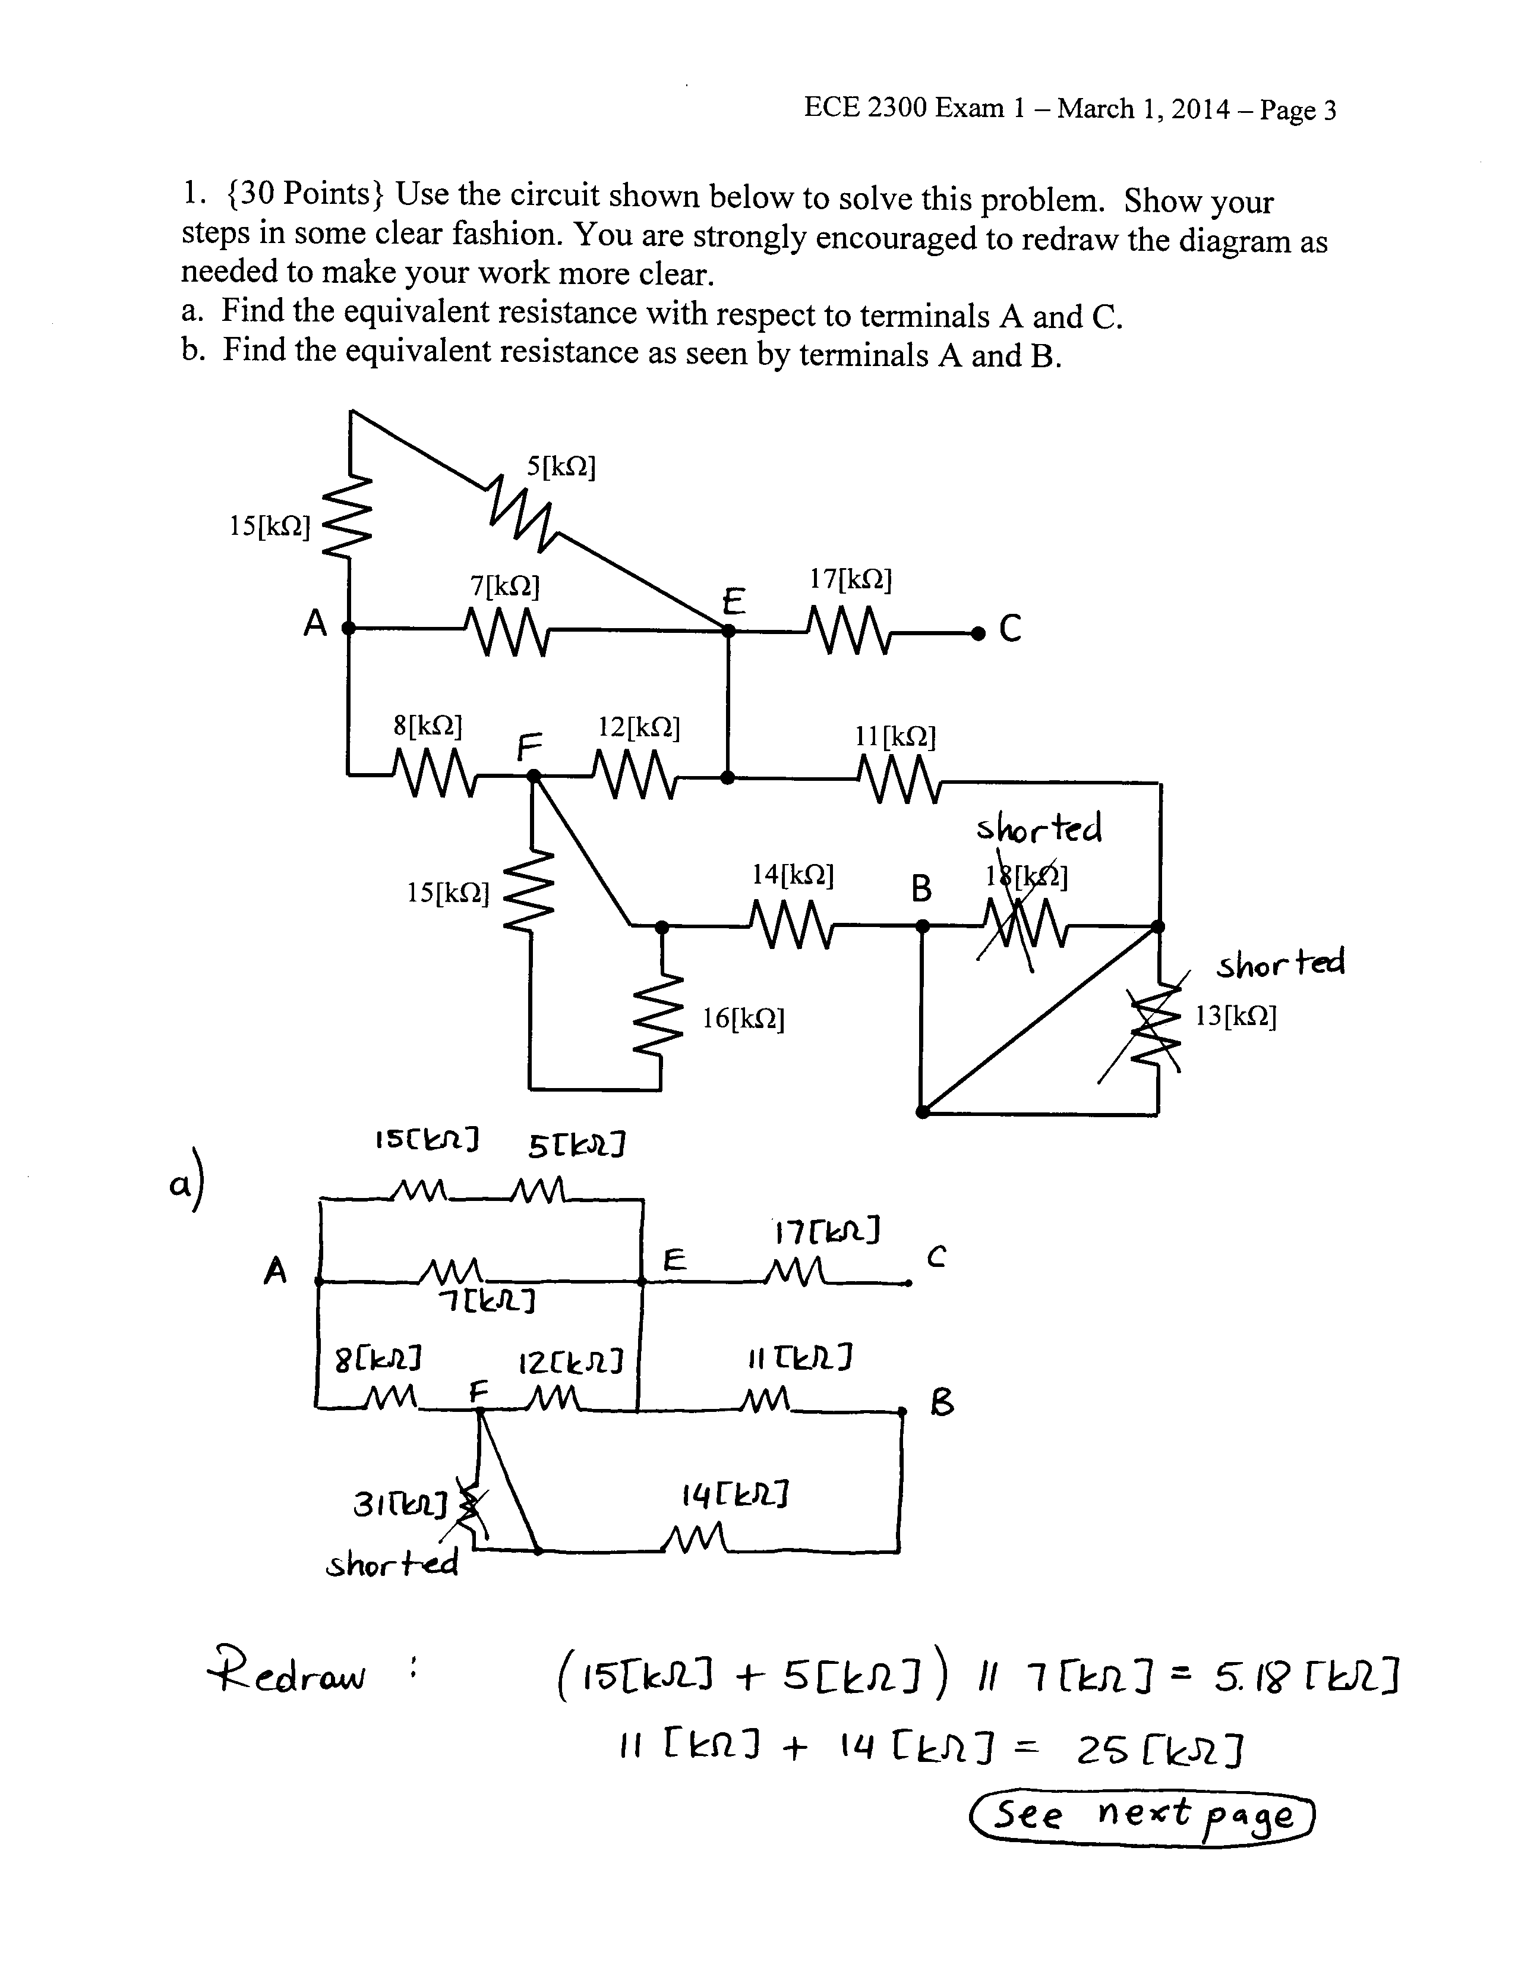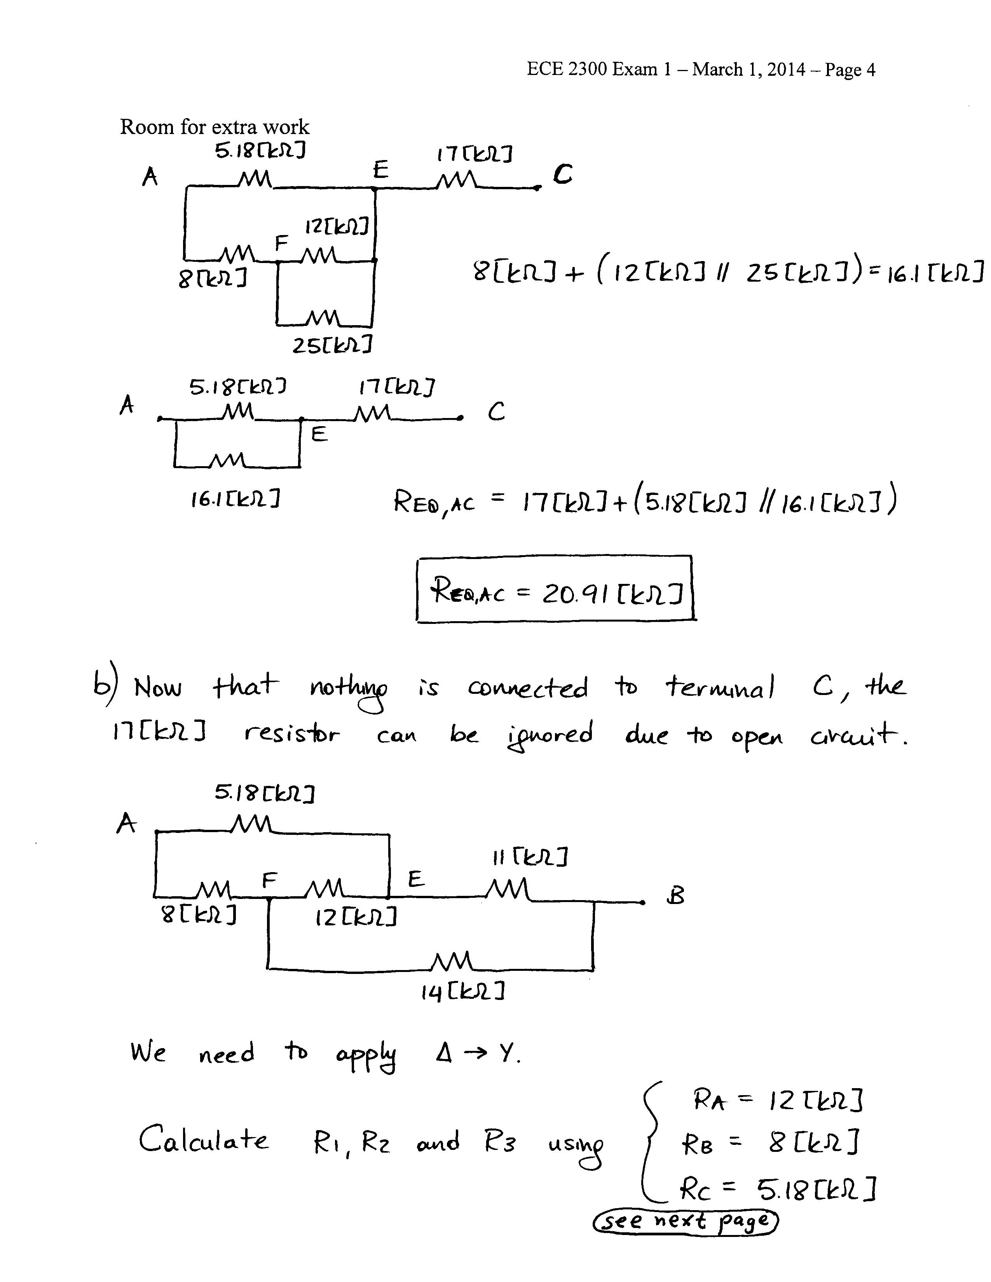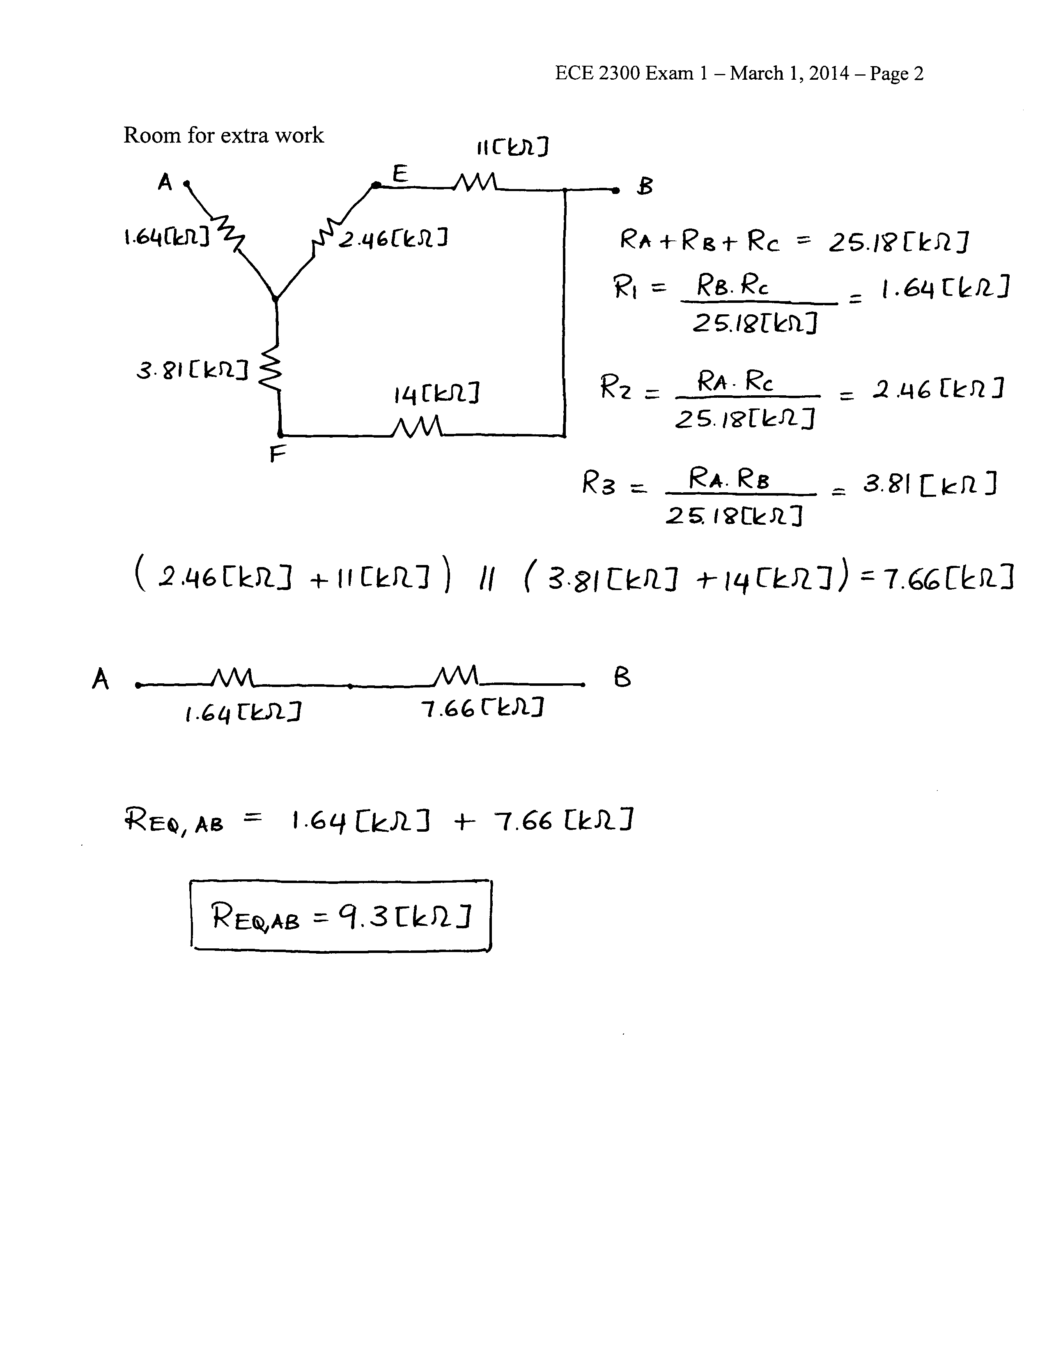

# 2. {30 Points} A d'Arsonval-based multi-range ammeter is shown in Figure 1. The rated values for the d'Arsonval meter movement are given as *vd'A,rated* = 50[mV] and *id'A,rated* = 1[mA]. At any given time, the common terminal and one of the other terminals is used to measure current. For any given measurement, consider that a positive current is entering the terminal named for the full-scale value, and leaving the Common terminal.

Specify the values of *R1*, *R2* and *R3* for the three current ranges shown in Figure 1.

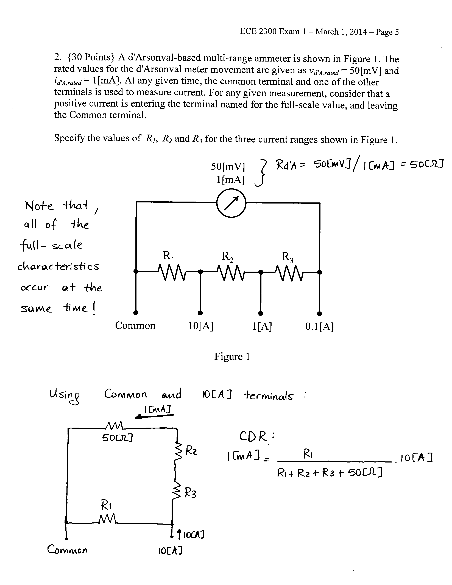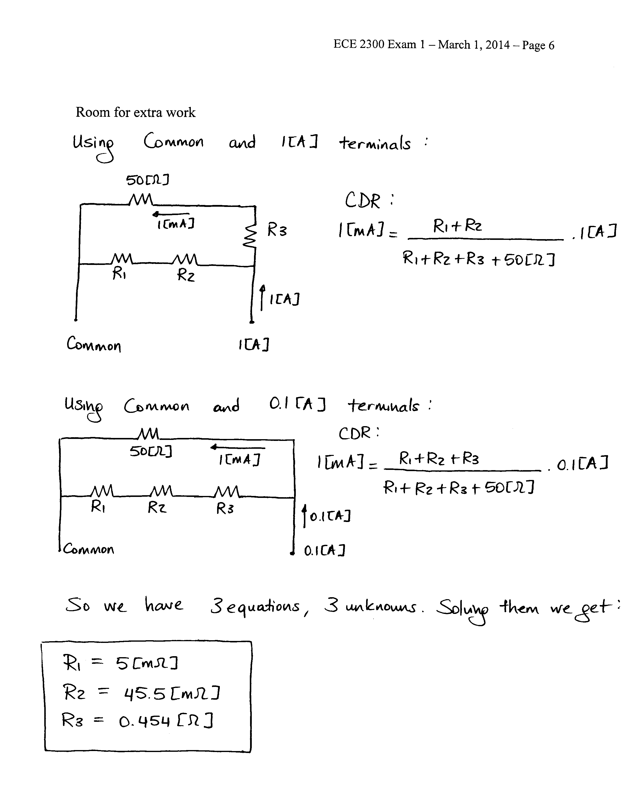

3. {40 Points} A device can be modeled using a voltage source in series with a resistance. That device is shown in Figure 1. A set of resistors were connected to the terminals of the device, one at a time, and the voltage at the device terminals, *vD*, was measured in each case. The results are shown in Table 1.

a. Find the device model, and redraw it showing terminals a and b.

Two identical versions of this device are connected to a circuit using terminals a and b to show the polarity, as shown in Figure 2.

b. Find the power delivered by *vS3*.

