Name: \_\_\_\_\_\_\_\_\_\_\_\_\_\_\_\_\_\_\_\_\_\_\_\_\_\_\_\_\_ (please print)

Signature: \_\_\_\_\_\_\_\_\_\_\_\_\_\_\_\_\_\_\_\_\_\_\_\_\_\_

ECE 2300 – Final Exam

May 3, 2014

Keep this exam closed until you are told to begin.

1. This exam is closed book, closed notes. You may use one 8.5” x 11” crib sheet, or its equivalent.

2. Show all work on these pages. Show all work necessary to complete the problem. A solution without the appropriate work shown will receive no credit. A solution that is not given in a reasonable order will lose credit. Clearly indicate your answer (for example by enclosing it in a box).

3. It is assumed that your work will begin on the same page as the problem statement. If you choose to begin your work on another page, you must indicate this on the page with the problem statement, with a clear indication of where the work can be found. **If your work continues on to another page, indicate clearly where your work can be found. Failure to indicate this clearly will result in a loss of credit.**

4. Show all units in solutions, intermediate results, and figures. Units in the exam will be included between square brackets.

5. Do not use red ink. Do not use red pencil.

6. You will have 170 minutes to work on this exam.

1. \_\_\_\_\_\_\_\_\_\_\_\_\_\_\_\_/20

2. \_\_\_\_\_\_\_\_\_\_\_\_\_\_\_\_/30

3. \_\_\_\_\_\_\_\_\_\_\_\_\_\_\_\_/35

4. \_\_\_\_\_\_\_\_\_\_\_\_\_\_\_\_/40

5. \_\_\_\_\_\_\_\_\_\_\_\_\_\_\_\_/35

6. \_\_\_\_\_\_\_\_\_\_\_\_\_\_\_\_/40

Total = 200

Room for extra work

1. {20 Points}

a) Find the equivalent resistance as seen from terminals A and B.

b) Find the equivalent resistance as seen from terminals C and D.

Show clearly the steps you used to find your solution, especially with intermediate diagrams.

final_q1.emf

Room for extra work

2. {30 Points} Use either the node-voltage method, or the mesh-current method, to write a complete set of equations that could be used to solve this circuit. Do not do both. Do not simplify the circuit. Do not attempt to simplify or solve your equations. Define all variables clearly.

final_q2.emf

Room for extra work

3. {35 Points} A multi-range voltmeter is shown in Figure 1. The meter has full scale voltages of 10[V], and 50[V]. The voltmeter is connected to the circuit shown in Figure 2 by using the 50[V] and Common terminals.

a) Find the Norton equivalent of the circuit shown in Figure 2, as seen by the voltmeter. Draw your Norton equivalent circuit, labeling all components with numerical values.

b) Find the reading of the multi-range voltmeter on the 10[V] scale.

final_q3_v3.emf

# Room for extra work

4. {40 Points} The switches in the circuit below had been open for a long time before *t=*0. At *t=*0, switch SWA closed. Then at *t=*5[ms], switch SWB closed.

a) Find .

b) Find *.*

c) Find the energy stored in *L2* at *t=*10[ms].

final_q4.emf

Room for extra work

5. {35 Points} The circuit shown is in steady state.

final_q5.emf

a) Find *CX* so that the Subcircuit A will be purely resistive.

b) For the value of CX you found in part a), find $i_{X}(t)$. If you cannot find *CX* in part a), then use *CX* .Room for extra work

6. {40 Points} The circuit had been in steady-state until switch SW1 opened and SW2 closed at t =0. Find the value of .

final_q6.emf

Room for extra work

Solutions:

1. {20 Points}

a) Find the equivalent resistance as seen from terminals A and B.

b) Find the equivalent resistance as seen from terminals C and D.

Show clearly the steps you used to find your solution, especially with intermediate diagrams.

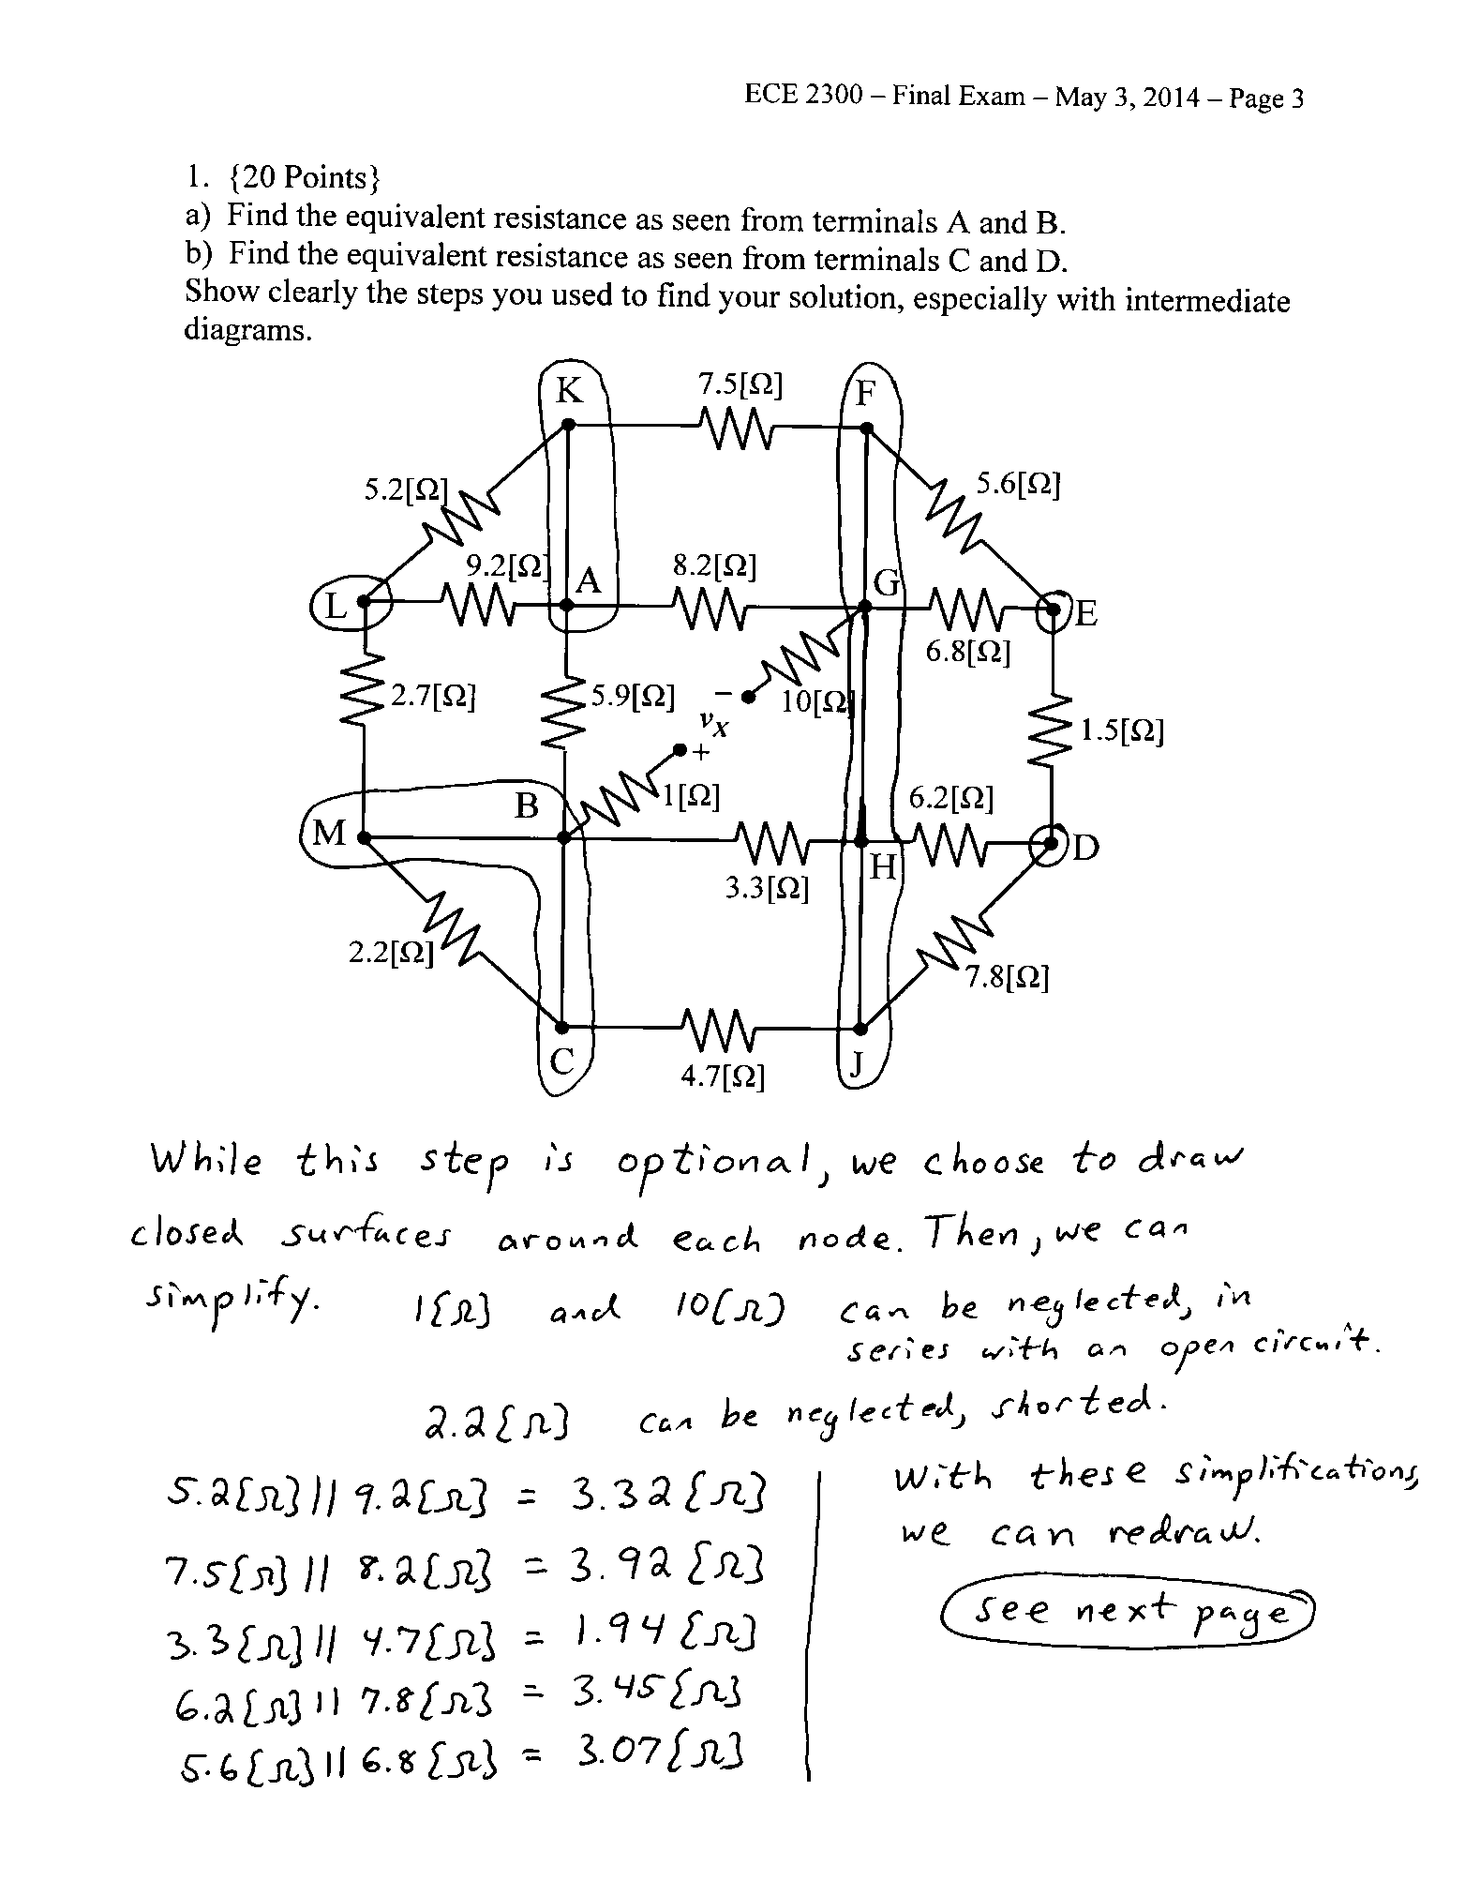

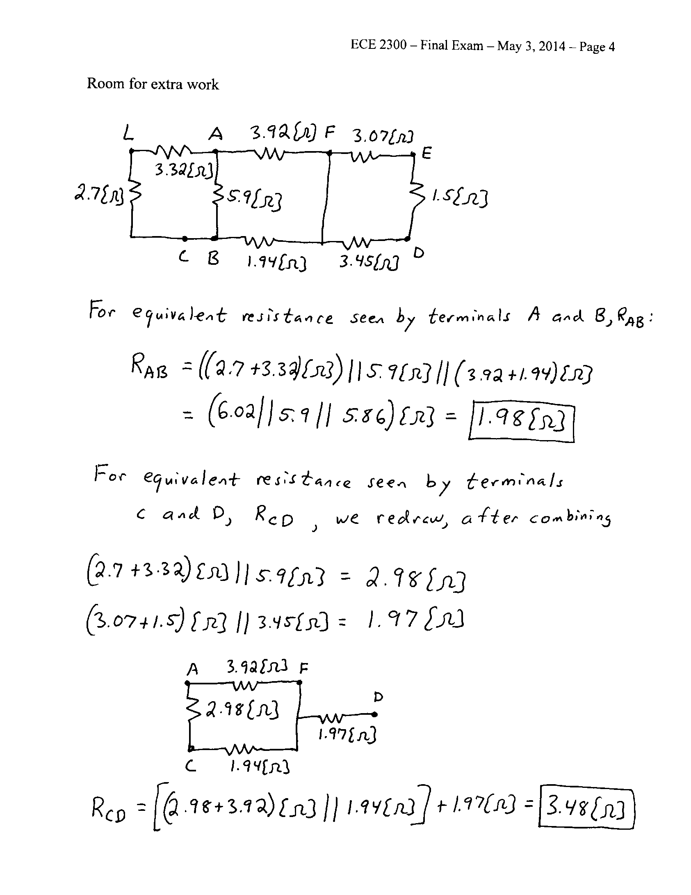

2. {30 Points} Use either the node-voltage method, or the mesh-current method, to write a complete set of equations that could be used to solve this circuit. Do not do both. Do not simplify the circuit. Do not attempt to simplify or solve your equations. Define all variables clearly.

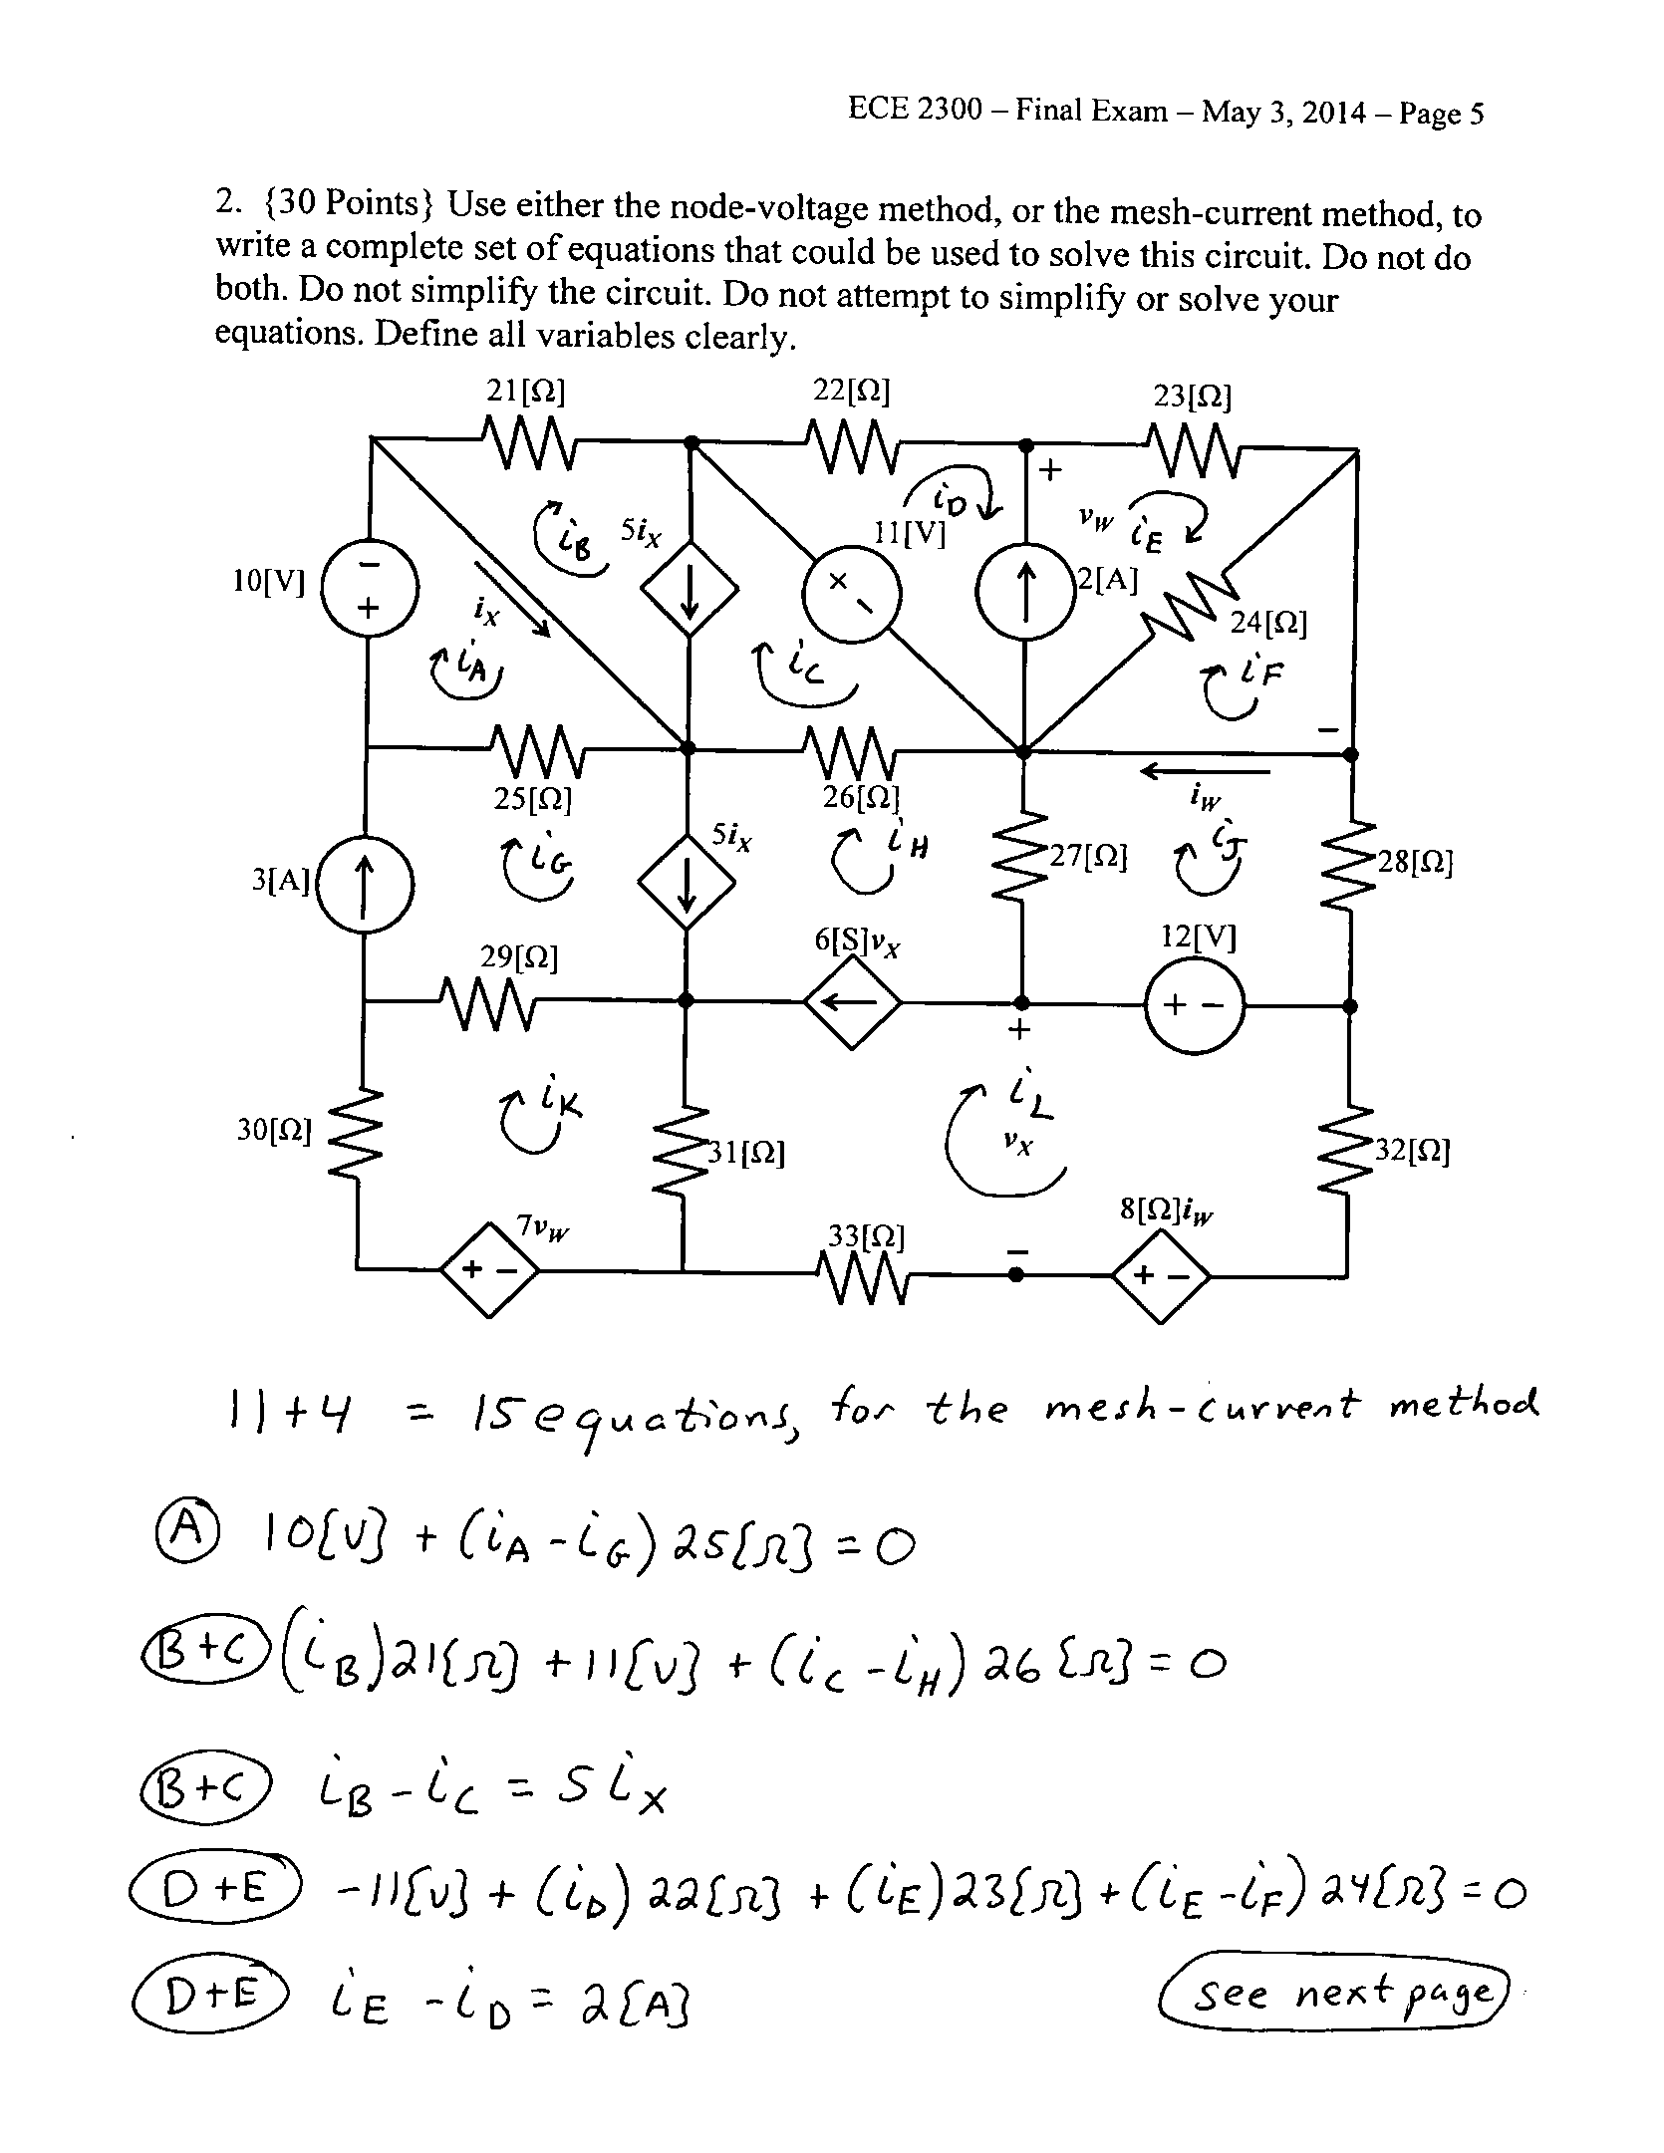

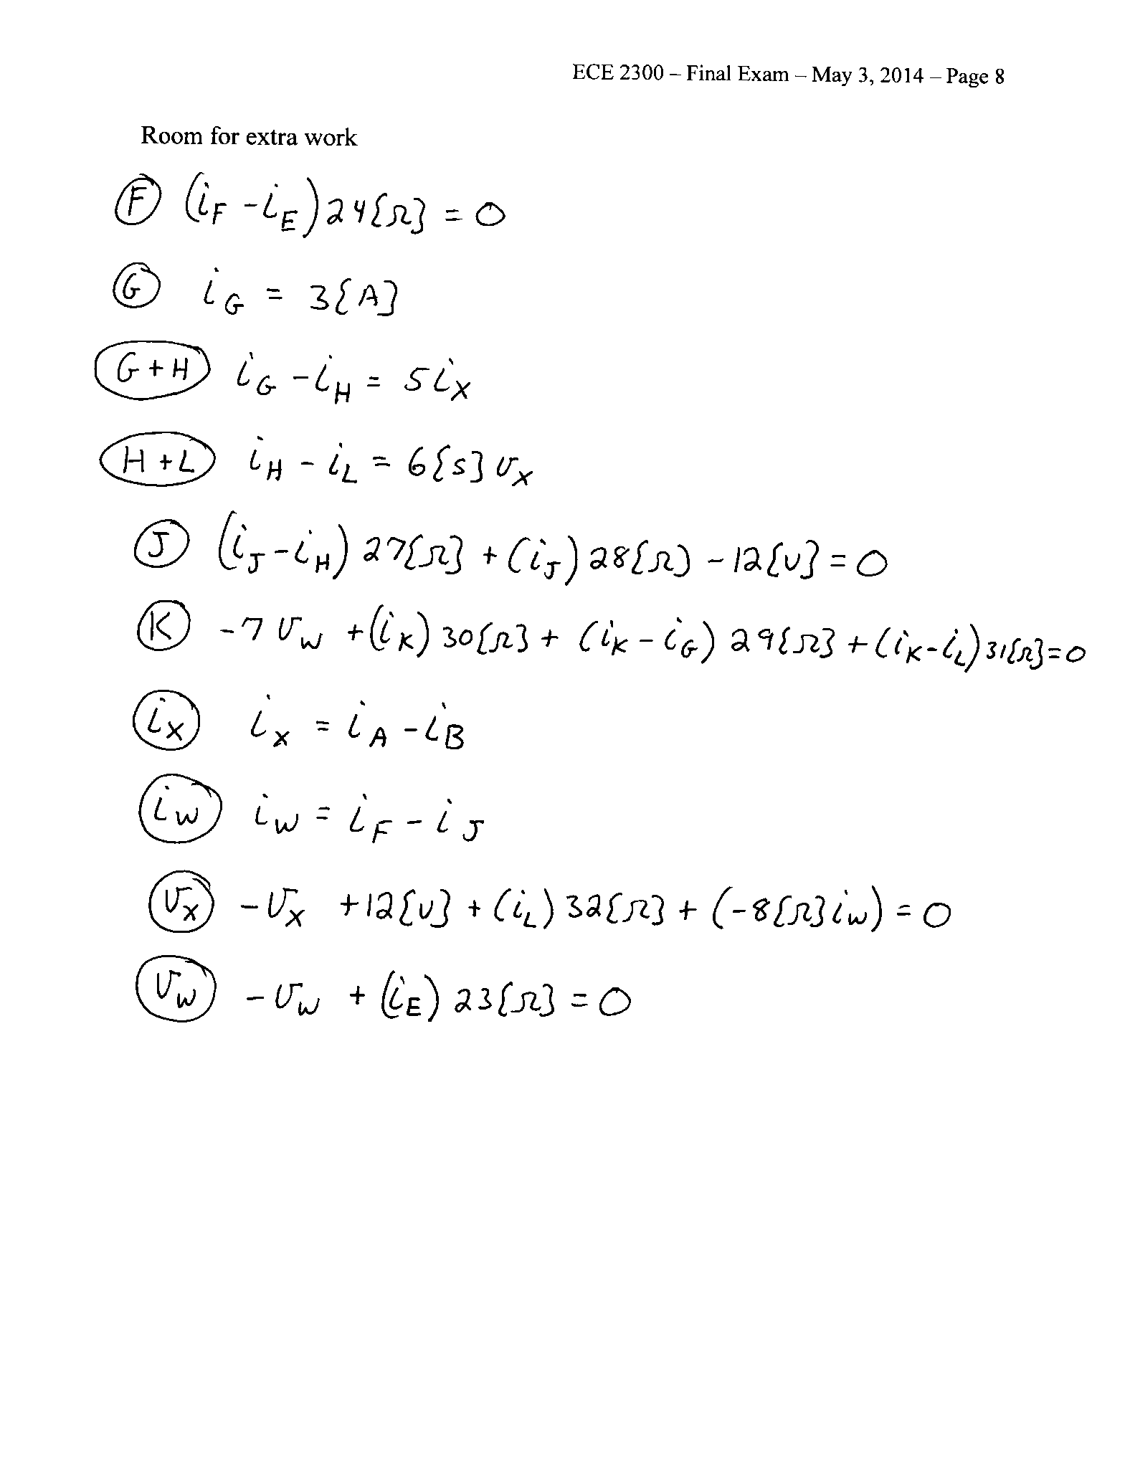

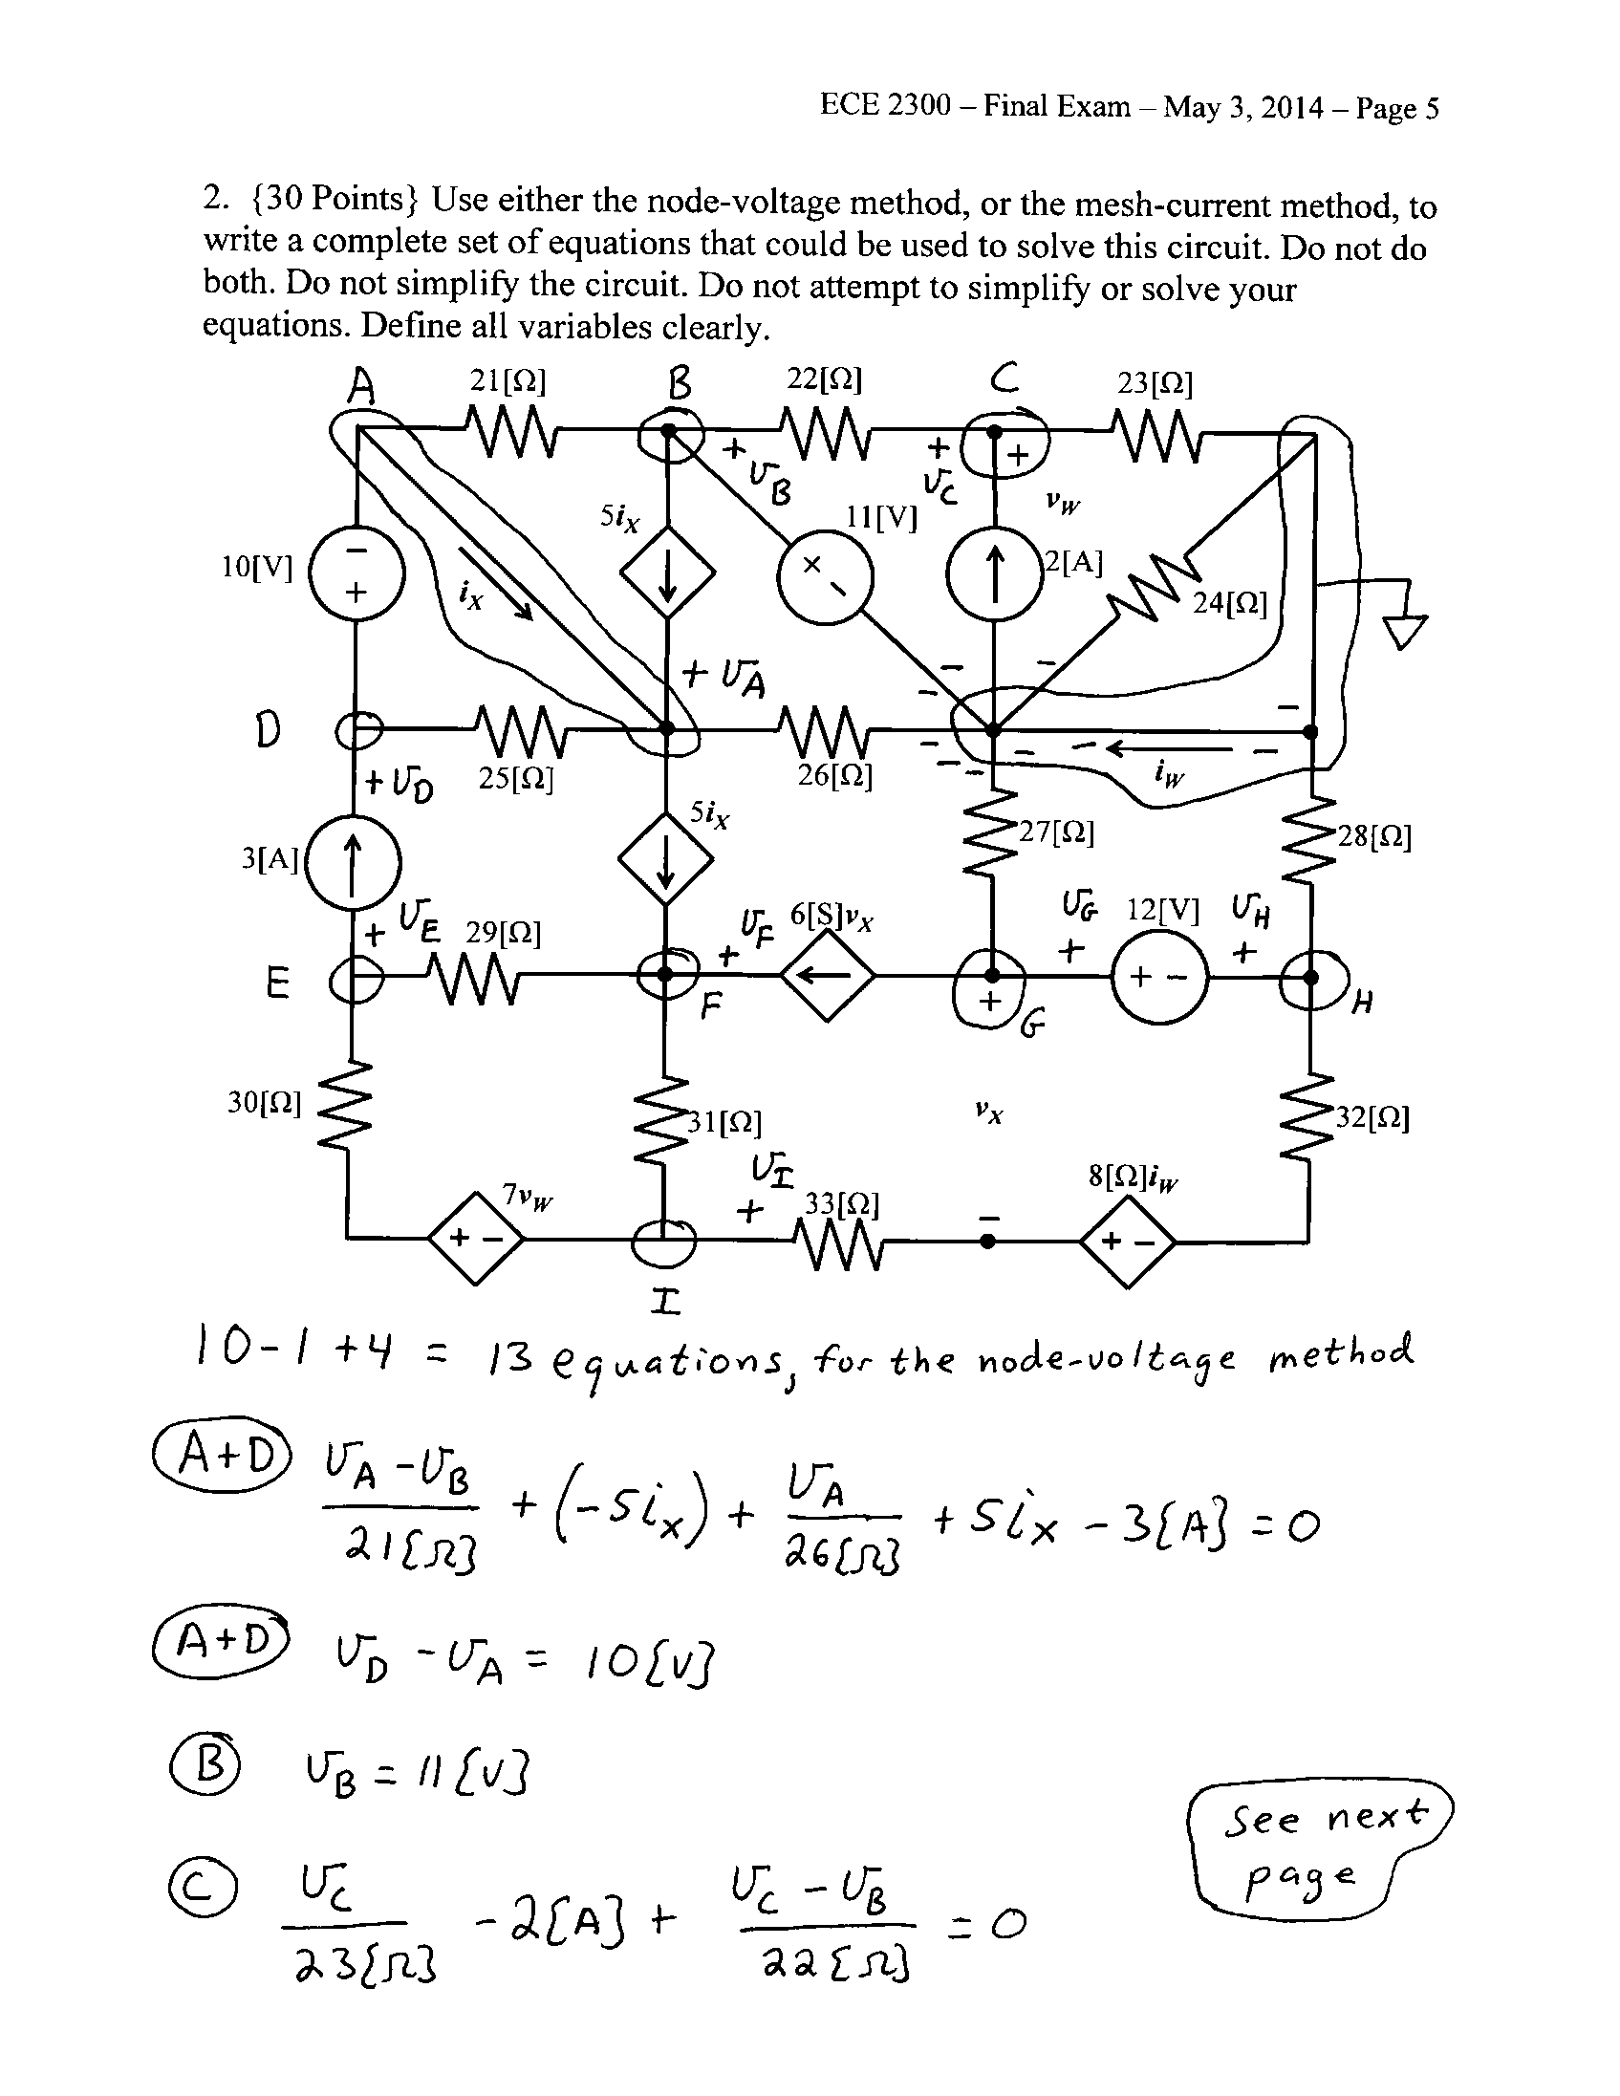

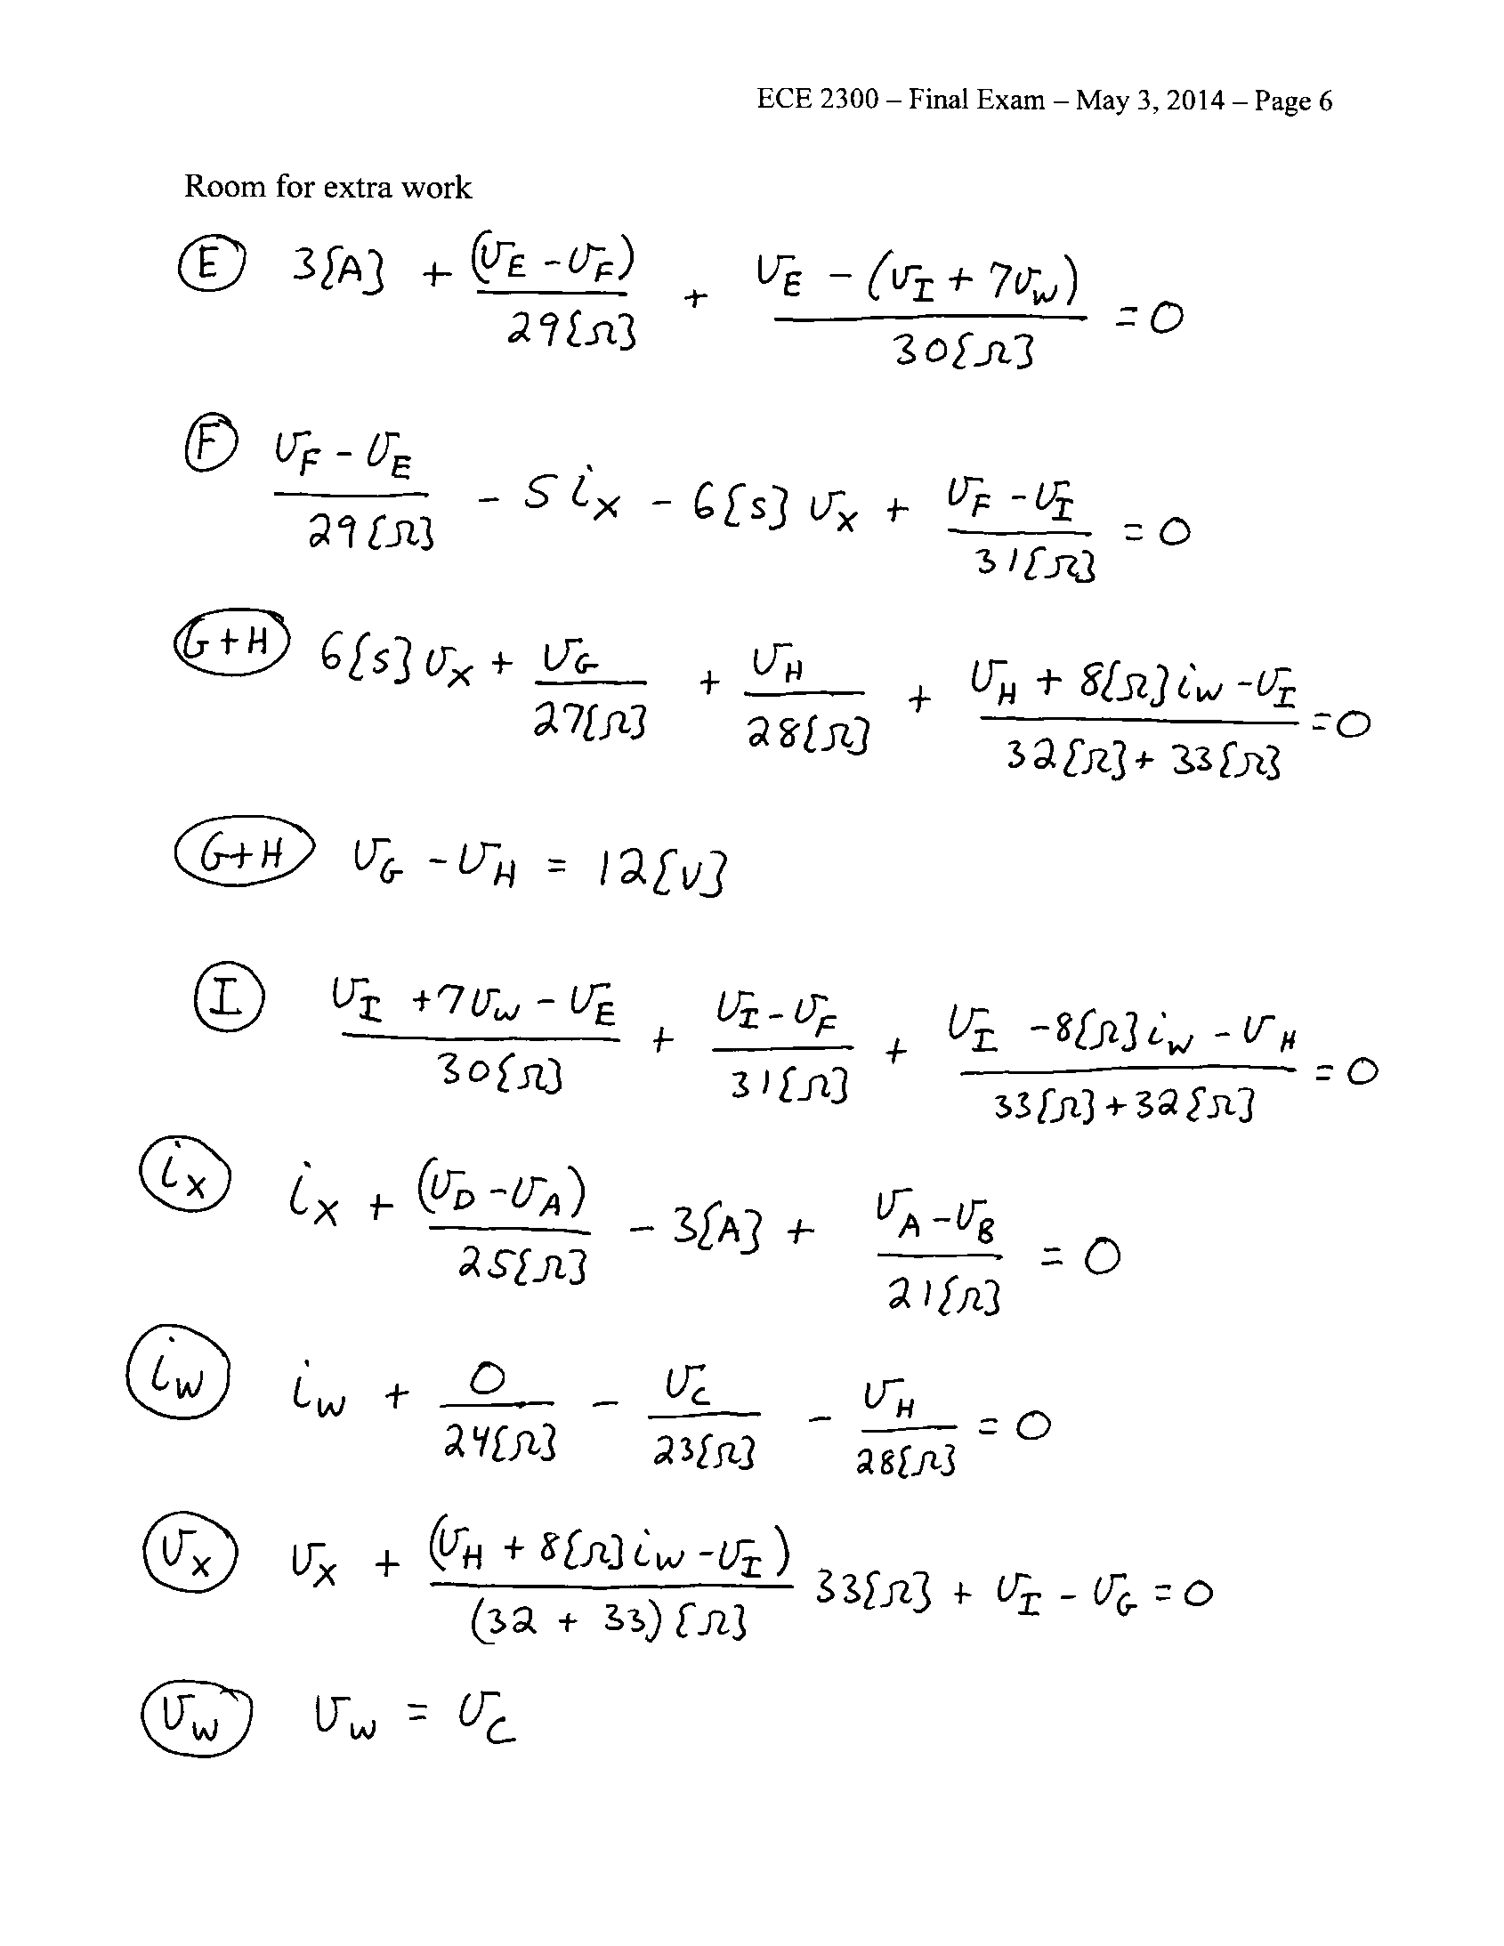

3. {35 Points} A multi-range voltmeter is shown in Figure 1. The meter has full scale voltages of 10[V], and 50[V]. The voltmeter is connected to the circuit shown in Figure 2 by using the 50[V] and Common terminals.

a) Find the Norton equivalent of the circuit shown in Figure 2, as seen by the voltmeter. Draw your Norton equivalent circuit, labeling all components with numerical values.

b) Find the reading of the multi-range voltmeter on the 10[V] scale.

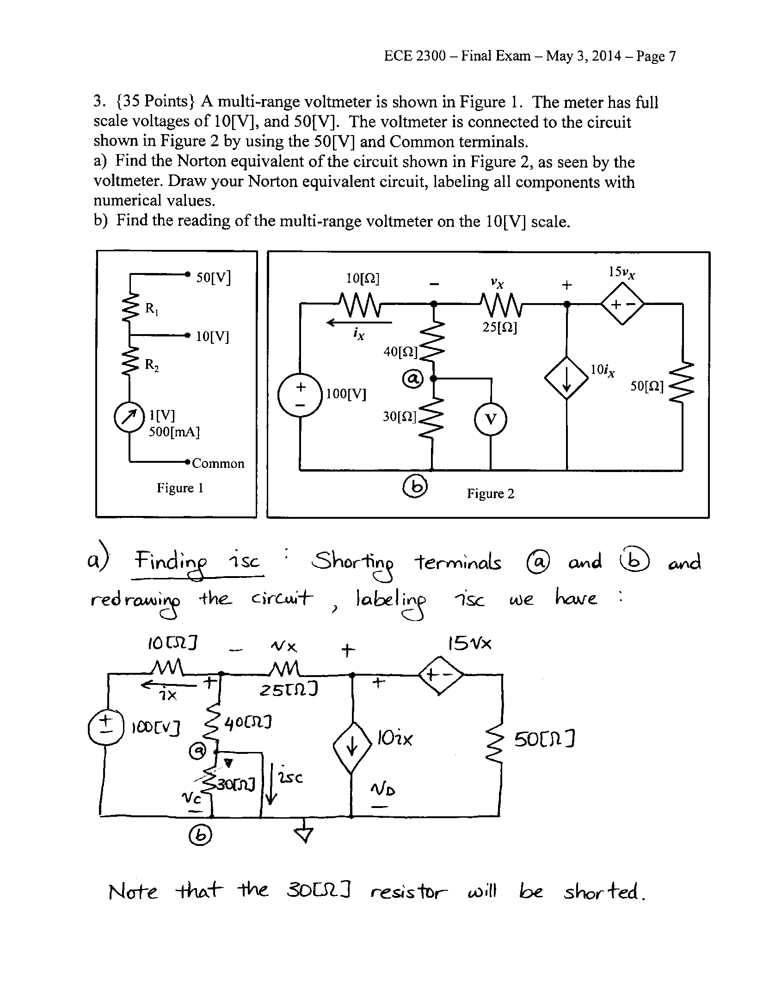

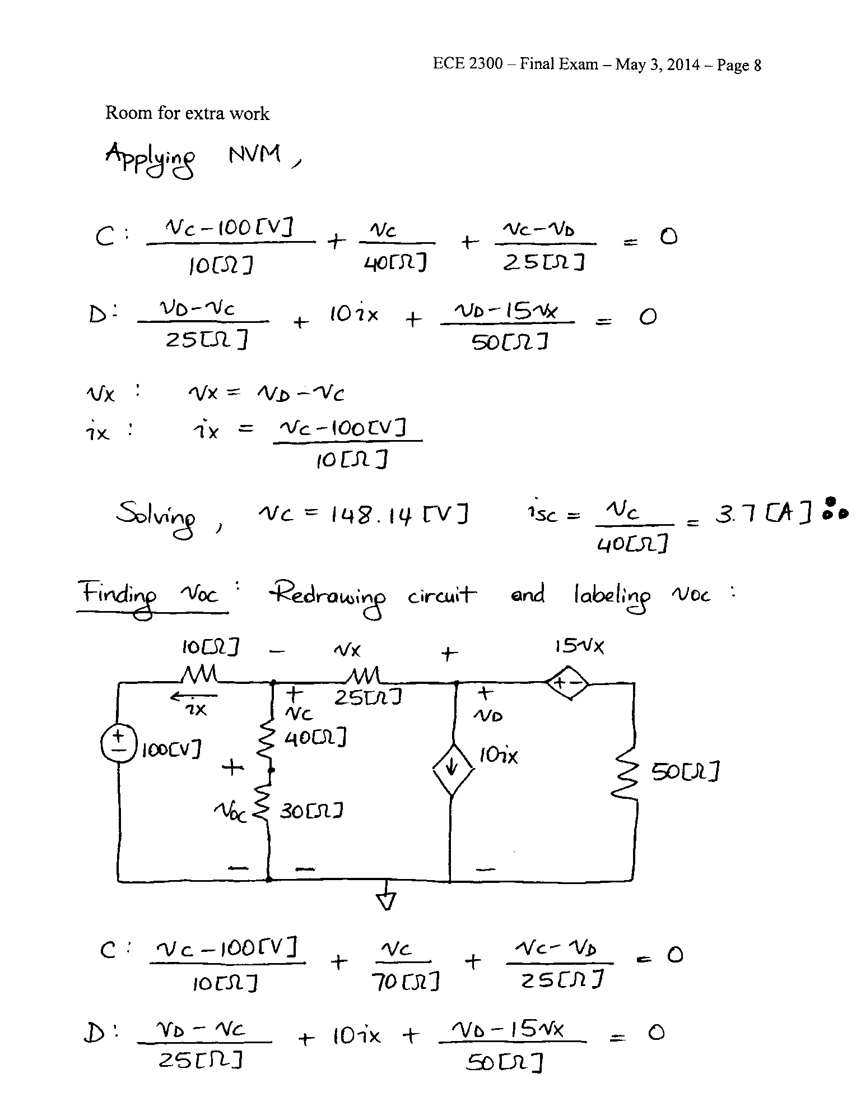

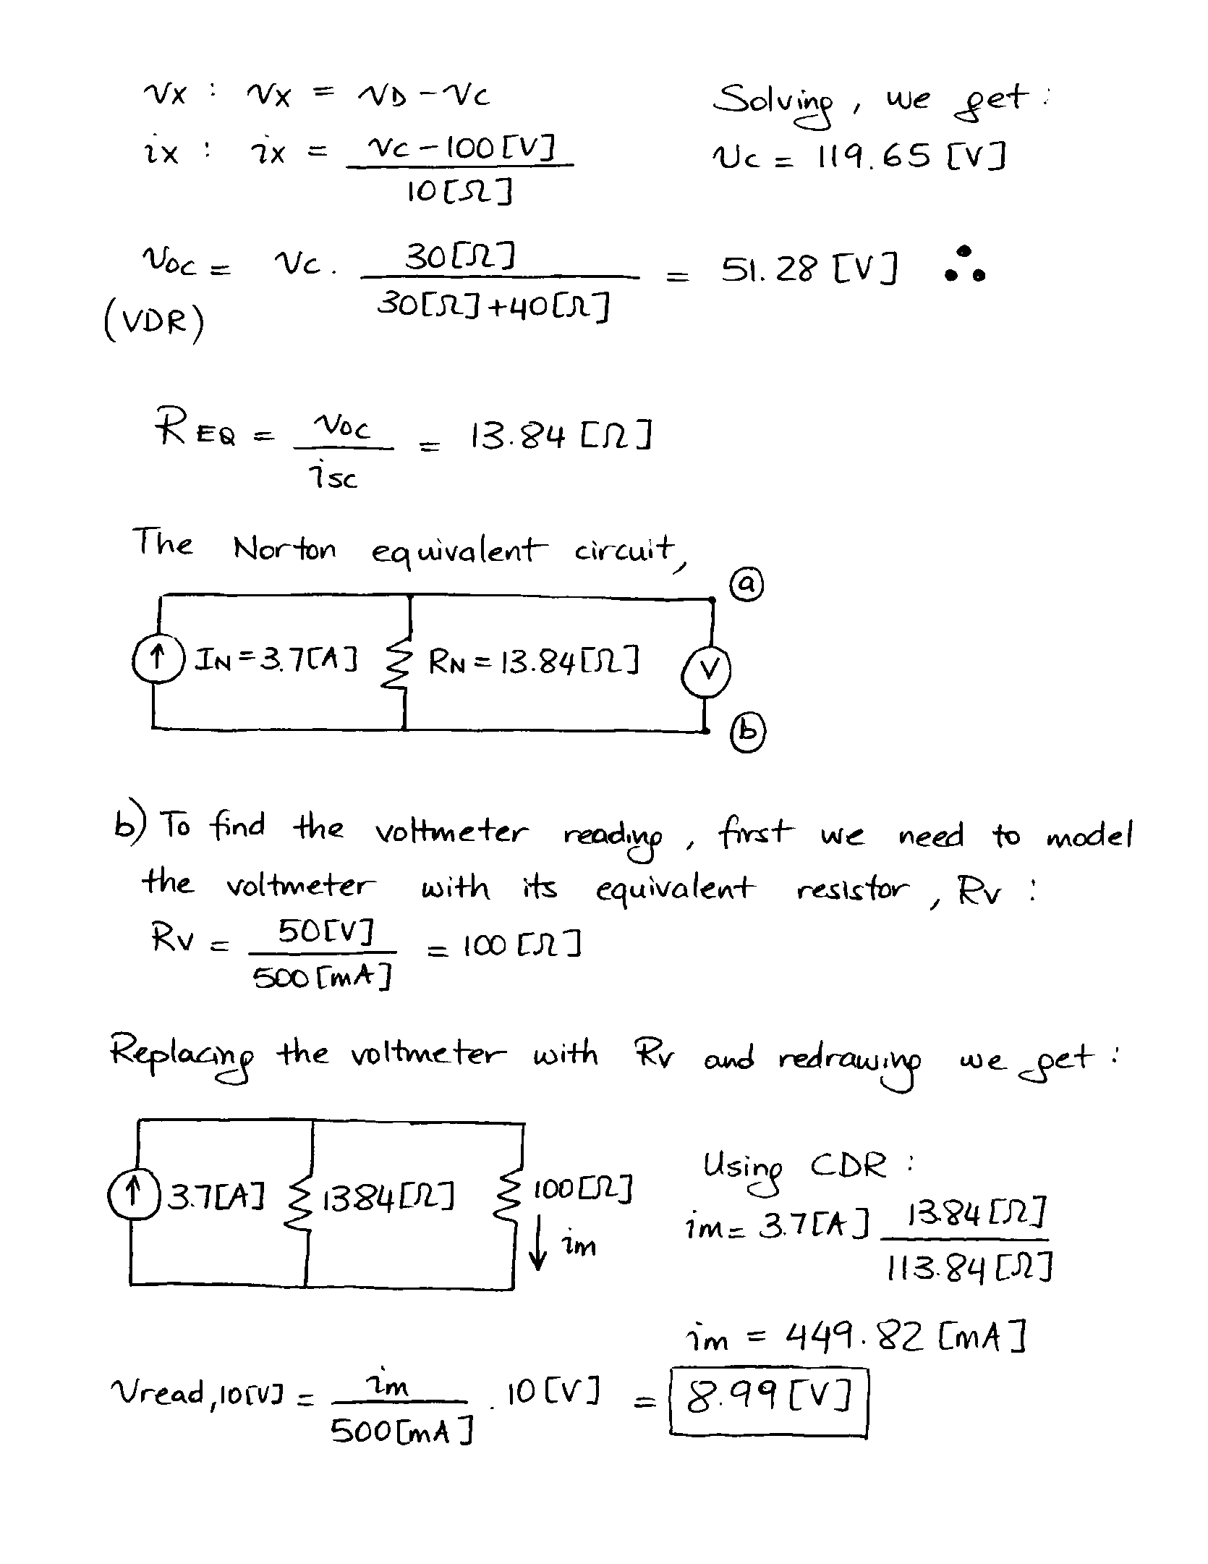

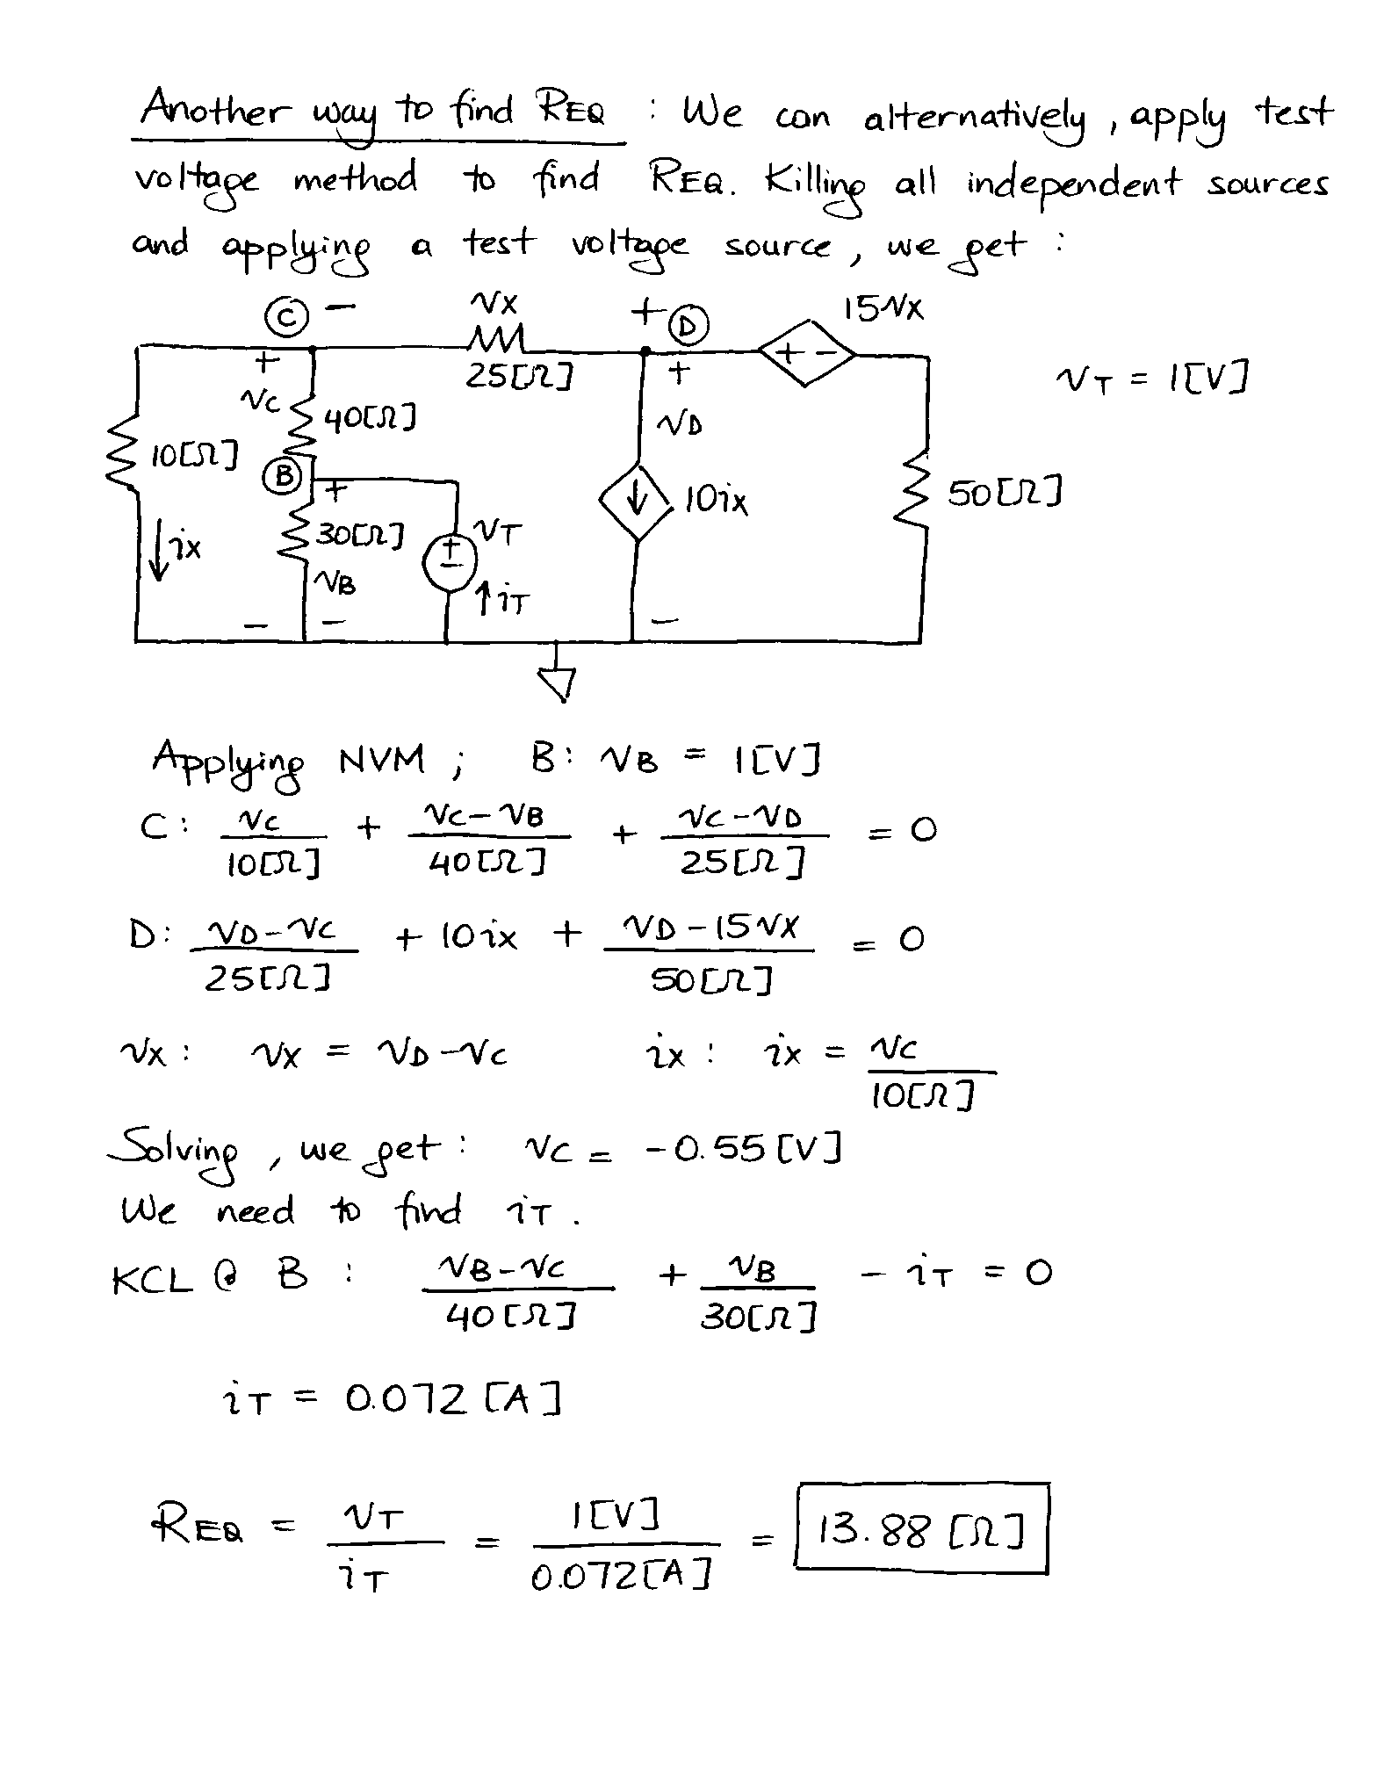

4. {40 Points} The switches in the circuit below had been open for a long time before *t=*0. At *t=*0, switch SWA closed. Then at *t=*5[ms], switch SWB closed.

a) Find .

b) Find *.*

c) Find the energy stored in *L2* at *t=*10[ms].

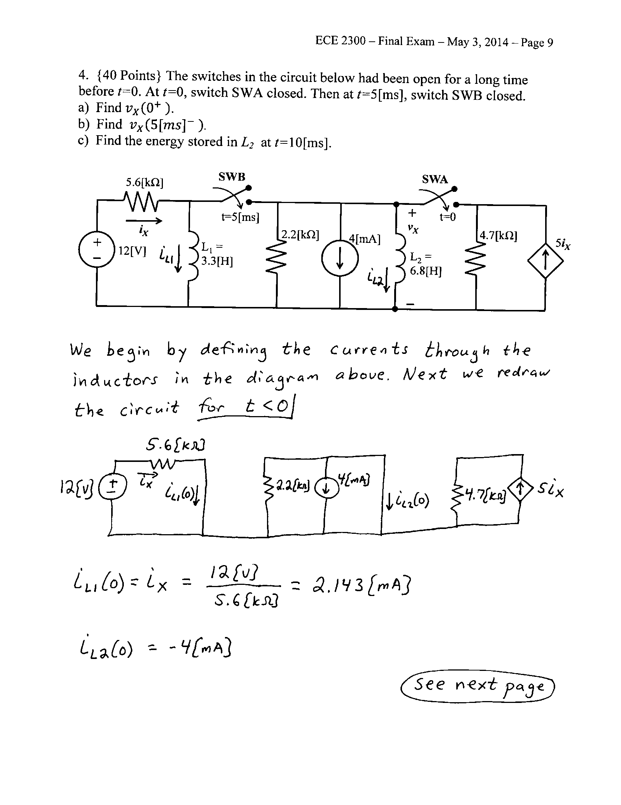

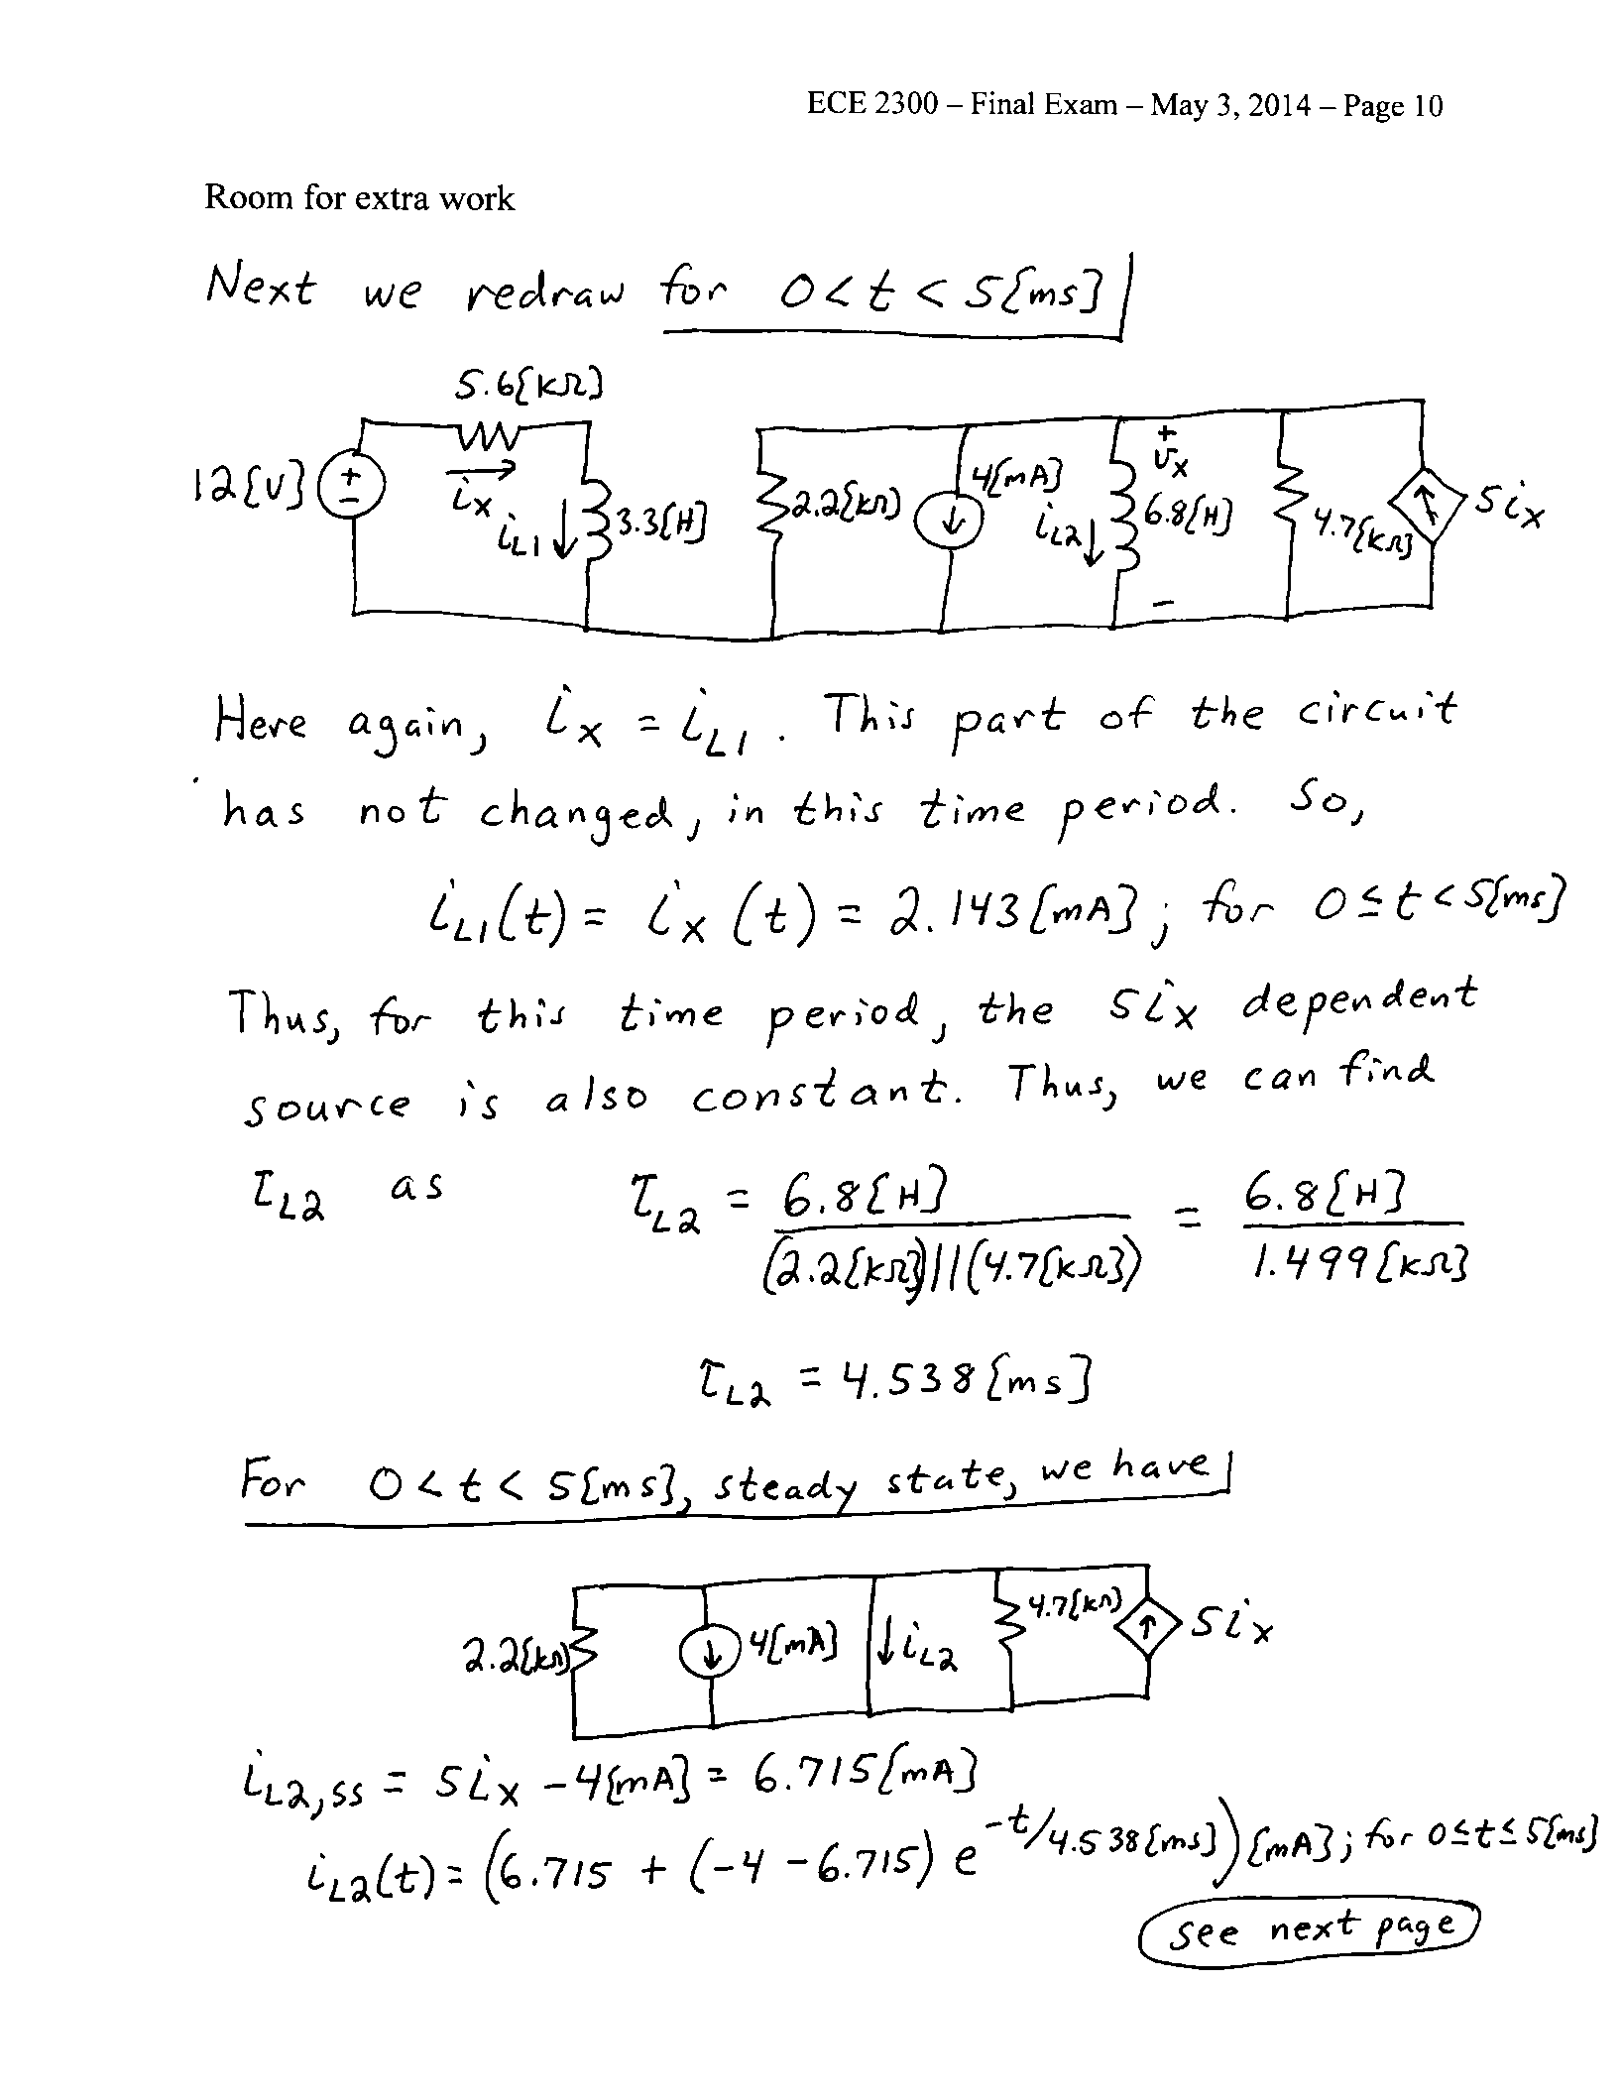

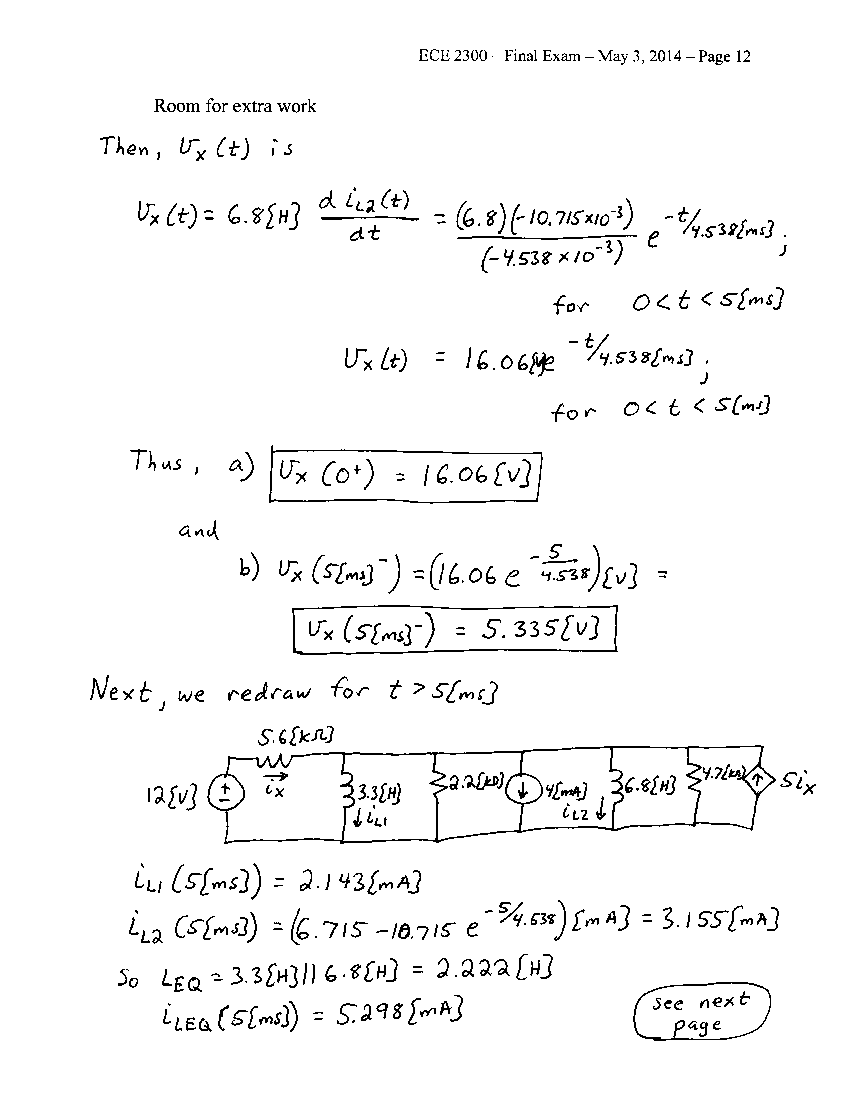

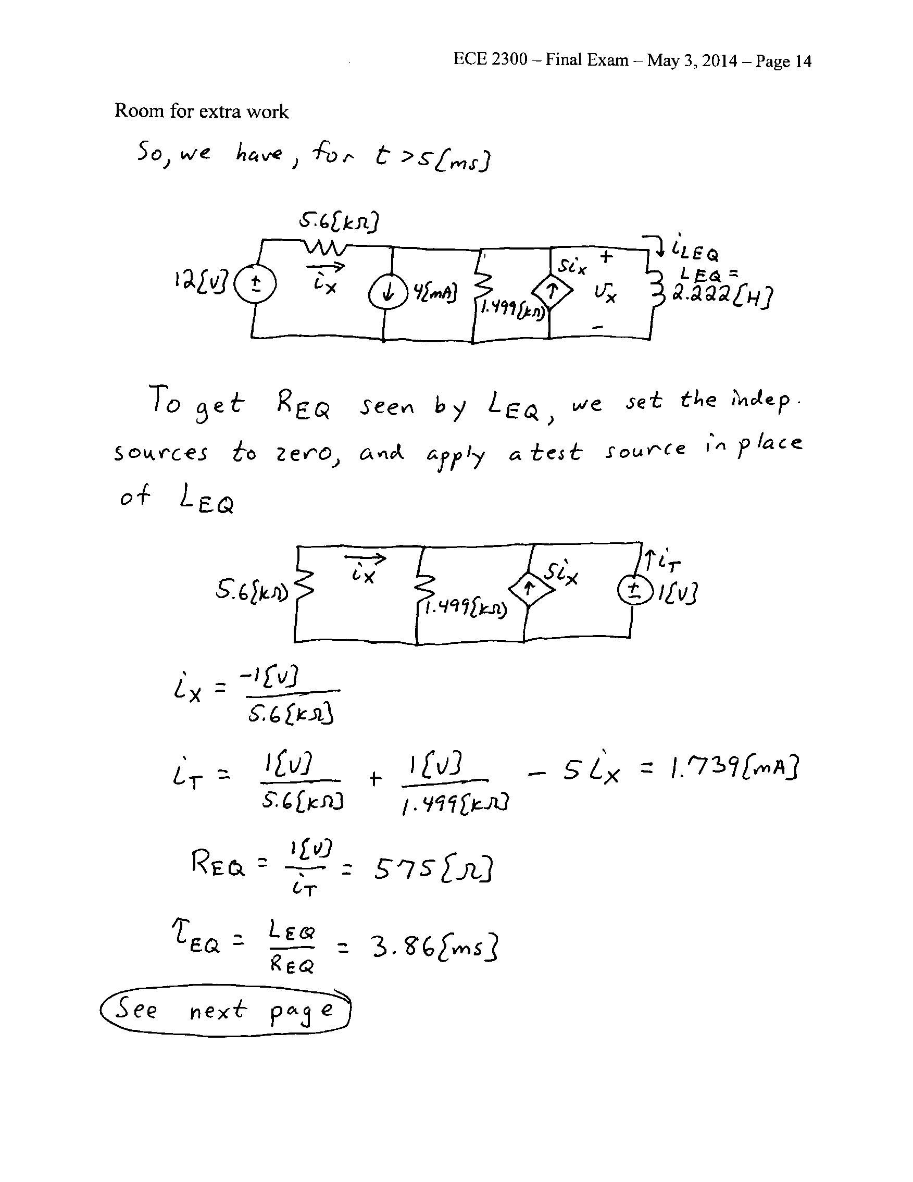

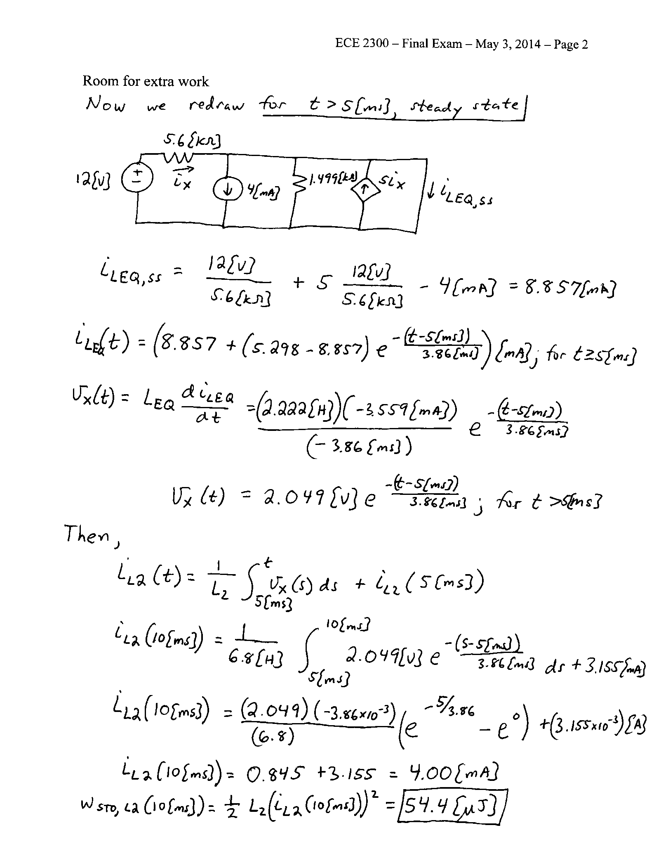

5. {35 Points} The circuit shown is in steady state.

final_q5.emf

a) Find *CX* so that the Subcircuit A will be purely resistive.

b) For the value of CX you found in part a), find . If you cannot find *CX* in part a), then use *CX* .

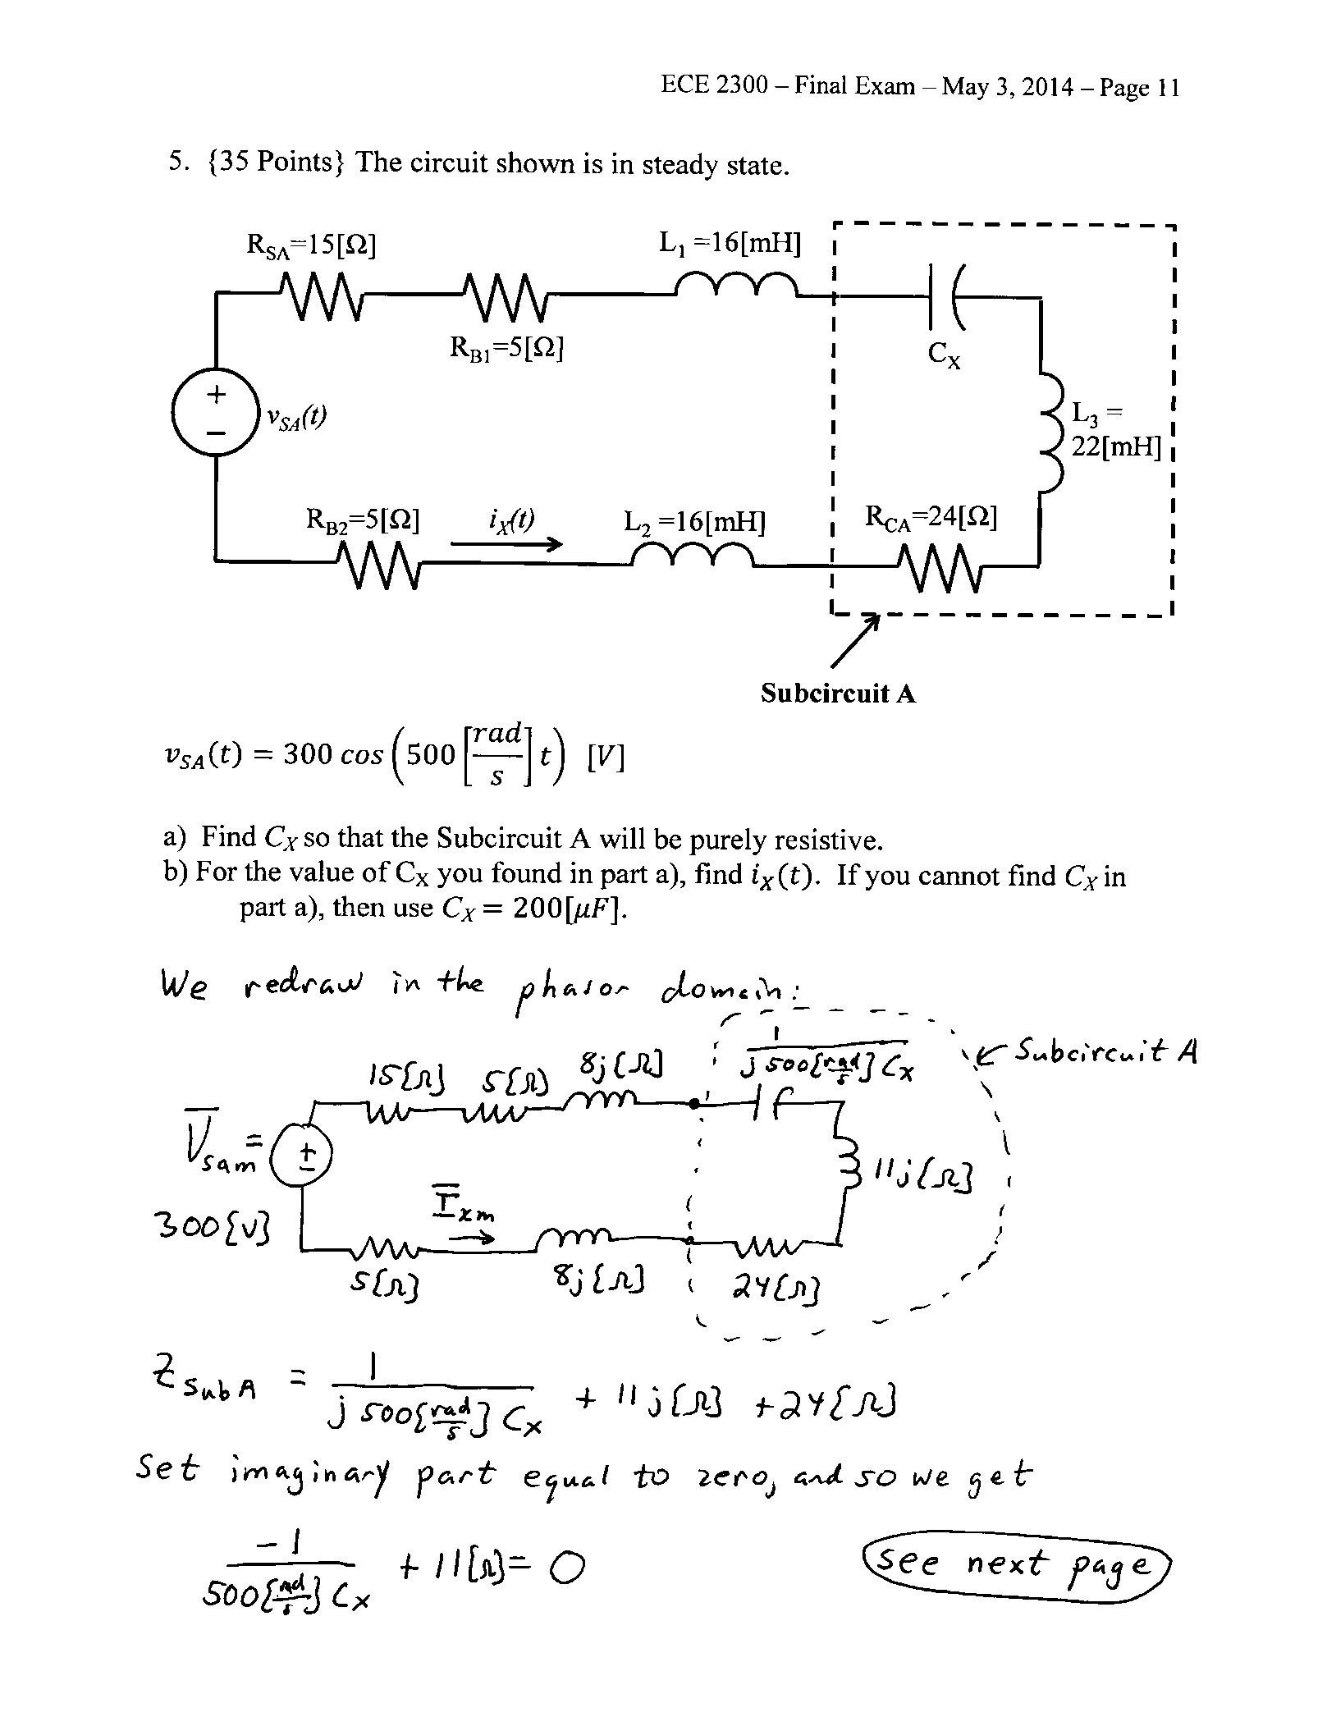

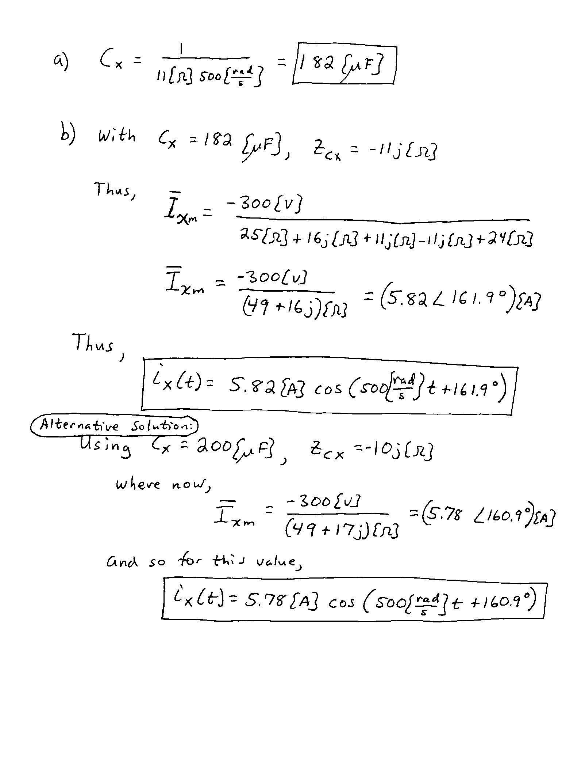

6. {40 Points} The circuit had been in steady-state until switch SW1 opened and SW2 closed at t =0. Find the value of .

final_q6.emf

