Name: _____________________________ (please print)

Signature: __________________________

ECE 2300 -- Exam #1

March 5, 2016

Keep this exam closed until you are told to begin.

1. This exam is closed book, closed notes. You may use one 8.5” x 11” crib sheet, or its equivalent.

2. Show all work on these pages. Show all work necessary to complete the problem. A solution without the appropriate work shown will receive no credit. A solution that is not given in a reasonable order will lose credit. Clearly indicate your answer (for example by enclosing it in a box).

3. It is assumed that your work will begin on the same page as the problem statement. If you choose to begin your work on another page, you must indicate this on the page with the problem statement, with a clear indication of where the work can be found. **If your work continues on to another page, indicate clearly where your work can be found. Failure to indicate this clearly will result in a loss of credit.**

4. Show all units in solutions, intermediate results, and figures. Units in the exam will be included between square brackets.

5. Do not use red ink. Do not use red pencil.

6. You will have 90 minutes to work on this exam.

1. ________________/30

2. ________________/35

3. ________________/35

Total = 100

Room for extra work

1. {30 Points} Use the figures given below to solve this problem.

a) Find the equivalent resistance of the circuit given in Figure 2 as seen by terminals A and B. Show your steps in some clear fashion.

b) The circuit in Figure 1 is connected to the circuit in Figure 2, by connecting terminal A to terminal C and terminal B to terminal D. Find *iX* and the power delivered by the voltage source.





Room for extra work

# Room for extra work

2. {35 Points} A device, shown in Figure 1, can be modeled by a voltage source (12[V]) in series with a resistance *RD*. This device has been connected to the circuit in Figure 2, connecting terminals a to a, and b to b.

|  |  |
| --- | --- |
|  | 1. Find the resistance *RD* in this device if the voltage *vz* is 13.9[V]. 2. Find the power in this device and determine if it is absorbed or delivered. 3. Find the power in the independent current source and determine if it is absorbed or delivered. 4. Plot *vD* as a function of *iD* for the device, for the range 0 ≤ *iD*≤ 2.4[A]. |



Room for extra work

3. {35 Points} Use the node-voltage method to write a complete set of equations that could be used to solve the circuit below. Define all variables. Do not attempt to simplify the circuit. Do not attempt to simplify or solve the equations.



Solution:

1. {30 Points} Use the figures given below to solve this problem.

a) Find the equivalent resistance of the circuit given in Figure 2 as seen by terminals A and B. Show your steps in some clear fashion.

b) The circuit in Figure 1 is connected to the circuit in Figure 2, by connecting terminal A to terminal C and terminal B to terminal D. Find *iX* and the power delivered by the voltage source.

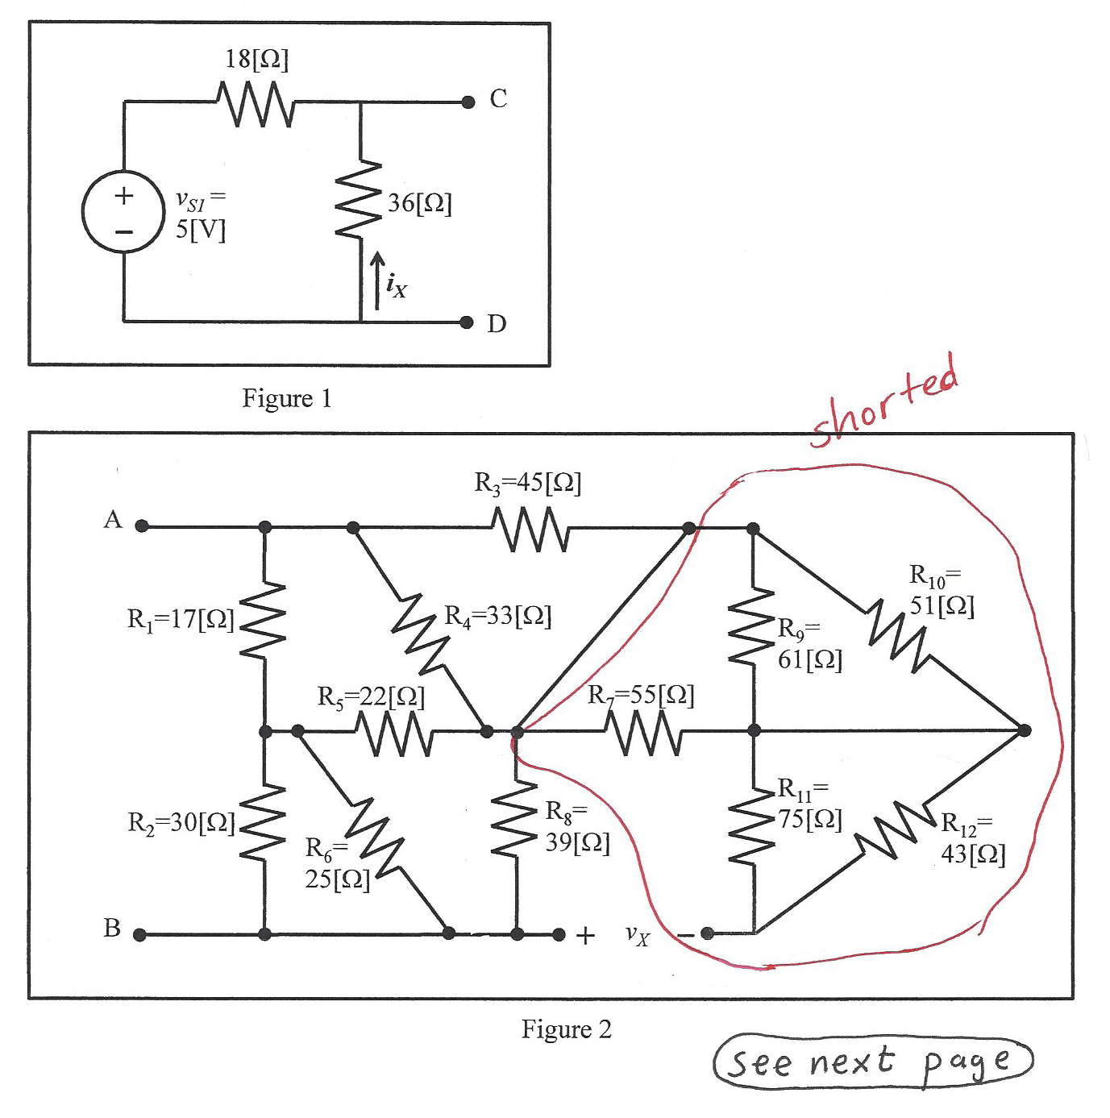

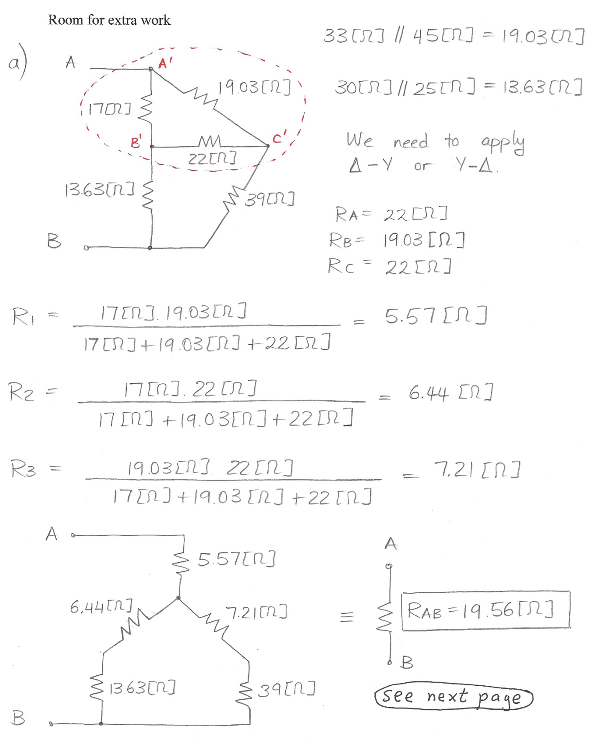

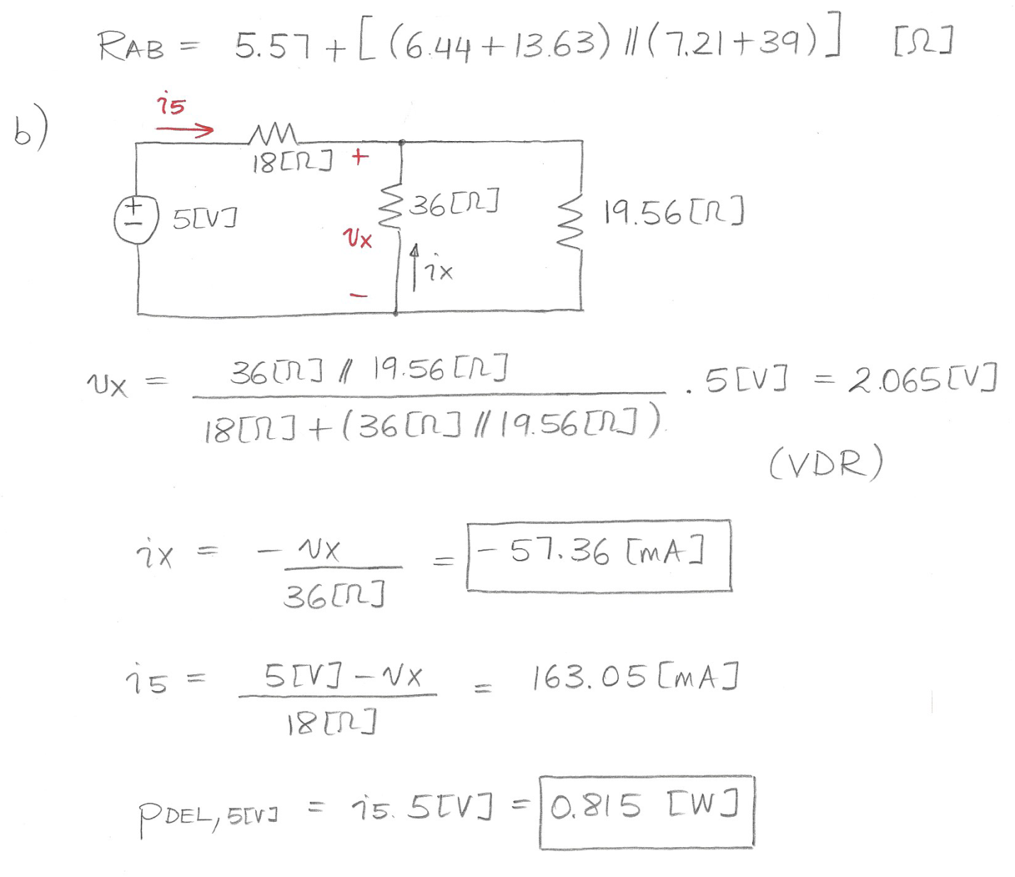

2. {35 Points} A device, shown in Figure 1, can be modeled by a voltage source (12[V]) in series with a resistance *RD*. This device has been connected to the circuit in Figure 2, connecting terminals a to a, and b to b.

|  |  |
| --- | --- |
|  | 1. Find the resistance *RD* in this device if the voltage *vz* is 13.9[V]. 2. Find the power in this device and determine if it is absorbed or delivered. 3. Find the power in the independent current source and determine if it is absorbed or delivered. 4. Plot *vD* as a function of *iD* for the device, for the range 0 ≤ *iD*≤ 2.4[A]. |



See next page

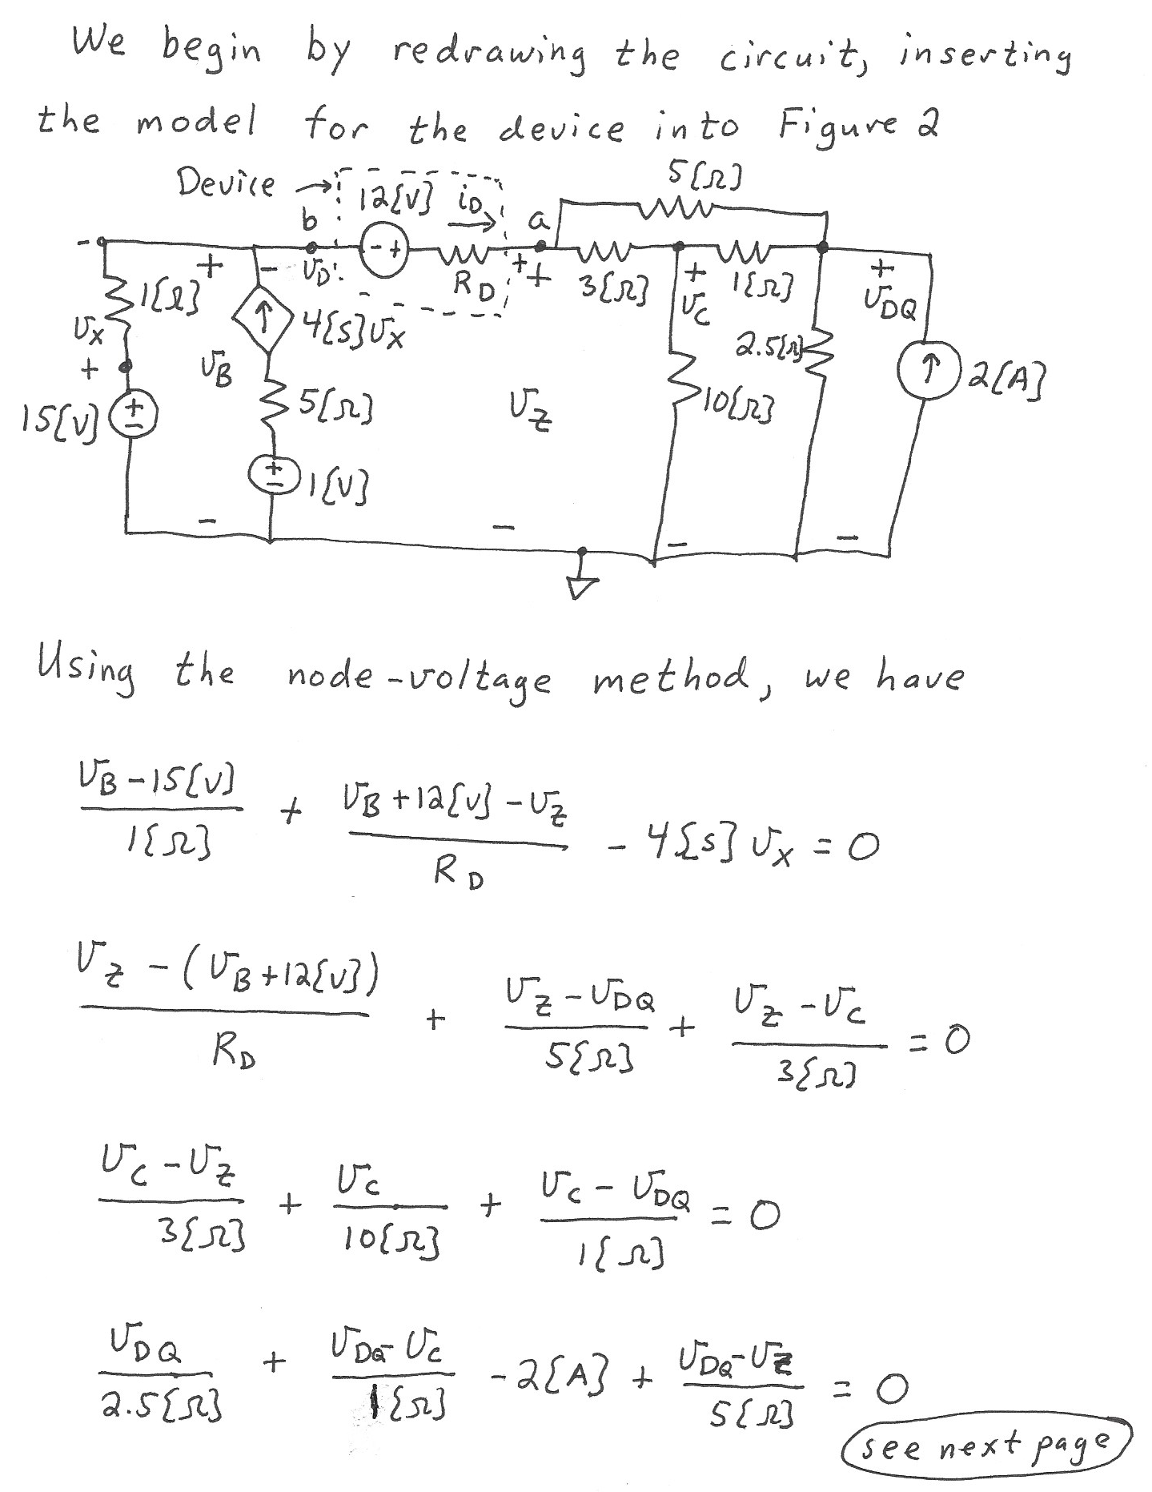

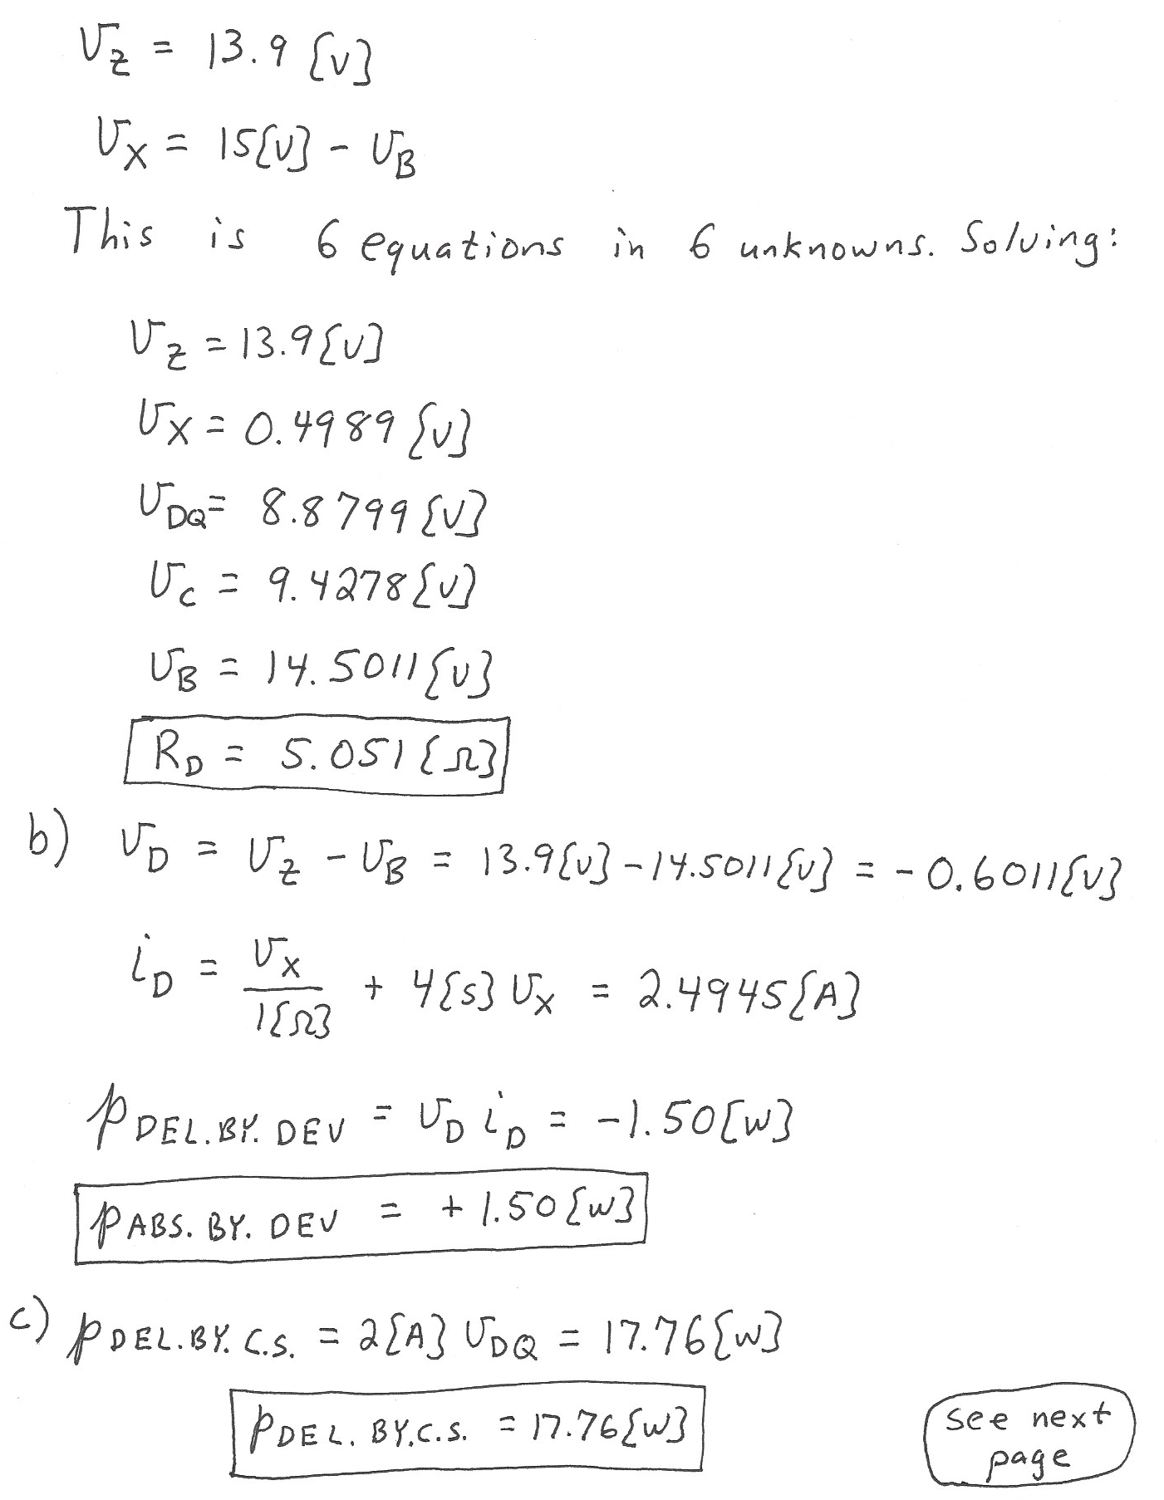

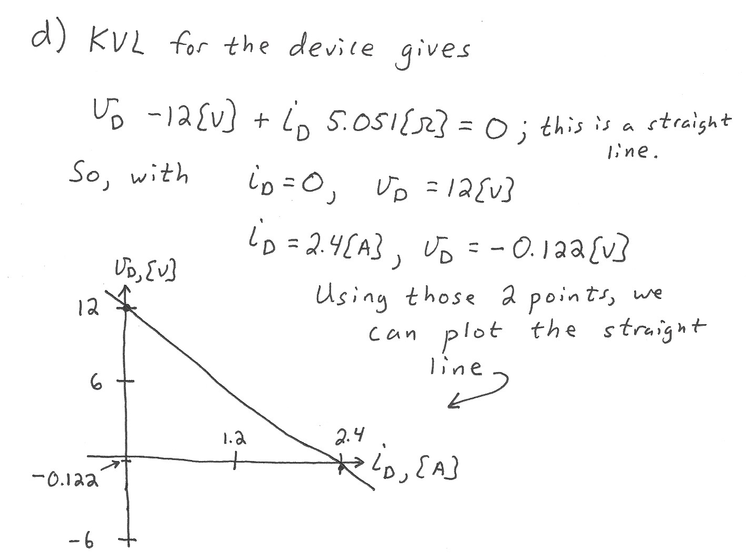

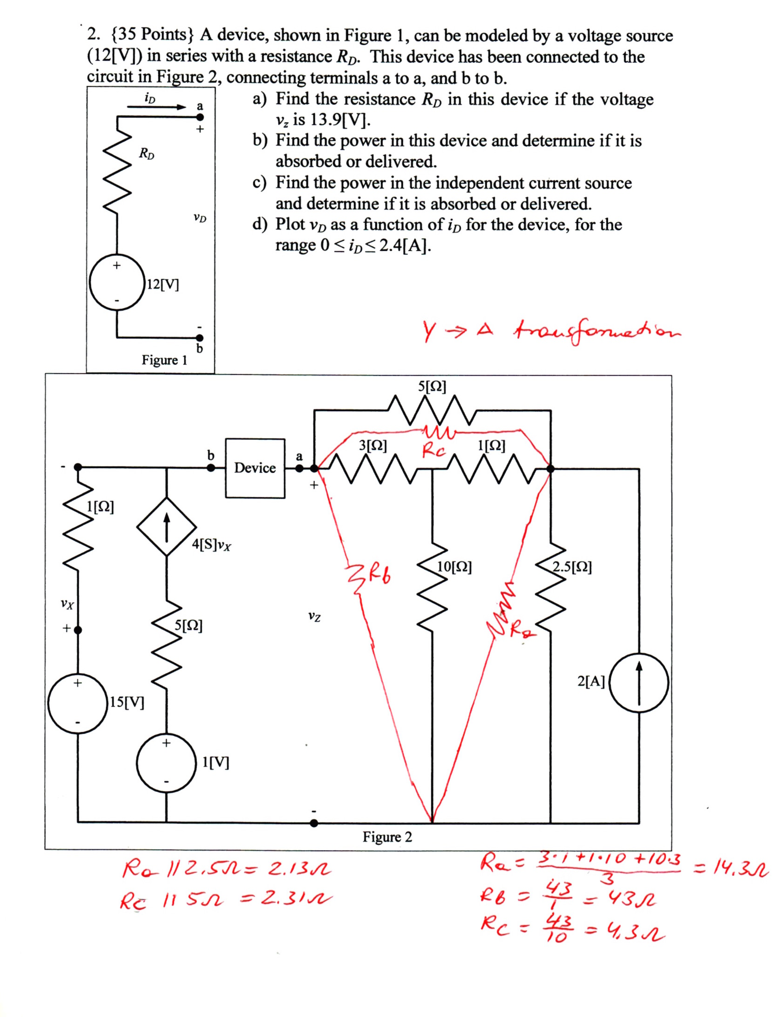

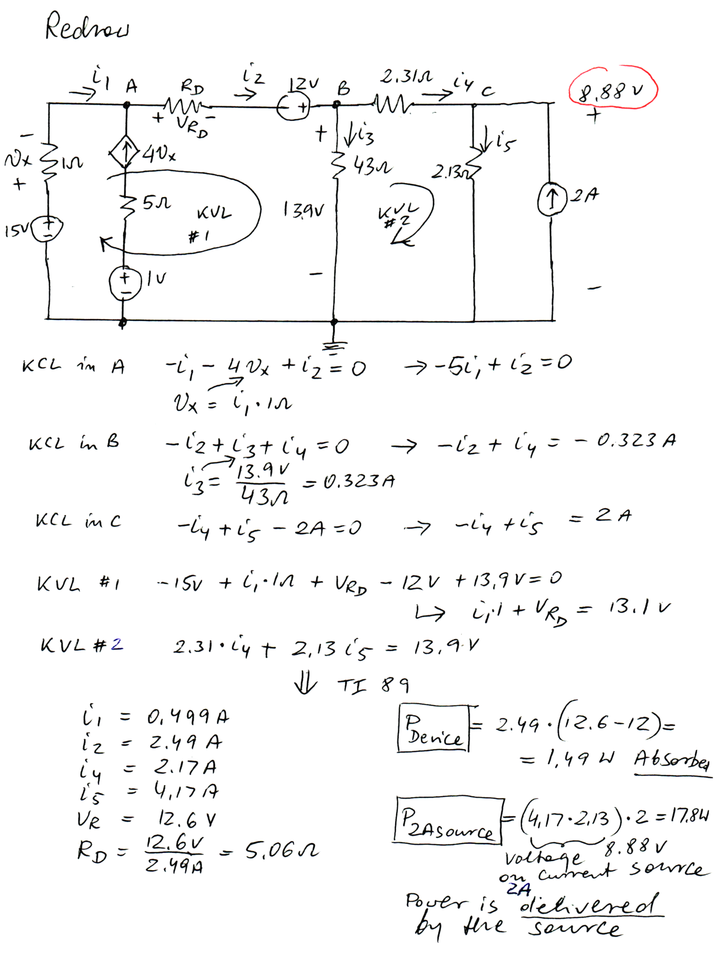

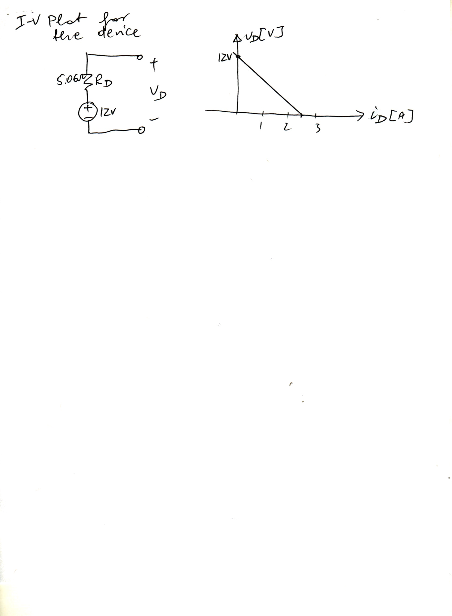

3. {35 Points} Use the node-voltage method to write a complete set of equations that could be used to solve the circuit below. Define all variables. Do not attempt to simplify the circuit. Do not attempt to simplify or solve the equations.

