Name: _____________________________ (please print)
Signature: __________________________

ECE 2300 – Quiz #3
March 1, 2016

Keep this quiz closed and face up until you are told to begin.

1. This quiz is closed book, closed notes. You may use one 8.5” x 11” crib sheet, or its equivalent.
2. Show all work on these pages. Show all work necessary to complete the problem. A solution without the appropriate work shown will receive no credit. A solution which is not given in a reasonable order will lose credit.
3. It is assumed that your work will begin on the same page as the problem statement. If you choose to begin your work on another page, you must indicate this on the page with the problem statement, with a clear indication of where the work can be found. If your work continues on to another page, indicate clearly where your work can be found. Failure to indicate this clearly will result in a loss of credit.
4. Show all units in solutions, intermediate results, and figures. Units in the quiz will be included between square brackets.
5. Do not use red ink. Do not use red pencil.
6. You will have 30 minutes to work on this quiz.

________________/20
Room for extra work
Use the node-voltage method to write a complete set of equations that could be used to solve this circuit. Do not simplify the circuit. Do not attempt to solve or simplify your equations. Define all variables.

Room for extra work
Solution: Quiz #3, Spring 2016 Use the node-voltage method to write a complete set of equations that could be used to solve this circuit. Do not simplify the circuit. Do not attempt to solve or simplify your equations. Define all variables.

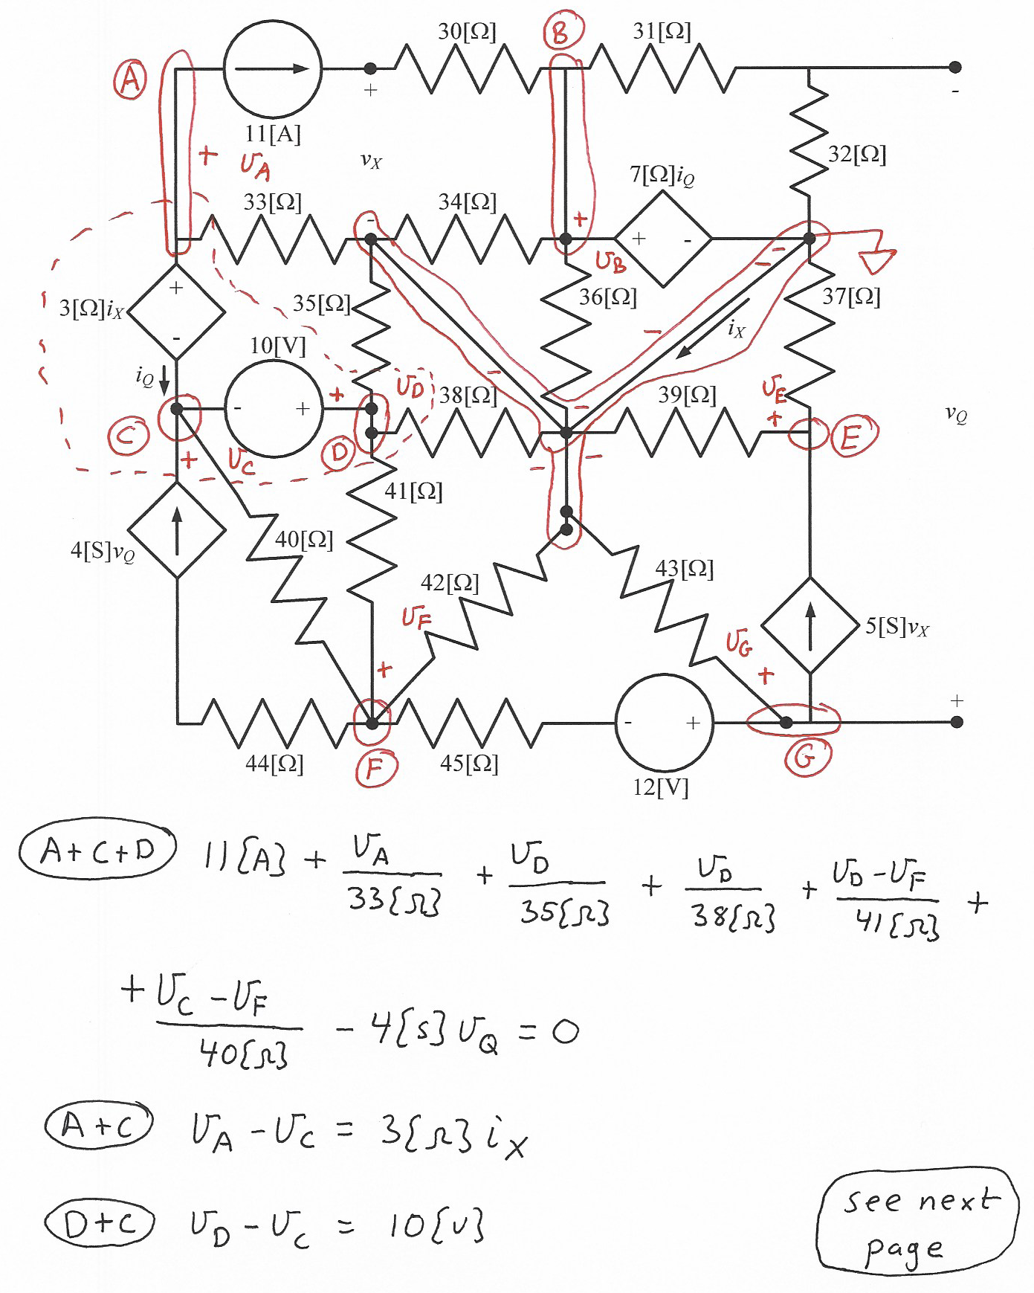
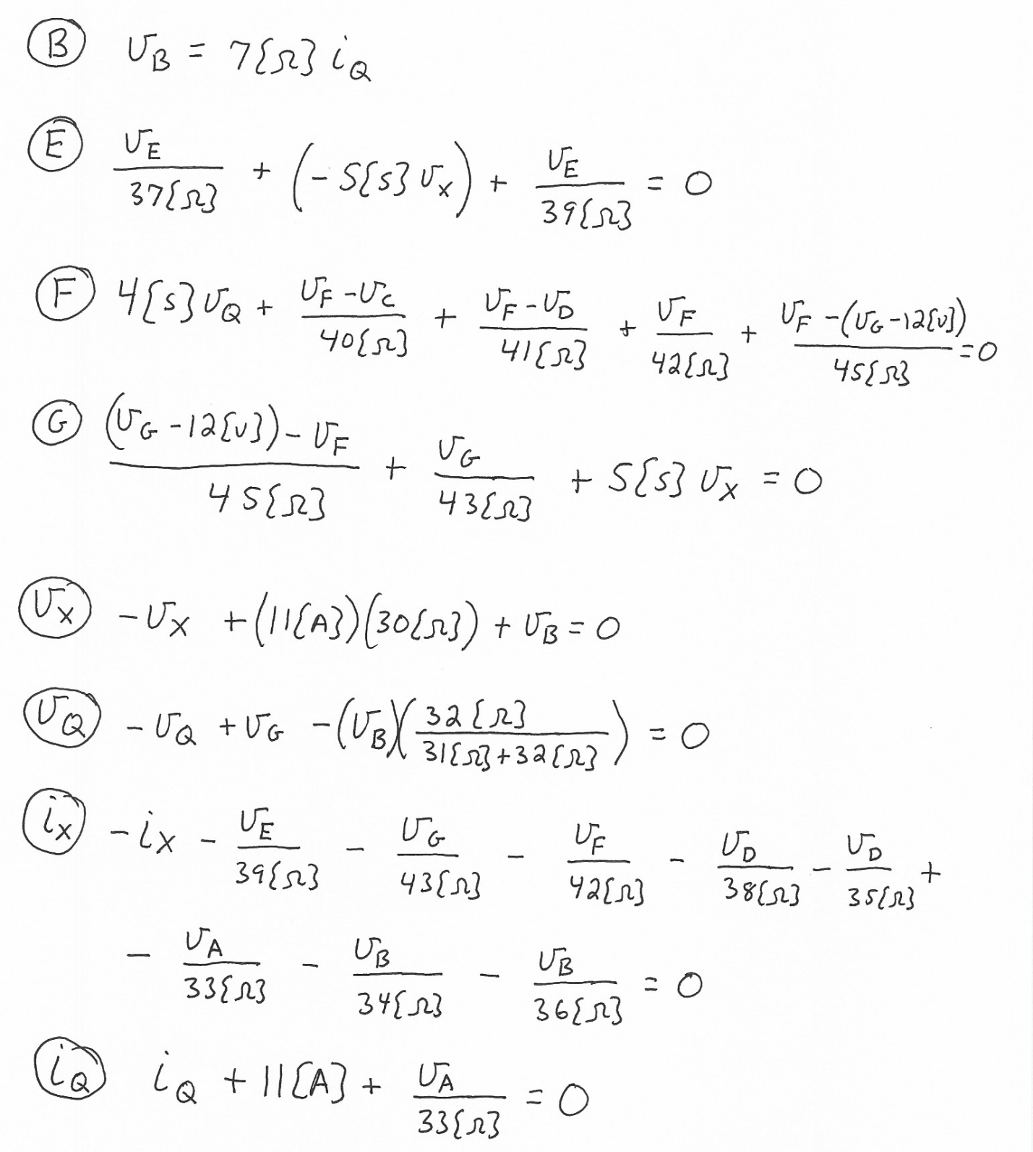
This is 11 equations in 11 unknowns, and can be solved.

Note: In the solution here, I have made a less advantageous choice for the closed surface for the KCL for i_{X}. It is possible to make better choices, which would result in fewer terms in the equation. While I realized this as I was writing the equation, I decided to continue with that choice, just to show that the equation can be written even for a less than optimal choice. The real difference in the time required is not very great.

