Name: _____________________________ (please print)

Signature: __________________________

ECE 2201 -- Exam #1

February 11, 2017

Keep this exam closed until you are told to begin.

1. This exam is closed book, closed notes. You may use one 8.5” x 11” crib sheet, or its equivalent.

2. Show all work on these pages. Show all work necessary to complete the problem. A solution without the appropriate work shown will receive no credit. A solution that is not given in a reasonable order will lose credit. Clearly indicate your answer (for example by enclosing it in a box).

3. It is assumed that your work will begin on the same page as the problem statement. If you choose to begin your work on another page, you must indicate this on the page with the problem statement, with a clear indication of where the work can be found. **If your work continues on to another page, indicate clearly where your work can be found. Failure to indicate this clearly will result in a loss of credit.**

4. Show all units in solutions, intermediate results, and figures. Units in the exam will be included between square brackets.

5. Do not use red ink. Do not use red pencil.

6. You will have 90 minutes to work on this exam.

1. ________________/35

2. ________________/30

3. ________________/35

Total = 100

Room for extra work

1. {35 Points} Four devices are connected as shown in Figure 1. The power delivered by Device 1 is given by the expression

$p_{DEL.BY.DEV1}\left(t\right)=36\left[\frac{μW}{s^{2}}\right]t^{2}-72\left[\frac{μW}{s}\right]t$ for 2[s] < t < 5[s].

The voltages $v_{X}\left(t\right)$ and $v_{Z}(t)$ are shown in Figures 2 and 3, respectively.





a) What is the energy absorbed by Device 1 during the time period 2[s] < t < 4[s]?

b) Which way are the electrons moving through Device 1 at t=3.5[s]? Your answer should be either left to right, or right to left. Explain how you got your answer.

c) Find the expression for the power delivered to Device 3 for the time interval 2[s] < t < 3[s].

# Rom for extra work

2. {30 Points} Six components, labeled A, B, C, D, E, and F, are connected as shown in Figure 1.



1. Find the value of $i_{X}$ based on the fact that energy is conserved in this circuit. Do NOT use Kirchhoff’s Laws in your solution.
2. Using the value of $i_{X}$ that you found in part a), show that the total power absorbed is equal to the total power delivered.
3. Are the electrons gaining or losing energy when they move through component F? Explain your answer.

Room for extra work

3. {35 Points} 4 components are connected together as shown in Figure 1. Assume that the charge carriers are electrons.

1. Find the expressions for the power delivered by the charger for the time interval 0 < t < 12[min] and plot it as a function of time.
2. Determine whether the electrons flowing through the charger at *t* = 5[min] are gaining or losing energy. Explain how you got your answer.
3. Find the expression for the power absorbed by the battery for 0 < t <12[min]. Calculate the numerical values of power absorbed by the battery for t= 5[min] and t=12[min] and decide if power is absorbed or delivered by the battery.
4. Within the time interval 0 < t < 12[min], calculate the amount of charge that flows through the battery, when battery is absorbing energy.
5. Within the time interval 0 < t < 12[min], calculate the amount of charge that flows through the battery, when battery is delivering energy.

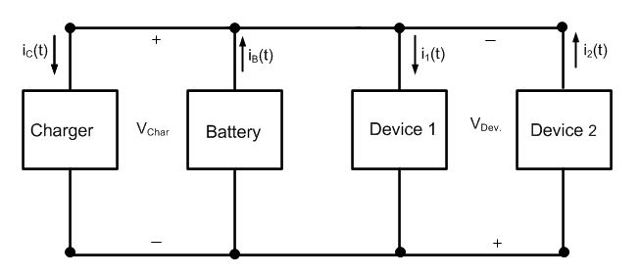

Figure 1

 Figure 2 Figure 3 Figure 4

R

oom for extra work

