Name: _____________________________ (please print)

Signature: __________________________

ECE 2201 -- Exam # 3

April 8, 2017

Keep this exam closed until you are told to begin.

1. This exam is closed book, closed notes. You may use one 8.5” x 11” crib sheet, or its equivalent.

2. Show all work on these pages. Show all work necessary to complete the problem. A solution without the appropriate work shown will receive no credit. A solution that is not given in a reasonable order will lose credit. Clearly indicate your answer (for example by enclosing it in a box).

3. It is assumed that your work will begin on the same page as the problem statement. If you choose to begin your work on another page, you must indicate this on the page with the problem statement, with a clear indication of where the work can be found. **If your work continues on to another page, indicate clearly where your work can be found. Failure to indicate this clearly will result in a loss of credit.**

4. Show all units in solutions, intermediate results, and figures. Units in the exam will be included between square brackets.

5. Do not use red ink. Do not use red pencil.

6. You will have 90 minutes to work on this exam.

1. ________________/35

2. ________________/30

3. ________________/35

Total = 100

Room for extra work

1. {35 Points} Use the node-voltage method to write a complete set of equations that could be used to solve this circuit. Do not simplify the circuit. Do not attempt to simplify or solve your equations. **Define all variables clearly.**



# Room for extra work

2. {30 Points}In the circuit shown below please find the value of the equivalent resistance seen from terminals A and B.

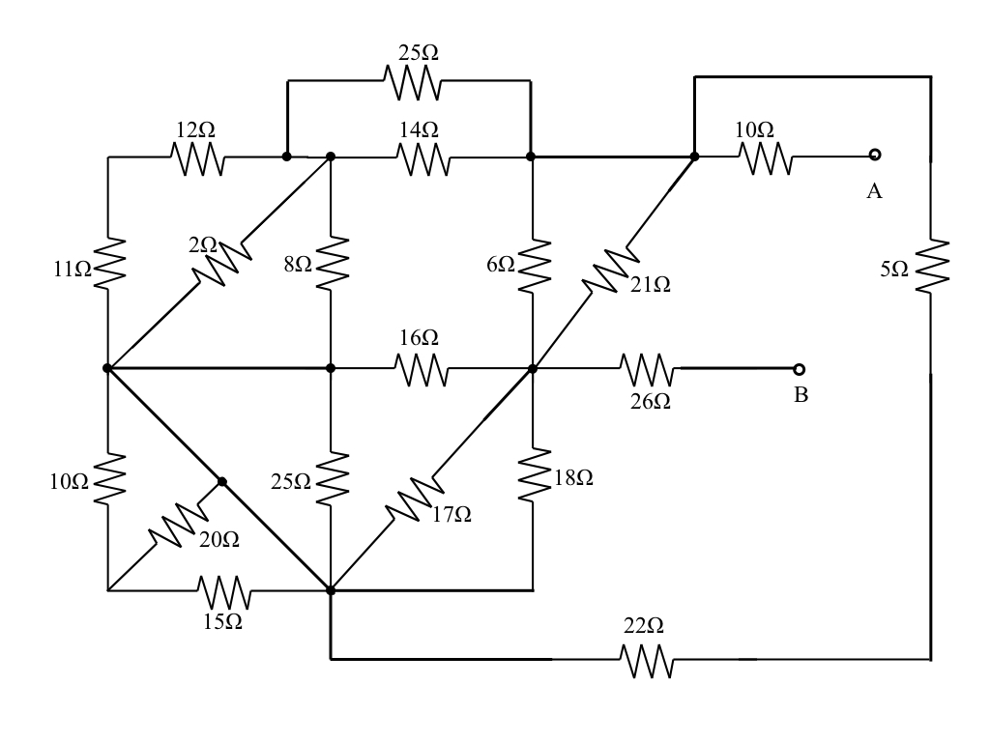

Room for extra work 3. {35 Points} A device (device1), shown in Figure 1, can be modeled as a current source in parallel with a resistance. The relationship between the voltage across device 1, $v_{D}$ and current through device 1, $i_{D}$ is shown in Figure 2.

Another device (device2), shown in Figure 3, can be modeled as a voltage source in series with a resistance. The relationship between the voltage across device 2, $v_{S}$ and current through device 2, $i_{S}$ is shown in Figure 4.

a) Find a model for Device 2 that would be valid for $9\left[mA\right]<i_{S}<12[mA]$ and draw it showing terminals C and D.

Device 2 and two identical versions of Device 1 are connected as shown in Figure 5. Pay attention to the way the terminals of the devices are connected. Refer to Figure 5, for the following questions:

b) Find $v_{X}$.

c) Find the power absorbed by Device 2.

d) Find the power delivered by $v_{P}$.







Room for extra work

Room for extra work