Name: _____________________________ (please print)

Signature: __________________________

ECE 2201 -- Exam #1

February 24, 2018

Keep this exam closed until you are told to begin.

1. This exam is closed book, closed notes. You may use one 8.5” x 11” crib sheet, or its equivalent.

2. Show all work on these pages. Show all work necessary to complete the problem. A solution without the appropriate work shown will receive no credit. A solution that is not given in a reasonable order will lose credit. Clearly indicate your answer (for example by enclosing it in a box).

3. It is assumed that your work will begin on the same page as the problem statement. If you choose to begin your work on another page, you must indicate this on the page with the problem statement, with a clear indication of where the work can be found. **If your work continues on to another page, indicate clearly where your work can be found. Failure to indicate this clearly will result in a loss of credit.**

4. Show all units in solutions, intermediate results, and figures. Units in the exam will be included between square brackets.

5. Do not use red ink. Do not use red pencil.

6. You will have 90 minutes to work on this exam.

1. ________________/35

2. ________________/30

3. ________________/35

Total = 100

Room for extra work

1. {35 Points} Five devices are connected as shown in Figure 1. Plots of the voltages $v_{X}\left(t\right)$ and $v_{Z}(t)$ and plot of the currents $i_{X}\left(t\right)$ and $i_{W}(t)$ are given in Figure 2.



a) For $0<t<10[ms]$ find the time interval (or intervals) when Device B absorbs power. Explain your answer.

b) Find the expressions for the power absorbed by Device E for the time interval $0<t<15[ms]$.

c) Calculate the energy delivered by Device E during the time interval $0<t<15[ms]$.

Figure 1

Figure 2

# Room for extra work

2. {30 Points} Four devices are connected as shown in Figure 1. The power delivered by Device A is given by the expression

$p_{DEL.BY.A}\left(t\right)=3.6\left[\frac{mW}{s^{2}}\right]t^{2}-12\left[\frac{mW}{s}\right]t-5.7[mW]$ for $0<t<10\left[s\right].$

The current $i_{C}\left(t\right)$ changes with time as shown in Figure 2.

1. Are electrons gaining or losing energy when they are moving through Device A at $t=3[s]$? Explain your answer.
2. At $t=8[s]$, it is known that devices B, C and D absorb same amount of power. Find $v_{A}(8[s])$.
3. How much charge moves through Device C from 0 to 15[s]?



Room for extra work

3. {35 Points} For the circuit shown below:

1. What is the power absorbed by the dependent current source? Are the electrons losing or gaining energy when they move through the dependent current source? Justify your answer.
2. What is the power absorbed by the 5[V] independent voltage source? Are the electrons losing or gaining energy when they move through the 5[V] independent voltage source? Justify your answer.

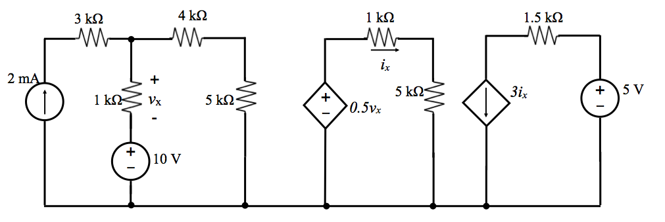

Room for extra work