Name: _____________________________ (please print)
Signature: __________________________

ECE 2201 – Exam #1
February 22, 2020

Keep this exam closed until you are told to begin.

1. This exam is closed book, closed notes. You may use one 8.5” x 11” crib sheet, or its equivalent.
2. Show all work on these pages. Show all work necessary to complete the problem. A solution without the appropriate work shown will receive no credit. A solution that is not given in a reasonable order will lose credit. Clearly indicate your answer (for example by enclosing it in a box).
3. It is assumed that your work will begin on the same page as the problem statement. If you choose to begin your work on another page, you must indicate this on the page with the problem statement, with a clear indication of where the work can be found. If your work continues on to another page, indicate clearly where your work can be found. Failure to indicate this clearly will result in a loss of credit.
4. Show all units in solutions, intermediate results, and figures. Units in the exam will be included between square brackets.
5. Do not use red ink. Do not use red pencil.
6. You will have 90 minutes to work on this exam.

1. ________________/35
2. ________________/30
3. ________________/35
Total = 100
Room for extra work
1. {35 Points} . Devices are connected as shown in Figure 1. Device A delivers power which is a function of time,
$p_{DEL by A}=2.5\left[\frac{mW}{(m{s)}^{2}}\right]t^{2}-5\left[\frac{mW}{ms}\right]t-4[mW]$.
The current i_{A}(t) in Device A is shown in Figure 2. Device C has the voltage v_{C}(t) and current i_{C}(t) shown in Figure 3. The charge carriers are electrons.
- Determine if Device A delivers or absorbs power at 2[ms]. In which direction electrons flow through this device? Do they gain or lose energy?
- When Device E delivers power at 2[ms] and its current i_{E} is 5[mA], find the voltage v_{B}(2[ms]) and current i_{B}(2[ms]).
- Find the current i_{F}(2[ms]) flowing through Device F.

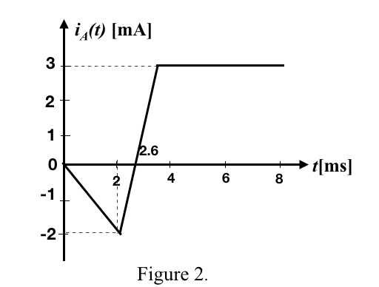
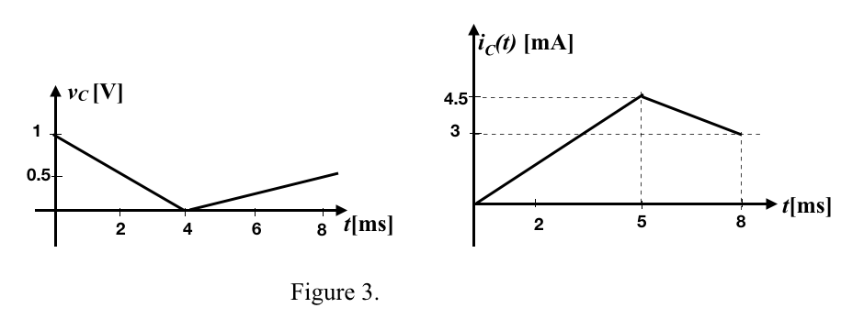

Room for extra work

2. {30 Points} In the circuit shown below, we know that the voltage v_{A} is
a) Find the value of i_{B} at t = 2[s].
b) Find the power absorbed by the device at t = 1.5[s].
c) Find the energy delivered by the 5[V] voltage source during the third [second], counting [seconds] starting at t = 2[s].

Room for extra work

3. {35 Points} Use the circuit below to solve.
a) Find the numerical value of i_{D}.
b) Find the numerical value for the power consumed by the v_{E} voltage source.

Room for extra work

1. {35 Points} . Devices are connected as shown in Figure 1. Device A delivers power which is a function of time,
$p_{DEL by A}=2.5\left[\frac{mW}{(m{s)}^{2}}\right]t^{2}-5\left[\frac{mW}{ms}\right]t-4[mW]$.
The current i_{A}(t) in Device A is shown in Figure 2. Device C has the voltage v_{C}(t) and current i_{C}(t) shown in Figure 3. The charge carriers are electrons.
- Determine if Device A delivers or absorbs power at 2[ms]. In which direction electrons flow through this device? Do they gain or lose energy?
- When Device E delivers power at 2[ms] and its current i_{E} is 5[mA], find the voltage v_{B}(2[ms]) and current i_{B}(2[ms]).
- Find the current i_{F}(2[ms]) flowing through Device F.
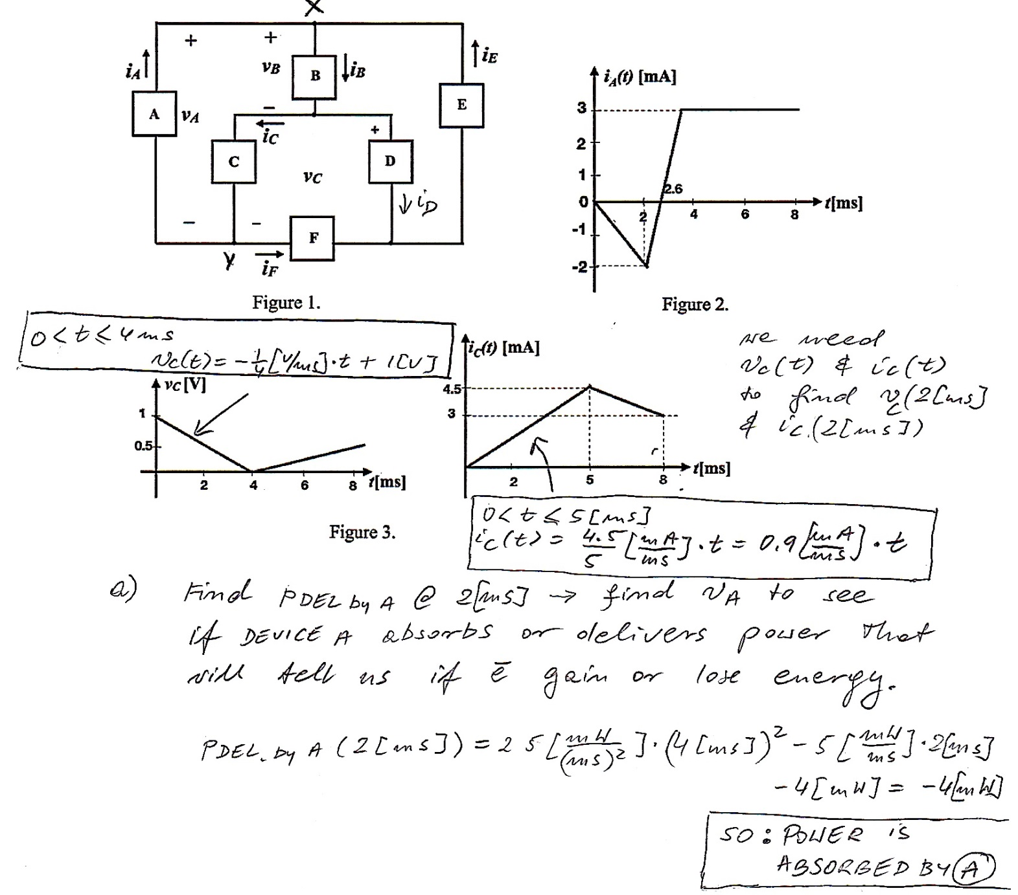

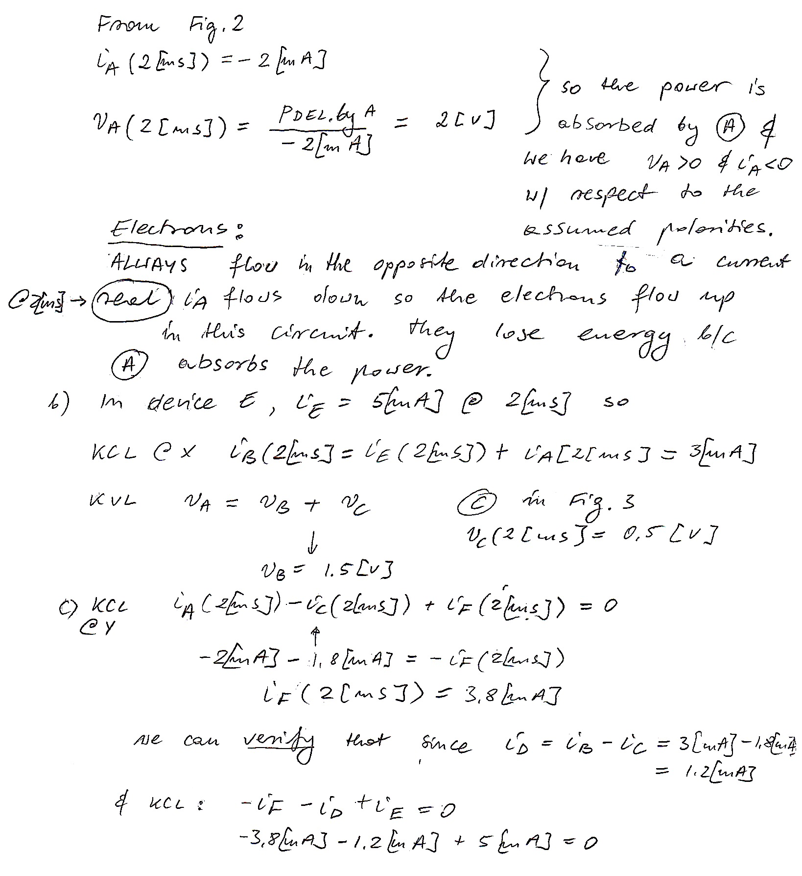

2. {30 Points} In the circuit shown below, we know that the voltage v_{A} is
a) Find the value of i_{B} at t = 2[s].
b) Find the power absorbed by the device at t = 1.5[s].
c) Find the energy delivered by the 5[V] voltage source during the third [second], counting [seconds] starting at t = 2[s].
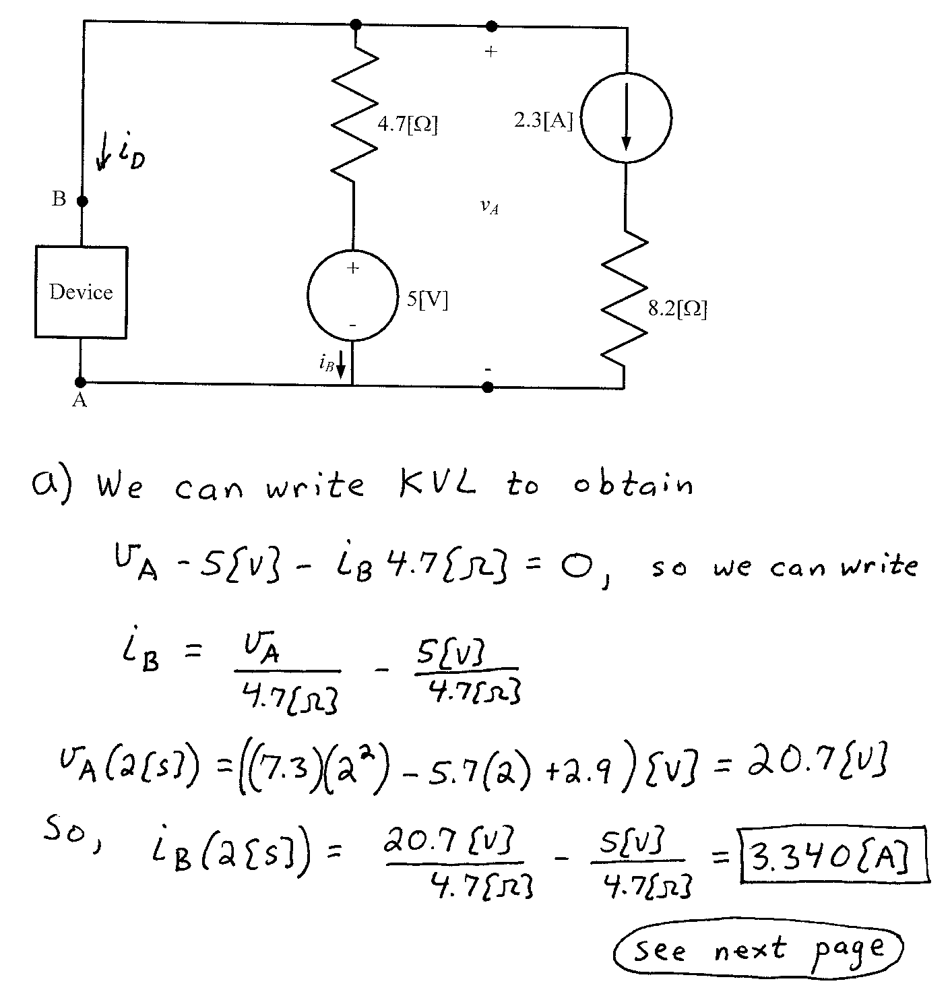
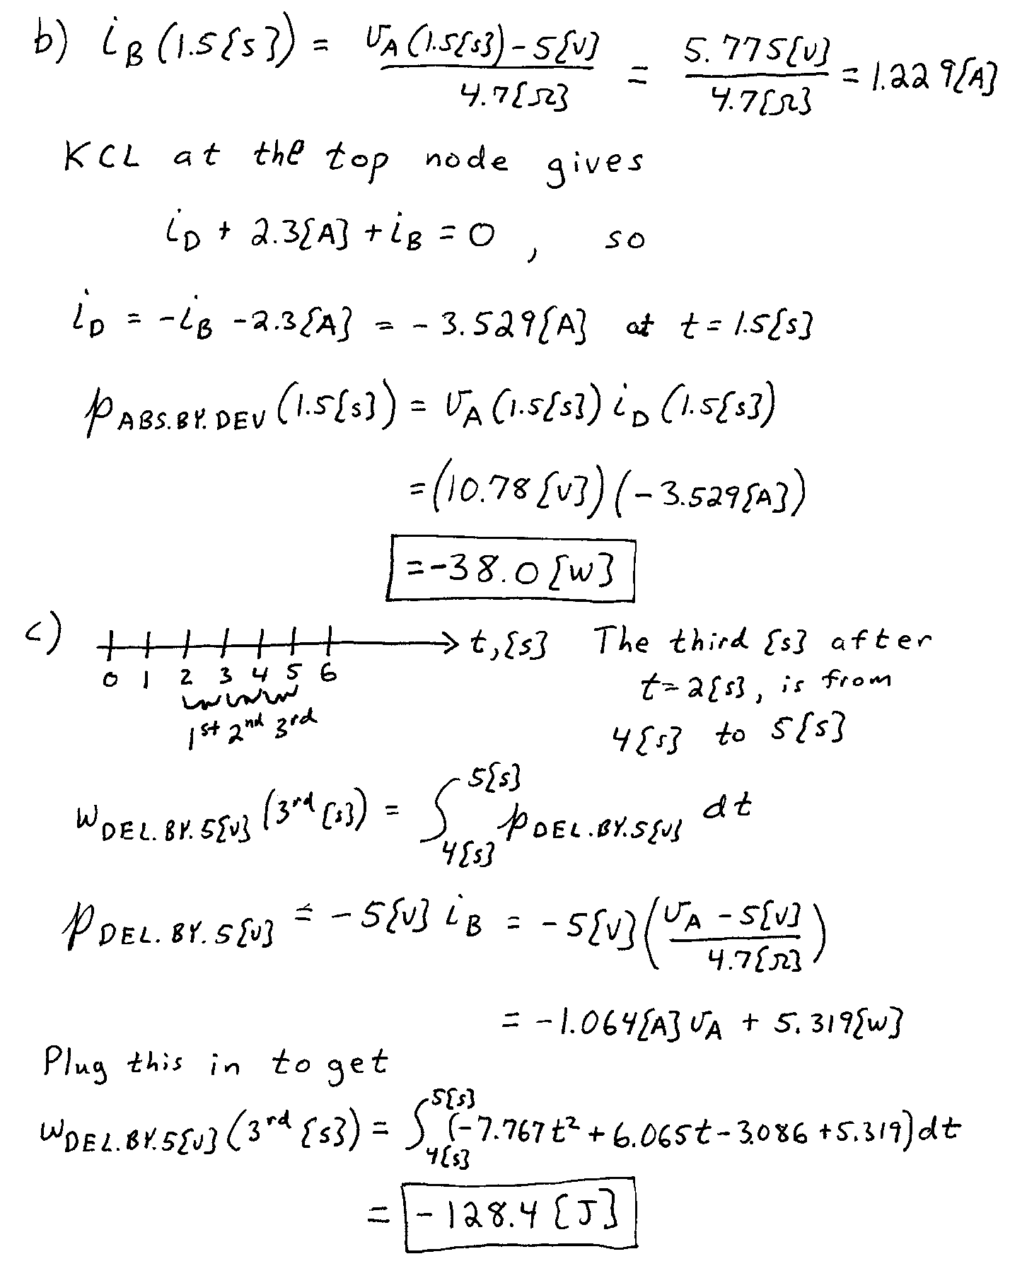

3. {35 Points} Use the circuit below to solve.
a) Find the numerical value of i_{D}.
b) Find the numerical value for the power consumed by the v_{E} voltage source.
