Name: _____________________________ (please print)
Signature: __________________________

ECE 2201 – Exam #2
April 18, 2020

1. This exam is closed book, closed notes. You may use one 8.5” x 11” crib sheet, or its equivalent. Do not communicate with anyone except Dr. Shattuck and Dr. Wosik while you are taking this exam.
2. Show all work necessary to complete the problem. Use additional sheets of paper as needed. A solution without the appropriate work shown will receive no credit. A solution which is not given in a reasonable order will lose credit.
3. It is assumed that your work will begin on the same page as the problem statement. If you choose to begin your work on another page, you must indicate this on the page with the problem statement, with a clear indication of where the work can be found. If your work continues on to another page, indicate clearly where your work can be found. Failure to indicate this clearly will result in a loss of credit.
4. Show all units in solutions, intermediate results, and figures. Units in the quiz will be included between square brackets.
5. Do not use red ink. Do not use red pencil.
6. You will have 90 minutes to work on this exam. Email your completed exam to Shattuck@uh.edu and Wosik@central.uh.edu . It must be sent before 11:00am CDT.

- ________________/35
- ________________/35
- ________________/30

1. {35 Points} A device can be modeled as a voltage source 9[V] in series with a resistance. The voltage source reference polarity has the plus sign closer to a, and the minus sign closer to b. The device is connected to a network of resistors as shown in Figure 1 and has the voltage v_{x} = 6[V] across its terminals. The same device is connected next to a circuit using terminals a and b as shown in Figure 2. In both figures, all resistances are given in [Ohms].
a) Find the device model and draw it, showing terminals a and b.
b) Find the power absorbed by the dependent voltage source 0.5v_{y} shown in Figure 2.

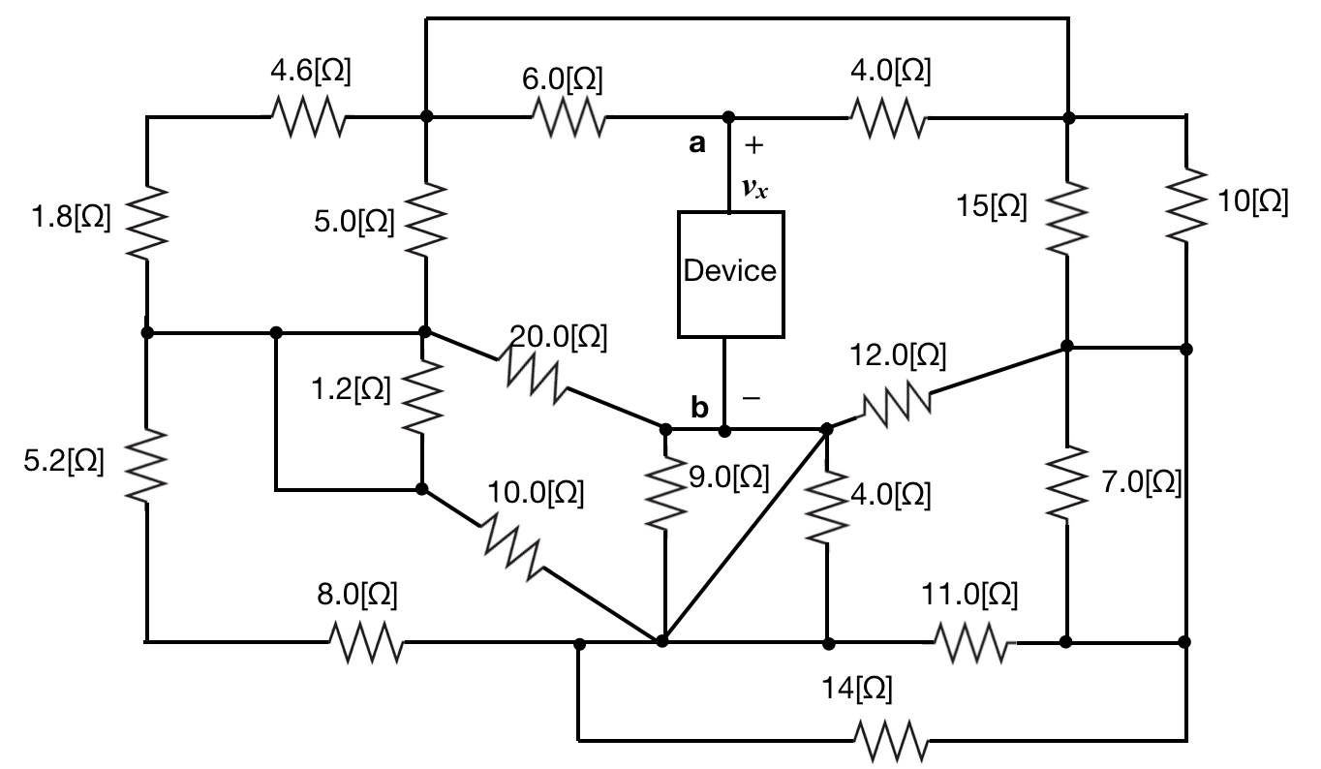.
Figure 1.

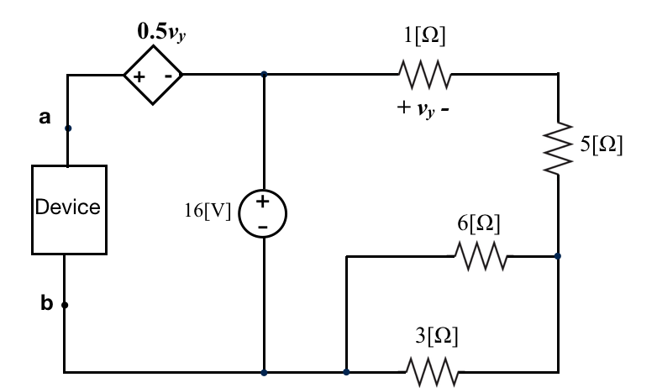
Figure 2.

2. {35 Points} Use the node-voltage method to write a complete set of equations that could be used to solve this circuit. Do not simplify the circuit. Do not attempt to simplify or solve your equations. Define all variables clearly. All resistances are given in [Ohms].
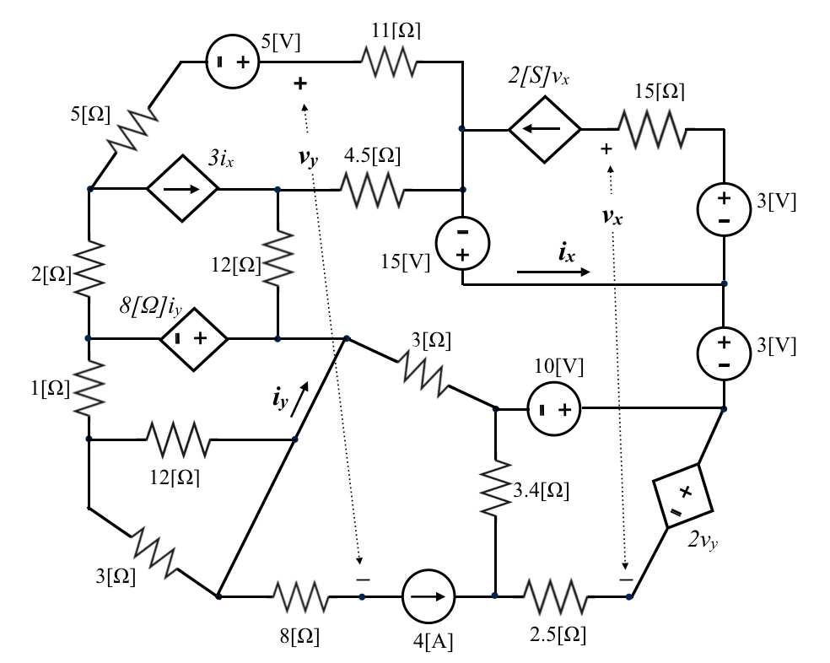

3. Use the mesh current method to write a complete set of equations that could be used to solve this circuit. Do not simplify the circuit. Do not attempt to solve or simplify your equations. All resistances in this circuit are given in [Ohms].

1. {35 Points} A device can be modeled as a voltage source 9[V] in series with a resistance. The voltage source reference polarity has the plus sign closer to a, and the minus sign closer to b. The device is connected to a network of resistors as shown in Figure 1 and has the voltage v_{x} = 6[V] across its terminals. The same device is connected next to a circuit using terminals a and b as shown in Figure 2. In both figures, all resistances are given in [Ohms].
a) Find the device model and draw it, showing terminals a and b.
b) Find the power absorbed by the dependent voltage source 0.5v_{y} shown in Figure 2.
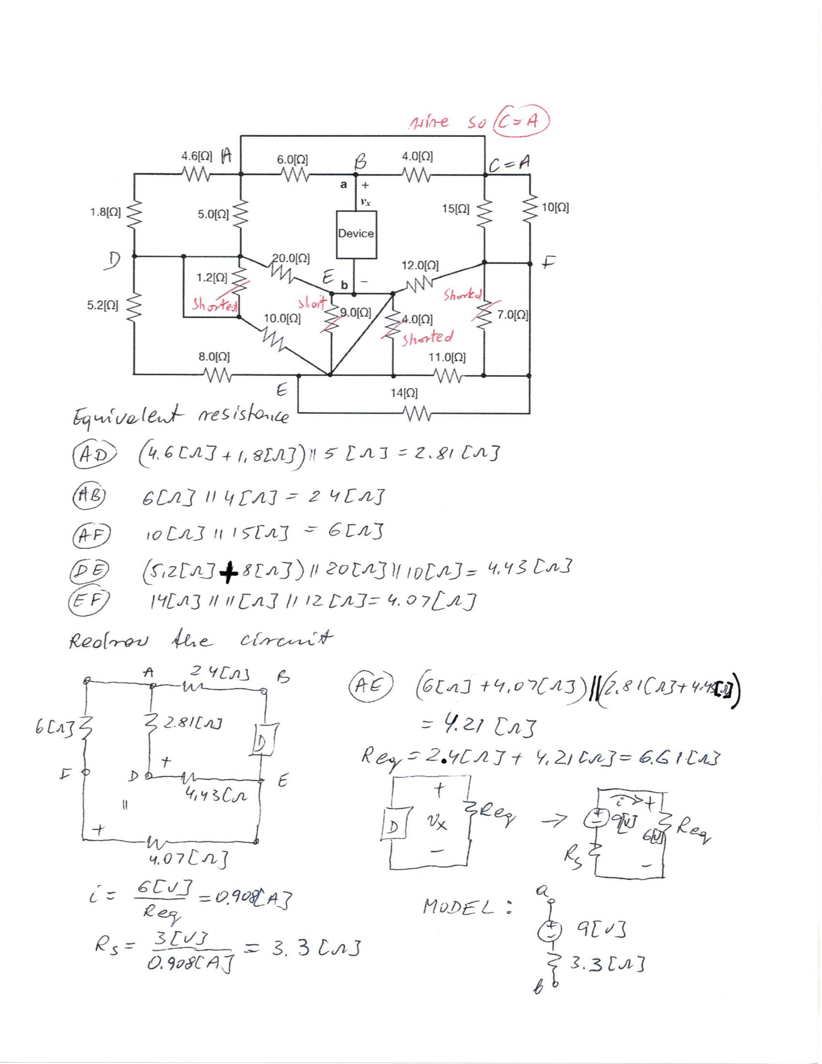
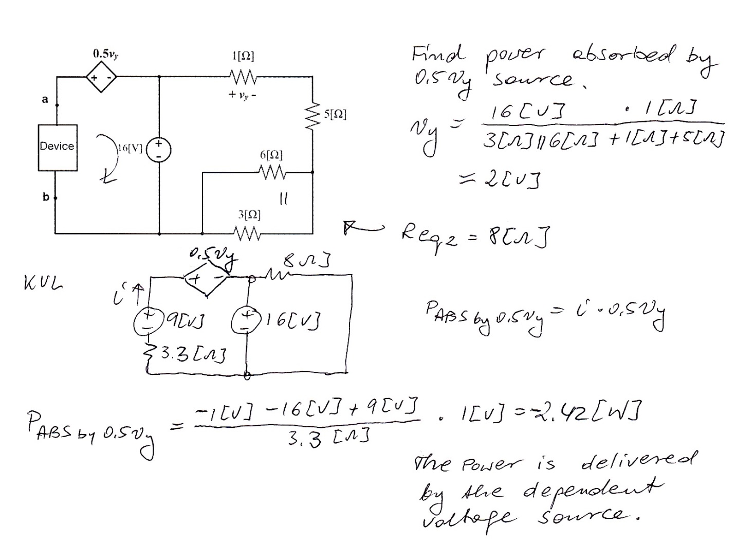

2. {35 Points} Use the node-voltage method to write a complete set of equations that could be used to solve this circuit. Do not simplify the circuit. Do not attempt to simplify or solve your equations. Define all variables clearly. All resistances are given in [Ohms].
