Name: _____________________________ (please print)
Signature: __________________________

ECE 2201 – Final Exam
April 29, 2020

1. This exam is closed book, closed notes. You may use one 8.5” x 11” crib sheet, or its equivalent. Do not communicate with anyone except Dr. Shattuck and Dr. Wosik while you are taking this exam.
2. Show all work necessary to complete the problem. Use additional sheets of paper as needed. A solution without the appropriate work shown will receive no credit. A solution which is not given in a reasonable order will lose credit.
3. It is assumed that your work will begin on the same page as the problem statement. If you choose to begin your work on another page, you must indicate this on the page with the problem statement, with a clear indication of where the work can be found. If your work continues on to another page, indicate clearly where your work can be found. Failure to indicate this clearly will result in a loss of credit.
4. Show all units in solutions, intermediate results, and figures. Units in the quiz will be included between square brackets.
5. Do not use red ink. Do not use red pencil.
6. You will have 140 minutes to work on this exam, plus additional time to print, scan and email your work. Email your completed exam to Shattuck@uh.edu and Wosik@central.uh.edu . It must be sent before 2:00pm CDT.

- ________________/25
- ________________/25
- ________________/25
- ________________/25

- {25 Points} Use the circuit below to solve. All resistor values are given in [Ohms].
- Find v_{X}.
- Find the power delivered by the i_{F} current source at t = 2[s].
- Find the energy absorbed by the i_{F} current source in the third [second] after
t = 2[s].
- Assume electrons are the charge carriers in this circuit. Which way are the electrons moving through the 5.1v_{A} voltage source, at t = 1[s]? Explain your answer briefly but clearly.
- {25 Points} Use the Node-Voltage Method to write a complete set of equations that could be used to solve this circuit. Do not simplify the circuit. Do not attempt to solve or simplify your equations. All resistances in this circuit are given in [Ohms].

3. {25 Points} The devices shown can be modeled as a voltage source in series with a resistance. These devices are connected in a circuit drawn in Figure 3.

- Find the equivalent model for Device 1 using data from Table 1 with current values in response to resistors connected to terminals A and B.
- Find the equivalent model for Device 2 using it i_{D2} vs. v_{D2} characteristic shown in Figure 2.
- Find the Thevenin equivalent of the circuit in Figure 3 as seen by Device 1. Draw its schematic showing terminals A and B with the connected Device 1.
- Find the power delivered to the circuit by Device 1.
R[kΩ] | i_{D1}[mA]
3 | 4
8 | 2
18 | 1
Table 1
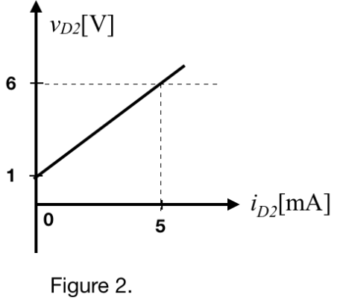
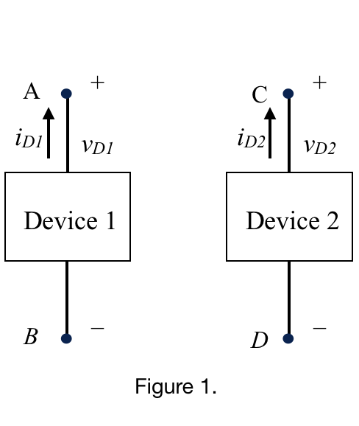

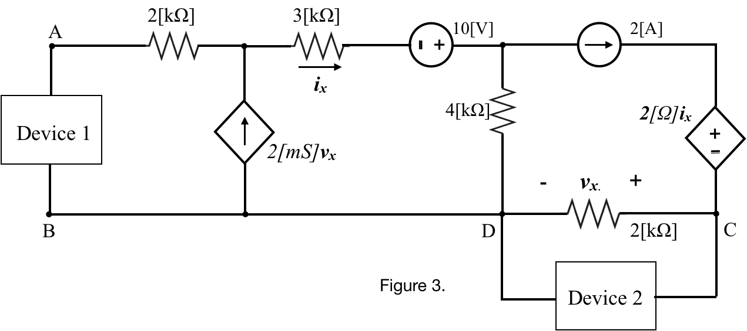
4. {25} Use the circuit given below to solve this problem.
a) Find the equivalent resistance of this circuit with respect to terminals A and B.
b) Find the equivalent resistance of this circuit with respect to terminals B and C.

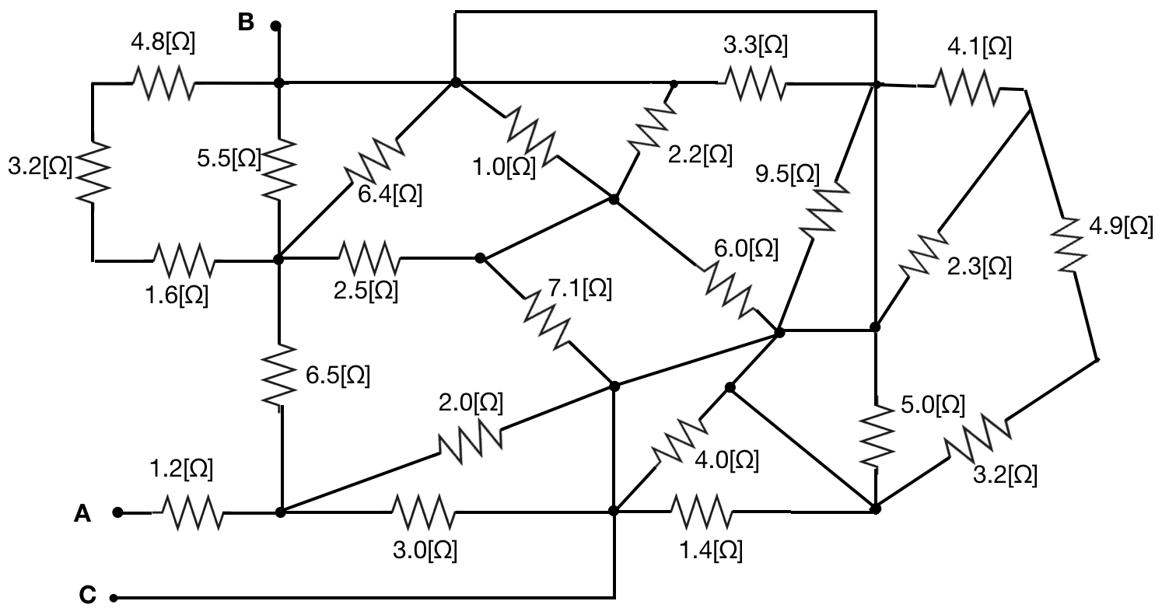

Solutions:
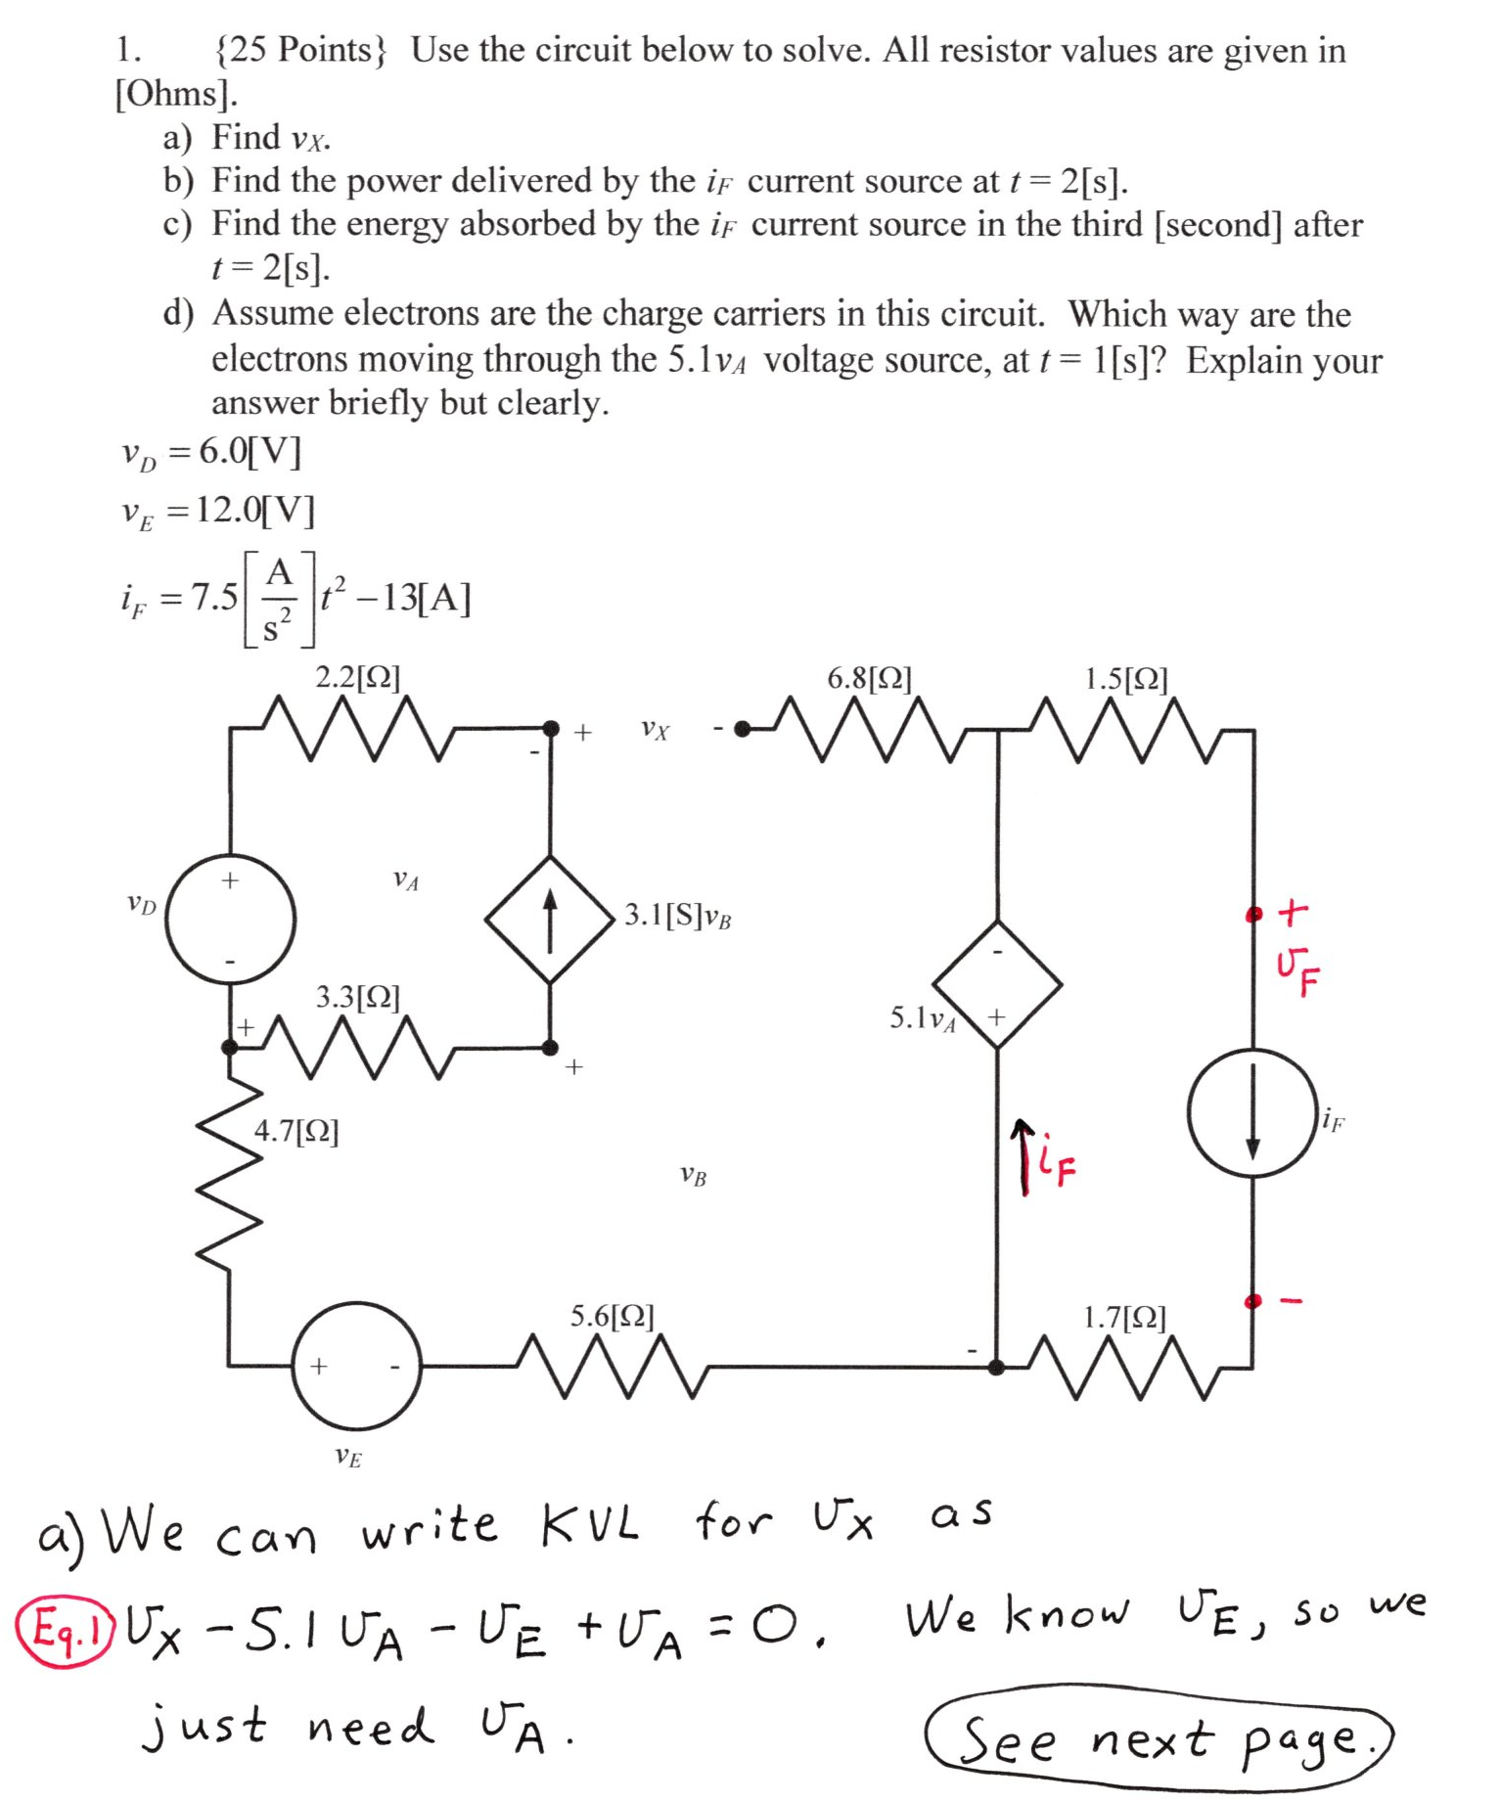
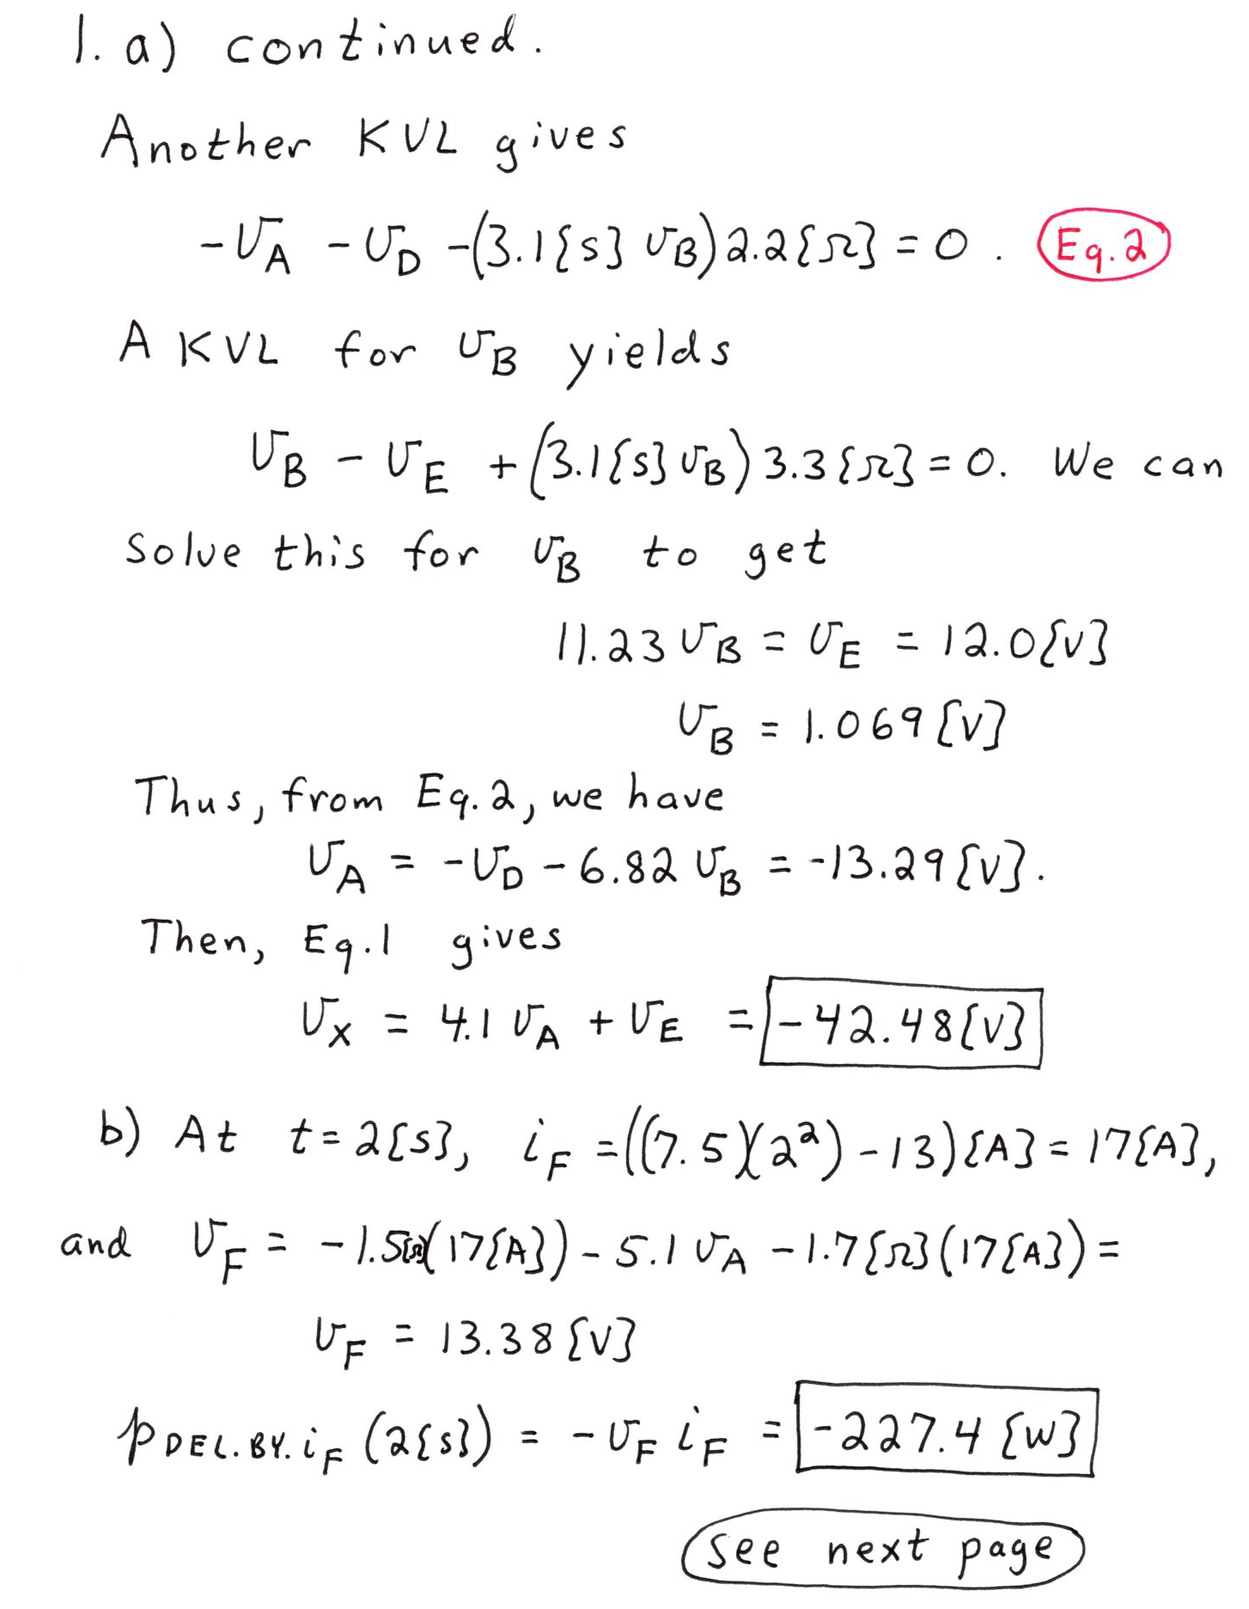
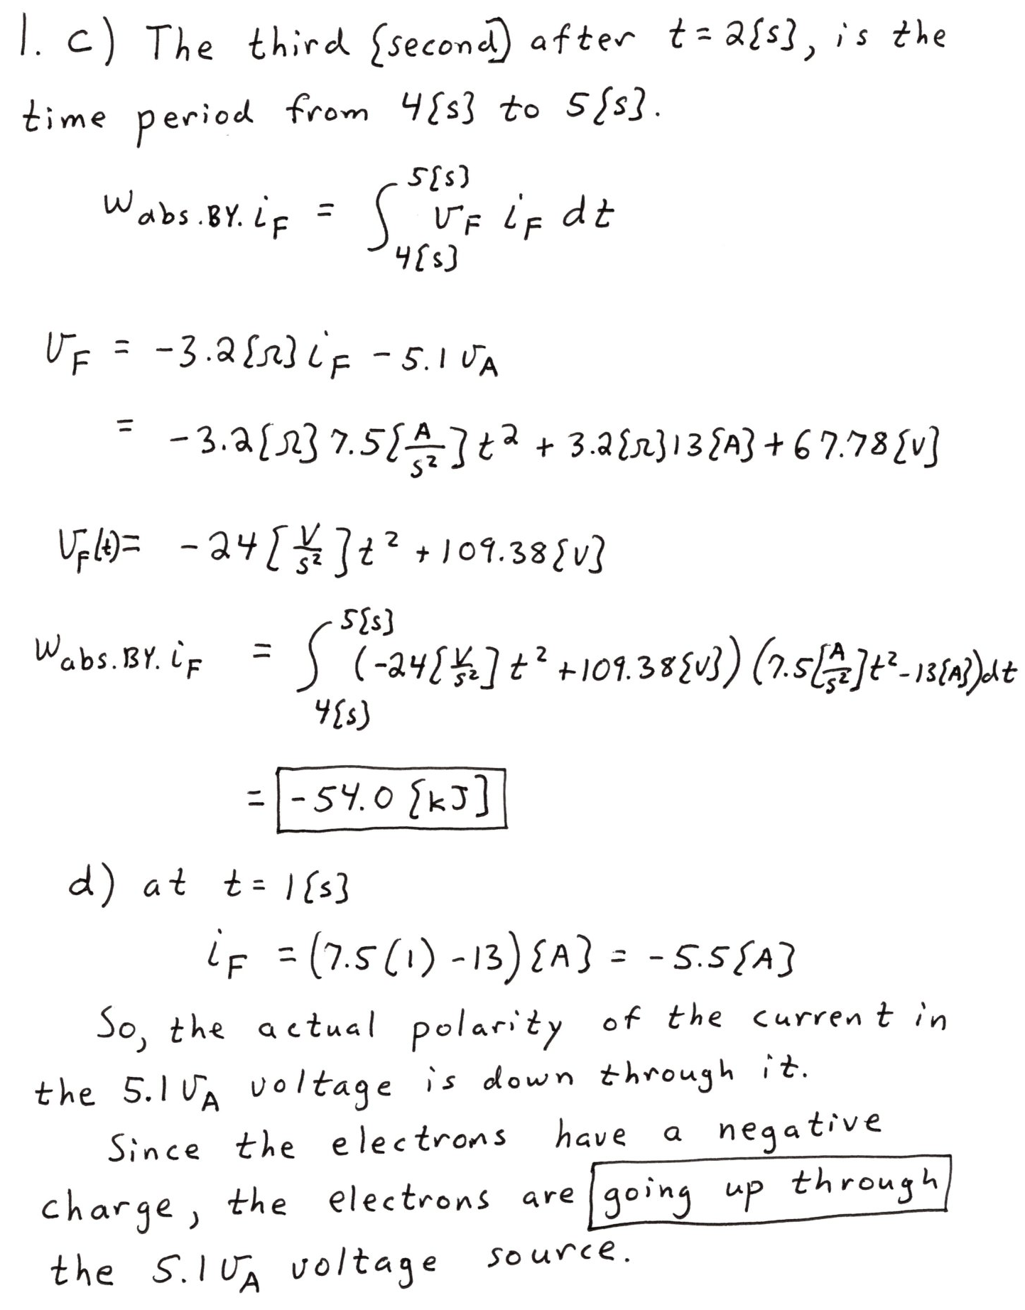
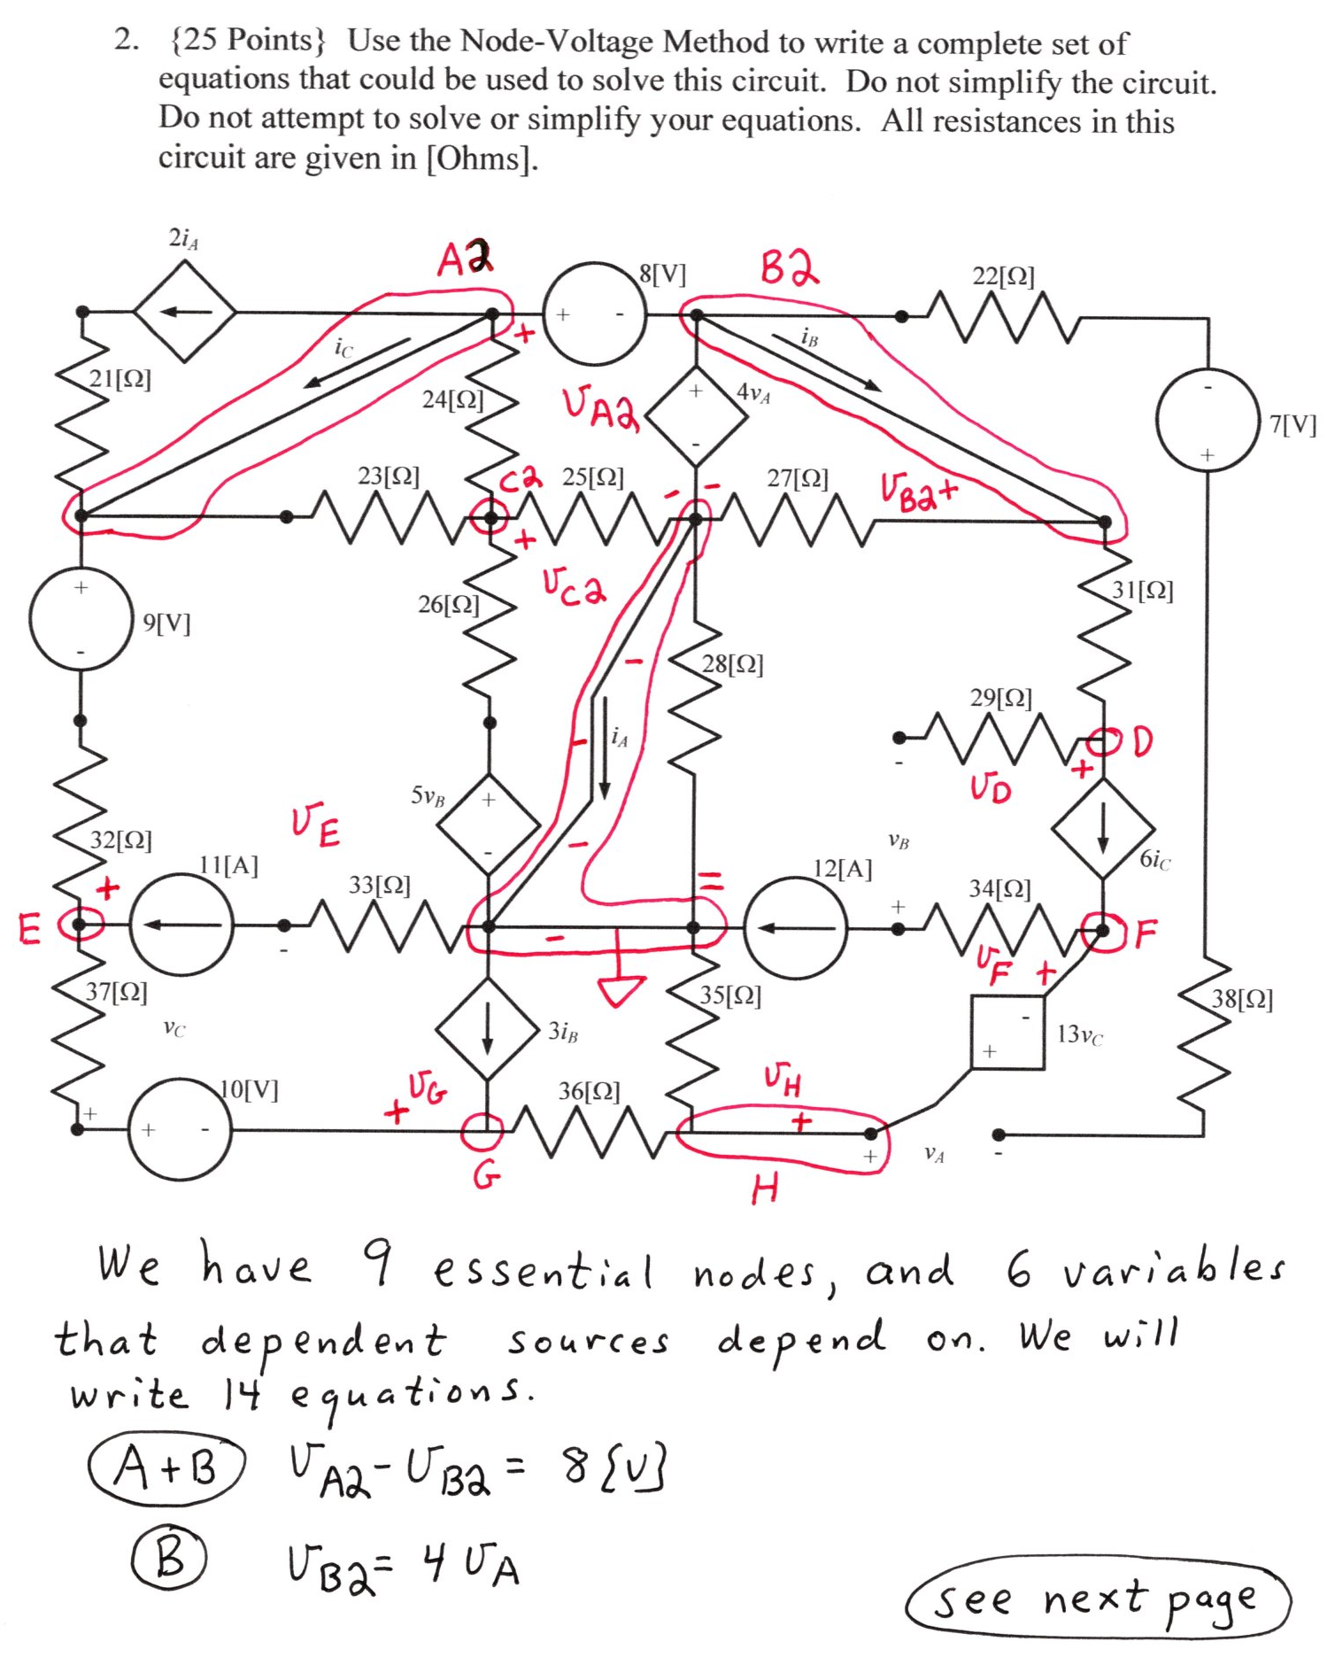
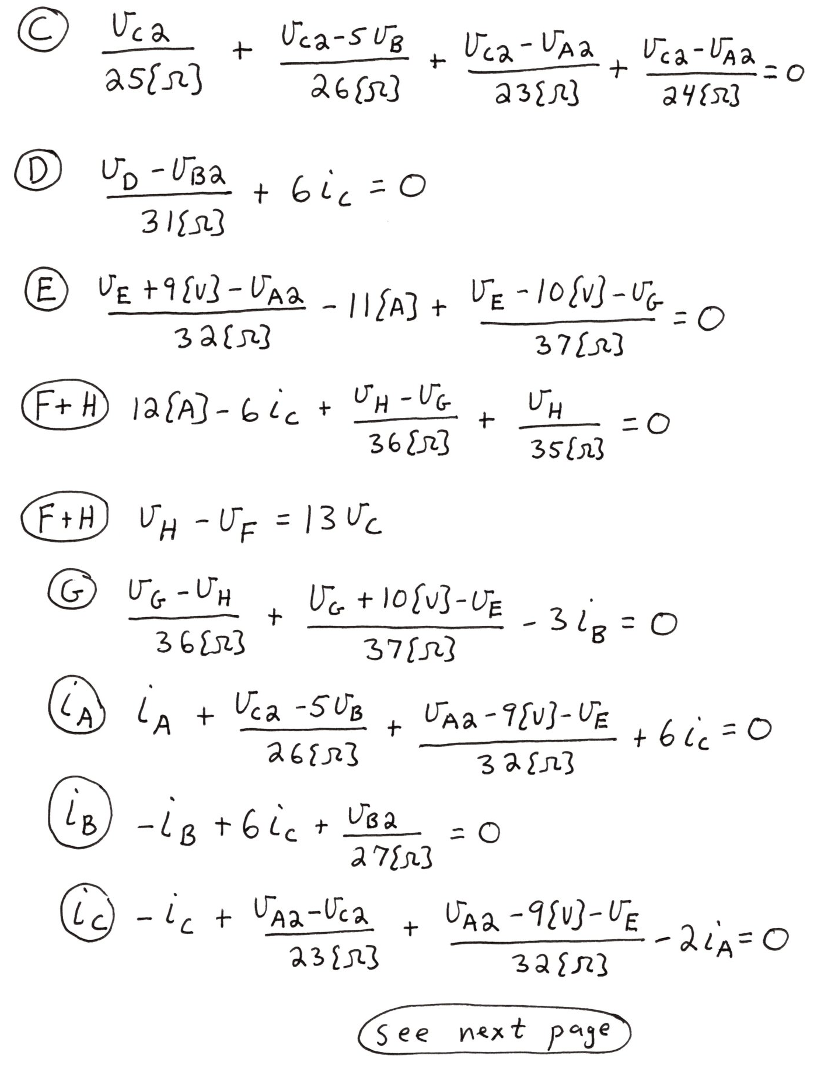

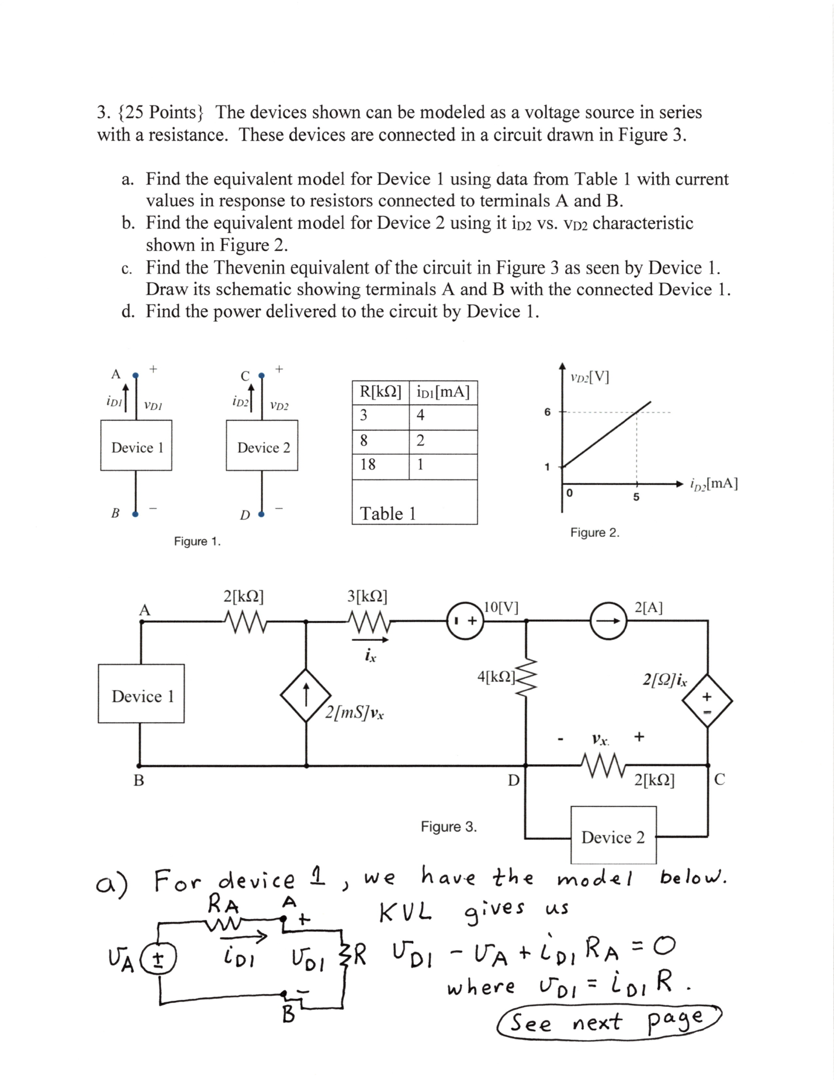
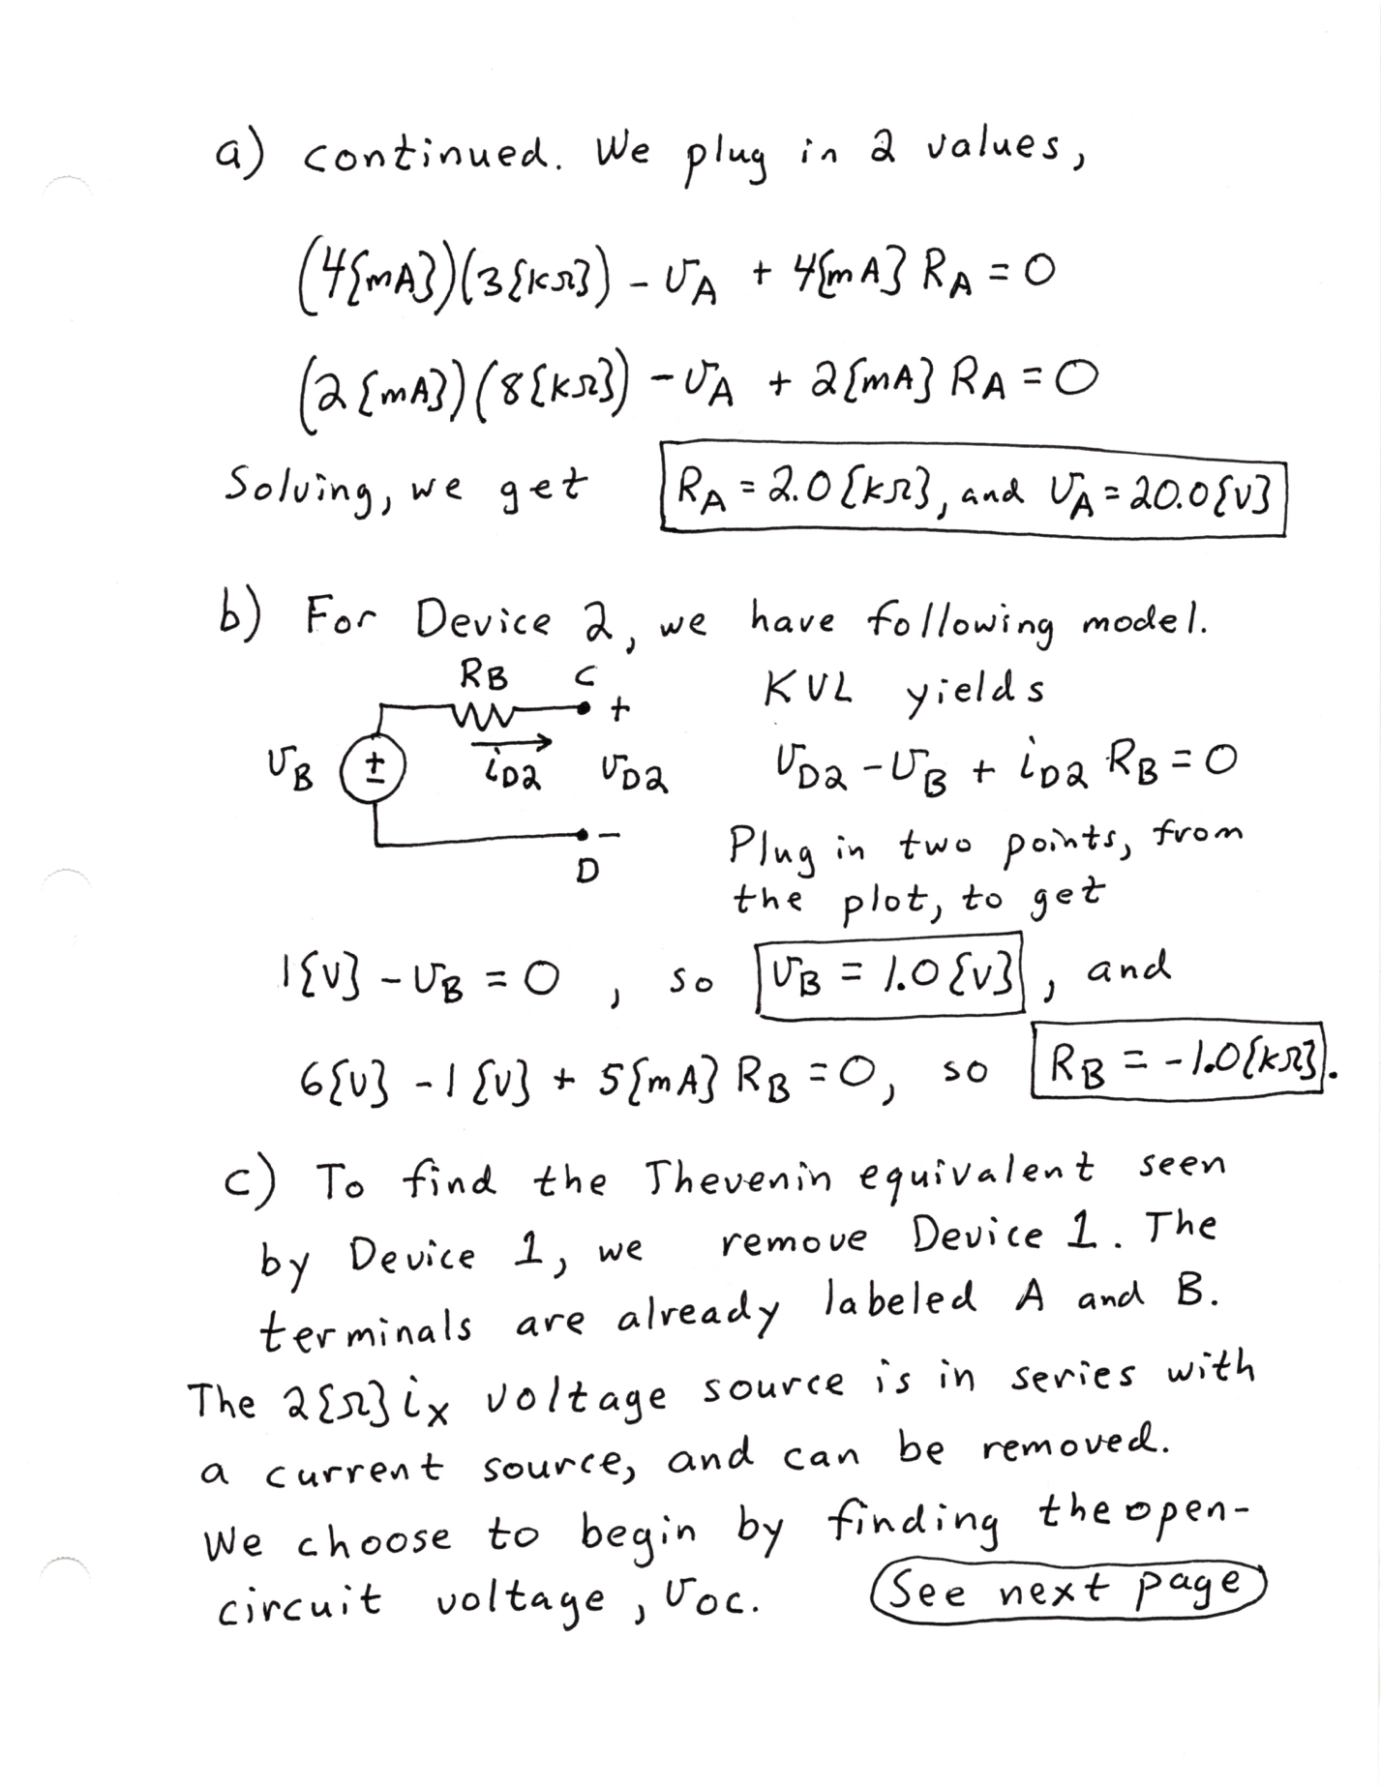
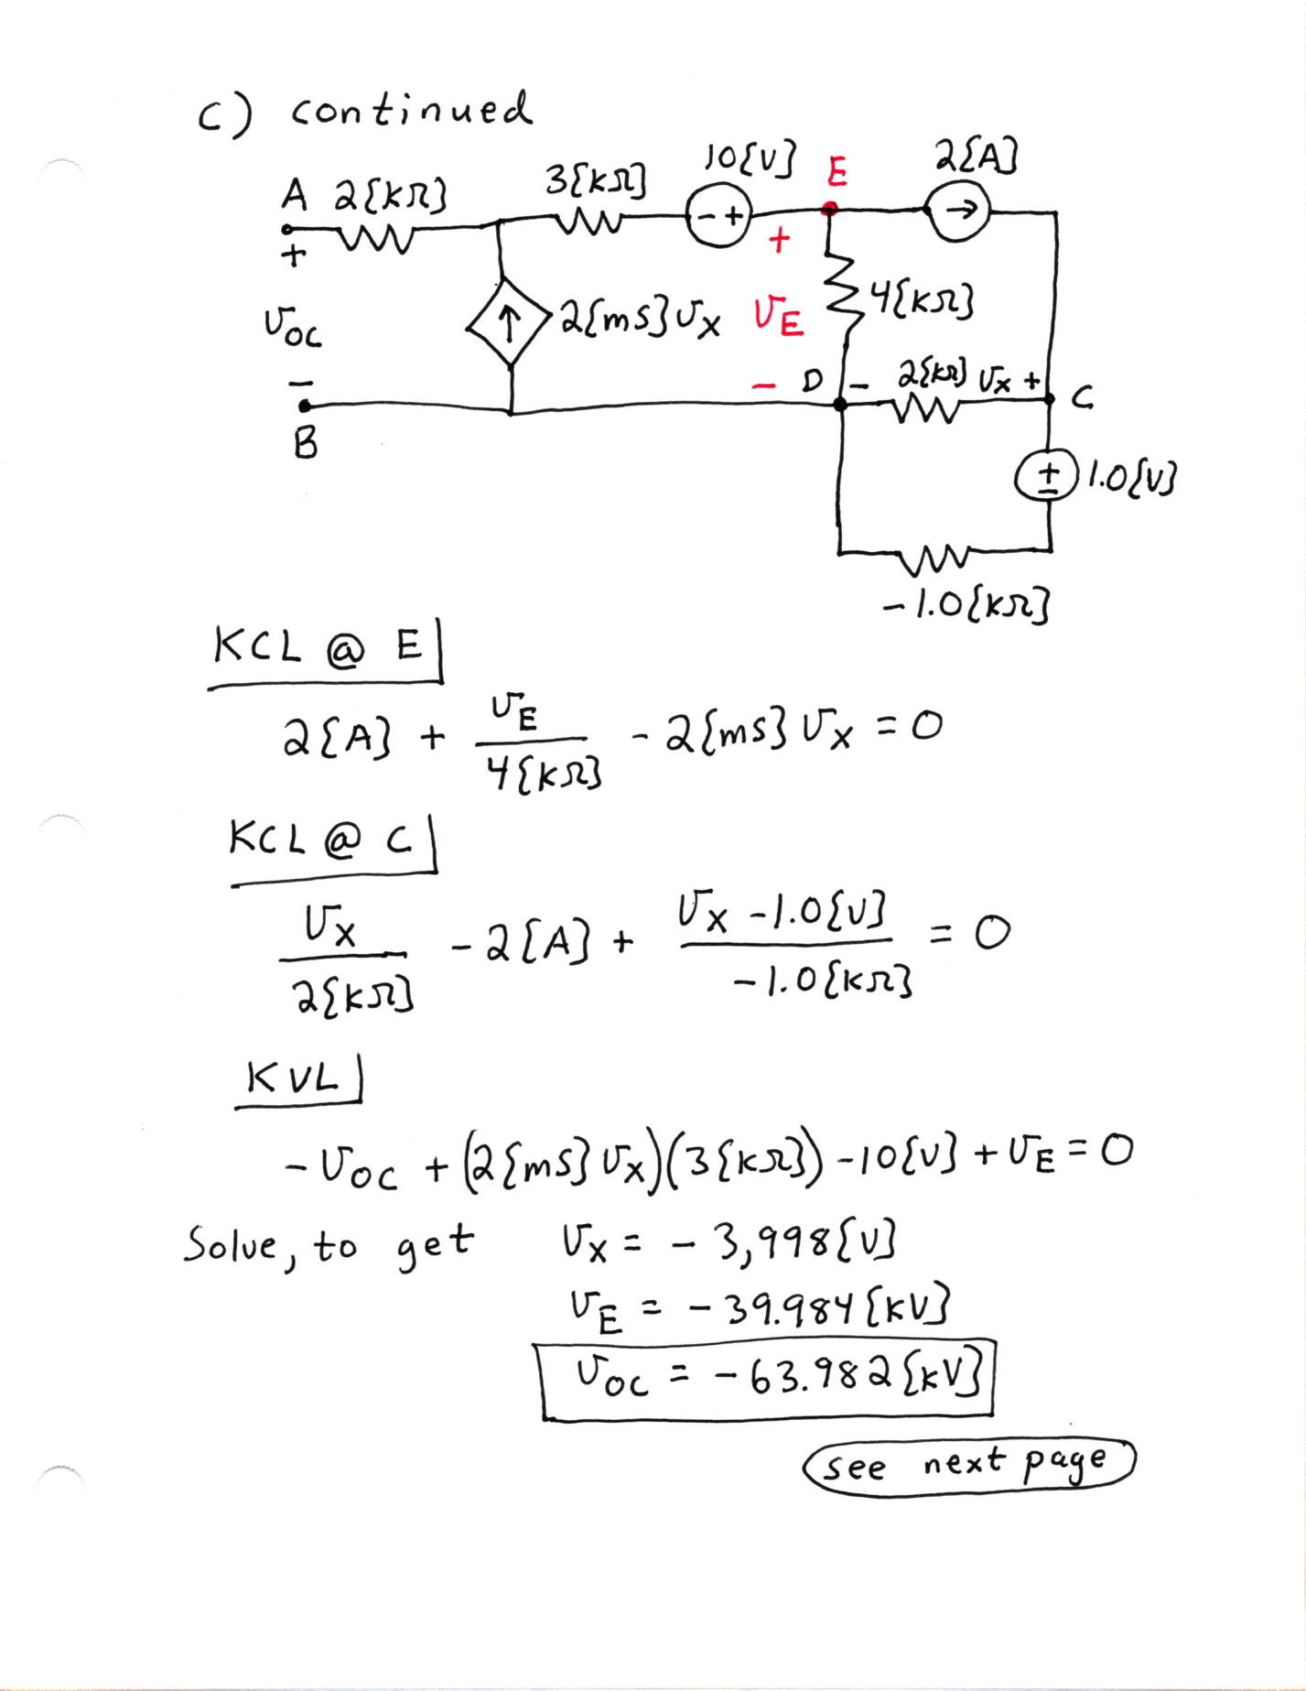

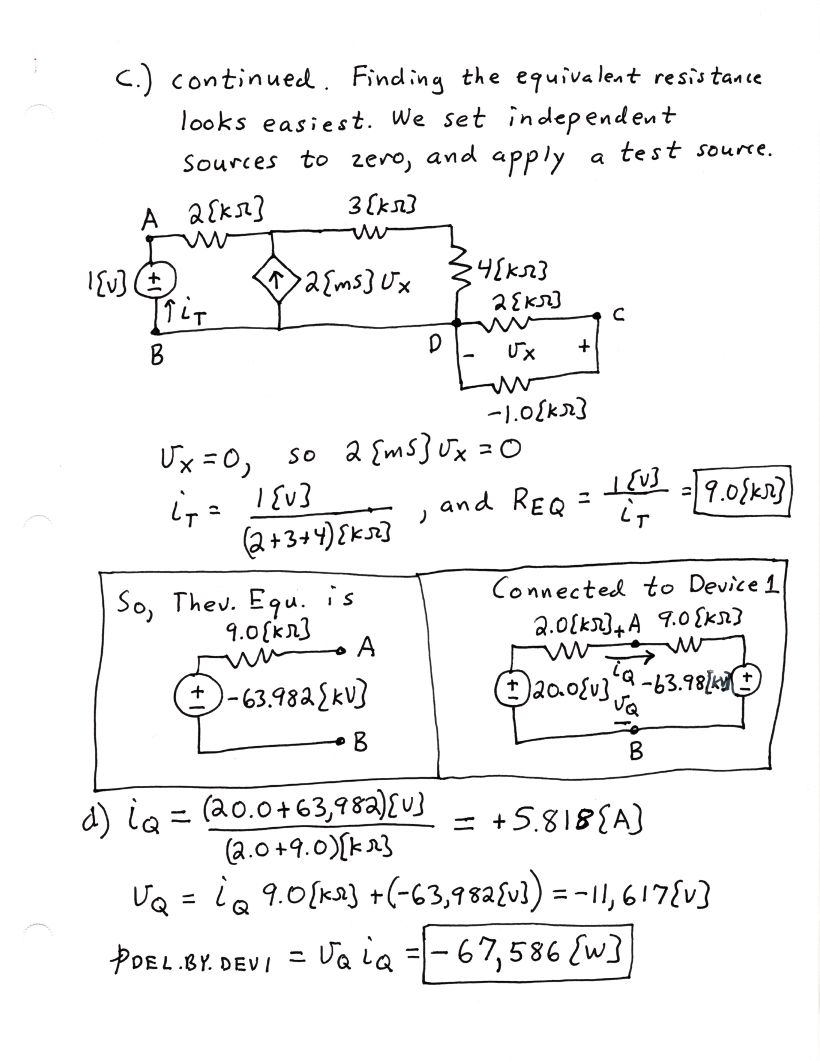

4. {25} Use the circuit given below to solve this problem.
a) Find the equivalent resistance of this circuit with respect to terminals A and B.
b) Find the equivalent resistance of this circuit with respect to terminals B and C.
