Name: _____________________________ (please print)

Signature: __________________________

ECE 2201 – Quiz #1

February 4, 2020

Keep this quiz closed and face up until you are told to begin.

1. This quiz is closed book, closed notes. You may use one 8.5” x 11” crib sheet, or its equivalent.

2. Show all work on these pages. Show all work necessary to complete the problem. A solution without the appropriate work shown will receive no credit. A solution which is not given in a reasonable order will lose credit.

3. It is assumed that your work will begin on the same page as the problem statement. If you choose to begin your work on another page, you must indicate this on the page with the problem statement, with a clear indication of where the work can be found. **If your work continues on to another page, indicate clearly where your work can be found. Failure to indicate this clearly will result in a loss of credit.**

4. Show all units in solutions, intermediate results, and figures. Units in the quiz will be included between square brackets.

5. Do not use red ink. Do not use red pencil.

6. You will have 30 minutes to work on this quiz.

________________/20

Room for extra work

In the circuit shown, four devices are connected together. The values for some of the voltages and currents are given.

1. Find the power delivered by Device 2.
2. Assume that the charge carriers are protons. Which way are the charge carriers moving through Device 3? Your answer should be either   
   from-left-to-right, or from-right-to-left. Explain your answer briefly.



1. How much energy is absorbed by Device 1 in a 4[ms] time period?
2. Assume that the charge carriers are protons. Are the charges gaining or losing energy as they move through Device 3? Explain your answer briefly, showing how you got your answer.



In the circuit shown, four devices are connected together. The values for some of the voltages and currents are given.

1. Find the power delivered by Device 2.
2. Assume that the charge carriers are protons. Which way are the charge carriers moving through Device 3? Your answer should be either   
   from-left-to-right, or from-right-to-left. Explain your answer briefly.



1. How much energy is absorbed by Device 1 in a 4[ms] time period?
2. Assume that the charge carriers are protons. Are the charges gaining or losing energy as they move through Device 3? Explain your answer briefly, showing how you got your answer.



In the circuit shown, four devices are connected together. The values for some of the voltages and currents are given.

1. Find the power delivered by Device 2.
2. Assume that the charge carriers are protons. Which way are the charge carriers moving through Device 3? Your answer should be either   
   from-left-to-right, or from-right-to-left. Explain your answer briefly.
3. How much energy is absorbed by Device 1 in a 4[ms] time period?
4. Assume that the charge carriers are protons. Are the charges gaining or losing energy as they move through Device 3? Explain your answer briefly, showing how you got your answer.





In the circuit shown, four devices are connected together. The values for some of the voltages and currents are given.

1. Find the power delivered by Device 2.
2. Assume that the charge carriers are protons. Which way are the charge carriers moving through Device 3? Your answer should be either   
   from-left-to-right, or from-right-to-left. Explain your answer briefly.



1. How much energy is absorbed by Device 1 in a 4[ms] time period?
2. Assume that the charge carriers are protons. Are the charges gaining or losing energy as they move through Device 3? Explain your answer briefly, showing how you got your answer.



Room for extra work

ECE 2201 – Quiz #1 – Shattuck Section – February 4, 2020 – Solution

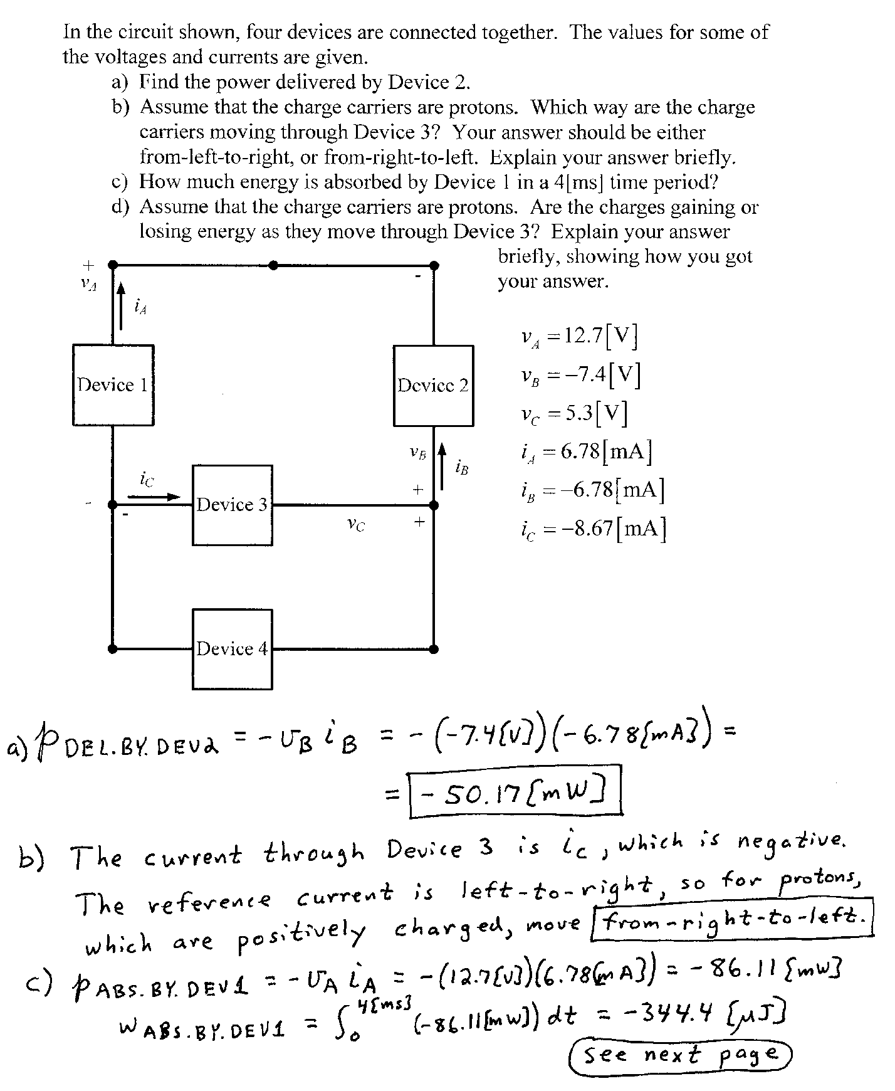

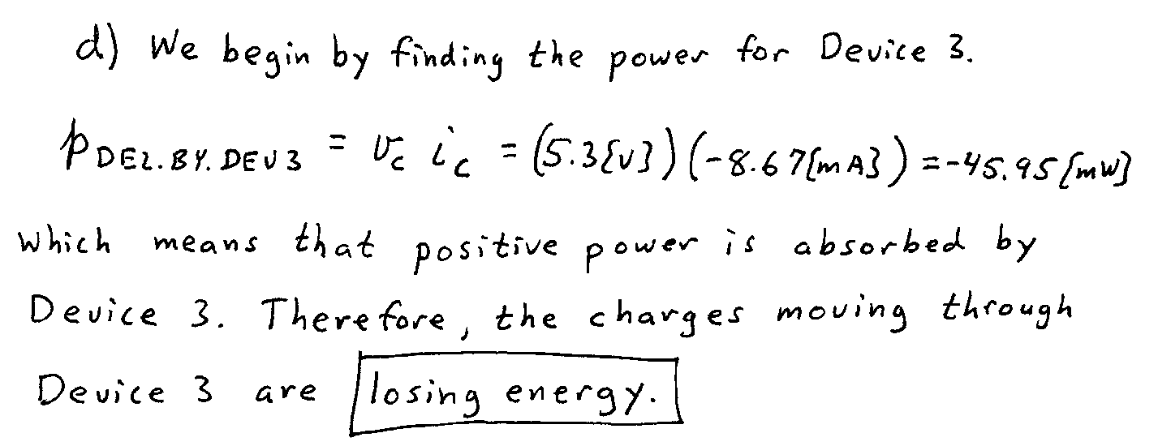

This is the solution for one of the four versions of this quiz. The abbreviated solutions for the other three versions are on the pages that follow. Those solutions do not have the same level of detail, but follow the approach given here in this solution. For some cases, the written explanations would not be considered sufficient as a student submission, since the explanations are given in the above solution.

