Name: _______SOLUTION____________ (please print)
Signature: __________________________

ECE 2201 – Exam 1
February 26, 2022

Keep this exam closed and face up until you are told to begin.

1. This exam is closed book, closed notes. You may have a crib sheet in the form of one 8 ½” x 11” piece of paper written on both sides.
2. Show all work on these pages. Show all work necessary to complete the problem. A solution without the appropriate work shown will receive no credit. A solution which is not given in a reasonable order will lose credit.
3. Show all units in solutions, intermediate results, and figures. Units in the exam will be included between square brackets.
4. If the grader has difficulty following your work because it is messy or disorganized, you will lose credit.
5. Do not use red ink. Do not use red pencil.
6. You will have 90 minutes to work on this exam.

1. ________________/30
2. ________________/35
3. ________________/35
Total = 100
Room for extra work
- (30 points) Four devices are connected as shown in Figure 1 for time t>0. The voltage v_{x} is shown in Figure 2. Device 1 and Device 4 deliver positive power at some time interval to identical devices i.e. Device 2 and Device 3. The expression for the energy delivered by Device 1 is given as $w_{del by D1}={5\left[\frac{mJ}{s^{3}}\right]t}^{3}-1\left[\frac{mJ}{s^{2}}\right]t^{2}$
and by Device 4 as $w_{del by D4}={2\left[\frac{mJ}{s^{3}}\right]t}^{3}-5\left[\frac{mJ}{s^{2}}\right]t^{2}$.

  - Find the currents flowing through Device 1 and Device 4 as a function of time.
  - Make plots of these currents i₁ and i₄ as a function of time and determine when each of these devices delivers power.
  - Find the time when both Device 2 and Device 3 start to absorb the power.
  - Make plots of the currents i₂ and i₃.

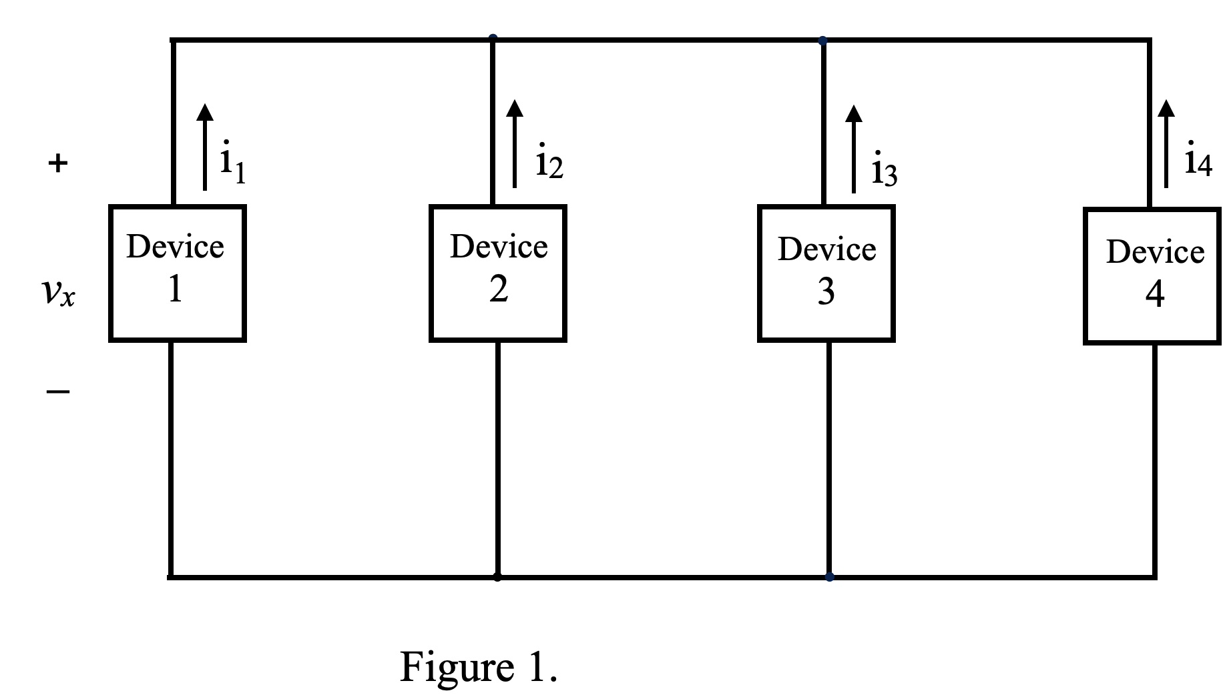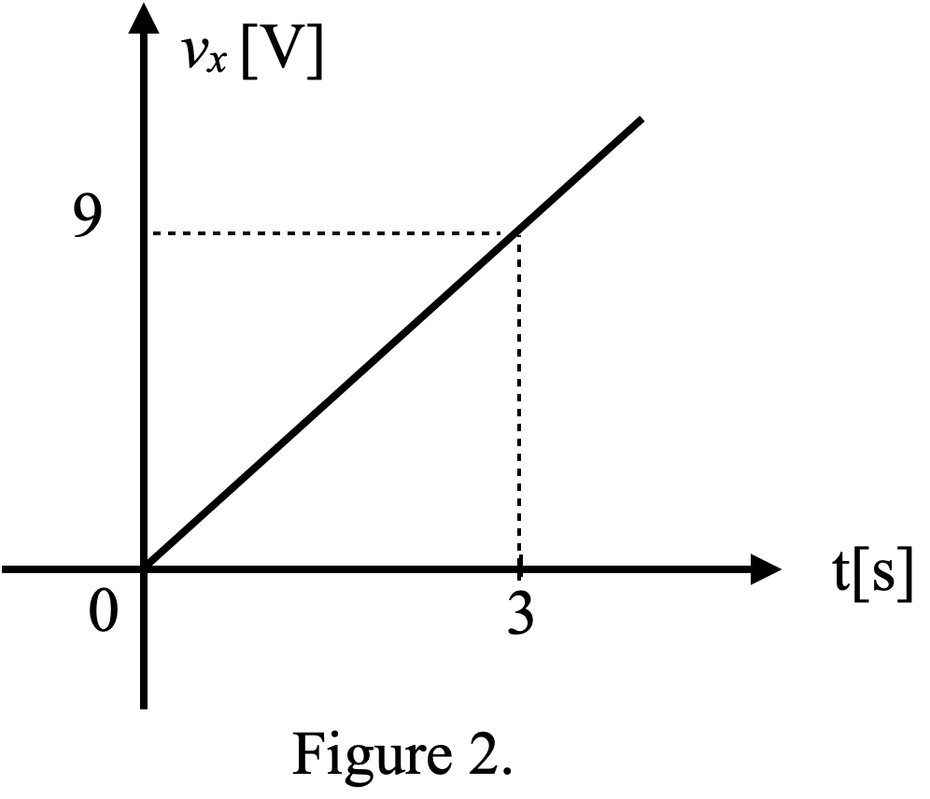

Room for Extra Work

2. (35 points) For the circuit below, do the following.

- Find the voltage v_{z}.
- Find the power delivered by the dependent voltage source 2v_{X}.

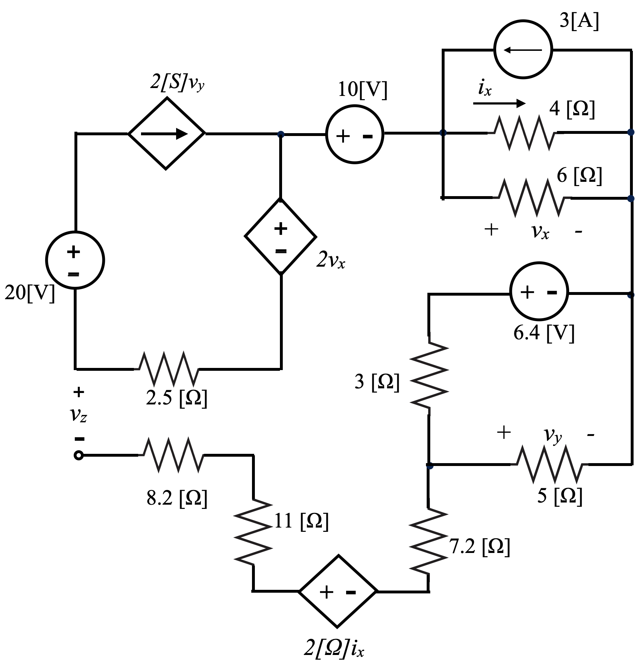

Room For Extra Work

- (35 points) Use the circuit shown below to solve.
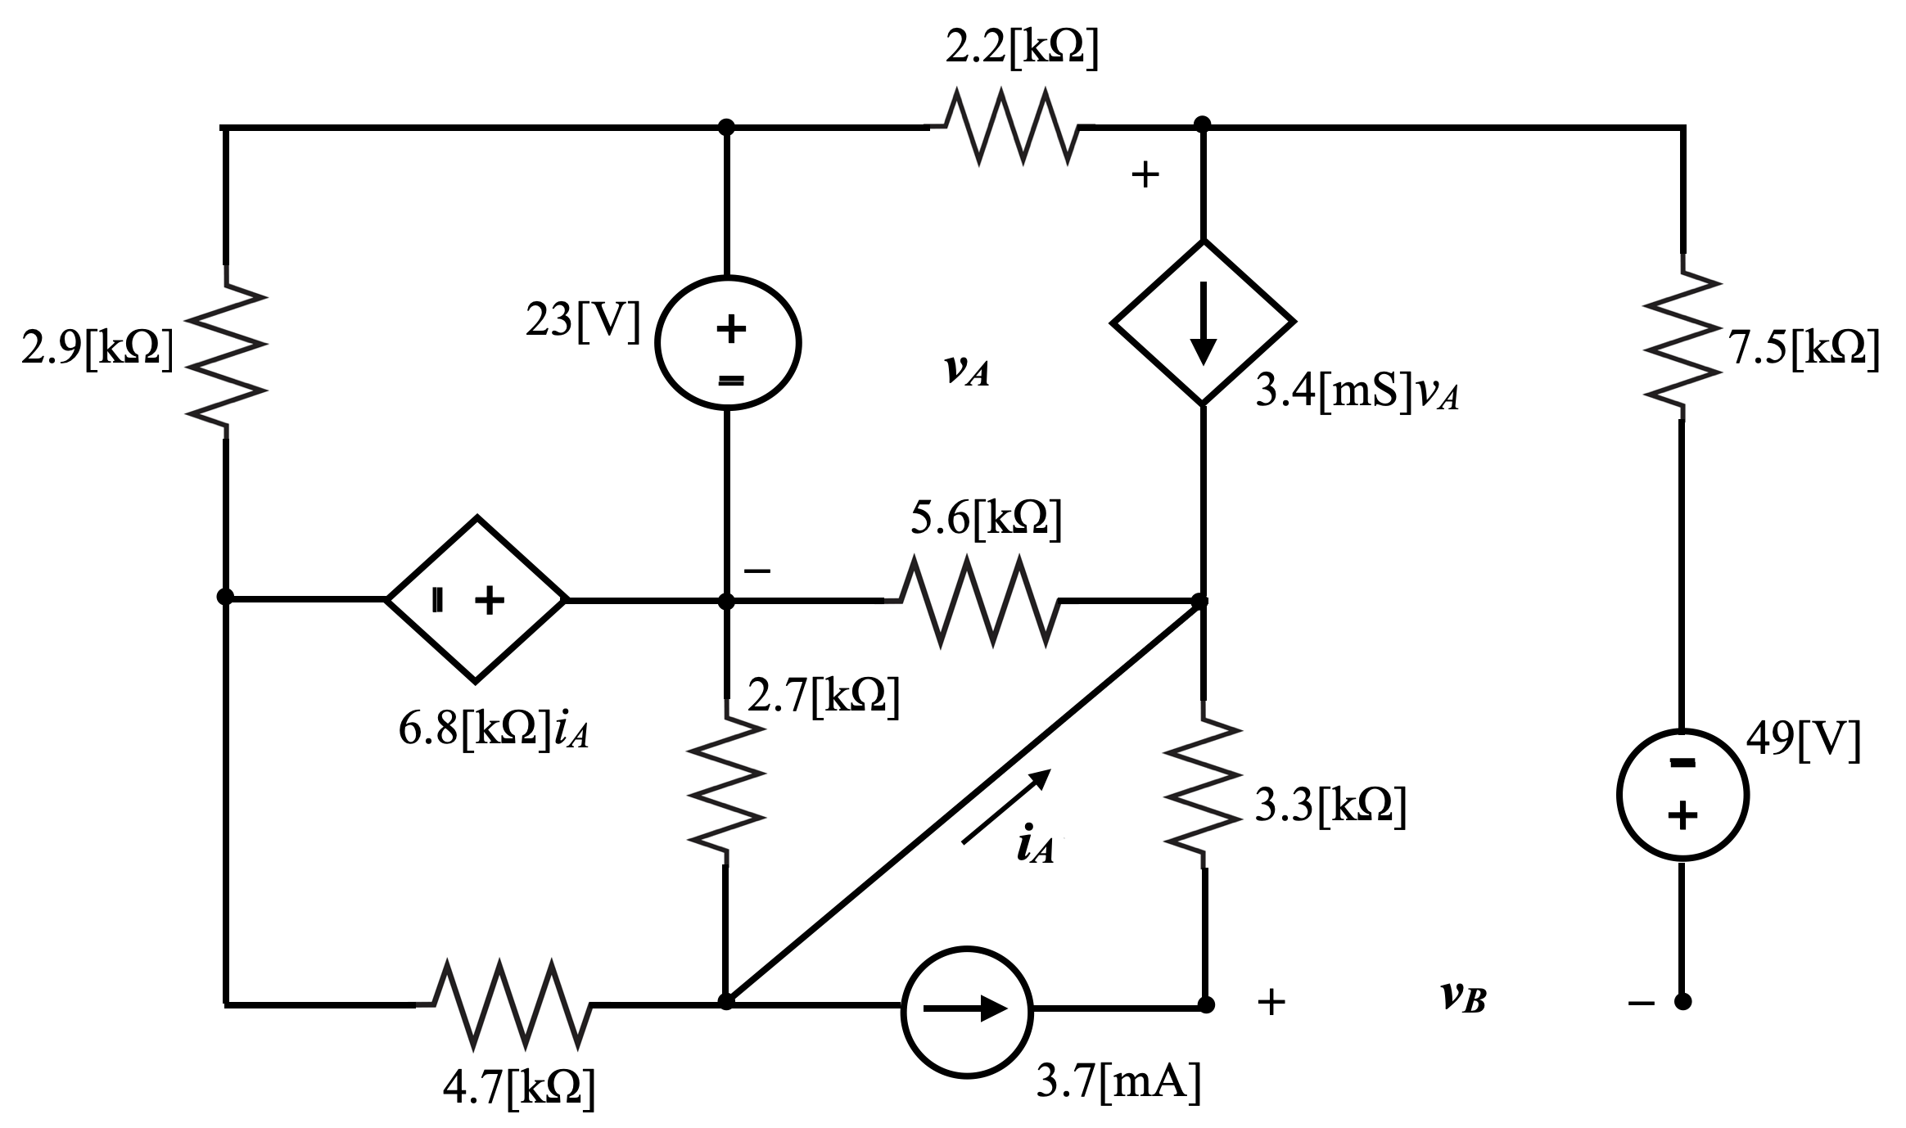

- Find the numerical value of v_{A}.
- Find the numerical value of i_{A}.
- Find the power delivered to the dependent voltage source.

Room For Extra Work

- (30 points) Four devices are connected as shown in Figure 1 for time t>0. The voltage v_{x} is shown in Figure 2. Device 1 and Device 4 deliver positive power at some time interval to identical devices i.e. Device 2 and Device 3. The expression for the energy delivered by Device 1 is given as $w_{del by D1}={5\left[\frac{mJ}{s^{3}}\right]t}^{3}-1\left[\frac{mJ}{s^{2}}\right]t^{2}$
and by Device 4 as $w_{del by D4}={2\left[\frac{mJ}{s^{3}}\right]t}^{3}-5\left[\frac{mJ}{s^{2}}\right]t^{2}$.
  - Find the currents flowing through Device 1 and Device 4 as a function of time.
  - Make plots of these currents i₁ and i₄ as a function of time and determine when each of these devices delivers power.
  - Find the time when both Device 2 and Device 3 start to absorb the power.
  - Make plots of the currents i₂ and i₃.
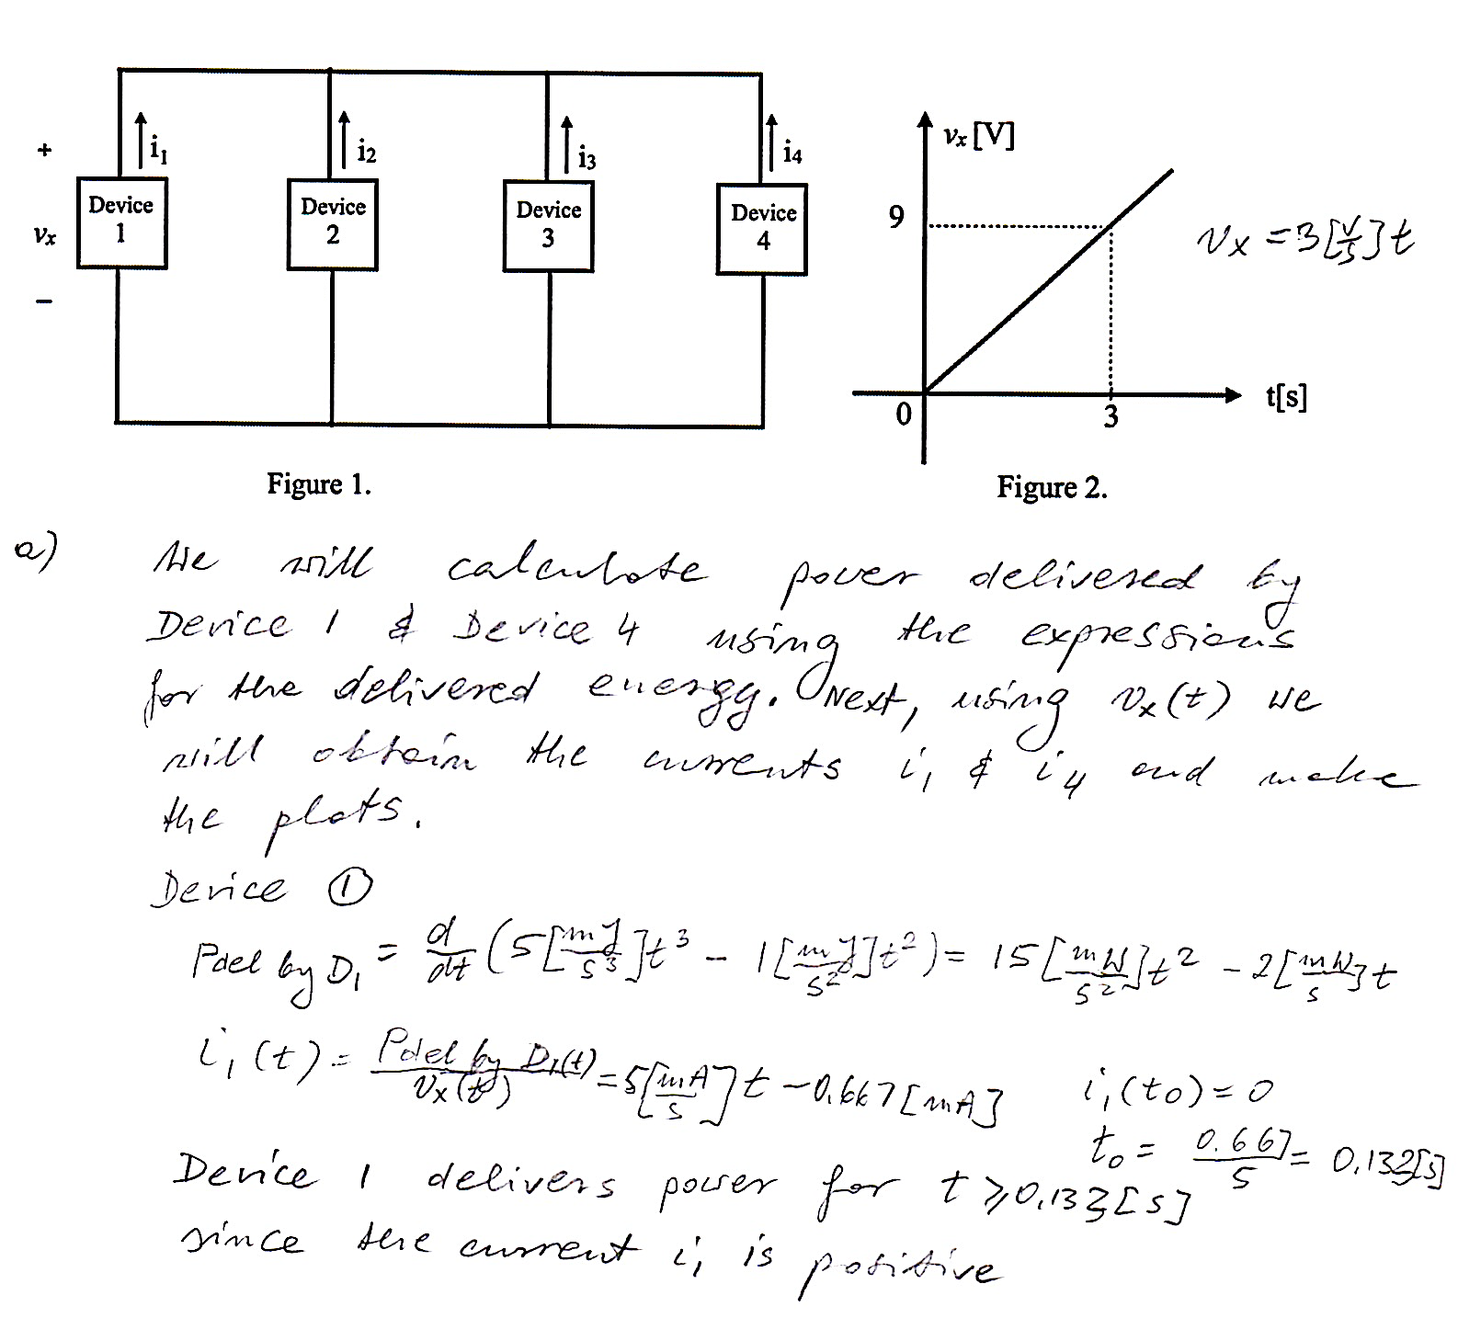

Room for extra work
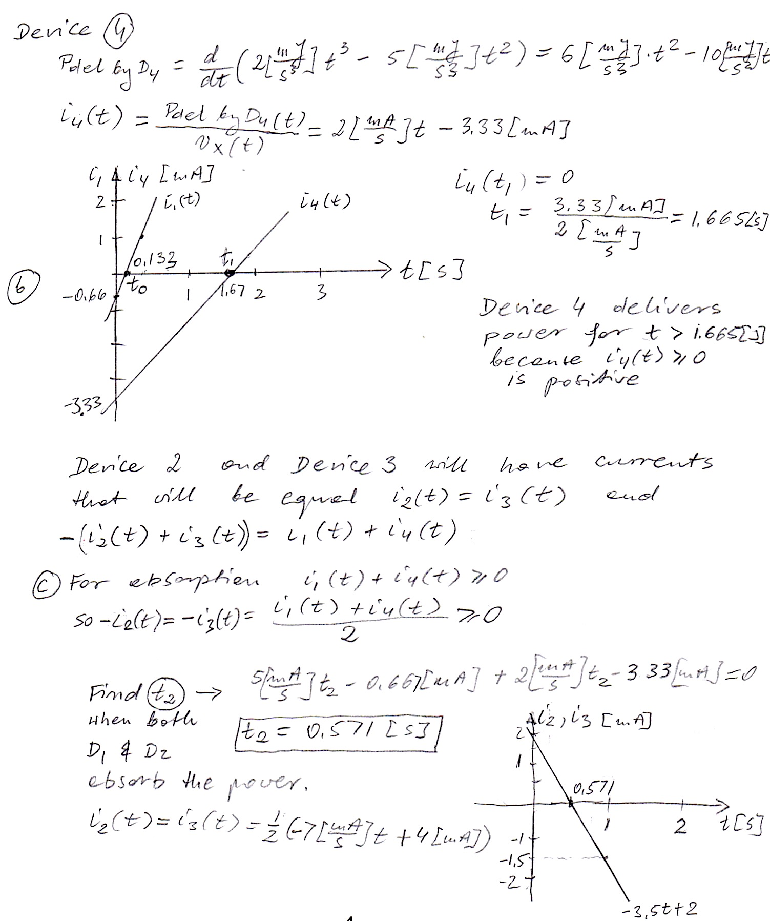
2. (35 points) For the circuit below, do the following.

- Find the voltage v_{z}.
- Find the power delivered by the dependent voltage source 2v_{X}.
