Name: ____________________________ (please print)
Signature: __________________________

ECE 2201 – Exam 2
April 9, 2022

Keep this exam closed and face up until you are told to begin.

1. This exam is closed book, closed notes. You may have a crib sheet in the form of one 8 ½” x 11” piece of paper written on both sides. Print your name, and provide your signature above.
2. Show all work on these pages. Show all work necessary to complete the problem. A solution without the appropriate work shown will receive no credit. A solution which is not given in a reasonable order will lose credit.
3. Show all units in solutions, intermediate results, and figures. Units in the exam will be included between square brackets.
4. If the grader has difficulty following your work because it is messy or disorganized, you will lose credit.
5. Do not use red ink. Do not use red pencil.
6. You will have 90 minutes to work on this exam.

1. ________________/30
2. ________________/35
3. ________________/35
Total = 100
Room for extra work
- (30 points) Use the circuit given below to solve this problem.
- Find the equivalent resistance of this circuit with respect to terminals A and B.
- Find the equivalent resistance of this circuit with respect to terminals A and C.

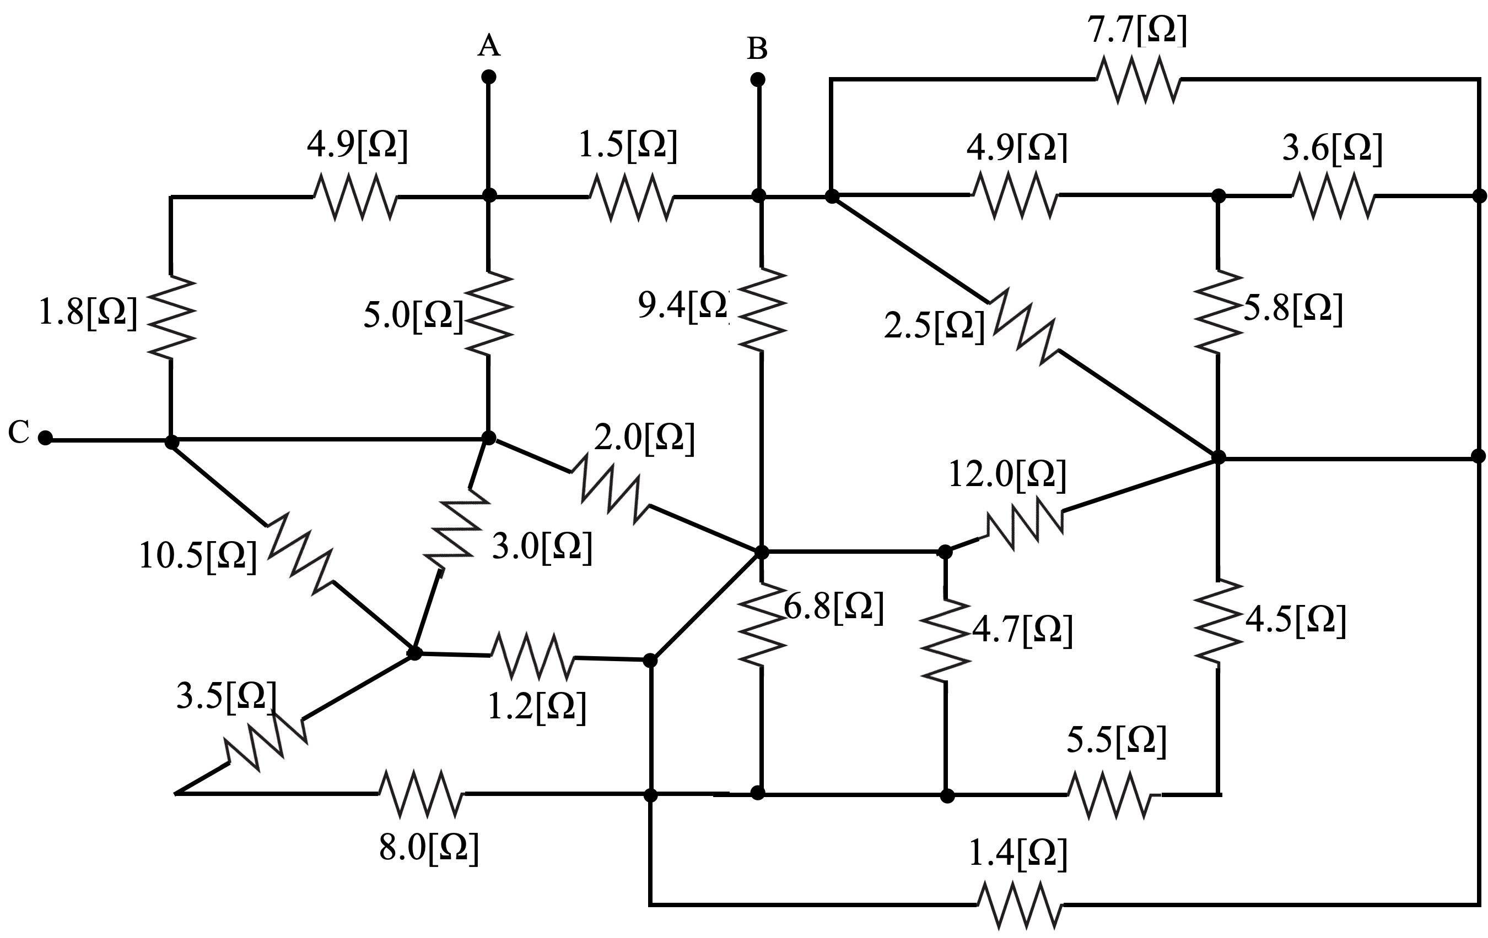

Room for Extra Work

2. (35 points) Two identical devices are used in the circuit in Figure 3. Each device has the characteristics shown in Figure 1, where v_{D} and i_{D} are defined as shown in Figure 2. Each device can be modeled as a voltage source in series with a resistance.
a) Find the model for the device. Draw your model, labeling all components with numerical values, and labeling terminals A and B.
b) Find v_{X} in Figure 3. Note the polarities of the devices used in Figure 3. The polarity of each device is indicated by the letters A and B next to the device.
c) Find the power absorbed by the device that is in series with the 330[Ω] resistor, in the circuit in Figure 3.
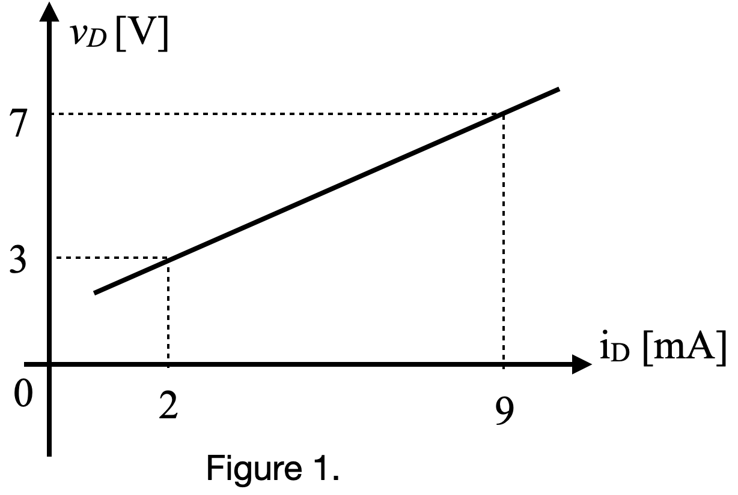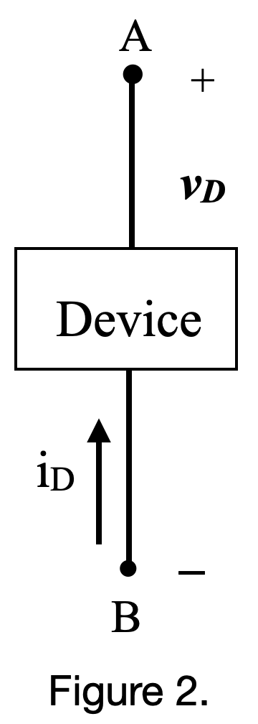

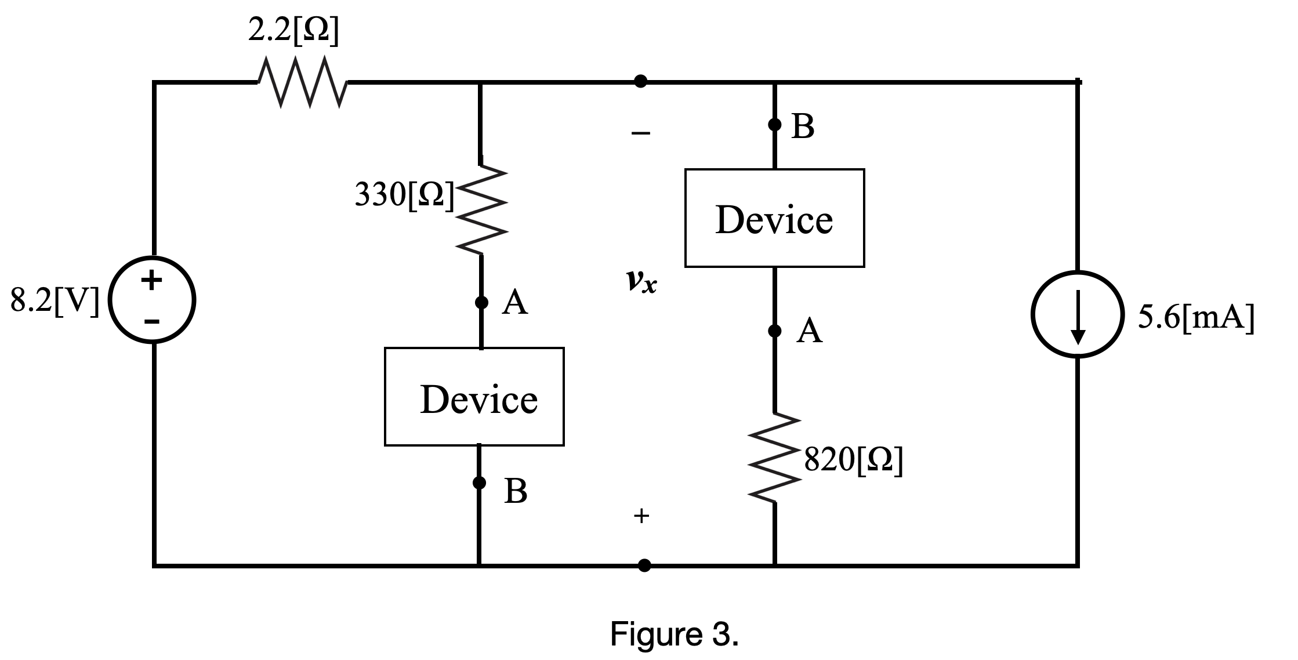
Room For Extra Work

- (35 points) Use the node-voltage method to write a complete set of equations that could be used to solve the circuit below. Do not attempt to simplify the circuit. Do not attempt to simplify or solve your equations. Define all variables clearly.

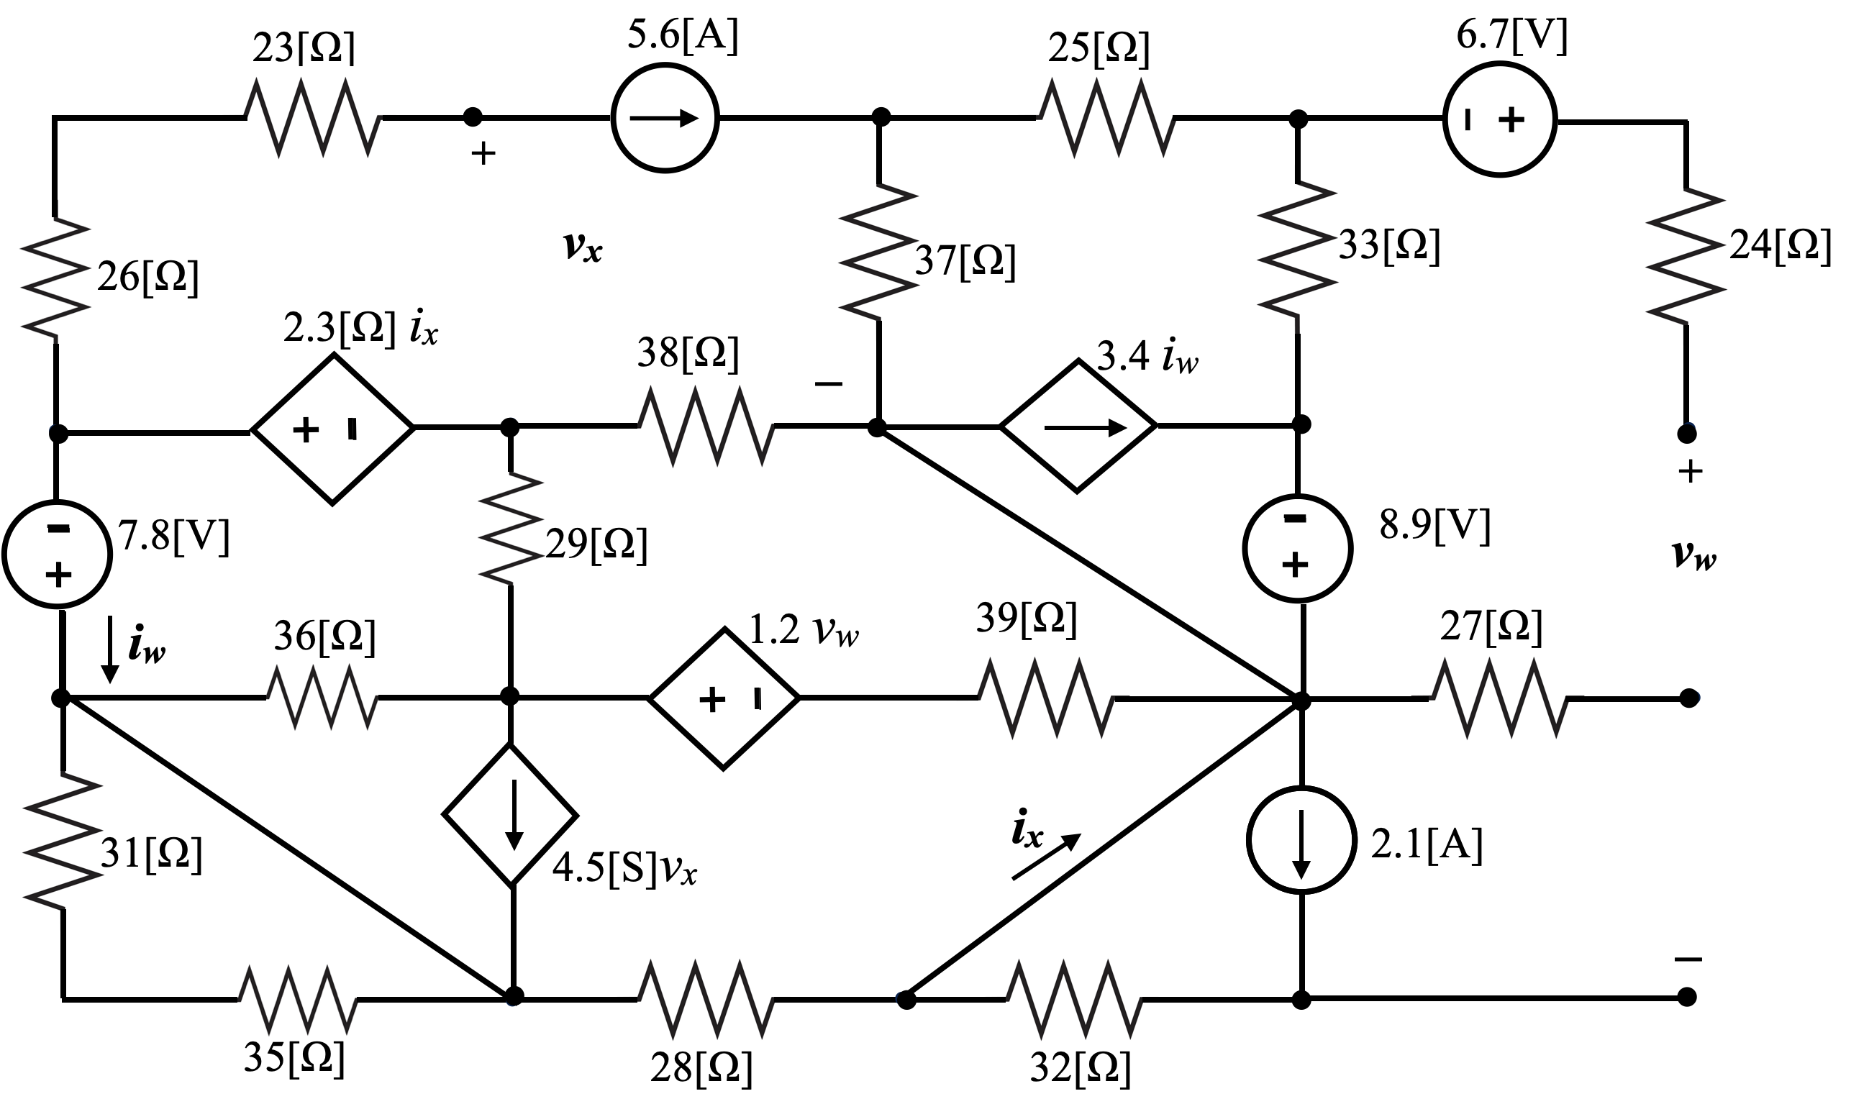

Room For Extra Work

- (30 points) Use the circuit given below to solve this problem.
- Find the equivalent resistance of this circuit with respect to terminals A and B.
- Find the equivalent resistance of this circuit with respect to terminals A and C.

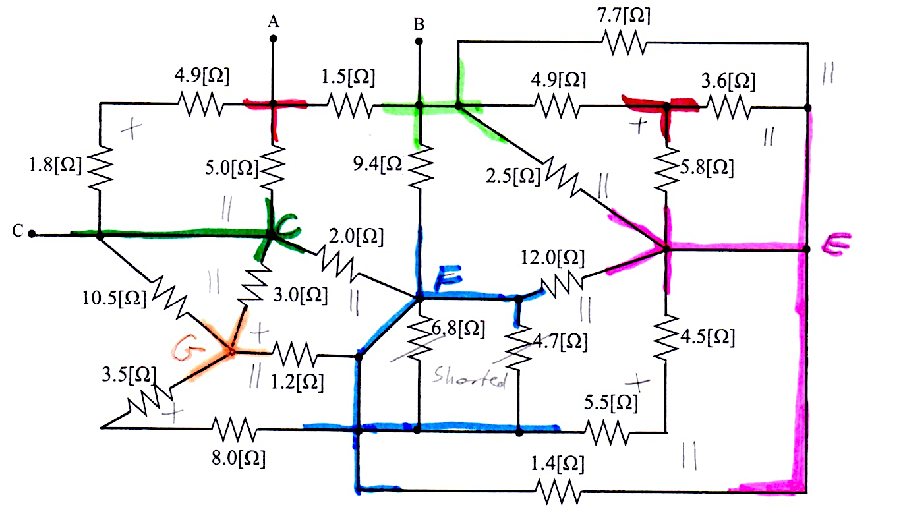

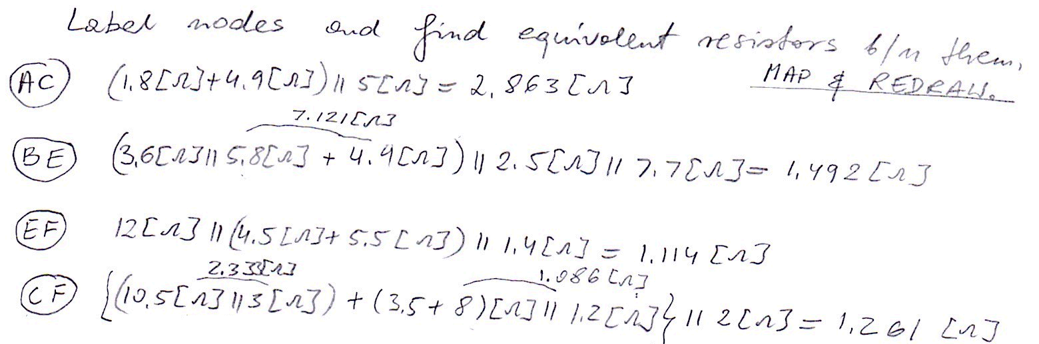

Room For Extra Work

