Name: ____________________________ (please print)
Signature: __________________________

ECE 2201 – Final Exam
May 4, 2022

Keep this exam closed and face up until you are told to begin.

1. This exam is closed book, closed notes. You may have a crib sheet in the form of one 8 ½” x 11” piece of paper written on both sides. Print your name, and provide your signature above.
2. Show all work on these pages. Show all work necessary to complete the problem. A solution without the appropriate work shown will receive no credit. A solution which is not given in a reasonable order will lose credit.
3. Show all units in solutions, intermediate results, and figures. Units in the exam will be included between square brackets.
4. If the grader has difficulty following your work because it is messy or disorganized, you will lose credit.
5. Do not use red ink. Do not use red pencil.
6. You will have 160 minutes to work on this exam.

1. ________________/40
2. ________________/40
3. ________________/40
4. ________________/40
5. ________________/40
Total = 200
Room for extra work
- (40 points)
For the circuit shown below
- find the Thevenin equivalent seen by the independent voltage source 5[V].
- calculate the power delivered by this 5[V] source to the Thevenin equivalent.
- use an arrow to mark the direction that electrons move through this 5[V] voltage source.

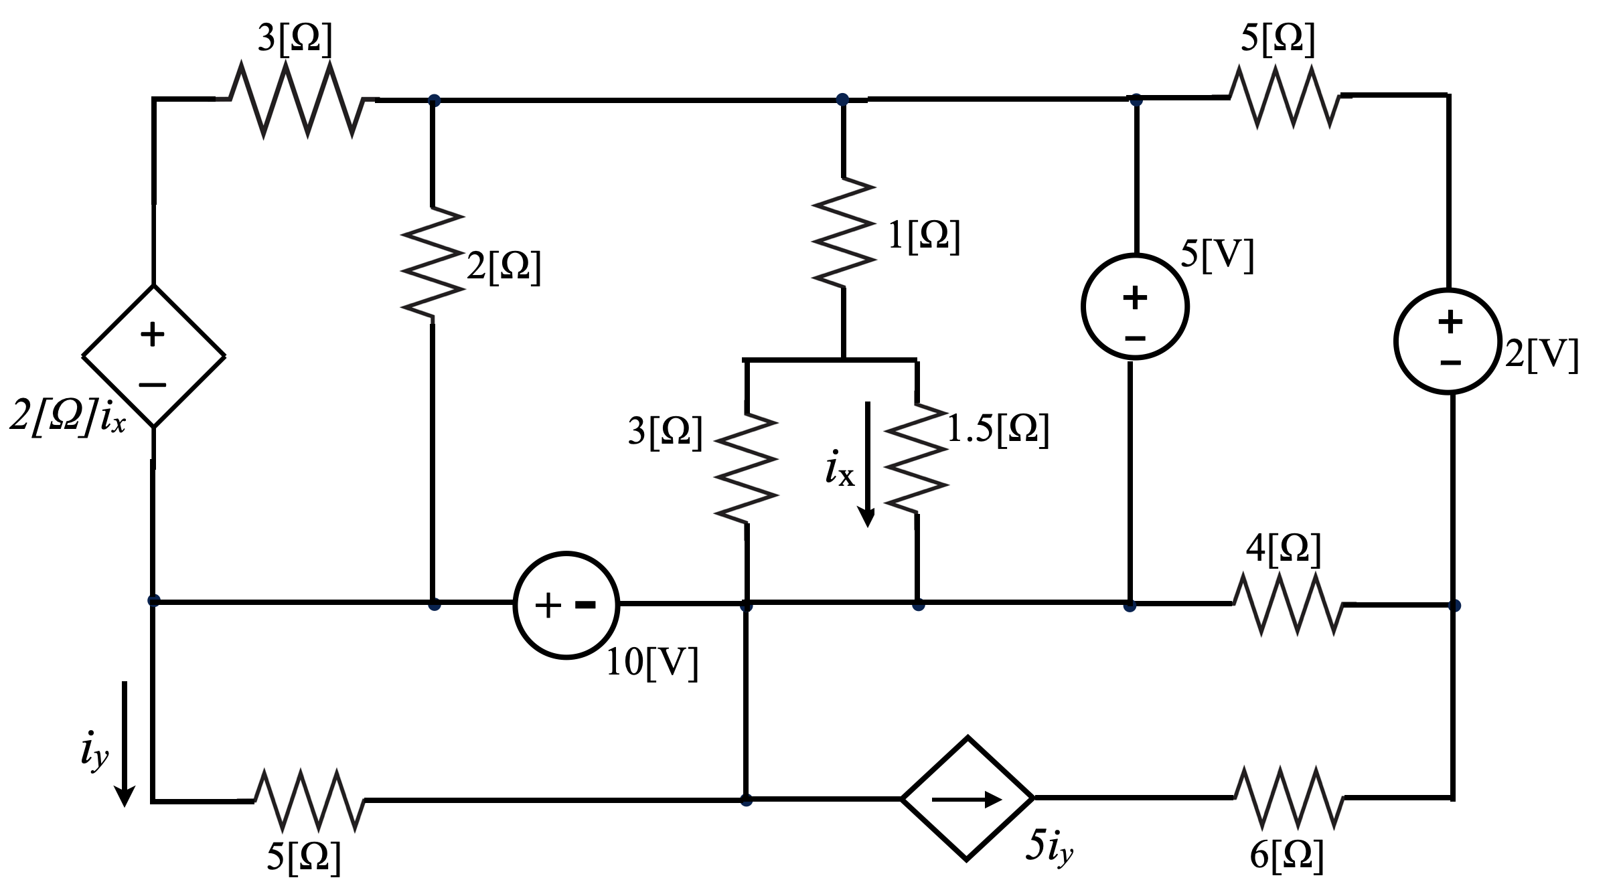

Room for Extra Work

- (40 points) Use the mesh-current method to write a complete set of equations that could be used to solve the circuit below. Do not attempt to simplify the circuit. Do not attempt to simplify or solve your equations. Define all variables clearly.

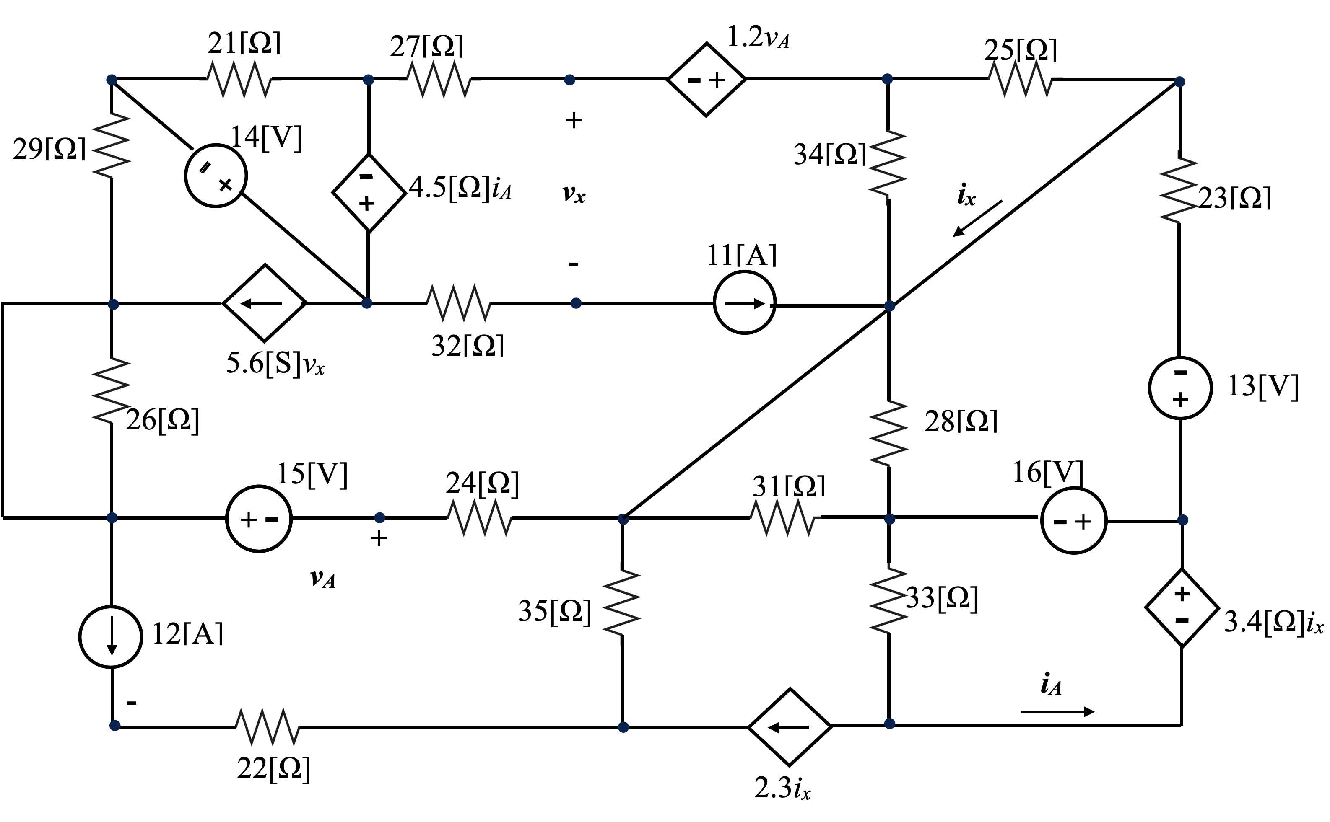

Room For Extra Work

- (40 points) Use the node-voltage method to write a complete set of equations that could be used to solve the circuit below. Do not attempt to simplify the circuit. Do not attempt to simplify or solve your equations. Define all variables clearly.

Room For Extra Work

4. (40 Points)
In the circuit shown below
- find the expression for the power delivered by each of the dependent sources: 2v_{x}, 2[S]v_{x}, 3i_{y} and 5i_{x}.
- calculate the numerical power values for each of these four sources and confirm which one is absorbed or is delivered.
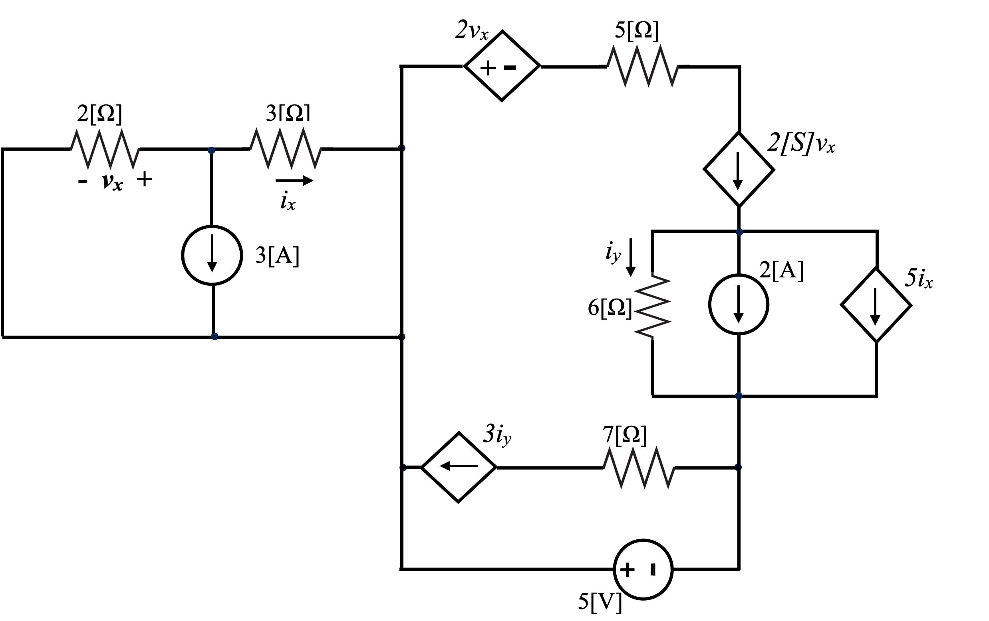

Room for extra work

5. (40 points) There is a group of devices, called Koevidors, that all behave the same way. Each device can be modeled as a current source in parallel with a resistance. When one of the Koevidors is connected to a resistor with a value of 330[Ω], that Koevidor delivers 1.52[W] to that resistor. When one of the Koevidors is connected to a resistor with a value of 470[Ω], that Koevidor delivers 4.18[W] to that resistor.
a) Find a model for the Koevidor, and draw it, labeling the components with numerical values. There is more than one valid answer. Give any valid answer.
b) Three of the Koevidors are connected in parallel, and also in parallel with a 560[Ω] resistor. Find the power absorbed by the 560[Ω] resistor in this circuit. There is more than one valid answer. Give any valid answer.

- (40 points)
For the circuit shown below
- find the Thevenin equivalent seen by the independent voltage source 5[V].
- calculate the power delivered by this 5[V] source to the Thevenin equivalent.
- use an arrow to mark the direction that electrons move through this 5[V] voltage source.

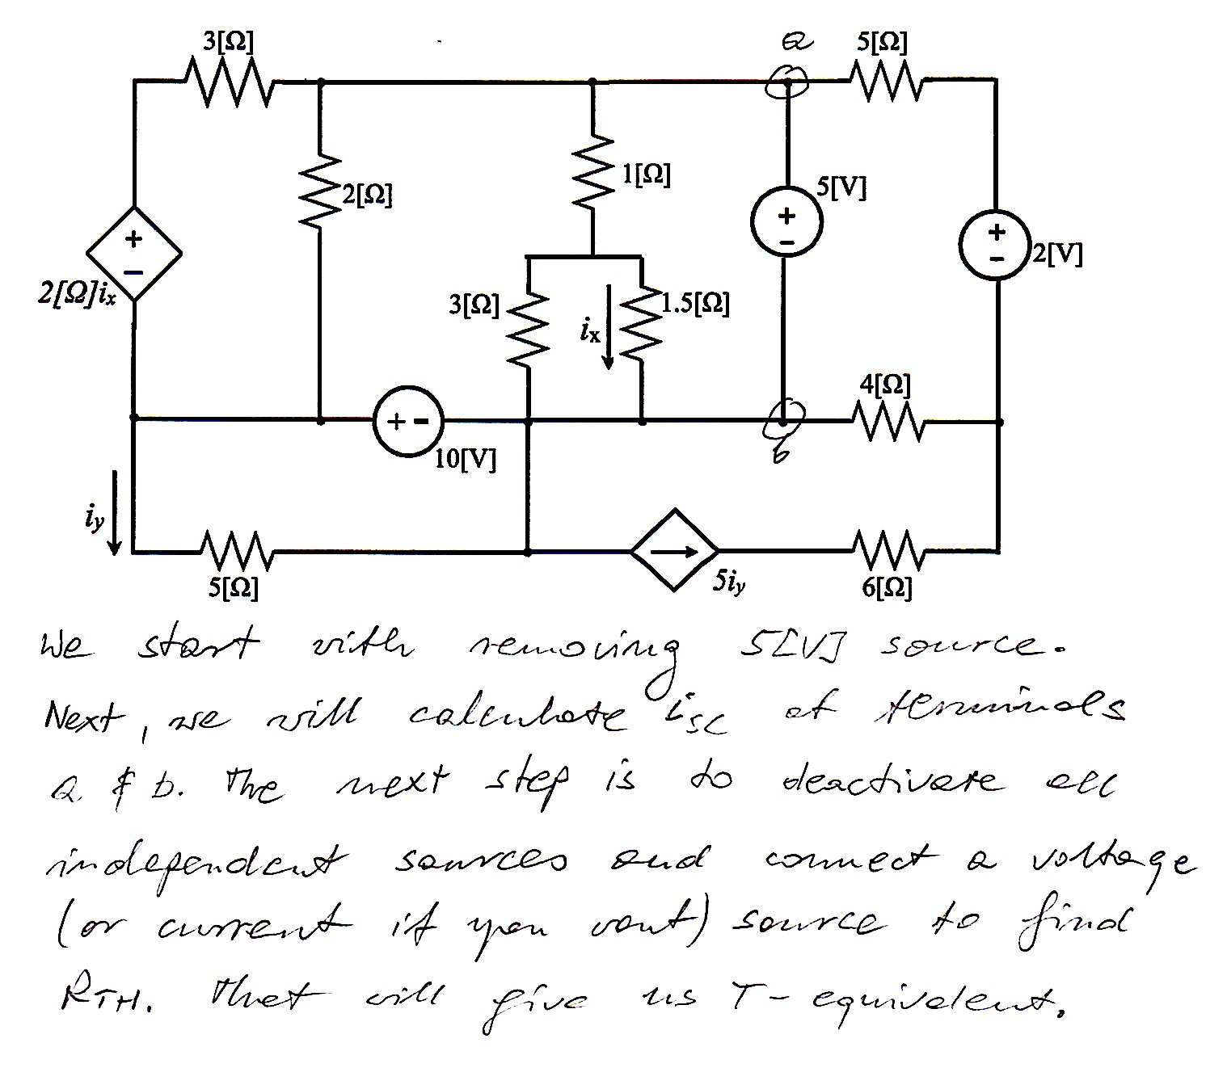
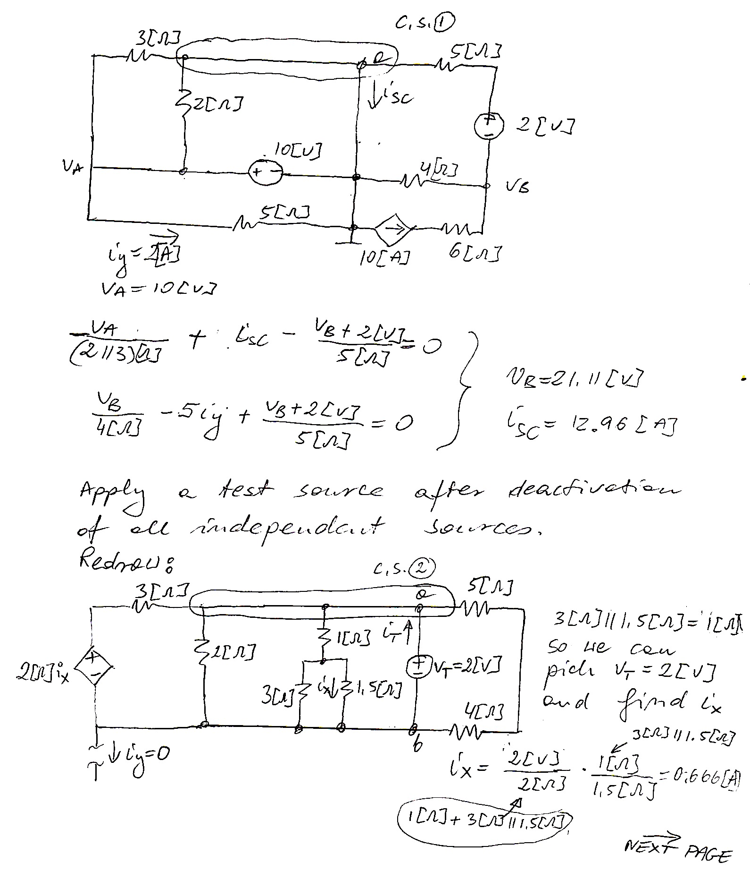
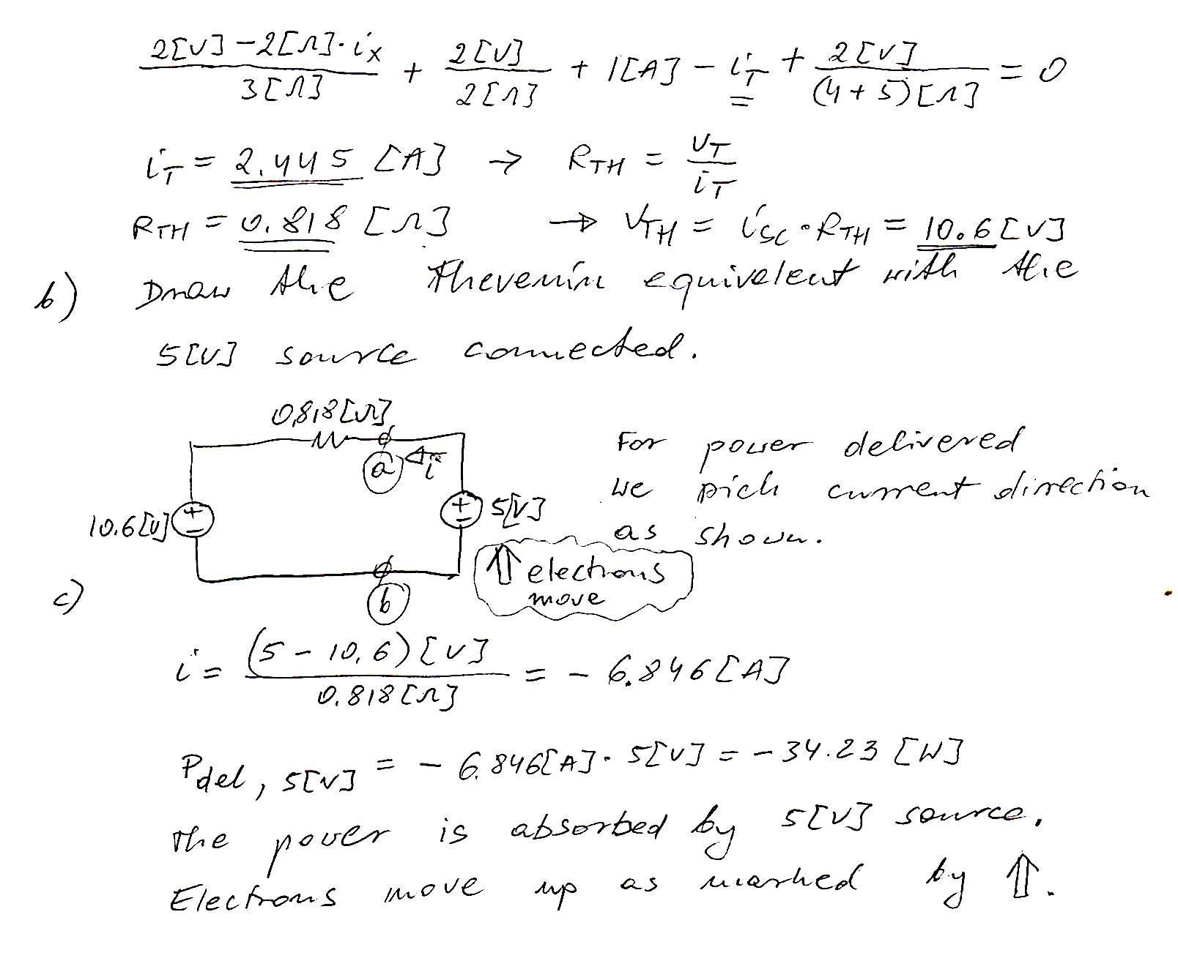

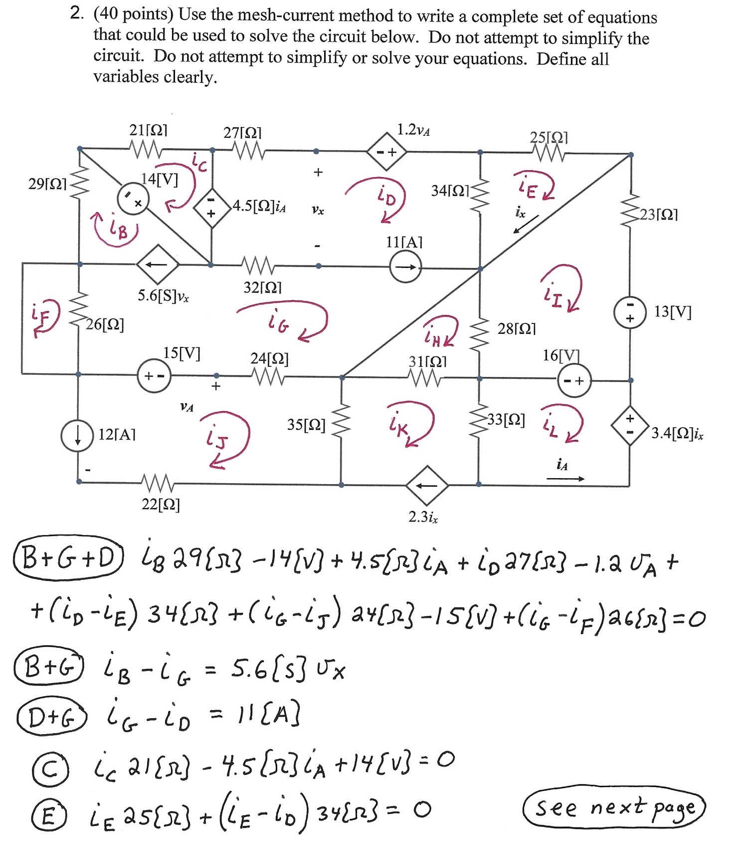

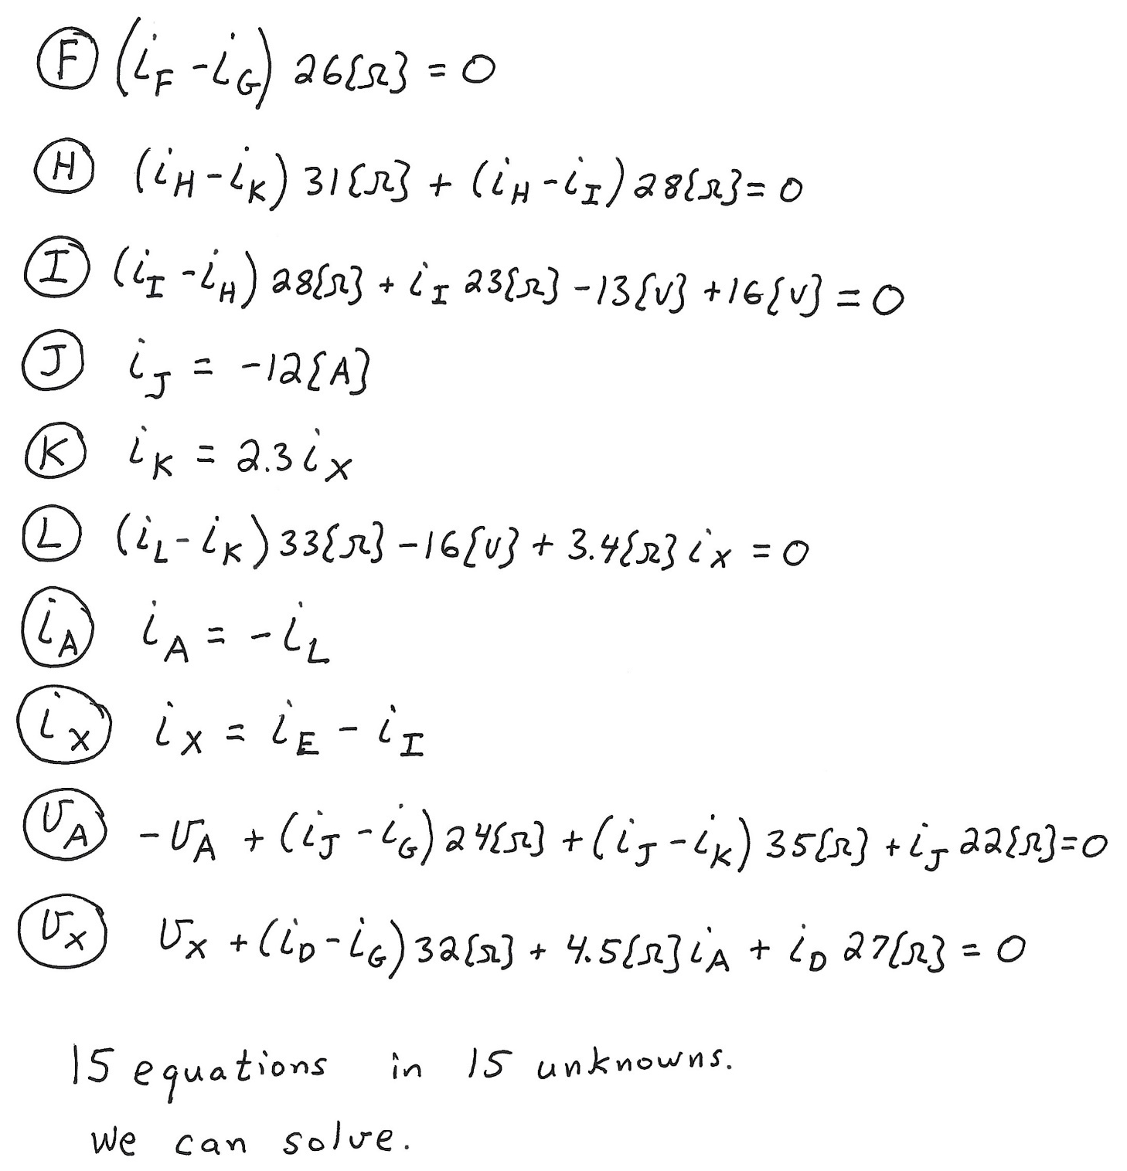

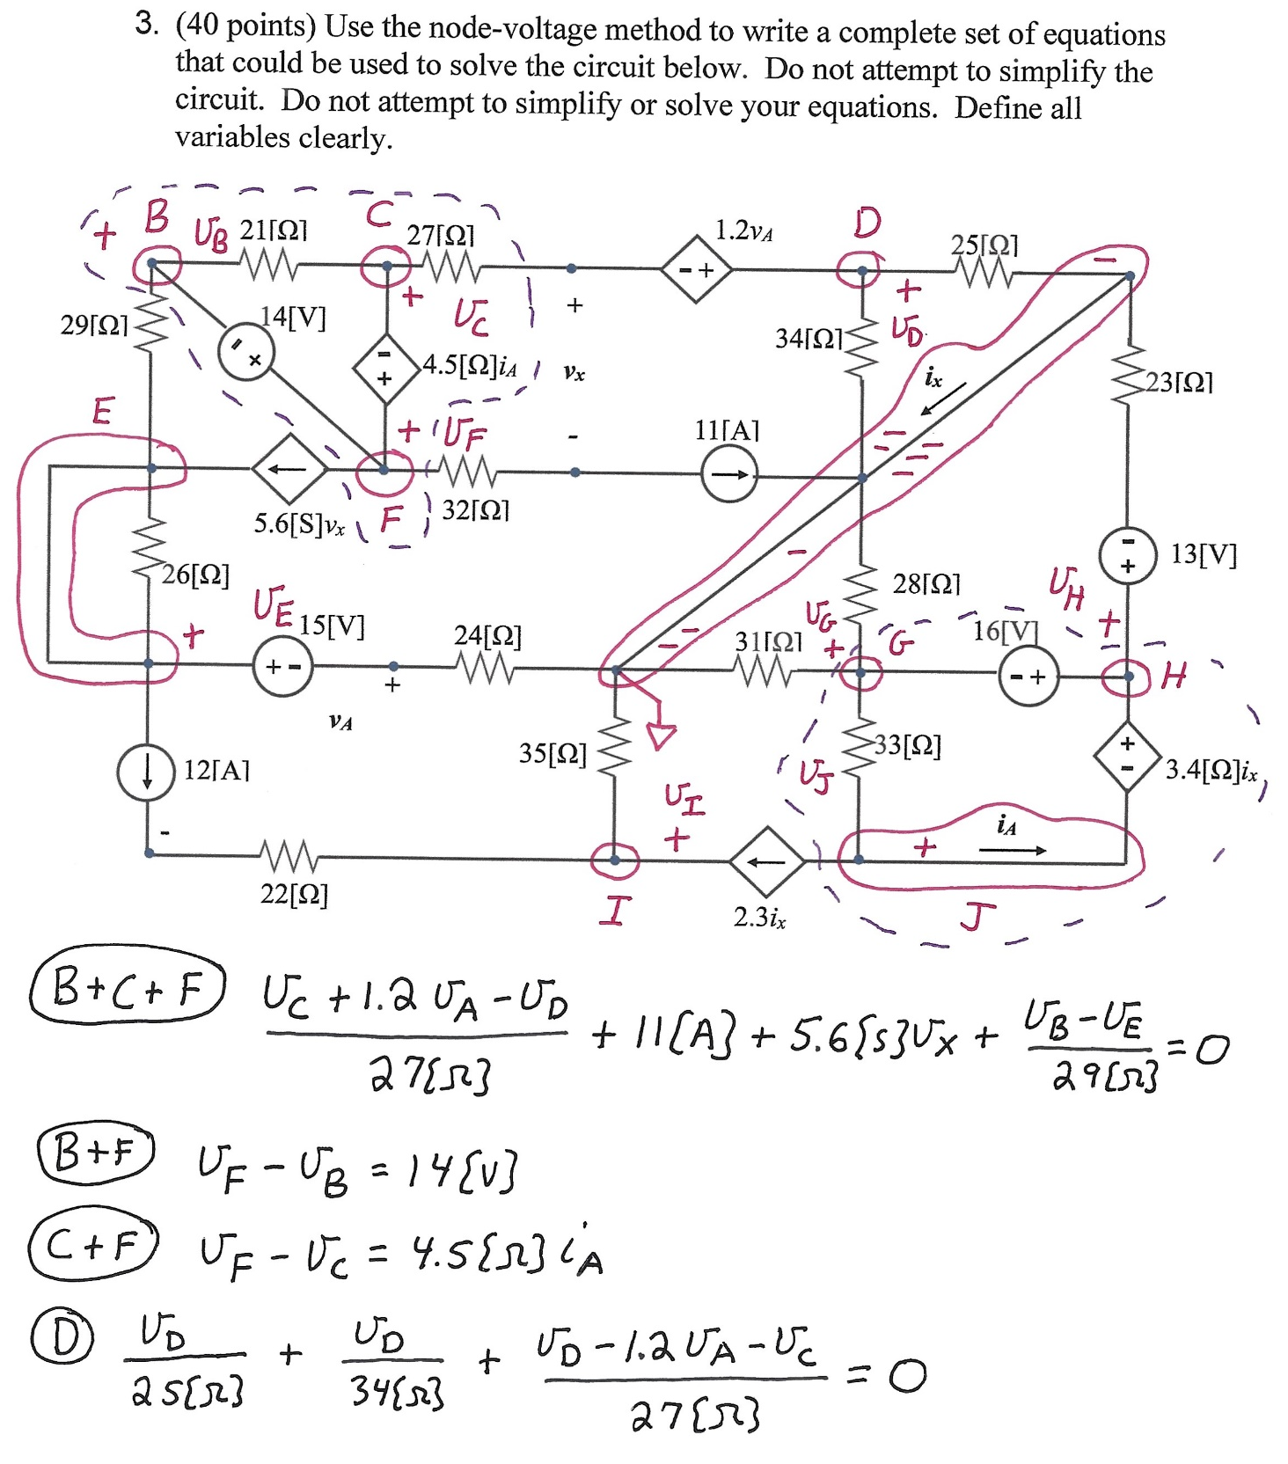
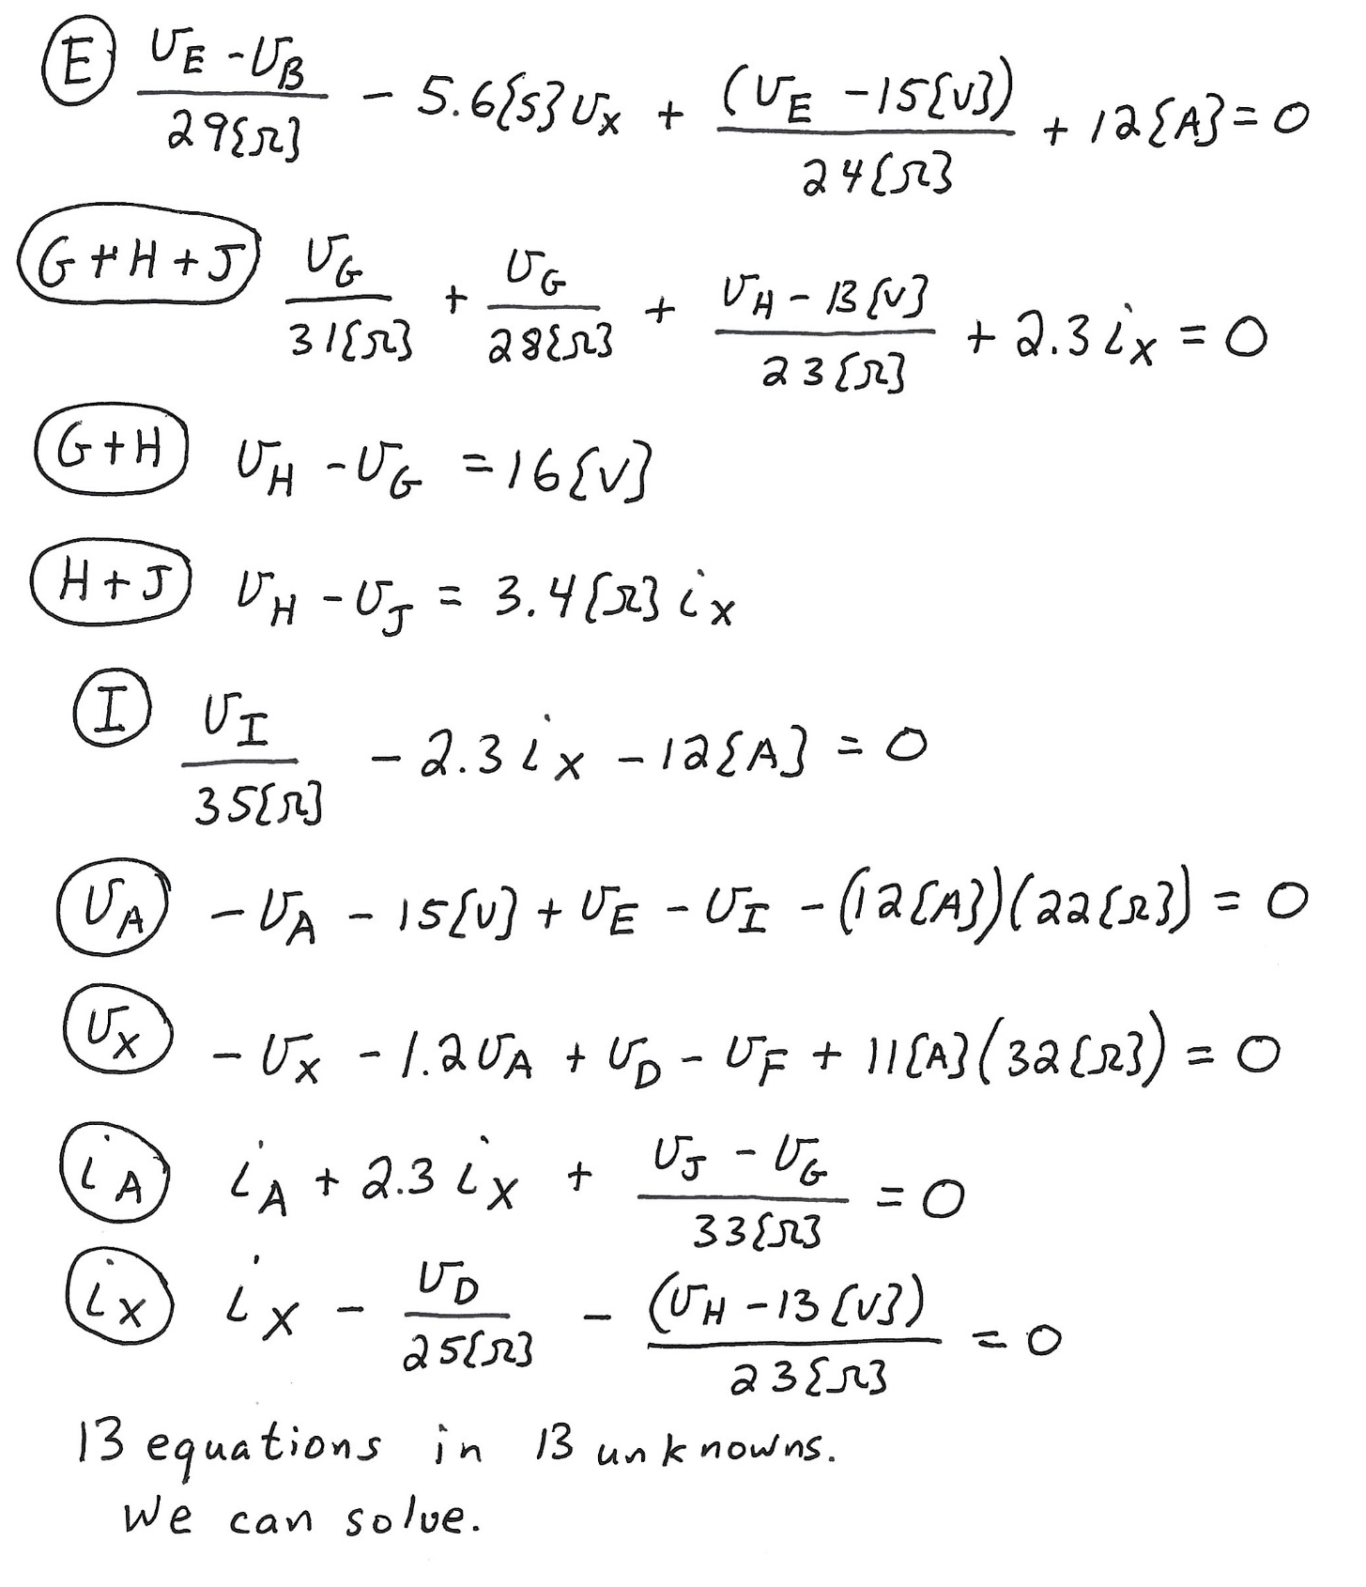

4. (40 Points)
In the circuit shown below
- find the expression for the power delivered by each of the dependent sources: 2v_{x}, 2[S]v_{x}, 3i_{y} and 5i_{x}.
- calculate the numerical power values for each of these four sources and confirm which one is absorbed or is delivered.
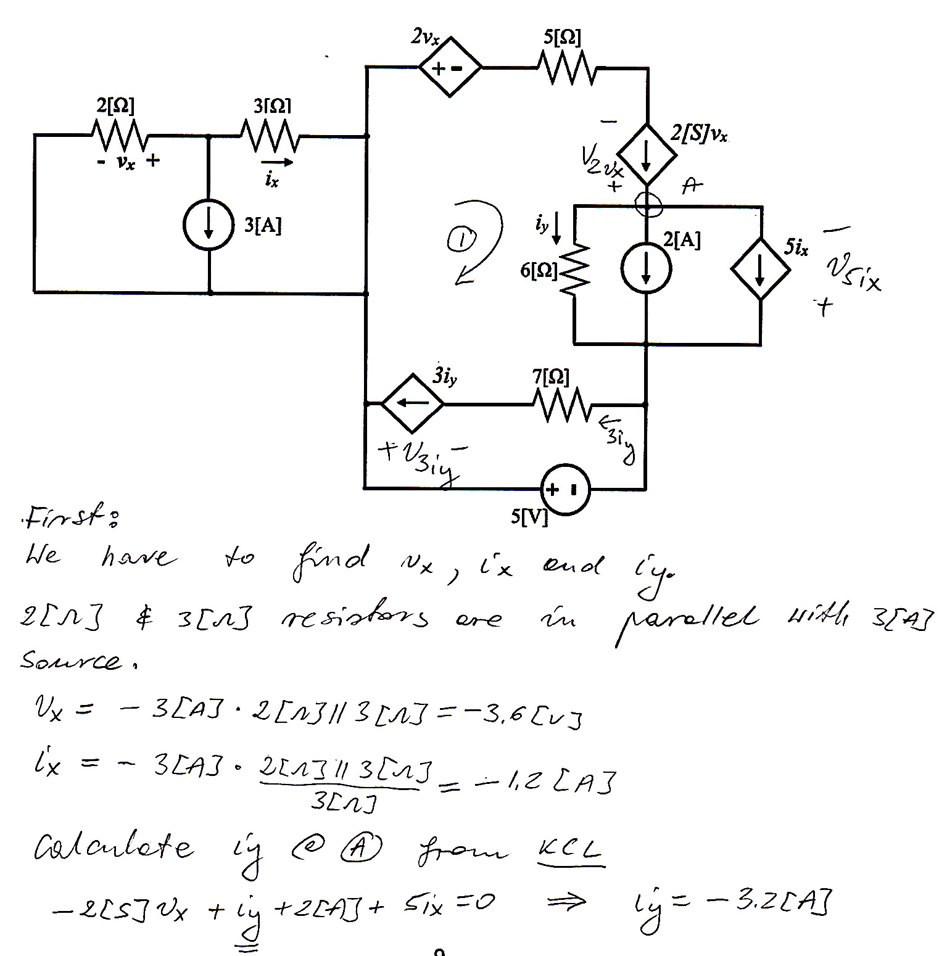

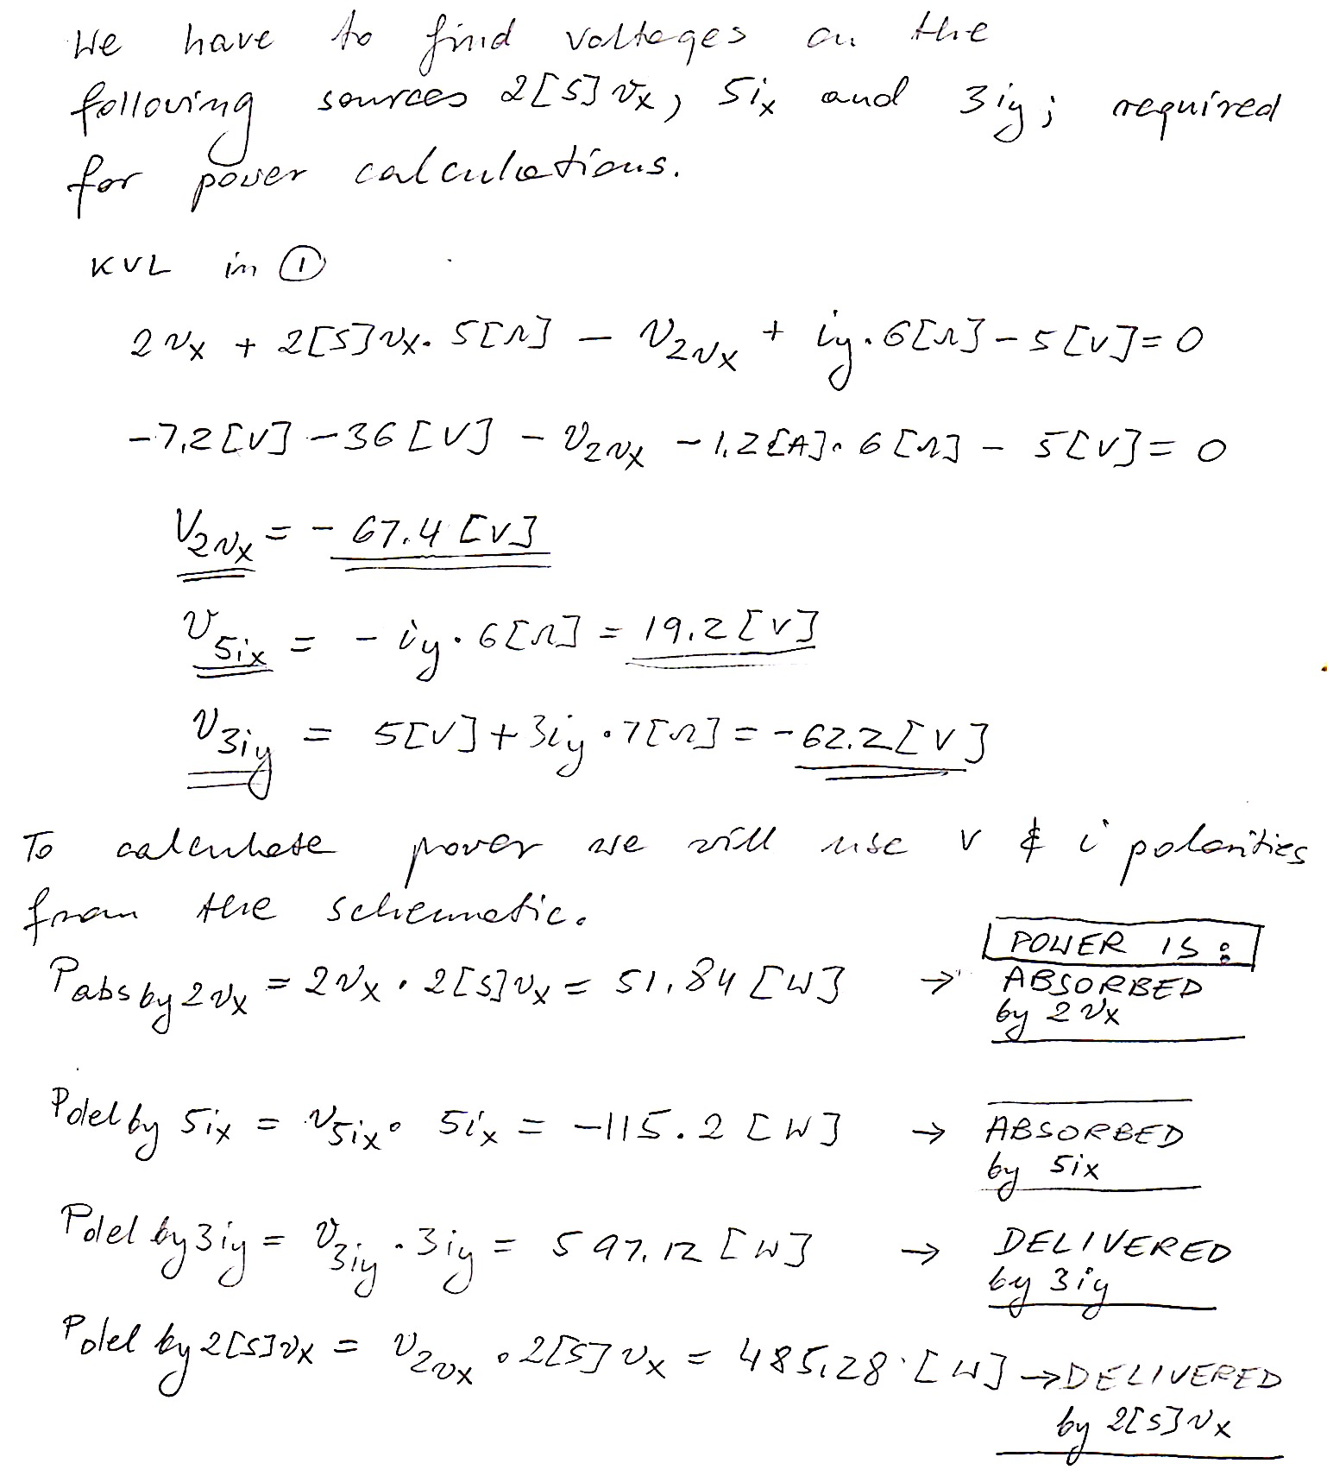
5. (40 points) There is a group of devices, called Koevidors, that all behave the same way. Each device can be modeled as a current source in parallel with a resistance. When one of the Koevidors is connected to a resistor with a value of 330[Ω], that Koevidor delivers 1.52[W] to that resistor. When one of the Koevidors is connected to a resistor with a value of 470[Ω], that Koevidor delivers 4.18[W] to that resistor.
a) Find a model for the Koevidor, and draw it, labeling the components with numerical values. There is more than one valid answer. Give any valid answer.
b) Three of the Koevidors are connected in parallel, and also in parallel with a 560[Ω] resistor. Find the power absorbed by the 560[Ω] resistor in this circuit. There is more than one valid answer. Give any valid answer.
