Name: _____________________________ (please print)
Signature: __________________________

ECE 2201 – Quiz #1
February 15, 2022 – 4pm Section

1. This quiz is closed book, closed notes. You may use one 8.5” x 11” crib sheet, or its equivalent. You may use a calculator. You should not use a cell phone, tablet computer, or laptop computer, as you work on this quiz.
2. Show all work on these pages, and you may use both sides of each page. Show all work necessary to complete the problem. A solution without the appropriate work shown will receive no credit. A solution which is not given in a reasonable order will lose credit. You may separate the pages as you work.
3. Show all units in solutions, intermediate results, and figures. Units in the quiz will be included between square brackets.
4. Do not use red ink. Do not use red pencil.
5. You will have 30 minutes to work on this quiz.

________________/20
Room for extra work

In the circuit shown, three components are connected together. The expressions for some of the voltages and currents are given.
- Find the power delivered by Device C at t = 34[ms].
- Find the energy absorbed by Device C in the fifth [millisecond] after
t = 2[ms].
- Assume that the charge carriers are electrons. Which way are the electrons moving through Device C at t = 65[ms]? Your answer should be either “from top to bottom” or “from bottom to top”. Briefly explain your answer, using complete sentences.
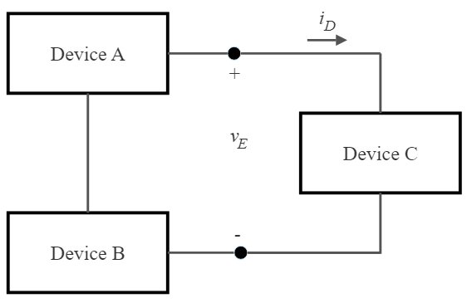

$v_{E}\left(t\right)=6.2\left[V\right]e^{\left(-47\left[s^{-1}\right]t\right)}-9.3[\text{V}]$

$i_{D}\left(t\right)=-530\left[\frac{\text{mA}}{\text{s}}\right]t+24\left[\text{mA}\right]$

