Name: _____________________________ (please print)
Signature: __________________________

ECE 2300 – Quiz #1 – Shattuck Section
June 11, 2007

Keep this quiz closed and face up until you are told to begin.

1. This quiz is closed book, closed notes. You may use one 8.5” x 11” crib sheet, or its equivalent.
2. Show all work on these pages. Show all work necessary to complete the problem. A solution without the appropriate work shown will receive no credit. A solution which is not given in a reasonable order will lose credit.
3. It is assumed that your work will begin on the same page as the problem statement. If you choose to begin your work on another page, you must indicate this on the page with the problem statement, with a clear indication of where the work can be found. If your work continues on to another page, indicate clearly where your work can be found. Failure to indicate this clearly will result in a loss of credit.
4. Show all units in solutions, intermediate results, and figures. Units in the quiz will be included between square brackets.
5. Do not use red ink. Do not use red pencil.
6. You will have 30 minutes to work on this quiz.

________________/20
Room for extra work
The circuit shown below is the electrical system for a hybrid vehicle. Components have been connected to the battery as shown.
The plots shown give the values of voltage and current, as a function of time, for several variables.
- Find the number of charges that move through component A between 3[s] and 8[s].
- Find a numerical expression for the power absorbed by component B between 1[s] and 5[s].
- Find the energy delivered by component C between 3[s] and 10[s].
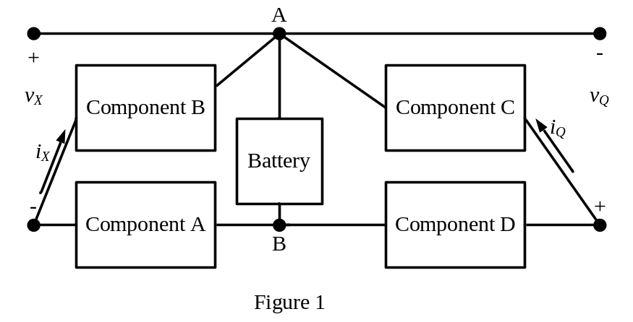
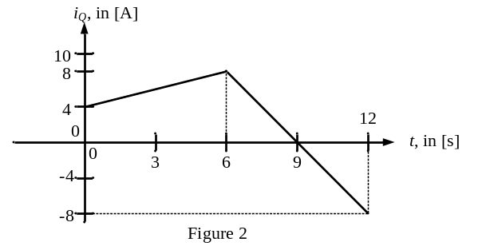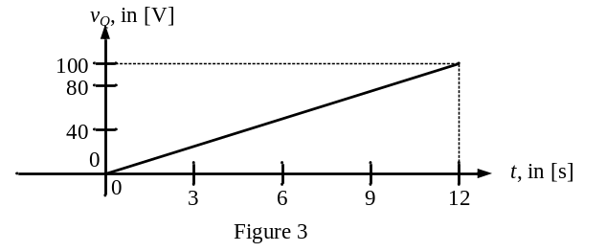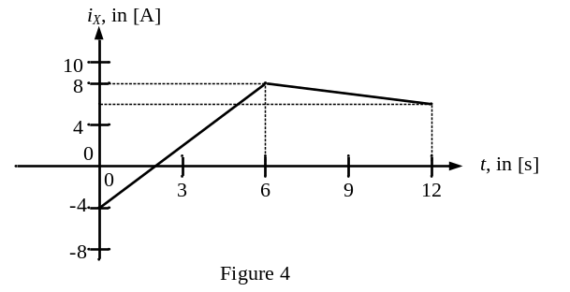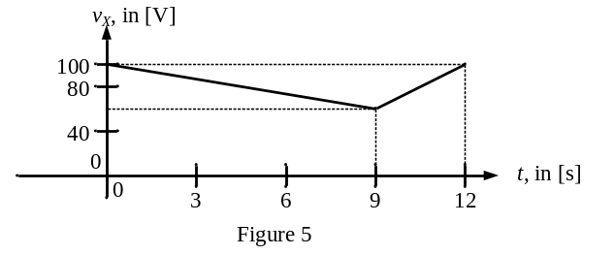

Room for extra work
ECE 2300 -- Quiz #1 – June 11, 2007 –Shattuck Section Solution
The circuit shown below is the electrical system for a hybrid vehicle. Components have been connected to the battery as shown.
The plots shown give the values of voltage and current, as a function of time, for several variables.
- Find the number of charges that move through component A between 3[s] and 8[s].
- Find a numerical expression for the power absorbed by component B between 1[s] and 5[s].
- Find the energy delivered by component C between 3[s] and 10[s].


