Name: _____________________________ (please print)
Signature: __________________________

ECE 2300 -- Quiz #5
July 31, 2008

Keep this quiz closed and face up until you are told to begin.

1. This quiz is closed book, closed notes. You may use one 8.5” x 11” crib sheet, or its equivalent.
2. Show all work on these pages. Show all work necessary to complete the problem. A solution without the appropriate work shown will receive no credit. A solution which is not given in a reasonable order will lose credit.
3. It is assumed that your work will begin on the same page as the problem statement. If you choose to begin your work on another page, you must indicate this on the page with the problem statement, with a clear indication of where the work can be found. If your work continues on to another page, indicate clearly where your work can be found. Failure to indicate this clearly will result in a loss of credit.
4. Show all units in solutions, intermediate results, and figures. Units in the quiz will be included between square brackets.
5. Do not use red ink. Do not use red pencil.
6. You will have 60 minutes to work on this quiz.

________________/20
Room for extra work
Use the circuit shown to solve this problem. Both switches were open for a long time before t = 0. Then, at t = 0, both switches closed. Find the energy stored in the L₁ inductor at t = 0.5[ms].
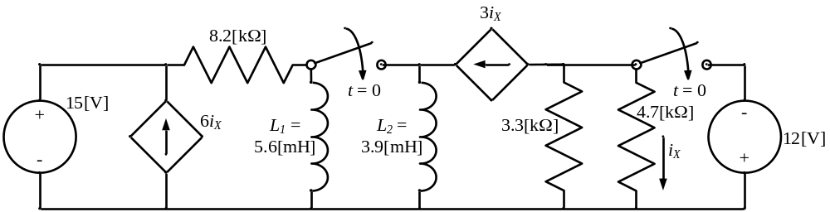

Room for extra work
ECE 2300 – Quiz #5 – July 31, 2008 – Solution
Use the circuit shown to solve this problem. Both switches were open for a long time before t = 0. Then, at t = 0, both switches closed. Find the energy stored in the L₁ inductor at t = 0.5[ms].

Solution: a) We begin by defining the inductor currents, i_{L1} and i_{L2}. We do this on the diagram which follows.
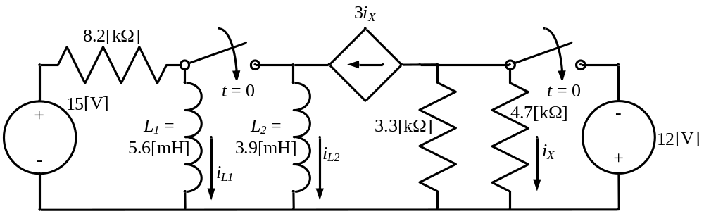
We have also taken the simplifying step of removing the 6i_{X} dependent current source, since it is in parallel with a voltage source, and we are not interested in anything within that parallel combination.
Now we can redraw this circuit for t < 0.
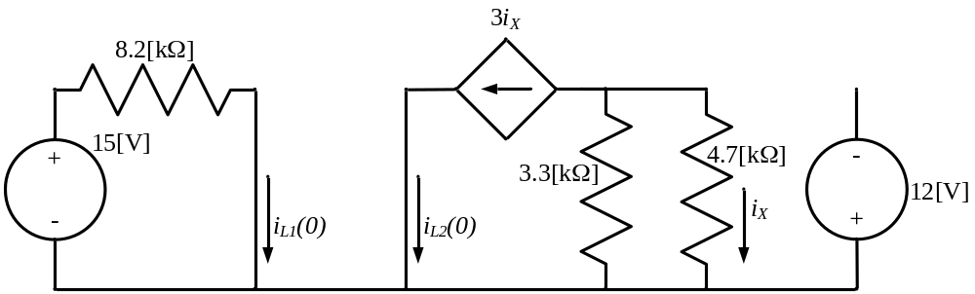

At this point, we can solve easily for iL1(0), and iL2(0) must be zero, since that part of the circuit has no independent sources. We have
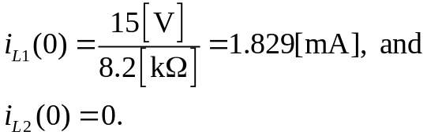
Now, we can redraw the circuit again, this time for t > 0.
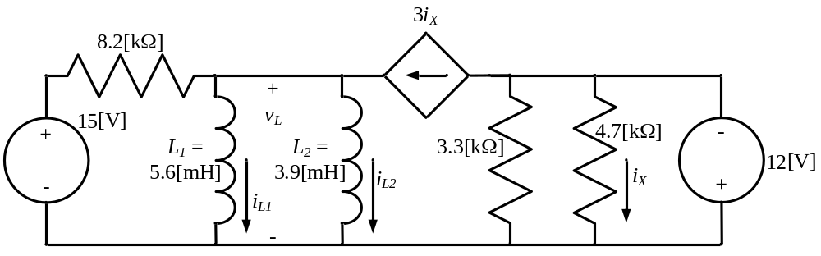
In this diagram, we have two inductors in parallel, so we can combine them into an equivalent inductor, where
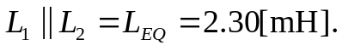
This equivalent inductor will have an initial condition, which is
We redraw this new circuit, valid for t > 0, as follows.
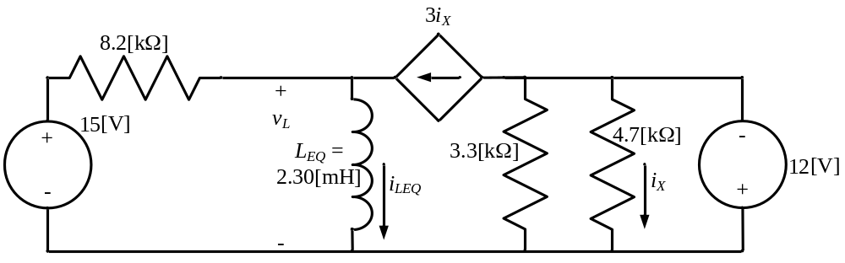
We need the equivalent resistance seen by this inductor, in order to get the time constant for this circuit. We remove the inductor, and set the independent sources equal to zero. We get the following circuit, with the terminals of the inductor labeled as A and B.
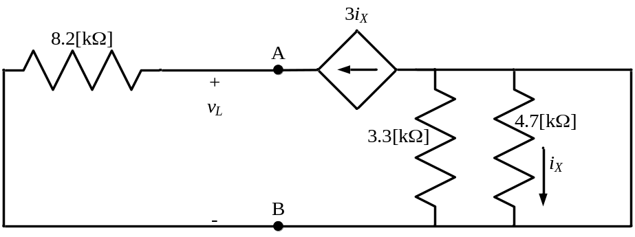
Clearly, i_{X} is zero, and so the dependent current source is also zero, or an open circuit. The equivalent resistance will be 8.2[kΩ]. This means the time constant will be
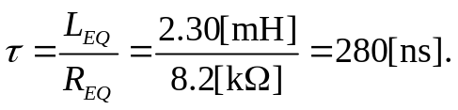

To get the steady-state value of i_{LEQ} for t > 0, we redraw for steady state, replacing the inductor with a short circuit. This gives us the following circuit.
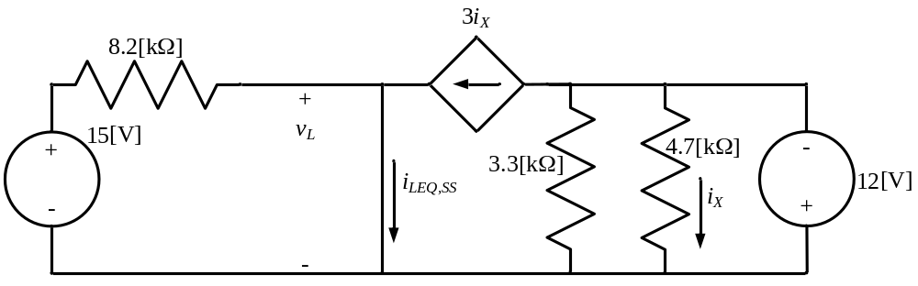
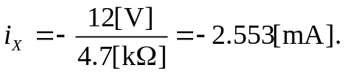
Using this value, we can write KCL to yield
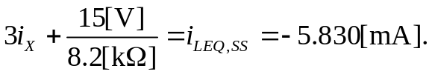
Now we can write the expression for i_{LEQ}, as
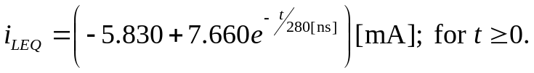
Then, using the defining equation for the inductor, we have
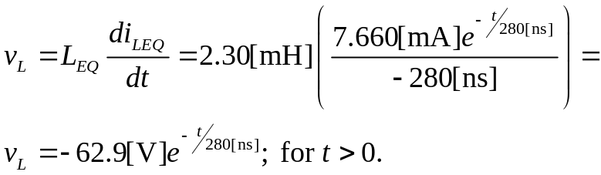
Now, we go back to the circuit for t > 0 again, and we see that we can use the v_{L}(t) that we have found to get i_{L1}(t). The circuit for t > 0 is reproduced here, for easy reference.
We now have
This means that for the time of interest, we have
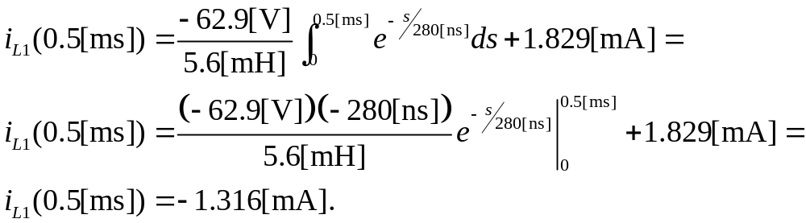
From this we can get the energy stored in L₁ at 0.5[ms] as



