Name: _____________________________ (please print)
Signature: __________________________

ECE 2300 – Midsemester Exam
July 3, 2008

Keep this exam closed and face up until you are told to begin.

1. This exam is closed book, closed notes. You may use one 8.5” x 11” crib sheet, or its equivalent.
2. Show all work on these pages. Show all work necessary to complete the problem. A solution without the appropriate work shown will receive no credit. A solution which is not given in a reasonable order will lose credit.
3. It is assumed that your work will begin on the same page as the problem statement. If you choose to begin your work on another page, you must indicate this on the page with the problem statement, with a clear indication of where the work can be found. If your work continues on to another page, indicate clearly where your work can be found. Failure to indicate this clearly will result in a loss of credit.
4. Show all units in solutions, intermediate results, and figures. Units in the exam will be included between square brackets.
5. Do not use red ink. Do not use red pencil.
6. You will have 110 minutes to work on this exam.

1. ________________/25
2. ________________/25
3. ________________/25
4. ________________/25
5. ________________/25
There are five problems in this exam, and each can count up to 25 points. Pick one problem that you wish to have only count for five points, and circle that problem number on the cover page. Thus, you can earn a maximum score of 105 points on this exam.
The exam will be counted as if out of 100 points. The extra five points are bonus points.
If you fail to circle a problem number on the cover page, then the fifth problem will count for five points on your exam.
1. {Up to 25 Points} Use the node-voltage method to write a complete set of equations that could be used to solve this circuit. Do not simplify the circuit. Do not attempt to solve or simplify your equations. Define all variables.

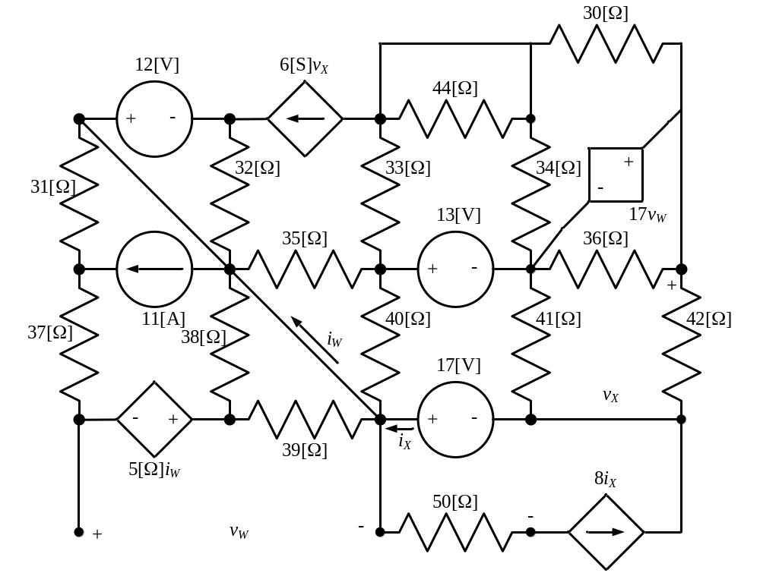

Room for extra work

2. {Up to 25 Points} Three voltmeters are put in series, and used to measure an unknown voltage. The unknown voltage is determined by adding the readings of the three voltmeters. Voltmeter #1 can read a maximum voltage of 50[V], and has a meter resistance of 7.59[MΩ]. Voltmeter #2 can read a maximum voltage of 150[V], and has a meter resistance of 3.74[MΩ]. Voltmeter #3 can read a maximum voltage of 200[V], and has a meter resistance of 1.79[MΩ].
a) What is the largest voltage that can be measured in this way, by adding the readings of the three voltmeters?
b) Assume that three identical resistors of 4.75[MΩ] are available, and one each is now placed in parallel with each voltmeter. These three parallel combinations are placed in series. What is the largest voltage that can be measured in this way, by adding the readings of the three voltmeters?

Room for extra work

3. {Up to 25 Points} Use the circuit given below to find the requested quantities.
a) Find the equivalent resistance as seen by terminals A and B.
b) Find the equivalent resistance as seen by terminals C and D.

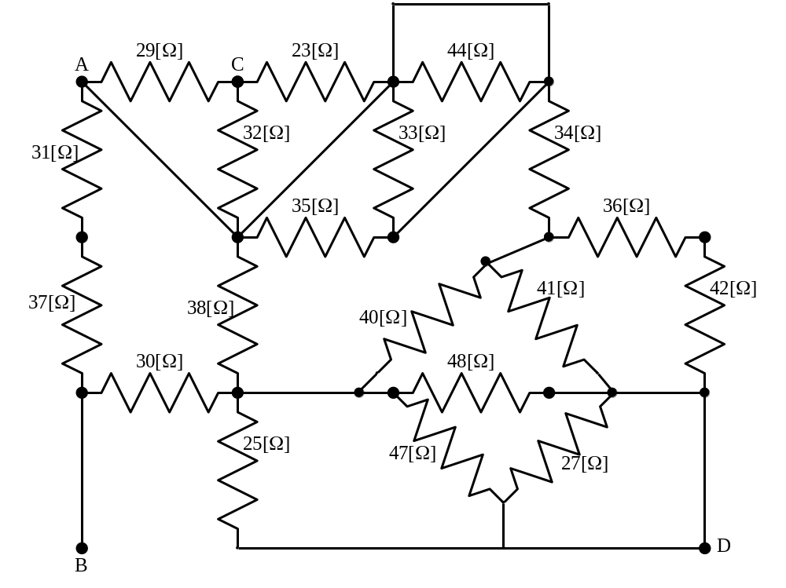

Room for extra work

4. {Up to 25 Points} Use the circuit given below to find the requested quantities.
a) Find v_{X}.
b) Find the power absorbed by the current source.

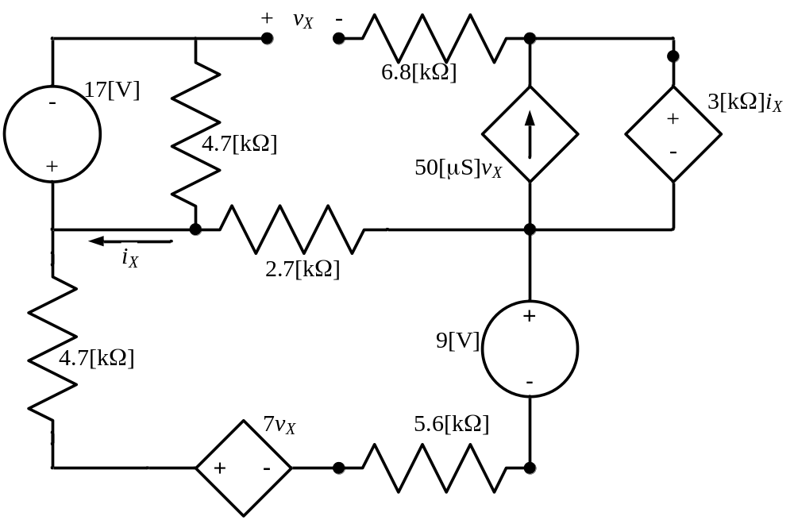

Room for extra work

5. {Up to 25 Points} A device can be modeled as a voltage source in series with a resistance. When this device is connected to a 23.7[V] voltage source, the voltage source absorbs 4.5[mW]. When the 23.7[V] voltage source is connected in the opposite polarity to the same device, the voltage source absorbs 65[mW]. Find the power absorbed by the device when it is removed from the voltage source, and connected to a 5.6[kΩ] resistor.

Solutions:
1. {Up to 25 Points} Use the node-voltage method to write a complete set of equations that could be used to solve this circuit. Do not simplify the circuit. Do not attempt to solve or simplify your equations. Define all variables.
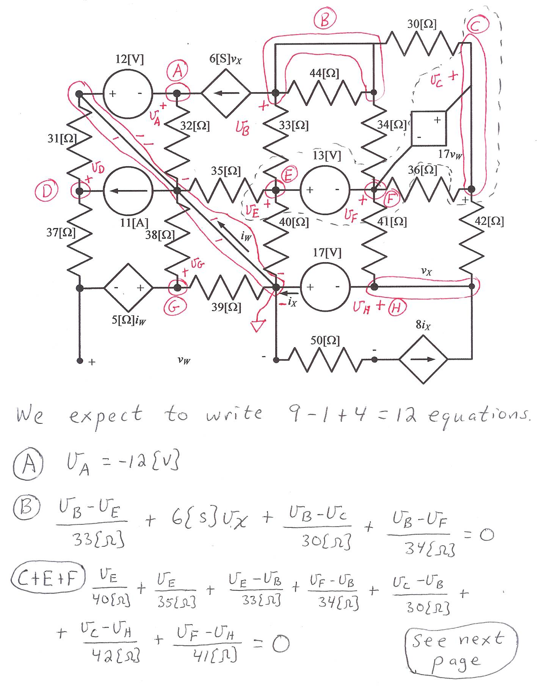
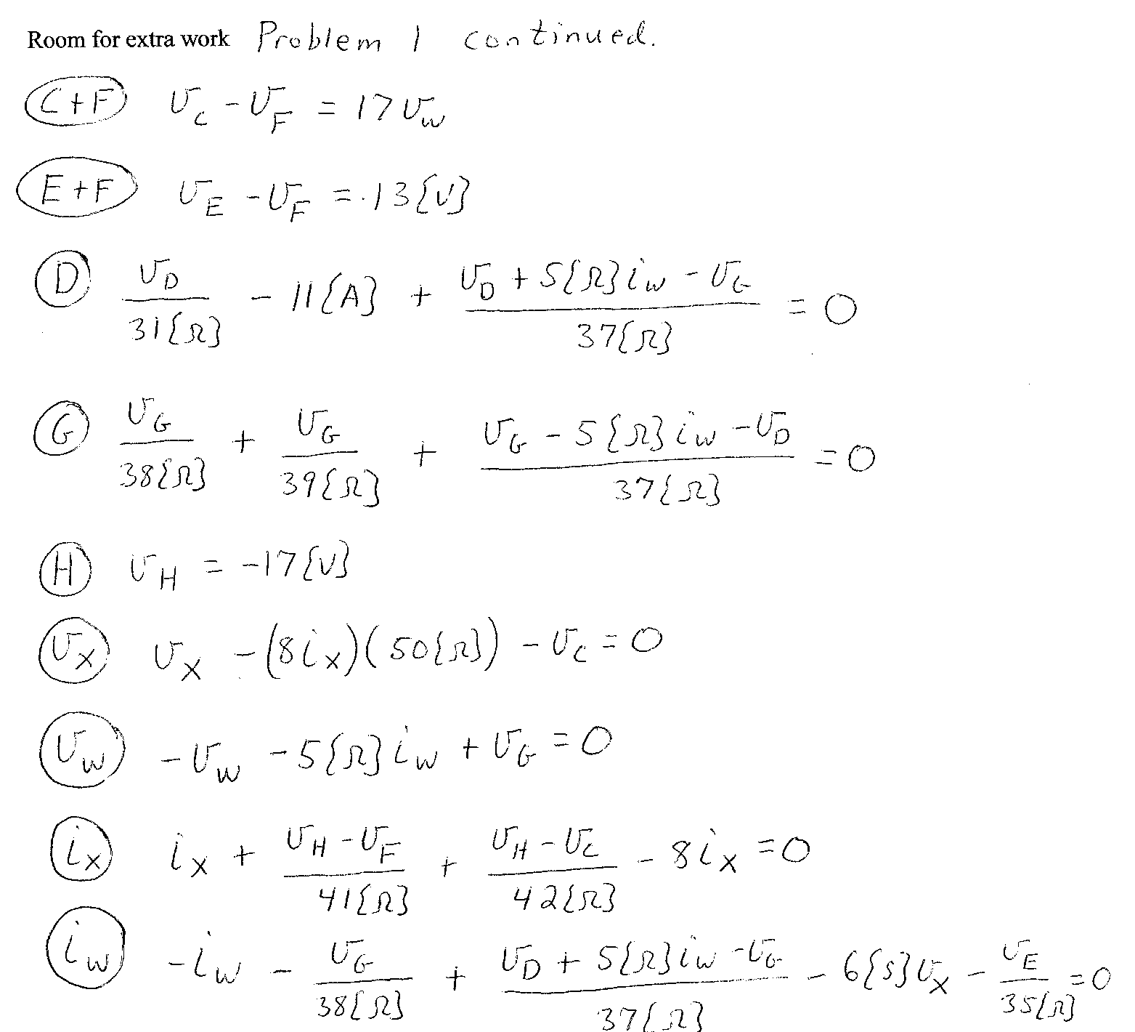

2. {Up to 25 Points} Three voltmeters are put in series, and used to measure an unknown voltage. The unknown voltage is determined by adding the readings of the three voltmeters. Voltmeter #1 can read a maximum voltage of 50[V], and has a meter resistance of 7.59[MΩ]. Voltmeter #2 can read a maximum voltage of 150[V], and has a meter resistance of 3.74[MΩ]. Voltmeter #3 can read a maximum voltage of 200[V], and has a meter resistance of 1.79[MΩ].
a) What is the largest voltage that can be measured in this way, by adding the readings of the three voltmeters?
b) Assume that three identical resistors of 4.75[MΩ] are available, and one each is now placed in parallel with each voltmeter. These three parallel combinations are placed in series. What is the largest voltage that can be measured in this way, by adding the readings of the three voltmeters?
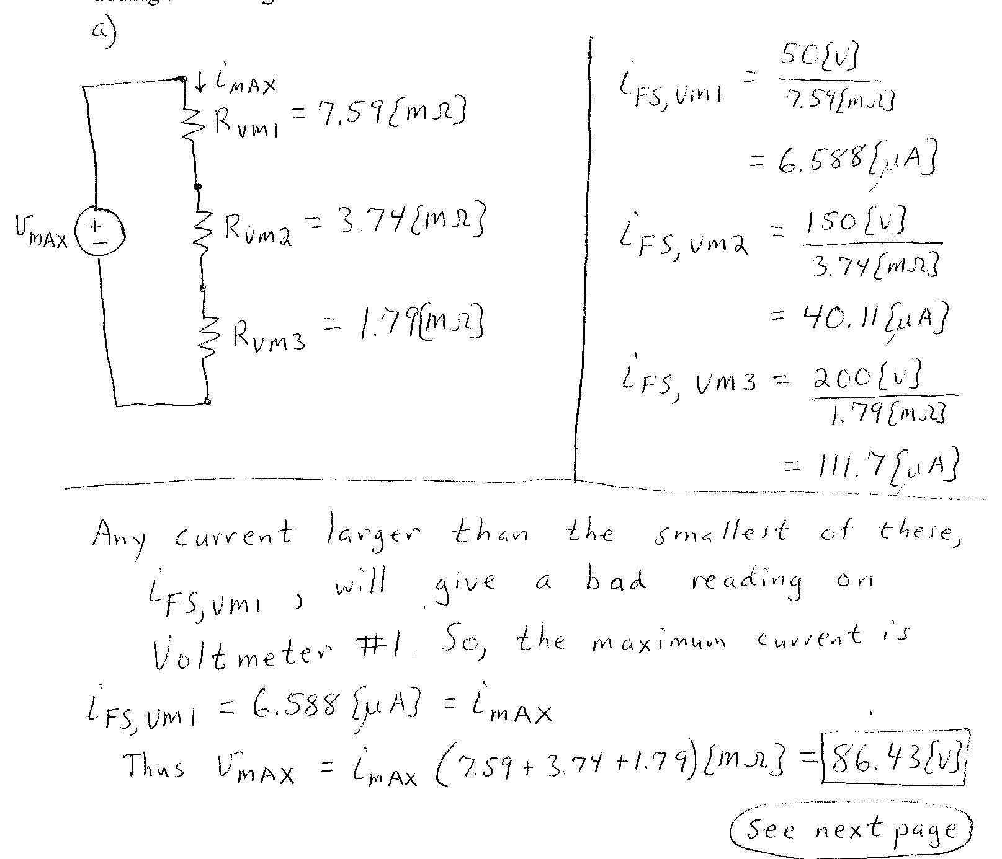
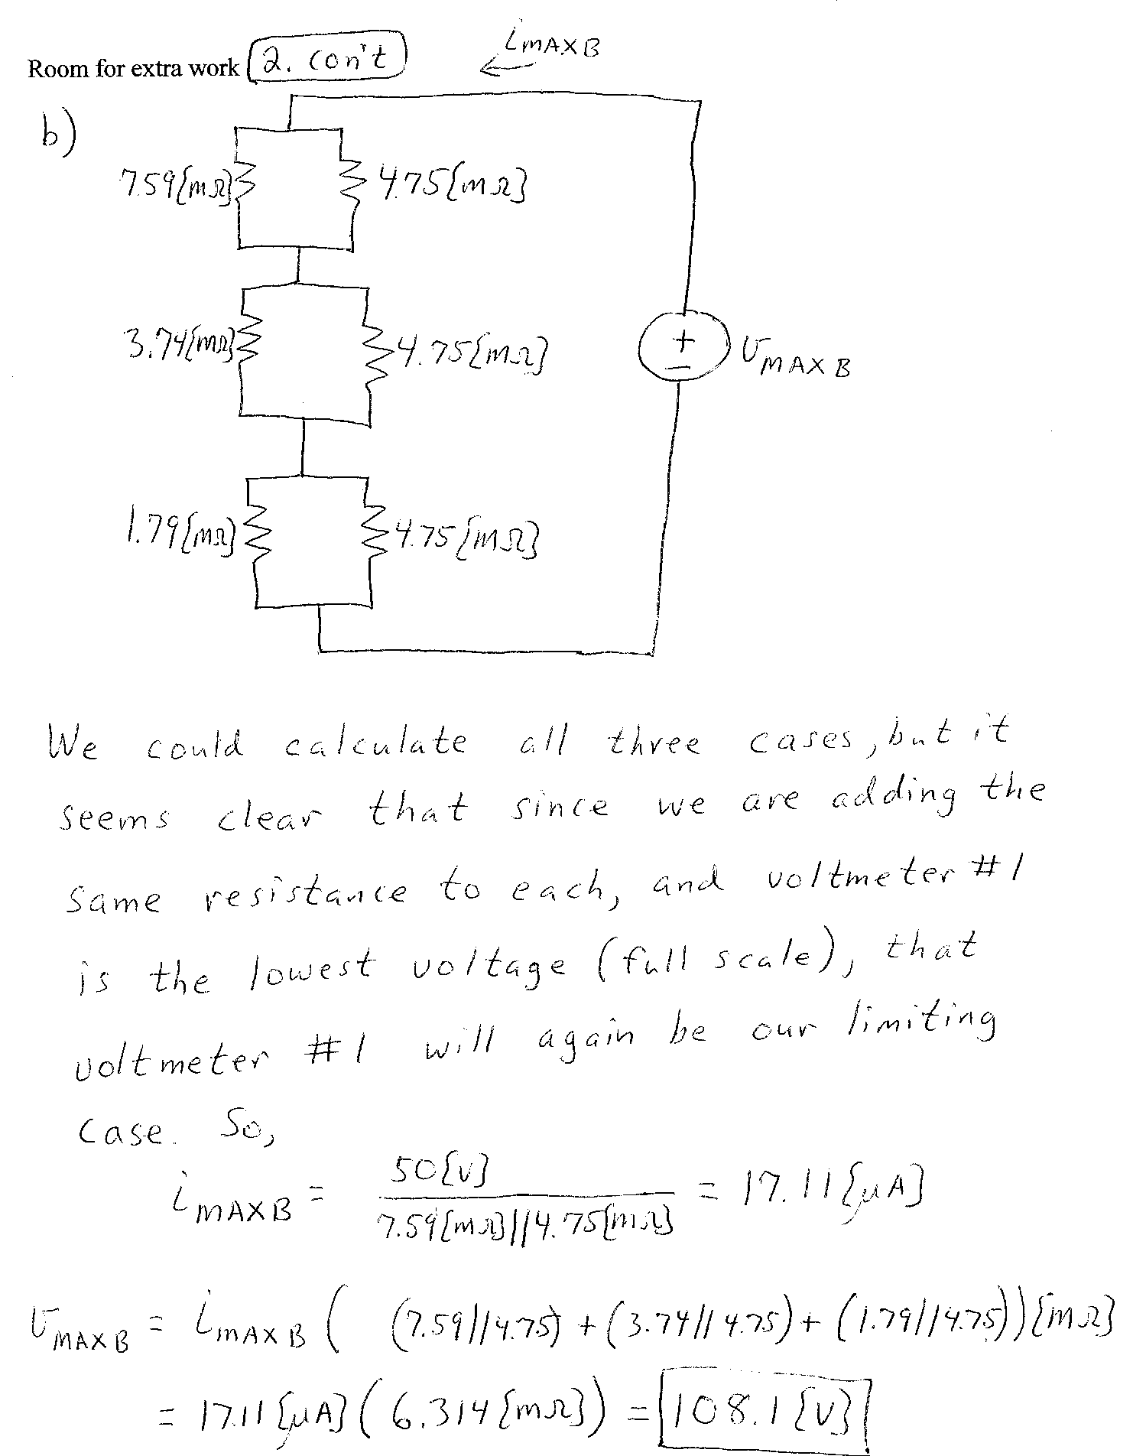

3. {Up to 25 Points} Use the circuit given below to find the requested quantities.
a) Find the equivalent resistance as seen by terminals A and B.
b) Find the equivalent resistance as seen by terminals C and D.
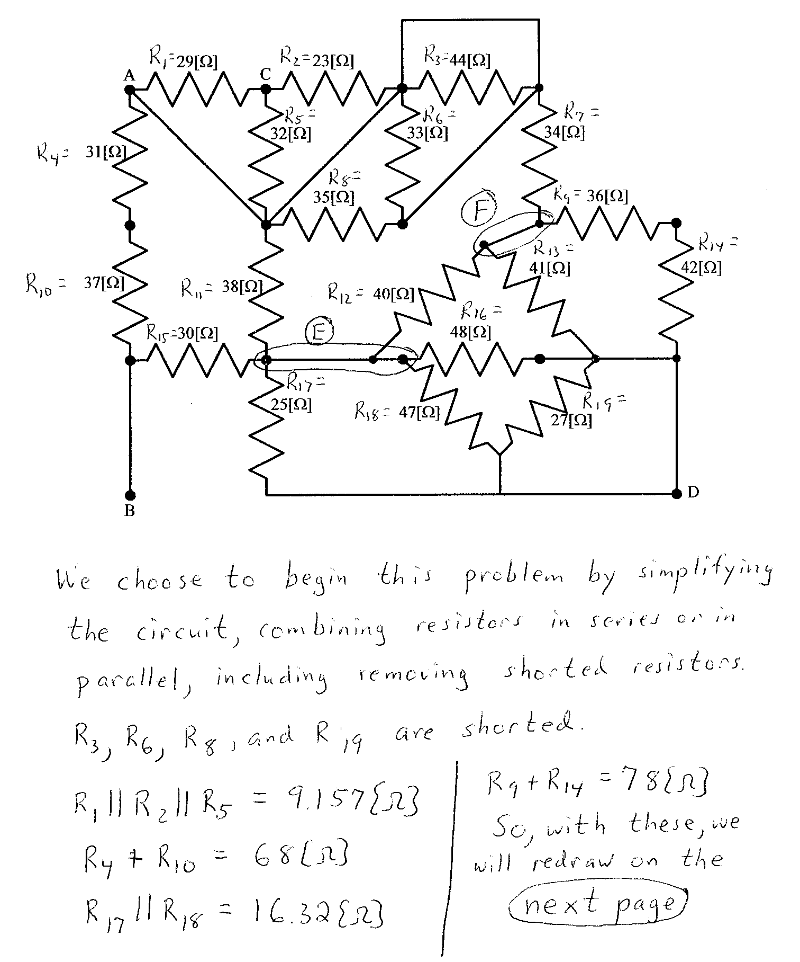
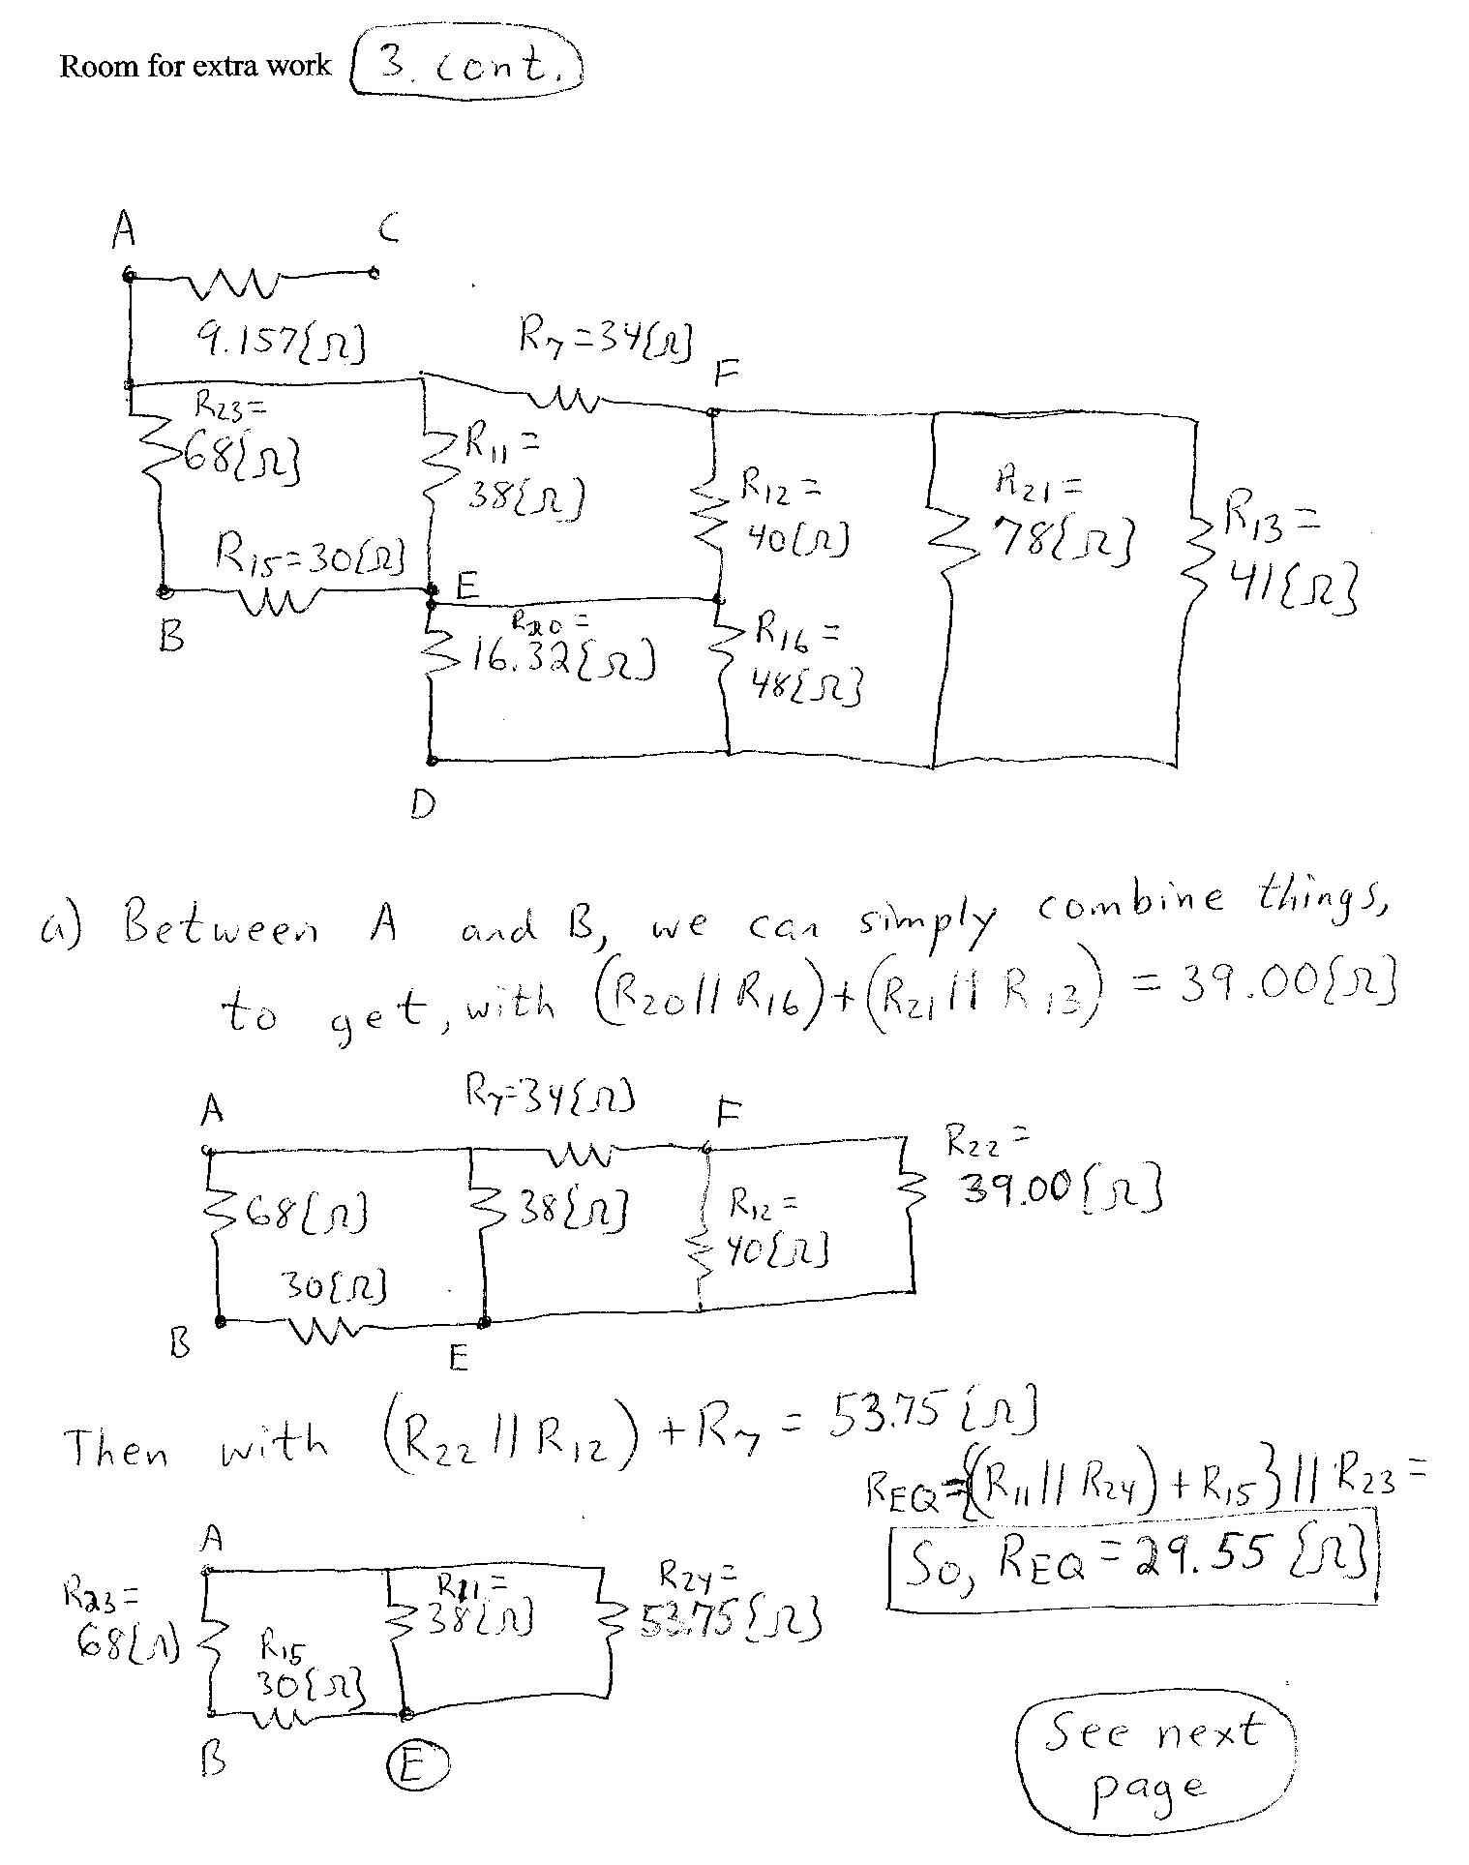

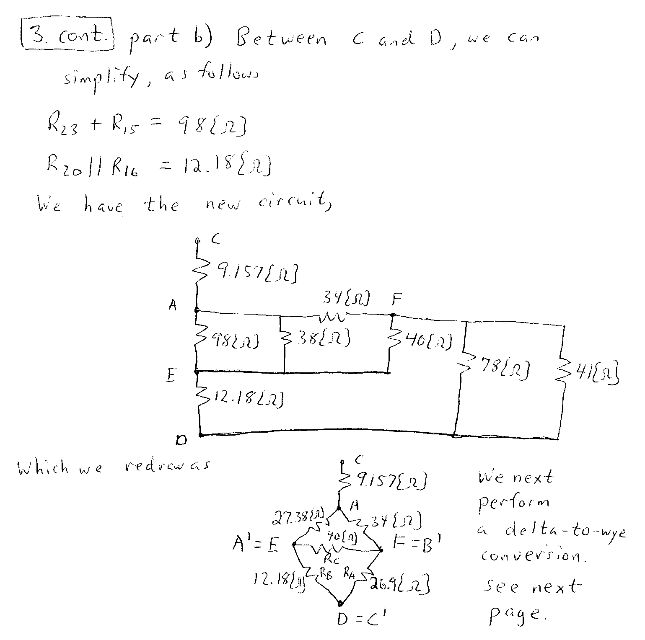

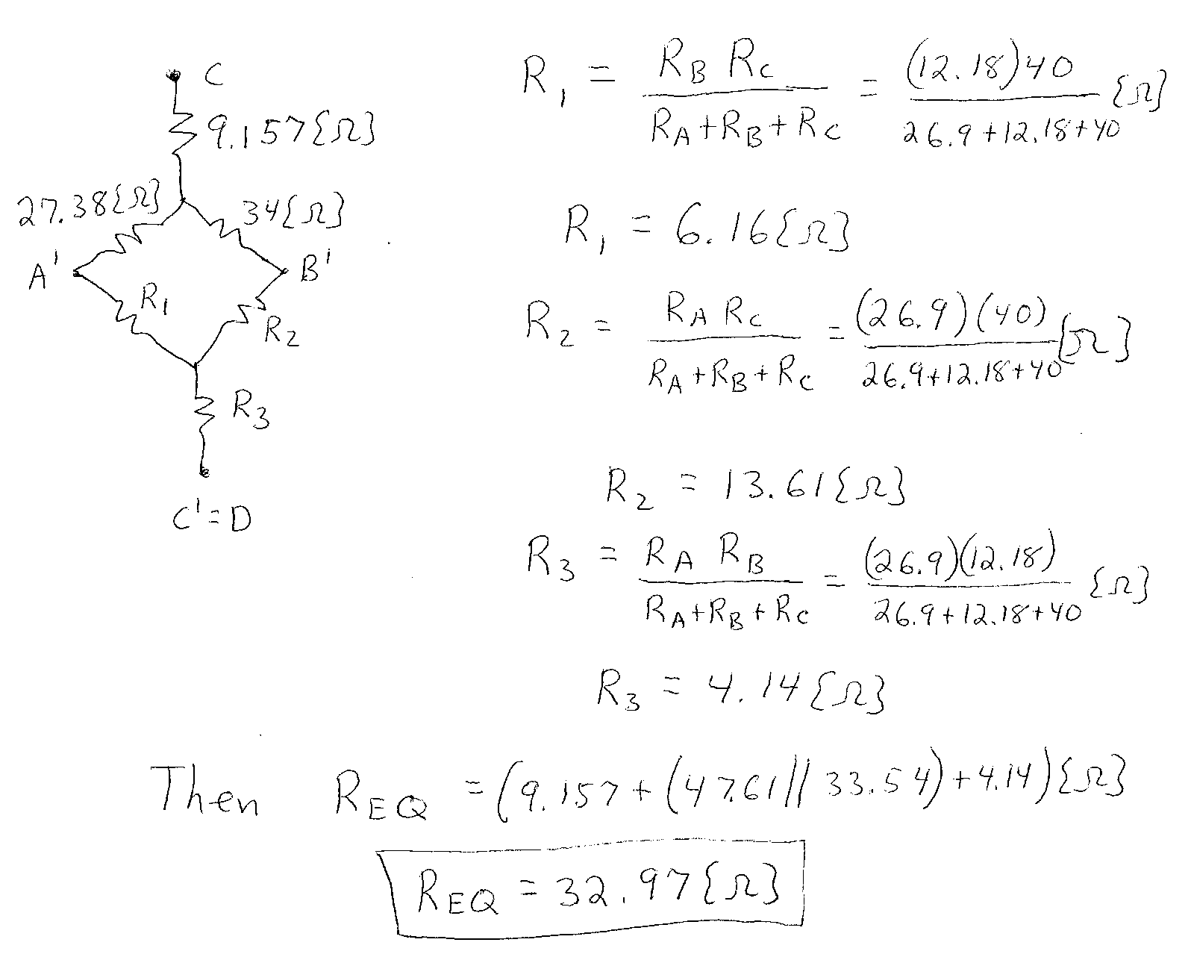

4. {Up to 25 Points} Use the circuit given below to find the requested quantities.
a) Find v_{X}.
b) Find the power absorbed by the current source.
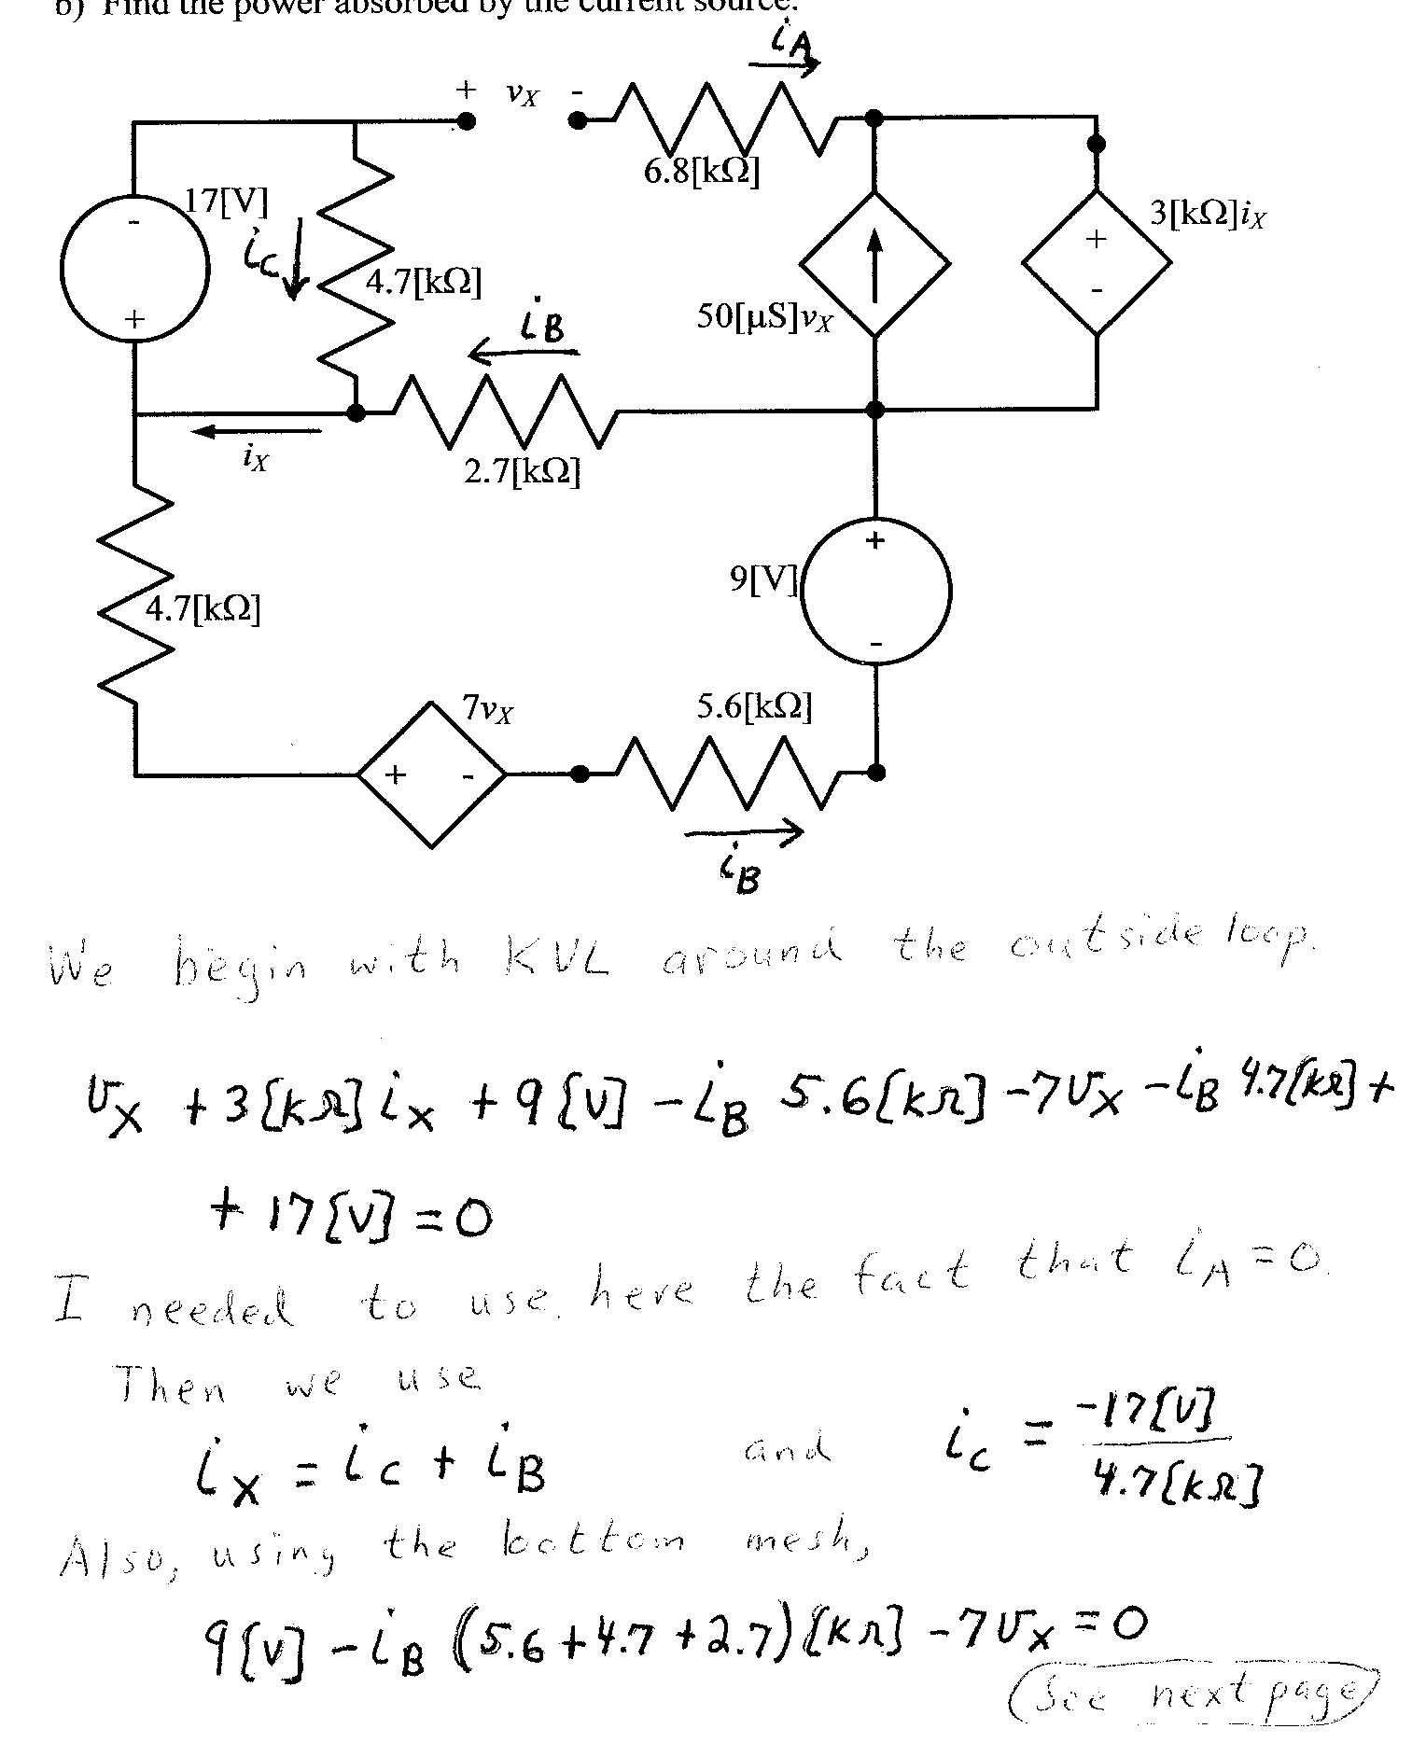
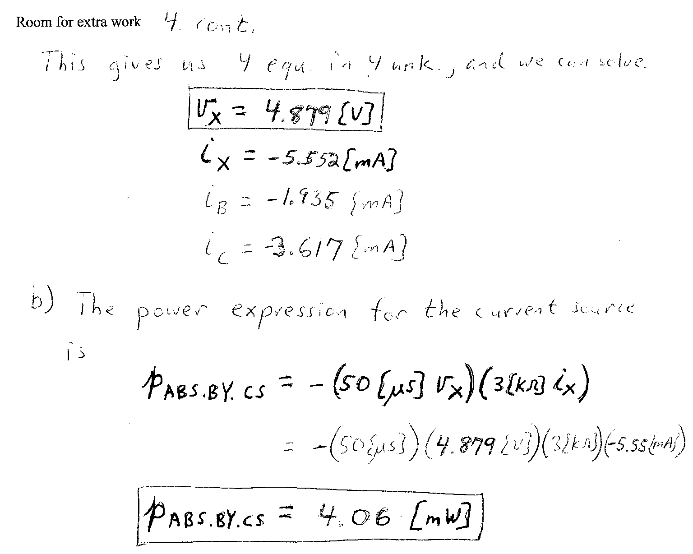

5. {Up to 25 Points} A device can be modeled as a voltage source in series with a resistance. When this device is connected to a 23.7[V] voltage source, the voltage source absorbs 4.5[mW]. When the 23.7[V] voltage source is connected in the opposite polarity to the same device, the voltage source absorbs 65[mW]. Find the power absorbed by the device when it is removed from the voltage source, and connected to a 5.6[kΩ] resistor.


