Name: _____________________________ (please print)
Signature: __________________________

ECE 2201 – Exam #1
June 20, 2017

Keep this quiz closed until you are told to begin.

1. This quiz is closed book, closed notes. You may use one 8.5” x 11” crib sheet, or its equivalent provided that it is hand-written by you.
2. Show all work on these pages. Show all work necessary to complete the problem. A solution without the appropriate work shown will receive no credit. A solution which is not given in a reasonable order will lose credit.
3. It is assumed that your work will begin on the same page as the problem statement. If you choose to begin your work on another page, you must indicate this on the page with the problem statement, with a clear indication of where the work can be found. If your work continues on to another page, indicate clearly where your work can be found. Failure to indicate this clearly will result in a loss of credit.
4. Show all units in solutions, and intermediate results and show it between square brackets.
5. Make sure to show your work in detail and refer to the figure as much as possible. Use a sentence or few words on what you are doing on a particular step. This will allow me to give more partial credit.
6. Do not use red ink. Do not use red pencil.
7. Never attach any extra papers to this quiz.
8. You will have 100 minutes to work on this exam.

1. ________________/35
2. ________________/35
3. ________________/30
Total = 100
- Referring to the figure below
- Calculate the equivalent resistance seen on the terminals A and B shown.
- Calculate the equivalent resistance seen on the terminals Y and Z shown.

Show your work in as much detail as possible. Circle resistances that are in parallel, cross out any resistances that are shorted (if applies) and indicate which ones are open (if applies)

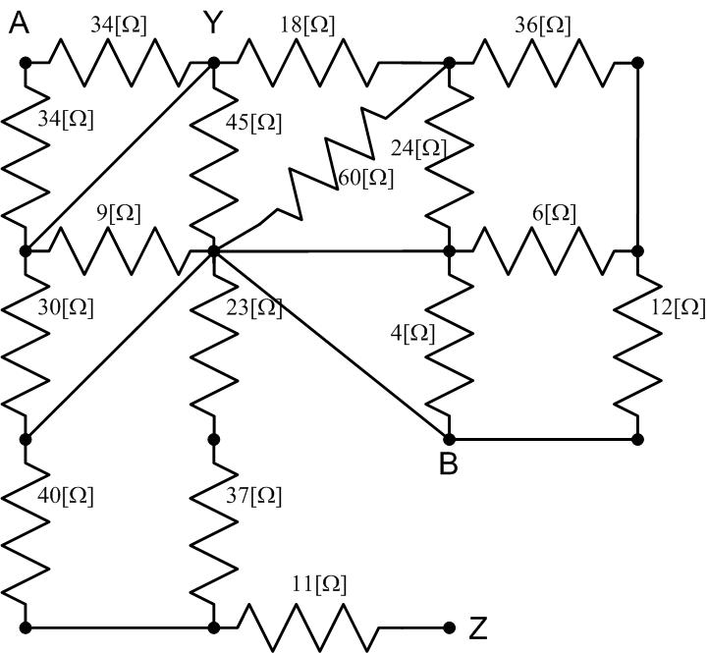

Room for extra work

2) Use the node-voltage method to write a complete set of equations that could be used to solve the circuit below. Define all variables. Do not attempt to simplify the circuit. Do not attempt to simplify or solve the equations.

When applying the node-voltage method, use the node with most connections as the reference (ground) node.

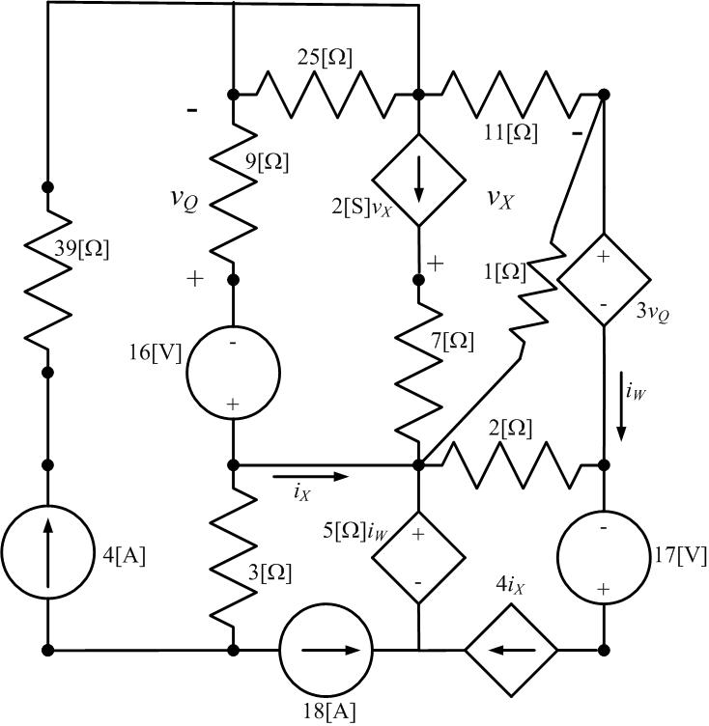
Room for extra work

3) Referring to the circuit below (30 pts):
a) Calculate the power supplied by the dependent current source (10 pts)
b) Calculate the power supplied by the 3V voltage source (10 pts)
c) Find the value of v_{Q} voltage (dependent variable) shown (10 pts)

