Name: _____________________________ (please print)
Signature: __________________________

ECE 2201 – Quiz #1
June 12, 2017

Keep this quiz closed until you are told to begin.

1. This quiz is closed book, closed notes. You may use one 8.5” x 11” crib sheet, or its equivalent provided that it is hand-written by you.
2. Show all work on these pages. Show all work necessary to complete the problem. A solution without the appropriate work shown will receive no credit. A solution which is not given in a reasonable order will lose credit.
3. It is assumed that your work will begin on the same page as the problem statement. If you choose to begin your work on another page, you must indicate this on the page with the problem statement, with a clear indication of where the work can be found. If your work continues on to another page, indicate clearly where your work can be found. Failure to indicate this clearly will result in a loss of credit.
4. Show all units in solutions, and intermediate results and show it between square brackets.
5. Make sure to show your work on the figure to the extent possible (e.g. marking of parallel resistance), this makes our grading easier.
5. Do not use red ink. Do not use red pencil.
6. Never attach any extra papers to this quiz.
7. You will have 90 minutes to work on this quiz.

1. ________________/30
2. ________________/35
3. ________________/35

Total = 100
- Calculate the equivalent resistance seen by terminal A and B shown. Show your work in as much detail as possible. 30 pts
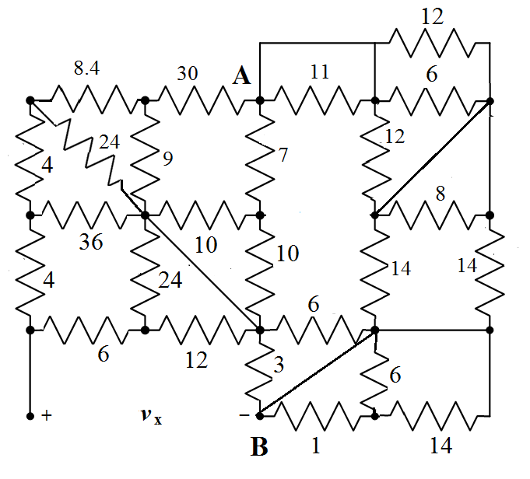
Room for extra work

- The device shown in Figure 1 below has the voltage v_{D}(t) as shown in Figure 2, and current i_{D}(t) as shown in Figure 3. (35 pts)

- The energy delivered by Device D during the time period 1[s] < t < 4[s]. (20 pts)
- Find the power absorbed by Device D at t = 3.5[s]. (15 pts)

For ease of calculation, keep voltage in [mV] and current in [mA] (do not convert it to [V] and [A]. Then find the power and energy in [µW] and [µJ], respectively

Room for extra work

- Calculate the power delivered by the dependent voltage source. (35 pts)

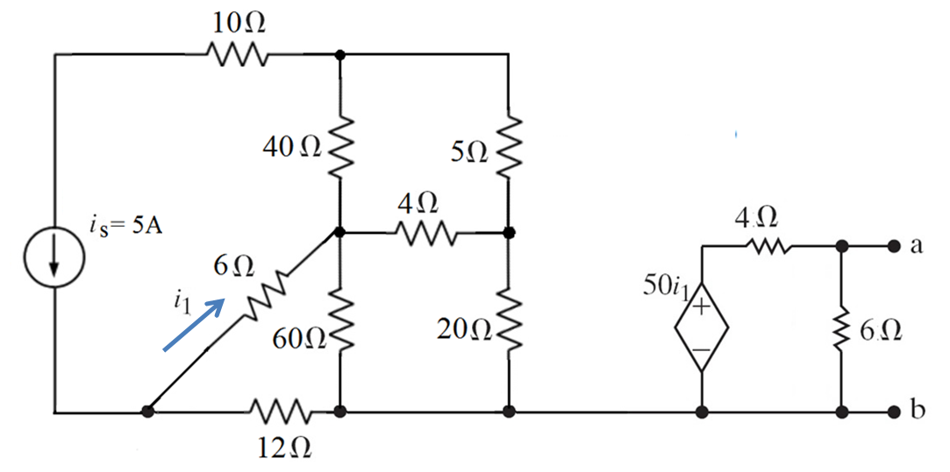

Room for extra work

