Name: _____________________________ (please print)
Signature: __________________________

ECE 2201 – Quiz #2
June 16, 2017

Keep this quiz closed until you are told to begin.

1. This quiz is closed book, closed notes. You may use one 8.5” x 11” crib sheet, or its equivalent provided that it is hand-written by you.
2. Show all work on these pages. Show all work necessary to complete the problem. A solution without the appropriate work shown will receive no credit. A solution which is not given in a reasonable order will lose credit.
3. It is assumed that your work will begin on the same page as the problem statement. If you choose to begin your work on another page, you must indicate this on the page with the problem statement, with a clear indication of where the work can be found. If your work continues on to another page, indicate clearly where your work can be found. Failure to indicate this clearly will result in a loss of credit.
4. Show all units in solutions, and intermediate results and show it between square brackets.
5. Make sure to show your work on the figure to the extent possible
5. Do not use red ink. Do not use red pencil.
6. Never attach any extra papers to this quiz.
7. You will have 40 minutes to work on this quiz.

Max available points for this quiz is 40 pts

Use the node-voltage method to write a complete set of equations that could be used to solve the circuit below. Define all variables. Do not attempt to simplify the circuit. Do not attempt to simplify or solve the equations.

When applying the node-voltage method, use the node with most connections as the reference (ground) node.

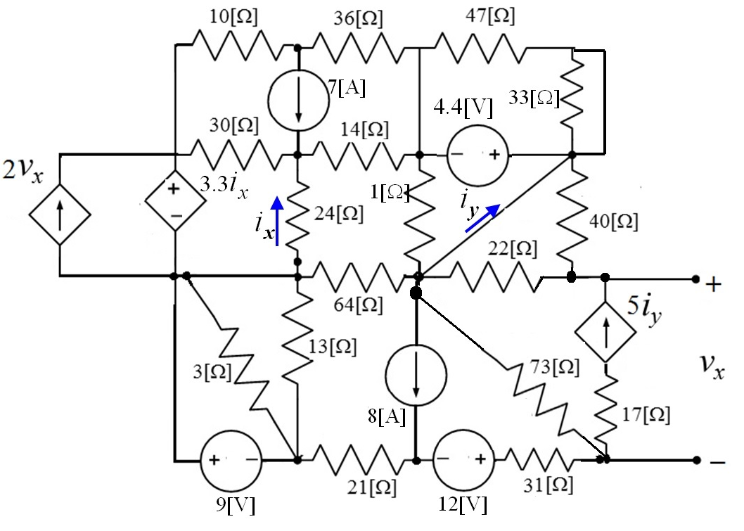
Room for extra work

