Name: _____________________________ (please print)
Signature: __________________________

ECE 2201 – Final Exam
July 5, 2017

Keep this exam closed until you are told to begin.

1. This exam is closed book, closed notes. You may use one 8.5” x 11” crib sheet.
2. Show all work on these pages. Show all work necessary to complete the problem. A solution without the appropriate work shown will receive no credit. A solution that is not given in a reasonable order will lose credit. Clearly indicate your answer (for example by enclosing it in a box).
3. It is assumed that your work will begin on the same page as the problem statement. If you choose to begin your work on another page, you must indicate this on the page with the problem statement, with a clear indication of where the work can be found. If your work continues on to another page, indicate clearly where your work can be found. Failure to indicate this clearly will result in a loss of credit.
4. Show all units in solutions, and intermediate results and show it between square brackets.
5. Make sure to show your work in detail and refer to the figure as much as possible. Use a sentence or few words on what you are doing on a particular step. This will allow me to give more partial credit.
6. Do not use red ink. Do not use red pencil. Print your answers legibly, make sure your letters are not too small to read. Points will be deducted otherwise.
7. Never attach any extra papers to this quiz.
6. You will have 150 minutes (2 ½ hours) to work on this exam.

1. ________________/44
2. ________________/44
3. ________________/44
4. ________________/34
5. ________________/34

Total = 200

Room for extra work

Q1) Use the node-voltage method to write a complete set of equations that could be used to solve the circuit below. Define all variables. Do not attempt to simplify the circuit. Do not attempt to simplify or solve the equations.

When applying the node-voltage method, use the node with most connections as the reference (ground) node otherwise you lose credit.

In addition, your node names should be named using node names V₁, V₂, V₃, in an increasing manner. Start naming nodes beginning at the top-left node. You should also number nodes from left to right or points will be deducted.
44 points
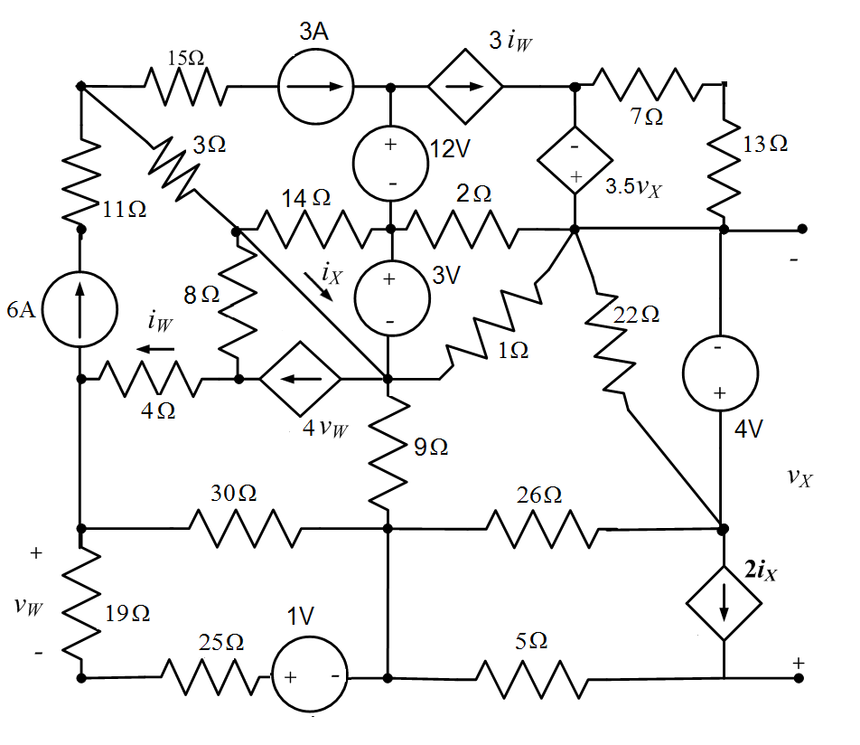

Room for extra work

Q2. Referring to the figure below calculate the equivalent resistance seen on the terminals A and B shown.

Show your work in as much detail as possible. Circle resistances that are in parallel, cross out any resistances that can be ignored or removed (if applies) and state the reason why it can be ignored.

Do a delta-wye conversion only if necessary. Otherwise points will be deducted.
44 points

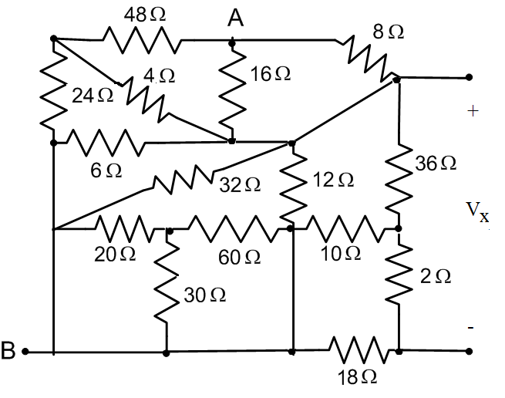

Room for extra work

Q3. 44 points

- Find the Norton equivalent of the circuit given below, as seen by the 4[A] current source. 30 pts.
- Find the power delivered by the 4[A] current source. 14 pts.

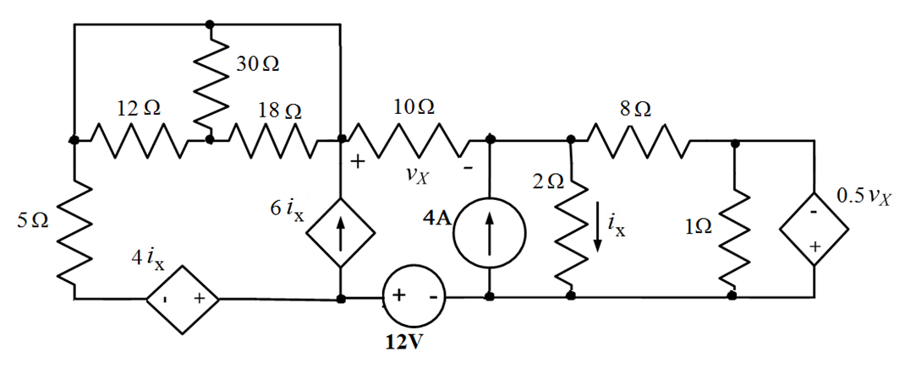

Room for extra work

Q4. A device called Device D is made up of sources and resistors. This device has voltages and currents as related in the plot in Figure 1, assuming reference polarities as defined in Figure 2.
34 pts

- Find a Thevenin model that can be used as an equivalent circuit for Device D for 0 < v_{D}< 2[V]. Draw the model, labeling terminals a and b 20 pts

- Find the power delivered by Device D for v_{D} = 2.5[V]. 14 pts

Room for extra work

Q5. Use Superposition Theorem and find the voltage v_{a} shown on the 6 Ohm resistor.
Show your work in full detail to get full credit 34 pts
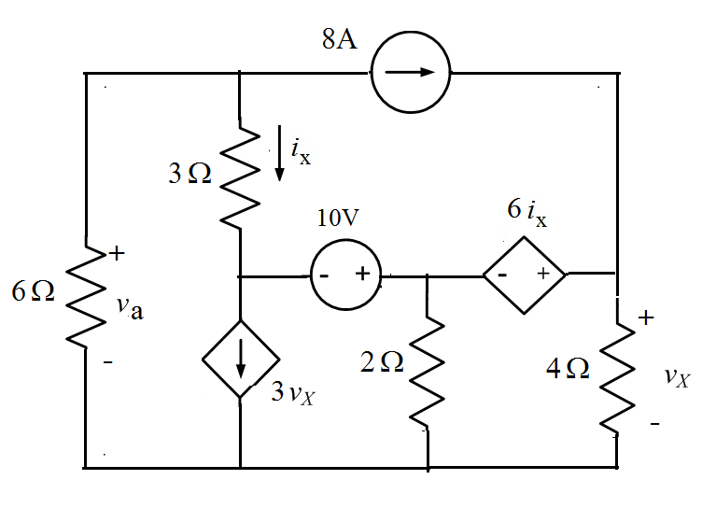

Room for extra work

