Good morning Dr. Dave,

I really need clarification on this one issue I was having when writing KVL eqs. As you can see in the
attached image, I made a loop to write a KVL for.

Now I don’t understand why we have to assign polarities to the resistors if we can just assign a current going thru it, and if that current going thru it matches the direction of the loop, then it would give a negative value (-IR) and positive if it was opposite.

I understand going from + to - across a resistors leads to a voltage drop and therefore needs a negative sign (-IR).

Do we assign both the polarities and current, if so how ? Say I assign a current going up thru R2 and also up thru R1. That seems like a mess as I all ready assigned a polarity and can just follow my loop and see if voltage drops or increases going thru the resistor judging off the polarities. If I assign the current and go around the loop I don’t know what to judge by! My polarities that I assigned or my current !

Thank you for your time and sorry if this didn’t make sense.

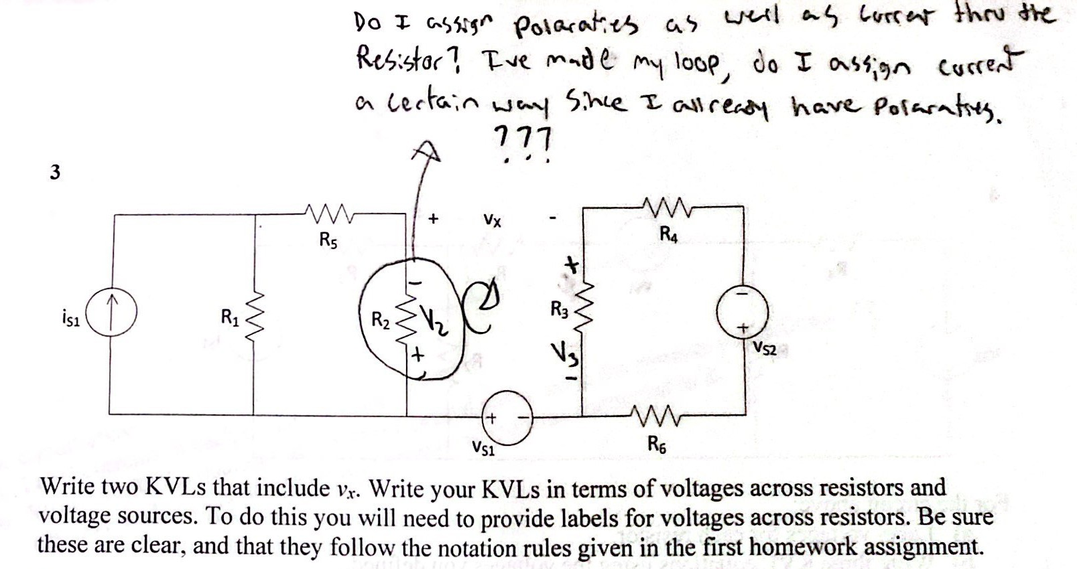

Salutations! I wanted everyone to see the question before I began to answer it. So, the rest of this page is blank, and on the following page I will answer the questions, nesting my comments and answers within the questions, in red.
Dr. Dave

I really need clarification on this one issue I was having when writing KVL eqs. As you can see in the attached image, I made a loop to write a KVL for. I should note that we are going to use the symbol for the loop that you chose here, in the future, for what we will call mesh currents. For now, however, I will accept this.

Now I don’t understand why we have to assign polarities (I assume that here, when you mention “polarities”, you meant to say reference polarities for the voltages. We also have polarities for the currents we choose to define.) to the resistors if we can just assign a current going thru it, (Yes, you can also do that. You can also do both.) and if that current going thru it matches the direction of the loop, then it would give a negative value (-IR) and positive if it was opposite. Really? How do you know that? How did you get the sign you give here? Is it correct? I have often heard this kind of thing said, although usually I hear it with the opposite of the signs you mention here. I am going to do my best to insist that you understand your rule when you give it, and be able to explain why the sign is correct. We will discuss this in class.

I understand going from + to - across a resistor leads to a voltage drop (Yes, this is correct.) and therefore needs a negative sign (-IR). Really? How do you know that? How did you get the sign you give here? Is it correct?

Do we assign both the polarities and current, if so how ? Again, you are using polarities as if it only applied to voltages. We have reference polarities for voltages and we have reference polarities for currents. You do not need to assign both, but you are allowed to assign both. These are reference polarities, so both voltage and current can be assigned in either polarity. Reference polarities are arbitrary. SSay I assign a current going up thru R2 and also up thru R1. You may certainly do that. That seems like a mess as I already assigned a polarity and can just follow my loop and see if voltage drops or increases going thru the resistor judging off the polarities. I do not see how that makes a mess. One more time, it appears you are using polarities when you appear to mean reference polarities for the voltages at the beginning of your statement, and reference polarities for the current at the end of your sentence. Therefore, I am not sure what you are saying. Taking an assumption on what you meant to say, I am going to ask you what polarity do you get for your reference current polarity? And how did you get it? If I assign the current and go around the loop I don’t know what to judge by! (Judge what?) My polarities that I assigned or my current !

Thank you for your time and sorry if this didn’t make sense. To a large extent, no, this did not make sense. You need to be careful in your use of the words we have defined. In addition, I suspect that you have learned somewhere else how to write KVL equations in terms of currents through resistors. This happens with many students. If you have a rule for how to do this, I am going to push you to understand why your rule works, and how to find voltages even when you are not writing KVL equations. This will be important. I look forward to talking to you about this in class!

Read the wording on this problem carefully.

