Name: _____________________________ (please print)
Signature: __________________________

ECE 2300 – Final Exam
December 7, 2005

Keep this exam closed until you are told to begin.

1. This exam is closed book, closed notes. You may use one 8.5” x 11” crib sheet, or its equivalent.
2. Show all work on these pages. Show all work necessary to complete the problem. A solution without the appropriate work shown will receive no credit. A solution that is not given in a reasonable order will lose credit. Clearly indicate your answer (for example by enclosing it in a box).
3. It is assumed that your work will begin on the same page as the problem statement. If you choose to begin your work on another page, you must indicate this on the page with the problem statement, with a clear indication of where the work can be found. If your work continues on to another page, indicate clearly where your work can be found. Failure to indicate this clearly will result in a loss of credit.
4. Show all units in solutions, intermediate results, and figures. Units in the exam will be included between square brackets.
5. Do not use red ink. Do not use red pencil.
6. You will have 180 minutes to work on this exam.

1. ________________/07
2. ________________/15
3. ________________/15
4. ________________/30
5. ________________/25
6. ________________/08
Total = 100
Room for extra work
1. {7 Points} Find the largest current that can be accurately measured with the ammeter given in the diagram below.
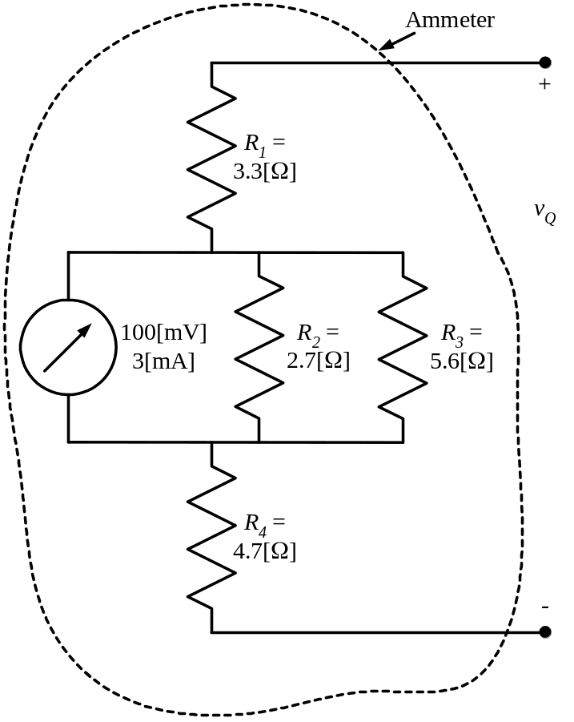

Room for extra work

2. {15 Points} Use the node-voltage method to write a complete set of equations that could be used to solve the circuit below. Do not attempt to simplify the circuit. Do not attempt to simplify or solve the equations. Define all variables.

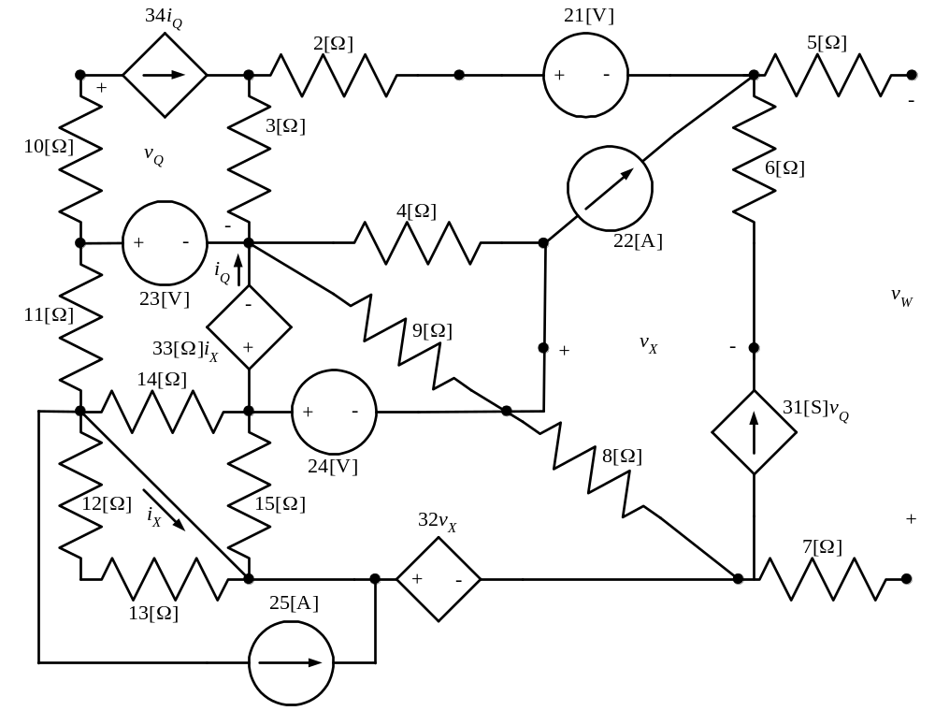

Room for extra work

3. {15 Points} A device called Device Q is made up of sources and resistors. This device has voltages and currents as related in the plot in Figure 1, assuming reference polarities as defined in Figure 2.
- Find a model that can be used as an equivalent circuit for Device Q for
0 < v_{Q} < 4[V]. Draw the model, labeling terminals a and b .
- Find the power delivered by device Q for v_{Q} = 6[V].
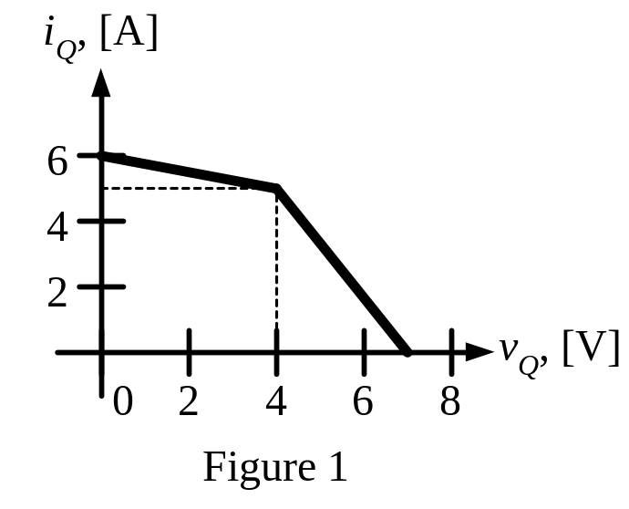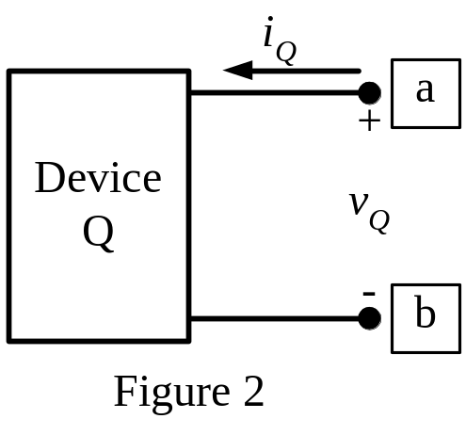

Room for extra work

4. {30 Points} It is given that v_{S2} has a positive value. The switch SWA was open and switch SWB was in position a for along time before t = 0. The inductor had 52[nJ] of energy stored in it just before t = 0.
Then switch SWA closed at t = 0. After that, switch SWB moved to position b at t = 1[s]. Finally, switch SWA opened again at t = 2[s].
Find numerical expressions for the current through the inductor, as a function of time, for t > 0.
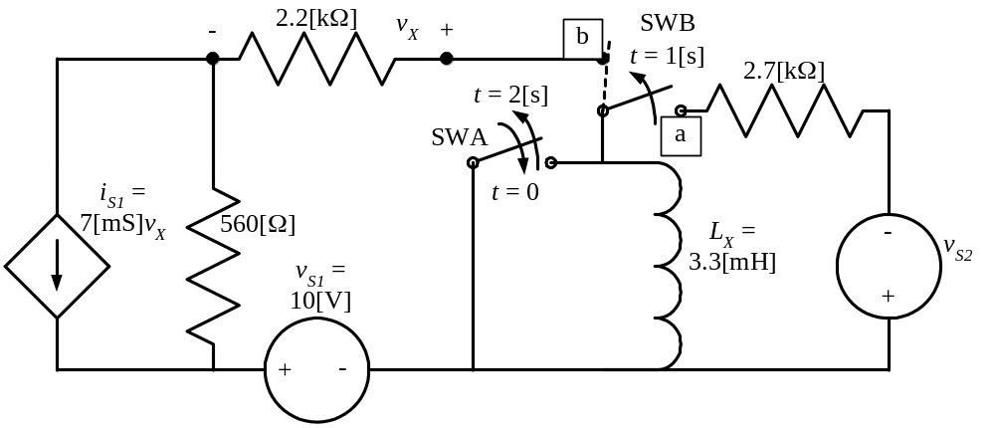

Room for extra work

5. {25 Points} It is given that:
- Load L₁ absorbs 5000[W] and delivers 6000[VAR].
- Load L₂ absorbs 4000∠–32°[VA].
- Load L₃ absorbs 9000[VA] at a lagging power factor of 0.5.
- Load L₄ absorbs 2000j[VA].
  - Find the equivalent impedance seen by the voltage source.
  - Find the power factor for this equivalent impedance.
  - Find i_{S}(t).
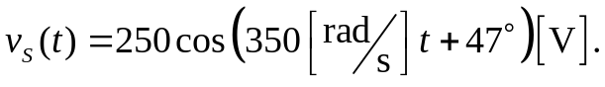
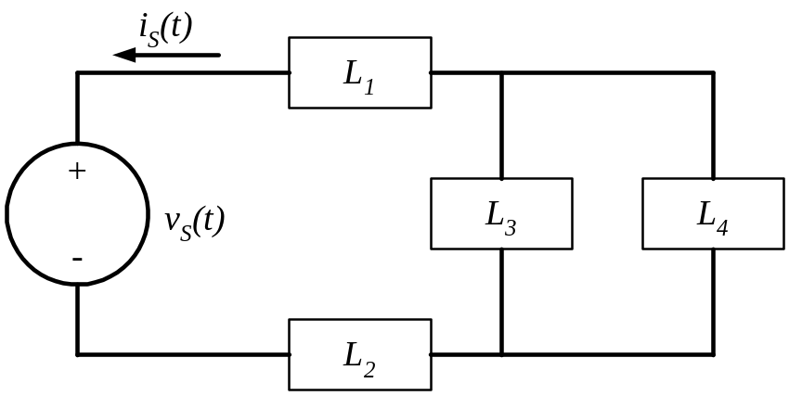

Room for extra work

6. {8 Points} The periodic function i_{S}(t) shown in Figure 1 is the value for the current source in Figure 2. Find the average power delivered by this current source in this circuit in Figure 2.
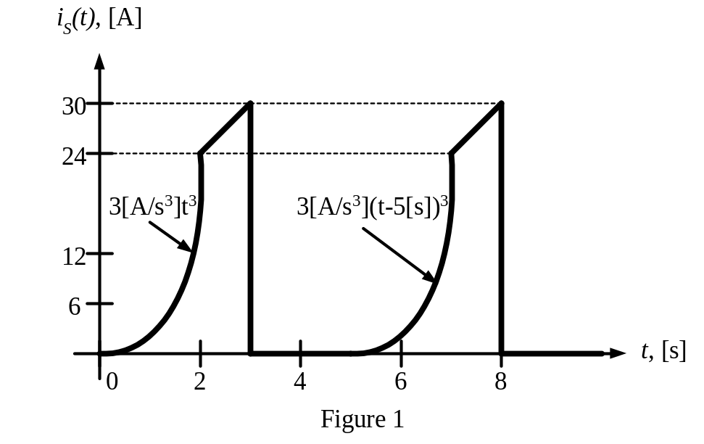
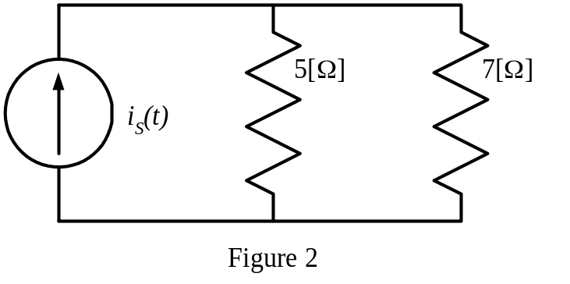

Solutions:
1. {7 Points} Find the largest current that can be accurately measured with the ammeter given in the diagram below.
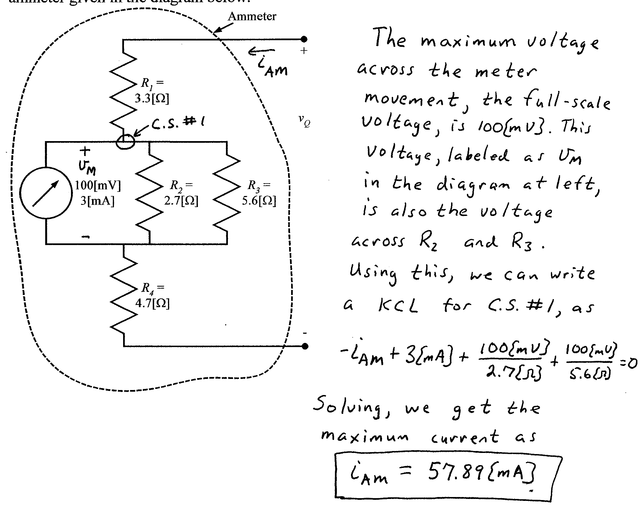

2. {15 Points} Use the node-voltage method to write a complete set of equations that could be used to solve the circuit below. Do not attempt to simplify the circuit. Do not attempt to simplify or solve the equations. Define all variables.
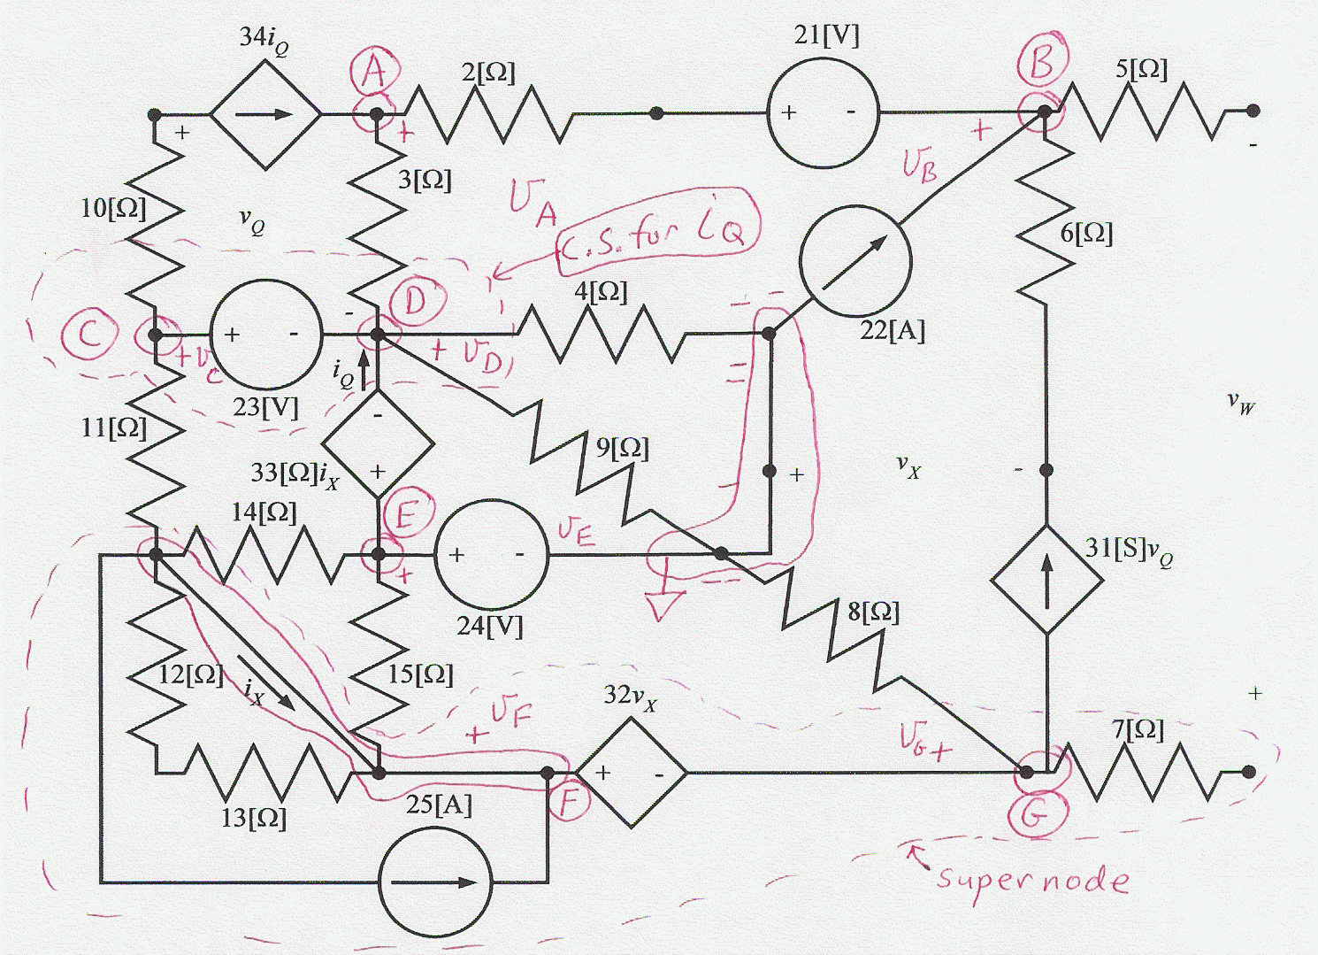
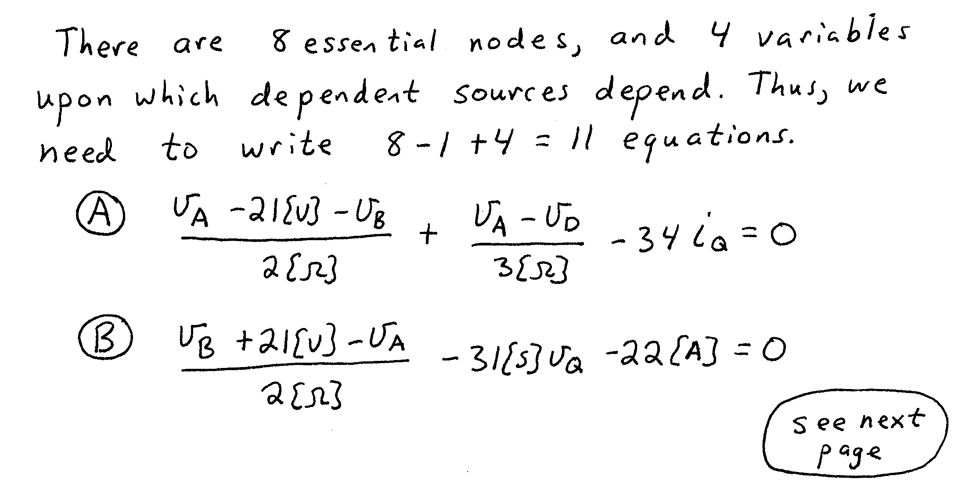
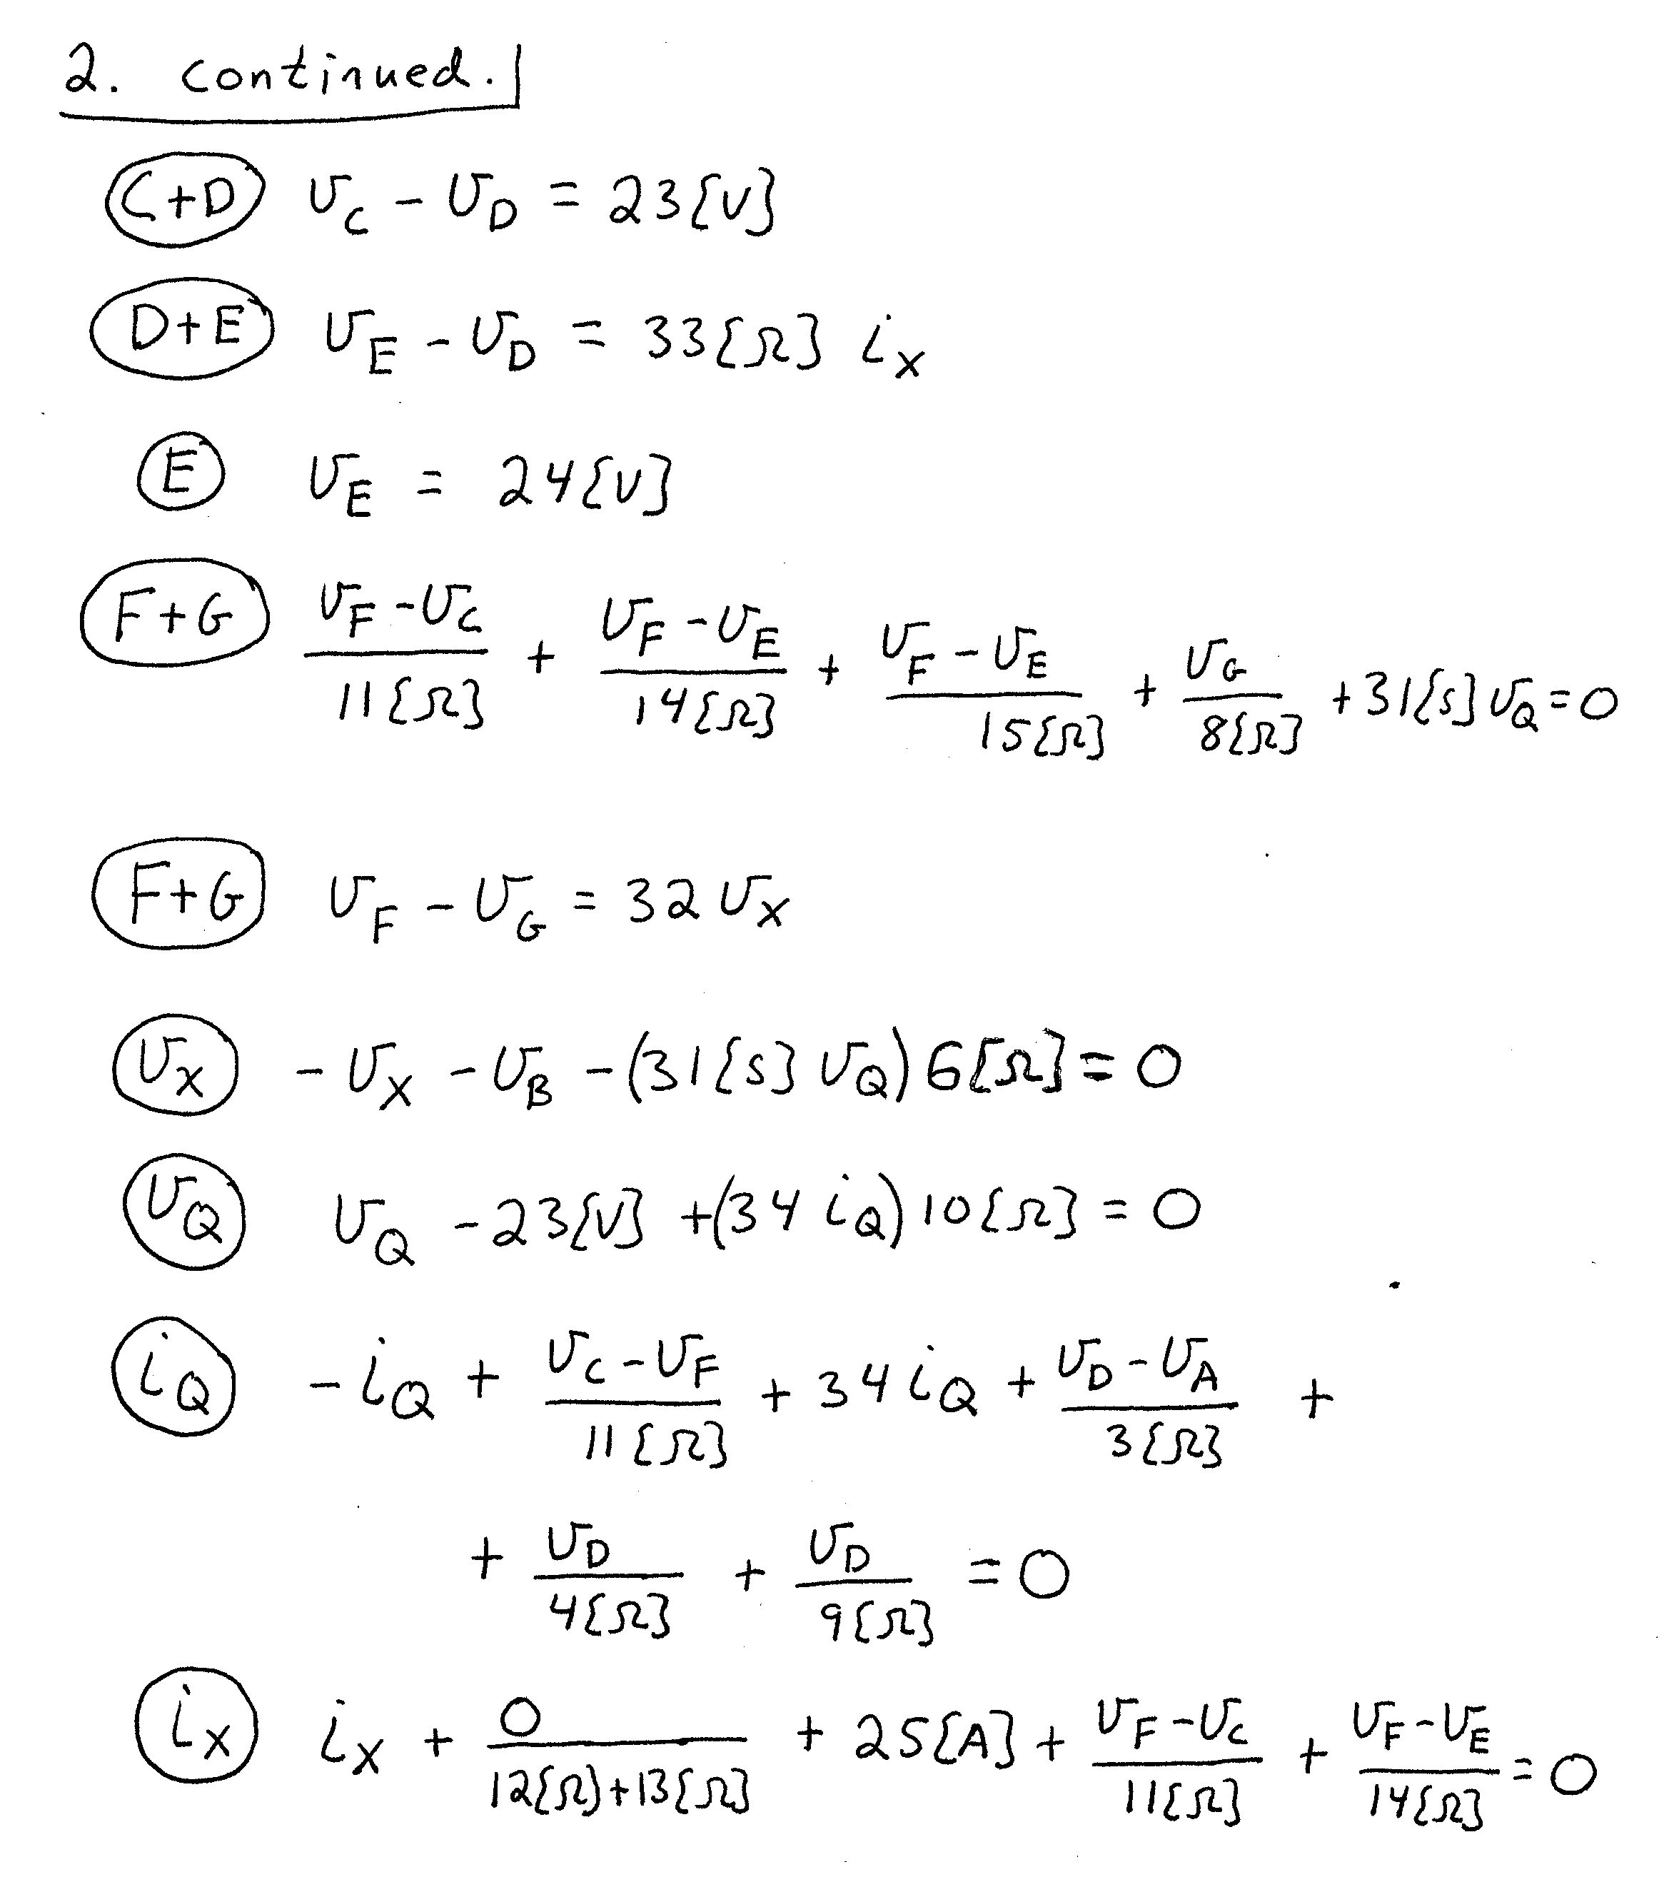
3. {15 Points} A device called Device Q is made up of sources and resistors. This device has voltages and currents as related in the plot in Figure 1, assuming reference polarities as defined in Figure 2.
- Find a model that can be used as an equivalent circuit for Device Q for
0 < v_{Q} < 4[V]. Draw the model, labeling terminals a and b .
- Find the power delivered by device Q for v_{Q} = 6[V].
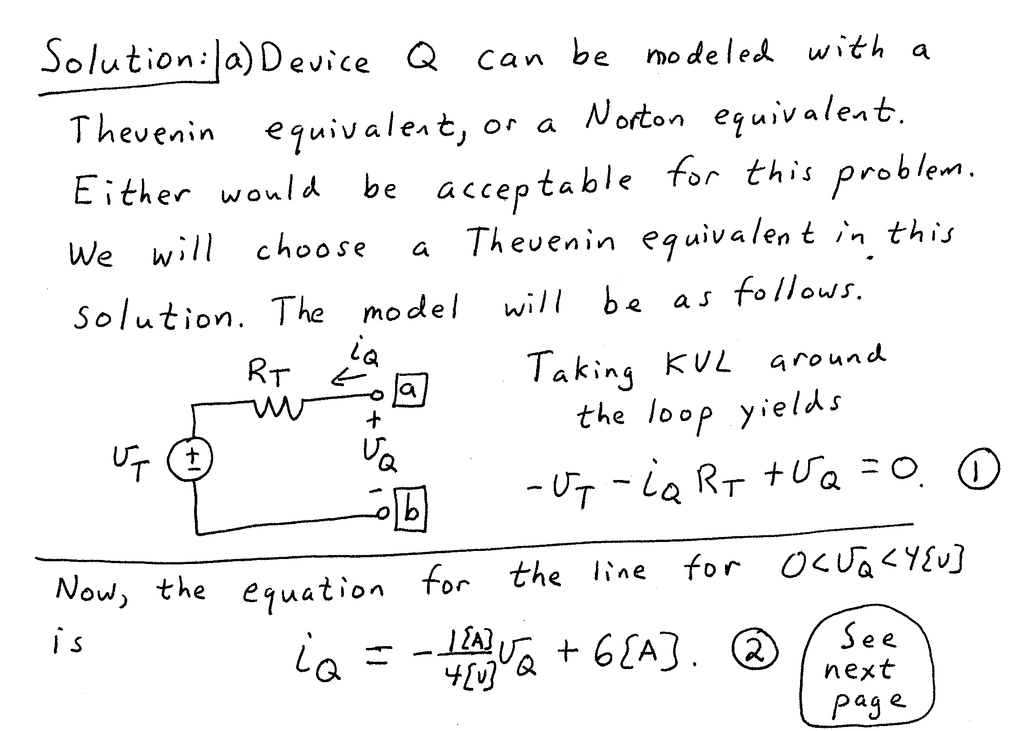
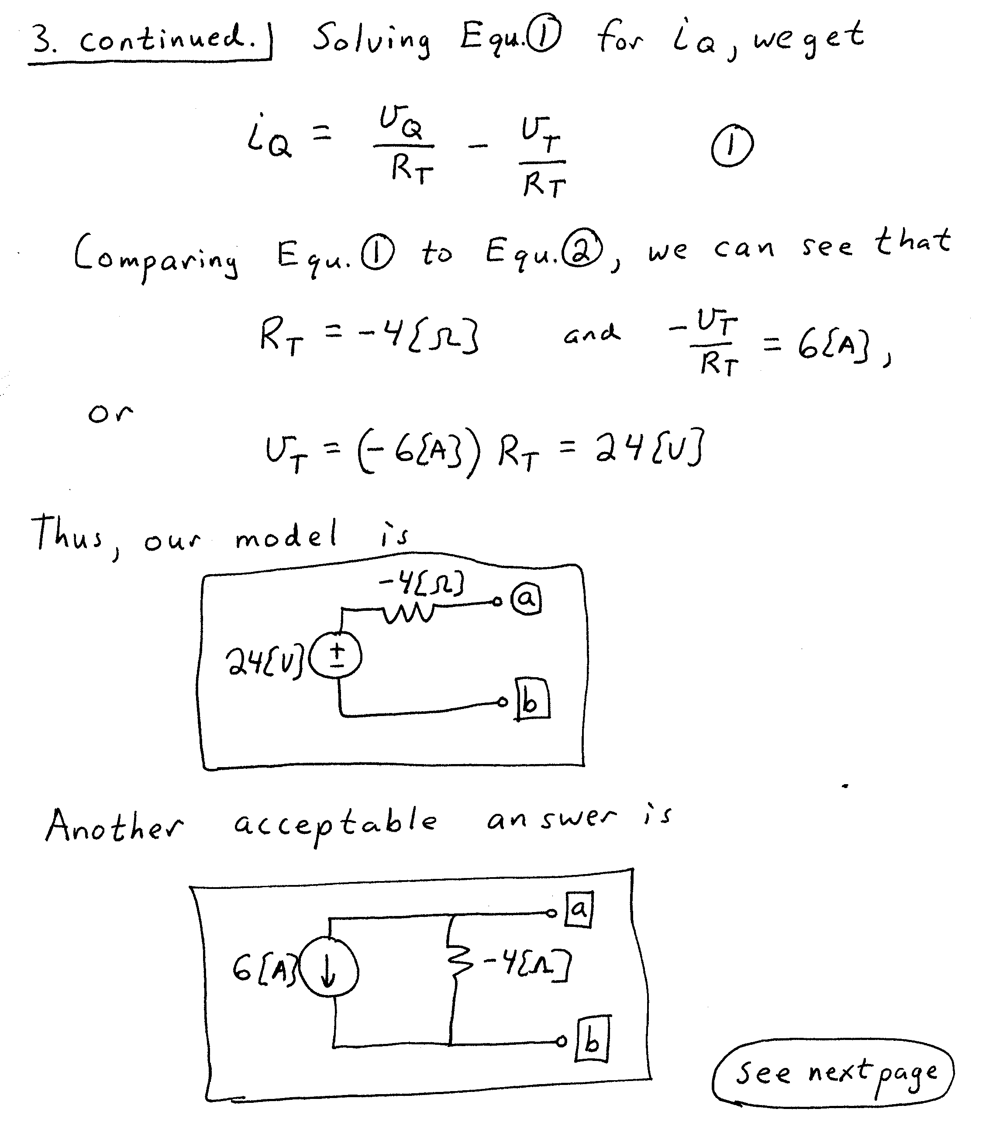
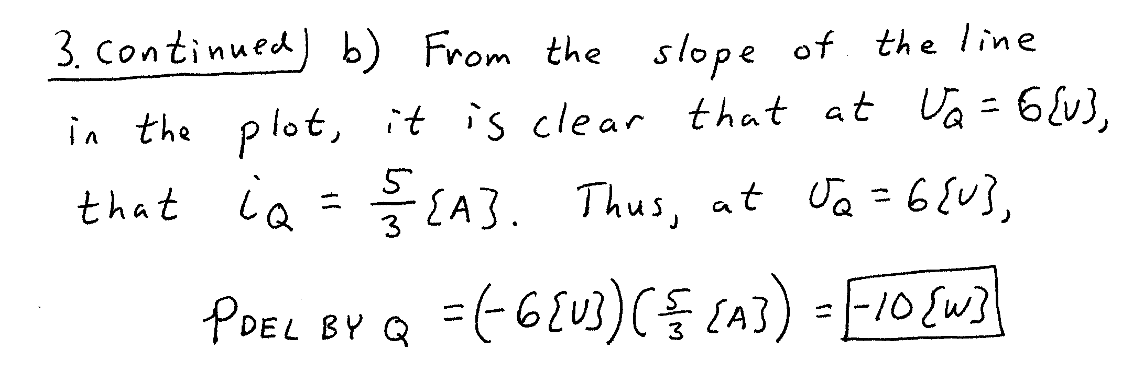

4. {30 Points} It is given that v_{S2} has a positive value. The switch SWA was open and switch SWB was in position a for along time before t = 0. The inductor had 52[nJ] of energy stored in it just before t = 0.
Then switch SWA closed at t = 0. After that, switch SWB moved to position b at t = 1[s]. Finally, switch SWA opened again at t = 2[s].
Find numerical expressions for the current through the inductor, as a function of time, for t > 0.
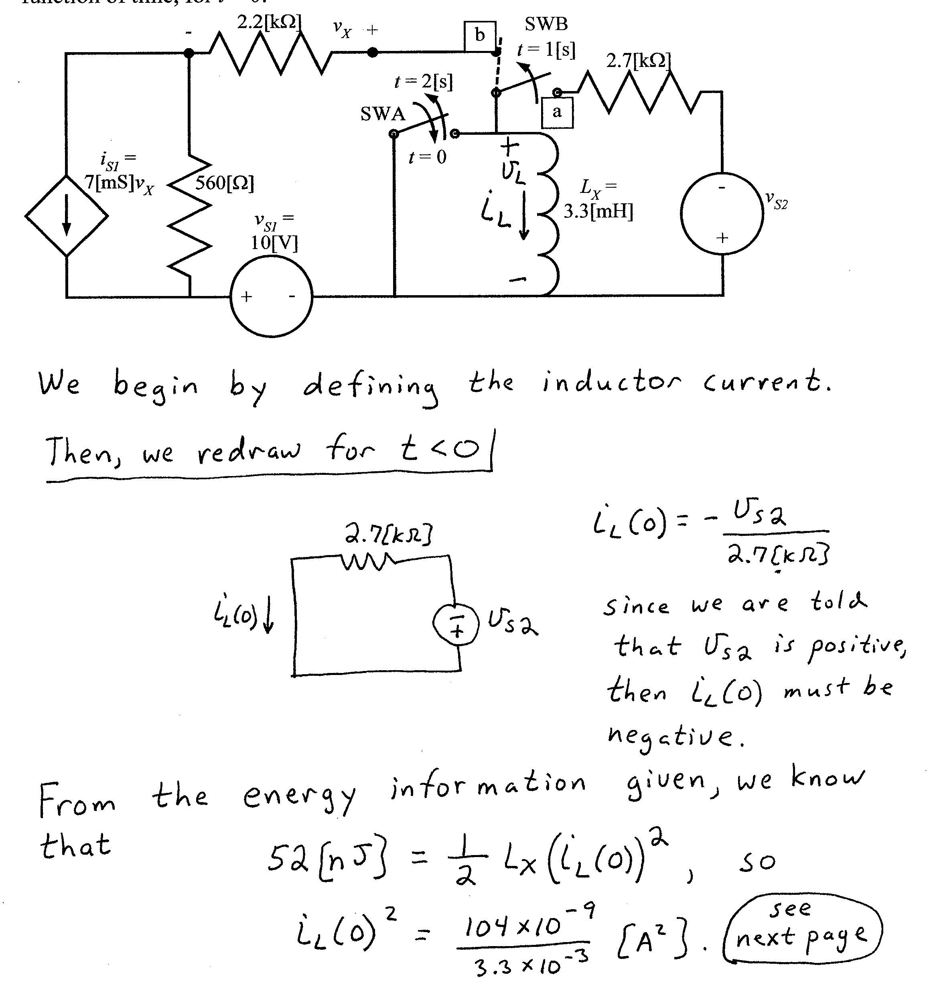
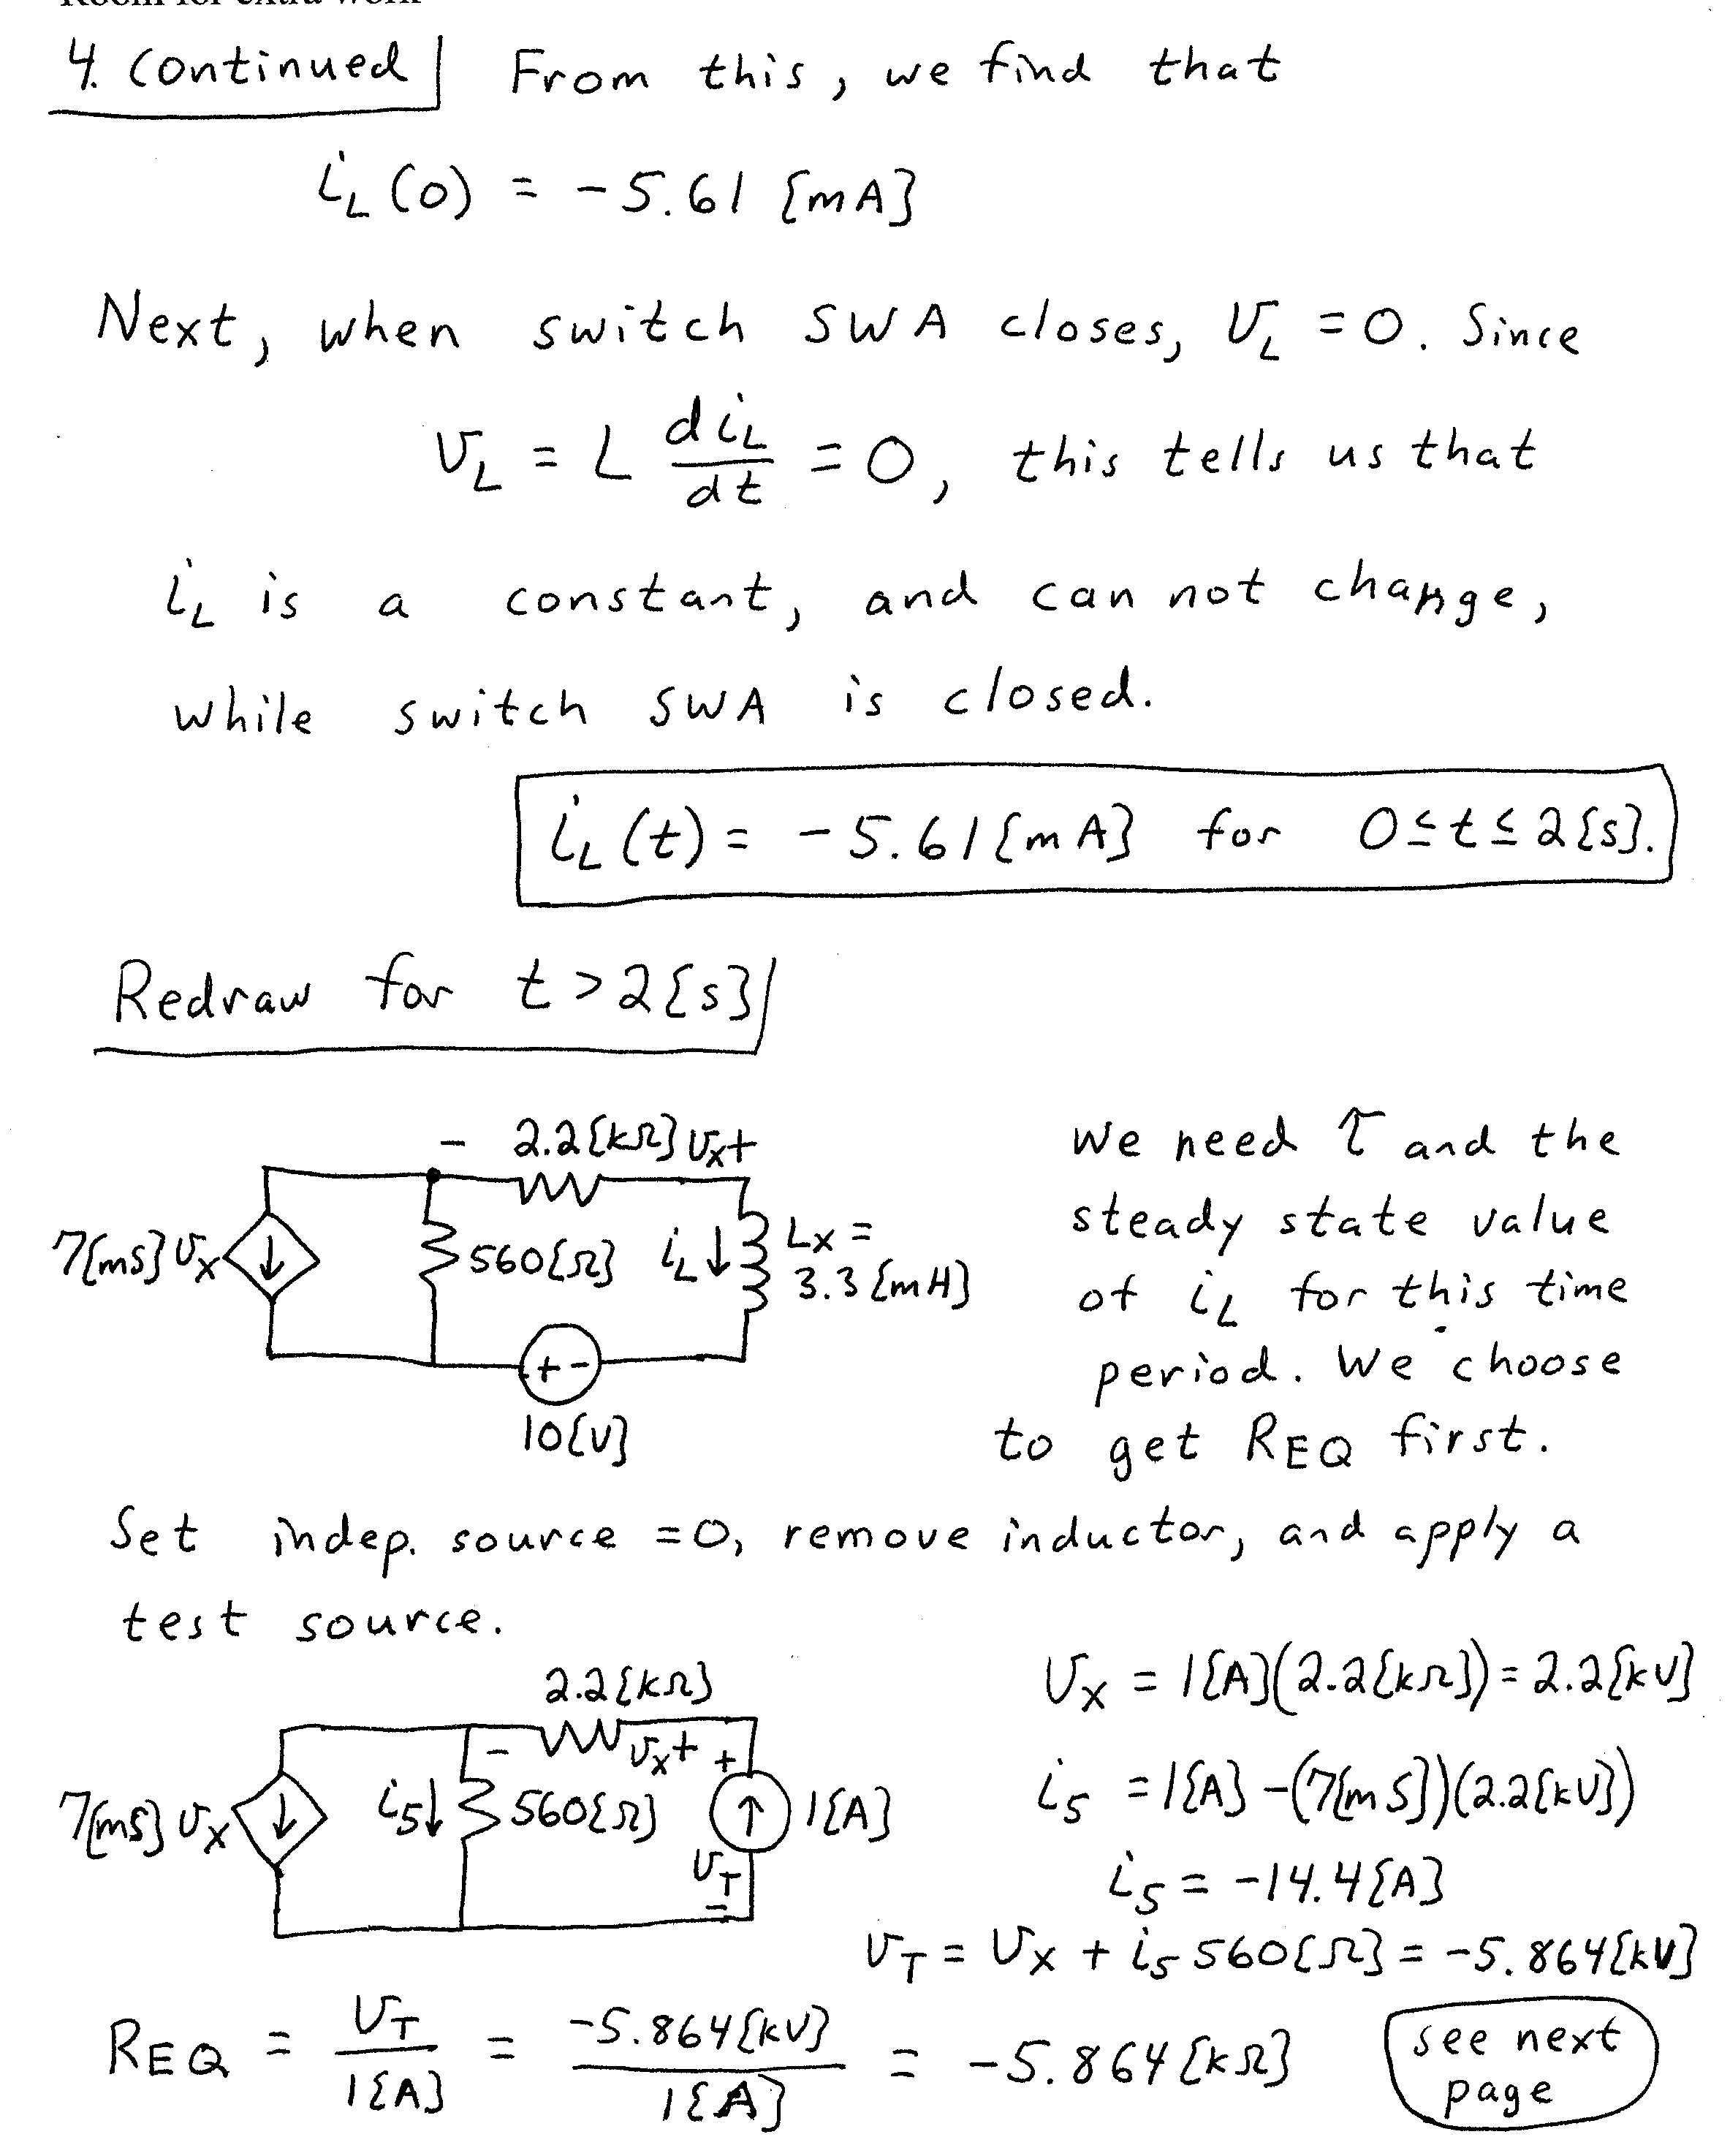
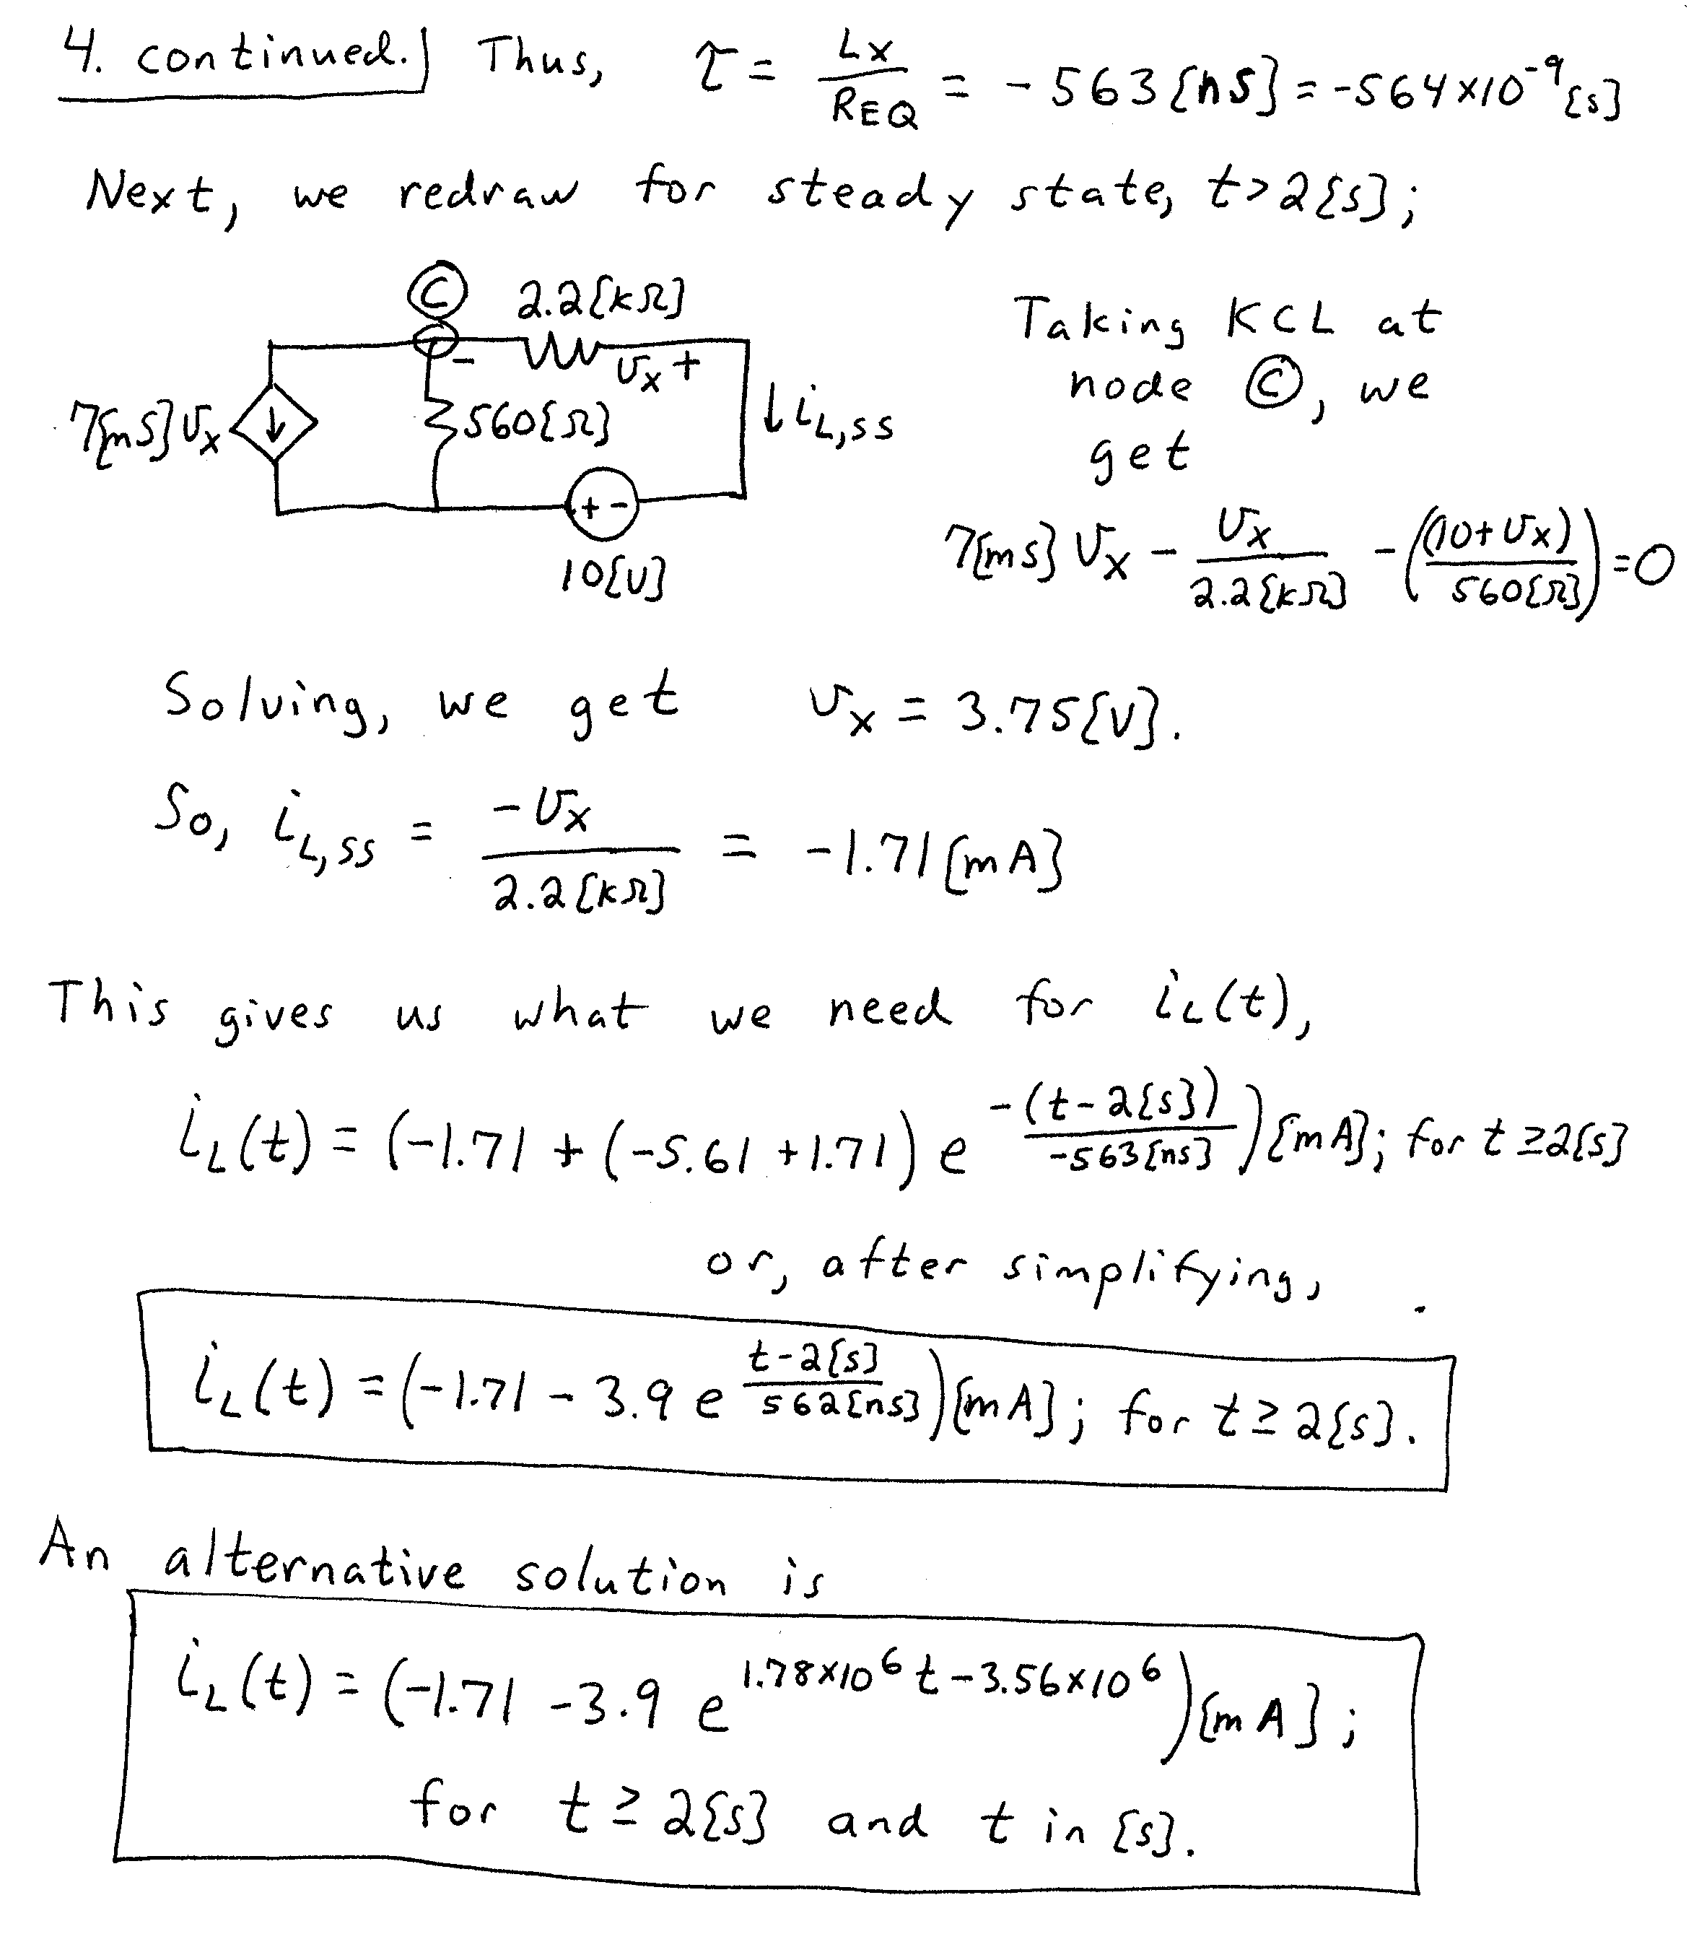

5. {25 Points} It is given that:
- Load L₁ absorbs 5000[W] and delivers 6000[VAR].
- Load L₂ absorbs 4000∠–32°[VA].
- Load L₃ absorbs 9000[VA] at a lagging power factor of 0.5.
- Load L₄ absorbs 2000j[VA].
  - Find the equivalent impedance seen by the voltage source.
  - Find the power factor for this equivalent impedance.
  - Find i_{S}(t).
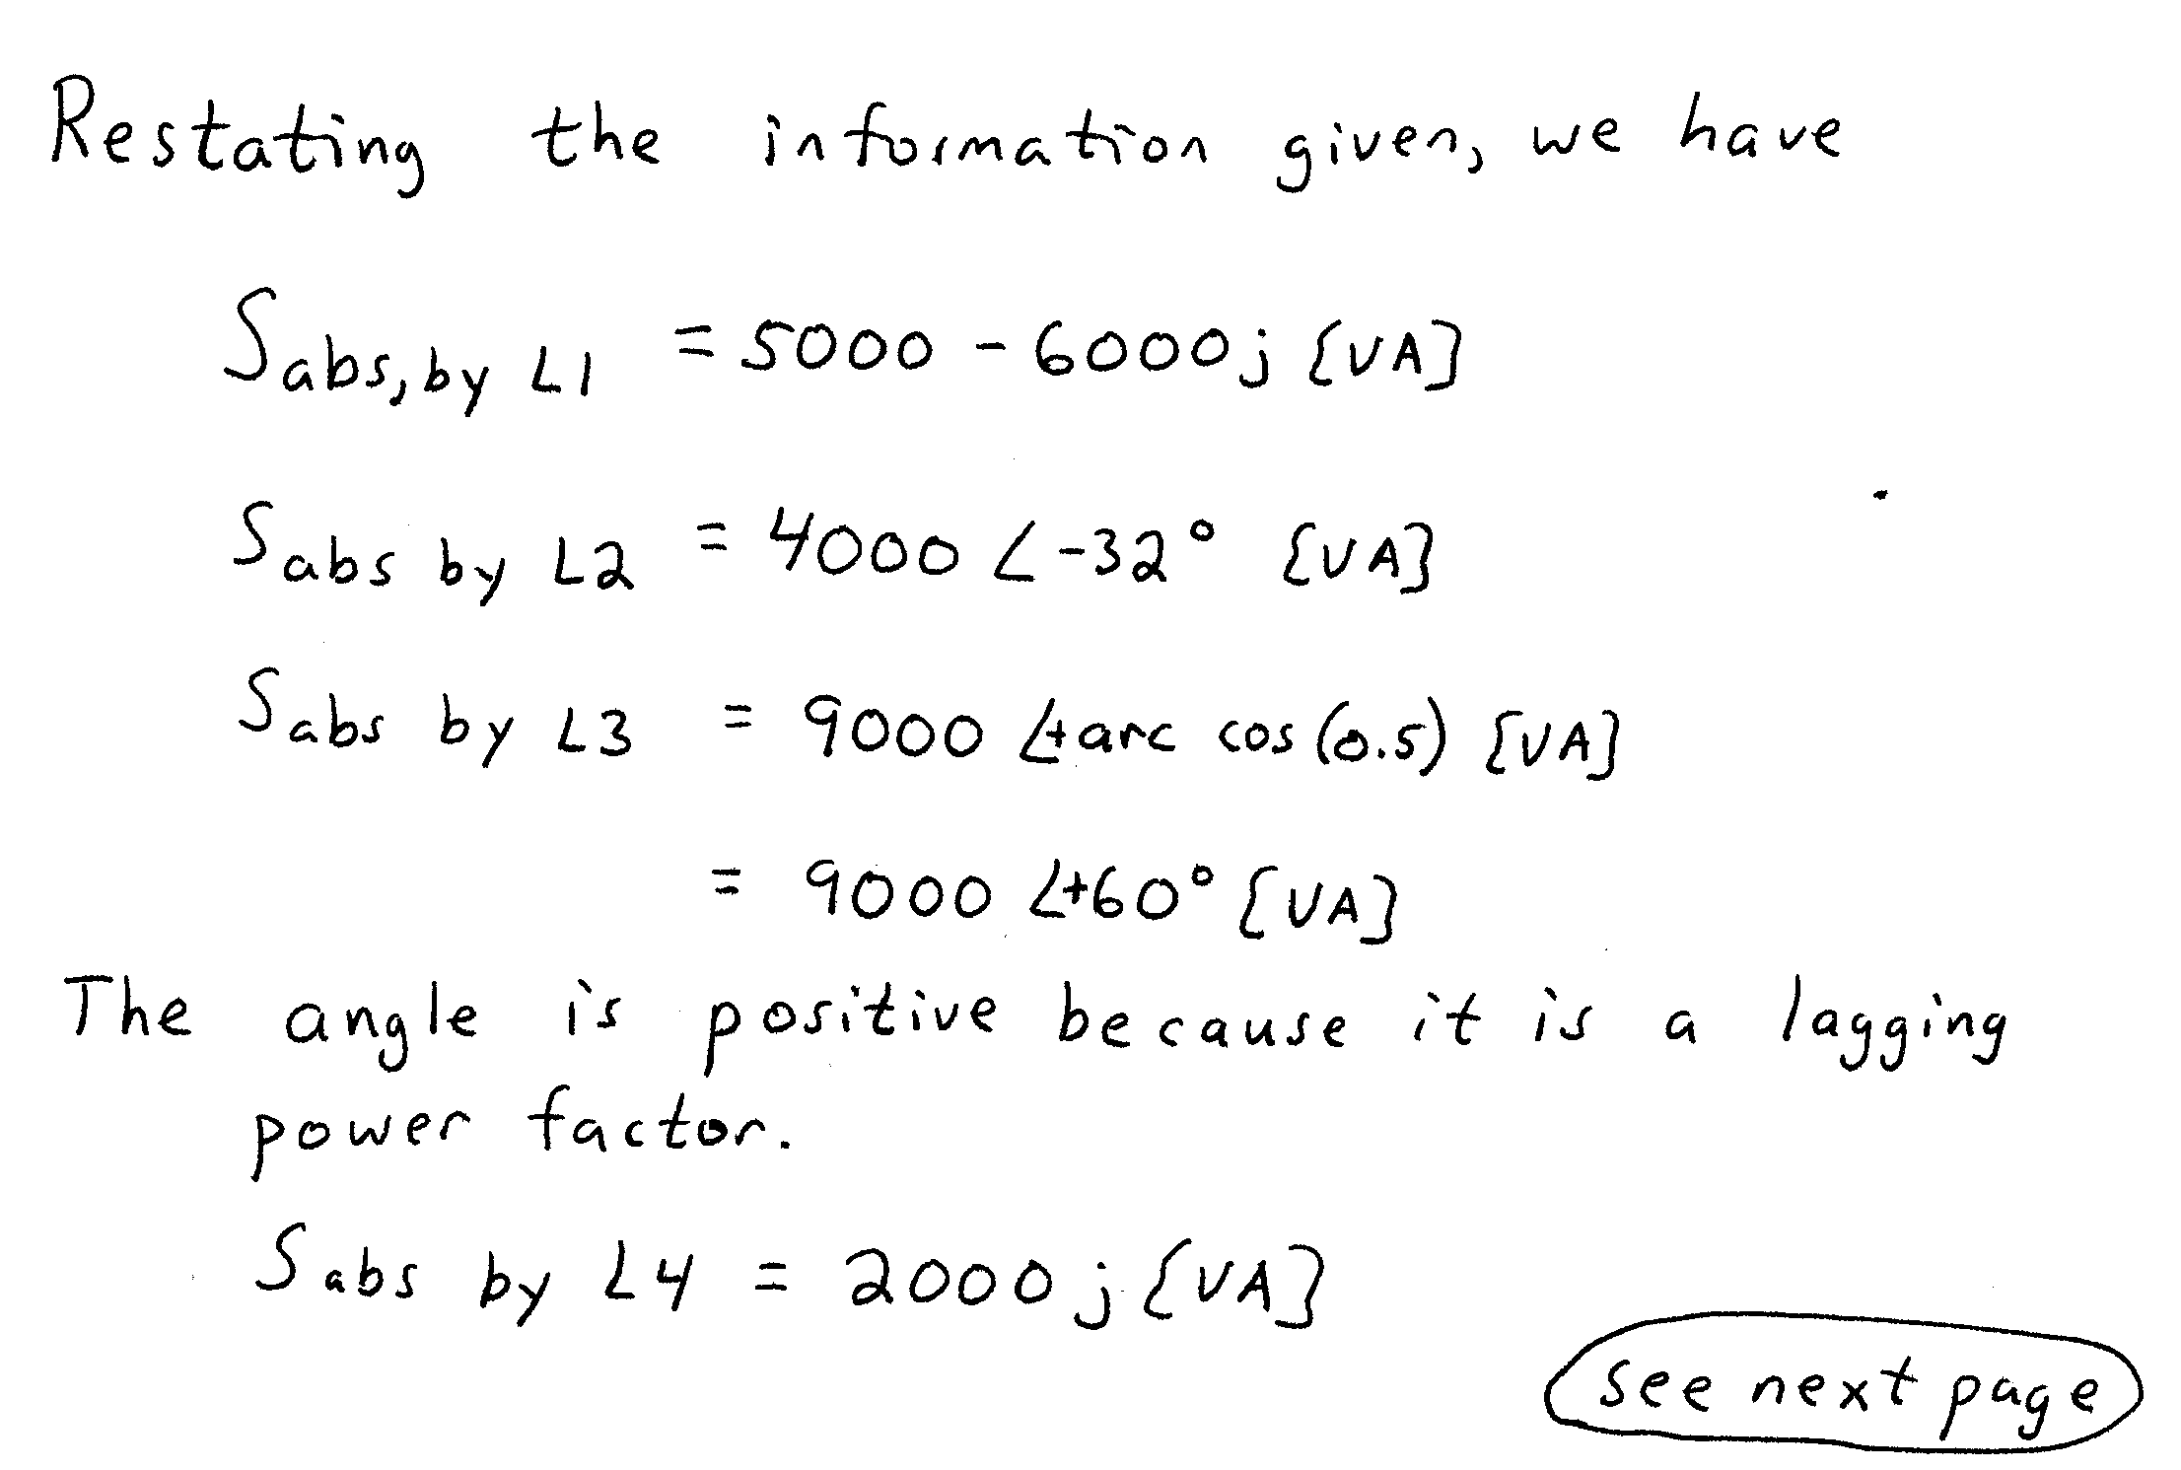
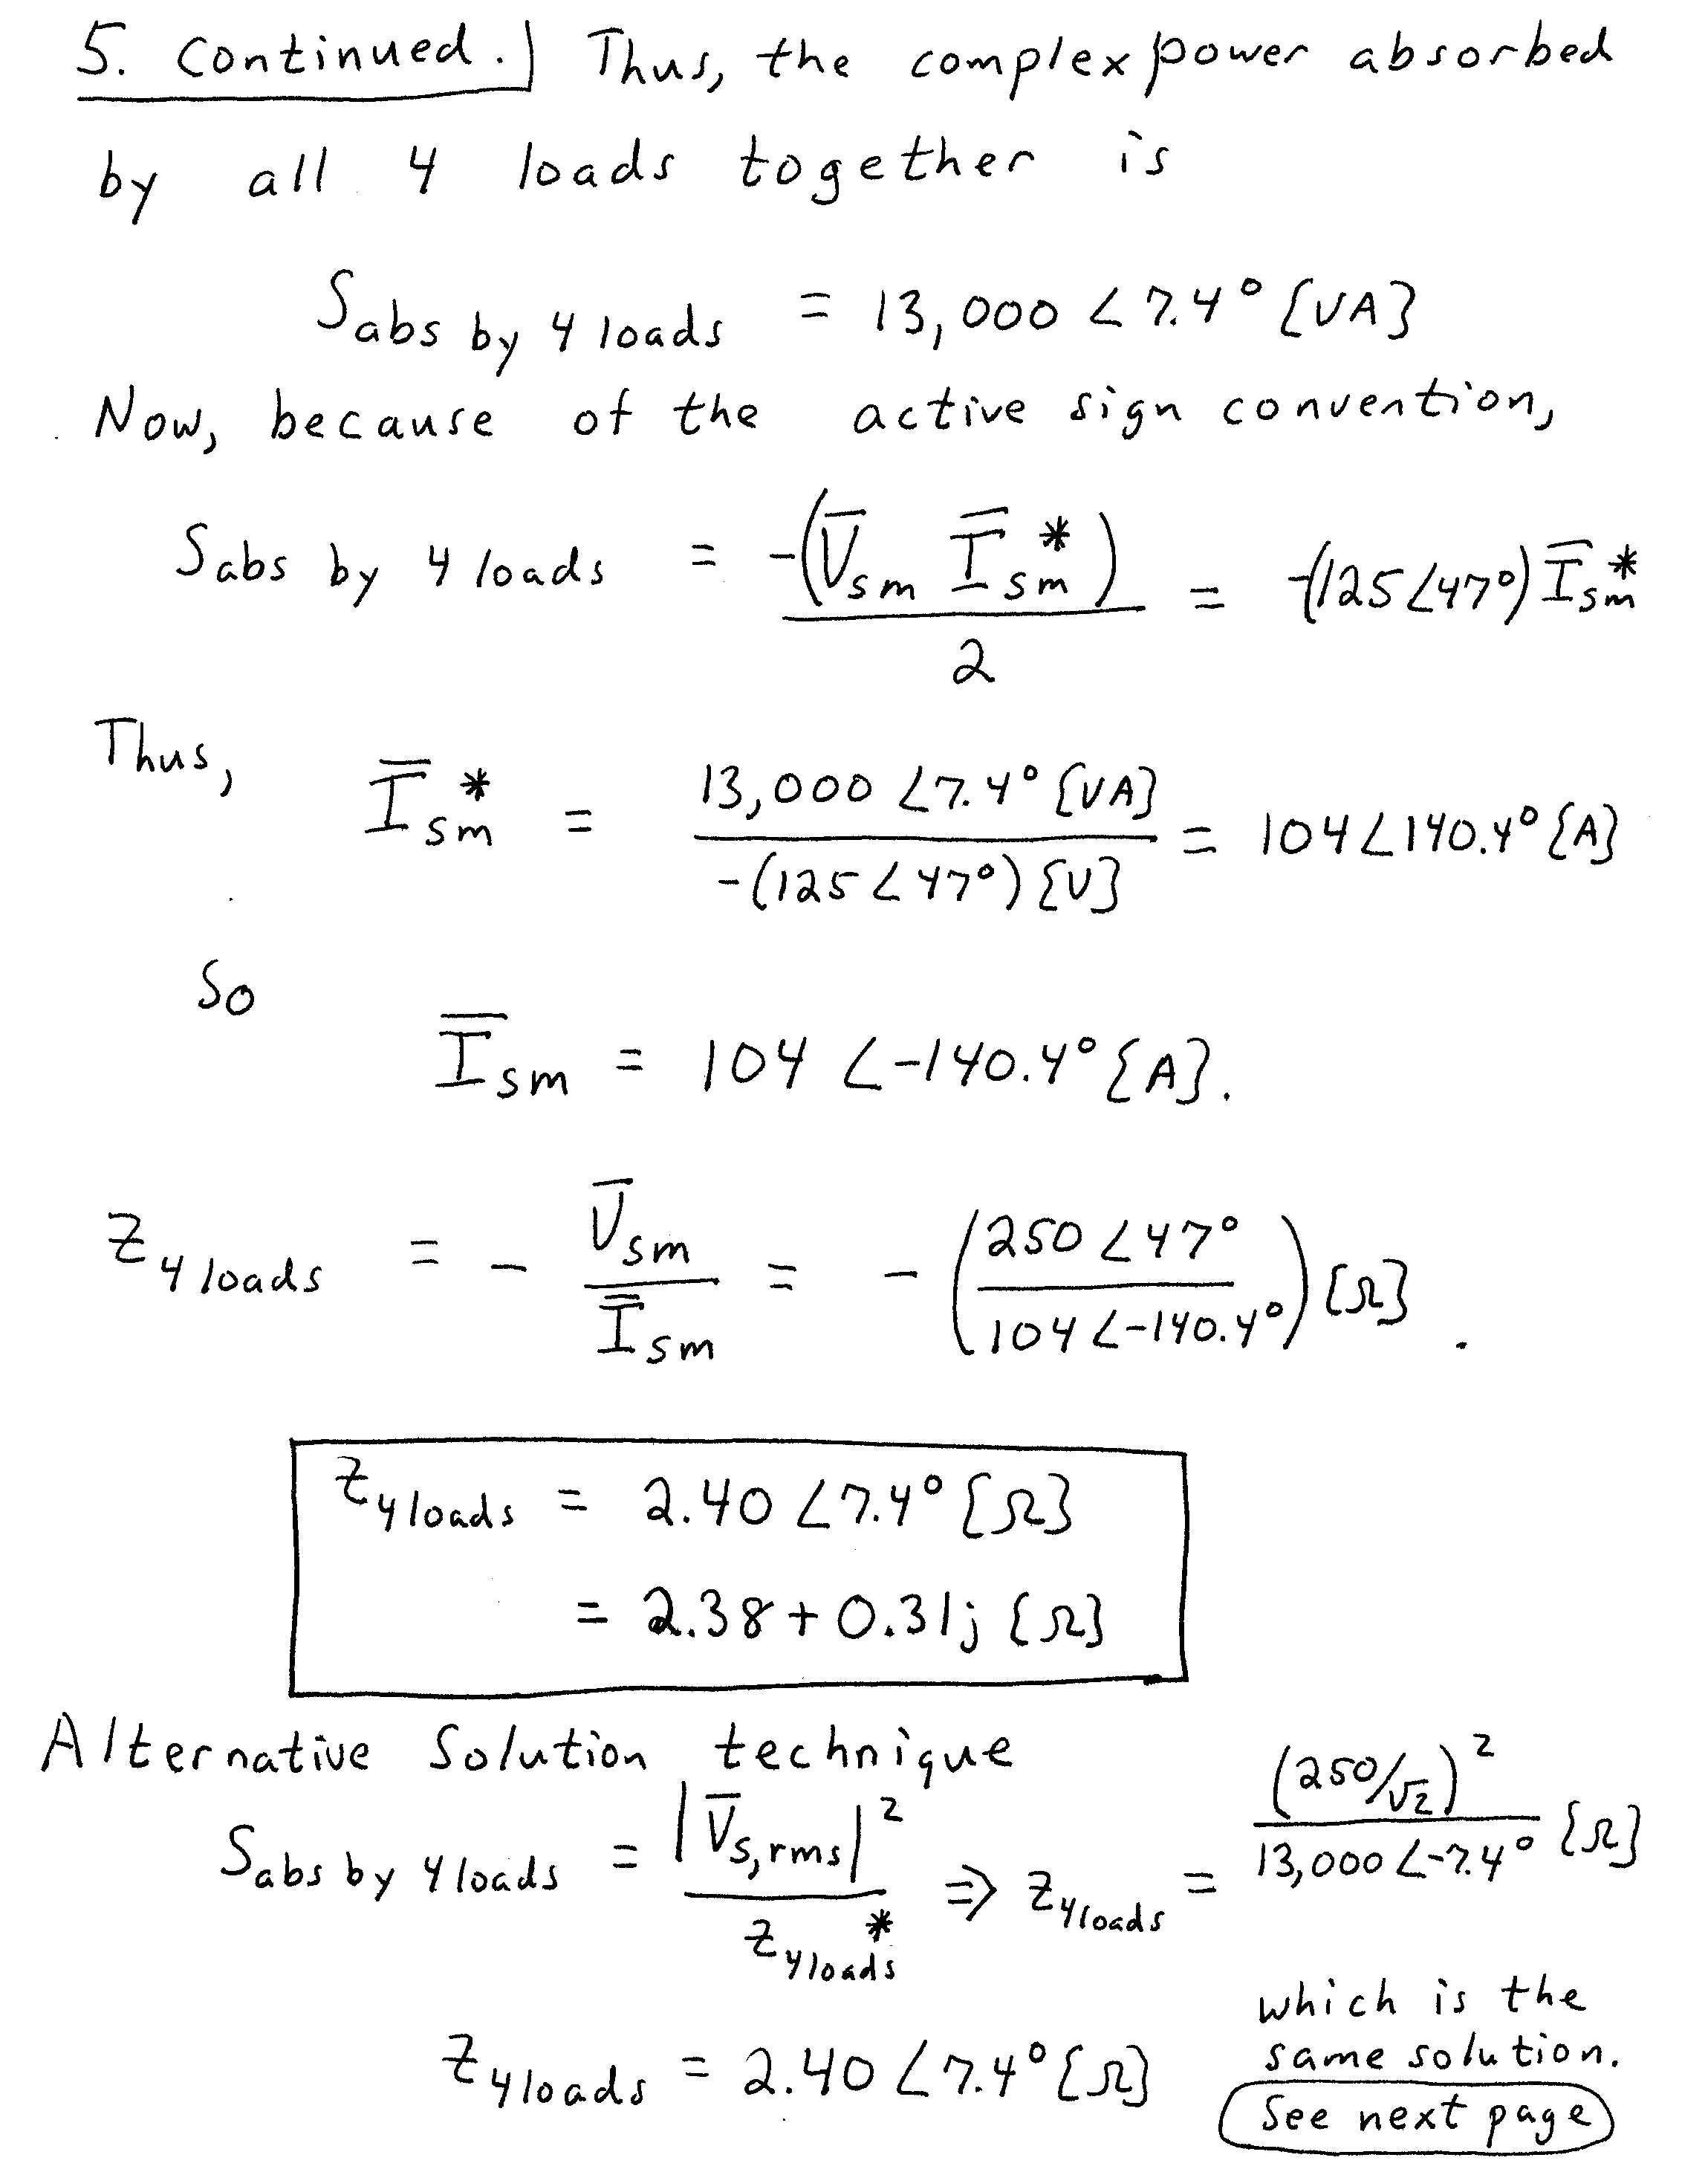
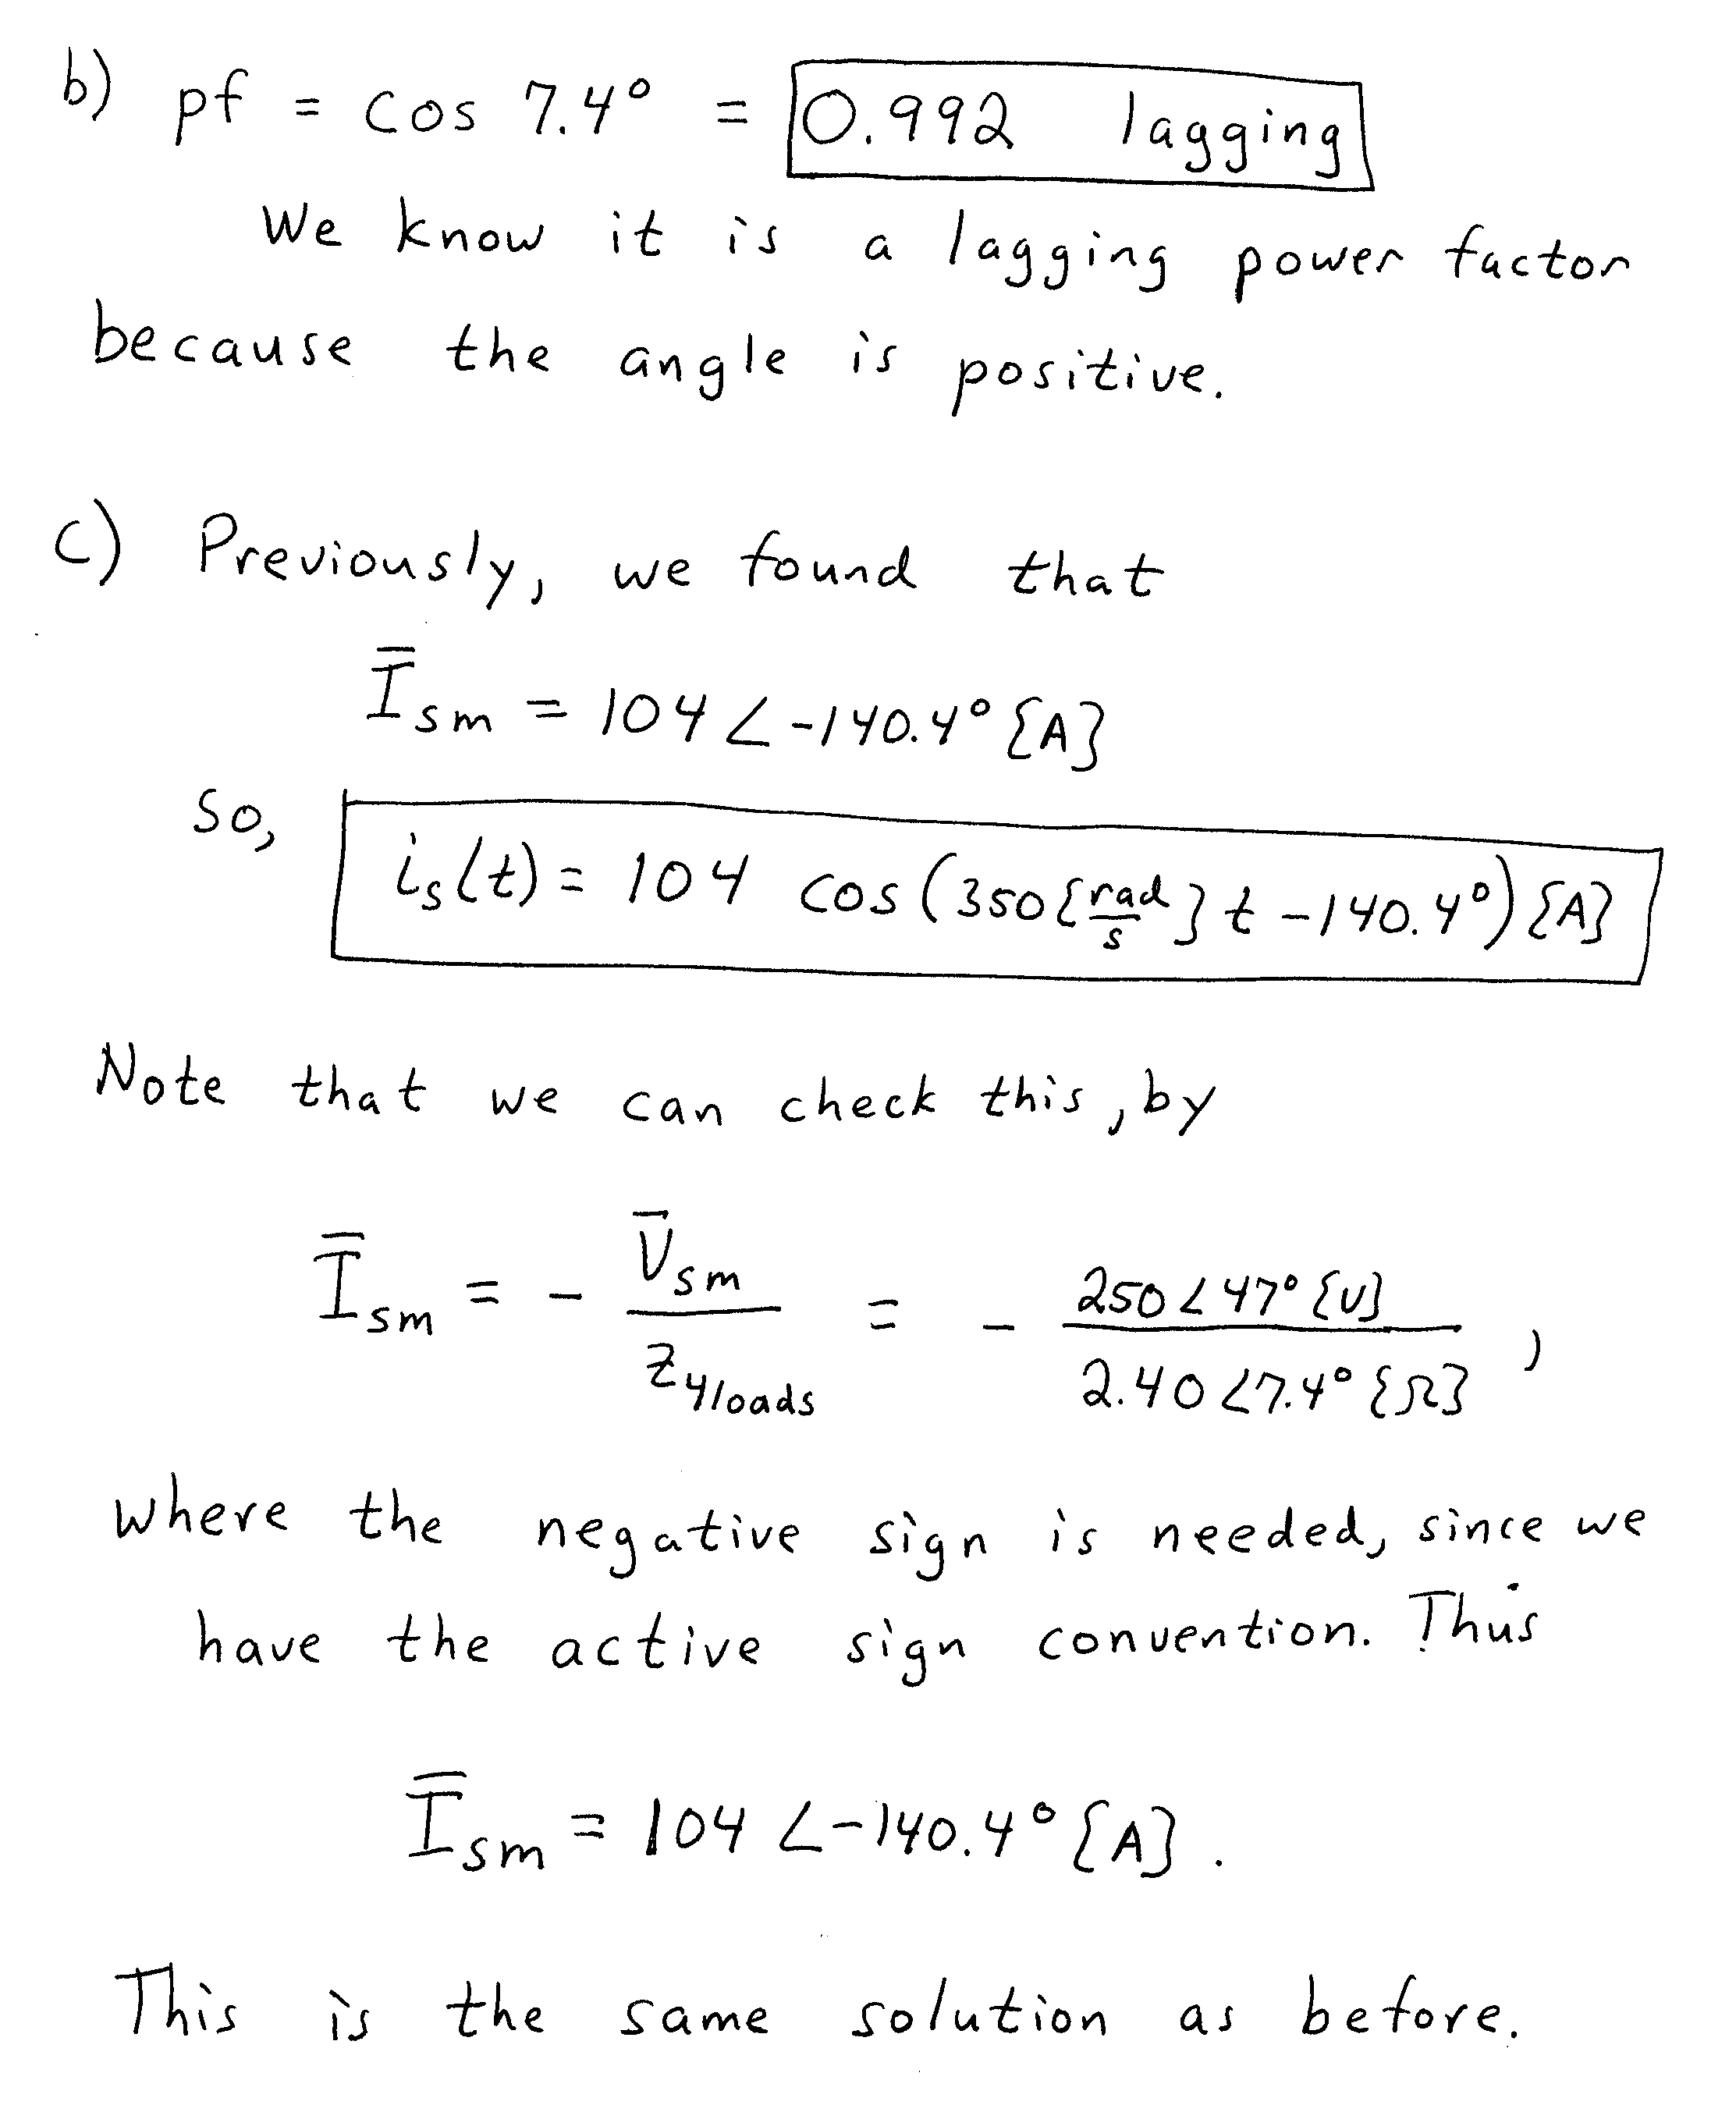

6. {8 Points} The periodic function i_{S}(t) shown in Figure 1 is the value for the current source in Figure 2. Find the average power delivered by this current source in this circuit in Figure 2.


