Name: _____________________________ (please print)
Signature: __________________________

ECE 2300 – Quiz #4 – 1PM Section
October 23, 2007

Keep this quiz closed and face up until you are told to begin.

1. This quiz is closed book, closed notes. You may use one 8.5” x 11” crib sheet, or its equivalent.
2. Show all work on these pages. Show all work necessary to complete the problem. A solution without the appropriate work shown will receive no credit. A solution which is not given in a reasonable order will lose credit.
3. It is assumed that your work will begin on the same page as the problem statement. If you choose to begin your work on another page, you must indicate this on the page with the problem statement, with a clear indication of where the work can be found. If your work continues on to another page, indicate clearly where your work can be found. Failure to indicate this clearly will result in a loss of credit.
4. Show all units in solutions, intermediate results, and figures. Units in the quiz will be included between square brackets.
5. Do not use red ink. Do not use red pencil.
6. You will have 45 minutes to work on this quiz.

________________/20
Room for extra work
For the circuit shown, the resistor R_{X} is adjustable.
- Find the value for R_{X} that will maximize the power delivered by the rest of the circuit, to R_{X}.
- If R_{X} is removed, leaving an open circuit, find the power delivered by the 25[V] voltage source in the circuit that remains.

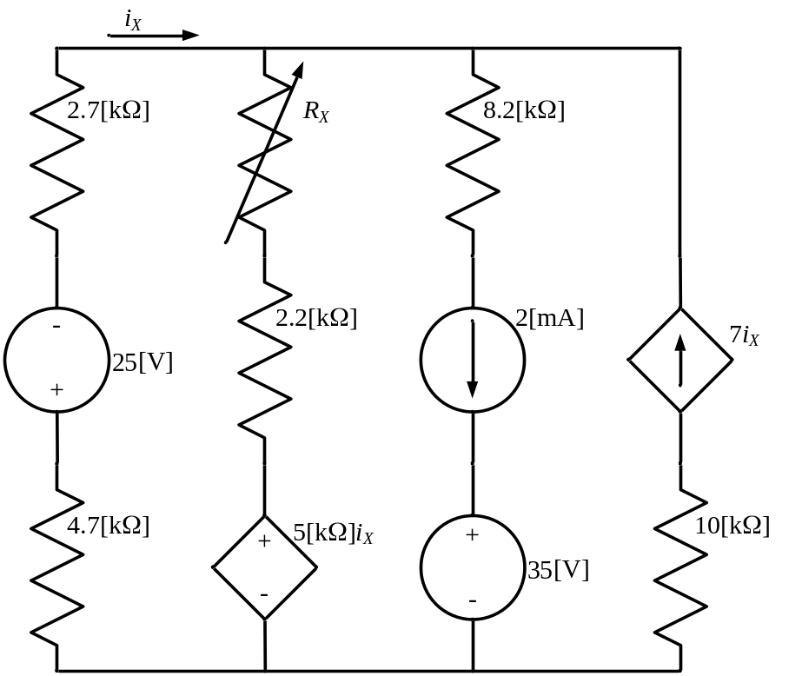

Room for extra work
ECE 2300 -- Quiz #4 – October 23, 2007 – 1PM Section Solution
For the circuit shown, the resistor R_{X} is adjustable.
- Find the value for R_{X} that will maximize the power delivered by the rest of the circuit, to R_{X}.
- If R_{X} is removed, leaving an open circuit, find the power delivered by the 25[V] voltage source in the circuit that remains.
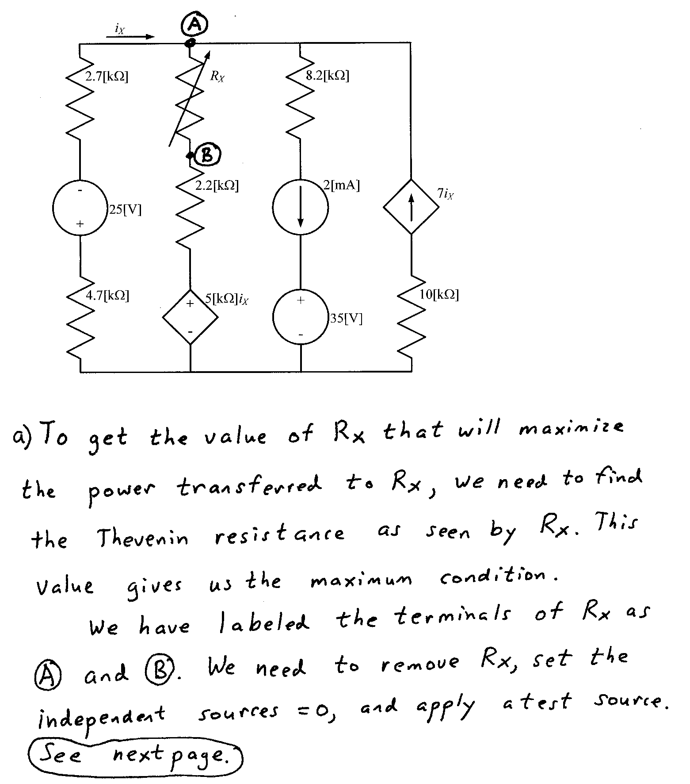
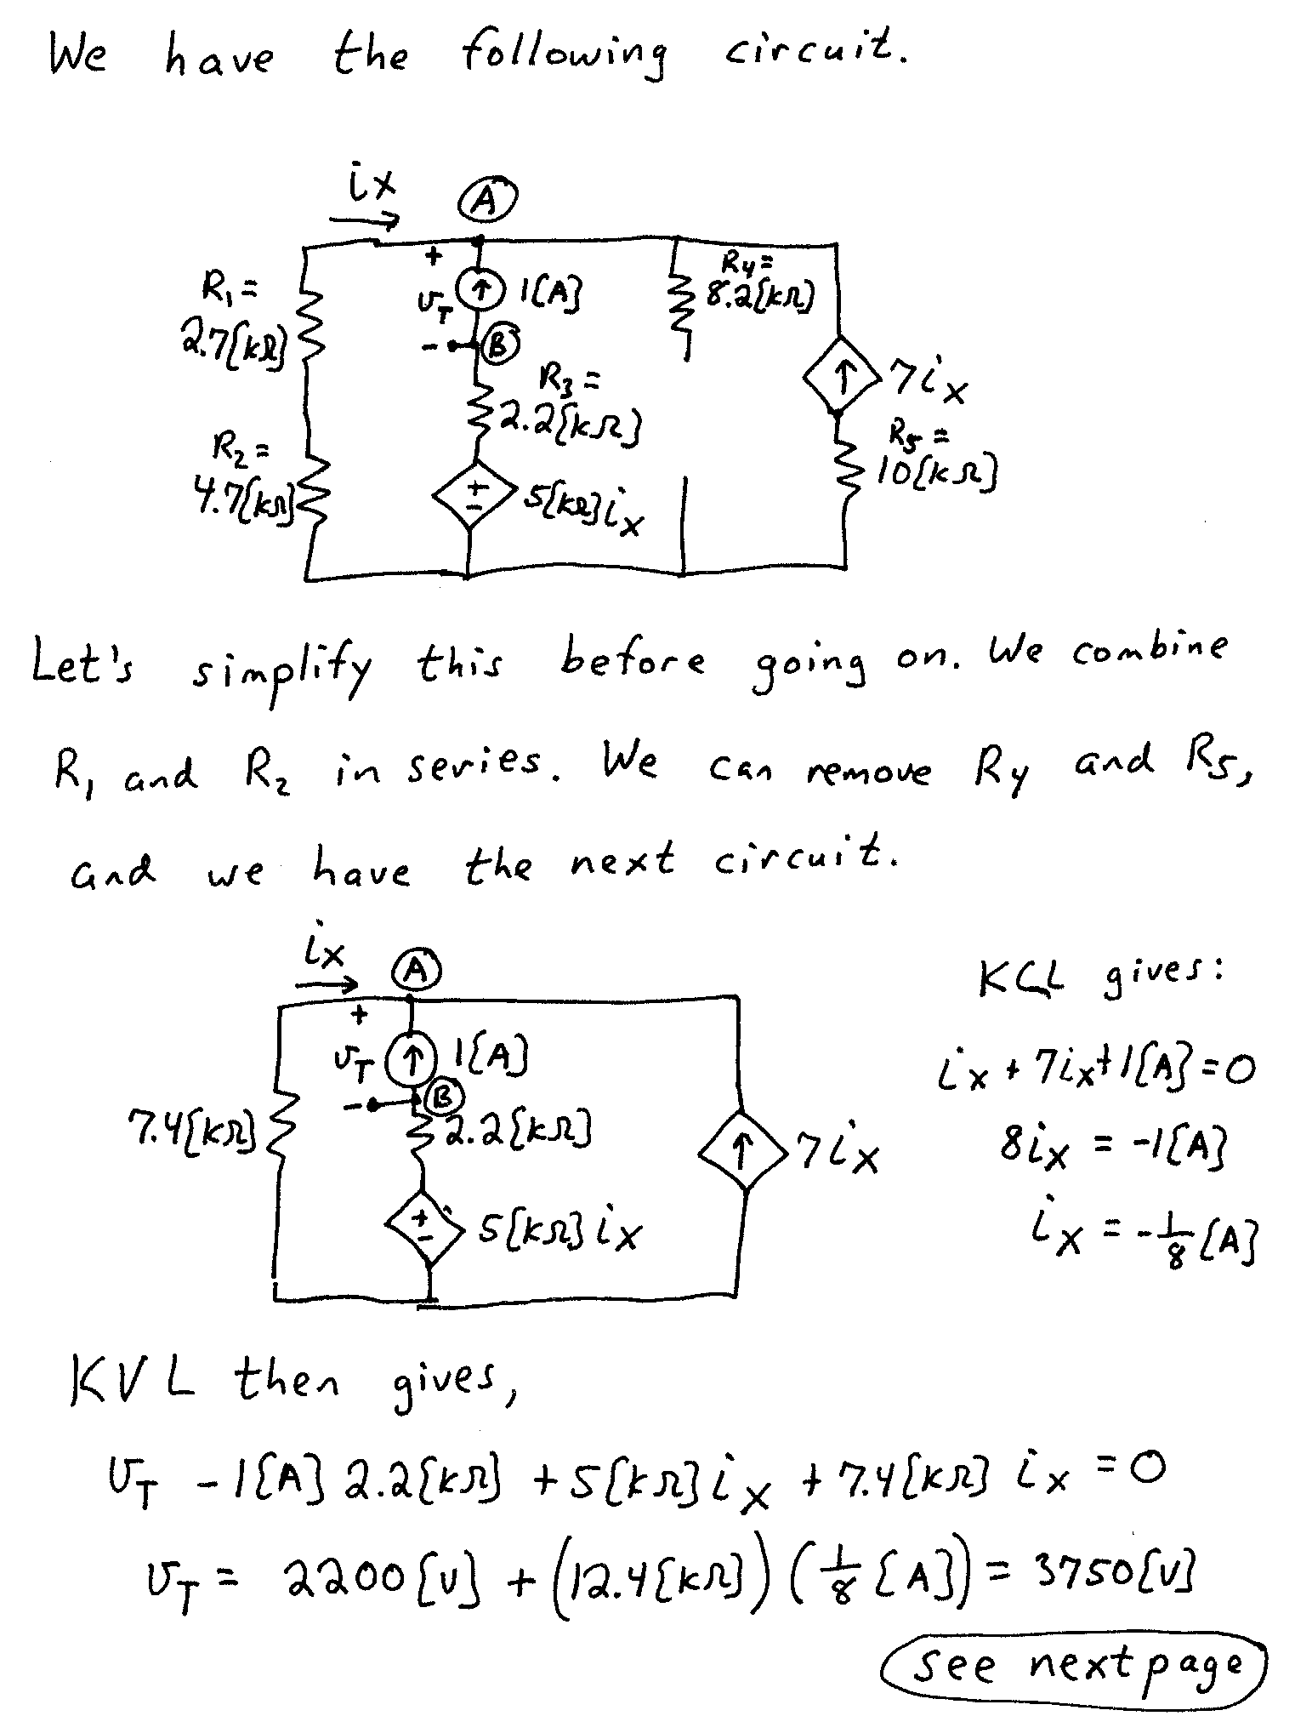
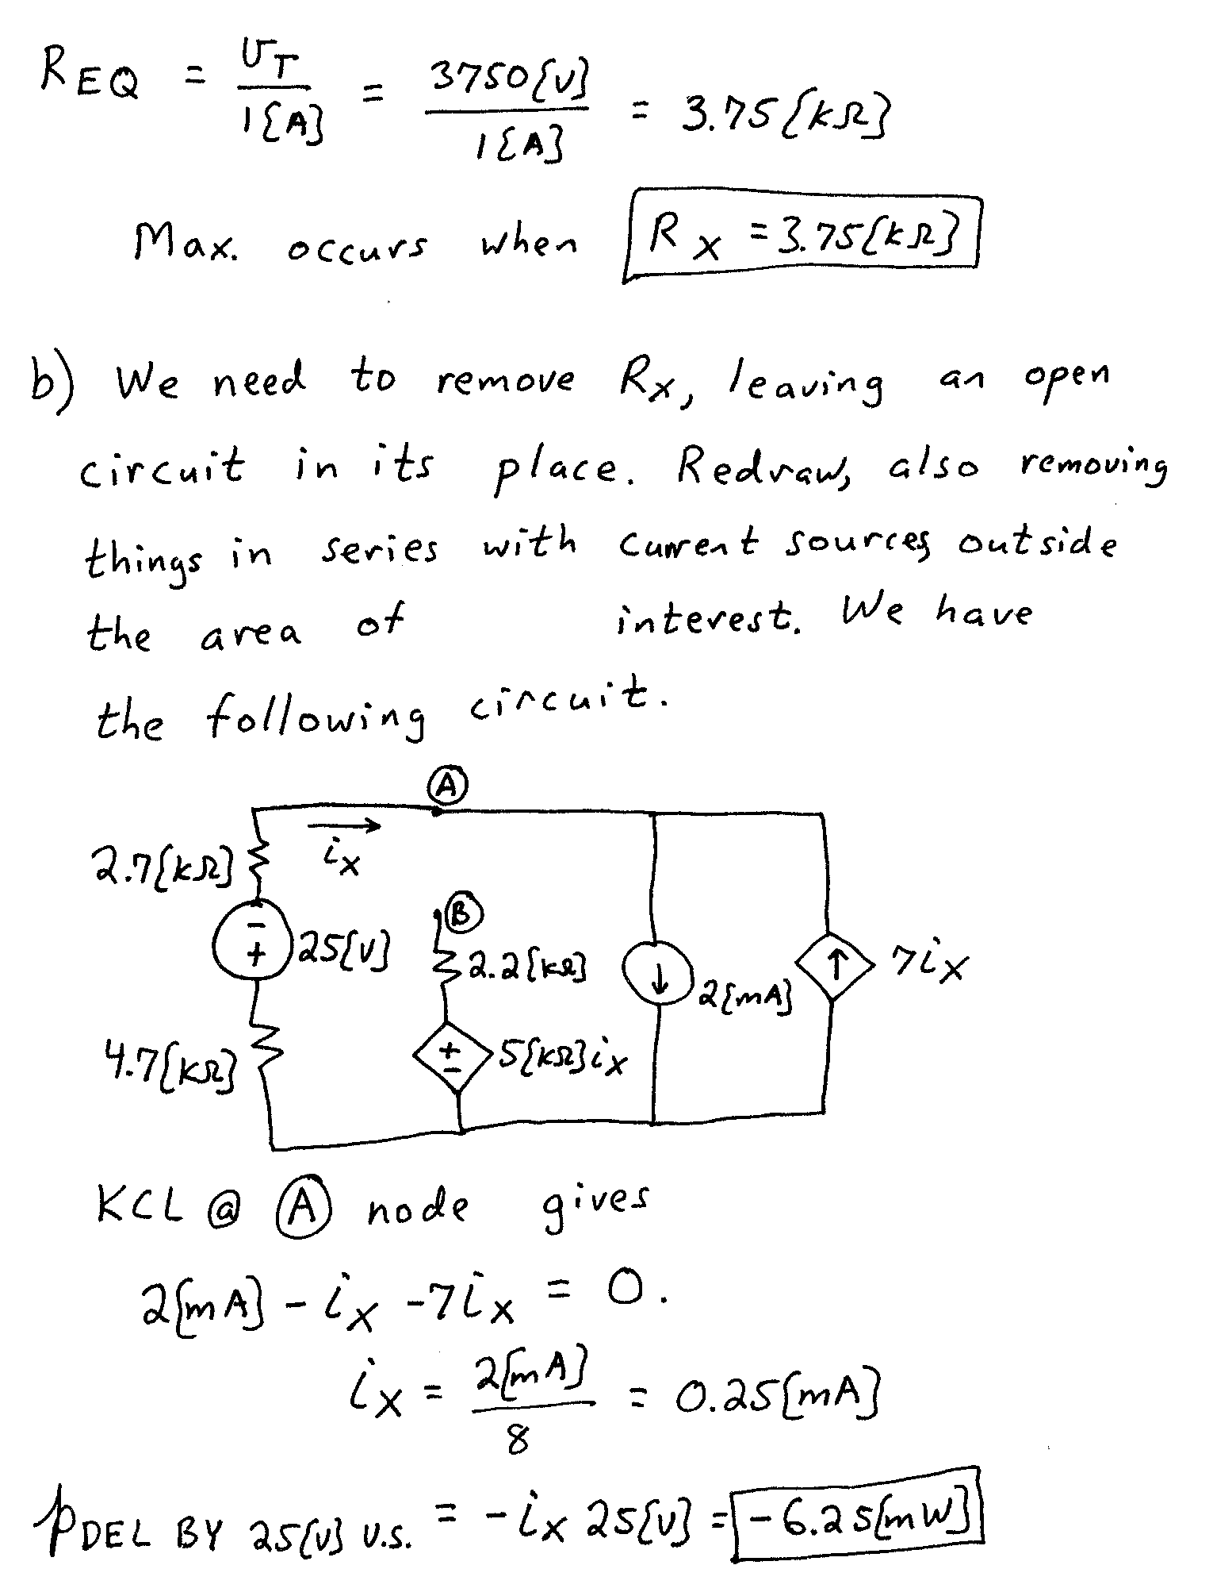

Name: _____________________________ (please print)
Signature: __________________________

ECE 2300 – Quiz #4 – 4PM Section
October 23, 2007

Keep this quiz closed and face up until you are told to begin.

1. This quiz is closed book, closed notes. You may use one 8.5” x 11” crib sheet, or its equivalent.
2. Show all work on these pages. Show all work necessary to complete the problem. A solution without the appropriate work shown will receive no credit. A solution which is not given in a reasonable order will lose credit.
3. It is assumed that your work will begin on the same page as the problem statement. If you choose to begin your work on another page, you must indicate this on the page with the problem statement, with a clear indication of where the work can be found. If your work continues on to another page, indicate clearly where your work can be found. Failure to indicate this clearly will result in a loss of credit.
4. Show all units in solutions, intermediate results, and figures. Units in the quiz will be included between square brackets.
5. Do not use red ink. Do not use red pencil.
6. You will have 45 minutes to work on this quiz.

________________/20
Room for extra work
Use the circuit shown to find the numerical values of the quantities requested.
- Find the Norton equivalent as seen by the i_{S2} current source.
- Find the power delivered by the i_{S2} current source in the circuit shown.

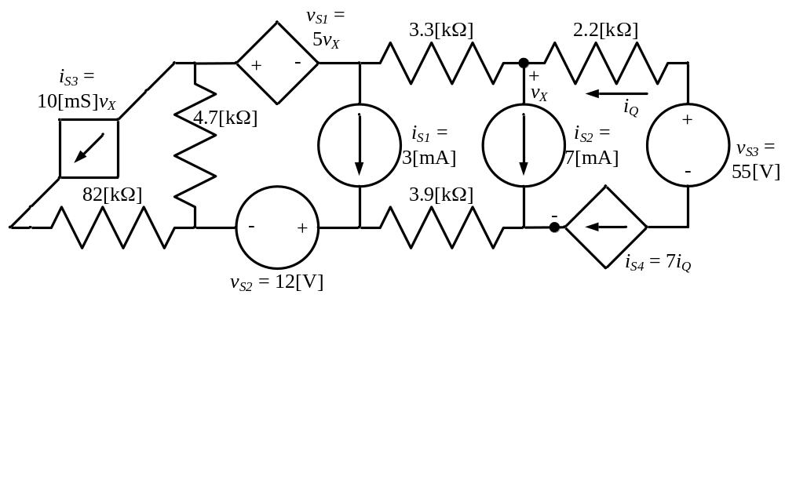

Room for extra work
ECE 2300 -- Quiz #4 – October 23, 2007 – 4PM Section Solution
Use the circuit shown to find the numerical values of the quantities requested.
- Find the Norton equivalent as seen by the i_{S2} current source.
- Find the power delivered by the i_{S2} current source in the circuit shown.


