Name: _____________________________ (please print)
Signature: __________________________

ECE 2300 -- Exam #1
October 9, 2010

Keep this exam closed until you are told to begin.

1. This exam is closed book, closed notes. You may use one 8.5” x 11” crib sheet, or its equivalent.
2. Show all work on these pages. Show all work necessary to complete the problem. A solution without the appropriate work shown will receive no credit. A solution that is not given in a reasonable order will lose credit. Clearly indicate your answer (for example by enclosing it in a box).
3. It is assumed that your work will begin on the same page as the problem statement. If you choose to begin your work on another page, you must indicate this on the page with the problem statement, with a clear indication of where the work can be found. If your work continues on to another page, indicate clearly where your work can be found. Failure to indicate this clearly will result in a loss of credit.
4. Show all units in solutions, intermediate results, and figures. Units in the exam will be included between square brackets.
5. Do not use red ink. Do not use red pencil.
6. You will have 90 minutes to work on this exam.

1. ________________/25
2. ________________/25
3. ________________/25
4. ________________/25
Total = 100
Room for extra work
1. {25 Points} A device can be modeled as a voltage source in series with a resistance. The device is shown in Figure 1. The characteristics of the device are given in terms of the relationship between the voltage across the device, and the current through the device, as shown in Figure 2.
Connect the device to the circuit in Figure 3, connecting terminal A to node C, and terminal B to node D. For this circuit with the device attached, find the power delivered by the 8[V] voltage source.

Room for extra work

2. {25 Points} Use the circuit shown in Figure 1 to solve this problem.
a) Find the voltage at point A with respect to point B, (v_{AB}).
b) If a resistor R_{X} is connected in parallel with the 5[Ω] resistor in the circuit, the voltage v_{AB} becomes equal to zero. Find the value of the R_{X}.
c) Find the energy absorbed by this R_{X} resistor after t = 10 [seconds].

Room for extra work

3. {25 Points} A d’Arsonval meter with rated values of 100[V] and 1[A] is connected to the combination of resistors as shown in Figure 1. The values of
R₁ = 5[Ω], and R₂ = 10[Ω].
a) Find the extended (maximum) range of the voltmeter at terminals A and B.
b) If the meter is connected to the circuit in Figure 2 to measure the voltage v_{X}, find the relative error of this measurement. In other words, find the percent error in v_{X} of what is measured, as compared to the voltage present without the meter.
c) If the resistor R₂ in this meter is shorted, find the extended (maximum) range of this meter at terminals A and B.
d) Find the relative error of the measurement if this modified meter is connected to the circuit in Figure 2 to measure v_{X}.

Room for extra work

4. {25 Points} For the given circuit, use the Node-Voltage method to write a complete set of independent equations that could be used to solve this circuit. Do not simplify the circuit. Do not attempt to solve or simplify your equations. Define all variables.

Solutions:
1. {25 Points} A device can be modeled as a voltage source in series with a resistance. The device is shown in Figure 1. The characteristics of the device are given in terms of the relationship between the voltage across the device, and the current through the device, as shown in Figure 2.
Connect the device to the circuit in Figure 3, connecting terminal A to node C, and terminal B to node D. For this circuit with the device attached, find the power delivered by the 8[V] voltage source.
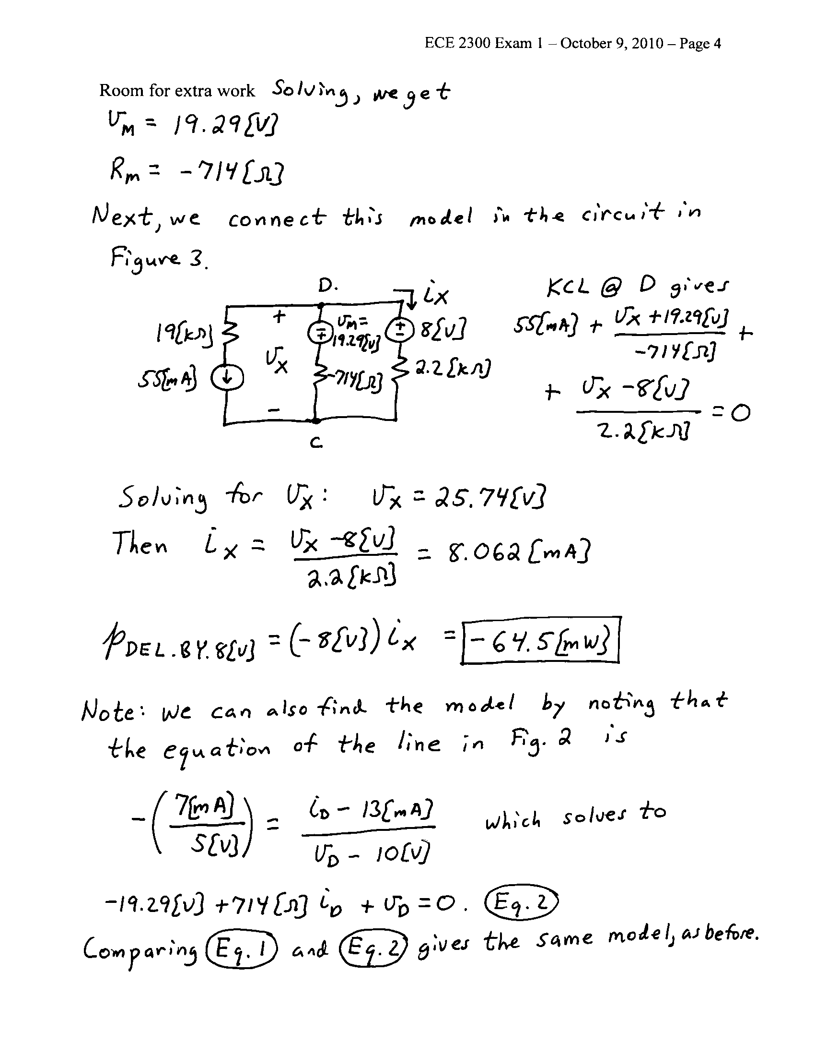

2. {25 Points} Use the circuit shown in Figure 1 to solve this problem.
a) Find the voltage at point A with respect to point B, (v_{AB}).
b) If a resistor R_{X} is connected in parallel with the 5[Ω] resistor in the circuit, the voltage v_{AB} becomes equal to zero. Find the value of the R_{X}.
c) Find the energy absorbed by this R_{X} resistor after t = 10 [seconds].
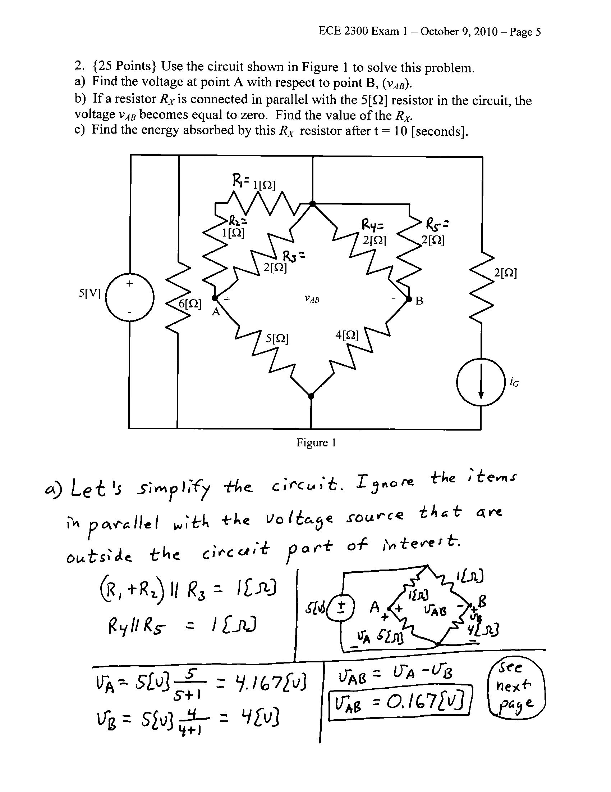
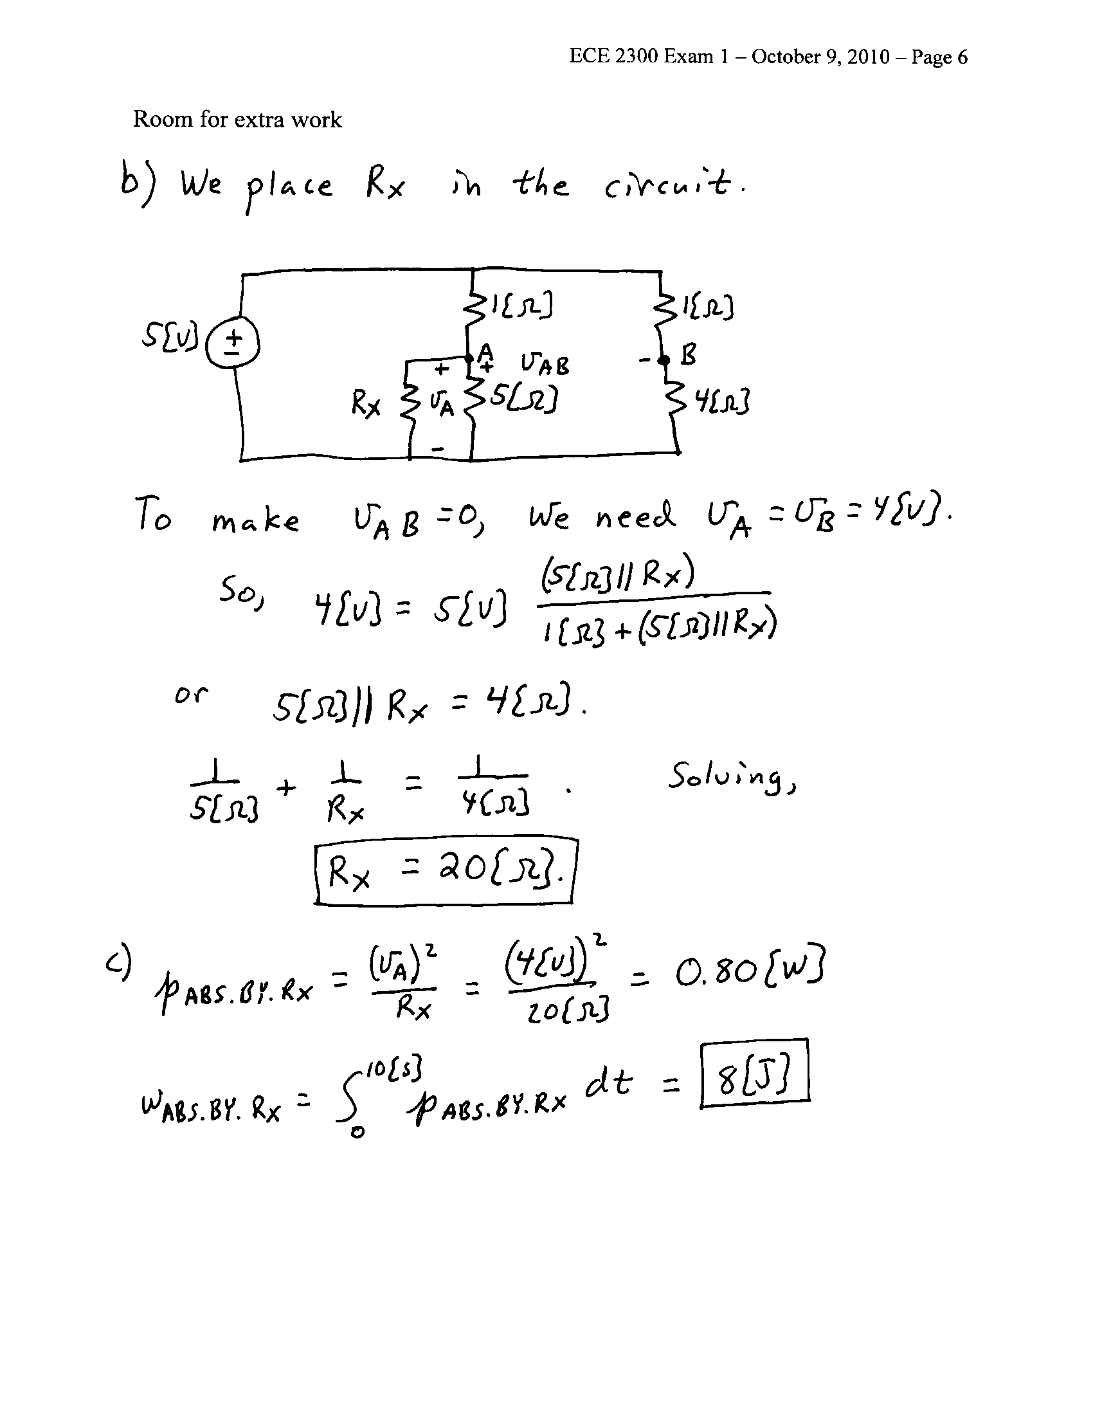

3. {25 Points} A d’Arsonval meter with rated values of 100[V] and 1[A] is connected to the combination of resistors as shown in Figure 1. The values of
R₁ = 5[Ω], and R₂ = 10[Ω].
a) Find the extended (maximum) range of the voltmeter at terminals A and B.
b) If the meter is connected to the circuit in Figure 2 to measure the voltage v_{X}, find the relative error of this measurement. In other words, find the percent error in v_{X} of what is measured, as compared to the voltage present without the meter.
c) If the resistor R₂ in this meter is shorted, find the extended (maximum) range of this meter at terminals A and B.
d) Find the relative error of the measurement if this modified meter is connected to the circuit in Figure 2 to measure v_{X}.
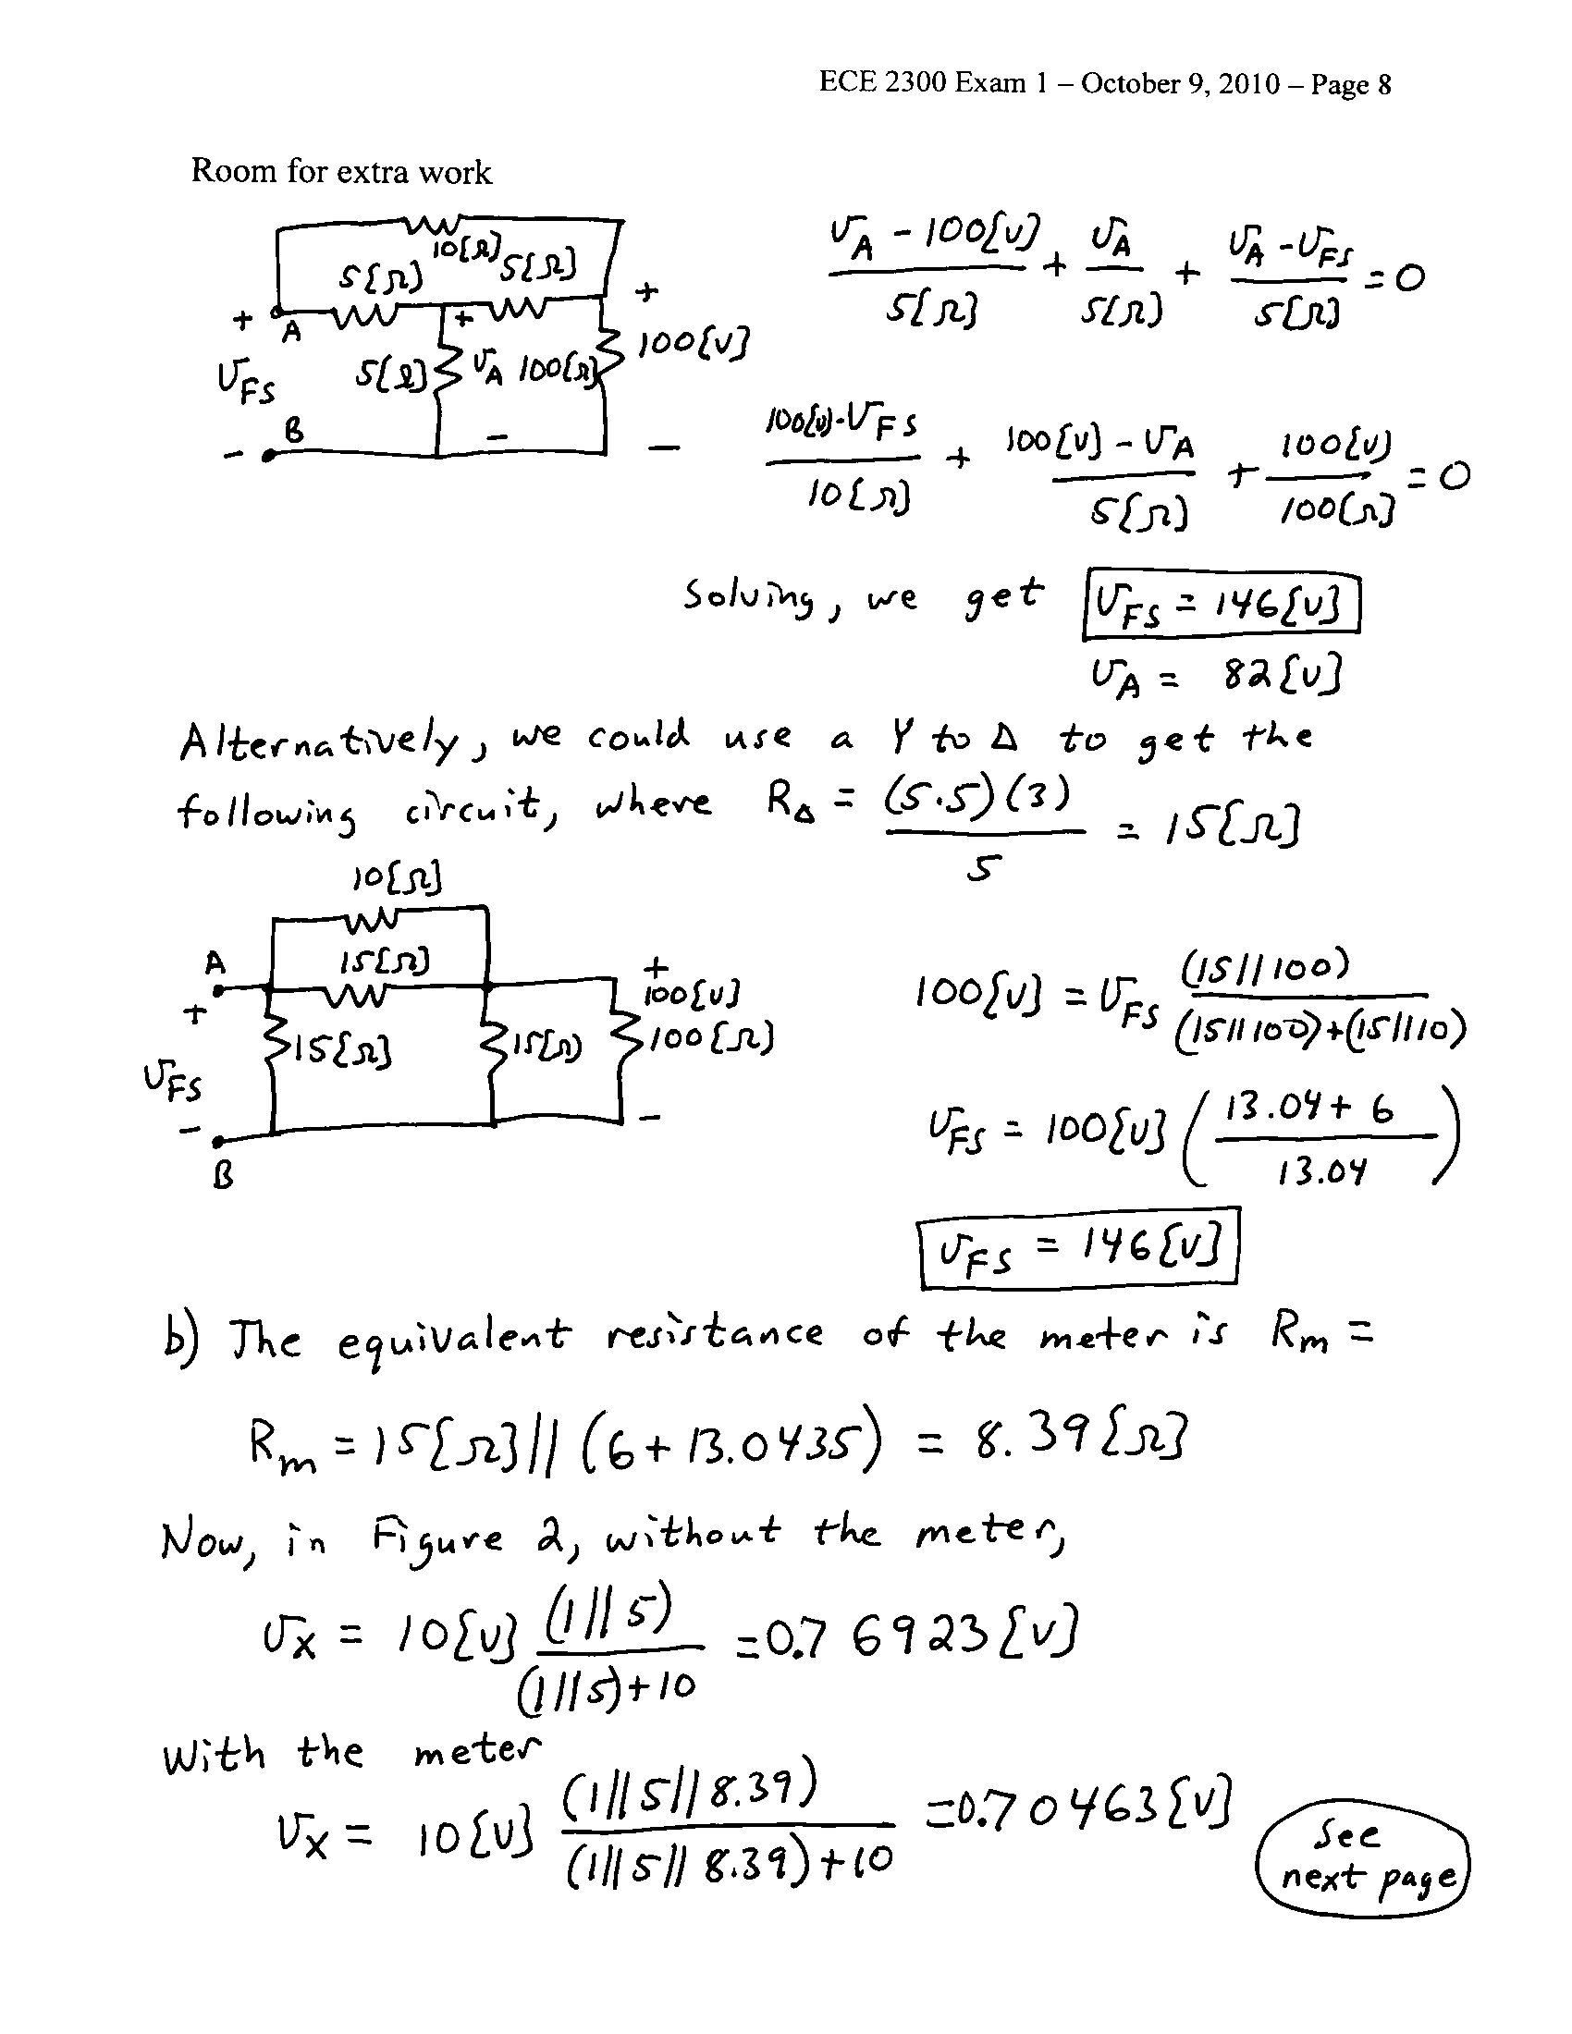
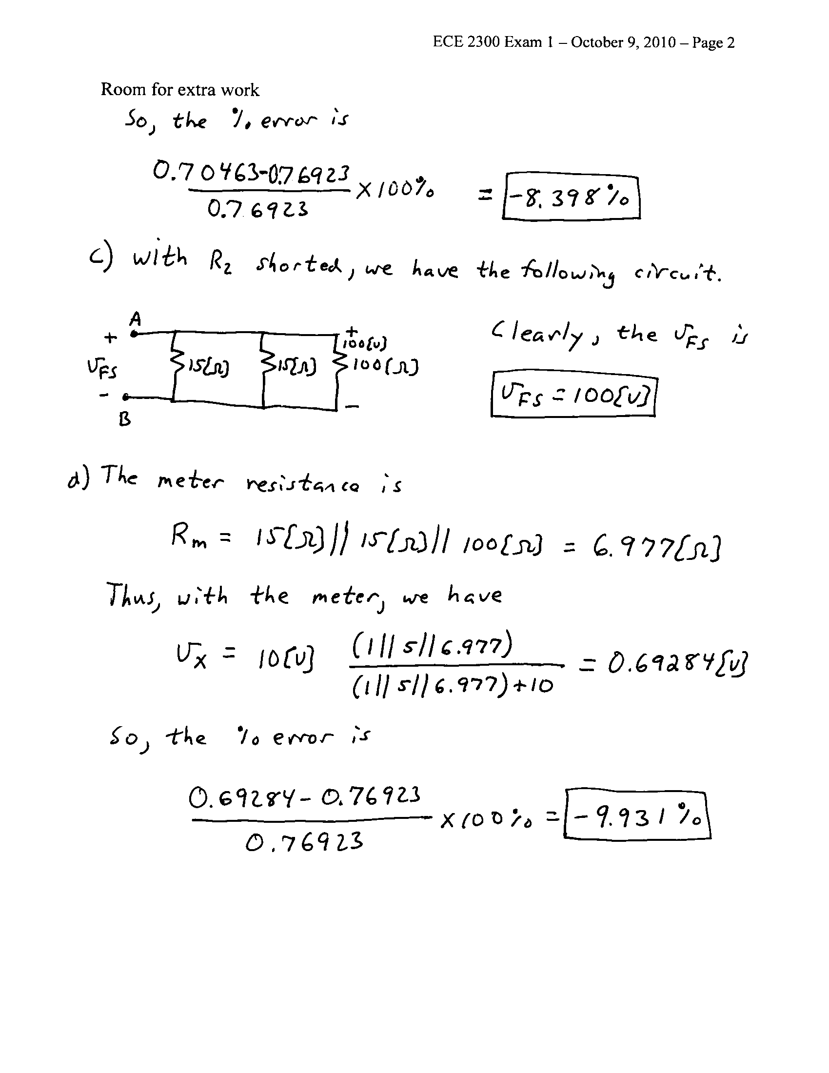
4. {25 Points} For the given circuit, use the Node-Voltage method to write a complete set of independent equations that could be used to solve this circuit. Do not simplify the circuit. Do not attempt to solve or simplify your equations. Define all variables.
