Name: _____________________________ (please print)
Signature: __________________________

ECE 2202 – Exam 1
October 21, 2017

Keep this exam closed until you are told to begin.

1. This exam is closed book, closed notes. You may use one 8.5” x 11” crib sheet, or its equivalent.
2. Show all work on these pages. Show all work necessary to complete the problem. A solution without the appropriate work shown will receive no credit. A solution that is not given in a reasonable order will lose credit. Clearly indicate your answer (for example by enclosing it in a box).
3. It is assumed that your work will begin on the same page as the problem statement. If you choose to begin your work on another page, you must indicate this on the page with the problem statement, with a clear indication of where the work can be found. If your work continues on to another page, indicate clearly where your work can be found. Failure to indicate this clearly will result in a loss of credit.
4. Show all units in solutions, intermediate results, and figures. Units in the exam will be included between square brackets.
5. Do not use red ink. Do not use red pencil.
6. You will have 90 minutes to work on this exam.

1. ________________/30
2. ________________/30
3. ________________/40
Total = 100
Room for extra work
1. {30 Points} Use the circuit shown below to solve. Find the value of the load resistor R_{L} that will maximize the power delivered to R_{L}.

Room for extra work

2. {30 Points} For the circuit shown, the current source i_{S}(t) is given as
The switch opened at t = 0.
- Find v_{X}(10[ms]).
- Find the power delivered by the i_{S}(t) current source at t = 10[ms].

Room for extra work

3. {40 Points} The switch SW1 in position a for a long time, and switch SW2 was closed for a long time, before t = 0. The switch SW2 opened at t = 0. After that, switch SW1 moved to position b at t = 100[ms].
- Find the energy absorbed by the R₃ resistor for the time period from
t = 200[ms] to t = 350[ms].
- Find the energy stored in capacitor C₁ at t = 350[ms].

Room for extra work

Solutions:
1. {30 Points} Use the circuit shown below to solve. Find the value of the load resistor R_{L} that will maximize the power delivered to R_{L}.
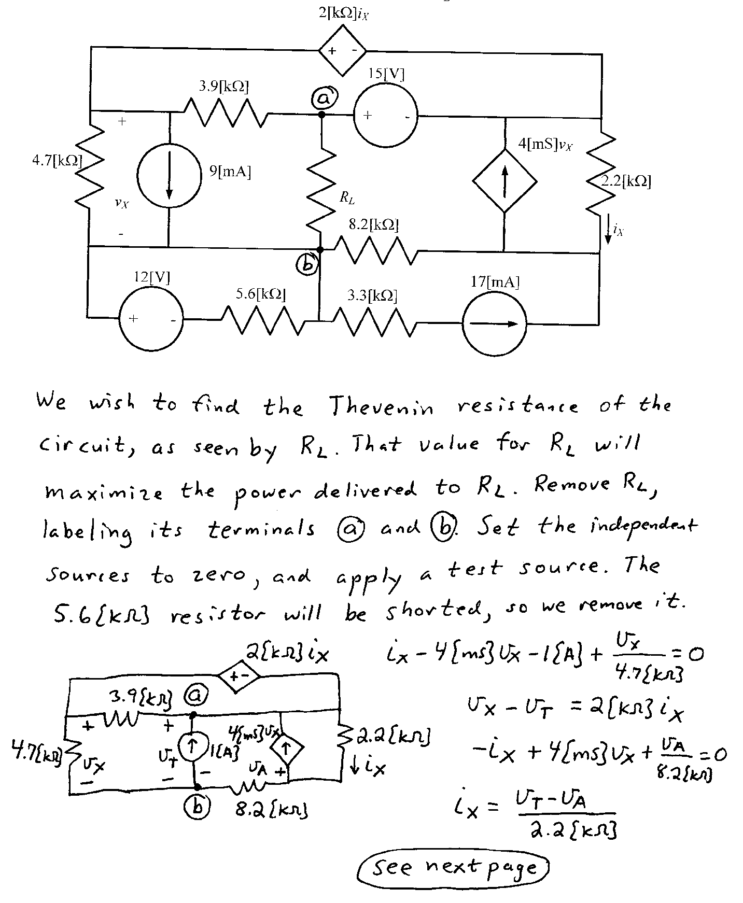
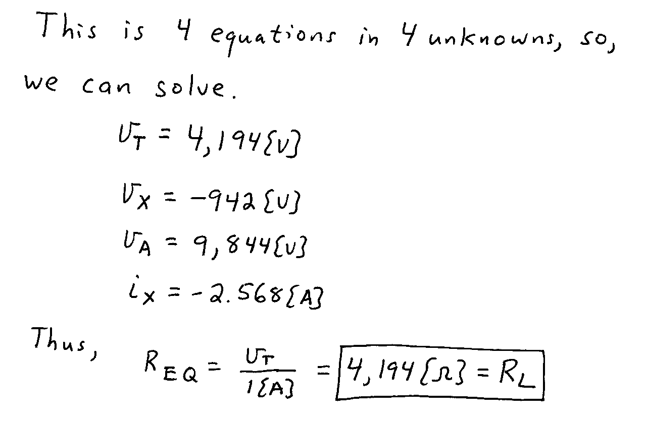

2. {30 Points} For the circuit shown, the current source i_{S}(t) is given as
The switch opened at t = 0.
- Find v_{X}(10[ms]).
- Find the power delivered by the i_{S}(t) current source at t = 10[ms].
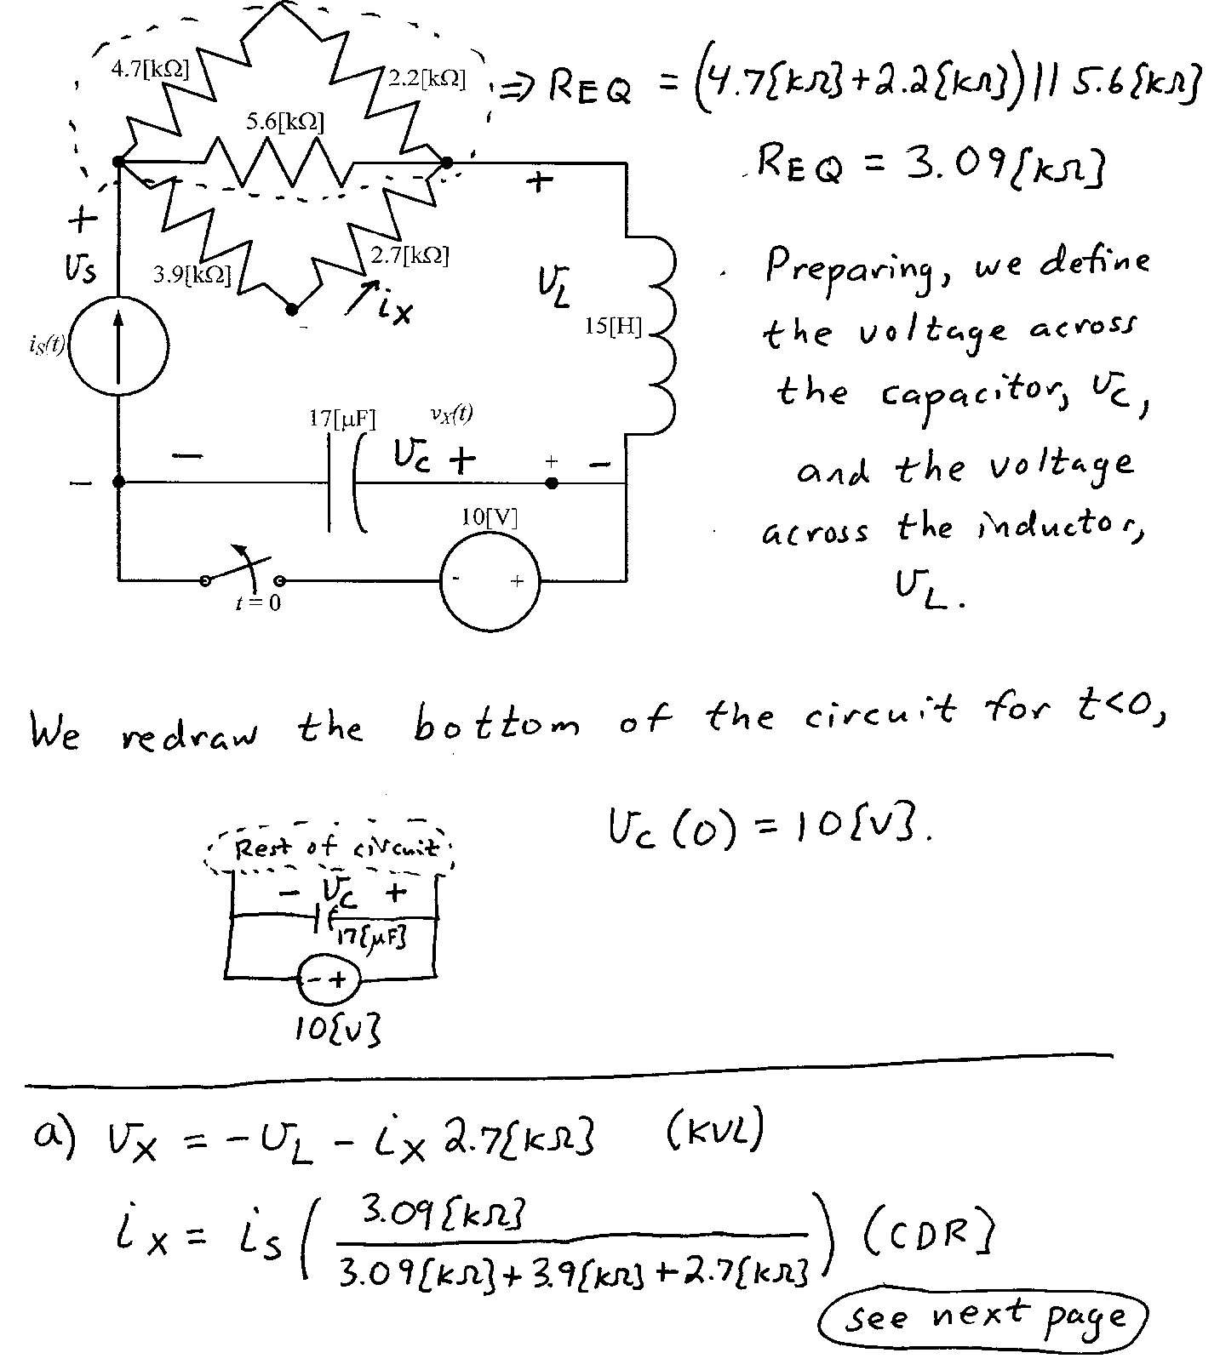

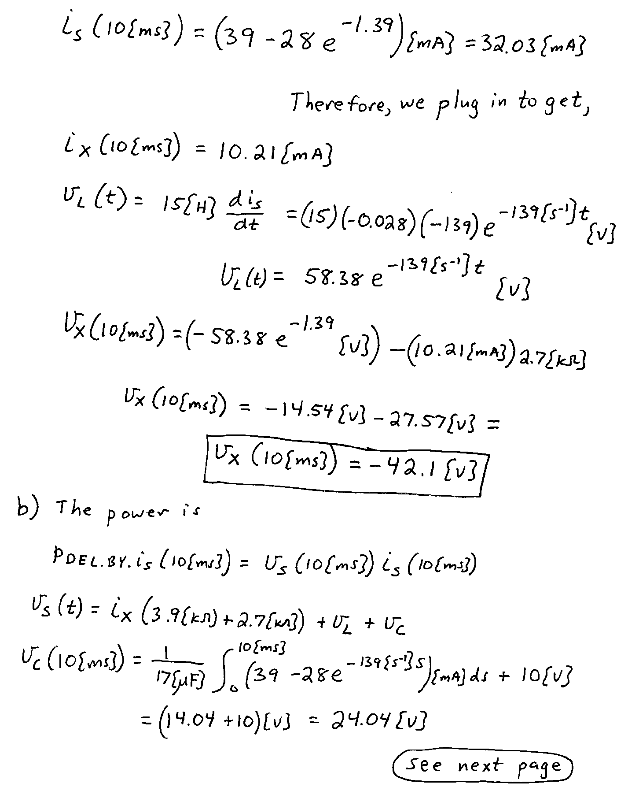
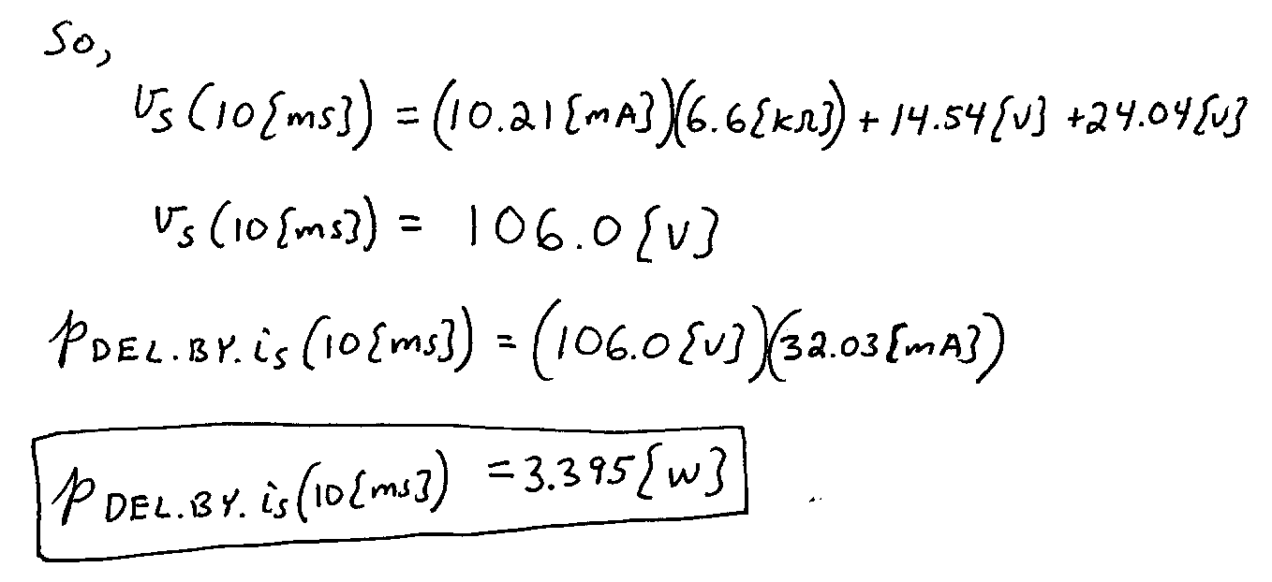

3. {40 Points} The switch SW1 in position a for a long time, and switch SW2 was closed for a long time, before t = 0. The switch SW2 opened at t = 0. After that, switch SW1 moved to position b at t = 100[ms].
- Find the energy absorbed by the R₃ resistor for the time period from
t = 200[ms] to t = 350[ms].
- Find the energy stored in capacitor C₁ at t = 350[ms].
